Caries Lesions and Aesthetic Concerns in Anterior Teeth
The Importance of Anterior Teeth in Aesthetics and Function
- Smiling, speaking, cutting food, and overall harmony of the face.
- Any damage or alteration in anterior teeth can have a significant impact on a patient's appearance, self-esteem, and quality of life.

Clinical Characteristics of the Caries Lesion
- The caries lesion results from disequilibrium between the demineralization and remineralization processes.
- Clinically, caries lesions can be present on various tooth surfaces, can be cavitated or noncavitated, active or inactive, and vary depending on their severity (initial, moderate, or severe).
- Radiographic information adds significantly to clinical findings in terms of finding lesions at different stages of progression.
- Radiographs help estimate the depth of caries demineralization into enamel and dentin.
- Radiographs are interpreted to evaluate possible caries progression.
- Additionally, in areas where sealants or restorations were placed without complete caries removal, bitewing/periapical radiographs should be evaluated to determine both the size and depth of lesion transition

Aesthetic Concerns in Anterior Teeth
In conservative aesthetic dentistry, these elements include the following:
- Shape or form
  - Knowledge of normal tooth anatomy is fundamental to the success of any conservative aesthetic dental procedure.
  - Changes over age
- Symmetry and proportionality
- Position and alignment
- Surface texture
- Colour

Minor modification of existing tooth contours, sometimes referred to as cosmetic contouring.

Normal tooth contours (A);
A tooth can be made to appear narrower by positioning the mesiofacial and distofacial line angles closer together (B);
Greater apparent width can be achieved by positioning the line angles and developmental depressions further apart (C).

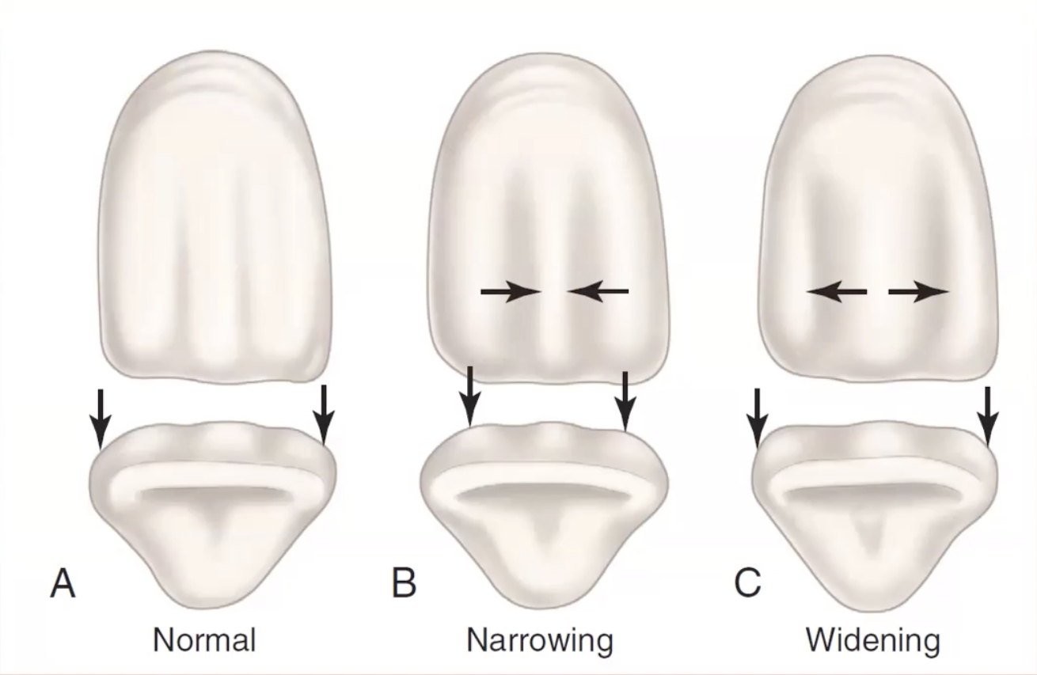
A tooth can be made to appear shorter by emphasizing the horizontal elements such as gingival perikymata and by positioning the gingival height of contour further incisally.

Symmetry and Proportionality
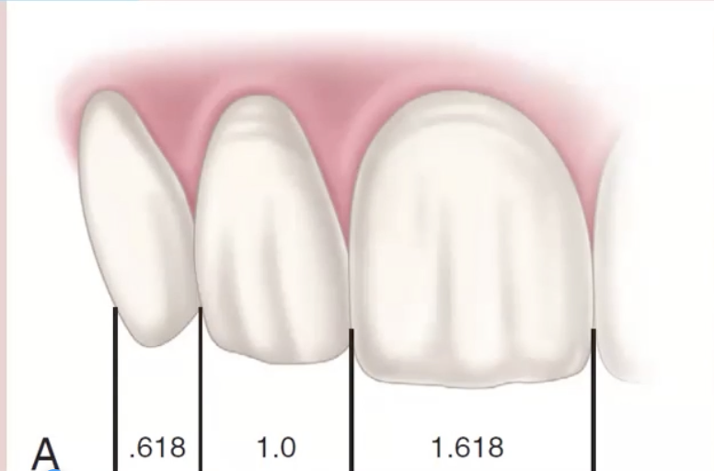
- Tooth proportions. The rule of the golden proportion. The exact ratios of proportionality.

Position and Alignment
- The overall harmony and balance of a smile depend largely on the proper position of teeth and their alignment in the arc.

Surface Texture
- Set of surface irregularities, holes, depressions, elevations, fissures, cracks, and lines.

Colour
- Most complex and least understood artistic element
Translucency
- Incisal is more translucent.
- Reproduce it
- Light penetrates the enamel - is a thin and translucent layer
- Light is absorbed and reflected by dentine - opaque
- Materials
  - RC, Ceramics

Let's recap the essential knowledge and insights from today's lecture:
- The Crucial Role of Anterior Teeth in Aesthetics and Function;
- Understanding Dental Caries;
- Clinical and Radiographic Assessment of Caries Lesions;
- Aesthetic Concerns and the Elements of Conservative Aesthetic Dentistry;
- Restorative Materials for Anterior Teeth.

