Procurement Data Dictionary
Week 1 Deliverable - Dataset Understanding & Governance
LCFA SQL & Power BI Procurement Project

Purpose
This document defines every column across the 8 source datasets (CD, CX, MDB, MM, MOBO15, MOBO25, MS, SI), records assumed ownership and refresh cadence, and logs data quality findings identified during profiling. It is the reference for the SQL ingestion, view, and dashboard layers built in subsequent weeks.

Dataset Overview
Code | Dataset | Row Count | Grain
SI | Site Info | 72 | 1 row per site
CD | Country Dimension | 20 | 1 row per country
CX | Currency Exchange Rates | 22 | 1 row per currency-pair rate
MM | Movement Metrics | 36,671 | 1 row per item_no + site
MS | Material/Stock Settings | 119,135 | 1 row per site + item_no (composite key, no duplicates)
MDB | Material Database | 180,143 | 1 row per item_no
MOBO25 | Stock On Hand (Current Balances) | 556,928 | 1 row per site + item_no + storage location
MOBO15 | Stock Movements (Transaction Log) | 203,265 | 1 row per stock movement transaction

Entity Relationship Diagram
Solid lines: item_no joins. Colour-coded per fact table. Dashed line: currency lookup relationship. Underlined attributes are primary/unique keys.
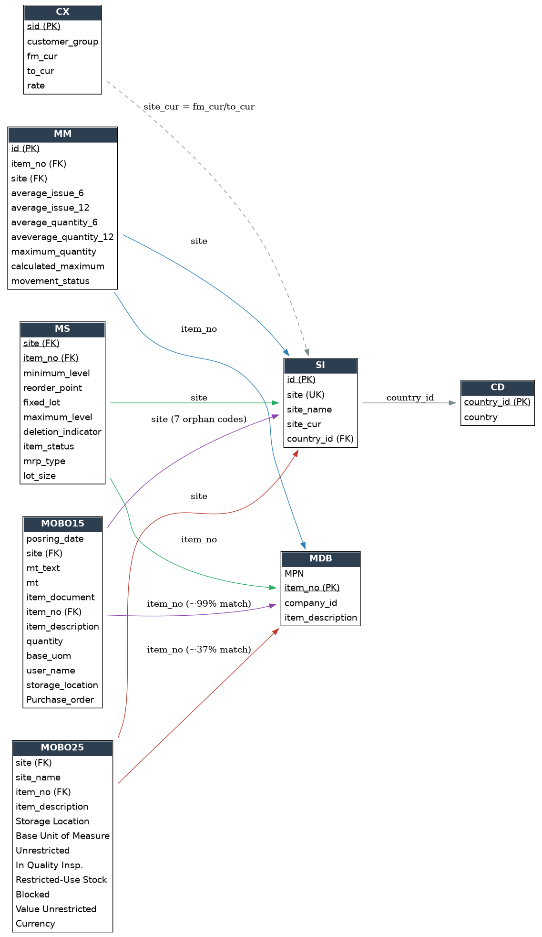

Movement Type Reference (from MOBO15.mt)
mt_text is only populated for ~13% of rows; treat mt (the code) as authoritative and use this lookup table.
mt Code | Label | Meaning | Quantity Sign | Row Count
471 | GI for order | Goods Issue - stock taken out for an order | Negative | 112,929
472 | RE for order | Reversal of a 471 issue - stock returned | Positive | 7,011
311 | Goods receipt | Stock received into inventory | Positive (typical) | 64,480
312 | Reversal of GR | Reversal of a goods receipt | Negative (typical) | 3,416
411 | GI for cost center | Goods issue charged to a cost center | Negative (typical) | 14,755
412 | RE for cost center | Reversal of a cost-center issue | Positive (typical) | 421
Other | 911,912,761,553,554,519,511,531,521,762,851 | Minor/rare movement codes | Mixed | ~229 combined

Column-Level Data Dictionary

SI - Site Info
Source file: 1769441194878-SI.csv
Row count: 72
Grain: 1 row per site
Assumed owner: Assumed: Master Data / Site Governance team
Assumed refresh cadence: Assumed static / low-frequency reference table

Column | Definition | Type | Notes / Quality
id | Surrogate primary key for the site record. | Integer | Unique, 72 values
site | Site code (business key), e.g. GDNP1. | Text (5 char) | Unique; used as FK in MM, MS, MOBO15, MOBO25
site_name | Short display name of the site. | Text | 71 unique (1 duplicate name across 2 sites)
site_cur | Site's local operating currency (ISO code). | Text (3 char) | 18 distinct currencies; joins to CX.fm_cur/to_cur
country_id | Foreign key to CD (country dimension). | Integer | 20 distinct values, all present in CD

CD - Country Dimension
Source file: 1769441253767-CD.csv
Row count: 20
Grain: 1 row per country
Assumed owner: Assumed: Master Data / Site Governance team
Assumed refresh cadence: Static reference table

Column | Definition | Type | Notes / Quality
country_id | Surrogate primary key. | Integer | Unique, 20 values
country | Country name. | Text | Unique

CX - Currency Exchange Rates
Source file: 1769441253942-CX.csv
Row count: 22
Grain: 1 row per currency-pair rate
Assumed owner: Assumed: Finance / Treasury
Assumed refresh cadence: Assumed periodic (rate snapshot, not real-time)

Column | Definition | Type | Notes / Quality
sid | Surrogate primary key. | Integer | Unique, 22 values
customer_group | Customer segmentation flag. | Text | 100% NULL in this extract - not usable as-is
fm_cur | 'From' currency (source of conversion). | Text (3 char) | 11 distinct currencies
to_cur | 'To' currency (target of conversion). | Text (3 char) | Only 2 distinct values seen (GBP, USD) - target currencies are limited
rate | Conversion rate, fm_cur -> to_cur. | Decimal | Use for currency normalisation in dashboard

MM - Movement Metrics
Source file: 1769441195082-MM.csv
Row count: 36,671
Grain: 1 row per item_no + site
Assumed owner: Assumed: Inventory Planning / Supply Chain
Assumed refresh cadence: Assumed periodic recalculation (6/12-month rolling averages)

Column | Definition | Type | Notes / Quality
id | Surrogate primary key. | Integer | Unique, 36,671 values
item_no | Material/item number. | Text/Numeric | FK to MDB.item_no, MS.item_no; 35,388 distinct items
site | Site code. | Text | FK to SI.site; 19 distinct sites represented
average_issue_6 | Average number of issue transactions over trailing 6 months. | Integer | -
average_issue_12 | Average number of issue transactions over trailing 12 months. | Integer | -
average_quantity_6 | Average quantity issued over trailing 6 months. | Decimal | -
aveverage_quantity_12 | Average quantity issued over trailing 12 months. (source typo retained: 'aveverage') | Decimal | Rename to average_quantity_12 in SQL view
maximum_quantity | Source system's stored maximum stock quantity. | Decimal | -
calculated_maximum | Recalculated/derived maximum quantity. | Decimal | Compare vs maximum_quantity for variance
movement_status | Pre-classified mover status. | Text (categorical) | Fast / Medium / Slow / No Mover - candidate seed for Opportunity Dashboard

MS - Material/Stock Settings
Source file: 1769441231065-MS.csv
Row count: 119,135
Grain: 1 row per site + item_no (composite key, no duplicates)
Assumed owner: Assumed: MRP / Materials Planning
Assumed refresh cadence: Assumed synced from ERP master data, periodic

Column | Definition | Type | Notes / Quality
site | Site code. | Text | FK to SI.site; 12 distinct sites
item_no | Material/item number. | Text/Numeric | FK to MDB.item_no; 113,122 distinct items
minimum_level | MRP minimum stock level. | Decimal | 16,447 NULL (~14%)
reorder_point | Reorder point threshold. | Decimal | -
fixed_lot | Fixed lot size quantity, if applicable. | Decimal | 2,641 NULL
maximum_level | MRP maximum stock level. | Decimal | -
deletion_indicator | Flag marking item for deletion in ERP. | Text ('X'/'0') | 82,096 NULL - treat NULL as 'not flagged'
item_status | Item lifecycle status code. | Text (categorical: ZD/ZB/0/1) | 76,915 NULL; 1 stray whitespace-only value found - needs trim/clean
mrp_type | MRP procedure type code. | Text (categorical) | 5 distinct codes, dominated by ANDV (88%)
lot_size | Lot-sizing procedure code. | Text (categorical) | 7 distinct codes, dominated by AFXV (58%)

MDB - Material Database
Source file: 1769441233720-MDB.csv
Row count: 180,143
Grain: 1 row per item_no
Assumed owner: Assumed: Master Data Management
Assumed refresh cadence: Assumed ERP material master sync

Column | Definition | Type | Notes / Quality
MPN | Manufacturer Part Number. | Text | 46,624 NULL (~26%); 93 rows have leading/trailing whitespace - needs trim
item_no | Material/item number (primary key of this table). | Text/Numeric | Unique across all 180,143 rows
company_id | Company/plant-level identifier associated with the item. | Text | 143,315 distinct values - not a clean dimension key on its own
item_description | Free-text material description. | Text | 145,147 distinct; 77 rows have whitespace padding - needs trim

MOBO25 - Stock On Hand (Current Balances)
Source file: MOBO25_clean.csv
Row count: 556,928
Grain: 1 row per site + item_no + storage location
Assumed owner: Assumed: Warehouse / Inventory Ops
Assumed refresh cadence: Point-in-time snapshot ('25' likely denotes extract period/version)

Column | Definition | Type | Notes / Quality
site | Site code. | Text | FK to SI.site; 73 distinct (1 code, GAEP2, not present in SI)
site_name | Denormalised site name (duplicate of SI.site_name). | Text | Redundant with SI - use SI as source of truth
item_no | Material/item number. | Text/Numeric | FK to MDB.item_no (~37% match rate - large share of stocked items have no MDB record); 479,196 distinct items
item_description | Item description. | Text | 108 NULL
Storage Location | Warehouse storage location code. | Text (categorical) | 2 values: 6000, 8000
Base Unit of Measure | Unit of measure for quantities. | Text (categorical) | 56 distinct UoM codes
Unrestricted | Quantity in unrestricted (usable) stock. | Decimal | Primary 'available stock' quantity
In Quality Insp. | Quantity currently in quality inspection. | Decimal | -
Restricted-Use Stock | Quantity in restricted-use status. | Decimal | Only 1 distinct value observed - likely always 0
Blocked | Quantity blocked from use. | Decimal | -
Value Unrestricted | Monetary value of unrestricted stock, in local site currency. | Decimal | Needs currency normalisation via CX before cross-site aggregation
Currency | Currency code of the Value Unrestricted amount. | Text (3 char) | 18 distinct currencies - matches site_cur pattern

MOBO15 - Stock Movements (Transaction Log)
Source file: MOBO15_clean.csv
Row count: 203,265
Grain: 1 row per stock movement transaction
Assumed owner: Assumed: Warehouse / Inventory Ops (transactional log)
Assumed refresh cadence: Transactional - continuously appended; '15' likely denotes extract period/version

Column | Definition | Type | Notes / Quality
posring_date | Posting date of the movement (source column name retains typo for 'posting_date'). | Date (DD/MM/YYYY) | 23,580 rows (~11.6%) contain literal text 'Not_found' instead of a date - must be cleaned/nulled before casting to DATE
site | Site code. | Text | FK to SI.site; 27 distinct, 7 orphan codes not in SI (GNULPL, GP1, GP2, GP3, G20P0, G-20P0, G-P1)
mt_text | Text label for movement type. | Text (categorical) | 87% NULL - sparse, unreliable; derive from mt via a code lookup instead
mt | Movement type code (SAP-style). | Text (categorical) | 17 distinct codes; 471 = GI for order (issue, qty negative), 472 = RE for order (reversal, qty positive); 24 rows NULL
item_document | Material document number for the transaction. | Text/Numeric | 112,050 distinct - one document can span multiple line items
item_no | Material/item number. | Text/Numeric | FK to MDB.item_no (~99% match rate); 48,229 distinct items
item_description | Item description at time of transaction. | Text | 16 NULL
quantity | Movement quantity. Sign indicates direction (negative = issue/out, positive = receipt/in). | Decimal | 23 NULL
base_uom | Unit of measure for the quantity. | Text (categorical) | 25 distinct codes
user_name | User who posted the transaction. | Text | 275 distinct users
storage_location | Warehouse storage location code. | Text (categorical) | 2 values, matches MOBO25.Storage Location domain
Purchase_order | Related purchase order number, where applicable. | Text/Numeric | 142,057 NULL (~70%) - expected, since not all movement types involve a PO

Stakeholder Q&A / Assumptions Log
Question / Observation | Assumption / Status
Site codes not in SI (MOBO15: GNULPL, GP1, GP2, GP3, G20P0, G-20P0, G-P1; MOBO25: GAEP2) | Assumed placeholder/unassigned or legacy site codes. NEEDS CONFIRMATION: exclude from site-level reporting, or map to real sites?
posring_date = 'Not_found' (11.6% of MOBO15) | Assumed a source-system export failure, not a real date value. Plan: cast to NULL and exclude from date-based KPIs unless a backfill source is identified.
mt_text mostly NULL | Assumed the label was only captured for a manual subset. Plan: build a static mt-code lookup table instead of relying on mt_text.
MDB coverage of MOBO25 items is only ~37% | NEEDS CONFIRMATION: are the unmatched items intentionally excluded from the material master (e.g., non-stock, obsolete), or is this a load/sync gap?
CX.customer_group 100% NULL, CX.to_cur only 2 distinct values | NEEDS CONFIRMATION: is this exchange table meant only for conversions into GBP/USD, or is the extract incomplete?
MOBO25 site_name duplicates SI.site_name | Assumed denormalised for convenience. Plan: treat SI as the single source of truth and drop MOBO25.site_name in the modeled views.
movement_status in MM appears pre-classified (Fast/Medium/Slow/No Mover) | NEEDS CONFIRMATION with stakeholder: can this be reused directly for the Week 3 Opportunity Dashboard classification, or should thresholds be recalculated independently?

