 | TOSTEM Site survey WINDOWS & DOORS |  |  |  |  |  |  | 2025-10-10 | Inside view
Ref | Series | Product type |  | Opening size |  | Color |  | Glass |  | Insect  screen
 |  |  |  | Wo | Ho
W12 | ATIS | Sliding window 2P2T (ATIS) + |  | 1200 | 1400 |  |  | LM Solar low-e 8.38mm |  | Yes
 |  | Fix window for ATIS |  | mm. | mm.
More Detial |  |  | Note |  |  |  | ☐For giesta series
image |  |  |  |  |  |  | Design : Select..  Color : Select..  Frame type : Select..  Handle : Select.. / Color : Select..  Door closer color : Select..  Door guard color : Select..  Cylinder lock color : Select..
 |  |  |  |  |  |  | ☐For exterior series
LATTICE Pattern : 60mm.
Remote control : No
ยืนยันการตรวจสอบ

(.....................................................) (.....................................................) (.....................................................)
ผู้สรุปผลสำรวจ ผู้ควบคุมงานโครงสร้าง ลูกค้า

 | TOSTEM Site survey WINDOWS & DOORS |  |  |  |  |  |  | 2025-10-10 | Inside view
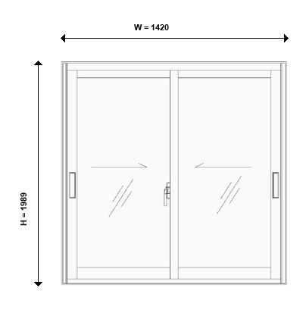
Ref | Series | Product type |  | Opening size |  | Color |  | Glass |  | Insect  screen
 |  |  |  | Wo | Ho
W8.1 | ATIS | Sliding door 2P2T(ATIS) |  | 1420 | 1989 |  |  | LM Solar low-e 12.38mm |  | Yes
 |  |  |  | mm. | mm.
More Detial |  |  | Note |  |  |  | ☐For giesta series
image |  |  |  |  |  |  | Design : Select..  Color : Select..  Frame type : Select..  Handle : Select.. / Color : Select..  Door closer color : Select..  Door guard color : Select..  Cylinder lock color : Select..
 |  |  |  |  |  |  | ☐For exterior series
LATTICE Pattern : 60mm.
Remote control : No
ยืนยันการตรวจสอบ

(.....................................................) (.....................................................) (.....................................................)
ผู้สรุปผลสำรวจ ผู้ควบคุมงานโครงสร้าง ลูกค้า

 | TOSTEM Site survey WINDOWS & DOORS |  |  |  |  |  |  | 2025-10-10 | Inside view
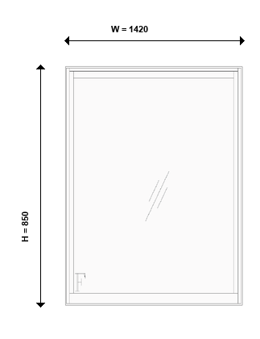
Ref | Series | Product type |  | Opening size |  | Color |  | Glass |  | Insect  screen
 |  |  |  | Wo | Ho
W8 | ATIS | Fix window for ATIS |  | 1420 | 850 |  |  | LM Solar low-e 12.38mm |  | No
 |  |  |  | mm. | mm.
More Detial |  |  | Note |  |  |  | ☐For giesta series
image |  |  |  |  |  |  | Design : Select..  Color : Select..  Frame type : Select..  Handle : Select.. / Color : Select..  Door closer color : Select..  Door guard color : Select..  Cylinder lock color : Select..
 |  |  |  |  |  |  | ☐For exterior series
LATTICE Pattern : 60mm.
Remote control : No
ยืนยันการตรวจสอบ

(.....................................................) (.....................................................) (.....................................................)
ผู้สรุปผลสำรวจ ผู้ควบคุมงานโครงสร้าง ลูกค้า

 | TOSTEM Site survey WINDOWS & DOORS |  |  |  |  |  |  | 2025-10-10 | Inside view
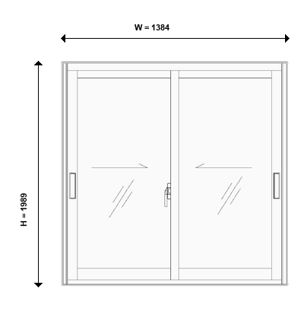
Ref | Series | Product type |  | Opening size |  | Color |  | Glass |  | Insect  screen
 |  |  |  | Wo | Ho
W8.2 | ATIS | Sliding door 2P2T(ATIS) |  | 1384 | 1989 |  |  | LM Solar low-e 12.38mm |  | Yes
 |  |  |  | mm. | mm.
More Detial |  |  | Note |  |  |  | ☐For giesta series
image |  |  |  |  |  |  | Design : Select..  Color : Select..  Frame type : Select..  Handle : Select.. / Color : Select..  Door closer color : Select..  Door guard color : Select..  Cylinder lock color : Select..
 |  |  |  |  |  |  | ☐For exterior series
LATTICE Pattern : 60mm.
Remote control : No
ยืนยันการตรวจสอบ

(.....................................................) (.....................................................) (.....................................................)
ผู้สรุปผลสำรวจ ผู้ควบคุมงานโครงสร้าง ลูกค้า

 | TOSTEM Site survey WINDOWS & DOORS |  |  |  |  |  |  | 2025-10-10 | Inside view
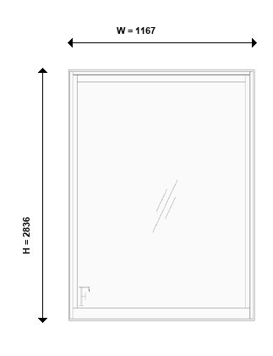
Ref | Series | Product type |  | Opening size |  | Color |  | Glass |  | Insect  screen
 |  |  |  | Wo | Ho
W3 | ATIS | Fix window for ATIS |  | 1167 | 2836 |  |  | LM Solar low-e 12.38mm |  | No
 |  |  |  | mm. | mm.
More Detial |  |  | Note |  |  |  | ☐For giesta series
image |  |  |  |  |  |  | Design : Select..  Color : Select..  Frame type : Select..  Handle : Select.. / Color : Select..  Door closer color : Select..  Door guard color : Select..  Cylinder lock color : Select..
 |  |  |  |  |  |  | ☐For exterior series
LATTICE Pattern : 60mm.
Remote control : No
ยืนยันการตรวจสอบ

(.....................................................) (.....................................................) (.....................................................)
ผู้สรุปผลสำรวจ ผู้ควบคุมงานโครงสร้าง ลูกค้า

 | TOSTEM Site survey WINDOWS & DOORS |  |  |  |  |  |  | 2025-10-10 | Inside view
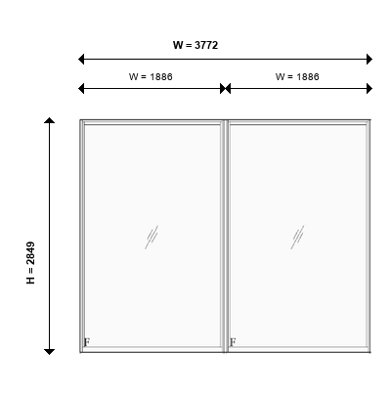
Ref | Series | Product type |  | Opening size |  | Color |  | Glass |  | Insect  screen
 |  |  |  | Wo | Ho
W2 | ATIS | Fix window for ATIS (2) |  | 3772 | 2849 |  |  | LM Solar low-e 10.38mm |  | No
 |  |  |  | mm. | mm.
More Detial |  |  | Note |  |  |  | ☐For giesta series
image |  |  |  |  |  |  | Design : Select..  Color : Select..  Frame type : Select..  Handle : Select.. / Color : Select..  Door closer color : Select..  Door guard color : Select..  Cylinder lock color : Select..
 |  |  |  |  |  |  | ☐For exterior series
LATTICE Pattern : 60mm.
Remote control : No
ยืนยันการตรวจสอบ

(.....................................................) (.....................................................) (.....................................................)
ผู้สรุปผลสำรวจ ผู้ควบคุมงานโครงสร้าง ลูกค้า

 | TOSTEM Site survey WINDOWS & DOORS |  |  |  |  |  |  | 2025-10-10 | Inside view
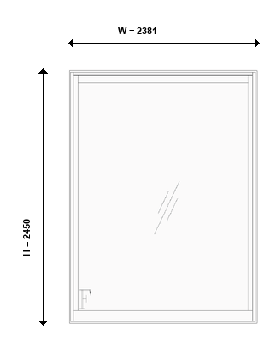
Ref | Series | Product type |  | Opening size |  | Color |  | Glass |  | Insect  screen
 |  |  |  | Wo | Ho
W5 | ATIS | Fix window for ATIS |  | 2381 | 2450 |  |  | LM Solar low-e 10.38mm |  | No
 |  |  |  | mm. | mm.
More Detial |  |  | Note |  |  |  | ☐For giesta series
image |  |  |  |  |  |  | Design : Select..  Color : Select..  Frame type : Select..  Handle : Select.. / Color : Select..  Door closer color : Select..  Door guard color : Select..  Cylinder lock color : Select..
 |  |  |  |  |  |  | ☐For exterior series
LATTICE Pattern : 60mm.
Remote control : No
ยืนยันการตรวจสอบ

(.....................................................) (.....................................................) (.....................................................)
ผู้สรุปผลสำรวจ ผู้ควบคุมงานโครงสร้าง ลูกค้า

 | TOSTEM Site survey WINDOWS & DOORS |  |  |  |  |  |  | 2025-10-10 | Inside view
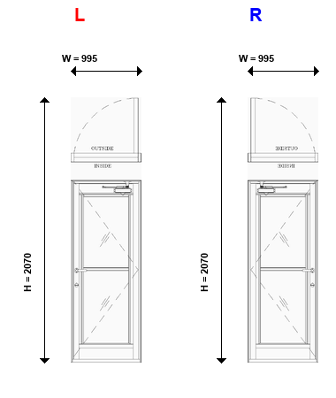
Ref | Series | Product type |  | Opening size |  | Color |  | Glass |  | Insect  screen
 |  |  |  | Wo | Ho
D9 | WE-70 | Airflow door L/R รวมุ้งแล้ว |  | 995 | 2070 |  |  |  |  | Yes
 |  |  |  | mm. | mm.
More Detial |  |  | Note |  |  |  | ☐For giesta series
image |  |  |  |  |  |  | Design : Select..  Color : Select..  Frame type : Select..  Handle : Select.. / Color : Select..  Door closer color : Select..  Door guard color : Select..  Cylinder lock color : Select..
 |  |  |  |  |  |  | ☐For exterior series
LATTICE Pattern : 60mm.
Remote control : No
ยืนยันการตรวจสอบ

(.....................................................) (.....................................................) (.....................................................)
ผู้สรุปผลสำรวจ ผู้ควบคุมงานโครงสร้าง ลูกค้า

 | TOSTEM Site survey WINDOWS & DOORS |  |  |  |  |  |  | 2025-10-10 | Inside view
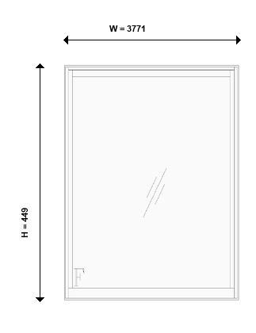
Ref | Series | Product type |  | Opening size |  | Color |  | Glass |  | Insect  screen
 |  |  |  | Wo | Ho
W18 | WE-70 | Fixed window |  | 3771 | 449 |  |  | LM Solar low-e 8.38mm |  | No
 |  |  |  | mm. | mm.
More Detial |  |  | Note |  |  |  | ☐For giesta series
image |  |  |  |  |  |  | Design : Select..  Color : Select..  Frame type : Select..  Handle : Select.. / Color : Select..  Door closer color : Select..  Door guard color : Select..  Cylinder lock color : Select..
 |  |  |  |  |  |  | ☐For exterior series
LATTICE Pattern : 60mm.
Remote control : No
ยืนยันการตรวจสอบ

(.....................................................) (.....................................................) (.....................................................)
ผู้สรุปผลสำรวจ ผู้ควบคุมงานโครงสร้าง ลูกค้า

 | TOSTEM Site survey WINDOWS & DOORS |  |  |  |  |  |  | 2025-10-10 | Inside view
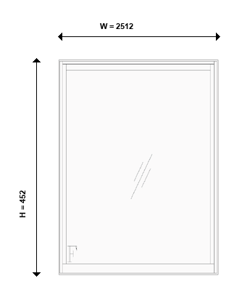
Ref | Series | Product type |  | Opening size |  | Color |  | Glass |  | Insect  screen
 |  |  |  | Wo | Ho
W16 | WE-70 | Fixed window |  | 2512 | 452 |  |  | LM Solar low-e 8.38mm |  | No
 |  |  |  | mm. | mm.
More Detial |  |  | Note |  |  |  | ☐For giesta series
image |  |  |  |  |  |  | Design : Select..  Color : Select..  Frame type : Select..  Handle : Select.. / Color : Select..  Door closer color : Select..  Door guard color : Select..  Cylinder lock color : Select..
 |  |  |  |  |  |  | ☐For exterior series
LATTICE Pattern : 60mm.
Remote control : No
ยืนยันการตรวจสอบ

(.....................................................) (.....................................................) (.....................................................)
ผู้สรุปผลสำรวจ ผู้ควบคุมงานโครงสร้าง ลูกค้า

 | TOSTEM Site survey WINDOWS & DOORS |  |  |  |  |  |  | 2025-10-10 | Inside view
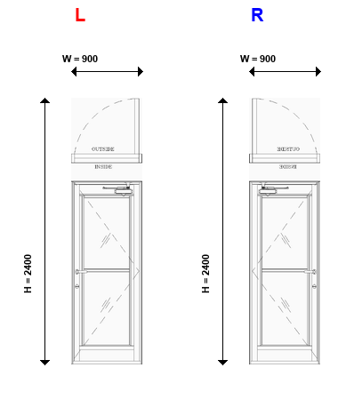
Ref | Series | Product type |  | Opening size |  | Color |  | Glass |  | Insect  screen
 |  |  |  | Wo | Ho
D15 | WE-70 | Airflow door L/R รวมุ้งแล้ว |  | 900 | 2400 |  |  |  |  | Yes
 |  |  |  | mm. | mm.
More Detial |  |  | Note |  |  |  | ☐For giesta series
image |  |  |  |  |  |  | Design : Select..  Color : Select..  Frame type : Select..  Handle : Select.. / Color : Select..  Door closer color : Select..  Door guard color : Select..  Cylinder lock color : Select..
 |  |  |  |  |  |  | ☐For exterior series
LATTICE Pattern : 60mm.
Remote control : No
ยืนยันการตรวจสอบ

(.....................................................) (.....................................................) (.....................................................)
ผู้สรุปผลสำรวจ ผู้ควบคุมงานโครงสร้าง ลูกค้า

 | TOSTEM Site survey WINDOWS & DOORS |  |  |  |  |  |  | 2025-10-10 | Inside view
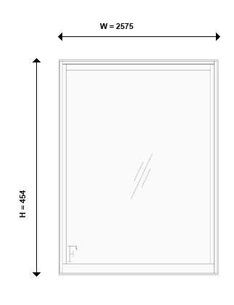
Ref | Series | Product type |  | Opening size |  | Color |  | Glass |  | Insect  screen
 |  |  |  | Wo | Ho
W15 | WE-70 | Fixed window |  | 2575 | 454 |  |  | LM Solar low-e 8.38mm |  | No
 |  |  |  | mm. | mm.
More Detial |  |  | Note |  |  |  | ☐For giesta series
image |  |  |  |  |  |  | Design : Select..  Color : Select..  Frame type : Select..  Handle : Select.. / Color : Select..  Door closer color : Select..  Door guard color : Select..  Cylinder lock color : Select..
 |  |  |  |  |  |  | ☐For exterior series
LATTICE Pattern : 60mm.
Remote control : No
ยืนยันการตรวจสอบ

(.....................................................) (.....................................................) (.....................................................)
ผู้สรุปผลสำรวจ ผู้ควบคุมงานโครงสร้าง ลูกค้า

 | TOSTEM Site survey WINDOWS & DOORS |  |  |  |  |  |  | 2025-10-10 | Inside view
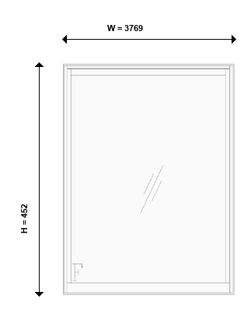
Ref | Series | Product type |  | Opening size |  | Color |  | Glass |  | Insect  screen
 |  |  |  | Wo | Ho
W14 | WE-70 | Fixed window |  | 3769 | 452 |  |  | LM Solar low-e 8.38mm |  | No
 |  |  |  | mm. | mm.
More Detial |  |  | Note |  |  |  | ☐For giesta series
image |  |  |  |  |  |  | Design : Select..  Color : Select..  Frame type : Select..  Handle : Select.. / Color : Select..  Door closer color : Select..  Door guard color : Select..  Cylinder lock color : Select..
 |  |  |  |  |  |  | ☐For exterior series
LATTICE Pattern : 60mm.
Remote control : No
ยืนยันการตรวจสอบ

(.....................................................) (.....................................................) (.....................................................)
ผู้สรุปผลสำรวจ ผู้ควบคุมงานโครงสร้าง ลูกค้า

 | TOSTEM Site survey WINDOWS & DOORS |  |  |  |  |  |  | 2025-10-10 | Inside view
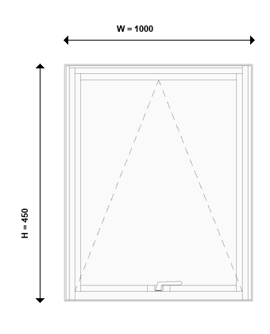
Ref | Series | Product type |  | Opening size |  | Color |  | Glass |  | Insect  screen
 |  |  |  | Wo | Ho
W17 | WE-70 | Awning window |  | 1000 | 450 |  |  |  |  | No
 |  |  |  | mm. | mm.
More Detial |  |  | Note |  |  |  | ☐For giesta series
image |  |  |  |  |  |  | Design : Select..  Color : Select..  Frame type : Select..  Handle : Select.. / Color : Select..  Door closer color : Select..  Door guard color : Select..  Cylinder lock color : Select..
 |  |  |  |  |  |  | ☐For exterior series
LATTICE Pattern : 60mm.
Remote control : No
ยืนยันการตรวจสอบ

(.....................................................) (.....................................................) (.....................................................)
ผู้สรุปผลสำรวจ ผู้ควบคุมงานโครงสร้าง ลูกค้า

 | TOSTEM Site survey WINDOWS & DOORS |  |  |  |  |  |  | 2025-10-10 | Inside view
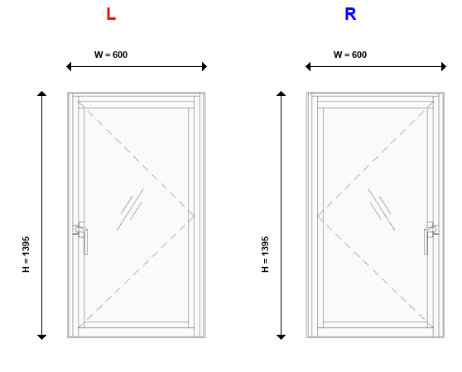
Ref | Series | Product type |  | Opening size |  | Color |  | Glass |  | Insect  screen
 |  |  |  | Wo | Ho
W13 | WE-70 | Single casement window L/R |  | 600 | 1395 |  |  |  |  | No
 |  |  |  | mm. | mm.
More Detial |  |  | Note |  |  |  | ☐For giesta series
image |  |  |  |  |  |  | Design : Select..  Color : Select..  Frame type : Select..  Handle : Select.. / Color : Select..  Door closer color : Select..  Door guard color : Select..  Cylinder lock color : Select..
 |  |  |  |  |  |  | ☐For exterior series
LATTICE Pattern : 60mm.
Remote control : No
ยืนยันการตรวจสอบ

(.....................................................) (.....................................................) (.....................................................)
ผู้สรุปผลสำรวจ ผู้ควบคุมงานโครงสร้าง ลูกค้า

 | TOSTEM Site survey WINDOWS & DOORS |  |  |  |  |  |  | 2025-10-10 | Inside view
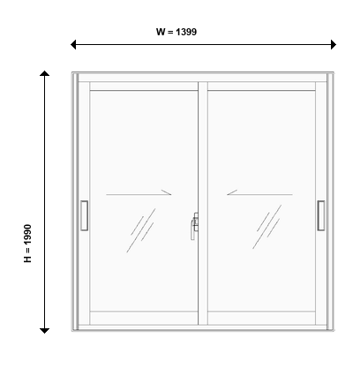
Ref | Series | Product type |  | Opening size |  | Color |  | Glass |  | Insect  screen
 |  |  |  | Wo | Ho
W8.3 | WE-70 | 2 panels 2 tracks sliding door |  | 1399 | 1990 |  |  | กระจกฝ้า 5mm |  | Yes
 |  |  |  | mm. | mm.
More Detial |  |  | Note |  |  |  | ☐For giesta series
image |  |  |  |  |  |  | Design : Select..  Color : Select..  Frame type : Select..  Handle : Select.. / Color : Select..  Door closer color : Select..  Door guard color : Select..  Cylinder lock color : Select..
 |  |  |  |  |  |  | ☐For exterior series
LATTICE Pattern : 60mm.
Remote control : No
ยืนยันการตรวจสอบ

(.....................................................) (.....................................................) (.....................................................)
ผู้สรุปผลสำรวจ ผู้ควบคุมงานโครงสร้าง ลูกค้า

 | TOSTEM Site survey WINDOWS & DOORS |  |  |  |  |  |  | 2025-10-10 | Inside view
Ref | Series | Product type |  | Opening size |  | Color |  | Glass |  | Insect  screen
 |  |  |  | Wo | Ho
W9 | WE-70 | 2 panels 2 tracks sliding door + |  | 1288 | 1986 |  |  |  |  | Yes
 |  | Fixed window |  | mm. | mm.
More Detial |  |  | Note |  |  |  | ☐For giesta series
image |  |  |  |  |  |  | Design : Select..  Color : Select..  Frame type : Select..  Handle : Select.. / Color : Select..  Door closer color : Select..  Door guard color : Select..  Cylinder lock color : Select..
 |  |  |  |  |  |  | ☐For exterior series
LATTICE Pattern : 60mm.
Remote control : No
ยืนยันการตรวจสอบ

(.....................................................) (.....................................................) (.....................................................)
ผู้สรุปผลสำรวจ ผู้ควบคุมงานโครงสร้าง ลูกค้า

 | TOSTEM Site survey WINDOWS & DOORS |  |  |  |  |  |  | 2025-10-10 | Inside view
Ref | Series | Product type |  | Opening size |  | Color |  | Glass |  | Insect  screen
 |  |  |  | Wo | Ho
W7 | WE-70 | 2 panels 2 tracks sliding door + |  | 1451 | 1986 |  |  | กระจกฝ้า 5mm |  | Yes
 |  | Fixed window |  | mm. | mm.
More Detial |  |  | Note |  |  |  | ☐For giesta series
image |  |  |  |  |  |  | Design : Select..  Color : Select..  Frame type : Select..  Handle : Select.. / Color : Select..  Door closer color : Select..  Door guard color : Select..  Cylinder lock color : Select..
 |  |  |  |  |  |  | ☐For exterior series
LATTICE Pattern : 60mm.
Remote control : No
ยืนยันการตรวจสอบ

(.....................................................) (.....................................................) (.....................................................)
ผู้สรุปผลสำรวจ ผู้ควบคุมงานโครงสร้าง ลูกค้า

 | TOSTEM Site survey WINDOWS & DOORS |  |  |  |  |  |  | 2025-10-10 | Inside view
Ref | Series | Product type |  | Opening size |  | Color |  | Glass |  | Insect  screen
 |  |  |  | Wo | Ho
D1 | Giesta | GIESTA - MS-P-P01-LT - Teak + Handle A out-swing |  | 1445 | 2471 |  |  |  |  | No
 |  |  |  | mm. | mm.
More Detial |  |  | Note |  |  |  | ☐For giesta series
image |  |  |  |  |  |  | Design : Select..  Color : Select..  Frame type : Select..  Handle : Select.. / Color : Select..  Door closer color : Select..  Door guard color : Select..  Cylinder lock color : Select..
 |  |  |  |  |  |  | ☐For exterior series
LATTICE Pattern : 60mm.
Remote control : No
ยืนยันการตรวจสอบ

(.....................................................) (.....................................................) (.....................................................)
ผู้สรุปผลสำรวจ ผู้ควบคุมงานโครงสร้าง ลูกค้า

 | TOSTEM Site survey WINDOWS & DOORS |  |  |  |  |  |  | 2025-10-10 | Inside view
Ref | Series | Product type |  | Opening size |  | Color |  | Glass |  | Insect  screen
 |  |  |  | Wo | Ho
W10 | WE-Plus | Casement window (multi lock) + |  | 690 | 1994 |  |  |  |  | No
 |  | Fixed window |  | mm. | mm.
More Detial |  |  | Note |  |  |  | ☐For giesta series
image |  |  |  |  |  |  | Design : Select..  Color : Select..  Frame type : Select..  Handle : Select.. / Color : Select..  Door closer color : Select..  Door guard color : Select..  Cylinder lock color : Select..
 |  |  |  |  |  |  | ☐For exterior series
LATTICE Pattern : 60mm.
Remote control : No
ยืนยันการตรวจสอบ

(.....................................................) (.....................................................) (.....................................................)
ผู้สรุปผลสำรวจ ผู้ควบคุมงานโครงสร้าง ลูกค้า

