IDEATHON-2K23

BLOCK CHAIN & CYBER SECURITY

TEAM PRAGYA

INTRODUCTION:

To make the effective voting system our idea is to build a virtual voting platform for remote people.

PROBLEM STATEMENT:

It might not be possible for the people who are in remote areas to travel to their resendential areas to vote. Due to which they are unable to use their fundamental right and this inability to not cast a vote would have a direct impact on democracy.

SOLUTION:

Inorder to support this solution,the Election commission should enable an option for voters who are unablr to travel and vote physically.The option provided by election commission will enable the voters to request Election commission to vote remotely.The voters will provide their basic details like Aadhar number and voter id and once the Aadhar is verified through the OTP process the election commission will store the details in a blockchain platform.Once the request is stored on blockchain will generate a User id and password and send through SMS.The user now can use these credentials to login and authentication should be done using biometrics to get into blockchain to cast their vote thus enabling the voter to cast his vote remotely.

FABRIC COMPONENTS:

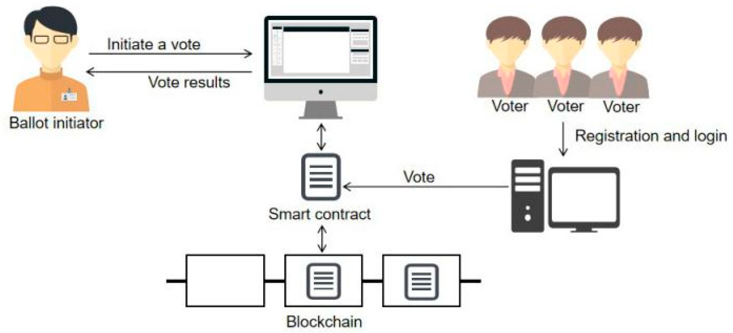

SMART CONTRACT:

ELECTION COMISSIONER CREATE (Aadhar No.,voter ID,Phone No.,Party)

VOTER APPEND(Aadhar No.,Voter ID)

ELECTION COMISSIONER

Verifies the voter ID in the voters list

If (present in the list)

Sends OTP to registered Phone No.

ELECTION C0MISSIONER Verify OTP

If (valid)

Send USER ID & PASSWORD to voter

Append to blockchain

VOTER proceed to login

Enter USER ID & PASSWORD

If(true)

Authentication through biometrics

If(valid)

VOTER UPDATE(party)

Commit.

PSEUDOCODE:

begin

step 1:otp generation

send request to voting authority

authority send otp

Step 2:Verify OTP

If(True)

proceed to next step

else

Re-enter OTP

Step 3:,Verify Biometric

Get biometric

Match biometrics

If(True)

Verified,allowed to vote

Else

Fake,not allowed

End

CODE:

Code for OTP

mport random as r

# function for otp generation

def otpgen():

otp=""

for i in range(4):

otp+=str(r.randint(1,9))

print ("Your One Time Password is ")

print (otp)

otpgen()

Code for Fingerprint:

Import tensorflow as tf

Data=tf.constant([1,2,3,4])

method=’farmhash64’

print(‘data:’,data)

print(‘method:’,method)

res=tf.fingerprint(data,method)

print(‘res:’,res)

CONCLUSION:

Voting details are stored in the blockchain database and they were sent to the respective constituency for calculation based on the residential address of the voter where the registered votes can’t be manipulated.