1. **Control Structures**

**Code:**

**Tables-**

CREATE TABLE customers (

customer_id NUMBER PRIMARY KEY,

customer_name VARCHAR2(100),

age NUMBER,

balance NUMBER(12, 2),

isVIP VARCHAR2(5) DEFAULT 'FALSE',

loan_interest_rate NUMBER(5, 2)

);

INSERT INTO customers (customer_id,customer_name,age,balance,loan_interest_rate) VALUES (1, 'Alice', 65, 15000, 8.5);

INSERT INTO customers (customer_id,customer_name,age,balance,loan_interest_rate) VALUES (2, 'Bob', 45, 7000, 9.0);

INSERT INTO customers (customer_id,customer_name,age,balance,loan_interest_rate) VALUES (3, 'Charlie', 61, 11000, 9.2);

INSERT INTO customers (customer_id,customer_name,age,balance,loan_interest_rate) VALUES (4, 'Diana', 30, 9500, 10.0);

**Scenario 1:**

SELECT customer_id, age, loan_interest_rate from customers;

DECLARE

CURSOR cur_senior_customers IS

SELECT customer_id, loan_interest_rate

FROM customers

WHERE age > 60;

v_customer_id customers.customer_id%TYPE;

v_loan_interest_rate customers.loan_interest_rate%TYPE;

BEGIN

OPEN cur_senior_customers;

LOOP

FETCH cur_senior_customers INTO v_customer_id, v_loan_interest_rate;

EXIT WHEN cur_senior_customers%NOTFOUND;

UPDATE customers

SET loan_interest_rate = v_loan_interest_rate - 1

WHERE customer_id = v_customer_id;

END LOOP;

CLOSE cur_senior_customers;

END;

/

SELECT customer_id, age, loan_interest_rate from customers;

**Output:**

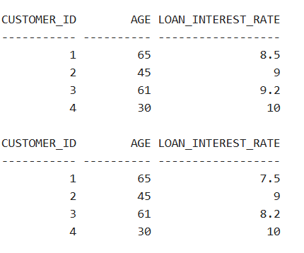

**Scenario 2:**

SELECT customer_id, age, loan_interest_rate from customers;

DECLARE

CURSOR cur_vip_candidates IS

SELECT customer_id

FROM customers

WHERE balance > 10000;

v_customer_id customers.customer_id%TYPE;

BEGIN

OPEN cur_vip_candidates;

LOOP

FETCH cur_vip_candidates INTO v_customer_id;

EXIT WHEN cur_vip_candidates%NOTFOUND;

UPDATE customers

SET isVIP = 'TRUE' -- use 'Y' or 1 based on your DB design

WHERE customer_id = v_customer_id;

END LOOP;

CLOSE cur_vip_candidates;

COMMIT;

END;

/

SELECT customer_id, age, loan_interest_rate from customers;

**Output:**

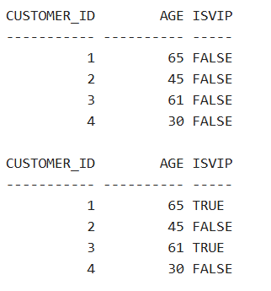

**Scenario 3:**

DECLARE

CURSOR cur_due_loans IS

SELECT l.loan_id, l.customer_id, l.due_date, c.customer_name

FROM loans l

JOIN customers c ON l.customer_id = c.customer_id

WHERE l.customer_id = 1;

v_loan_id loans.loan_id%TYPE;

v_customer_id customers.customer_id%TYPE;

v_due_date loans.due_date%TYPE;

v_customer_name customers.customer_name%TYPE;

BEGIN

OPEN cur_due_loans;

LOOP

FETCH cur_due_loans INTO v_loan_id, v_customer_id, v_due_date, v_customer_name;

EXIT WHEN cur_due_loans%NOTFOUND;

DBMS_OUTPUT.PUT_LINE('Reminder: Dear ' || v_customer_name ||

', your loan (ID: ' || v_loan_id ||

') is due on ' || TO_CHAR(v_due_date, 'DD-MON-YYYY'));

END LOOP;

CLOSE cur_due_loans;

END;

/

**3) Stored Procedures**

**Scenario 1:**

CREATE TABLE accounts(

account_id number PRIMARY KEY,

customer_id number,

balance number(12, 2),

account_type VARCHAR2(20)

);

INSERT INTO accounts VALUES (1, 101, 5000.00, 'SAVINGS');

INSERT INTO accounts VALUES (2, 102, 15000.50, 'CURRENT');

INSERT INTO accounts VALUES (3, 103, 8000.75, 'SAVINGS');

INSERT INTO accounts VALUES (4, 104, 25000.00, 'CURRENT');

SELECT * from accounts;

CREATE or REPLACE PROCEDURE ProcessMonthlyInterest

IS

BEGIN

UPDATE accounts

SET balance=balance*101/100

WHERE account_type=’SAVINGS’;

END;

/

BEGIN

ProcessMonthlyInterest;

END;

/

SELECT * from accounts;

**Output:**

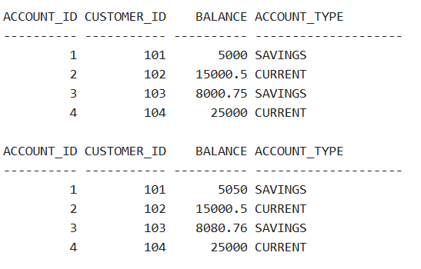

**Scenario 2:**

CREATE TABLE employees (

employee_id NUMBER PRIMARY KEY,

employee_name VARCHAR2(100),

department_id NUMBER,

salary NUMBER(10, 2)

);

INSERT INTO employees VALUES (1, 'Alice', 10, 50000);

INSERT INTO employees VALUES (2, 'Bob', 20, 60000);

INSERT INTO employees VALUES (3, 'Charlie', 10, 55000);

INSERT INTO employees VALUES (4, 'Diana', 30, 70000);

SELECT employee_id, department_id, salary FROM employees;

CREATE OR REPLACE PROCEDURE UpdateEmployeeBonus (

p_department_id IN NUMBER,

p_bonus_percent IN NUMBER

) AS

BEGIN

UPDATE employees

SET salary = salary + (salary * p_bonus_percent / 100)

WHERE department_id = p_department_id;

END UpdateEmployeeBonus;

/

BEGIN

UpdateEmployeeBonus(10, 10);

END;

/

SELECT employee_id, department_id, salary FROM employees;

**Output:**

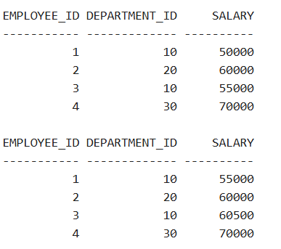

**Scenario 3:**

CREATE TABLE accounts(

account_id number PRIMARY KEY,

customer_id number,

balance number(12, 2)

);

INSERT INTO accounts VALUES (1, 101, 5000.00);

INSERT INTO accounts VALUES (2, 102, 15000.50);

INSERT INTO accounts VALUES (3, 103, 8000.75);

INSERT INTO accounts VALUES (4, 104, 25000.00);

SELECT account_id, balance FROM accounts;

CREATE OR REPLACE PROCEDURE TransferFunds (

p_source_account IN accounts.account_id%TYPE,

p_target_account IN accounts.account_id%TYPE,

p_amount IN NUMBER

) AS

v_source_balance accounts.balance%TYPE;

BEGIN

SELECT balance INTO v_source_balance

FROM accounts

WHERE account_id = p_source_account

FOR UPDATE;

IF v_source_balance < p_amount THEN

RAISE_APPLICATION_ERROR(-20001, 'Insufficient balance in source account.');

END IF;

UPDATE accounts

SET balance = balance - p_amount

WHERE account_id = p_source_account;

UPDATE accounts

SET balance = balance + p_amount

WHERE account_id = p_target_account;

COMMIT;

END TransferFunds;

/

BEGIN

TransferFunds(2, 1, 10000);

END;

/

SELECT account_id, balance FROM accounts;

**Output:**

