W02 — Leakage-Safe Evaluation Protocol
InGen Dynamics — Robot Fleet Telemetry Analytics & Predictive Health · Week 2 · Synthetic Aido Rover fleet (simulator v0.2, 50 units × 60 days) · Generated from reports/w02/*.json

1. Purpose
This protocol defines how every Week 2 metric is produced. Both model tracks, 72-hour fault early warning and battery state-of-health (SoH) forecasting, are evaluated only on robots the model has never seen, at times after its training data, separated by an embargo at least as long as the prediction horizon. A random split is used exactly once, in Section 6, to measure how far it overstates performance. The decision record is docs/adr/0004-evaluation-protocol.md.

2. Prediction targets
- Early warning (ADR-003 rev1): at each hourly prediction time t, y = 1 if a qualifying fault onset (severity >= 0.3 in the simulator's P-F timeline) of that robot falls in (t, t + 72 h]. Rows are excluded while a fault is active (onset <= t < repair end), for 24 h after a repair, and when t + 72 h is beyond the end of observation (censored, not labelled negative).
- SoH forecasting: at the end of day d, predict the true SoH at the end of day d + h for h in {1, 7, 14} days. The true SoH is simulator ground truth; in a real fleet it would come from periodic capacity tests. The BMS estimate in telemetry is noisy and biased per unit.

3. Split design
Element | Early warning | SoH forecasting
Unit grouping | 5 groups x 10 robots, stratified by fault count; a group is train or test, never both | same groups
Walk-forward cut-offs | simulation days 20, 30, 40, 50 (expanding training window) | same
Test window | 10 days after each cut-off | 10 days after each cut-off
Purge / embargo | train rows t <= cut-off - 72 h; test from cut-off | train rows d <= cut-off - h days
Inner validation | last 6 days of training period, purged again by 72 h; used for variant selection, calibration and the alert threshold | none (fixed hyper-parameters)
Folds | 20 (4 cut-offs x 5 groups) | up to 20 per horizon; folds with < 200 training rows skipped
Pooling | each test (unit, hour) is scored once; metrics on pooled out-of-fold predictions; 95 % CI by unit-level cluster bootstrap | same

Automated audit: 20 folds were checked by evaluation/splits.py::check_fold. Maximum number of robots shared between train and test: 0. Maximum duplicate (unit, t) keys across train/test: 0. Minimum embargo: 72 h. A violation raises an error before any metric is produced.

4. Walk-forward schedule
Fold (cut-off_group) | fit rows | fit positives | val rows | val positives | test rows
c1115_g0 | 6728 | 72 | 5611 | 282 | 2242
c1115_g1 | 6728 | 72 | 5611 | 282 | 2240
c1115_g2 | 6728 | 72 | 5682 | 234 | 2400
c1115_g3 | 6728 | 72 | 5666 | 210 | 2400
c1115_g4 | 6760 | 0 | 5634 | 120 | 2263
c1125_g0 | 16082 | 425 | 5587 | 77 | 2342
c1125_g1 | 16082 | 443 | 5622 | 72 | 2333
c1125_g2 | 16153 | 371 | 5518 | 149 | 2339
c1125_g3 | 16137 | 371 | 5518 | 149 | 2308
c1125_g4 | 16234 | 162 | 5587 | 149 | 2268
c1205_g0 | 25283 | 576 | 5697 | 366 | 2034
c1205_g1 | 25300 | 576 | 5697 | 346 | 2334
c1205_g2 | 25243 | 648 | 5758 | 342 | 2158
c1205_g3 | 25227 | 648 | 5697 | 320 | 2180
c1205_g4 | 25595 | 432 | 5699 | 282 | 2327
c1215_g0 | 34723 | 997 | 5413 | 256 | 1603
c1215_g1 | 34734 | 1024 | 5228 | 329 | 1552
c1215_g2 | 34686 | 1096 | 5363 | 209 | 1524
c1215_g3 | 34618 | 1035 | 5398 | 367 | 1509
c1215_g4 | 35015 | 808 | 5270 | 387 | 1614

Early cut-offs train on few onset events. This is pessimistic for supervised models; the folds are kept rather than removed, because an operator deploying early in a fleet's life faces exactly this situation.

5. Leakage audit checklist
Risk | How it would leak | Control in this repository | Evidence
Features computed after the label time | rolling windows centred or back-filled | all windows trailing (t - w, t]; only forward fill; minute grid reindexed per unit | test_features.py::test_features_ignore_future_data perturbs all data after a cut-off: features at t <= cut-off are identical
Normalisation fitted on the full dataset | scaler or residual model sees test robots | physics normalisation uses config priors; unit baselines use the unit's own past; learned normaliser, LSTM scaler and calibration fitted in-fold only | EnvironmentResidualizer test; soh_forecast.fit_predict_lstm fits mean/std on training rows
Duplicate rows across splits | same (unit, t) in train and test | unit-disjoint groups | check_fold: max duplicates 0
Label information through maintenance events | repairs happen after faults; future repair times reveal the fault | only hours_since_repair, counting repairs completed at or before t; active-fault and post-repair rows excluded | build.hours_since_last_repair uses completed_at_utc <= t
Overlapping label windows | neighbouring hours share the same 72 h window | purge t <= cut-off - 72 h | min embargo 72 h
Unit memorisation | per-robot baselines learned and recognised | unit-grouped test sets | Section 6, middle protocol
Calendar / time proxies | onsets cluster later in the run, so elapsed-time features predict labels | time-proxy features excluded from the main models; probe model trained on them alone | Section 6, probe column
Ground-truth columns among features | label or fault table joined into X | explicit forbidden-column assertion | forbidden columns found: 0
Threshold / calibration tuned on test | optimistic alert precision | chosen on inner validation rows | early_warning_run.pooled_scores

6. Deliberate leakage demonstration
The same LightGBM configuration with the same features was trained under three protocols. The no-skill PR-AUC equals the positive rate of the test rows.
Protocol | PR-AUC (main features) | PR-AUC (time-proxy probe) | test base rate
Random 80/20 row shuffle (wrong) | 0.999 | 0.810 | 0.043
Time-ordered + purge, same robots | 0.362 | 0.071 | 0.055
Unit-grouped walk-forward + 72 h embargo (proper) | 0.261 | 0.055 | 0.055

Measured gap. The random shuffle reports PR-AUC 0.999 against 0.261 under the proper protocol, an overstatement of 0.738 (3.8x the proper value). Restricted to the same evaluation period (days >= 20), the shuffled PR-AUC is 0.999.
SoH analogue (LightGBM, h = 7 d): MAE 0.1794 percentage points under a random split versus 0.3127 under the proper protocol.
Simulator v0.1 artefact: the 20 v0.1 robots had 1 distinct onset time(s). A model given only the elapsed hours reaches PR-AUC 1.000 (base rate 0.130). That is why v0.2 randomises fault timelines per robot.
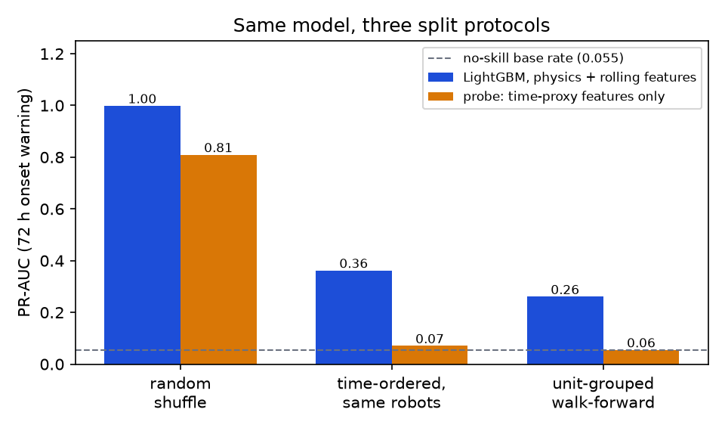
Figure 1. Same model, three split protocols (PR-AUC, 72 h onset warning).
Interpretation. Two separate effects inflate the shuffled number: label-window overlap between neighbouring hours of the same robot, and memorisation of each robot's baseline. The middle protocol removes the first and keeps the second. The time-proxy probe measures how much the calendar distribution of faults alone can be exploited. Note: in this demonstration every protocol trains on all of its training rows without calibration, so the proper-protocol value differs slightly from the calibrated, validation-split models in W02_Model_Results.docx.

7. Limitations
- The data are synthetic. The protocol removes leakage between splits, but it cannot remove artefacts the simulator builds into every split, such as the fixed P-F severity threshold and Gaussian noise.
- 41 in-run onsets across 50 robots: event-level metrics have wide confidence intervals, which are reported.
- The first 20 days are training-only, so results describe a fleet with some failure history.
MLflow references: leakage demonstration run 08531598aeeb44be8a5b03acb611588d; early-warning run c9d96429ec674e4d92f8320e11b99012.

