W02 — Health Model Results
InGen Dynamics — Robot Fleet Telemetry Analytics & Predictive Health · Week 2 · Synthetic Aido Rover fleet (simulator v0.2, 50 units × 60 days) · Generated from reports/w02/*.json

1. Summary
- Naive baseline check: 5 of 5 early-warning models have a PR-AUC 95 % CI entirely above the no-skill level (0.055) on unseen robots. The stronger, hand-built physics rule is the bar that matters.
- Early warning (72 h, unseen robots): LightGBM (validation-selected) PR-AUC 0.210 versus no-skill 0.055, physics rule 0.215 and Isolation Forest 0.330. Paired unit-bootstrap test: LightGBM is not significantly different from the physics rule and significantly worse than the Isolation Forest.
- At the budget of 1.00 alert per unit-week, LightGBM warned 13/31 onsets (recall 0.42), with precision 0.11, 0.47 false alarms per unit-week and a median lead time of 27 h.
- SoH h = 1 d: lowest MAE 0.262 pp (LightGBM (residual target)). LightGBM is not significantly different from linear extrapolation; the LSTM is not significantly different from linear extrapolation.
- SoH h = 7 d: lowest MAE 0.313 pp (LightGBM (residual target)). LightGBM is significantly better than linear extrapolation; the LSTM is not significantly different from linear extrapolation.
- SoH h = 14 d: lowest MAE 0.414 pp (LightGBM (residual target)). LightGBM is significantly better than linear extrapolation; the LSTM is not significantly different from linear extrapolation.
- Leakage demonstration: a random shuffle overstates PR-AUC by 0.738.
- External benchmark (C-MAPSS FD001, RUL in cycles, not comparable with SoH percentage points): best test RMSE 13.09 cycles (LightGBM) against constant 41.94 and age-linear 37.00. Published FD001 references range from 37.6 (MLP) to about 12.6 (DCNN).

2. Data and setup
Synthetic Aido Rover fleet from simulator v0.2 (configs/aido_rover_v0_2.yaml): 50 robots, 60 days, 1-minute telemetry (4.30 M records after simulated dropouts), 3 site climates, route terrain, single or double shifts, 45 P-F fault timelines (bearing wear, cooling degradation, battery cell fault; 41 onsets inside the run), with repairs and independent temperature-sensor drift. The evaluation protocol is described in W02_Evaluation_Protocol.docx; every model below is scored on robots excluded from its training data, after a cut-off, with an embargo of at least one horizon.
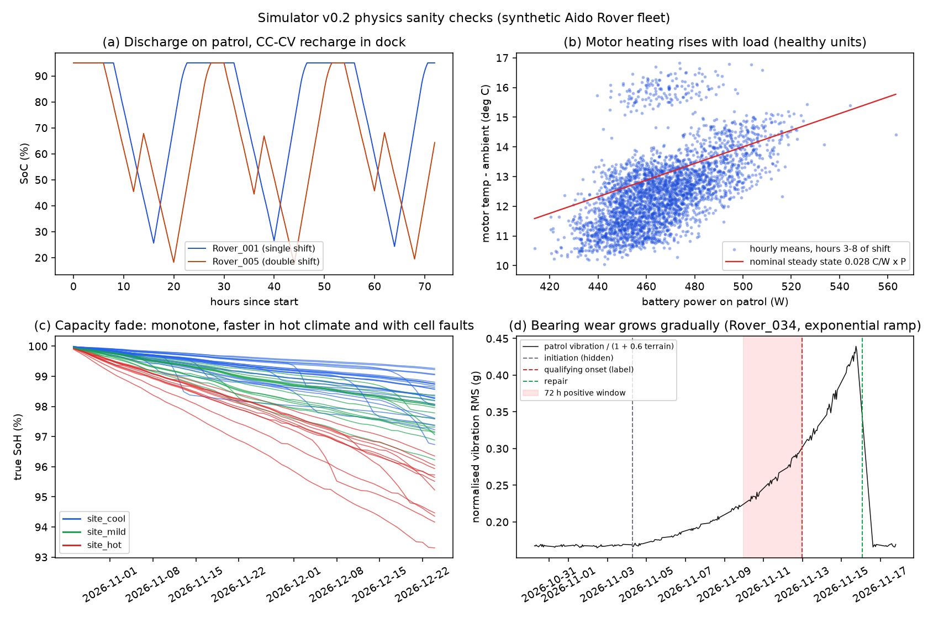
Figure 1. Simulator v0.2 sanity checks.

3. Model track 1 — battery state-of-health forecasting
Horizon | Model | MAE (pp) | MAE 95 % CI | RMSE (pp) | vs persistence | vs linear
1 d | Persistence (BMS 24 h mean) | 0.3354 | [0.2975, 0.3737] | 0.4162 | — | —
1 d | Linear extrapolation (14 d OLS) | 0.3074 | [0.2650, 0.3517] | 0.3748 | significantly better than | —
1 d | LightGBM (residual target) | 0.2620 | [0.2272, 0.2984] | 0.3325 | significantly better than | not significantly different from
1 d | LSTM (14-day sequence) | 0.2713 | [0.2269, 0.3244] | 0.3505 | significantly better than | not significantly different from
7 d | Persistence (BMS 24 h mean) | 0.4447 | [0.3849, 0.5118] | 0.5616 | — | —
7 d | Linear extrapolation (14 d OLS) | 0.3852 | [0.3379, 0.4358] | 0.4837 | significantly better than | —
7 d | LightGBM (residual target) | 0.3127 | [0.2666, 0.3669] | 0.4106 | significantly better than | significantly better than
7 d | LSTM (14-day sequence) | 0.3991 | [0.3382, 0.4706] | 0.5251 | not significantly different from | not significantly different from
14 d | Persistence (BMS 24 h mean) | 0.6748 | [0.5751, 0.7936] | 0.8357 | — | —
14 d | Linear extrapolation (14 d OLS) | 0.4986 | [0.4416, 0.5603] | 0.6263 | significantly better than | —
14 d | LightGBM (residual target) | 0.4141 | [0.3417, 0.5056] | 0.5572 | significantly better than | significantly better than
14 d | LSTM (14-day sequence) | 0.5151 | [0.4139, 0.6418] | 0.7084 | significantly better than | not significantly different from

MAE and RMSE are in SoH percentage points on unseen robots. 'vs' columns use a paired unit-level bootstrap of the MAE difference; 'significantly better' means the 95 % interval of the MAE difference lies entirely below zero.
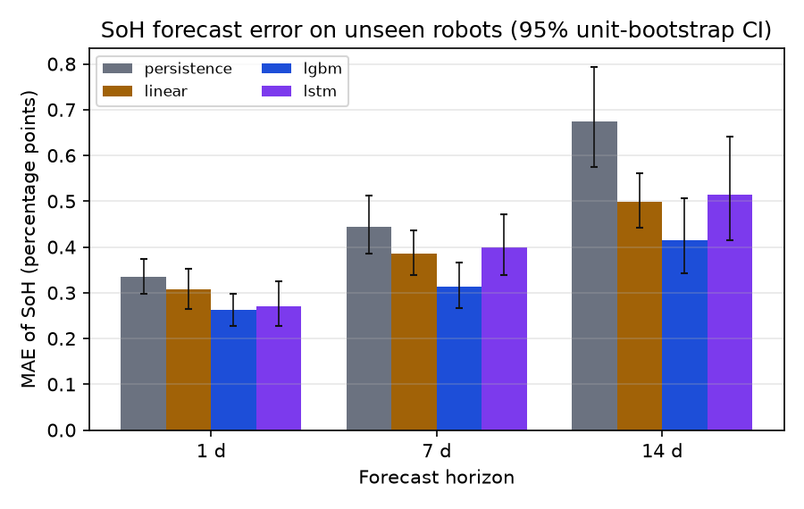
Figure 2. SoH forecast MAE by horizon (95 % unit-bootstrap CI).
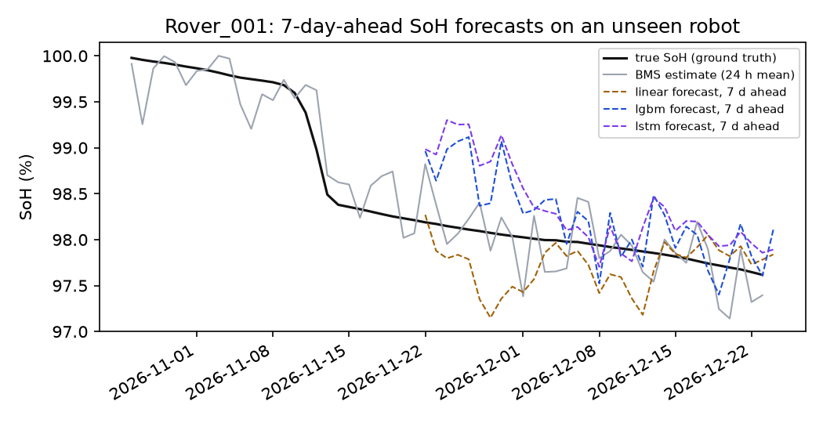
Figure 3. 7-day-ahead forecasts for one unseen robot.
Interpretation. Over 60 days, true SoH falls by 0.7–6.7 pp across robots, almost linearly, so persistence error grows with the horizon and linear extrapolation removes much of it. LightGBM's MAE reduction relative to linear extrapolation is 15 % at 1 d, 19 % at 7 d, 17 % at 14 d. This is consistent with the model using fade-rate drivers that are visible in telemetry (temperature, duty, internal-resistance growth). That explanation is a hypothesis; we have not run an attribution analysis to confirm it. The per-robot BMS bias is fixed for each unit and cannot be learned from other robots, so it sets a floor for every model. The LSTM sees about one to two thousand training sequences per fold. With fixed hyper-parameters it did not beat linear extrapolation consistently, and we report that rather than tune it on the test data.

4. Model track 2 — fault early warning (qualifying onset within 72 h)
Model | PR-AUC | PR-AUC 95 % CI | onsets warned | recall 95 % CI | precision | false alarms / unit-wk | alerts / unit-wk | median lead (h)
No-skill (constant prevalence) | 0.055 | [0.055, 0.055] | 0/31 | [0.00, 0.00] | n/a | 0.00 | 0.00 | n/a
Physics rule (max deviation from unit baseline) | 0.215 | [0.149, 0.328] | 27/31 | [0.76, 0.97] | 0.09 | 1.07 | 1.18 | 30
LightGBM, all non-proxy features | 0.224 | [0.119, 0.369] | 16/31 | [0.36, 0.69] | 0.11 | 0.60 | 0.67 | 23
LightGBM, physics features | 0.230 | [0.132, 0.355] | 12/31 | [0.24, 0.56] | 0.12 | 0.40 | 0.46 | 29
LightGBM, variant selected on validation | 0.210 | [0.114, 0.327] | 13/31 | [0.27, 0.60] | 0.11 | 0.47 | 0.53 | 27
Isolation Forest (unsupervised) | 0.330 | [0.202, 0.484] | 25/31 | [0.68, 0.93] | 0.09 | 1.06 | 1.17 | 32

Alert policy: an alert fires when the score crosses a threshold chosen on each fold's validation rows so that it raises at most 1.00 alert per unit-week; a robot is then muted for 72 h. An onset counts as warned if an alert fires 0–72 h before it. Lead time is onset minus the first such alert. Base rate of positive hours: 0.055.
PR-AUC(LightGBM selected) − PR-AUC(physics rule): 95 % CI [-0.101, 0.079].
PR-AUC(LightGBM selected) − PR-AUC(Isolation Forest): 95 % CI [-0.224, -0.033].
PR-AUC(Isolation Forest) − PR-AUC(physics rule): 95 % CI [0.016, 0.212].
Variant chosen on validation per fold: lgbm_physics 13/20, lgbm_all 7/20.
Where the false alarms fall. This uses the hidden initiation time, for analysis only. An 'early-precursor' false alarm fires while a fault is already developing but more than 72 h before its qualifying onset. The label calls it negative, although a technician would find real wear.
Model | false alarms | in early precursor | on healthy robots
Physics rule (max deviation from unit baseline) | 267 | 8 % | 92 %
LightGBM, variant selected on validation | 117 | 9 % | 91 %
Isolation Forest (unsupervised) | 265 | 10 % | 90 %

LightGBM fires 0.53 alerts per unit-week on test, below the budget of 1.00. Its validation-chosen thresholds are conservative because most validation slices contain only a few onsets. Its lower recall is therefore partly a threshold effect. The budget curve compares the models across budgets for this reason.
Sensor drift as a false-alarm source. Robots with injected temperature-sensor drift account for 10 % of scored rows but for 20 % of physics-rule false alarms, 3 % of LightGBM false alarms, 20 % of Isolation Forest false alarms. This is computed from the saved out-of-fold predictions and the hidden impairment table (scripts/build_w02_docs.py::drift_false_alarm_shares).
Interpretation. Most false alarms of every model fall on robots with no fault developing, so they are genuine noise: weather, terrain mix, sensor drift and unit-to-unit spread that the unit baseline does not fully remove. The early-precursor effect explains only a small share. The supervised classifier sees roughly 3–30 training onsets per fold, spread across three fault types. Its validation thresholds are conservative, and it under-detects fault types it was not trained on (Section 4.2). It is, however, the least sensitive to sensor drift, which suggests it learned that a docked-motor temperature offset is not a cooling fault. The unsupervised Isolation Forest needs no fault examples and has the highest PR-AUC on unseen robots. On this data the evidence favours the anomaly detector as the primary alert source, with the classifier as a candidate second stage to suppress drift-type false alarms. That combination has not been tested yet.
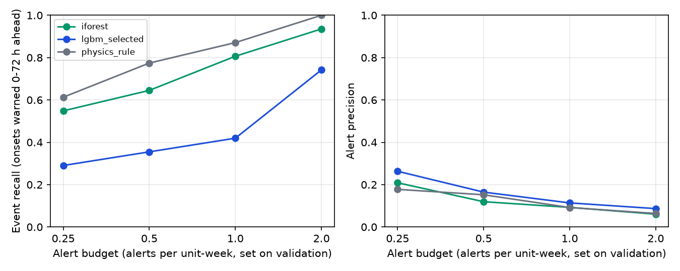
Figure 4. Recall and precision across alert budgets (thresholds set on validation).
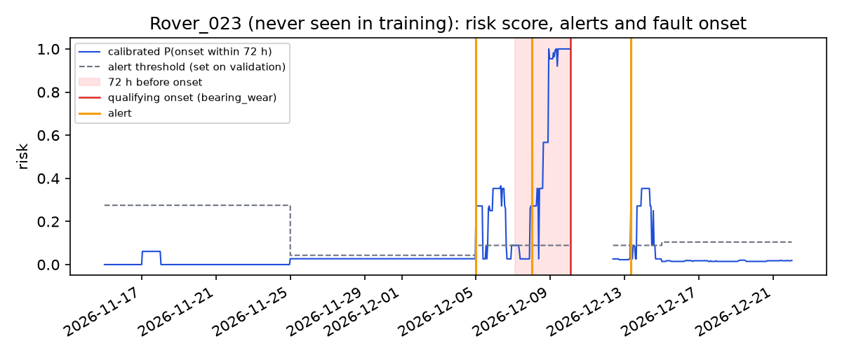
Figure 5. Example: risk, threshold and alerts for one unseen robot.

4.1 Calibration
LightGBM probabilities were recalibrated on each fold's validation slice: isotonic regression with at least 100 positive rows, Platt scaling otherwise. Brier score on pooled test rows: LightGBM uncalibrated 0.0532; LightGBM calibrated 0.0530.
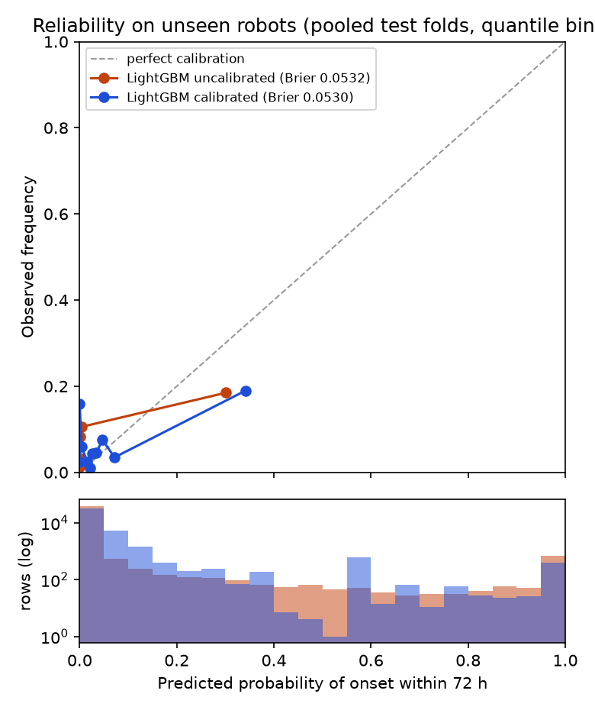
Figure 6. Reliability diagram on unseen robots.

4.2 Faults not seen in training
Held-out fault type | Model | onsets warned | recall | median lead (h)
battery_cell_fault | lgbm_without_type | 3/12 | 0.25 | 9
battery_cell_fault | iforest | 10/12 | 0.83 | 42
battery_cell_fault | physics_rule | 11/12 | 0.92 | 29
bearing_wear | lgbm_without_type | 1/11 | 0.09 | 4
bearing_wear | iforest | 11/11 | 1.00 | 30
bearing_wear | physics_rule | 11/11 | 1.00 | 32
cooling_degradation | lgbm_without_type | 3/8 | 0.38 | 34
cooling_degradation | iforest | 4/8 | 0.50 | 43
cooling_degradation | physics_rule | 5/8 | 0.62 | 14

For each fault type, its positive rows were removed from LightGBM's training and validation data, and recall was measured on that type's onsets only. The Isolation Forest and the physics rule never use labels. This experiment is the reason an unsupervised detector belongs in the alert queue alongside the classifier.

4.3 What the classifier relies on
Feature (LightGBM all-feature variant) | mean gain
energy_ratio_to_baseline | 73407
vib_norm_ratio_to_baseline | 37787
motor_temp_resid_dock_mean_24h | 36479
vibration_mean_24h | 29356
energy_ratio_to_expected_24h | 29240
r_bms_max_24h | 25343
vib_norm_mean_24h | 22348
bms_soh_mean_24h | 15291
motor_temp_resid_patrol_mean_24h | 11918
r_bms_min_24h | 11832

Round 1 (MLflow run ff0eb6f5e2004c22824afb22e089e637) trained only the all-feature model. It did not beat the physics rule, and its top features included absolute per-robot levels, a sign of memorising robots rather than learning degradation. Round 2 therefore added a physics-feature variant declared before looking at its test result, with the choice between variants made per fold on validation rows only. Both variants are reported above so that the selection is visible. Outcome: the physics variant scored PR-AUC 0.230 and the all-feature variant 0.224, so the change did not materially help. We stopped iterating at this point: further rounds driven by test results would amount to tuning on the test set.

5. External benchmark (C-MAPSS FD001)
Purpose: check that the same evaluation discipline and model families produce sensible numbers on a public, standard prognostics benchmark. Data: A. Saxena and K. Goebel (2008), Turbofan Engine Degradation Simulation Data Set, NASA Prognostics Data Repository, NASA Ames Research Center. It was downloaded from the link on the NASA PCoE data-set repository page; SHA-256 hashes are in reports/w02/cmapss_fd001_results.json.
 | C-MAPSS FD001 (this section) | Fleet SoH track (Section 3)
Quantity predicted | remaining useful life, in operating cycles | state of health, in % of capacity
When | once per test engine, at its last observed cycle | every day, 1 / 7 / 14 days ahead
Ground truth | official RUL_FD001.txt (100 engines) | simulator ground-truth SoH
Units in test | 100 official test engines, none in training | unseen robots, unit-grouped walk-forward
Error metric | RMSE in cycles (+ PHM08 asymmetric score) | MAE / RMSE in SoH percentage points
Failure process | run-to-failure, one fault mode, no repair | slow capacity fade, faults and repairs

Comparability. The two tracks are not compared numerically: an RMSE in cycles and an MAE in percentage points measure different quantities. What carries over is the method: hold out whole engines or robots, report baselines first, keep hyper-parameters fixed, and fit any scaler on training units only.
Model | RMSE vs capped truth (cycles) | RMSE vs raw truth (cycles) | PHM08 score (capped)
Constant (mean capped training RUL) | 41.94 | 43.07 | 33354
Age-based linear (median life − cycle) | 37.00 | 37.78 | 22227
LightGBM (30-cycle window features) | 13.09 | 14.23 | 263
LSTM (30-cycle raw windows) | 14.38 | 16.08 | 360

Seed robustness over seeds [0, 1, 2] (capped-truth RMSE, mean ± sd): LightGBM (30-cycle window features) 13.07 ± 0.01; LSTM (30-cycle raw windows) 14.29 ± 0.20. The table above shows the first seed.
Truth convention: the literature trains on a piecewise-linear target capped at 125–130 cycles, and most papers score against the capped truth. 11 of the 100 test engines have a true RUL above 125. Their raw-truth error is dominated by the cap, so both conventions are shown.
Published method (FD001) | reported test RMSE | check in this work
MLP (Babu et al., 2016) | 37.56 | secondary: 37.6
SVR (Babu et al., 2016) | 20.96 | secondary: 21.0
CNN (Babu et al., 2016) | 18.45 | secondary: 18.4 / 18.44
Deep LSTM (Zheng et al., 2017) | 16.14 | secondary: 16.1 / 16.14
DCNN (Li et al., 2018) | 12.61 | secondary: about 12.6 (table layout ambiguous); unverified

The published values were cross-checked in two secondary sources (Serradilla et al., arXiv:2010.03207, Table 7; arXiv:2603.00745, Table V). The original papers were not accessed. The deep-learning papers use tuned architectures and sometimes different caps (125 or 130), so the comparison is indicative, not a like-for-like ranking.
Leakage check on public data (training engines, 5-fold CV, all cycles scored): random-row CV RMSE 9.13 versus engine-grouped CV RMSE 13.03 cycles. The same direction as the fleet leakage demonstration. This CV number scores every cycle and is not comparable with the official last-cycle test RMSE above.
Reading. Our LightGBM (13.09) and LSTM (14.38) land inside the published FD001 range: below the CNN (18.45) and Deep LSTM (16.14) references and above the DCNN (about 12.6). The learned models beat both naive baselines by a wide margin. We read this as a sanity check that the pipeline and protocol produce realistic numbers on a public benchmark, not as a claim of state-of-the-art: preprocessing, the cap and the truth convention differ between papers, and our number is scored against the capped truth.
LSTM training (first seed): 13 epochs with early stopping on 10 held-out training engines (never on the official test set).
MLflow run: 7399caffc1384d319be348f606fdf6c6 (experiment w02_external_cmapss).

6. Limitations
- All results are on synthetic data from our own simulator. The models detect the degradation signatures the simulator was built to produce, and real robots would need re-validation.
- Event counts are small (tens of onsets), so recall and lead-time intervals are wide; per-fold PR-AUC varies a lot.
- Hyper-parameters were fixed a priori and not tuned. A tuned model could do better, but tuning must be nested inside validation.
- SoH targets come from simulator ground truth at daily resolution; a real fleet observes SoH only through occasional capacity tests.
- The alert budget (1 per unit-week) and the 72 h refractory period are assumptions stored in config, pending operator input.

7. MLflow references
Experiment | Run ID
w02_early_warning | c9d96429ec674e4d92f8320e11b99012
w02_soh_forecast | 26f206a5214540fd86e3491465d08398
w02_leakage_demo | 08531598aeeb44be8a5b03acb611588d
w02_external_cmapss | 7399caffc1384d319be348f606fdf6c6
w02_early_warning (round 1, superseded) | ff0eb6f5e2004c22824afb22e089e637

