Dataset Description - Mall Customers Dataset

By Kunt James Washima-541036

1. Data Mining and Dataset Exploration

1.1 Importing Libraries
In this project, Python libraries were imported for data handling, visualisation and clustering.
- pandas → dataset manipulation
- matplotlib → plotting
- numpy → numerical operations
- StandardScaler → feature scaling
- KMeans → clustering
- silhouette_score → cluster validation
- PCA → dimensionality reduction
These tools form the complete clustering pipeline.

1.2 Importing the Dataset
The dataset was loaded using:
df = pd.read_csv("Mall_Customers.csv")
The dataset contains:
- 200 customers
- 5 variables:
  - CustomerID
  - Gender
  - Age
  - Annual Income (k$)
  - Spending Score (1–100)
For clustering, only numerical behavioural features were selected:
X = df[["Age", "Annual Income (k$)", "Spending Score (1-100)"]]
CustomerID was excluded because it carries no analytical value. Gender was excluded to focus on behavioural segmentation.

2. Exploratory Data Analysis

2.1 Distribution of Features
Understanding feature distribution helps evaluate variability before clustering.
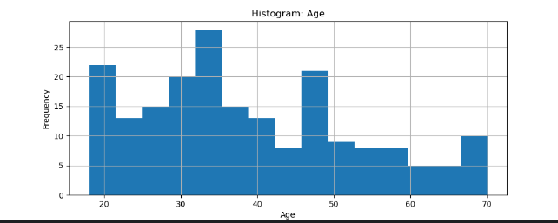

Figure 1: Histogram of Age
This plot was generated using plt.hist(df["Age"]) to analyse the distribution of customer ages.
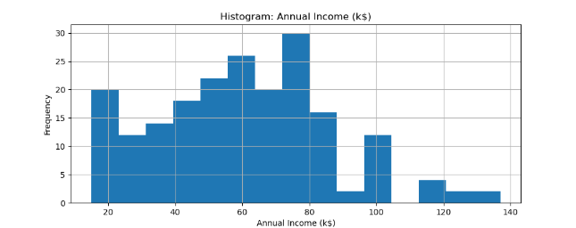

Figure 2: Histogram of Annual Income (k$)
This histogram was created using plt.hist(df["Annual Income (k$)"]) to observe income variability.
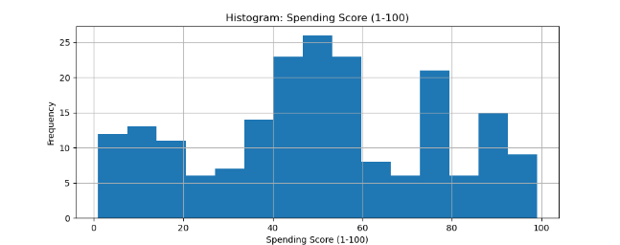

Figure 3: Histogram of Spending Score (1–100)
This plot was generated using plt.hist(df["Spending Score (1-100)"]) to visualise customer spending behaviour.

2.2 Correlation Analysis
Correlation between features was computed using:
corr = numeric_df.corr()
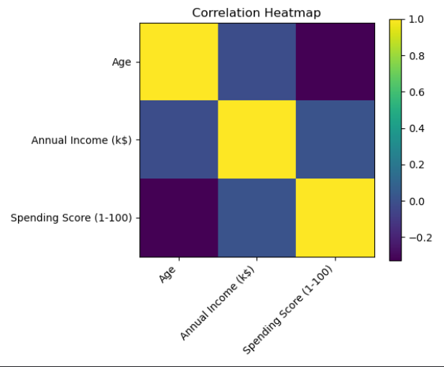

Figure 4: Correlation Heatmap
The heatmap was generated using plt.imshow(corr) to examine linear relationships between Age, Income and Spending Score.
The correlations are generally weak, meaning no strong multicollinearity exists. Therefore, all selected features were retained for clustering.

3. Data Preprocessing

3.1 Feature Scaling
Since K-Means relies on Euclidean distance, feature scaling is required.
scaler = StandardScaler()
X_scaled = scaler.fit_transform(X)
Standardisation ensures:
- Mean = 0
- Standard Deviation = 1
This prevents income from dominating distance calculations.

4. Determining Optimal Number of Clusters

4.1 Elbow Method
Inertia values were computed for k = 1 to 10.
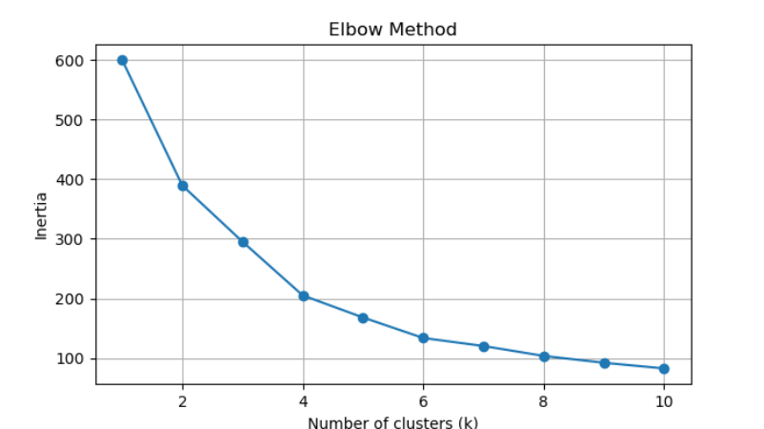

Figure 5: Elbow Method
This figure was generated by computing km.inertia_ for multiple k values to determine the optimal cluster number.
The elbow appears around k = 5, indicating diminishing returns beyond this point.

4.2 Silhouette Score
Silhouette scores were computed using:
score = silhouette_score(X_scaled, labels_k)
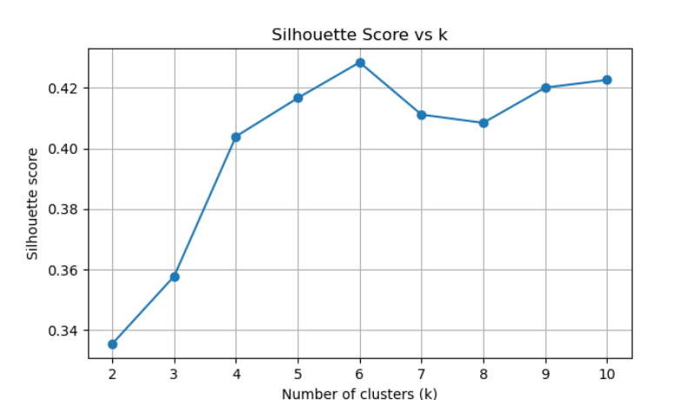

Figure 6: Silhouette Score vs k
This figure shows silhouette scores across different cluster values. The highest score occurs around k = 5, confirming the elbow result.

5. Final K-Means Clustering Model
The final clustering model was trained using:
kmeans = KMeans(n_clusters=5, random_state=42, n_init=10)
labels = kmeans.fit_predict(X_scaled)
df["Cluster"] = labels
Each customer was assigned a cluster label from 0 to 4.

6. PCA for Cluster Visualisation
To visualise clusters in two dimensions, PCA was applied:
pca = PCA(n_components=2)
X_pca = pca.fit_transform(X_scaled)
PCA reduces the 3-dimensional feature space to 2 principal components while preserving maximum variance.
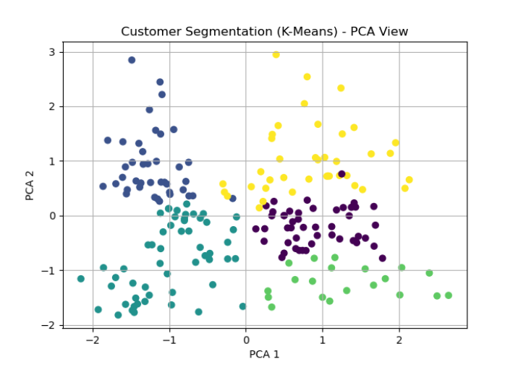

Figure 7: PCA Projection of Clusters
This plot was generated using plt.scatter(X_pca[:, 0], X_pca[:, 1], c=labels) to visualise cluster separation in reduced dimensional space.
Clusters appear reasonably separated, confirming effective segmentation.

7. Interpretation of Clusters
Based on Age, Income and Spending Score, the clusters represent different customer behavioural profiles:
- High income – High spending (Premium segment)
- High income – Low spending (Conservative segment)
- Low income – High spending (Enthusiastic young buyers)
- Low income – Low spending (Budget segment)
- Moderate income – Moderate spending (Average customers)
This segmentation can assist in:
- Targeted marketing strategies
- Personalised offers
- Resource allocation optimisation

8. Conclusion
This project implemented an unsupervised learning approach using K-Means clustering to segment customers based on behavioural features.
The workflow included:
- Exploratory data analysis
- Feature scaling
- Elbow and silhouette validation
- Final K-Means training
- PCA visual validation
Both validation techniques indicated that k = 5 provides the most appropriate segmentation structure.

