Relations:

Movies(MID, Rating, Genre, AID, title, user rating, format, language, DIR, feeling, available)

Genre_Movies(MID, genre)

Actor_Movies(MID, AID)

Director_Movies(MID, DIR)

TVShows(SID, Rating, Genre, AID, title, user rating, format, language, DIR, feeling, available)

Genre_ TVShows (SID, genre)

Actor_ TVShows (SID, AID)

Director_TVShows(SID, DIR)

Actors( AID, DOB, first, last, MID, SID, awards)

Award_Actor(AID, name of award)

Director(DIR, MID, SID, awards, DOB, first, last)

Award_Director(DIR, name of award)

Queue(QID, CID, location, type, MID, SID, RDate, SDate, BDate, borrow)

Inventory(IID, MID, SID, location)

Customer( CID, QID, first, last, address, Status, BID, email address)

Customer_Queue(CID, QID)

Customer_Billing(CID, BID)

Billing(BID, CID, Address, Payments)

Billing_Payments(BID, methods of payment, amount)

Domains:

Address: A single string of data

Rating: G, PG, PG-13, R, NR

Queue: DVD’s waiting to be borrowed

User rating: 1,2,3,4,5

Format: DVD, Blue-ray, streaming

Feeling: exciting, imaginative, scary, suspenseful, chilling, dark, ominous, heartfelt, emotional, etc

Genre: TV Shows, Action & Adventure, Sci-Fi, Courtroom Drama, Tearierkers, Drama, Rock & Pop, comedy, etc

Date: Date are in MM/DD/YYYY

Status: Trial, Basic, VIP

Stock: 1-10 million, if stream it would be infinite

DOB: MM/DD/YYYY

Payments: VISA, Mastercard, Discover, America Express

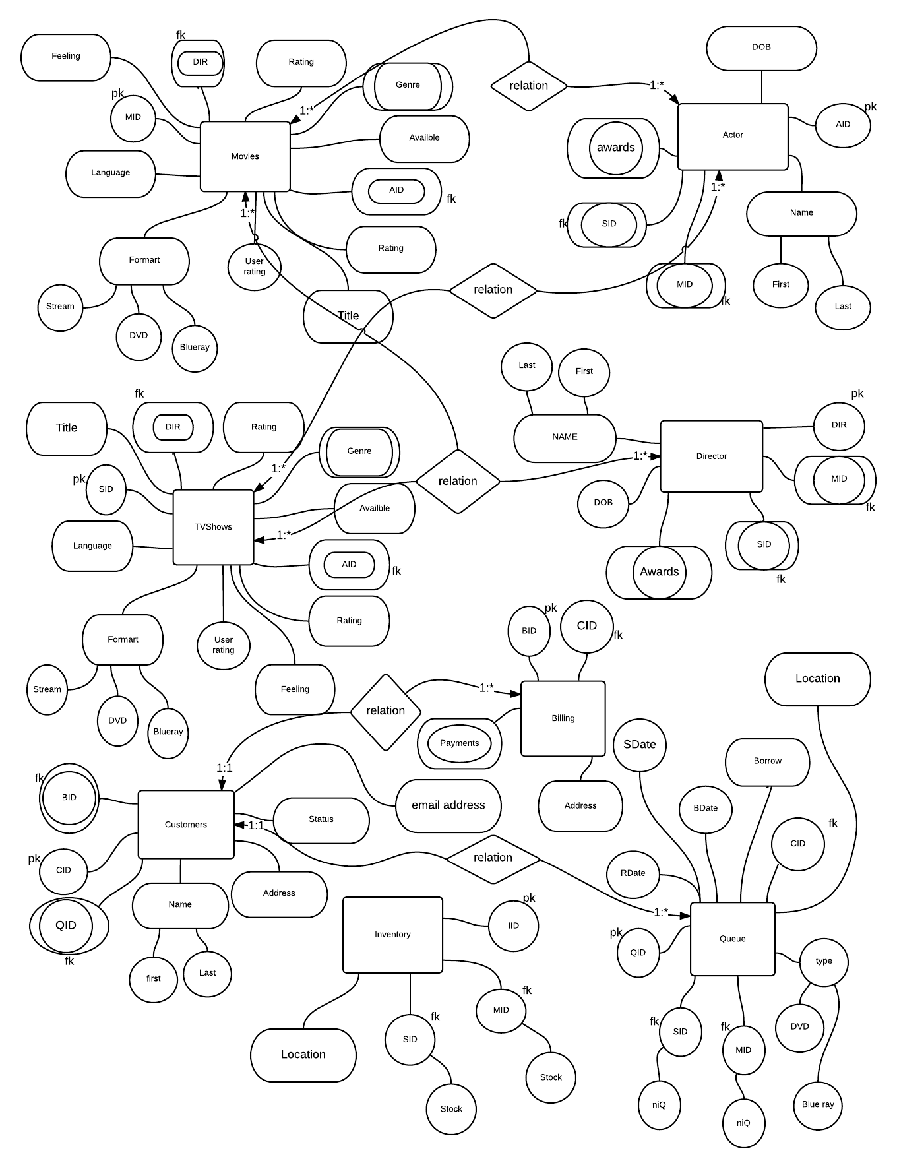

1. Identify all drama TV Shows in streaming with Jet Li or Stephen Chow. Display the show name, rating and feeling.

Stream 🡨Format = Stream(TVShows)

AC🡨Stream.AID = Actor.AID (Stream **** Actor)

shows 🡨 (first = ‘Jet’  last = ‘Li’)  (first = ‘Stephen’  last = ‘Chow’) (AC)

answer🡨 title, rating, feeling(shows)  

1. Identify all TV Shows saved to Ivan Yu DVD rental queue. Display the placement in the queue, show name and average user rating.

cust🡨 first = ‘Ivan’  last = ‘Yu’ (Customers)

que 🡨 cust.QID = Queue.QID (cust **** Queue)

user 🡨que.SID = TVShows.SID (que ** **TVShows)

answer 🡨 niQ, title, J AVG user rating(user)

1. Identify all DVD shows borrowed by Min Mick in the last year. Display the show name, borrow date and return date.

cust🡨 first = ‘Min’  last = ‘Mick’ (Customers)

A🡨cust.QID = Queue.QID (cust ** **Queue)

Date🡨BDate <= ‘03/09/2016’  BDate >= ‘03/09/2015’  type = ‘DVD’(A)

almost🡨 Date.SID = TVShows.SID(Date ** **TVShows)

answer🡨  title, BDate, RDate(almost)

1. Identify highly rated Sci-Fi shows. Display the show name and average user rating.

Sci🡨  Genre = ‘Sci-Fi’(TVShows)  Genre = ‘Sci-Fi’ (Movies)

High🡨 user rating >= 4(Sci)

Answer 🡨  title, J AVG user rating(High)

1. Identify the number of DVD’s borrowed by genre. Display the two columns: genre and number of rentals. Display one row for each genre.

type🡨 type = ‘DVD’ (Queue)

tv🡨 type.SID = TVShows.SID (type **** TVShows)

A🡨 tv.MID = Movies.MID (tv **** Movies)

answer (Genre, number of rentals) J count genre(A)

1. Identify popular shows borrowed or streamed near Queens College in the last 3 months. Display the show name and number of times borrowed or streamed. Display one row for each show name.

loca🡨 location = ‘Queens College’(Queue)

A🡨  loca.SID = TVShows.SID (loca **** TVShows)

B🡨 Movies.MID = A.MID(A **** Movies )

C🡨  user rating >= 4  BDate <= ‘3/9/2016’  BDate >= ‘12/9/2015’ SDate <= ‘3/9/2016’  SDate >= ‘12/09/2015’ (B)

❒ answer (title, numbers borrowed or stream) J count title(C)

1. Identify the number of shows by cast. Display two columns: cast name and number of shows they appear. Display one row for each cast name.

movie🡨 Actors.AID = Movies.AID (Actors Movies)

both🡨 movie.AID = TVShows.AID (movie TVShows)

❒ answer( first, last, number of shows) J count (both)

1. Identify shows not streamed or borrowed in the last year. Display two columns: show name and average user rating.

Last year🡨 BDate <= ‘03/09/2016’  BDate >= ‘03/09/2015’  SDate <= ‘03/09/2016’  SDate >= ‘03/09/2015’(Queue)

borrow🡨  borrow(Queue) -  borrow(Last year)

mon🡨 borrow.MID = Movies.MID (borrow **** Movies)

A🡨 mon.SID = TVShows.SID (mon **** TVShows)

❒ answer (title, average user rating) J AVG user rating(A)

1. Identify customers with no activity in the last year (customers who have not borrowed a DVD or streamed a show). Display two columns: customer name and email address.

Last year🡨 BDate <= ‘03/09/2016’  BDate >= ‘03/09/2015’  SDate <= ‘03/09/2016’  SDate >= ‘03/09/2015’(Queue)

dates🡨  borrow(Queue) -  borrow(Last year)

act🡨 dates.CID = Customer.CID (dates **** Customer)

❒ answer ( first, last, email address)(act)

1. Identify shows without user ratings. Display the two columns: show name, release date and cast.

null🡨 user rating = null (Movies)   user rating = null (TVShows)

actor🡨 null.AID == Actors.AID ( null ** **Actors)

❒ answer (title, release date, first, last)(actor)