Case Tools Lab 2 – Term End

12MSE1086
Kunwarjeet Singh

1) Class Design Diagram + Forward Engineering

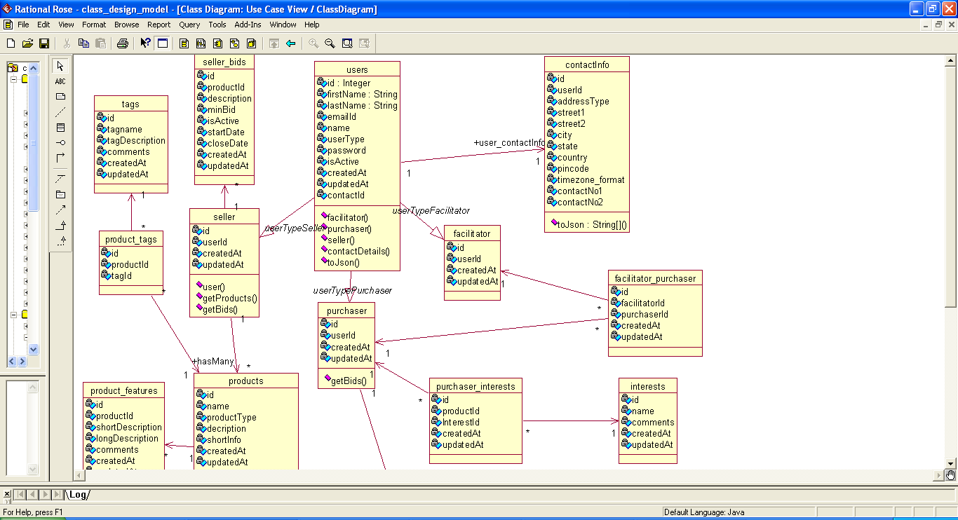

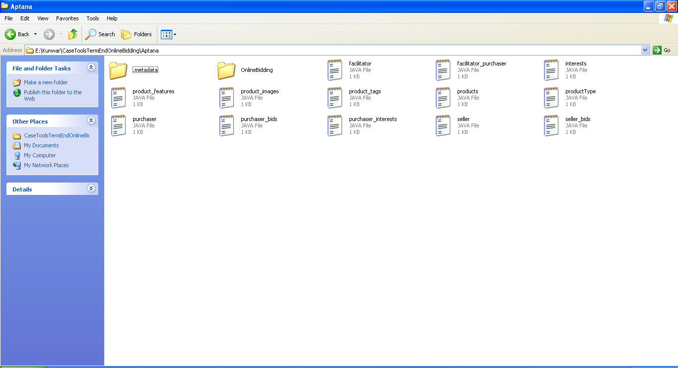

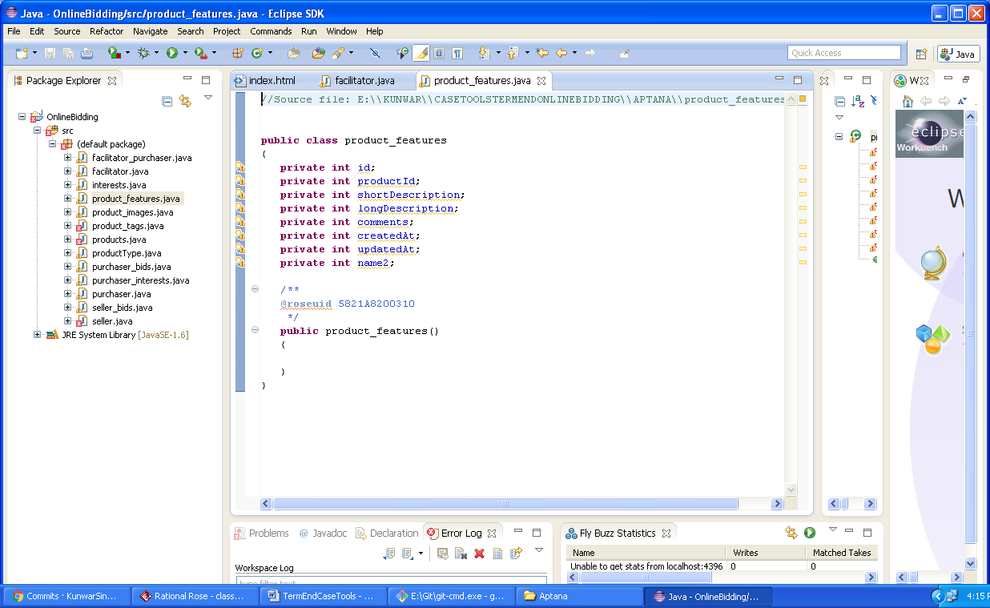

2) Login Page using Aptana studio

Src code

<!DOCTYPE html>
<html lang="en">
<head>
<title>Bootstrap Case</title>
<meta charset="utf-8">
<meta name="viewport" content="width=device-width, initial-scale=1">
<link rel="stylesheet" href="https://maxcdn.bootstrapcdn.com/bootstrap/3.3.7/css/bootstrap.min.css">
<script src="https://ajax.googleapis.com/ajax/libs/jquery/3.1.1/jquery.min.js"></script>
<script src="https://maxcdn.bootstrapcdn.com/bootstrap/3.3.7/js/bootstrap.min.js"></script>
</head>
<body>

<nav class="navbar navbar-inverse">
<div class="container-fluid">
<div class="navbar-header">
<a class="navbar-brand" href="#">Online Bidding</a>
</div>
<ul class="nav navbar-nav">
<li class="active"><a href="#">Home</a></li>
<li><a href="#">Products</a></li>
<li><a href="#">History</a></li>
<li><a href="#">Trending Bids</a></li>
</ul>
</div>
</nav>

<div class="container">
<h3>Login</h3>
<p>Please enter your login info</p>

<div class="col-lg-6" style="margin-top:40px;">
<div class="row">
<div class="col-lg-4">UserName</div>
<div class="col-lg-8"><input type="text" class="form-control"></div>
</div>

<div class="row">
<div class="col-lg-4">Password</div>
<div class="col-lg-8"><input type="password" class="form-control"></div>
</div>
<br>
<div class="row">
<div class="col-lg-4"><input type="submit" class="form-control" value="Login"></div>
</div>
</div>

</div>

</body>
</html>

Screenshot

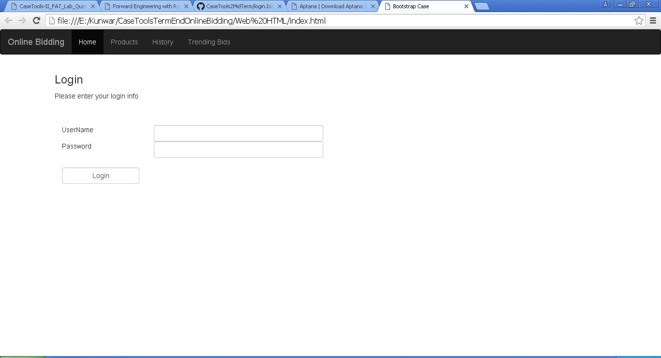

3) GitHub Pull – Push

