DRAFT: Harmonized and trait aggregation paper

# Introduction

Explaining and predicting how communities are shaped by environmental factors is one of the main goals of ecology. Organismal traits, defined as measurable properties of an organism [1], might be beneficial in achieving this goal [2]. Traits evolve through adaptations (e.g., physiological, behavioral, etc.) of organisms to their environment and indicate direct or indirect linkages between the biological response of an organism to its environment [3, 4]. Besides providing a mechanistic explanation of species-environment relationships, trait-based approaches might be suitable for large scale analysis because the variability in trait responses is lower than for taxonomic responses [5, 6]. Traits of freshwater invertebrates are difficult to determine because, unlike plants, their traits often cannot be measured directly. For example, to gain knowledge on feeding habits requires evaluating mouthpart morphology, consumed food, and the organisms function within its community [7]. Nevertheless, invertebrate traits have been increasingly used in freshwater ecology, e.g. by relating macroinvertebrate trait composition to environmental factors or as trait metrics in biomonitoring [8–11].

In the last decades, freshwater ecologists developed comprehensive invertebrate trait databases for various biogeographic regions [12–17]. The availability of invertebrate trait data from different biogeographic regions enables comparisons of trait variation and their relation to environmental factors across large scales. However, such analyses have been carried out mostly within biogeographic regions, using information from one or two trait databases. For example, Bonada et al. [5] compared trait composition for mediterranean and temperate regions in Europe using traits from Usseglio-Polatera et al. [12], Poff et al. [8] characterized trait composition across sites in the Western US using traits from Poff et al. [18], and Botwe et al. [19] investigated the effect of salinity on invertebrate traits in different sites in South Australia using trait data from Poff et al. [18] and Schäfer et al. [20]. Analyses of invertebrate traits that synthesize information on invertebrate grouping features from more than two different biogeographic regions are rare. A grouping feature is defined by Schmera et al. as a general property (e.g. feeding mode) that comprises a ”group of related traits (e.g., predator, shredder, etc.) that vary among species or among individuals within a species” [21]. To our knowledge, only Brown et al. [22] harmonized grouping features from more than two geographically distant invertebrate trait databases in a study on the influence of decreasing glacier cover on functional diversity and community assembly of invertebrates.

We suspect that the heterogeneity of information in freshwater invertebrate trait databases is likely a major reason for the lack of studies across biogeographic regions. To harmonize grouping features from different regions, first commonly accepted and unambiguous trait definitions are required [23]. In the best case, grouping features would be classified into the same traits across databases or they could easily be harmonized using standardized terminology. However, a lack of standardized terminology of trait definitions and poor metadata quality in many trait databases is a common issue throughout the field of trait-based ecology [6, 23]. Secondly, consistent coding of traits facilitates the compatibility of trait data from different databases. Traits can be binary (i.e. trait exists or not), continuous, or fuzzy coded variables. Fuzzy codes represent the affinity of an organism to express a certain trait. They are used to account for plasticity in traits and are usually converted to percentages. Continuous values are typically used for grouping features that can be measured, like body size. However, invertebrate trait databases are heterogeneous with regard to the coding they use for their traits [24] (Table 5). Brown et al. [22] harmonized grouping features based on trait databases from Europe, North America, and New Zealand because in these trait databases identical grouping features are classified differently into traits. As the traits from North America were coded binary in contrast to the fuzzy coded traits from from Europe and New Zealand, the authors consulted experts to assign fuzzy coded traits to North American taxa or inferred them from the European trait database. Thus, it becomes apparent that using invertebrate trait data from several regions requires extensive data processing prior to the actual data analysis. A centralized database with standardized and unambiguous traits and a consistent coding of traits would minimize data processing effort.

Differing taxonomic resolutions between the observed taxa in a study and the used trait database is another challenge when working with trait data. When observations are on a lower taxonomic level than data available in the trait databases (e.g. observations on species-level, trait data on genus-level) trait data of the higher taxonomic level are often assigned, e.g. [9, 25]. Conversely, if trait information is only available on lower taxonomic levels than the observed taxa, traits are aggregated to a higher taxonomic level, e.g. [9, 18, 26, 27]. Thereby, trait aggregation is often done using the mean [28], median [9] or the mode [26]. Up to now, studies on how and to which extent different trait aggregation methods influence trait-based analysis are missing. Knowing this can aid the choice of aggregation method for future studies.

We analyzed the influence of grouping feature harmonization and trait aggregation on trait-environment relationships. Therefore, we (1) harmonized four invertebrate grouping feature datasets for seven grouping features based on information from trait databases of the regions Europe, North America, New Zealand, and Australia. Furthermore, we (2) compare trait affinities obtained through different trait aggregation methods to trait affinities assigned at family-level by experts. We (3) re-analyze data on the effect of anthropogenic salinization on biological traits by Szöcs et al. [9] using harmonized grouping features and aggregated traits. By comparison with the original analysis, we investigate how harmonizing and aggregating trait data can alter the outcome of trait-environment relationships. Finally, we (4) present an overview of discrepancies in trait definition between the used invertebrate trait datasets and discuss challenges of trait data synthesis.

# Methods

## Selection of traits and harmonization of trait databases

We extracted information from 6 trait databases from Europe, North America, Australia, and New Zealand and harmonized 7 grouping features. Trait information for Europe was obtained from the Freshwaterecology database [13] and complemented by Tachet [12] to fill missing information (e.g. for size). Trait information for North America was obtained from Twardochleb et al. [29] and complemented by Vieira et al. [14]. Data on body form for European and North American taxa was provided based on expert knowledge [30]. For Australia and New Zealand, we used trait databases from Kefford et al. [16] and Philips and Smith respectively [15].

We selected traits of seven grouping features that were available in all databases, are commonly used, and describe different parts of the biology of an organism: life history (Voltinism), morphology (Respiration, Body form, Size), ecology (Locomotion, Feeding mode) and reproduction (Oviposition). We omitted ecological traits that describe habitat preferences (e.g. temperature preference) because these traits are missing in the New Zealand trait database. The grouping features were differently classified across the databases, we therefore harmonized them into 26 traits (Table 1). Harmonization was undertaken by amalgamating similar traits into one trait (e.g. crawlers and sprawlers into crawlers). Thereby, the highest trait affinity among the amalgamated traits was taken.

We used fuzzy coded traits for establishing our harmonized datasets unless data quality prohibited and then we used binary traits, i.e. categorical and continuous traits were converted into binary traits. Implicitly, we assumed for binary traits that a value of 1 corresponds to the highest affinity for a particular trait and 0 to no affinity for a particular trait. Fuzzy codes are reported with different ranges in the trait databases (e.g. freshwaterecology 0 to 10, Tachet 0 to 3 or 0 to 5). We standardized them to a range between 0 and 1 and converted trait affinities to percentages. Thus, fuzzy coded and binary traits were in the same range.

Prior harmonization we amalgamated duplicate taxa on species, genus or family-level if present. We omitted taxa with a lower taxonomic resolution than family-level.

Table 1: Traits of the harmonized grouping features. The last column indicates traits that were amalgamated for harmonization (no amalgamation needed if empty).

|  |  |  |
| --- | --- | --- |
| Grouping feature | Trait | Amalgamated traits |
| Voltinism | Semivoltine  Univoltine  Bi/multivoltine | *<*1 generation per year 1 generation per year  *>*1 generation per year |
| Body Form | Cylindrical  Flattenend  Spherical  Streamlined | Cylindrical, round (humped)  Flattend, dorsoventrally flattened  Spherical, tubular  Streamlined, fusiform |
| Size | Small  Medium  Large | *<*9 mm, *<*10 mm  9 - 16 mm, 10 - 20 mm  *>*16 mm, *>*20 mm |
| Respiration | Gills  Plastron/Spiracle  Tegument | Temporary air store, tracheal gills, gills Spiracular gills, atmospheric breathers, plant breathers, functional spiracles, air (plants), aerial, plastron/spiracle  Cutaneous, tegument |
| Locomotion | Burrower  Crawler  Sessil  Swimmer | Interstitial, boring, burrowing  Sprawler, walking, climber, clinger, crawler  Attached, sessil  Skating, diving, planctonic, swimming |
| Feeding mode | Filterer  Gatherer  Herbivore  Parasite  Predator  Shredder | Active/passive filterer, absorber, filter-feeder, collector-filterer, filterer Deposit-feeder, collector-gatherer, detrivore, gatherer  Grazer, scraper, piercer herbivore, herbivore, algal piercer, piercer (plants)*a*  Piercer (animals)*a*, predator Miner, xylophagus, shredder, shredder detrivore |
| Oviposition | Aquatic eggs  Ovoviviparity  Terrestrial eggs | Eggs attached to substrate/plants/stones, free/fixed eggs/clutches  Terrestrial clutches, terrestrial |

*a* The trait piercer was defined in the Tachet database for piercing plants and animals, in contrast to the other databases [12]. Taxa exhibiting this trait have been assigned to predators or herbivores based on expert knowledge [31].

## Trait aggregation

Traits of the harmonized grouping feature datasets were aggregated to family-level using three approaches. I) direct aggregation of taxa to family-level giving equal weight to every species using the mean or median, denoted *direct_aggmean* and *direct_aggmedian*, respectively. II) stepwise aggregation, i.e. first to the genus-level and subsequently to the family-level using the mean or median. This approach gives equal weights to each genus. Hereafter, we denote this aggregation type as *stepwise_aggmean* or *stepwise_aggmedian*, respectively. III) aggregation using a weighted mean approach, denoted as *weighted_agg*. This method weights the genera according to the number of their species in the databases.

## Comparison of aggregated traits with traits assigned by experts

Aggregated trait affinities of the five trait aggregation methods (*direct_aggmedian*, *direct_aggmean*, *stepwise_aggmedian*, *stepwiseaggmean*, and *weighted_agg*) were compared to trait affinities assigned at family-level by experts, which were available for the Australian and North American database for a subset of grouping features and taxa. For the Australian database, we compared aggregated trait affinities with assigned trait affinities resolved at family-level for the grouping features feeding mode and size using data from Chessman et al. [32]. In Chessman et al. [32] feeding mode is classified similarly as in the harmonized Australian database except that the trait parasite is missing. We conducted the comparison for the 220 families available in Chessman et al. [32]. Considering each factor combination of family and trait (in total 8) this amounts to 1760 cases.

For the North American database, we compared aggregated trait affinities with assigned trait affinities on family-level for the grouping features feeding mode, respiration, size, voltinism, and locomotion. The assigned trait affinities at family-level are part of the North American database [29] and originate from expert knowledge. Trait information was available for 94 families of which all were present in the aggregated North American database (total number of cases 1598). The traits were on the categorical scale and were converted to binary traits prior to the comparison with aggregated trait affinities.

As mentioned above, trait affinities ranged from 0 to 1. Hence, the maximum difference possible in trait affinities is 1 or -1 (corresponds to 100 %). For convenience and to improve interpretation, we report absolute trait differences.

## Analysis of the effect of harmonization and trait aggregation on traitenvironment relationships

We repeated the analysis in Szöcs et al. [9] who studied the effect of anthropogenic salinization on invertebrates in the River Werra in Germany. As a case study, we used for the re-analysis the established harmonized grouping features for Europe and additionally aggregated traits using the aforementioned aggregation methods.

The river has been subject to effluents from the potash industry since the mid of the 20th century and allows to study responses of invertebrates and their trait compositions to salinization. Sites downstream, upstream, and close to the salt discharge (transition) were compared regarding their trait composition. Further details can be found in Szöcs et al. [9]. We compared the species scores obtained from redundancy analysis (RDA) for traits constrained by electric conductivity from the original study to species scores when including harmonized grouping features. We used the same grouping features that Szöcs et al. [9] used, but 6 of them have been harmonized from the European

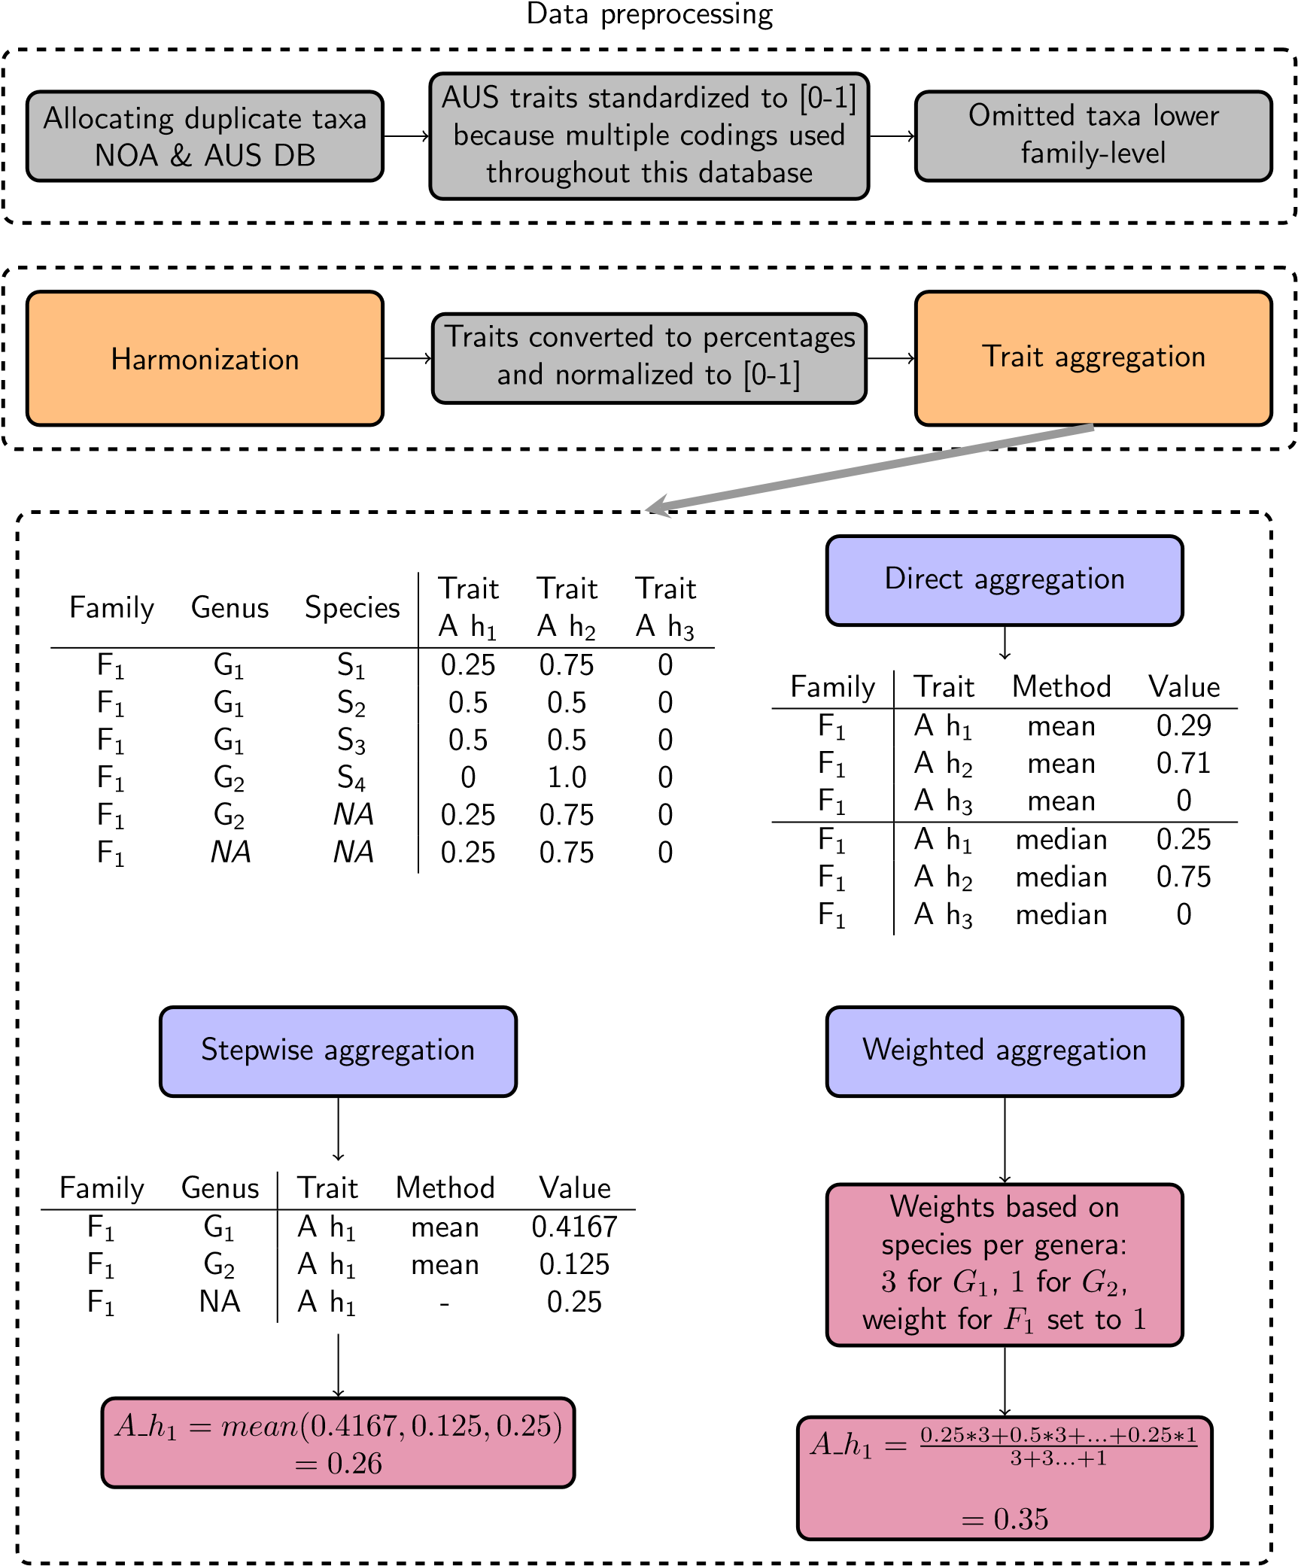

Figure 1: Data processing steps of the selected traits. Intermediate (gray) and main (orange) steps of data preparation are depicted. The dashed bottom box illustrates the different trait aggregation methods using a small made-up example (data in the upper left corner). Displayed are the aggregation methods (blue) and intermediate steps of the aggregation methods (purple). For the stepwise and weighted aggregation only results for one trait are displayed.

harmonized grouping feature dataset for our analysis. The harmonized grouping features used were *Size, Feeding mode, Locomotion, Oviposition, Respiration*, and *Voltinism*. Traits of those grouping features responded strongly to salinity in the study of [9]. Additionally, for testing the effect of aggregated traits we assigned to each taxon in Szöcs et al. [9] the aggregated trait value for its corresponding family and repeated the RDA.

## Data analysis

The data processing and aforementioned analysis were carried out using R (Version 3.6.1). Raw data and the R code for data processing and grouping feature harmonization is located in the

Github repository: [https://github.com/KunzstLD/Invertebrate_traits.](https://github.com/KunzstLD/Invertebrate_traits) Scripts and data to reproduce the trait aggregation and analysis with aggregated traits are located in the Github repository [https://github.com/KunzstLD/Trait-aggregation.](https://github.com/KunzstLD/Trait-aggregation)

# Results

## Taxonomic coverage of the harmonized trait datasets

Regarding the taxonomical coverage, the New Zealand dataset has, as expected, the smallest taxon pool (478 taxa, Table 2). By contrast, the largest taxon pool is spanned by the European trait dataset with 4110 taxa followed by the North American trait dataset that contained trait information on 3753 taxa. The Australian dataset contains 1402 taxa. The European, New Zealand, and North American datasets have most taxa on the highest taxonomical resolution while the Australian dataset has a similar number of taxa on species and genus-level.

Table 2: Number of taxa per harmonized database and per taxonomic level. Numbers in parenthesis show relative frequencies in percentage.

|  |  |  |  |  |  |
| --- | --- | --- | --- | --- | --- |
| Database | Nr. of taxa | Species | Genus | Family | Nr. aquatic taxa |
| EU | 4110 | 3848 (93.63) | 237 (5.77) | 25 (0.61) | 3579 (87.08) |
| NOA | 3753 | 2414 (64.32) | 1163 (30.99) | 176 (4.69) | 3305 (88.06) |
| AUS | 1402 | 564 (40.23) | 578 (41.23) | 260 (18.54) | 1016 (72.47) |
| NZ | 478 | 404 (84.52) | 47 (9.83) | 27 (5.65) | 443 (92.68) |

## Completeness of trait information

The amount of entries with available information for the selected grouping features varied strongly for the European, North American, and Australian datasets (Table 3). By contrast, the New Zealand dataset contained complete trait information for most of the investigated grouping features (between 94 % and 100 %).

Table 3: Displayed is the percentage of entries that have information for the individual grouping features per dataset.

|  |  |  |  |  |  |  |  |
| --- | --- | --- | --- | --- | --- | --- | --- |
| Database | Body form | Oviposition | Voltinism | Locomotion | Size | Respiration | Feeding mode |
| EU | 7 | 16 | 24 | 33 | 11 | 56 | 65 |
| NOA | 28 | 13 | 47 | 52 | 73 | 44 | 63 |
| AUS | 5 | 48 | 51 | 42 | 78 | 70 | 99 |
| NZ | 100 | 94 | 100 | 99 | 100 | 100 | 99 |

## Differences in trait affinities obtained by trait aggregation methods compared to traits assigned at family-level

The percentage of differing cases of trait affinities obtained by the trait aggregation methods compared to trait affinities assigned at family-level varied between 16.18 % and 22.9 % for the Australian database. For the North American database, comparison of the trait aggregation methods to trait affinities assigned at family-level yielded between 15.3 % and 47 % differing cases (Table 4).

In general, trait aggregation methods using the median yielded fewer cases with differences compared to approaches using the mean. However, aggregation methods using the median produced greater differences for both databases. Standard deviations of absolute differences were similar for all tested aggregation methods. For both databases maximum differences of 1 occurred for all investigated grouping features (Figure 2 and Figure 3).

A comparison of the aggregation methods with each other for the 4 datasets revealed that differences in aggregated trait affinities were largest between the *stepwiseaggmedian* and *directaggmedian* (Figure S1).

Table 4: Amount of differing cases, the minimum and maximum, and means and standard deviations of absolute differences between trait affinities assigned at family-level and aggregated trait affinities.

|  |  |  |  |  |  |  |
| --- | --- | --- | --- | --- | --- | --- |
| Database | Comparison to traits at fam.-lvl. | Differing cases [%] | Min.  differences | Max.  differences | Mean abs. differences | SD abs.  differences |

Australia

(

)

Chessman

direct

agg(median)

0.45

1.00

0.27

0.01

16.53

direct

agg(mean)

23.24

*<*

0

*.*

01

0.34

0.99

0.23

stepwise

agg(median)

0.42

0.01

17.90

1.00

0.26

stepwise

agg(mean)

23.24

*<*

0

*.*

0.33

0.99

0.22

01

weighted

agg

23.24

*<*

0

*.*

1.00

0.34

01

0.24

NorthAmerica

)

(

Pyne

direct

agg(median)

0.17

1.00

15.33

0.26

0.70

direct

agg(mean)

47.00

*<*

0

*.*

01

0.26

1.00

0.30

stepwise

agg(median)

0.28

1.00

18.00

0.63

0.08

stepwise

agg(mean)

47.00

*<*

0

*.*

1.00

0.27

01

0.30

weighted

agg

47.00

*<*

0

*.*

0.31

01

0.28

1.00

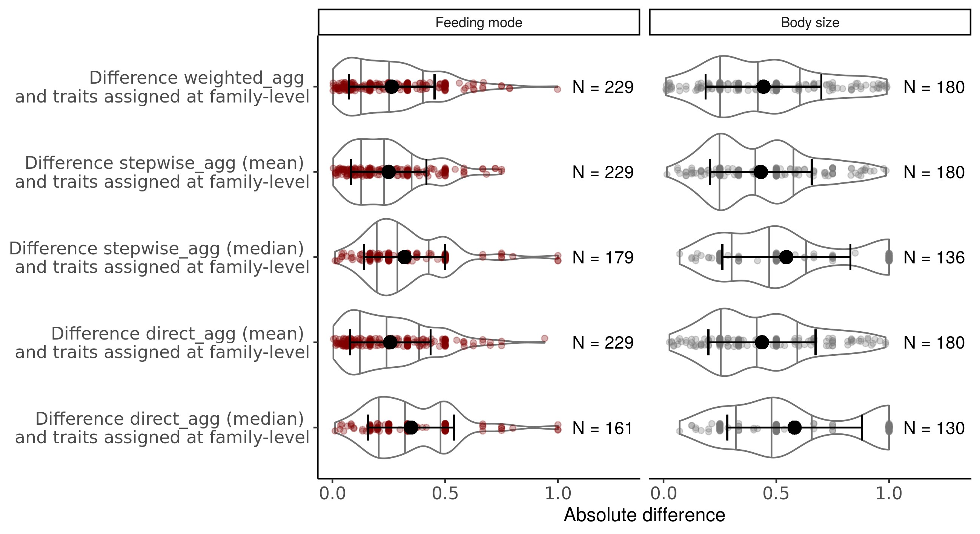

Figure 2: Absolute differences in trait affinities between aggregated traits and traits assigned at family-level by Chessman et al. [32] for the grouping features feeding mode and body size. N denotes the number of cases for each comparison. The black dot indicates the mean absolute difference, the error bars the standard deviation. The gray horizontal lines show the 25th, 50th and 75th quantile of the density estimate.

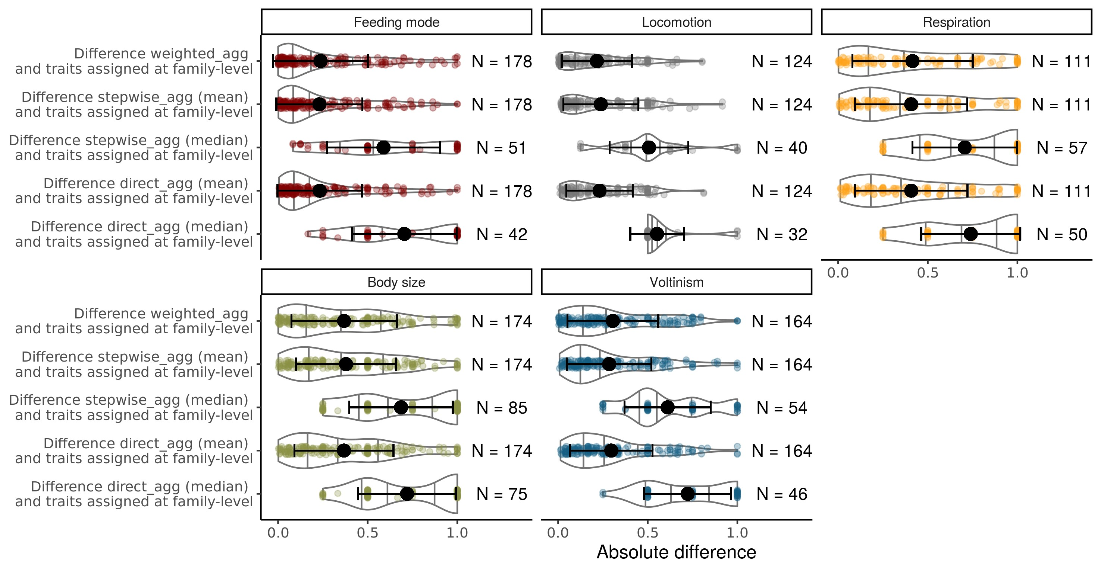

Figure 3: Absolute differences in trait affinities between aggregated traits and traits assigned at family-level in the North American dataset for the grouping features feeding mode, locomotion, respiration, body size and voltinism. N denotes the number of cases for each comparison. The black dot indicates the mean absolute difference, the error bars the standard deviation. The gray horizontal lines show the 25th, 50th and 75th quantile of the density estimate.

## Re-analysis of Szöcs et al. 2014 using harmonized and aggregated grouping features

Overall, using the harmonized grouping features lead only to slightly different results in comparison to the original analysis (Figure 4 and SI). According to the RDA of the trait composition sites with high salinity were characterized by multivoltine, ovivoparous, gill-respirating, and shredder species. Only species with the trait life cycle duration *>* 1 year fail to characterize sites with high salinization. Also, life cycle duration *<*= 1 year is not anymore characterizing sites not impacted by salinity. Like in the original analysis, transition and upstream sites from the point source are characterized by univoltine species and species that lay their eggs in an aquatic environment. We constructed also the linear models of the original analyses, using the traits on the extremes of the conductivity axis and found results similar to the original analysis (Table S1 and S2).

For every aggregation method compared, using at family-level aggregated traits did only slightly change the species scores compared to not aggregated traits (Figure 4). Hence, the interpretation of the trait composition is the same as when only using harmonized grouping features.

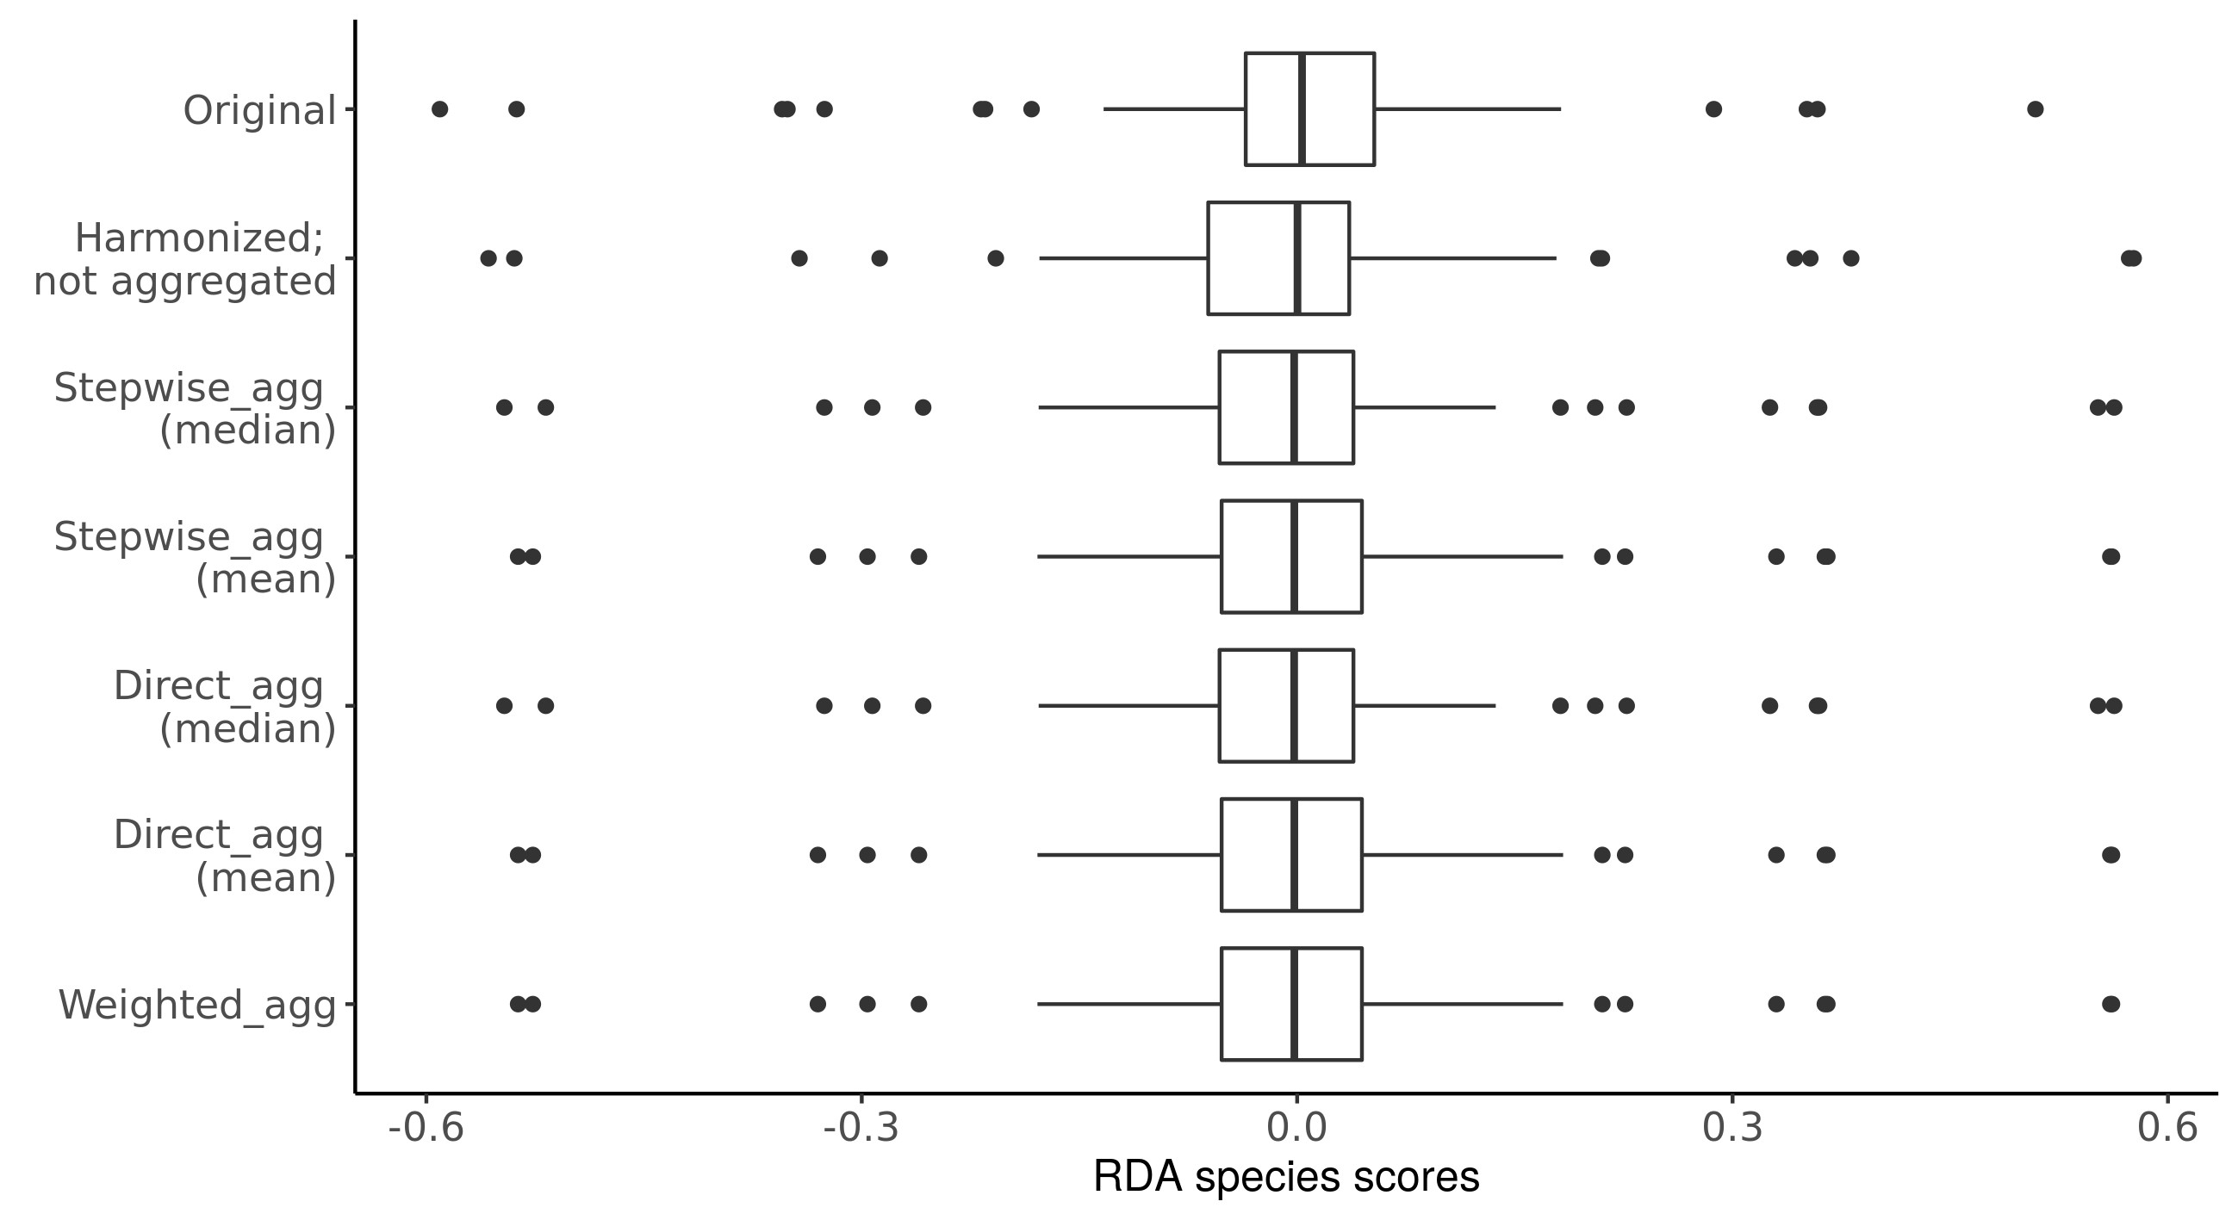

Figure 4: Species scores obtained by RDA from the original analysis [9], using harmonized grouping features, and using harmonized grouping features with assigned trait affinities aggregated to familylevel.

## Discrepancies of invertebrate trait definitions

Definitions of the used grouping features and traits varied in their level of detail. The Freshwaterecology database, and databases from Tachet and Twardochleb et al. provided more detailed descriptions of their trait information compared to the databases from Vieira et al. and New Zealand. An exception is the Australian trait database which is a collection of seven trait datasets [16]. Thus, grouping features occur multiple times with varying differentiation into traits. Depending on the dataset trait information is described with more or less detail.

The definition of grouping features varied across databases mainly concerning their differentiation into traits but also in their scope. We provide a summary of discrepancies in trait definitions in the appendix (Table S3). Both, differences in differentiation and scope can lead to discrepancies in trait definitions. For example, for the grouping feature feeding mode discrepancies arise because traits are assigned in different ways. Tachet defines predators as carvers, engulfers and swallowers. By contrast, in the North American (Twardochleb) database predators are defined as engulfers and carnivorous piercers. In turn, in the Tachet database, piercers are defined as a separate trait encompassing herbivorous and carnivorous piercers. Furthermore, the scope in the Freshwaterecology database for feeding mode is primarily on the food source of a species (except for filterers), while the other databases focus on the strategies of food acquisition. Therefore, the Freshwaterecology database defines e.g. predator as ”eating from prey”, while the other databases use the mouthpart morphology as basis of their definition. The Tachet database captures the food source in an additional grouping feature. Varying levels of differentiation are also present in all other investigated grouping features between the trait databases (Table 5 and Table S3). Locomotion definitions differ also in scope between databases. Freshwaterecology and New Zealand databases describe locomotion as the way of movement of an organism, Tachet as substrate relation, the North American (Vieira) as how organisms deal with flow, Australia as attachment, and the North American (Twardochleb) database includes among the way of movement also the location of movement. Similarly, regarding reproduction trait databases differ in their scope. Reproduction is captured in one grouping feature and defined as location of oviposit clutches and mode of reproduction in the Freshwaterecology and Tachet databases. North America (Vieira) provides information on the oviposition location but not on reproductive behavior. The Australian database report traits for reproductive behavior but also on oviposition site. The New Zealand database distinguishes three grouping features related to reproduction: reproductive technique, oviposition site (e.g. water surface, terrestrial), and egg/egg mass (e.g. free, cemented).

Various codings of traits are used throughout the databases (e.g. binary, fuzzy, continuous). The freshwaterecology and Australian use different codings in their databases. Tachet and the New Zealand database use exclusively fuzzy coding. Both North American trait databases contain categorical grouping features that can be converted into traits using a binary coding (Table 5). Binary coding represents a simple approach in which a taxon either expresses a trait or not. Fuzzy coding characterizes the affinity of an organism to exert a certain trait. It is used to account for plasticity in traits, e.g. taking into account that traits can change over the development time of an organism. Usually, fuzzy coded affinities are converted into proportional values. Continuous coding is used for traits like body size.

Table5:Numberoftraitspergroupingfeatureandtypeofcoding

ofthetraitsfortherespectivegroupingfeatureperdatabase.

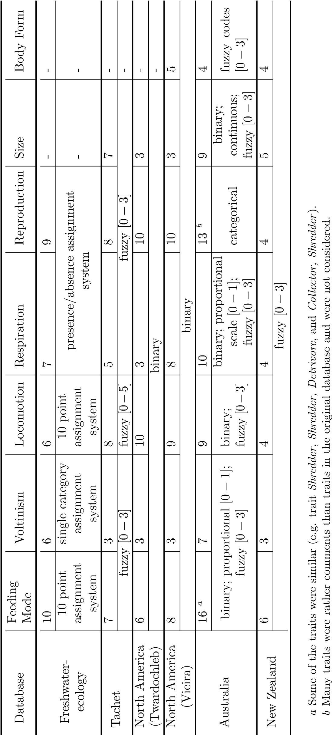

**Discussion**

**-**

# References

1. B. J. McGill, B. J. Enquist, E. Weiher, and M. Westoby, “Rebuilding community ecology from functional traits,” *Trends in Ecology & Evolution*, vol. 21, no. 4, pp. 178–185, 2006, issn: 0169-5347. doi: [10.1016/j.tree.2006.02.002.](https://doi.org/10.1016/j.tree.2006.02.002) [Online]. Available: [http://www. sciencedirect.com/science/article/pii/S0169534706000334.](http://www.sciencedirect.com/science/article/pii/S0169534706000334)
2. Heino Jani, Schmera D´enes, and Er˝os Tibor, “A macroecological perspective of trait patterns in stream communities,” *Freshwater Biology*, vol. 58, no. 8, pp. 1539–1555, May 28, 2013, issn: 0046-5070. doi: [10.1111/fwb.12164.](https://doi.org/10.1111/fwb.12164) [Online]. Available: [https://onlinelibrary. wiley.com/doi/full/10.1111/fwb.12164](https://onlinelibrary.wiley.com/doi/full/10.1111/fwb.12164) (visited on 04/14/2018).
3. T. R. E. Southwood, “Habitat, the templet for ecological strategies?” *Journal of Animal Ecology*, vol. 46, no. 2, pp. 337–365, 1977, issn: 0021-8790. doi: [10.2307/3817.](https://doi.org/10.2307/3817) [Online]. Available: [https://www.jstor.org/stable/3817.](https://www.jstor.org/stable/3817)
4. W. C. E. P. Verberk, C. G. E. van Noordwijk, and A. G. Hildrew, “Delivering on a promise: Integrating species traits to transform descriptive community ecology into a predictive science,” *Freshwater Science*, vol. 32, no. 2, pp. 531–547, 2013, issn: 2161-9549. doi: [10.1899/12-](https://doi.org/10.1899/12-092.1)

[092.1.](https://doi.org/10.1899/12-092.1) [Online]. Available: [https://www.journals.uchicago.edu/doi/10.1899/12-092.1.](https://www.journals.uchicago.edu/doi/10.1899/12-092.1)

1. N. Bonada, S. Dol´edec, and B. Statzner, “Taxonomic and biological trait differences of stream macroinvertebrate communities between mediterranean and temperate regions: Implications for future climatic scenarios,” *Global Change Biology*, vol. 13, no. 8, pp. 1658–1671, 2007, issn: 1354-1013, 1365-2486. doi: [10.1111/j.1365-2486.2007.01375.x.](https://doi.org/10.1111/j.1365-2486.2007.01375.x) [Online]. Available:

[http://doi.wiley.com/10.1111/j.1365-2486.2007.01375.x.](http://doi.wiley.com/10.1111/j.1365-2486.2007.01375.x)

1. D. J. Baird, C. J. O. Baker, R. B. Brua, M. Hajibabaei, K. McNicol, T. J. Pascoe, and D. d. Zwart, “Toward a knowledge infrastructure for traits-based ecological risk assessment,” *Integrated Environmental Assessment and Management*, vol. 7, no. 2, pp. 209–215, 2011, eprint: https://setac.onlinelibrary.wiley.com/doi/pdf/10.1002/ieam.129, issn: 1551-3793. doi: [10.](https://doi.org/10.1002/ieam.129)

[1002/ieam.129.](https://doi.org/10.1002/ieam.129) [Online]. Available: [https://setac.onlinelibrary.wiley.com/doi/ abs/10.1002/ieam.129.](https://setac.onlinelibrary.wiley.com/doi/abs/10.1002/ieam.129)

1. O. Moog and A. Hartmann, “A comprehensive species inventory of austrian aquatic organisms with ecological notes,” p. 86, 1995.
2. N. L. Poff, M. I. Pyne, B. P. Bledsoe, C. C. Cuhaciyan, and D. M. Carlisle, “Developing linkages between species traits and multiscaled environmental variation to explore vulnerability of stream benthic communities to climate change,” *Journal of the North American Benthological Society*, vol. 29, no. 4, pp. 1441–1458, 2010, issn: 0887-3593. doi: [10.1899/10-030.1.](https://doi.org/10.1899/10-030.1) [Online]. Available: [https://www.journals.uchicago.edu/doi/abs/10.1899/10-030.1.](https://www.journals.uchicago.edu/doi/abs/10.1899/10-030.1)
3. E. Sz¨ocs, E. Coring, J. B¨athe, and R. B. Sch¨afer, “Effects of anthropogenic salinization on biological traits and community composition of stream macroinvertebrates,” *Science of The Total Environment*, vol. 468-469, pp. 943–949, 2014, issn: 00489697. doi: [10.1016/j.scitotenv. 2013.08.058.](https://doi.org/10.1016/j.scitotenv.2013.08.058) [Online]. Available: [https://linkinghub.elsevier.com/retrieve/pii/ S0048969713009728.](https://linkinghub.elsevier.com/retrieve/pii/S0048969713009728)
4. A. K. Bhowmik and R. B. Sch¨afer, “Large scale relationship between aquatic insect traits and climate,” *PLoS ONE*, vol. 10, no. 6, 2015, issn: 1932-6203. doi: [10.1371/journal. pone.0130025.](https://doi.org/10.1371/journal.pone.0130025) [Online]. Available: [https://www.ncbi.nlm.nih.gov/pmc/articles/ PMC4469582/.](https://www.ncbi.nlm.nih.gov/pmc/articles/PMC4469582/)
5. S. Menezes, D. J. Baird, and A. M. V. M. Soares, “Beyond taxonomy: A review of macroinvertebrate trait-based community descriptors as tools for freshwater biomonitoring,” *Journal of Applied Ecology*, vol. 47, no. 4, pp. 711–719, 2010, issn: 1365-2664. doi: [10.1111/j.13652664.2010.01819.x.](https://doi.org/10.1111/j.1365-2664.2010.01819.x) [Online]. Available: [https://besjournals.onlinelibrary.wiley. com/doi/abs/10.1111/j.1365-2664.2010.01819.x.](https://besjournals.onlinelibrary.wiley.com/doi/abs/10.1111/j.1365-2664.2010.01819.x)
6. P. Usseglio-Polatera, M. Bournaud, P. Richoux, and H. Tachet, “Biomonitoring through biological traits of benthic macroinvertebrates: How to use species trait databases?” *Hydrobiologia*, vol. 422, no. 0, pp. 153–162, 2000, issn: 1573-5117. doi: [10.1023/A:1017042921298.](https://doi.org/10.1023/A:1017042921298) [Online]. Available: [https://doi.org/10.1023/A:1017042921298.](https://doi.org/10.1023/A:1017042921298)
7. A. Schmidt-Kloiber and D. Hering, “Www.freshwaterecology.info – an online tool that unifies, standardises and codifies more than 20,000 european freshwater organisms and their ecological preferences,” *Ecological Indicators*, vol. 53, pp. 271–282, 2015, issn: 1470-160X. doi: [10.1016/ j.ecolind.2015.02.007.](https://doi.org/10.1016/j.ecolind.2015.02.007) [Online]. Available: [http://www.sciencedirect.com/science/ article/pii/S1470160X15000758.](http://www.sciencedirect.com/science/article/pii/S1470160X15000758)
8. N. K. M. Vieira, N. L. Poff, D. M. Carlisle, S. R. M. II, M. L. Koski, and B. C. Kondratieff, “A database of lotic invertebrate traits for north america,” p. 19, 2006.
9. N. Philips and B. Smith, “New zealand freshwater macroinvertebrate trait database,” *NIWA*, 2018.
10. B. J. Kefford, P. K. Botwe, A. J. Brooks, S. Kunz, R. Marchant, S. Maxwell, L. Metzeling, R. B. Sch¨afer, and R. M. Thompson, “An integrated database of stream macroinvertebrate traits for australia: Concept and application,” *Ecological Indicators*, vol. 114, p. 106280, 2020, issn: 1470160X. doi: [10.1016/j.ecolind.2020.106280.](https://doi.org/10.1016/j.ecolind.2020.106280) [Online]. Available: [https:](https://linkinghub.elsevier.com/retrieve/pii/S1470160X2030217X)

[//linkinghub.elsevier.com/retrieve/pii/S1470160X2030217X.](https://linkinghub.elsevier.com/retrieve/pii/S1470160X2030217X)

1. S. Tomanova, E. Goitia, and J. Heleˇsic, “Trophic levels and functional feeding groups of macroinvertebrates in neotropical streams,” *Hydrobiologia*, vol. 556, no. 1, pp. 251–264, 2006, issn: 1573-5117. doi: [10.1007/s10750-005-1255-5.](https://doi.org/10.1007/s10750-005-1255-5) [Online]. Available: [https://doi.org/ 10.1007/s10750-005-1255-5.](https://doi.org/10.1007/s10750-005-1255-5)
2. N. L. Poff, J. D. Olden, N. K. M. Vieira, D. S. Finn, M. P. Simmons, and B. C. Kondratieff, “Functional trait niches of north american lotic insects: Traits-based ecological applications in light of phylogenetic relationships,” *Journal of the North American Benthological Society*, vol. 25, no. 4, pp. 730–755, 2006, issn: 0887-3593. doi: [10.1899/0887-3593(2006)025[0730: FTNONA]2.0.CO;2.](https://doi.org/10.1899/0887-3593(2006)025%5B0730:FTNONA%5D2.0.CO;2) [Online]. Available: [https://www.journals.uchicago.edu/doi/10.](https://www.journals.uchicago.edu/doi/10.1899/0887-3593(2006)025%5B0730%3AFTNONA%5D2.0.CO%3B2)

[1899/0887-3593%282006%29025%5B0730%3AFTNONA%5D2.0.CO%3B2.](https://www.journals.uchicago.edu/doi/10.1899/0887-3593(2006)025%5B0730%3AFTNONA%5D2.0.CO%3B2)

1. P. K. Botwe, S. Carver, R. Magierowski, P. McEvoy, P. Goonan, C. Madden, and L. A. Barmuta, “Effects of salinity and flow interactions on macroinvertebrate traits in temporary streams,” *Ecological Indicators*, vol. 89, pp. 74–83, 2018, issn: 1470160X. doi: [10.1016/ j.ecolind.2018.01.036.](https://doi.org/10.1016/j.ecolind.2018.01.036) [Online]. Available: [https://linkinghub.elsevier.com/ retrieve/pii/S1470160X18300384.](https://linkinghub.elsevier.com/retrieve/pii/S1470160X18300384)
2. R. B. Schäfer, B. J. Kefford, L. Metzeling, M. Liess, S. Burgert, R. Marchant, V. Pettigrove, P. Goonan, and D. Nugegoda, “A trait database of stream invertebrates for the ecological risk assessment of single and combined effects of salinity and pesticides in south-east australia,” *Science of The Total Environment*, vol. 409, no. 11, pp. 2055–2063, 2011, issn: 00489697. doi:

[10.1016/j.scitotenv.2011.01.053.](https://doi.org/10.1016/j.scitotenv.2011.01.053) [Online]. Available: [http://linkinghub.elsevier.](http://linkinghub.elsevier.com/retrieve/pii/S0048969711001124)

[com/retrieve/pii/S0048969711001124.](http://linkinghub.elsevier.com/retrieve/pii/S0048969711001124)

1. D. Schmera, J. Podani, J. Heino, T. Er˝os, and N. L. Poff, “A proposed unified terminology of species traits in stream ecology,” *Freshwater Science*, vol. 34, no. 3, pp. 823–830, 2015, issn: 2161-9549, 2161-9565. doi: [10.1086/681623.](https://doi.org/10.1086/681623) [Online]. Available: [https://www.journals.](https://www.journals.uchicago.edu/doi/10.1086/681623)

[uchicago.edu/doi/10.1086/681623.](https://www.journals.uchicago.edu/doi/10.1086/681623)

1. L. E. Brown, K. Khamis, M. Wilkes, P. Blaen, J. E. Brittain, J. L. Carrivick, S. Fell, N. Friberg, L. Fu¨reder, G. M. Gislason, S. Hainie, D. M. Hannah, W. H. M. James, V. Lencioni, J. S. Olafsson, C. T. Robinson, S. J. Saltveit, C. Thompson, and A. M. Milner, “Functional diversity and community assembly of river invertebrates show globally consistent responses to decreasing glacier cover,” *Nature Ecology & Evolution*, vol. 2, no. 2, pp. 325–333, 2018, issn: 2397-334X. doi: [10.1038/s41559-017-0426-x.](https://doi.org/10.1038/s41559-017-0426-x) [Online]. Available: [http://www.nature.](http://www.nature.com/articles/s41559-017-0426-x)

[com/articles/s41559-017-0426-x.](http://www.nature.com/articles/s41559-017-0426-x)

1. F. D. Schneider, D. Fichtmueller, M. M. Gossner, A. Gu¨ntsch, M. Jochum, B. K¨onig-Ries, G. Le Provost, P. Manning, A. Ostrowski, C. Penone, and N. K. Simons, “Towards an ecological trait-data standard,” *Methods in Ecology and Evolution*, D. Orme, Ed., pp. 2041–210X.13288, 2019, issn: 2041-210X, 2041-210X. doi: [10.1111/2041-210X.13288.](https://doi.org/10.1111/2041-210X.13288) [Online]. Available:

[https://onlinelibrary.wiley.com/doi/abs/10.1111/2041-210X.13288.](https://onlinelibrary.wiley.com/doi/abs/10.1111/2041-210X.13288)

1. J. M. Culp, D. G. Armanini, M. J. Dunbar, J. M. Orlofske, N. L. Poff, A. I. Pollard, A. G. Yates, and G. C. Hose, “Incorporating traits in aquatic biomonitoring to enhance causal diagnosis and prediction,” *Integrated Environmental Assessment and Management*, vol. 7, no. 2, pp. 187–197, 2011, eprint: https://setac.onlinelibrary.wiley.com/doi/pdf/10.1002/ieam.128, issn: 1551-3793. doi: [10.1002/ieam.128.](https://doi.org/10.1002/ieam.128) [Online]. Available: [https://setac.onlinelibrary](https://setac.onlinelibrary.wiley.com/doi/abs/10.1002/ieam.128). [wiley.com/doi/abs/10.1002/ieam.128.](https://setac.onlinelibrary.wiley.com/doi/abs/10.1002/ieam.128)
2. K. Voß and R. Sch¨afer, “Taxonomic and functional diversity of stream invertebrates along an environmental stress gradient,” *Ecological Indicators*, vol. 81, pp. 235–242, 2017, issn: 1470160X. doi: [10.1016/j.ecolind.2017.05.072.](https://doi.org/10.1016/j.ecolind.2017.05.072) [Online]. Available: [http://linkinghub. elsevier.com/retrieve/pii/S1470160X17303412.](http://linkinghub.elsevier.com/retrieve/pii/S1470160X17303412)
3. Pili`ere A. F. H., Verberk W. C. E. P., Gr¨awe M., Breure A. M., Dyer S. D., Posthuma L., Zwart D., Huijbregts M. A. J., and Schipper A. M., “On the importance of trait interrelationships for understanding environmental responses of stream macroinvertebrates,” *Freshwater Biology*, vol. 61, no. 2, pp. 181–194, 2016, issn: 0046-5070. doi: [10.1111/fwb.12690.](https://doi.org/10.1111/fwb.12690) [Online]. Available: [https://onlinelibrary.wiley.com/doi/abs/10.1111/fwb.12690.](https://onlinelibrary.wiley.com/doi/abs/10.1111/fwb.12690)
4. T. W. H. Aspin, K. Khamis, T. J. Matthews, A. M. Milner, M. J. O’Callaghan, M. Trimmer, G. Woodward, and M. E. Ledger, “Extreme drought pushes stream invertebrate communities over functional thresholds,” *Global Change Biology*, vol. 25, no. 1, pp. 230–244, 2019, issn: 1365-2486. doi: [10.1111/gcb.14495.](https://doi.org/10.1111/gcb.14495) [Online]. Available: [https://onlinelibrary.wiley. com/doi/abs/10.1111/gcb.14495.](https://onlinelibrary.wiley.com/doi/abs/10.1111/gcb.14495)
5. C. Magliozzi, P. Usseglio-Polatera, A. Meyer, and R. C. Grabowski, “Functional traits of hyporheic and benthic invertebrates reveal importance of wood-driven geomorphological processes in rivers,” *Functional Ecology*, vol. 33, no. 9, J. Alahuhta, Ed., pp. 1758–1770, 2019, issn: 0269-8463, 1365-2435. doi: [10.1111/1365-2435.13381.](https://doi.org/10.1111/1365-2435.13381) [Online]. Available: [https:](https://onlinelibrary.wiley.com/doi/abs/10.1111/1365-2435.13381)

[//onlinelibrary.wiley.com/doi/abs/10.1111/1365-2435.13381.](https://onlinelibrary.wiley.com/doi/abs/10.1111/1365-2435.13381)

1. L. A. Twardochleb, E. Hilter, M. Pyne, P. Bills, and P. L. Zarnetske, *Freshwater insect occurrences and traits for the contiguous united states, 2001 - 2018 ver 5. environmental data initiative.* https://doi.org/10.6073/pasta/8238ea9bc15840844b3a023b6b6ed158, 2020.
2. P. Usseglio-Polatera, *Personal information on body form traits.* Personal information, 2020.
3. ——, *Classification of piercers as herbivores or predators.* Personal information, 2020.
4. B. C. Chessman, “Dissolved-oxygen, current and temperature preferences of stream invertebrates estimated from field distributions: Application to assemblage responses to drought,” *Hydrobiologia*, vol. 809, no. 1, pp. 141–153, 2018, issn: 1573-5117. doi: [10.1007/s10750017-3455-1.](https://doi.org/10.1007/s10750-017-3455-1) [Online]. Available: [https://doi.org/10.1007/s10750-017-3455-1.](https://doi.org/10.1007/s10750-017-3455-1)

# Supporting Information

## Comparison of the trait aggregation methods with each other

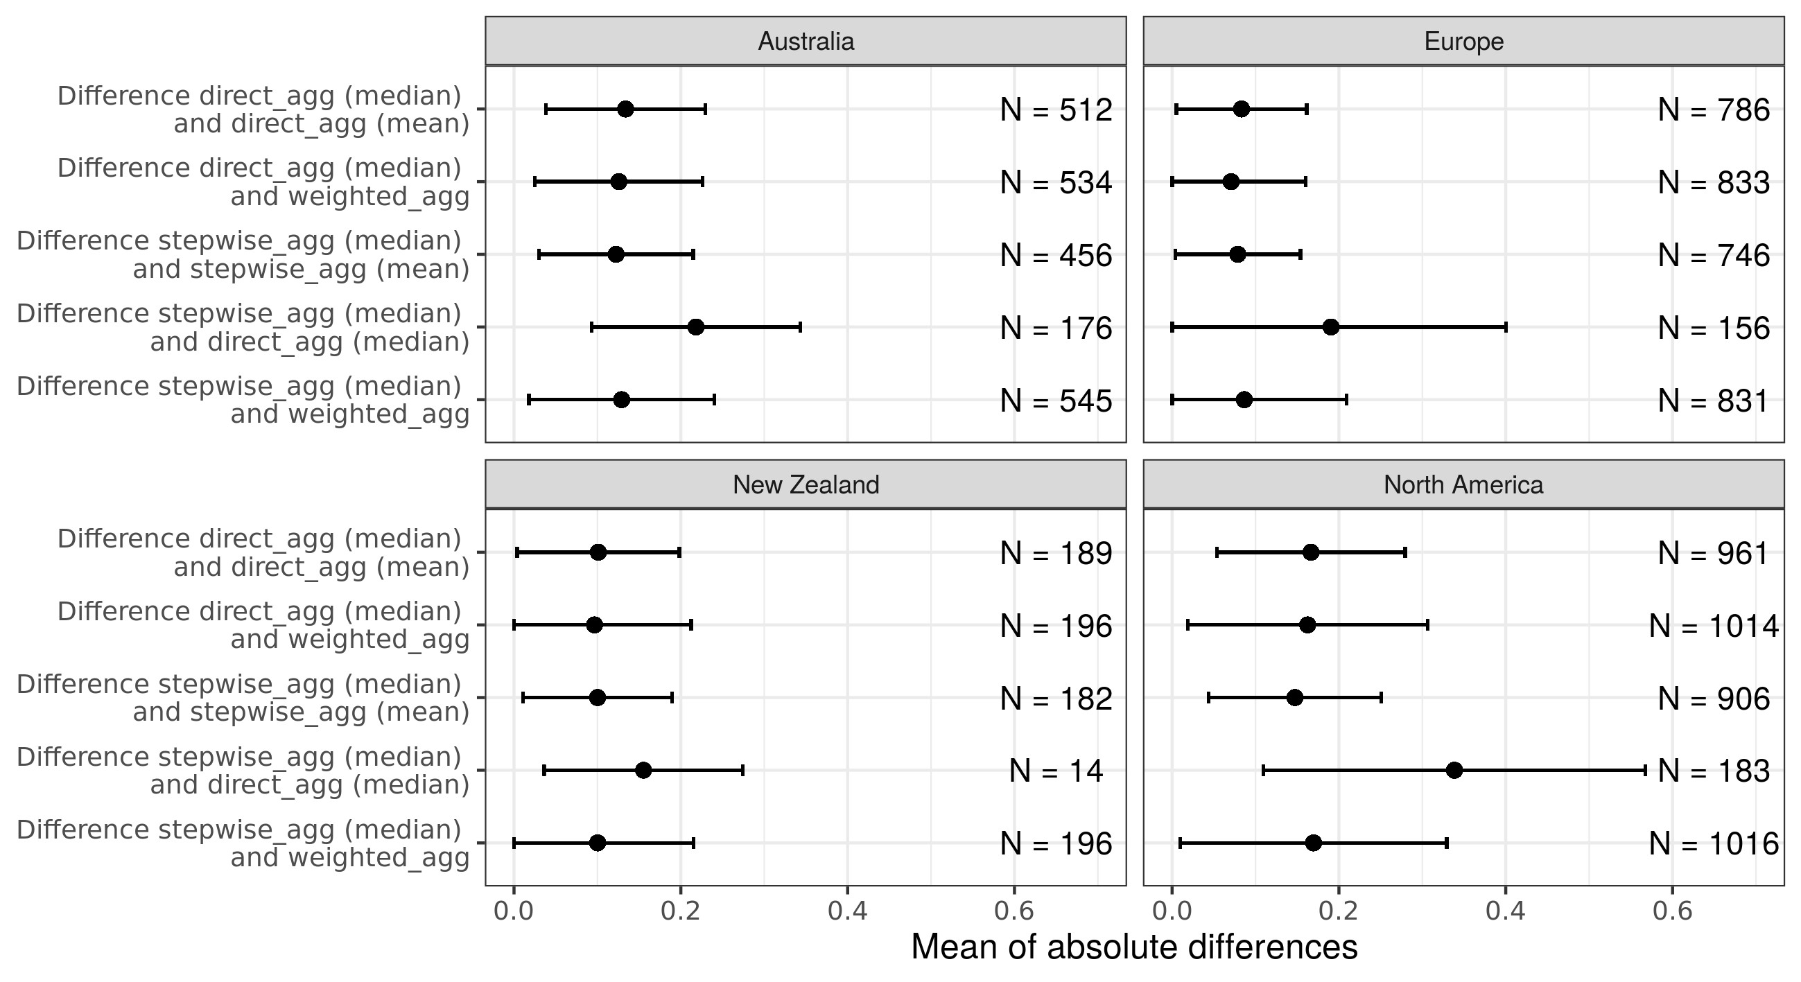

Figure 1: Comparison of trait aggregation methods when aggregating over all traits for all datasets. Displayed are means of absolute differences in trait affinities with standard deviations (truncated at 0). Compared aggregation methods are displayed on the y-axis. N indicates the number of cases where differences occurred. Total number of cases: Australia 2223, Europe 3352, New Zealand 777, and North America 4080.

**Re-analysis of Sz¨ocs et al. using harmonized grouping features.**

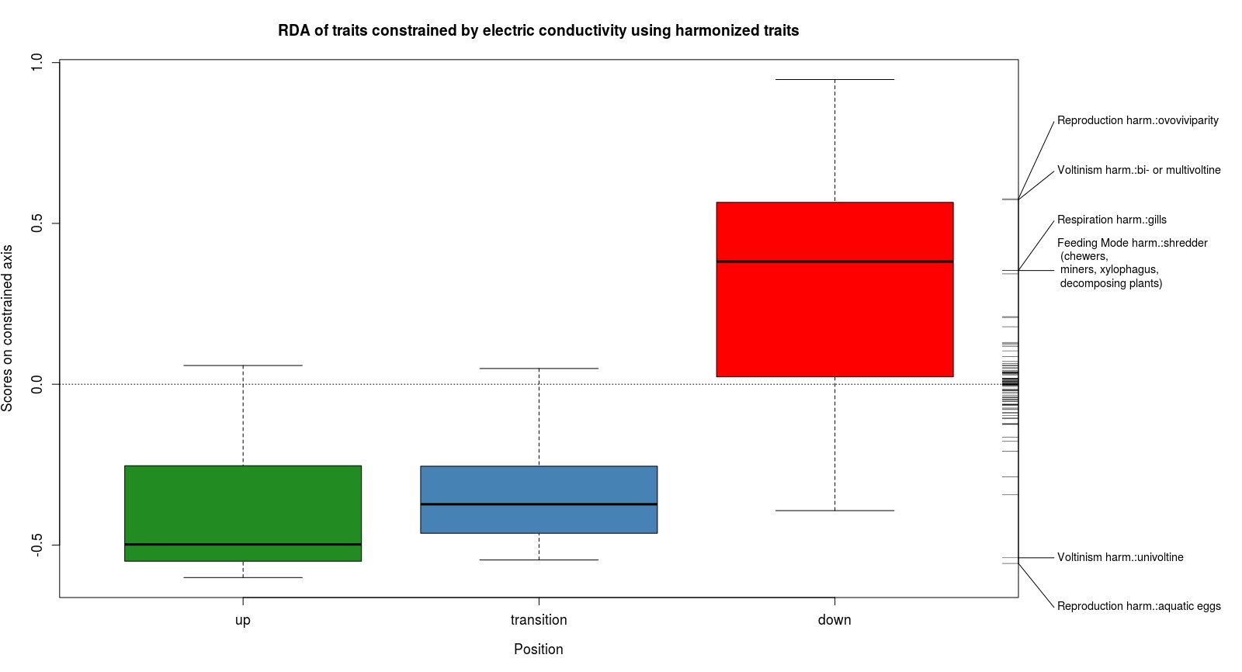

Figure 2: RDA of traits constrained by electric conductivity using harmonized grouping features. Boxplot of site scores along the conductivity axis (31*.*44% explained variance, p = 0.001, 1000 permutations). Rug on the left indicates trait scores on the conductivity axis. Only traits with a mahalanobis distance greater than 5.02 were labeled in accordance to the procedure in Sz¨ocs et al. 2014.

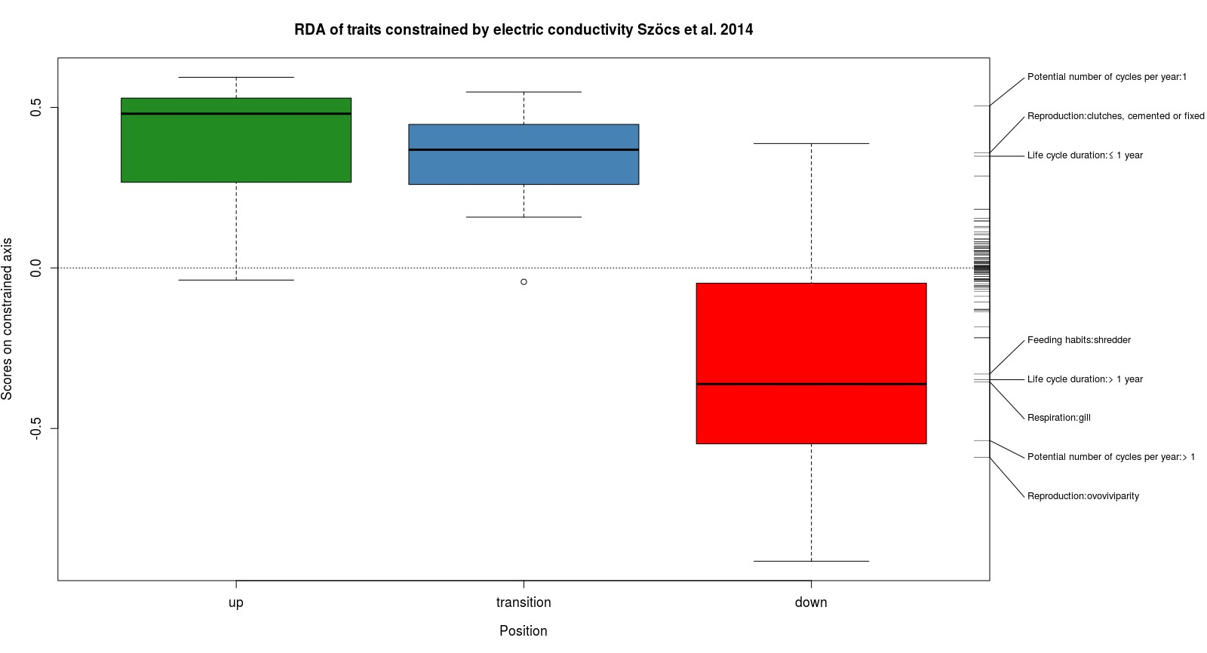

Figure 3: RDA of traits constrained by electric conductivity. Boxplot of site scores along the conductivity axis (30*.*09% explained variance, p = 0.001, 1000 permutations). Rug on the left indicates trait scores on the conductivity axis. Only traits with a mahalanobis distance greater than 5.02 were labeled.

# Trait distribution along first RDA axis

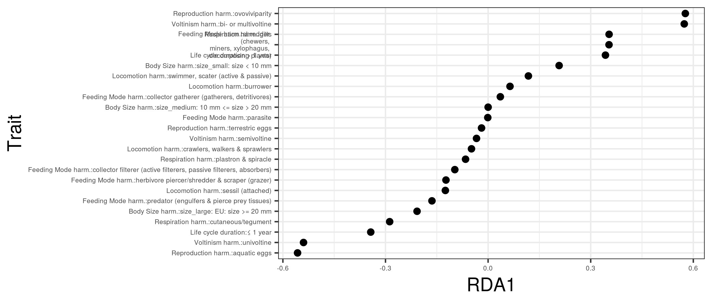

Figure 4: Trait scores on the first RDA axis for harmonized traits and traits of the grouping feature *life cycle duration*.

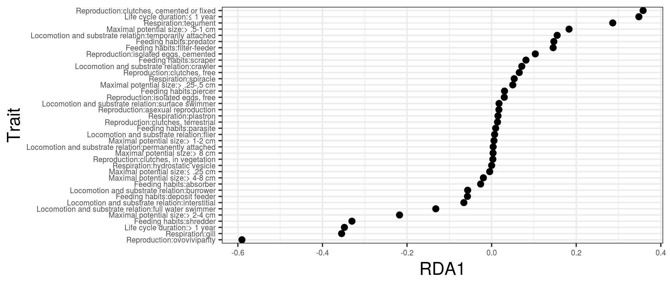

Figure 5: Trait scores on the first RDA axis for the traits responding to high salinity in Sz¨ocs et al. 2014 .

# Linear models of trait proportions

*Linear models of trait proportions with harmonized traits:*

Table 1: Results of linear models for the four selected harmonized traits and life cycle duration *>* 1 year. Trait proportions were logit transformed prior model building, estimates are on the logit scale. Although years were statistically not significant we kept this factor in the model to avoid temporal autocorrelation. Bold values indicate statistically significant effects (p *<* 0.05).

|  |  |  |  |  |
| --- | --- | --- | --- | --- |
| Feeding mode: shredder | Life cycle duration:  *>* 1 year | Voltinism:  bi- or multivoltine | Reproduction: ovoviviparity | Respiration:  gills |

Intercept(=upstream)

**-1.041**

**-0.486**

0.375*

**-0.823**

0.092

Downstream

**1.376**

**0.926**

**0.605**

**1.684**

**0.854**

Downstreamx2008

-0.235

-0.117

0.106

-0.088

-0.317

Downstreamx2009

0.030

-0.056

0.001

0.245

0.180

Year2008

-0.115

0.033

-0.182

-0.151

-0.167

Year2009

0.175

0.086

-0.088

0.141

0.246

*\*p.value=0.055*

*Linear models of trait proportions Szöcs et al. 2014:*

Table 2: Results of linear models for the five selected traits for Sz¨ocs et al. 2014. Trait proportions were logit transformed prior model building, estimates are on the logit scale. Although years were statistically not significant we kept this factor in the model to avoid temporal autocorrelation. Bold values indicate statistically significant effects (p *<* 0.05).

|  |  |  |  |  |  |  |
| --- | --- | --- | --- | --- | --- | --- |
|  | Feeding habits:  shredder | Life cycle duration:  *>* 1 year | Cycles per year:  *>* 1 | Reproduction: ovoviviparity | Respiration:  gills | |
| Intercept (= upstream)  Downstream  Downstream x 2008  Downstream x 2009  Year 2008  Year 2009 | **-0.853**  **0.819** -0.155  0.073  -0.122  0.167 | **-0.478**  **0.594**  0.102  -0.053  -0.112  0.084 | **0.603**  **1.297** -0.227  -0.020  0.026  -0.104 | **-0.838**  **1.679** -0.070  0.248  -0.192  0.250 | 0.111  **0.839** -0.314  0.176  -0.154  0.139 |  |

# Trait proportions over time

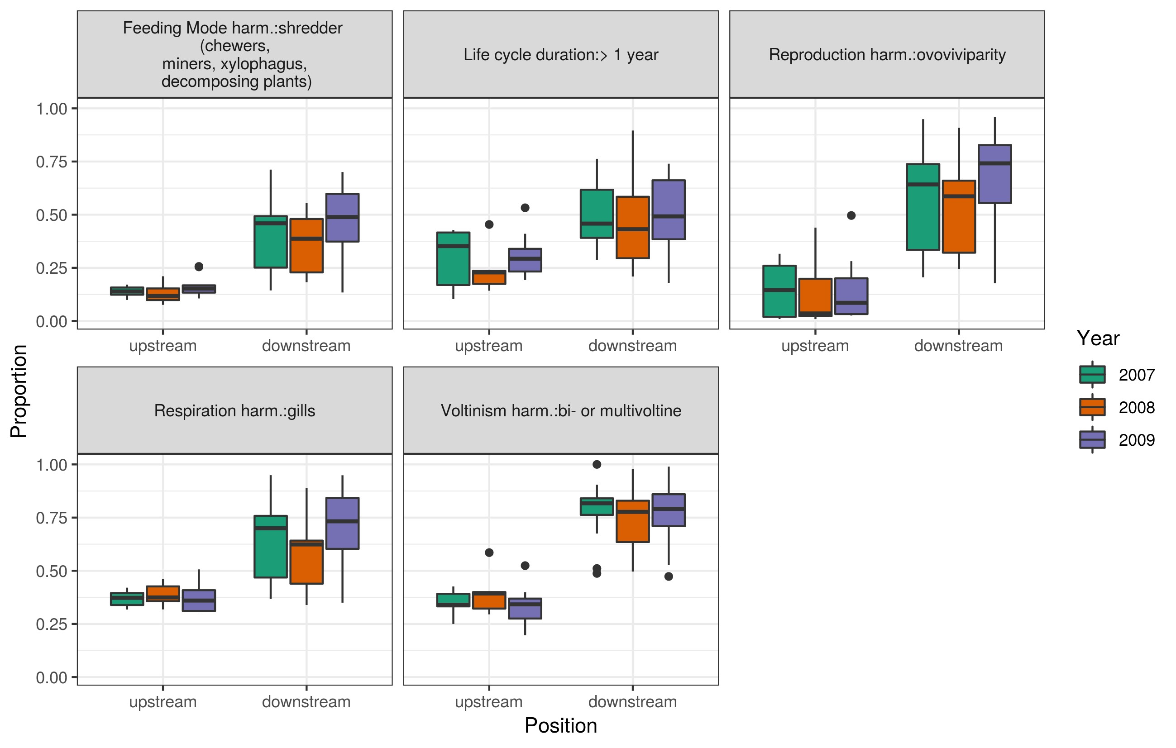

Figure 6: Proportions for the four harmonized traits that have been promoted by salinization and life cycle duration *>* 1 year for down- and upstream sites.

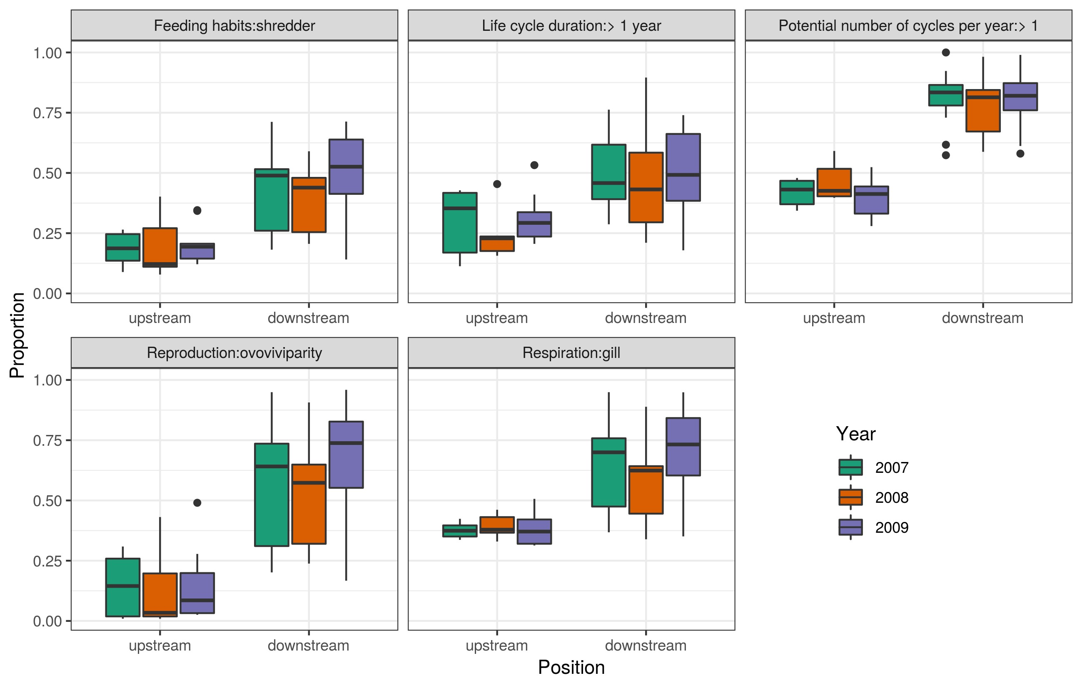

Figure 7: Proportions for five selected traits for down- and upstream sites (traits that have been promoted by salinization) from Sz¨ocs et al. 2014.

|  |  |
| --- | --- |
|  |  |
|  |
|  |