1. Edge Impulse tutorial: <https://docs.edgeimpulse.com/docs/tutorials/continuous-motion-recognition#2.-collecting-your-first-data>

Arduino Part

1. Add the “EmbeddedMachineLearning_DetectAbnormalGait\Arduino Library zip file downloaded from Edge Impulse \ei-cen598_finalproject_v3-arduino-1.0.1.zip” to your Arduino Library

After adding the library, you should see “CEN598_finalproject_v3_inferencing” library exist in the contributed libraries.

1. choose Arduino board

1. Upload “EmbeddedMachineLearning_DetectAbnormalGait\Arduino Code\nano_ble33_sense_accelerometer\nano_ble33_sense_accelerometer.ino” to Nano 33 Sense board. (Better to compile the Arduino code first)

Python program on your PC part

1. Use “bluetooh2.py” python program to find any Bluetooth device that has name: “SendInteger”, and get it’s Bluetooth address.

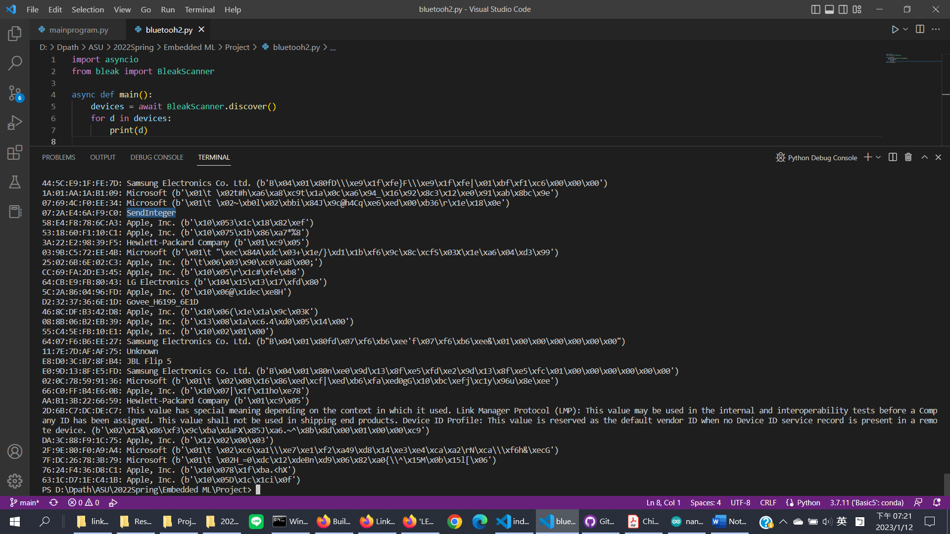

1. Edit the Bluetooth address in “EmbeddedMachineLearning_DetectAbnormalGait\Python program on base station \mainprogram.py” file
2. Might need to add some python libraries to your python system.
3. Run the “mainprogram.py” file

