# 12.1 Singly-linked lists

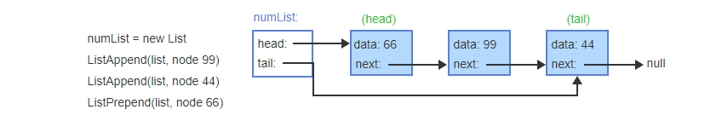

Prepending & Appending.

# 12.2 Singly-linked lists: Insert

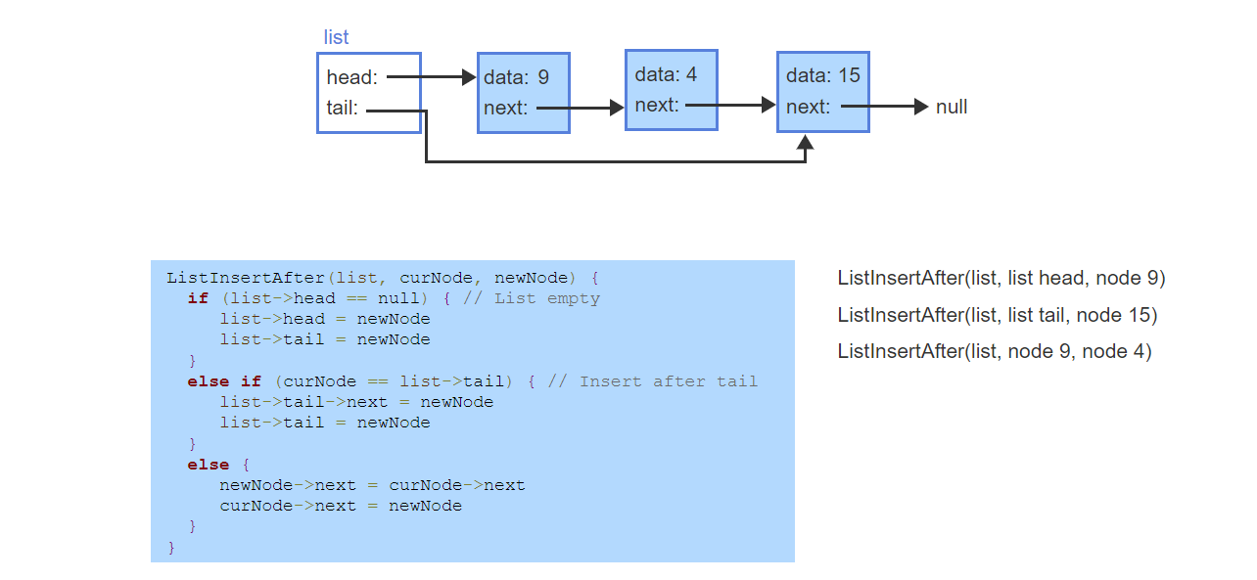

# 12.3 Singly-linked lists: Remove

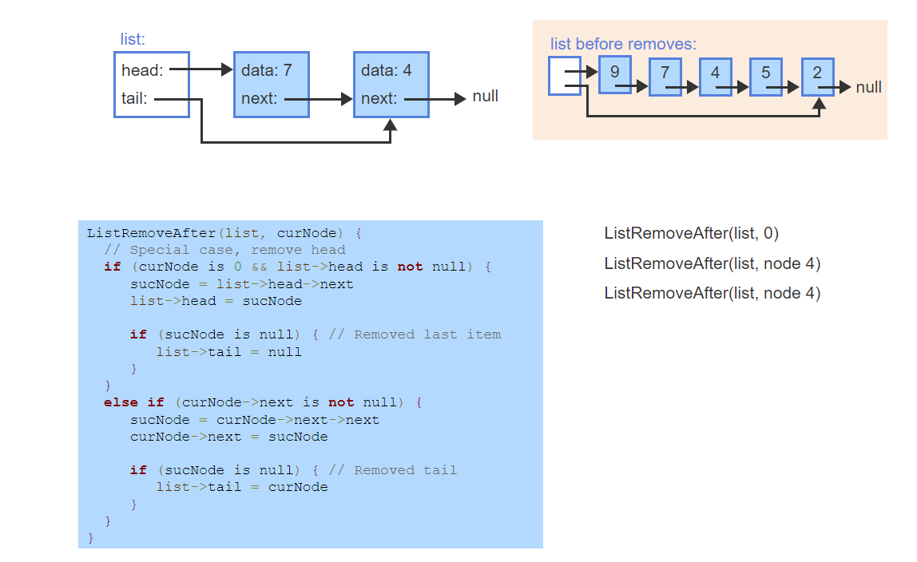

# 12.4 Python: Singly-linked lists

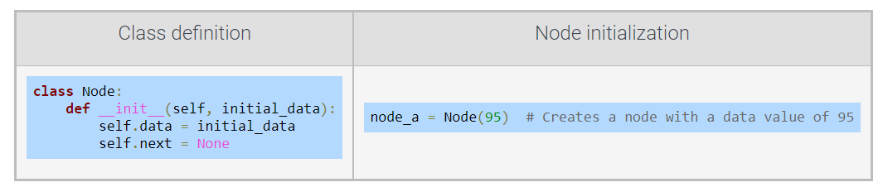

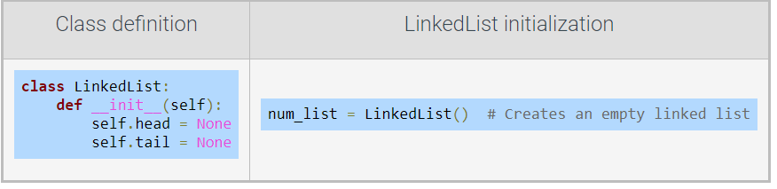

### Appending a node to a singly-linked list

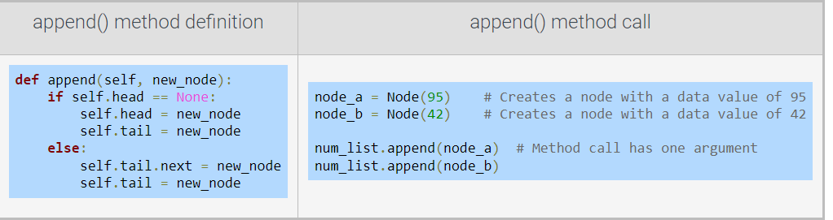

### Additional singly-linked list methods

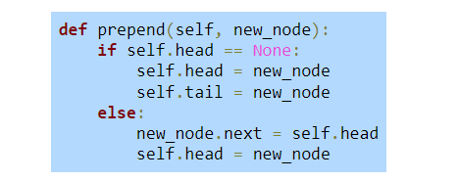

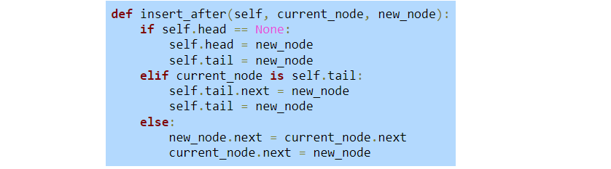

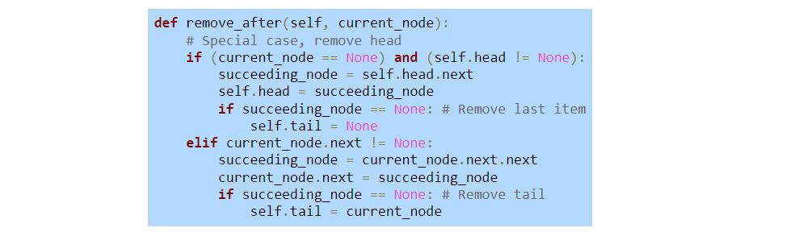

# 12.5 Doubly-linked lists

A ***doubly-linked list*** is a data structure for implementing a list ADT, where each node has data, a pointer to the next node, and a pointer to the previous node.

Append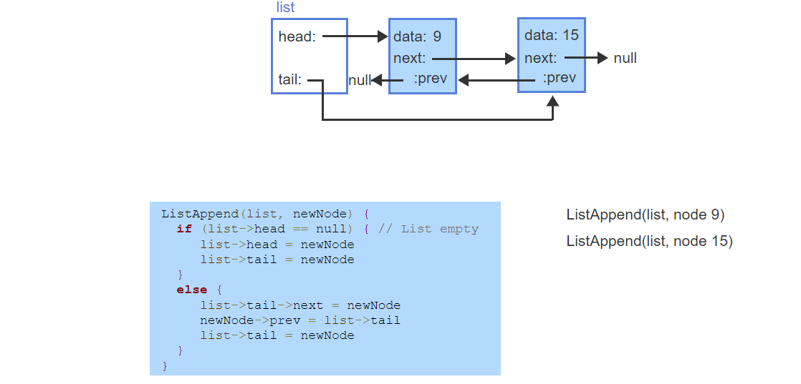

prepend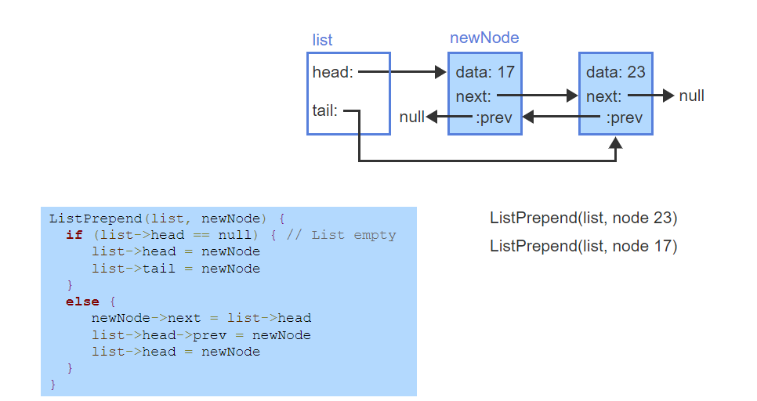

# 12.6 Doubly-linked lists: Insert

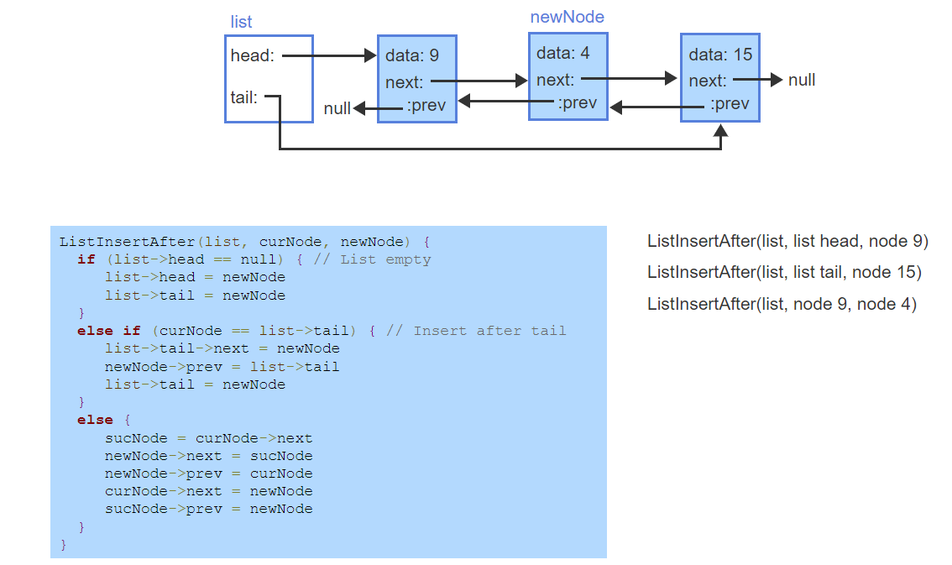

# 12.7 Doubly-linked lists: Remove

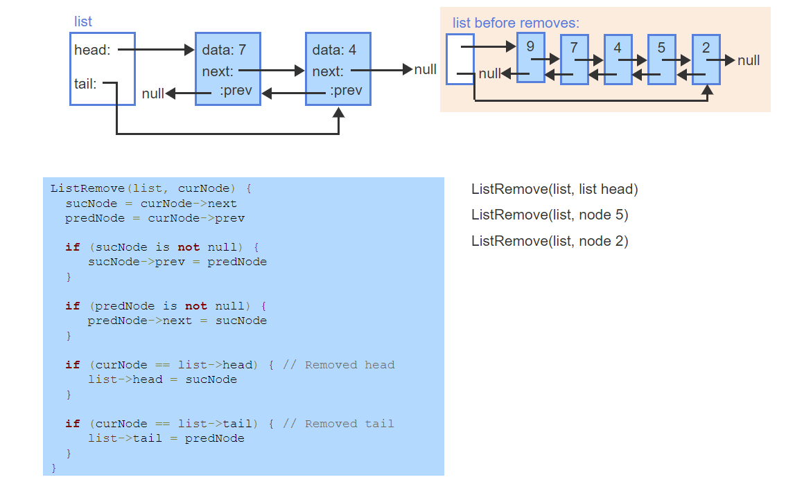

# 12.8 Python: Doubly-linked lists

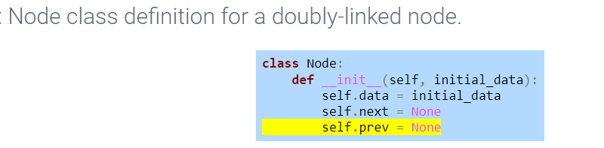

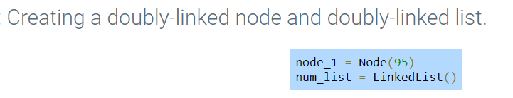

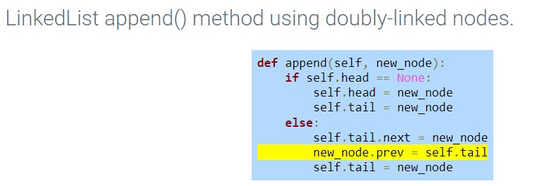

### Additional doubly-linked list methods

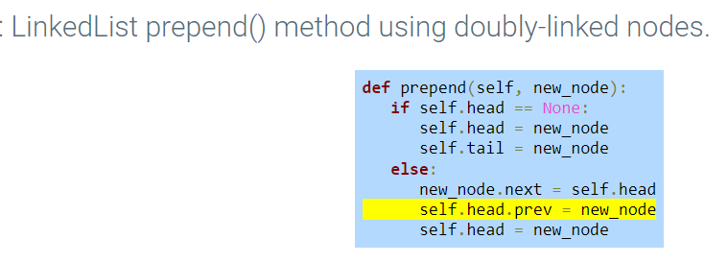

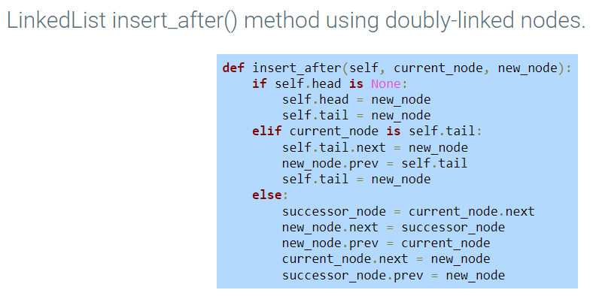

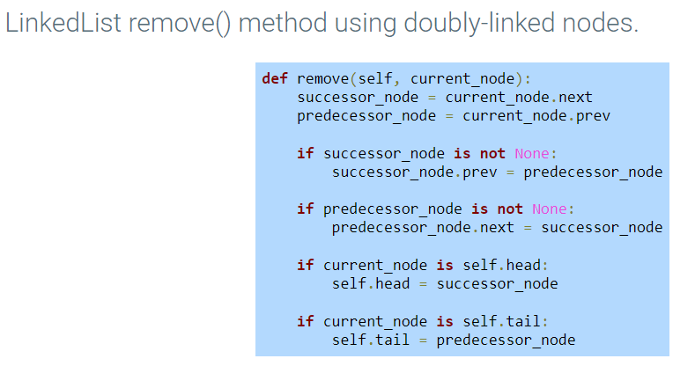

# 12.10 Linked list traversal

A ***list traversal*** algorithm visits all nodes in the list once and performs an operation on each node.

A common traversal operation prints all list nodes.

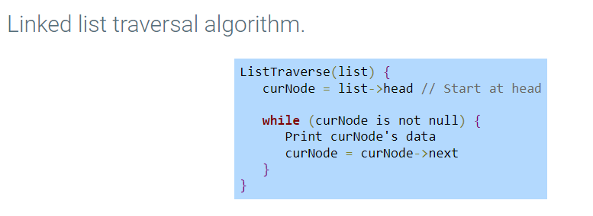

### Doubly-linked list reverse traversal

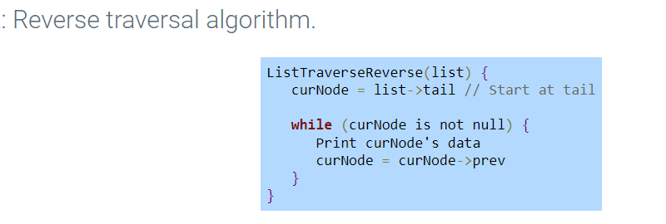

# 12.11 Linked list search

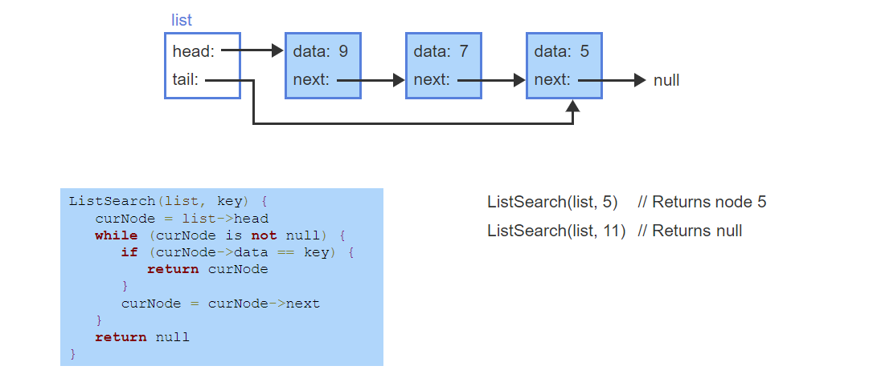

# 12.12 Circular lists

A ***circular linked list*** is a linked list where the tail node's next pointer points to the head of the list, instead of null.

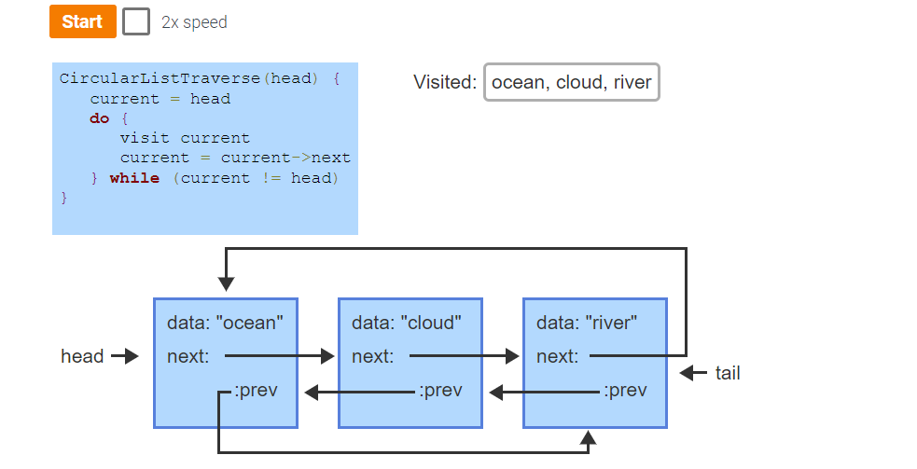

# 12.13 Stack abstract data type (ADT)

A ***stack*** is an ADT in which items are only inserted on or removed from the top of a stack.

The stack ***push*** operation inserts an item on the top of the stack.

The stack ***pop*** operation removes and returns the item at the top of the stack.

A stack is referred to as a ***last-in first-out*** ADT. A stack can be implemented using a linked list, an array, or a vector.

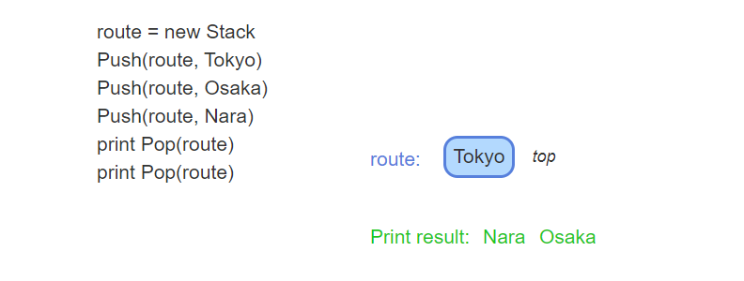

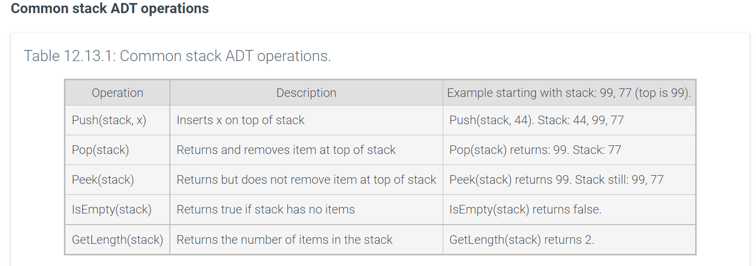

# 12.14 Stacks using linked lists

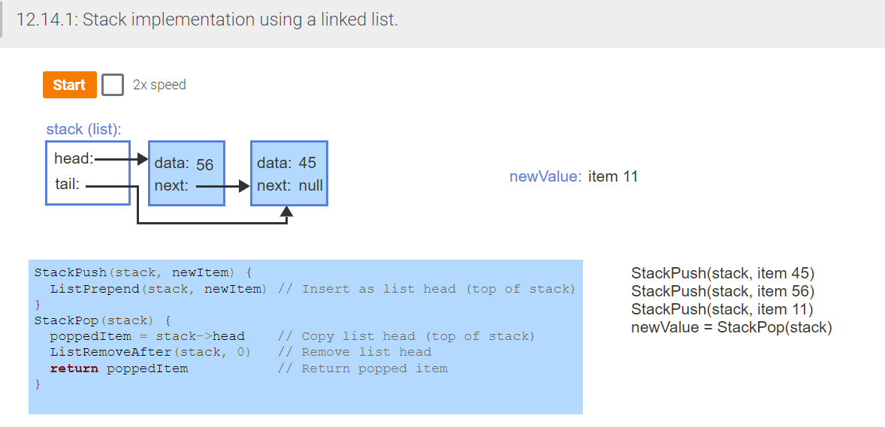

# 12.15 Queues using linked lists

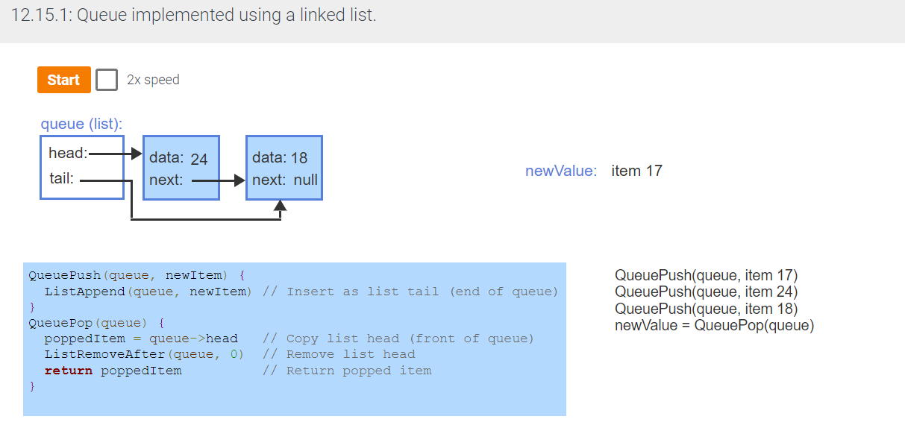

# 12.16 Deque abstract data type (ADT)

A ***deque*** (pronounced "deck" and short for double-ended queue) is an ADT in which items can be inserted and removed at both the front and back.

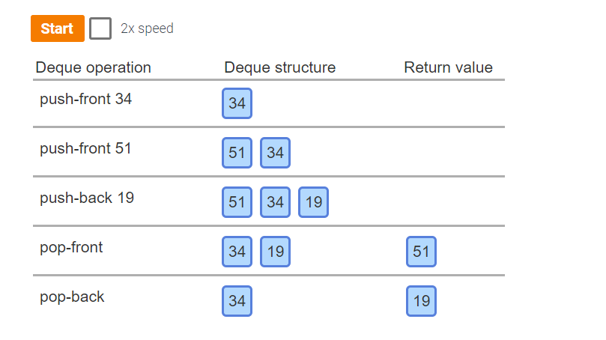

### Common deque ADT operations

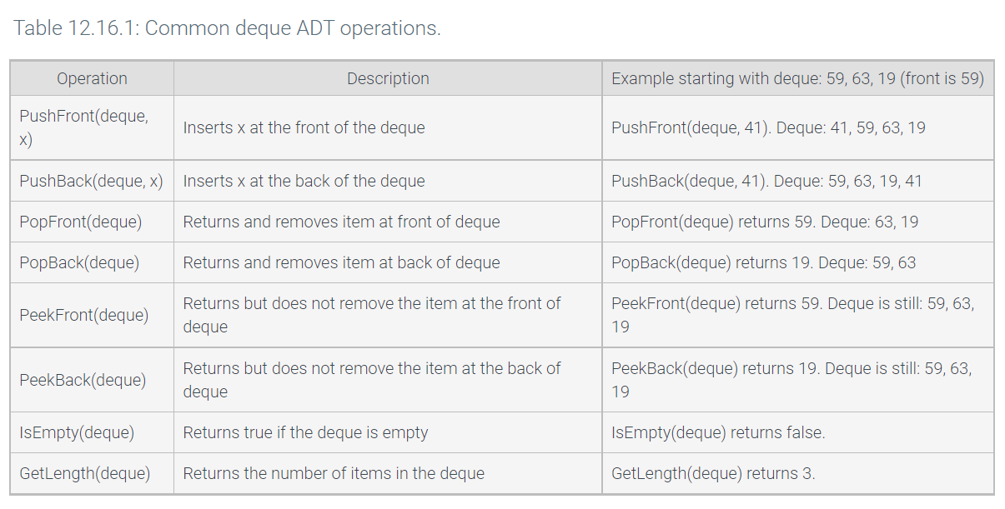

# 12.17 Python: Stacks and queues

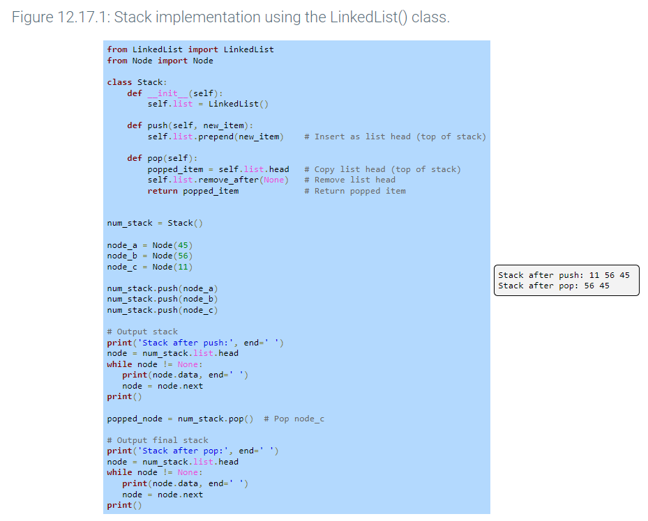

# 12.19 Sorting linked lists

### Insertion sort for doubly-linked lists

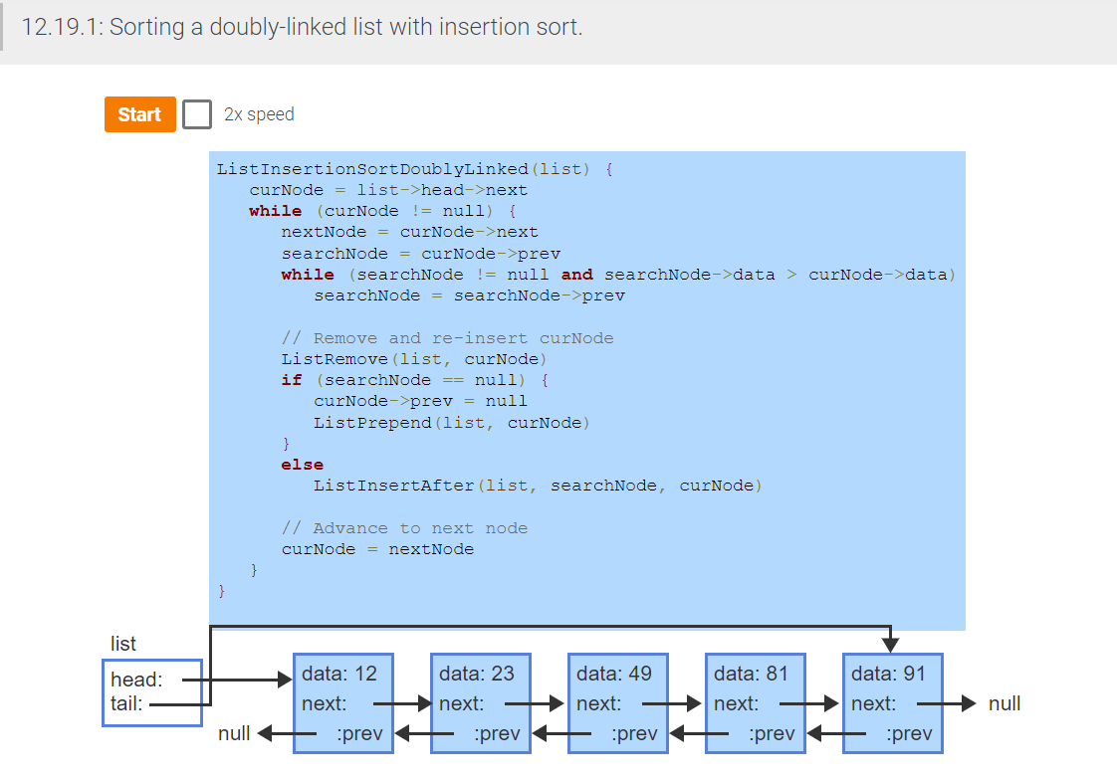

### Insertion sort for singly-linked lists

### Sorting linked-lists vs. arrays

# 12.20 Python: Sorting linked lists

### Python insertion sort variant for singly-linked lists

