SpotMini Platform Crash-Test Report
This report documents deliberate attempts to crash or break the SpotMini simulation and reinforcement-learning platform. Each case includes the attack, the expected failure mode, the prevention implemented in the project, and what screenshot evidence should be captured.

Platform Under Test
- Project: SpotMini Mini PyBullet reinforcement-learning platform
- Main scripts:
  - spot_bullet/src/spot_train_ml.py
  - spot_bullet/src/spot_play_ml.py
  - spot_bullet/src/spot_compare_ml.py
- Simulator: PyBullet
- ML stack: Stable-Baselines3 PPO, VecNormalize
- Primary GUI: native PyBullet GUI on macOS when --render --bullet-gui is used

Case 1: Platform / GUI Dependency Attack

Attack Goal
Break visualization by running the simulator on macOS where native PyBullet GUI behavior can differ from headless or OpenCV preview behavior.

Attack Commands
Run playback without visualization:
python3 spot_bullet/src/spot_play_ml.py \
--run-dir "spot_bullet/training runs/dual_imu_longwalk_yaw_lowbody_v1" \
--model best \
--episodes 1
Then run native PyBullet GUI:
python3 spot_bullet/src/spot_play_ml.py \
--run-dir "spot_bullet/training runs/dual_imu_longwalk_yaw_lowbody_v1" \
--model best \
--episodes 1 \
--render --bullet-gui
Optional fallback test:
python3 spot_bullet/src/spot_play_ml.py \
--run-dir "spot_bullet/training runs/dual_imu_longwalk_yaw_lowbody_v1" \
--model best \
--episodes 1 \
--render

Expected Failure Before Prevention
Users could think the platform was frozen because the simulation runs headlessly unless --render is passed. On some macOS setups, native GUI launch can also be fragile.

Prevention Implemented
- spot_play_ml.py explicitly supports native PyBullet GUI with --render --bullet-gui.
- On macOS, plain --render uses a safer live-preview fallback instead of forcing native GUI.
- The script prints the selected render mode, such as Render mode: native PyBullet GUI or Render mode: live preview window (macOS fallback).

Result
The simulator runs headlessly when intended, and opens the native PyBullet GUI when --render --bullet-gui is used. This prevents false failure reports and gives a reliable visualization path.

Screenshot Evidence
- Screenshot 1: Terminal showing headless playback completing an episode.

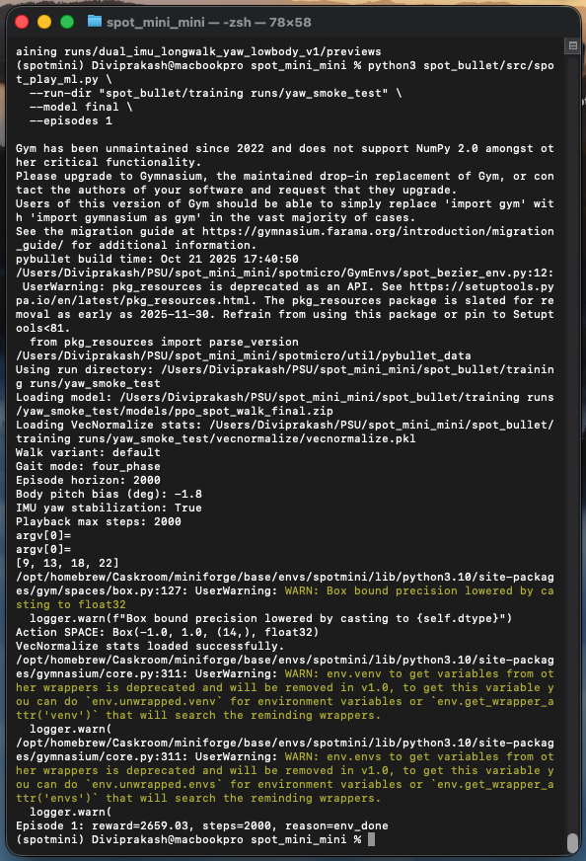

- Screenshot 2: Native PyBullet GUI window with the SpotMini robot visible.

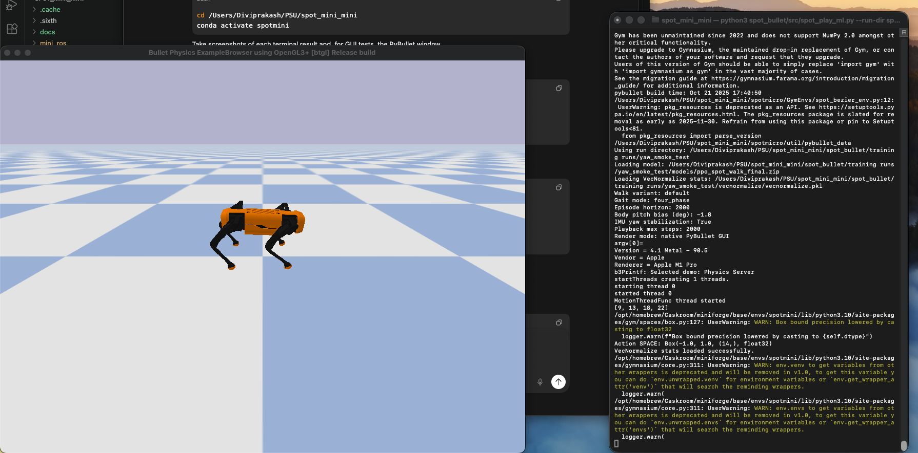

Case 2: Model / Environment Mismatch Attack

Attack Goal
Crash playback by forcing an old checkpoint to load with a different observation space. This is easy to trigger when a model trained without yaw-aware IMU features is played with yaw features forced on.

Attack Command
python3 spot_bullet/src/spot_play_ml.py \
--run-dir "spot_bullet/training runs/dual_imu_stable_forward_v2" \
--model best \
--episodes 1 \
--enable-imu-yaw

Expected Failure Before Prevention
Stable-Baselines3 can throw a raw PyTorch stack trace similar to:
RuntimeError: size mismatch for mlp_extractor.policy_net.0.weight
This is confusing for users and looks like a platform crash.

Prevention Implemented
- spot_play_ml.py now loads PPO models through load_ppo_model(...).
- If a size mismatch is detected, the platform exits with a clear explanation:
  - The checkpoint and environment feature set do not match.
  - Remove overrides such as --enable-imu-yaw, or retrain with the same flags.
- The raw stack trace is avoided for this known crash case.

Repeat Attack After Prevention
Run the same command again. The platform should stop safely with a readable error message instead of a long stack trace.

Screenshot Evidence
- Screenshot 1: Terminal command that forces --enable-imu-yaw on an older model. Friendly error explaining model/environment observation mismatch.
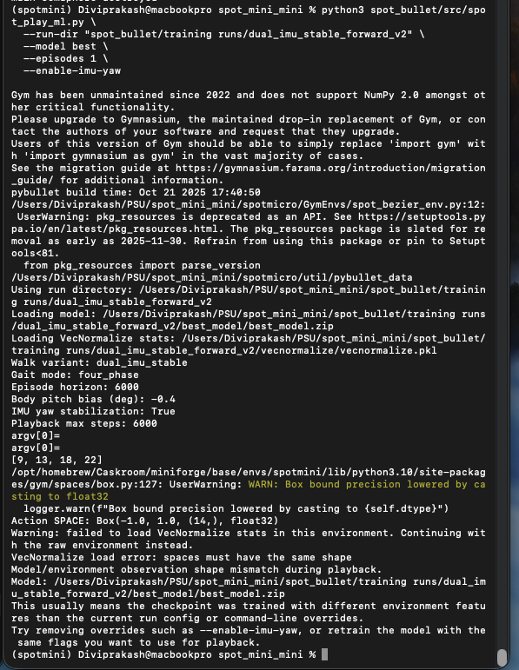
- Screenshot 2: Successful playback after removing the bad override:
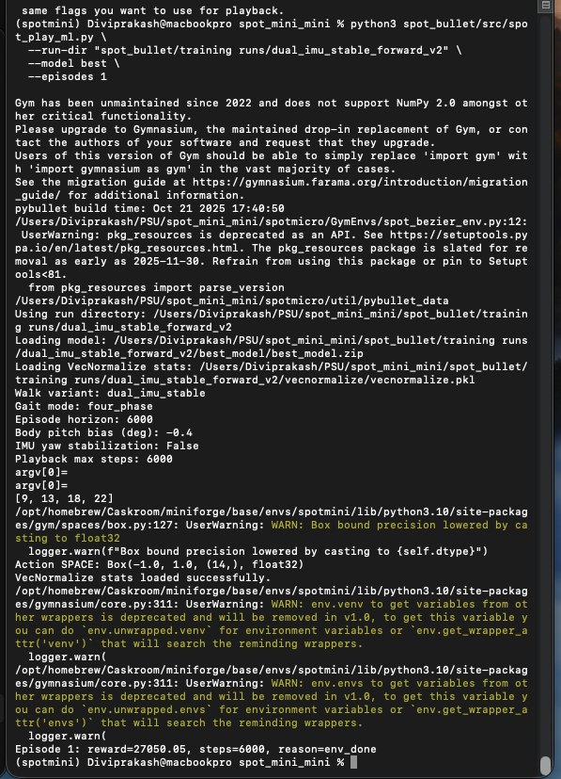

Case 3: Batch Evaluation / Bad Candidate Attack

Attack Goal
Crash a multi-model comparison by mixing valid runs with a missing or incompatible run. This tests whether one bad candidate can bring down the whole evaluation platform.

Attack Command
python3 spot_bullet/src/spot_compare_ml.py \
"spot_bullet/training runs/with_yaw_test" \
"spot_bullet/training runs/does_not_exist" \
"spot_bullet/training runs/no_yaw_test" \
--model final \
--episodes 3 \
--sort-by reward

Expected Failure Before Prevention
The comparison script could abort when it reached the missing run, preventing all remaining valid runs from being scored.

Prevention Implemented
- spot_compare_ml.py now catches per-run failures.
- A failed candidate is reported as a failed row instead of aborting the entire comparison.
- Valid candidates continue to run and are still included in the final table.

Repeat Attack After Prevention
Run the same command again. The output table should include:
- with_yaw_test scored normally
- no_yaw_test scored normally
- does_not_exist marked as failed
- A one-line reason explaining the failure

Screenshot Evidence
- Screenshot 1:
  - Terminal command with one intentionally bad run directory.
  - Final comparison table showing successful rows and one failed row.

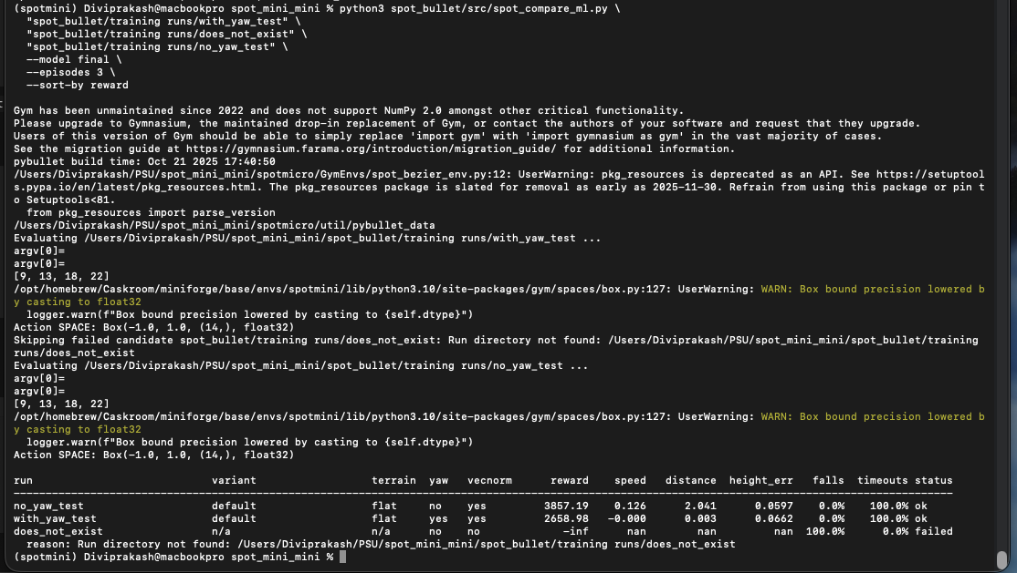

Short UI Dependency Note

Goal
Document that the local dashboard itself is also part of the platform and can fail differently depending on whether it is opened in a browser or through the local desktop launcher.

What Was Tested
- The dashboard was opened locally through the Streamlit interface.
- The platform was checked to confirm that the UI still loaded, rendered the control panels, and showed the ML camera area even when feed-selection state was not fully synchronized.

Why This Matters
This is a platform dependency case because the dashboard is one of the main user-facing control surfaces. If the UI fails to open, or if the browser/app window behaves differently on another machine, users may think the whole platform is broken even when the simulator and ML worker are still running correctly.

Prevention Implemented
- The dashboard has a dedicated launcher in spot_bullet/Sim Display/launch_dashboard.py.
- The manual controller has a separate launcher in spot_bullet/Sim Display/launch_manual_app.py.
- The ML camera area can still display the latest frame and worker status, which helps separate a UI issue from a simulator crash.
- Windows-aware process handling was added so dashboard workers shut down more safely across operating systems.

Result
The dashboard loaded successfully and remained usable as a local control surface. Even when the UI state and live-feed selection were not perfectly aligned, the platform still exposed enough status information to show that the backend worker was running instead of silently crashing.

Screenshot Evidence
- Screenshot 1: Dashboard window or browser tab showing the SpotMini control UI loaded.
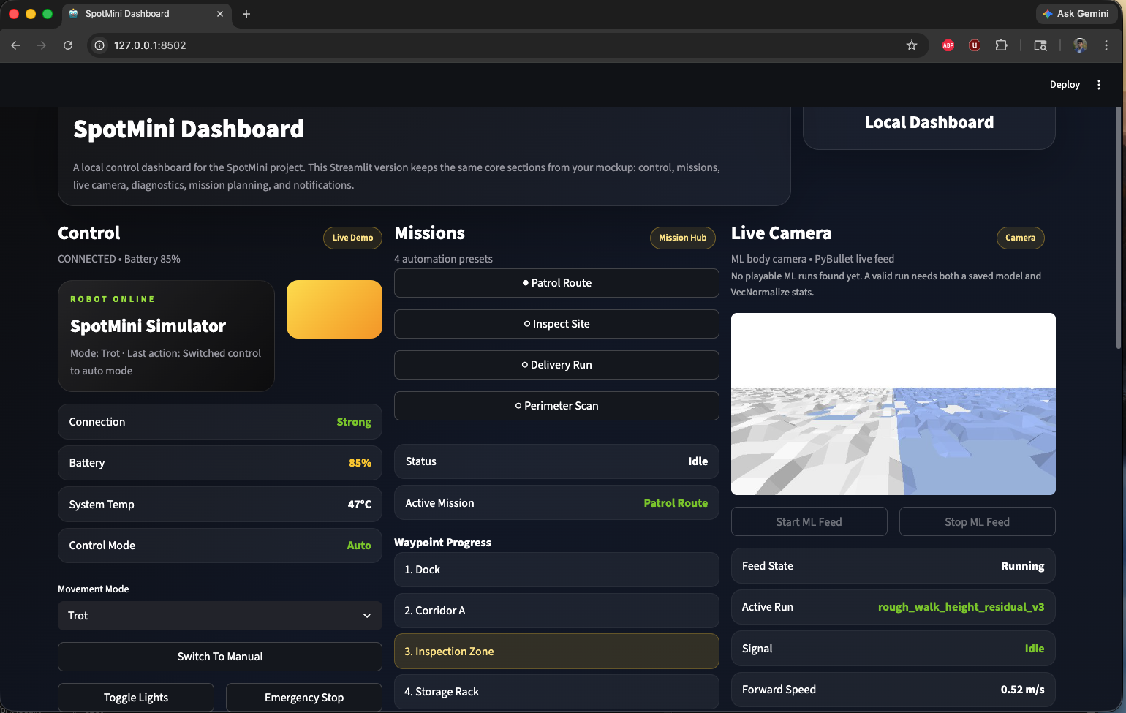

Summary Of Preventive Measures
- Native PyBullet GUI is explicitly selected with --render --bullet-gui.
- macOS fallback rendering avoids GUI dependency crashes.
- Model/environment observation mismatches now produce clear, actionable errors.
- Batch comparison continues even when one model candidate is bad.
- Existing training runs are protected from accidental overwrite.
- VecNormalize compatibility shims are used in playback and comparison so old saved normalization files still load.
- The dashboard and manual app use launcher-based process handling to improve local UI reliability across machines.

Final Notes
The most important screenshots for submission are the terminal outputs showing:
- The attack command.
- The safe failure or graceful recovery.
- The repeated attack after prevention.
- The successful normal operation after using the correct command or settings.

