The Business Model Canvas

***Iteration:***

No.

***On: 454545***

Day

Month Year

***Designed by:***

***Designed for:***

|  |  |  |  |  |  |
| --- | --- | --- | --- | --- | --- |
| *Key Partners*  The Marconi institute’s teachers | *Key Activities*  The main activity was create a working chat with detailed documentation  The main problem was make sure the client connects to the server without any errors | *Value Propositions*  We are offering to our clients a solution to improve communications between students and teachers | | *Customer Relationships*  There isn’t any customer assistance and we don’t have a plan to implement it | *Customer Segments*  We have two main type of customers, there are the teachers and the students |
|  | *Key Resources* |  | | *Channels* |  |
|  | The main resource was python, used for making the chat  client and the chat server |  | | The code will be available on campus.marconivr.it and could be released on GitHUB in a public repository in the future |  |
|  |  |  | |  |  |
|  |  |  | |  |  |
|  |  |  | |  |  |
|  |  |  | |  |  |
|  |  |  | |  |  |
| *Cost Structure* | | | *Revenue Streams* | | |
| All resources were offered by the school, there weren’t any expenses | | | All services are completely free and we don’t plan on charging in the future | | |
|  | | |  | | |

[***www.businessmodelgeneration.com***](http://www.businessmodelgeneration.com/)

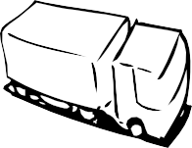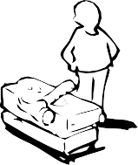

This work is licensed under the Creative Commons Attribution-Share Alike 3.0 Unported License.

To view a copy of this license, visit <http://creativecommons.org/licenses/by-sa/3.0/> or send a letter to Creative Commons, 171 Second Street, Suite 300, San Francisco, California, 94105, USA.