CHAPTER II

LITERATURE REVIEW

This chapter surveys the state of the art at the intersection of Explainable Artificial Intelligence (XAI), enterprise machine learning, multi-tenant Software-as-a-Service (SaaS) architectures, and the cold-start problem. The chapter is organized into three sections: a review of representative previous research with explicit identification of its limitations (Section 2.1), a theoretical review of the concepts and mathematical foundations on which this thesis rests (Section 2.2), and the research thinking framework that links these components into a single causal chain (Section 2.3).

2.1 Review of Previous Research
Each study is assessed not only for its individual contribution but, more importantly, for the degree to which it leaves the specific research gap addressed by the present thesis unresolved.
Table 1. Literature review of previous research.
Title | Researcher | Explanation
A Unified Approach to Interpreting Model Predictions | Lundberg & Lee (2017) | Introduced SHAP (SHapley Additive exPlanations), unifying six prior attribution methods under a single game-theoretic framework grounded in Shapley values from cooperative game theory. Demonstrated empirically that SHAP attributions are locally accurate and globally consistent on standard benchmark datasets (UCI Adult, MNIST). The study, however, evaluates SHAP exclusively on data-rich datasets and offers no analysis of how attribution fidelity behaves when the underlying model is trained on extremely small samples; consequently it does not address the degradation of explanation reliability under tenant-level data sparsity, which is the central concern of the present work.
"Why Should I Trust You?": Explaining the Predictions of Any Classifier | Ribeiro, Singh & Guestrin (2016) | Proposed LIME (Local Interpretable Model-agnostic Explanations), which fits a sparse linear surrogate to a perturbation neighbourhood of each instance to recover locally faithful feature attributions for any black-box classifier. Validated on text and image classifiers and credited with seeding the modern XAI field. The study assumes that the underlying classifier itself is competent; it neither defines nor measures the failure mode in which LIME continues to emit confident explanations on top of a model that has collapsed to random performance the hallucinated explanation phenomenon central to this thesis.
Fooling LIME and SHAP: Adversarial Attacks on Post-hoc Explanation Methods | Slack et al. (2020) | Demonstrated that adversarially-constructed classifiers can deliberately deceive both SHAP and LIME, producing innocuous-looking attributions that mask discriminatory behaviour. This was a foundational result on the fragility of post-hoc explanations. However, the failure mode considered is adversarial and intentional; the study does not investigate the non-adversarial, structurally-induced failure of these explainers when training data is naturally scarce, as occurs by design in cold-start multi-tenant SaaS environments.
Multi-Tenant SaaS Applications: Maintenance Dream or Nightmare? | Bezemer & Zaidman (2010) | Provided one of the most-cited characterizations of the multi-tenant SaaS architecture, including the trade-offs between shared-schema, schema-per-tenant and database-per-tenant isolation models from a software-maintenance perspective. The work focuses on operational, security and maintainability concerns of multi-tenancy; it does not consider the downstream consequence of tenant-level data silos for embedded ML and XAI subsystems, and therefore does not anticipate the explanatory cold-start regime that this thesis identifies.
Addressing Cold Start in Recommender Systems: A Semi-Supervised Co-Training Algorithm | Zhang, Cao & Yeung (2014) | Surveyed and proposed a hybrid semi-supervised approach to mitigate the cold-start problem in collaborative-filtering recommender systems, where new users or items lack interaction history. Defined the cold-start problem in strictly predictive terms: insufficient data to generate an accurate recommendation. The study, like the wider cold-start literature, does not distinguish between predictive cold-start and explanatory cold-start, and offers no mechanism by which a system might preserve user trust through architectural routing when explanations rather than predictions become unreliable.
Synthesis of the Research Gap.
Taken together, the surveyed literature establishes the methodological foundations of SHAP and LIME (Lundberg & Lee, 2017; Ribeiro et al., 2016), exposes their adversarial fragility (Slack et al., 2020; Rudin, 2019), characterizes the structural properties of multi-tenant SaaS
(Bezemer & Zaidman, 2010), and formalizes the predictive cold-start problem in recommender systems. Yet no identified study (i) quantifies the natural, non-adversarial degradation of XAI fidelity as a function of tenant-level training-data volume in a multi-tenant ERP context, (ii) operationally distinguishes predictive cold-start from explanatory cold-start, nor (iii) proposes an architectural routing gate that conditions the choice of explanation strategy on per-tenant data maturity. This three-fold gap defines the contribution space of the present thesis.

2.2 Theoretical Review

2.2.1 Explainable Artificial Intelligence (XAI) in Enterprise Systems
Explainable Artificial Intelligence (XAI) denotes the family of techniques, models, and architectural practices whose objective is to render the predictions of machine-learning systems intelligible to human stakeholders. In enterprise contexts, the demand for XAI is driven less by intellectual curiosity than by operational and regulatory necessity. ML-driven decisions in credit scoring, lead qualification, employee-attrition prediction and supplier risk assessment carry direct economic and legal consequences; under regulatory regimes such as the European Union's General Data Protection Regulation (GDPR, Art. 22) and the forthcoming EU Artificial Intelligence Act, affected individuals possess a qualified right to a meaningful explanation of automated decisions made about them (European Commission, 2024).
The XAI literature broadly distinguishes two paradigms. The first is the construction of intrinsically interpretable models decision lists, generalized additive models, and sparse linear models whose decision logic is directly readable from the model itself (Rudin, 2019). The second, and by a wide margin the more commercially deployed, is the use of post-hoc explainers that operate on top of a pre-trained black-box model, generating an interpretation after the fact. Rudin (2019) argues forcefully against the latter paradigm in high-stakes domains, on the grounds that a post-hoc explanation is not a description of what the model does, but rather an approximation of what the model does that is itself subject to error. The present thesis builds directly on this critique by demonstrating empirically that, under data sparsity, the approximation error of post-hoc explainers becomes large enough to invert the sign of the explanation's epistemic value: the explanation no longer reduces uncertainty about the model's behavior, it manufactures false certainty.
A second methodologically important distinction is between global and
local explanations. Global explanations characterize the average behaviour of the model across an entire dataset (for example, a global feature-importance bar chart). Local explanations characterize the behaviour of the model for a single specific instance ("for this particular invoice, the predicted late-payment probability is driven primarily by feature X"). The shift in the XAI literature over the past decade has been decisively towards local explanations (Lipton, 2018), because operational ERP decisions are made one transaction, one customer, and one employee at a time. It is precisely the local-explanation regime SHAP local attributions and LIME local surrogates that the present thesis identifies as most vulnerable to the cold-start failure mode.

2.2.2 Post-Hoc Explanation Methods: SHAP and LIME
SHAP (SHapley Additive exPlanations).
Mathematically, SHAP grounds the problem of feature attribution in cooperative game theory. Consider a model f and a prediction f(x) for a single instance x with M input features. The Shapley value _i assigned to feature i is defined as the average marginal contribution of that feature across all possible orderings in which features may be added to a coalition (Lundberg & Lee, 2017):
$$ϕ_{i}=\sum_{S⊆F∖\{i\}}{\frac{\left|S\right|!\left(M-\left|S\right|-1\right)!}{M!}\left[f_{\left(S∪\{i\}\right)\left(x_{S∪\{i\}}\right)}-f_{S\left(x_{S}\right)}\right]}$$

where F is the full set of features, S is any subset of features not containing i, and f_S(x_S) denotes the expected model output when only the features in S are known. SHAP attributions satisfy three axiomatic guarantees inherited from cooperative game theory local accuracy, missingness and consistency which together motivate its theoretical preference over earlier ad-hoc attribution methods.
Because the exhaustive Shapley summation above is exponential in the number of features, practical SHAP implementations rely on model-class-specific approximations. The most relevant to this thesis is Tree Explainer, a polynomial-time exact algorithm for tree ensembles such as gradient-boosted decision trees and random forests (Lundberg et al., 2020). SHAP attributions support both local interpretability (instance-level waterfall and force plots) and global interpretability (aggregations such as the beeswarm summary plot and mean-absolute-value bar charts).
LIME (Local Interpretable Model-agnostic Explanations).
LIME approaches the same problem from a fundamentally different direction. Rather than computing a closed-form attribution from the structure of the model itself, LIME treats f as an opaque oracle and fits an interpretable surrogate g (typically a sparse linear model) to a perturbation neighbourhood of the instance x being explained. Formally, LIME solves (Ribeiro et al., 2016):
$$ξ\left(x\right)=\arg{\min_{g∈G}{L\left(f,g,π_{x}\right)}}+Ω\left(g\right)$$
Where G is the class of interpretable surrogate models (typically sparse linear functions), _x is a proximity kernel that weights perturbed samples by their similarity to x, L is a locality-aware loss measuring how faithfully g approximates f within _x, and (g) is a complexity penalty (for example, the number of non-zero coefficients) that enforces interpretability.
The critical theoretical observation, and the one that motivates the empirical investigation of this thesis, is that both SHAP and LIME are explainers of f, not of the ground truth the modeller hoped f would learn. If f has been trained on a sample too small to recover the underlying signal as is the structural condition of cold-start tenants then SHAP will faithfully attribute f's noisy decisions, and LIME will fit a faithful linear surrogate to that same noise. Faithfulness to a degenerate model is not a virtue; it is the technical mechanism by which the hallucinated explanation is produced.

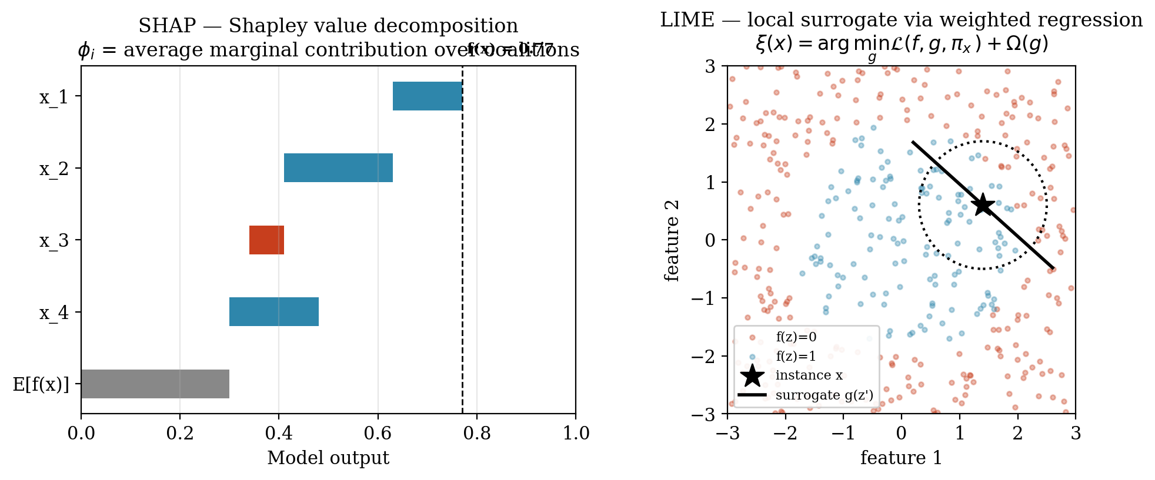
Figure 1. SHAP vs. LIME mechanism.

2.2.3 Multi-Tenant Architecture and Data Isolation
A multi-tenant application is one in which a single deployment of the software serves multiple independent customer organizations, called
tenants, while preserving the logical isolation of each tenant's data, configuration and access permissions (Bezemer & Zaidman, 2010). The literature recognizes three canonical isolation models, in order of increasing isolation strength: (i) shared schema with a discriminator column, (ii) schema-per-tenant within a single database, and (iii) database-per-tenant, in which each tenant is allocated a physically distinct database (Krebs et al., 2014).
The system studied in this thesis adopts the database-per-tenant model on PostgreSQL, orchestrated by Django 4.2 via a routed connection layer that resolves each inbound request to the appropriate tenant database. This choice maximizes data-isolation guarantees: a SQL injection or query-construction error in one tenant's context cannot, by construction, leak rows belonging to another tenant. From a security and compliance perspective the model is conservative and defensible.
From a machine-learning perspective, however, the same isolation property has a corrosive side effect. Each tenant's ML pipeline is confined to that tenant's own database, which means that the training corpus available to any per-tenant model is bounded above by the operational history of a single SME. A tenant who joined the platform three weeks ago and has issued forty invoices simply has no way to participate in a training process that requires thousands of labelled observations. The isolation that protects the SME tenant's data from its competitors also starves the ML and XAI subsystems that the platform offers to that same SME. This structural tension between data-isolation security and data-volume sufficiency is the architectural origin of the cold-start regime addressed by this thesis.

2.2.4 The Cold-Start Problem in ML versus XAI
The traditional cold-start problem, as formulated in the recommender-systems and personalization literature, is predictive: a newly-introduced user or item lacks the interaction history required for an accurate prediction to be made. The remedies developed in that literature content-based fallbacks, transfer learning, meta-learning and warm-start priors are correspondingly aimed at improving the prediction.
The present thesis introduces a conceptually distinct second variant, the explanatory cold-start. An explanatory cold-start occurs when the system possesses enough engineering machinery to emit a prediction and an accompanying SHAP or LIME explanation, but the underlying model is too poorly fit to make either the prediction or the explanation faithful representations of any real-world phenomenon. Critically, the failure modes of predictive and explanatory cold-start are not aligned: a predictive cold-start fails loudly (the prediction is wrong and is sometimes recognized as such), whereas an explanatory cold-start fails silently and confidently (a polished, axiomatically-grounded SHAP attribution is rendered for a model that has collapsed to chance performance).
This silent failure mode is what this thesis names the hallucinated explanation: an explanation that is internally faithful (to the degenerate model that produced it) and externally meaningless (with respect to the business process the model was intended to capture). The phenomenon is not a flaw of SHAP or LIME per se both methods are operating exactly as specified but rather a failure of the surrounding system to recognize that explaining a noise-fitting model is a category error. The architectural implication is that no defensible XAI deployment in a multi-tenant SaaS context can treat the explanation layer as unconditional; it must be guarded by a mechanism that detects the explanatory cold-start regime and refuses to enter it.

2.2.5 Metrics for Explanation Reliability
To convert the abstract notion of "explanation reliability" into a measurable quantity, this thesis adopts and combines several established metrics from the XAI-stability literature.
Spearman Rank Correlation (ρ).
Given two rankings of n features one produced by the explainer under evaluation and one produced by a reference data-rich baseline explainer trained on the largest available data partition the Spearman rank correlation is defined as
$$ρ = 1 -\frac{6∑dᵢ^{2}}{n\left(n^{2}- 1\right)}$$
where dᵢ is the difference between the ranks of feature i under the two rankings. A value of ρ = 1 denotes perfect rank agreement (the sparse-tenant model orders feature importances identically to the data-rich baseline); a value of ρ ≈ 0 denotes that the two rankings are uncorrelated or reversed. A conventional threshold of ρ ≥ 0.70 is used in the explanation-stability literature as the lower bound of operationally defensible ranking agreement; below this value, the explainer can no longer be regarded as recovering the same feature-importance signal as a well-trained reference.
SHAP Absolute Variance.
Defined as the variance of the per-feature mean absolute SHAP value across the feature set, this metric quantifies how concentrated the explanation mass is on a small number of features versus how evenly distributed it is across many. A high SHAP absolute variance indicates that a single feature is dominating the attribution a signature symptom of over-fitting to a spurious correlation in a small sample. A low variance indicates that explanatory weight is distributed across a plausible coalition of features, consistent with a well-regularized model. In the experimental results of this thesis, SHAP absolute variance rises from 0.0224 at the data-rich tier (n = 50,000) to 0.2017 at the n = 200 tier, a nearly nine-fold spike that empirically witnesses the over-fitting collapse of the sparse-tenant model.
Complementary metrics employed in the empirical study include SHAP entropy (an information-theoretic measure of the diffuseness of the attribution distribution), the top-k Jaccard similarity of LIME feature selections across repeated runs (a measure of explanation stability), and standard predictive metrics such as AUC-ROC. The full operational definitions are deferred to Chapter III; what matters for the theoretical framework is that, taken together, these metrics make it possible to measure, rather than merely assert, the degradation of explanation reliability as a continuous function of tenant data volume.
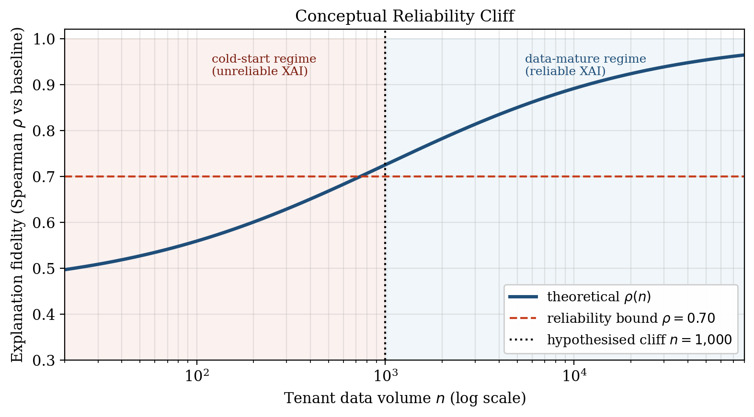
Figure 2. Conceptual Reliability Cliff

2.3 Research Thinking Framework
The conceptual architecture of this research connects the theoretical components reviewed above into a single causal chain, which simultaneously functions as the logical scaffold of the empirical study and as the blueprint for the proposed architectural solution.
The chain begins with multi-tenant data isolation. The database-per-tenant architecture adopted by the studied ERP enforces strict logical and physical separation between tenant datasets. This isolation is non-negotiable from a security and regulatory standpoint, yet it has the unavoidable consequence that the data available to each tenant's ML pipeline is bounded by that tenant's own operational history. For mature tenants this bound is large; for cold-start SMEs it is small, sometimes vanishingly so.
This produces the second link in the chain: data sparsity at the tenant level. Sparsity is not a transient anomaly but a structural property of the multi-tenant SaaS distribution, in which a long tail of small tenants persists indefinitely alongside a smaller head of data-rich enterprises.
Sparsity then propagates into the ML layer, where per-tenant models trained on small samples regress toward random performance. Under classical ML evaluation this is recognized as the predictive cold-start. However, in any deployment in which SHAP or LIME is applied unconditionally to such a degraded model, the sparsity propagates one layer further into the XAI subsystem, producing the third link in the chain: XAI degradation in the form of hallucinated explanations confident, well-formatted attributions over a model that has no genuine signal to attribute.
The fourth link is empirical measurement. Hallucinated explanations are dangerous precisely because they do not announce themselves. The framework therefore prescribes that the phenomenon be made visible through quantitative metrics: Spearman rank correlation against a data-rich baseline (fidelity), absolute SHAP variance and SHAP entropy (stability), and LIME top-k Jaccard similarity (overlap). The empirical layer of the framework operationalizes the conceptual claim that the failure of XAI under sparsity is not merely theoretically plausible but empirically measurable and, therefore, engineering-actionable.
The chain closes with the fifth link: the architectural solution. Because the failure regime can be detected ahead of time from a single observable property of the tenant its row count the framework proposes the Maturity-Aware AI Routing pattern. Tenants whose data volume falls below the empirically-identified cold-start threshold (n 1,000, as established in Chapter IV) are routed to a global, heuristic-based explanation strategy derived from the data-rich baseline; tenants at or above the threshold receive local SHAP/LIME explanations. The routing decision is made at the architectural layer, before any explanation is generated, and is therefore guaranteed to prevent the rendering of a hallucinated explanation regardless of downstream UI behaviour.
The framework is deliberately constructed so that each conceptual link is, in the chapters that follow, either operationalized as a methodological procedure (Chapter III), instantiated as an experimental artefact (Chapter IV), or implemented as a software component within that same chapter's reference implementation. The theoretical crux that the framework formalizes and that the remainder of the thesis empirically defends is the strict separation between predictive accuracy and explanatory fidelity, and the architectural consequence that, in multi-tenant SaaS ERPs, the latter requires its own dedicated reliability gate.

