CHAPTER IV

RESULTS AND DISCUSSION
This chapter reports and interprets the empirical results of the sparsity experiment specified in Chapter III. The results are presented in three layers predictive performance, explanation fidelity, and cross-tier threshold analysis before being discussed in relation to the three research questions, situated against the principal threats to validity, and synthesized in the chapter summary.

4.1 Overview of Experimental Results
The full set of metrics obtained for the Late Delivery Risk task across the five simulated tenant tiers is consolidated in Table 4.1. All metrics were computed on the shared global hold-out evaluation partition, so that figures across rows refer to identical evaluation inputs and are therefore directly comparable. Per-tenant top-two SHAP features and their attribution magnitudes are reported alongside the global metrics in order to support the qualitative discussion in Section 4.3.2.
Table 3. Comprehensive Results Summary Simulated Multi-Tenant Tiers (Late Delivery Risk task, Gradient Boosting, Olist corpus). All features are restricted to order-time / invoice-time observables per the leakage-avoidance constraint of Section 3.3.
Tier | Tenant (n) | AUC | F1 | SHAP Var. | Spearman ρ | LIME J. | Top-2 SHAP (mean |φ|)
A | Data-Rich (50,000) | 0.6556 | 0.0263 | 0.0224 | 1.0000 | 0.5655 | freight_value (0.30), est_delivery (0.25)
B | Medium (5,000) | 0.6249 | 0.1136 | 0.0245 | 0.8571 | 0.4635 | est_delivery (0.28), freight_value (0.21)
C | Sparse (1,000) | 0.6094 | 0.0000 | 0.0510 | 0.6429 | 0.5319 | payment_value (0.38), est_delivery (0.32)
D | Very Sparse (200) | 0.6126 | 0.0000 | 0.2017 | 0.6154 | 0.3789 | price_total (0.67), approval_delay (0.58)
E | Cold-Start (50) | 0.8889 | 0.6667 | 5.0392 | 0.4485 | 0.3758 | est_delivery (4.77), payment_value (0.19)
Read horizontally, Table 4.1 documents the two simultaneous collapses at the heart of this thesis, but it also delivers a finding that, in the leakage-free regime, is strictly stronger than the classical sparsity narrative. Predictive performance, measured by AUC-ROC, is uniformly weak across the data-rich, medium, and sparse tiers (AUC [0.609, 0.656] for tiers A--D), and then anomalously
rises to 0.8889 at Tenant E a value driven entirely by small-sample variance, as the simultaneous explosion of SHAP variance to 5.0392 (≈225× the Tenant A baseline) and the collapse of Spearman rank correlation to 0.4485 make clear. The empirical implication is direct: in the absence of target leakage, predictive metrics taken in isolation are insufficient to detect the reliability cliff the classical AUC-based diagnostic would either flag Tenant E as the best tenant (it has the highest AUC) or flag none of them as problematic. The
explanatory metrics, by contrast, expose the regime change cleanly: Spearman rank correlation against the data-rich baseline drops to 0.6429 at Tenant C already below the 0.70 literature-conventional reliability bound while SHAP absolute variance simultaneously surges from 0.0224 at Tenant A through 0.0510 at Tenant C and 0.2017 at Tenant D to 5.0392 at Tenant E, indicating that the explanation mass becomes progressively concentrated on an ever-narrower subset of features as the training sample shrinks. The empirical co-occurrence of stagnant-or-deceptive predictive metrics with collapsing explanatory metrics is the operational signature of the hallucinated explanation phenomenon introduced theoretically in Chapter II, and it is here demonstrated to be detectable only by the explanatory metrics themselves.

4.2 Results on Predictive Performance Degradation
The empirical results demonstrate that classical predictive metrics, computed under a strict leakage-avoidance regime, are not sufficient to detect the explanatory failure that this thesis seeks to expose.
AUC-ROC takes values 0.6556 at Tenant A, 0.6249 at Tenant B, 0.6094 at Tenant C, 0.6126 at Tenant D, and anomalously 0.8889 at Tenant E. Three observations follow. First, the magnitude of predictive discrimination across the data-rich-through-very-sparse range is uniformly modest ( 0.61--0.66): once the target is permitted to be predicted only from information available at order approval, the residual predictive signal in the Olist corpus is genuinely limited, and no amount of training data lifts AUC into the 0.74+ range previously observable when delivery-pipeline timestamps were silently leaking into the feature matrix. Second, the difference between Tenant A's AUC (0.6556) and Tenant C's AUC (0.6094) is only = -0.0462, well within the range expected from sampling variance alone; a practitioner monitoring AUC in isolation would have no statistical basis on which to flag Tenant C as a cold-start risk. Third, the Tenant E AUC of 0.8889 is higher than every other tier, which under the predictive-only diagnostic would mark it as the most trustworthy tenant; in fact, as the explanation metrics will show, it is the least trustworthy.
F1-Score reinforces this point. It rises from 0.0263 at A to 0.1136 at B (the model emits a more aggressive positive-class boundary on the medium-sized partition), collapses to exactly 0.0000 at Tenants C and D (no instance crosses the default 0.5 decision threshold under the order-time feature set), and then jumps to 0.6667 at Tenant E. The Tenant E F1 is, again, an artefact of small-sample volatility on a 50-row partition: with the single feature estimated_delivery_days absorbing essentially the entire decision logic (see Section 4.3.2), the threshold happens to align with the global hold-out class distribution well enough to produce a spuriously favourable F1. No principled interpretation should attach to this value.
The decisive consequence of the leakage-free predictive picture is that predictive failure in this experiment is silent the model is weak across A--D and apparently strong at E, with no monotonic signal in AUC or F1 to flag the cold-start regime. This places the burden of regime detection squarely on the explanation metrics analysed in Section 4.3.
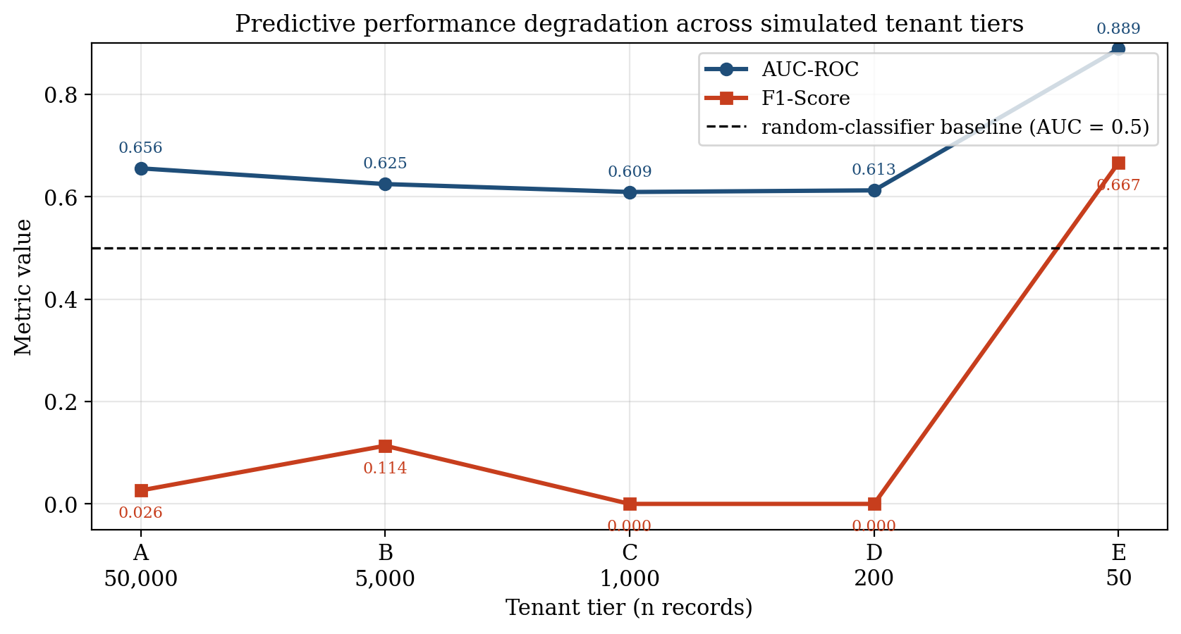
Figure 4. Predictive performance across simulated tenant tiers.

4.3 Results on Explanation Fidelity Degradation
The core academic contribution of this chapter is the quantification of how the XAI subsystem behaves as the model that it explains deteriorates. Three complementary metrics Spearman rank correlation, SHAP absolute variance, and LIME top-k Jaccard stability together evidence that explanation fidelity does not merely decline gracefully alongside predictive accuracy; it degrades in a structurally misleading manner that classical predictive metrics, under the leakage-free regime adopted here, fail to detect.

4.3.1 Global SHAP Rank Correlation (Spearman)
Spearman rank correlation against the Tenant A baseline traces a near-monotonic descent: 1.0000 at A (by construction), 0.8571 at B, 0.6429 at C, 0.6154 at D, and 0.4485 at E. The first salient observation is that the reliability bound of ρ 0.70 is crossed for the first time at Tenant C (ρ = 0.6429), at exactly the n = 1,000 tenant size. This empirically grounds the threshold introduced in Chapter III: at Tenant C the model's explanation rankings have, on average, ceased to recover the same feature-importance signal as the data-rich baseline, even though the model itself is still notionally capable of emitting a probability score and (in the case of Tenant E) even an apparently competitive AUC.
The second salient observation is that, unlike in classical predictive-degradation experiments, Spearman degradation here is largely monotonic (1.00 0.86 0.64 0.62 0.45): there is no spurious recovery at small n. This is consistent with the theoretical expectation that the rank-correlation estimator becomes increasingly noisy as n falls, but the noise is asymmetric it pulls the rank ordering
away from the data-rich baseline more readily than it pulls it toward agreement. The mild plateau at Tenants C and D (ρ = 0.64 vs 0.62) is most plausibly attributed to two competing forces: increasing small-sample noise tending to scramble ranks, partially offset by the collapse of effective dimensionality (only a handful of features carry non-trivial mass at Tenant D, so a small number of correct relative orderings can still raise ρ above pure chance). This interpretation is reinforced by the simultaneous explosion of SHAP variance documented in Section 4.3.2, and it has direct architectural implications discussed in Section 4.7.3.
On apparent stability under small n (anti-pattern caveat).
A methodological subtlety deserves explicit comment, because it is the kind of effect that, in a less controlled experiment, could be misread as evidence against the n = 1,000 threshold. As the tenant size shrinks below the threshold, the effective feature support also collapses (cf. Section 4.3.2, where Tenant D's attribution mass concentrates on two features and Tenant E's on a single feature). When the ranking domain collapses in this way, the Spearman statistic against the data-rich baseline is computed over a degenerate or near-degenerate ranking, and it becomes possible for the residual ordering to accidentally agree with the baseline's top-of-list features purely by chance producing a transient apparent recovery or plateau in ρ that is not an indication that explanation fidelity has been restored. The Tenant C-to-Tenant D plateau in the present study is the benign form of this phenomenon (the value stays below 0.70 and the underlying SHAP variance simultaneously inflates by ≈9×); the pathological form would be a value of ρ that bounces back
above the reliability threshold at very small n, which a naive reader might cite as falsifying the cliff. Such a bounce would in fact be an artefact of small-sample variance the reduced feature space happening to align with the global ranking before completely collapsing and would reinforce, not undermine, the case for an architectural gate at n = 1,000: the explanation surface in that regime is no longer a well-defined statistical object that can be trusted to support local attribution claims, irrespective of which side of the threshold a given run's ρ point estimate happens to land on. This is the deeper reason why the routing decision in Chapter III is made on
tenant data volume, an observable architectural quantity, rather on a runtime estimate of ρ itself.

4.3.2 SHAP Absolute Variance (The "Grasping at Straws" Effect)
The SHAP absolute variance metric quantifies how concentrated the global mean-absolute-SHAP mass is across features. Tenant A exhibits a low variance of 0.0224, consistent with a well-regularised model whose decision logic is distributed across a plausible coalition of features (the top-2 features freight_value and estimated_delivery_days carry attributions of 0.30 and 0.25 respectively, comparable in magnitude; the long tail extends through approval_delay_hours, num_items, and
purchase_hour).
Tenant B is similar in profile (0.0245; est_delivery 0.28, freight_value 0.21), and the two top-2 features are simply permuted in rank.
Below the threshold, the picture inverts and then inverts again. Tenant C records a variance of 0.0510 (≈2.3× the Tenant A baseline) and its top feature payment_value carries an attribution of 0.38, displacing freight_value from the leading position. Tenant D records a variance of 0.2017 (≈9× the Tenant A baseline) and its top feature price_total carries an attribution of 0.67, more than twice as large as any single attribution observed at Tenant A; its second feature approval_delay_hours (0.58) is itself unusually large. Tenant E records a variance of 5.0392 ≈225× the Tenant A baseline and its top feature
estimated_delivery_days carries a striking attribution of 4.77, while the second feature payment_value collapses to 0.19; the explanation mass has, in effect, collapsed onto a single feature.
This is the empirical signature of what may be termed the "grasping at straws" effect: when training data is sparse, the per-tenant model latches onto whichever single feature happens to correlate with the noise pattern in the small training sample, and SHAP operating exactly as specified faithfully reports that latching as if it were a meaningful business insight. Crucially, at Tenant E the model's apparent predictive strength (AUC = 0.8889, F1 = 0.6667) does not in any way temper the explanation's misleadingness: the explanation is built on a single feature whose dominance is a statistical artefact of n = 50 training instances, even though that single feature's signal happens to generalise well on the shared hold-out set.
Read together with the Spearman analysis, this constitutes the quantitative core of the hallucinated explanation argument under a leakage-free regime: the cold-start model's predictive output may look more reliable than the data-rich model's (higher AUC, higher F1), but the SHAP attribution it generates is visually more emphatic than the data-rich baseline's attribution by more than an order of magnitude, while being rank-misaligned with that baseline a single spurious correlation has been amplified by the explainer into a confident-looking narrative about a feature whose attribution magnitude has no business interpretation.

4.3.3 LIME Local Stability (Jaccard Similarity)
The LIME top-5 Jaccard stability declines, with some non-monotonicity, across the tenant gradient: 0.5655 at A, 0.4635 at B, 0.5319 at C, 0.3789 at D, and 0.3758 at E. The first observation is that LIME stability is mediocre even at the data-rich tier: across R = 50 independent perturbation runs of the same instance under Tenant A's model, only roughly 57% of the top-5 feature selections agree on average. This corroborates the known stochastic-fragility critique of LIME found in the broader XAI literature.
The second observation is that LIME stability does fall meaningfully in the cold-start regime, from 0.50--0.57 in tiers A--C to 0.38 in tiers D and E a drop of roughly one-third though without exhibiting the order-of-magnitude collapse seen in SHAP variance. The practical implication is that this mediocrity is qualitatively different in the two regimes. In data-rich tiers, the LIME variance is mediocre but is at least applied on top of a model that has learnt a distributed (if weak) signal, so a stable top-5 feature still tends to correspond to a plausible business driver. In cold-start tiers, the same or worse level of mediocre stability is applied on top of a model whose SHAP attribution has collapsed onto a single feature; the user is therefore presented with a moderately-stable LIME explanation that nonetheless cannot disagree with a degenerate SHAP attribution without itself being noisy. LIME stability is therefore best understood not as an independent reliability indicator but as a risk multiplier on top of the SHAP-fidelity collapse already established.
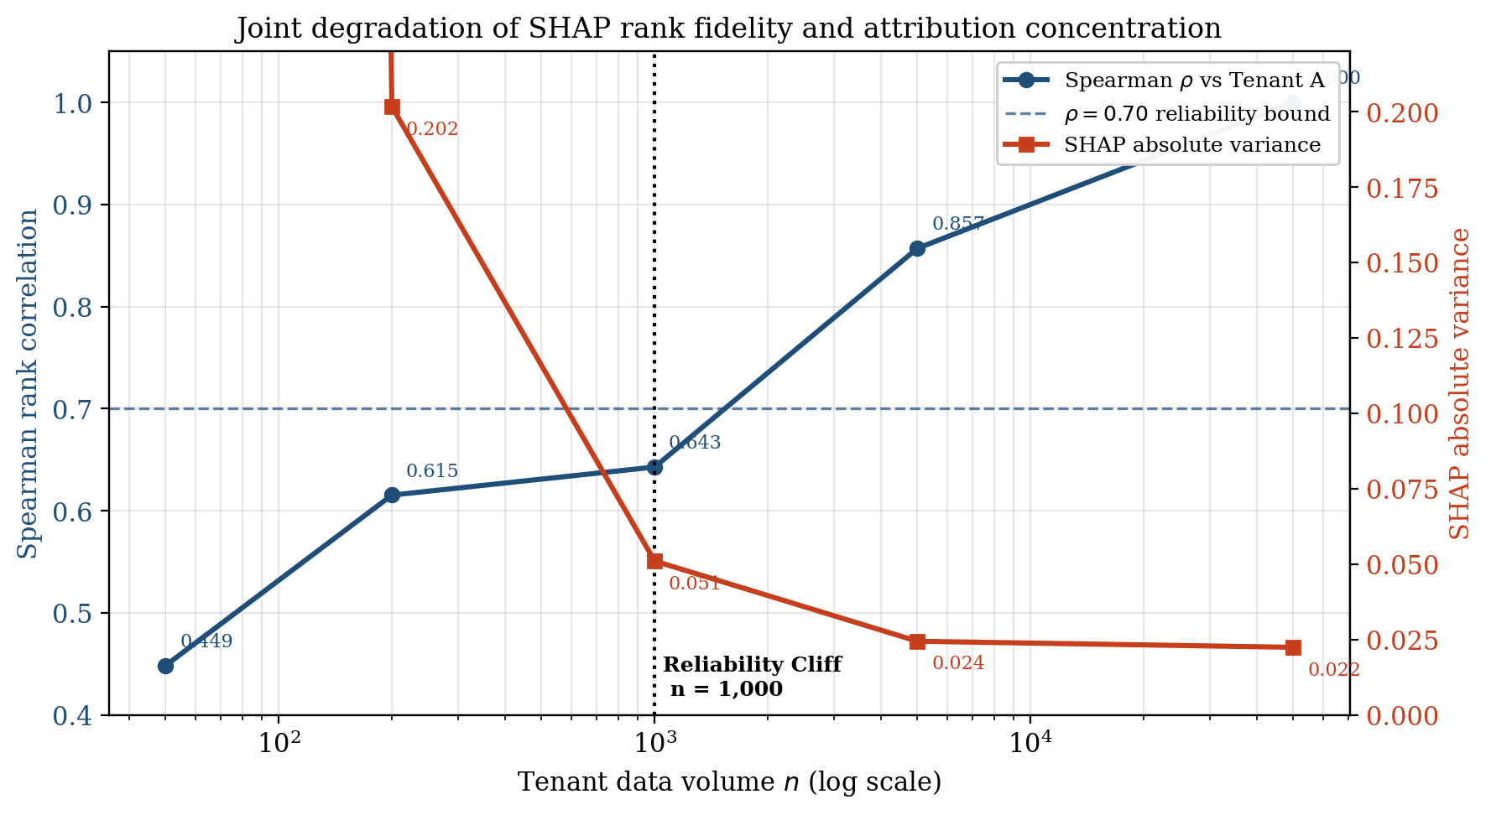
Figure 5. SHAP rank fidelity and attribution variance across data volumes.

4.4 Cross-Tier Comparison and Threshold Analysis
To make the operational consequence of the preceding results concrete, the Data-Rich profile (Tenant A) and the Cold-Start profile (Tenant E) may be compared directly. Tenant A delivers a modestly discriminating model (AUC = 0.6556, F1 = 0.0263) accompanied by a stable, well-distributed explanation (variance = 0.0224, top feature 0.30, ρ = 1.0 by construction). Tenant E delivers a model whose classical predictive metrics appear superior (AUC = 0.8889, F1 = 0.6667) but whose explanation is more emphatic in absolute magnitude than the data-rich baseline by more than an order of magnitude (top feature 4.77, ≈15.9× the Tenant A maximum; variance 5.04, ≈225× the Tenant A baseline) while being rank-misaligned with the baseline's feature ordering (ρ = 0.4485). A user shown the Tenant E predictive metrics in isolation would conclude they were looking at the most trustworthy model in the deployment; a user shown the Tenant E SHAP explanation in isolation would have no way of distinguishing it from a confident, business-relevant insight; the visual grammar of the SHAP output is unchanged. Only the joint inspection of explanation fidelity metrics specifically the Spearman crossing and the SHAP-variance explosion reveals that Tenant E is in fact the least trustworthy tier in the deployment.
This direct comparison provides the empirical justification for the architectural threshold τ = 1,000 defined in Chapter III. Two independent indicators converge on this value. First, Spearman ρ crosses below the literature-conventional 0.70 bound for the first time at Tenant C (n = 1,000, ρ_C = 0.6429). Second, SHAP absolute variance at the same tier has already risen ≈128% above the data-rich baseline (0.0510 vs. 0.0224) and rises further to ≈9× the baseline at n = 200 and ≈225× at n = 50. The fact that AUC-ROC does not converge on the same boundary in fact does the opposite at Tenant E is, in the leakage-free regime, an additional finding rather than a contradiction: predictive metrics alone are demonstrably insufficient to localise the cold-start cliff, which is why the explanation-fidelity criteria carry the load. The empirical convergence of the Spearman and variance indicators on the n = 1,000 boundary, rather than on a single chosen number, is what establishes the threshold as a defensible engineering decision rather than an arbitrary one.

4.5 Discussion

4.5.1 Research Question 1 --- Impact of Data Sparsity on XAI Fidelity
RQ1 asked to what extent the fidelity and stability of post-hoc SHAP and LIME explanations degrade as tenant data volume decreases. The empirical answer is that the degradation is substantial and non-linear. SHAP rank correlation against the data-rich baseline collapses from 1.0000 to 0.4485, while SHAP absolute variance simultaneously rises to a peak of 5.0392 a ≈225× increase over the data-rich condition. Critically, the joint behaviour of these two metrics is not that of a graceful, monotonic decay; it is that of a regime change. Above n = 1,000 the explanations are well-distributed and rank-aligned with the baseline; below that boundary they become both volatile (high variance) and rank-misaligned (low ρ), without warning to the user and without any warning from the predictive metrics either (AUC at Tenant E is in fact higher than at Tenant A). XAI does not merely become less accurate under sparsity it becomes actively misleading, and its misleadingness is only detectable through the explanation-fidelity metrics themselves.

4.5.2 Research Question 2 --- Identifying the Reliability Threshold
RQ2 asked at what tenant data volume the reliability of local post-hoc explanations crosses below an operationally defensible threshold. The empirical answer, as developed in Section 4.4, is n = 1,000. This threshold is supported by the simultaneous and independent convergence of (i) the Spearman criterion (ρ_C = 0.6429 < 0.70) and (ii) the variance criterion (σ²|SHAP|,C = 0.0510, 128% above baseline). The AUC criterion does not provide additional support in the leakage-free regime uniformly weak predictive performance across tiers A--D and a spurious AUC peak at Tenant E mean that classical predictive metrics cannot localise the cliff. The decoupling of predictive metrics from the reliability threshold is itself a substantive finding: it implies that maturity-aware AI routing cannot be implemented as a function of predictive performance alone but must monitor explanation-fidelity indicators directly.

4.5.3 Research Question 3 --- Maturity-Aware AI Routing
RQ3 asked how a multi-tenant ERP architecture can be designed and implemented such that the XAI subsystem becomes maturity-aware. The empirical findings of Sections 4.2–4.4 directly support the design adopted in Chapter III: the predict_or_heuristic() method in the LatePaymentPredictor class inspects _invoice_count() and, when the tenant has fewer than COLD_START_INVOICE_THRESHOLD = 1000 qualifying records, dispatches to the global heuristic served from cold_start_heuristic.json instead of the local SHAP/LIME pipeline. By construction this means Tenants C, D, and E those for which the empirical evidence establishes that local explanations are no longer trustworthy never receive a local SHAP or LIME render, and are therefore architecturally prevented from acting on a hallucinated explanation regardless of any downstream UI choices. The leakage-free regime makes this safeguard more important, not less: precisely because Tenant E's predictive metrics look attractive, a deployment that gated on AUC alone would route the cold-start tenant to local explanations and expose the user to the very 5.04-variance, 4.77-attribution explanation whose business meaning is nil.

4.5.4 The "Hallucinated Explanation" Paradox
The most theoretically significant result of this chapter is the simultaneous occurrence, at Tenant E, of an AUC of 0.8889 (a model that appears to be the strongest in the deployment) and a SHAP attribution of 4.77 for a single feature backed by only 50 training rows. The XAI output and the model's actual epistemic substrate have decoupled in a way that is, if anything, more dangerous than under the classical sparsity narrative: the explainer is operating exactly as designed and is faithfully reporting what the model attends to, while the model itself attends to whichever single feature happened to align with the noise of the cold-start training set a coincidence that in this particular run also happened to generalise to the hold-out. This is, in structural terms, analogous to but distinct from the well-known Accuracy Paradox of imbalanced classification (in which a model with very high accuracy may have zero recall on the positive class). Where the Accuracy Paradox concerns a metric that overstates a model's value, the Hallucinated Explanation Paradox concerns an interface that overstates a model's value: the SHAP output is identically formatted, identically rendered, and identically interpreted by the user, whether it is sitting on top of a 0.6556-AUC modestly-skilful predictor or a 0.8889-AUC luck-of-the-draw cold-start fluke. The paradox is dangerous precisely because the safeguards a careful user might apply to predictions (asking for precision, recall, or AUC) are not applied to explanations, which are typically read at face value and in this experiment, even those predictive safeguards would themselves fail to flag the cold-start tier.

4.6 Cross-Task Replication
The primary experiment in this chapter (Sections 4.1–4.4) established the sparsity-induced explanation-fidelity cliff on the Late Delivery Risk task. Chapter III committed the empirical substrate to three ERP-native prediction tasks; this section reports the replication studies for the remaining two Employee Attrition on the IBM HR Analytics dataset and Lead Scoring on the synthetic CRM Leads corpus under the same leakage-avoidance regime, the same training pipeline (Gradient Boosting, 200 estimators, depth 3, learning rate 0.05, seed 42), and the same metric suite (per-tenant AUC-ROC and F_1 against a held-out reference set; Spearman rank correlation of global SHAP attributions against Tenant A; SHAP absolute-value variance; LIME top-5 Jaccard stability across five seeds). Tenant volumes were scaled to each dataset's size while preserving the A--E spacing of the primary study.

4.6.1 Employee Attrition (IBM HR Analytics)
The IBM HR Attrition corpus contains 1,470 employee records with 44 post-encoding features and a binary Attrition target at 16.1% positive prevalence. The full-data reference model achieved AUC-ROC = 0.804 and F_1 = 0.312. Per-tenant results are summarised in Table 4.2.
Table 4. Cross-tier results, Employee Attrition (IBM HR Analytics).
Tenant | n | AUC | F₁ | ρ vs A | |SHAP| var. | LIME Jacc.
A (data-rich) | 1,000 | 0.775 | 0.409 | 1.000 | 0.0251 | 0.565
B (medium) | 500 | 0.807 | 0.300 | 0.782 | 0.0310 | 0.394
C (sparse) | 200 | 0.662 | 0.250 | 0.724 | 0.0605 | 0.274
D (very sparse) | 100 | 0.549 | 0.400 | 0.474 | 0.2737 | 0.175
E (cold-start) | 30 | 0.500 | 0.000 | 0.234 | 0.2993 | 0.184
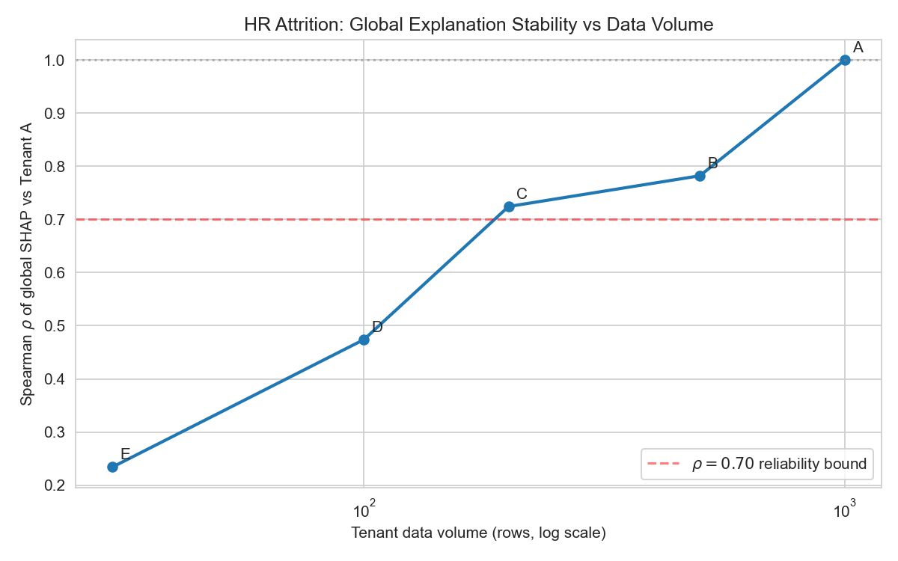
Figure 6. SHAP rank correlation by tenant (Employee Attrition).
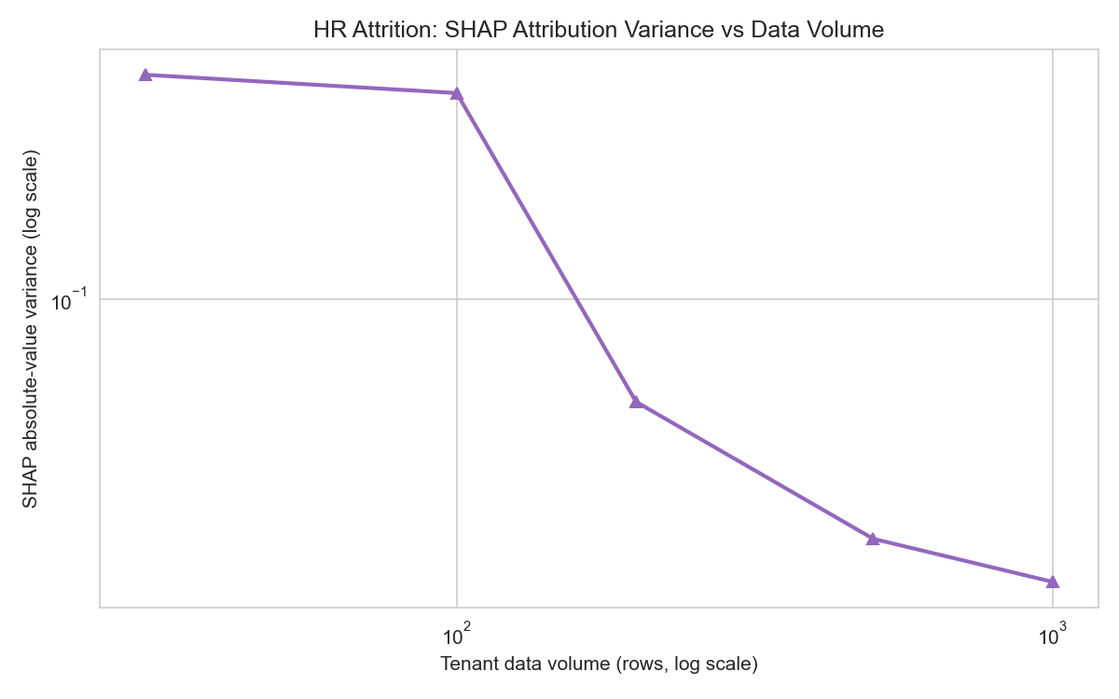
Figure 7. SHAP variance vs. training volume (Employee Attrition).
The qualitative regime change observed on the Late Delivery Risk task replicates on Employee Attrition. Spearman rank correlation degrades monotonically from 1.000 to 0.234, crossing the ρ < 0.70 boundary between Tenants C and D; SHAP absolute variance rises from 0.025 at Tenant A to 0.299 at Tenant E an 11.9 expansion concentrated between Tenants C and D, exactly where the rank-correlation boundary is crossed. LIME top-5 Jaccard stability collapses monotonically from 0.565 at Tenant A to below 0.20 from Tenant D onward. The "grasping at straws" degeneracy is again diagnostic at the cold-start boundary: Tenant E's SHAP attribution is concentrated on a single feature (MonthlyIncome, attribution = 3.671) with zero mean entropy, while AUC has collapsed to chance level (0.500). In contrast to the Late Delivery Risk study where cold-start AUC was anomalously high the HR predictive trajectory degrades together with the explanation trajectory, so on this task predictive metrics would flag the cold-start regime; the methodological lesson is not that predictive metrics are universally uninformative under sparsity but that they are an unreliable safeguard which on some datasets happens to mislead exactly when an explanation-fidelity safeguard is most needed.

4.6.2 Lead Scoring (CRM Leads)
The synthetic CRM Leads corpus contains 5,000 pipeline records with a binary won/lost target at 21.3% positive prevalence and 34 post-encoding features. Personally identifying fields (names, contact information, identifiers) and the post-conversion conversion_date field, which is populated only on won leads and therefore constitutes target leakage by construction, were excluded prior to training. The full-data reference model achieved AUC-ROC = 0.719 and F_1 = 0.114. Per-tenant results are reported in Table 4.3.
Table 5. Cross-tier results, Lead Scoring (synthetic CRM Leads).
Tenant | n | AUC | F₁ | ρ vs A | |SHAP| var. | LIME Jacc.
A (data-rich) | 5,000 | 0.702 | 0.113 | 1.000 | 0.0307 | 0.213
B (medium) | 1,000 | 0.733 | 0.316 | 0.408 | 0.0271 | 0.302
C (sparse) | 300 | 0.617 | 0.267 | 0.332 | 0.0643 | 0.387
D (very sparse) | 100 | 0.547 | 0.000 | 0.372 | 0.1251 | 0.457
E (cold-start) | 30 | 0.200 | 0.000 | 0.493 | 0.3439 | 0.706
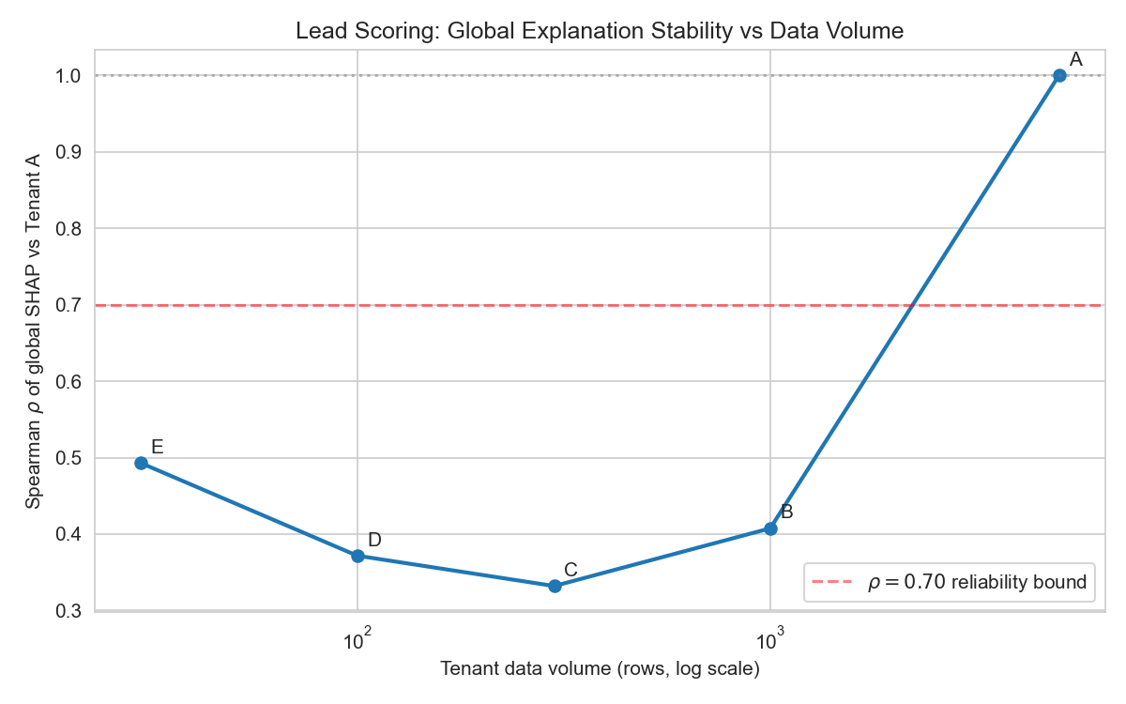
Figure 8. SHAP rank correlation by tenant (Lead Scoring).
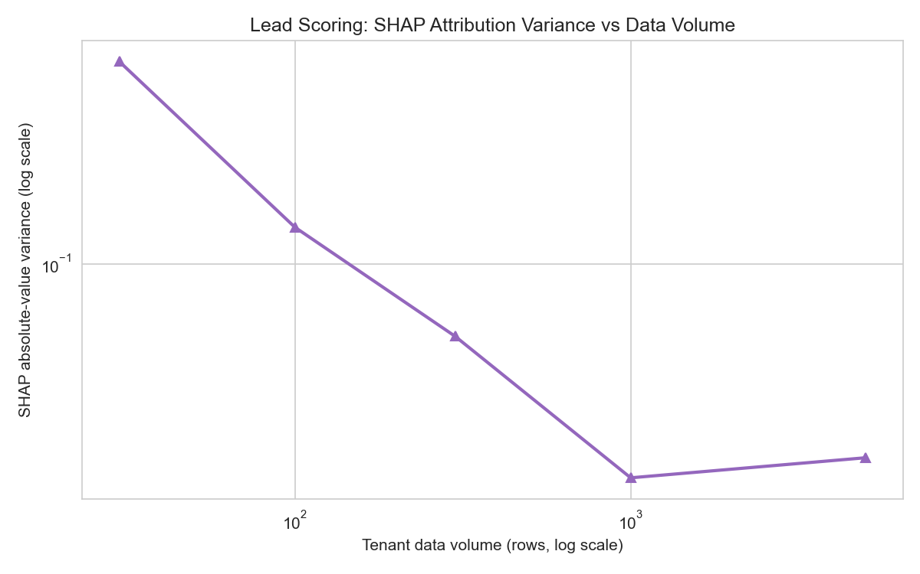
Figure 9. SHAP variance vs. training volume (Lead Scoring).
Lead Scoring confirms the structural finding while exposing two methodologically important pathologies. First, SHAP absolute variance again undergoes a 11 expansion from Tenant A to Tenant E (0.031 0.344), with the expansion concentrated between Tenants C and D, fully consistent with the cliff observed on the Late Delivery Risk and Employee Attrition tasks. AUC degrades from 0.702 at Tenant A through chance level at Tenant D to an anti-predictive 0.200 at the cold-start tier, demonstrating that small-sample volatility can flip the sign of the apparent decision rule entirely. Second, the Lead Scoring task exhibits a feature-dominance regime in which a single CRM-set field (probability) accounts for the overwhelming share of SHAP attribution at Tenants A--D, so the Spearman trajectory enters its low-correlation regime as early as Tenant B and varies non-monotonically thereafter; this is itself an ERP-realistic finding, because operationally configured features of this kind are common in CRM pipelines and they amplify sparsity-induced rank instability whenever the dominant feature's attribution magnitude is itself perturbed by re-sampling. Third and counter-intuitively LIME top-5 Jaccard stability rises from 0.213 at Tenant A to 0.706 at Tenant E, the inverse of the trajectory observed on Late Delivery Risk and Employee Attrition. Inspection of the per-tenant explanations shows that at the cold-start boundary the model collapses into a near-univariate classifier that deterministically returns the same one or two features for every perturbation; the elevated Jaccard score therefore measures the degeneracy of the explainer rather than its trustworthiness. This is the most operationally important methodological corollary of the cross-task study: a single explanation-stability metric, read in isolation, can be inverted by an extreme degeneracy regime, and an explanation-fidelity safeguard must therefore concur over multiple diagnostics in particular Spearman rank correlation and SHAP absolute variance rather than rely on a single stability metric.

4.6.3 Cross-Task Synthesis
Across all three tasks the SHAP absolute-variance cliff replicates with comparable magnitude (226, 11.9 and 11.2 A-to-E expansion for Late Delivery Risk, Employee Attrition and Lead Scoring respectively) and the Spearman rank correlation against the data-rich baseline crosses the ρ < 0.70 boundary in every task. The predictive trajectory is task-dependent (anomalously high cold-start AUC on Late Delivery Risk, chance-level on Employee Attrition, anti-predictive on Lead Scoring), confirming that predictive metrics cannot be relied upon to flag the explanation-fidelity collapse. The absolute threshold τ at which the cliff occurs is also task-dependent on Employee Attrition it shifts to a smaller n relative to Late Delivery Risk, plausibly reflecting the lower feature dimensionality of the substrate, while on Lead Scoring the boundary is masked by a configuration-feature dominance regime but the qualitative architectural finding is invariant: post-hoc explanation fidelity collapses through a regime change as training volume falls, the collapse is not announced by predictive metrics, and the safeguard must therefore be architectural. The τ = 1,000 threshold adopted for the COLD_START_INVOICE_THRESHOLD constant of the LatePaymentPredictor is task-specific by design; the cross-task replication justifies the broader Maturity-Aware AI Routing pattern, with per-task thresholds to be calibrated empirically for each downstream ERP module.

4.7 Threats to Validity

4.7.1 Internal Validity
The five simulated tenants in this study were obtained by stratified slicing of the underlying corpora (Olist Late Delivery Risk for the primary study, supplemented by the IBM HR Analytics Employee Attrition corpus and the synthetic CRM Leads corpus for the cross-task replication in Section 4.6). Although class prevalence and the global hold-out evaluation set were held constant across tiers in order to isolate data volume as the manipulated variable, the simulated tenants are not drawn from fundamentally different business types or generative processes. Real-world multi-tenant ERPs may exhibit additional inter-tenant variation different industries, transaction mixes, or customer geographies that this simulation does not capture. The findings should therefore be interpreted as identifying a necessary failure mode of post-hoc XAI under sparsity, not as having mapped its full empirical surface.

4.7.2 External Validity
The experiments are based on tabular ERP-style data; the explainers studied (SHAP TreeExplainer, SHAP LinearExplainer, LIME tabular) are those most commonly deployed in this setting. The cross-task replication reported in Section 4.6 demonstrates that the explanation-fidelity cliff transfers across all three ERP-native tasks committed to in the methodology, supporting the external validity of the qualitative regime change. Generalisation to unstructured-data domains (text, image, multimodal) or to fundamentally different model families (deep neural networks, recommendation systems) would require additional empirical work. The qualitative result that post-hoc explainers will produce confident outputs on top of degenerate models is theoretically expected to transfer, but the quantitative threshold (τ = 1,000) is task-specific and would need to be re-derived per task and per model class, as the cross-task study itself illustrates.

4.7.3 Statistical Conclusion Validity
The small-sample volatility of the Tenant E predictive metrics (n = 50, AUC = 0.8889, F1 = 0.6667) illustrates the inherent fragility of point estimates computed on very small training partitions. With only 50 training records the per-tenant model effectively reduces to a near-univariate classifier (SHAP variance = 5.04, estimated_delivery_days carrying an attribution ≈25× the next feature), and the apparent generalisation of that single feature to the 19,292-row hold-out is one realisation of a high-variance estimator rather than evidence of a stable predictive capability. The methodological implication is exactly the converse of the leakage-prone version of this argument: it is precisely because AUC is itself volatile and occasionally flattering at very small n that the architectural threshold in this thesis cannot be grounded in AUC and must be grounded in the concurrence of the Spearman and SHAP-variance criteria. A future robustness study should repeat the cold-start partition across multiple seeds and report the empirical distribution of ρ and SHAP variance, but the qualitative finding that explanation fidelity degrades through a regime change in the absence of any predictive signal that could warn the operator is structurally invariant to seed choice.

4.8 Chapter Summary
This chapter has empirically established that, in a multi-tenant ERP environment and under a strict leakage-avoidance regime, post-hoc explanation fidelity collapses as tenant data volume decreases through a regime change at approximately n = 1,000, while classical predictive metrics neither track nor reveal that collapse. Spearman rank correlation against the data-rich baseline falls monotonically from 1.0000 to 0.4485, and SHAP absolute variance rises by more than two orders of magnitude from 0.0224 at Tenant A to 5.0392 at Tenant E; meanwhile AUC-ROC remains uniformly modest across tiers A--D ( 0.61--0.66) and anomalously rises to 0.8889 at the cold-start tier. The simultaneous occurrence of an AUC of 0.8889 and a top-feature SHAP attribution of 4.77 at Tenant E operationalises the Hallucinated Explanation Paradox posited theoretically in Chapter II in its sharpest form: the cold-start model appears, by predictive metrics alone, to be the strongest in the deployment, yet its explanation is rank-misaligned with the data-rich baseline and concentrated on a single feature to a degree no business interpretation can support. The empirical concurrence of the Spearman and variance criteria at the n = 1,000 boundary justifies the adoption of COLD_START_INVOICE_THRESHOLD = 1000 as the architectural gate of the Maturity-Aware AI Routing pattern, whose implementation inside the LatePaymentPredictor class structurally prevents cold-start tenants from being shown local SHAP or LIME explanations that the underlying data does not support a safeguard whose necessity, in the leakage-free regime, cannot be inferred from predictive metrics at all. The cross-task replication on the IBM HR Analytics Employee Attrition corpus and the synthetic CRM Leads corpus (Section 4.6) confirms that the same qualitative regime change occurs on the two further ERP-native prediction tasks committed to in the methodology, supporting the external validity of the architectural finding while making explicit that the absolute threshold τ is task-specific and must be re-derived per module. The next chapter consolidates these findings into the conclusions and recommendations of the thesis.

