EXPLAINABLE AI IN MULTI-TENANT ERPS: DATA SPARSITY AND THE COLD-START PROBLEM
THESIS
BY
AHMED AMEEN HASSAN ALKURAIMI
NIM 220535618354


STATE UNIVERSITY OF MALANG
FACULTY OF ENGINEERING
BACHELOR'S PROGRAM IN INFORMATICS ENGINEERING
2026

EXPLAINABLE AI IN MULTI-TENANT ERPS: DATA SPARSITY AND THE COLD-START PROBLEM

THESIS
submitted to
State University of Malang
to fulfil one of the requirements
in completing the Bachelor's program
Informatics Engineering

BY
AHMED AMEEN HASSAN ALKURAIMI
NIM 220535618354

STATE UNIVERSITY OF MALANG
FACULTY OF ENGINEERING
BACHELOR'S PROGRAM IN INFORMATICS ENGINEERING
2026

FOREWORD

The author would like to praise and thank Allah SWT for His mercy and grace in being able to complete the thesis entitled "Explainable AI in Multi-Tenant ERPs: Data Sparsity and the Cold-Start Problem". The purpose of this thesis is to fulfil the requirements for graduation at the Bachelor's Degree level in the Informatics Engineering Study Program, Department of Electrical and Informatics Engineering at the State University of Malang.
The author does not forget to express his thanks to all parties for all forms of assistance so that the author can complete this research. The author expresses his sincere thanks especially to:
1. Dr. Ir. Triyanna Widiyaningtyas, ST, MT, as Chair of the Department of Electrical and Informatics Engineering, State University of Malang.
2. Dr. Eng. Didik Dwi Prasetya, ST, MT, as Coordinator of the Undergraduate Informatics Engineering Study Program, State University of Malang.
3. The Supervisor who has provided direction, guidance, motivation, and input during the process of preparing this thesis.
4. The academic supervisor who has provided motivation and guidance since the first semester.
5. The author's parents, who have cared for the author since childhood and provided encouragement, motivation, and prayers which continue to spur the author's enthusiasm in completing the thesis.
6. The Lecturers at the Department of Electrical and Informatics Engineering who have educated and provided very useful knowledge while the author was studying.
7. Friends of the Bachelor's Informatics Engineering programme who have accompanied the author in studying.
8. All the author's friends and companions, both in the real world and the virtual world, who always give colour to the author's life.
9. Everyone who has provided moral and material assistance throughout the author's life so that the author can reach this point.
The author admits that there are deficiencies in both content and writing techniques in preparing this thesis. Therefore, the author expects constructive criticism and suggestions for improvement. Thus, it is hoped that this thesis can provide benefits and become a source of useful information for readers.

LIST OF CONTENTS
ABSTRACT 8
CHAPTER I 10
INTRODUCTION 10
1.1 Background 10
1.2 Problem Statement 12
1.3 Problem Limitation 14
1.4 Research Objectives 15
1.5 Research Benefits 15
CHAPTER II 17
LITERATURE REVIEW 17
2.1 Review of Previous Research 17
2.2 Theoretical Review 21
2.2.1 Explainable Artificial Intelligence (XAI) in Enterprise Systems 21
2.2.2 Post-Hoc Explanation Methods: SHAP and LIME 22
2.2.3 Multi-Tenant Architecture and Data Isolation 25
2.2.4 The Cold-Start Problem in ML versus XAI 25
2.2.5 Metrics for Explanation Reliability 26
2.3 Research Thinking Framework 28
CHAPTER III 31
RESEARCH METHODOLOGY 31
3.1 Problem Scoping 31
3.1.1 Research Objectives 31
3.1.2 Research Scope 32
3.1.3 Research Contribution 32
3.2 Data Gathering 33
3.2.1 Open-Source ERP Datasets 33
3.3 Data Preparation 36
3.3.1 Feature Engineering 36
3.3.2 Multi-Tenant Simulation Strategy 38
3.4 Modelling 40
3.4.1 Machine Learning Algorithms 40
3.4.2 Explainable AI (XAI) Integration 41
3.4.3 Maturity-Aware AI Routing Architecture 42
3.5 Evaluation 43
3.5.1 Predictive Performance Metrics 43
3.5.2 Explanation Fidelity Metrics 44
3.5.3 Threshold Determination Strategy 46
3.6 Deployment 47
3.6.1 Software Environment 47
3.6.2 Architectural Implementation 48
3.6.3 Global Heuristic Artefact 49
CHAPTER IV 51
RESULTS AND DISCUSSION 51
4.1 Overview of Experimental Results 51
4.2 Results on Predictive Performance Degradation 53
4.3 Results on Explanation Fidelity Degradation 54
4.3.1 Global SHAP Rank Correlation (Spearman) 55
4.3.2 SHAP Absolute Variance (The "Grasping at Straws" Effect) 56
4.3.3 LIME Local Stability (Jaccard Similarity) 58
4.4 Cross-Tier Comparison and Threshold Analysis 59
4.5 Discussion 60
4.5.1 Research Question 1 --- Impact of Data Sparsity on XAI Fidelity 60
4.5.2 Research Question 2 --- Identifying the Reliability Threshold 61
4.5.3 Research Question 3 --- Maturity-Aware AI Routing 61
4.5.4 The "Hallucinated Explanation" Paradox 62
4.6 Cross-Task Replication 63
4.6.1 Employee Attrition (IBM HR Analytics) 63
4.6.2 Lead Scoring (CRM Leads) 66
4.6.3 Cross-Task Synthesis 68
4.7 Threats to Validity 69
4.7.1 Internal Validity 69
4.7.2 External Validity 70
4.7.3 Statistical Conclusion Validity 70
4.8 Chapter Summary 71
CHAPTER V 73
CONCLUSION 73
5.1 Conclusion 73
5.2 Suggestions 75
5.2.1 For Future Research (Academic) 75
5.2.2 For System Development (Practical) 76
BIBLIOGRAPHY 77

ABSTRACT
The proliferation of multi-tenant Enterprise Resource Planning (ERP) systems has democratized access to embedded Machine Learning (ML) services for Small and Medium-sized Enterprises (SMEs). Modern ERP platforms ship with predictive modules for late-payment risk, lead scoring, and employee attrition, and increasingly augment these models with post-hoc Explainable AI (XAI) techniques such as SHAP and LIME. While the data-rich enterprise regime is well served by this combination, the long tail of cold-start tenants---those with only tens or hundreds of historical records---reveals a previously under-examined failure mode: hallucinated explanations. SHAP and LIME continue to produce confident, well-formatted attributions even when the underlying classifier is statistically equivalent to random guessing, exposing SME users to authoritative-looking but epistemically empty recommendations. This thesis quantifies the phenomenon through a controlled sparsity experiment across five simulated tenants (50,000; 5,000; 1,000; 200; 50 rows) drawn from the Brazilian Olist e-commerce corpus, operationalised as a Late Delivery Risk prediction task (1[delivered_customer_date > estimated_delivery_date]) that serves as a structural ERP-style operational-risk substrate generalising to the studied system's late-payment module, and trained under a strict leakage-avoidance regime in which only order-time observables are admitted into the feature matrix. Classical predictive metrics fail to track the regime change: AUC-ROC remains uniformly modest across the data-rich, medium, sparse, and very-sparse tiers (0.6556, 0.6249, 0.6094, 0.6126) and rises anomalously to 0.8889 at the cold-start tier as a small-sample artefact. Baseline rank agreement of SHAP explanations against the data-rich reference tenant (a reference-aligned explanation-stability measure, not a ground-truth fidelity claim), quantified by the Spearman rank correlation of global SHAP importances, drops monotonically from ρ = 1.000 to ρ = 0.4485, crossing below the ρ = 0.70 reliability threshold at the 1,000-row mark (ρ_C = 0.6429). Explanation volatility, measured by the variance of absolute SHAP values, expands by more than two orders of magnitude---from 0.0224 at the data-rich tier to 5.0392 at the cold-start tier. The qualitative cliff is replicated under the same pipeline on two further ERP-native tasks (IBM HR Analytics Employee Attrition; synthetic CRM Lead Scoring), supporting the external validity of the architectural finding. Building on these empirical findings, the thesis proposes and implements a Maturity-Aware AI Routing pattern in a Django 4.2 multi-tenant ERP: a tier-logic gate (LatePaymentPredictor.predict_or_heuristic) that suppresses local predictions for tenants below the 1,000-invoice threshold and substitutes platform-wide global heuristics derived from the data-rich reference. The proposed architecture provides a concrete, auditable systems-level control against hallucinated explanations and offers SaaS vendors a scalable cold-start fallback consistent with emerging AI-accountability regulation.
Keywords: Explainable AI, SHAP, LIME, multi-tenant SaaS, ERP, cold-start, data sparsity, Django, reliability cliff.

CHAPTER I

INTRODUCTION

1.1 Background
Enterprise Resource Planning (ERP) systems have evolved over the past two decades from monolithic, on-premise installations affordable only to large corporations into cloud-delivered, multi-tenant Software-as-a-Service (SaaS) platforms accessible to small and medium-sized enterprises (SMEs). This democratization has been driven by the multi-tenant architectural model, in which a single application instance---or a single application instance coupled with isolated per-tenant databases---serves many customer organizations simultaneously, dramatically reducing the marginal cost of onboarding a new business. As a consequence, the modern ERP is no longer merely a transactional system of record for finance, sales, and human resources; it is increasingly expected to function as an analytical platform capable of forecasting late payments, scoring sales leads, and predicting employee attrition.
The mechanism through which contemporary ERP vendors deliver these analytical capabilities is machine learning (ML). Tabular classifiers such as gradient-boosted decision trees and random forests have proven highly effective at predicting business outcomes from the structured operational data that ERPs accumulate. However, these models are widely characterized as "black boxes": their internal decision logic is not directly interpretable by the business users who are expected to act on their outputs. In a B2B context where an algorithmic recommendation may directly influence whether credit is extended to a customer, whether a salesperson pursues a lead, or whether a manager intervenes to retain an employee, an opaque prediction is operationally unacceptable and, under emerging regulation such as the European Union's Artificial Intelligence Act, increasingly legally untenable.
The academic and industrial response to this opacity has been the rapid maturation of the field of Explainable Artificial Intelligence (XAI). Post-hoc, model-agnostic techniques---most prominently SHapley Additive exPlanations (SHAP) and Local Interpretable Model-agnostic Explanations (LIME)---have emerged as de facto standards for translating the predictions of any tabular classifier into human-readable feature attributions. The prevailing narrative in both the literature and vendor marketing positions SHAP and LIME as the architectural component that closes the loop between predictive ML and trustworthy business decision-making.
This narrative, however, has been validated almost exclusively on data-rich settings: large, mature, single-tenant enterprises whose historical record contains tens of thousands of labelled transactions. The multi-tenant SaaS ERP context is fundamentally different. In a platform serving thousands of tenants, the data volume per tenant follows a long-tail distribution: a small number of mature customers contribute the bulk of the records, while the majority of tenants---particularly newly-onboarded SMEs---operate in a persistent state of data scarcity, the so-called cold-start regime. Under such conditions, a per-tenant ML model is trained on a handful of observations and consequently exhibits little to no genuine predictive power.
What has gone largely unexamined in the literature is the behaviour of post-hoc XAI techniques under exactly these conditions. SHAP and LIME are unconditional explainers: they will produce a confidently-rendered, visually-compelling attribution diagram for any prediction made by any model, regardless of whether that model is actually learning a signal or merely interpolating noise. The result is a phenomenon this thesis names the hallucinated explanation: a polished, business-grade narrative ("This invoice is at risk of late payment primarily because of payment_value and freight_value") that is generated with full visual authority on top of a model whose discriminative performance is statistically indistinguishable from random guessing. For the cold-start SME tenant, the XAI layer that was supposed to function as a trust-building safeguard becomes, instead, a mechanism for the systematic manufacture of false confidence.
The "Reliability Cliff" in multi-tenant XAI. Spearman rank agreement of per-tenant SHAP rankings against the data-rich reference (Tenant A) plotted against tenant size nₜ on a logarithmic axis. Agreement collapses below the conventional ρ = 0.70 reliability threshold at the n = 1,000 mark.
Preliminary empirical work conducted as part of this study quantifies this phenomenon for the first time in a multi-tenant ERP setting. Using the Olist Brazilian e-commerce corpus partitioned into five synthetic tenants of decreasing size (50,000; 5,000; 1,000; 200; and 50 records), and under a strict leakage-avoidance regime in which only order-time observables are admitted into the feature matrix, the Spearman rank correlation between local SHAP attributions and the data-rich baseline was observed to fall monotonically from 1.000 to 0.449, and the absolute SHAP variance simultaneously rose by more than two orders of magnitude---from 0.022 at the data-rich tier to 5.04 at the cold-start tier. By contrast, classical predictive metrics offered no warning of this regime change: AUC-ROC remained uniformly modest (between 0.61 and 0.66) across the data-rich, medium, sparse, and very-sparse tiers, and rose anomalously to 0.89 at the cold-start tier as a small-sample artefact. These figures motivate the central claim of this thesis: in multi-tenant ERPs, XAI cannot be deployed as a uniform, tenant-agnostic feature; it must be governed by an architectural mechanism that is aware of each tenant's data maturity and that monitors explanation-fidelity metrics directly, because predictive metrics alone cannot localise the cold-start cliff.

1.2 Problem Statement
The problem addressed by this research arises at the intersection of three structurally interconnected issues that, taken together, render the na"ive deployment of XAI in multi-tenant ERPs unsafe.
Problem 1 --- Cold-start data sparsity in multi-tenant ERPs.
The multi-tenant SaaS model, by design, exposes the platform to a wide spectrum of customer maturity levels. A newly-onboarded SME tenant may possess only tens or low hundreds of invoices, leads, or employee records at the moment when the ML and XAI capabilities of the platform are first activated for them. Per-tenant ML models trained on such cohorts cannot, in general, recover the underlying statistical structure of the business process they are meant to predict, and consequently degrade towards random performance.
Problem 2 --- The "hallucinated explanation" phenomenon.
Post-hoc explainers such as SHAP and LIME continue to produce confident, well-formatted attribution outputs even when the underlying model is no longer predictive. The empirical evidence developed in this study makes this concrete: at the n = 1,000 tier, Spearman fidelity has already fallen to 0.6429, which is below the 0.70 reliability threshold conventionally used in the explanation-stability literature; at n = 200, the absolute SHAP variance reaches 0.2017, an order of magnitude above the data-rich baseline of 0.0224, indicating an unstable attribution surface; and at n = 50, the explanations are still rendered to the end user even though the underlying model has collapsed into a near-univariate classifier whose top-feature SHAP attribution (4.77) is more than two hundred times its data-rich counterpart. The XAI layer therefore does not fail loudly---it fails silently and confidently, which is the worst possible failure mode in a decision-support system.
Problem 3 --- Absence of architectural safeguards.
Current ERP--AI implementations, both commercial and in the research literature, treat the XAI layer as an unconditional reporting feature: every prediction is accompanied by an explanation, independent of whether that explanation is statistically defensible. There exists no widely-adopted architectural pattern by which the platform itself refuses to serve a local explanation when the tenant's data is too sparse for that explanation to be trusted. End users are therefore structurally unprotected from acting on hallucinated insights.
From these three problems, this study derives the following research questions:
- To what extent do the fidelity and stability of post-hoc SHAP and LIME explanations degrade as tenant data volume decreases in a multi-tenant ERP environment, when measured by Spearman rank correlation against a data-rich baseline, absolute SHAP variance, SHAP entropy, and LIME top-k Jaccard similarity?
- At what tenant data volume does the reliability of local post-hoc explanations cross below an operationally defensible threshold, thereby defining the boundary of the cold-start regime in XAI terms?
- How can a multi-tenant ERP architecture be designed and implemented such that the XAI subsystem is maturity-aware---that is, automatically substituting a global, heuristic-based explanation for an unreliable local one when a tenant is on the wrong side of that boundary?

1.3 Problem Limitation
To preserve methodological focus and ensure that the empirical findings remain interpretable, the scope of this research is constrained as follows.
- XAI scope. Only two post-hoc, model-agnostic explainers are evaluated: SHAP (specifically the TreeExplainer variant) and LIME (tabular). Intrinsically interpretable models (e.g., generalized additive models, rule lists) and gradient-based explainers for deep networks are not within scope.
- ML model scope. Only supervised tabular classifiers are considered, instantiated on three ERP-native prediction tasks: Late Delivery Risk prediction (Olist substrate; structurally analogous to and generalising to the studied ERP's late-payment module), Lead Scoring, and Employee Attrition. Recommendation systems, time-series forecasters, and unstructured-data models (NLP, vision) are excluded.
- Architectural scope. The multi-tenant architecture studied is the database-per-tenant pattern implemented on Django 4.2 and PostgreSQL. Schema-per-tenant and shared-schema (row-level) variants are acknowledged but not empirically evaluated.
- Experimental scope. Tenant heterogeneity is simulated by stratified data-volume slicing of open-source datasets (Olist Brazilian E-Commerce and the IBM HR Employee Attrition dataset). The study does not perform a longitudinal observation of live SaaS tenants accumulating data over real calendar time; the sparsity gradient is constructed cross-sectionally.
- Evaluation scope. Fidelity is measured by Spearman rank correlation against the data-rich baseline; stability by absolute SHAP variance and SHAP entropy; explanation overlap by LIME top-5 Jaccard similarity; predictive performance by AUC-ROC. User-perceived trust, qualitative interviews, and downstream business-outcome A/B testing are out of scope.

1.4 Research Objectives
This research pursues four interlocking objectives:
- Quantify the degradation of post-hoc XAI under data sparsity. Establish, through controlled experimentation across five synthetic tenant tiers, the empirical relationship between tenant data volume and the fidelity, stability, and overlap of SHAP and LIME explanations in a multi-tenant ERP setting.
- Identify the cold-start XAI threshold. Determine the data-volume boundary at which local post-hoc explanations cease to be reliable in operationally defensible terms, and characterize the non-linear "reliability cliff" observed around that boundary.
- Design a Maturity-Aware AI Routing architectural pattern. Specify a tier-logic gate that conditions the choice of explanation strategy on per-tenant data maturity, serving local SHAP/LIME outputs to data-rich tenants and statistically defensible global heuristics to cold-start tenants.
- Implement and evaluate the tier-logic gate. Realise the proposed pattern as a concrete component inside the Django/PostgreSQL multi-tenant ERP, demonstrating that the routing decision is correct, backward-compatible with existing ML services, and architecturally minimal.

1.5 Research Benefits
The contributions of this study are intended to be both theoretical and practical.
Theoretical benefits.
This research provides what is, to the best of the author's knowledge, the first systematic empirical characterization of post-hoc XAI degradation under tenant-level data sparsity in a B2B ERP context. By demonstrating quantitatively that SHAP and LIME continue to emit confident attributions over models that have collapsed to random performance, the study repositions XAI within the academic discourse: from a reporting feature assumed to be uniformly beneficial, to a diagnostic validation tool whose own outputs must themselves be validated against the data-maturity state of the system that produced them. The metrics, thresholds, and degradation curves established here are intended to serve as a reusable empirical baseline for subsequent work on XAI reliability in long-tailed, multi-tenant data environments.
Practical benefits.
For software architects and ML engineers building multi-tenant SaaS platforms, this research delivers a concrete, implementable architectural pattern---Maturity-Aware AI Routing---together with a worked reference implementation in Django and PostgreSQL. For SME end-users of such platforms, the pattern provides direct protection against a class of failure that is currently invisible to them: it ensures that, when a tenant's data is too sparse to support a trustworthy local explanation, the platform refuses to manufacture one and instead surfaces a statistically defensible global heuristic. In doing so, the research contributes to the broader goal of making AI-augmented enterprise software not merely explainable, but honestly explainable.

CHAPTER II

LITERATURE REVIEW
This chapter surveys the state of the art at the intersection of Explainable Artificial Intelligence (XAI), enterprise machine learning, multi-tenant Software-as-a-Service (SaaS) architectures, and the cold-start problem. The chapter is organized into three sections: a review of representative previous research with explicit identification of its limitations (Section 2.1), a theoretical review of the concepts and mathematical foundations on which this thesis rests (Section 2.2), and the research thinking framework that links these components into a single causal chain (Section 2.3).

2.1 Review of Previous Research
Each study is assessed not only for its individual contribution but, more importantly, for the degree to which it leaves the specific research gap addressed by the present thesis unresolved.
Literature review of previous research.
Title | Researcher | Explanation
A Unified Approach to Interpreting Model Predictions | Lundberg & Lee (2017) | Introduced SHAP (SHapley Additive exPlanations), unifying six prior attribution methods under a single game-theoretic framework grounded in Shapley values from cooperative game theory. Demonstrated empirically that SHAP attributions are locally accurate and globally consistent on standard benchmark datasets (UCI Adult, MNIST). The study, however, evaluates SHAP exclusively on data-rich datasets and offers no analysis of how attribution fidelity behaves when the underlying model is trained on extremely small samples; consequently it does not address the degradation of explanation reliability under tenant-level data sparsity, which is the central concern of the present work.
"Why Should I Trust You?": Explaining the Predictions of Any Classifier | Ribeiro, Singh & Guestrin (2016) | Proposed LIME (Local Interpretable Model-agnostic Explanations), which fits a sparse linear surrogate to a perturbation neighbourhood of each instance to recover locally faithful feature attributions for any black-box classifier. Validated on text and image classifiers and credited with seeding the modern XAI field. The study assumes that the underlying classifier itself is competent; it neither defines nor measures the failure mode in which LIME continues to emit confident explanations on top of a model that has collapsed to random performance---the hallucinated explanation phenomenon central to this thesis.
Fooling LIME and SHAP: Adversarial Attacks on Post-hoc Explanation Methods | Slack et al. (2020) | Demonstrated that adversarially-constructed classifiers can deliberately deceive both SHAP and LIME, producing innocuous-looking attributions that mask discriminatory behaviour. This was a foundational result on the fragility of post-hoc explanations. However, the failure mode considered is adversarial and intentional; the study does not investigate the non-adversarial, structurally-induced failure of these explainers when training data is naturally scarce, as occurs by design in cold-start multi-tenant SaaS environments.
Multi-Tenant SaaS Applications: Maintenance Dream or Nightmare? | Bezemer & Zaidman (2010) | Provided one of the most-cited characterizations of the multi-tenant SaaS architecture, including the trade-offs between shared-schema, schema-per-tenant and database-per-tenant isolation models from a software-maintenance perspective. The work focuses on operational, security and maintainability concerns of multi-tenancy; it does not consider the downstream consequence of tenant-level data silos for embedded ML and XAI subsystems, and therefore does not anticipate the explanatory cold-start regime that this thesis identifies.
Addressing Cold Start in Recommender Systems: A Semi-Supervised Co-Training Algorithm | Zhang, Cao & Yeung (2014) | Surveyed and proposed a hybrid semi-supervised approach to mitigate the cold-start problem in collaborative-filtering recommender systems, where new users or items lack interaction history. Defined the cold-start problem in strictly predictive terms: insufficient data to generate an accurate recommendation. The study, like the wider cold-start literature, does not distinguish between predictive cold-start and explanatory cold-start, and offers no mechanism by which a system might preserve user trust through architectural routing when explanations---rather than predictions---become unreliable.
Synthesis of the Research Gap.
Taken together, the surveyed literature establishes the methodological foundations of SHAP and LIME (Lundberg & Lee, 2017; Ribeiro et al., 2016), exposes their adversarial fragility (Slack et al., 2020; Rudin, 2019), characterizes the structural properties of multi-tenant SaaS
(Bezemer & Zaidman, 2010), and formalizes the predictive cold-start problem in recommender systems. Yet no identified study (i) quantifies the natural, non-adversarial degradation of XAI fidelity as a function of tenant-level training-data volume in a multi-tenant ERP context, (ii) operationally distinguishes predictive cold-start from explanatory cold-start, nor (iii) proposes an architectural routing gate that conditions the choice of explanation strategy on per-tenant data maturity. This three-fold gap defines the contribution space of the present thesis.

2.2 Theoretical Review

2.2.1 Explainable Artificial Intelligence (XAI) in Enterprise Systems
Explainable Artificial Intelligence (XAI) denotes the family of techniques, models, and architectural practices whose objective is to render the predictions of machine-learning systems intelligible to human stakeholders. In enterprise contexts, the demand for XAI is driven less by intellectual curiosity than by operational and regulatory necessity. ML-driven decisions in credit scoring, lead qualification, employee-attrition prediction and supplier risk assessment carry direct economic and legal consequences; under regulatory regimes such as the European Union's General Data Protection Regulation (GDPR, Art. 22) and the forthcoming EU Artificial Intelligence Act, affected individuals possess a qualified right to a meaningful explanation of automated decisions made about them (European Commission, 2024).
The XAI literature broadly distinguishes two paradigms. The first is the construction of intrinsically interpretable models---decision lists, generalized additive models, and sparse linear models---whose decision logic is directly readable from the model itself (Rudin, 2019). The second, and by a wide margin the more commercially deployed, is the use of post-hoc explainers that operate on top of a pre-trained black-box model, generating an interpretation after the fact. Rudin (2019) argues forcefully against the latter paradigm in high-stakes domains, on the grounds that a post-hoc explanation is not a description of what the model does, but rather an approximation of what the model does that is itself subject to error. The present thesis builds directly on this critique by demonstrating empirically that, under data sparsity, the approximation error of post-hoc explainers becomes large enough to invert the sign of the explanation's epistemic value: the explanation no longer reduces uncertainty about the model's behaviour, it manufactures false certainty.
A second methodologically important distinction is between global and
local explanations. Global explanations characterize the average behaviour of the model across an entire dataset (for example, a global feature-importance bar chart). Local explanations characterize the behaviour of the model for a single specific instance ("for this particular invoice, the predicted late-payment probability is driven primarily by feature X"). The shift in the XAI literature over the past decade has been decisively towards local explanations (Lipton, 2018), because operational ERP decisions are made one transaction, one customer, and one employee at a time. It is precisely the local-explanation regime---SHAP local attributions and LIME local surrogates---that the present thesis identifies as most vulnerable to the cold-start failure mode.

2.2.2 Post-Hoc Explanation Methods: SHAP and LIME
SHAP (SHapley Additive exPlanations).
Mathematically, SHAP grounds the problem of feature attribution in cooperative game theory. Consider a model f and a prediction f(x) for a single instance x with M input features. The Shapley value _i assigned to feature i is defined as the average marginal contribution of that feature across all possible orderings in which features may be added to a coalition (Lundberg & Lee, 2017):
φᵢ = Σ_{S ⊆ F \ {i}} [ |S|! (M − |S| − 1)! / M! ] [ f_{S ∪ {i}}(x_{S ∪ {i}}) − f_S(x_S) ],
where F is the full set of features, S is any subset of features not containing i, and f_S(x_S) denotes the expected model output when only the features in S are known. SHAP attributions satisfy three axiomatic guarantees inherited from cooperative game theory---local accuracy,
missingness and consistency---which together motivate its theoretical preference over earlier ad-hoc attribution methods.
Because the exhaustive Shapley summation above is exponential in the number of features, practical SHAP implementations rely on model-class-specific approximations. The most relevant to this thesis is
TreeExplainer, a polynomial-time exact algorithm for tree ensembles such as gradient-boosted decision trees and random forests (Lundberg et al., 2020). SHAP attributions support both local interpretability (instance-level waterfall and force plots) and global interpretability (aggregations such as the beeswarm summary plot and mean-absolute-value bar charts).
LIME (Local Interpretable Model-agnostic Explanations).
LIME approaches the same problem from a fundamentally different direction. Rather than computing a closed-form attribution from the structure of the model itself, LIME treats f as an opaque oracle and fits an
interpretable surrogate g (typically a sparse linear model) to a
perturbation neighbourhood of the instance x being explained. Formally, LIME solves (Ribeiro et al., 2016):
ξ(x) = argmin_{g ∈ G} L(f, g, π_x) + Ω(g),
where G is the class of interpretable surrogate models (typically sparse linear functions), _x is a proximity kernel that weights perturbed samples by their similarity to x, L is a locality-aware loss measuring how faithfully g approximates f within _x, and (g) is a complexity penalty (for example, the number of non-zero coefficients) that enforces interpretability.
The critical theoretical observation, and the one that motivates the empirical investigation of this thesis, is that both SHAP and LIME are explainers of f, not of the ground truth the modeller hoped f would learn. If f has been trained on a sample too small to recover the underlying signal---as is the structural condition of cold-start tenants---then SHAP will faithfully attribute f's noisy decisions, and LIME will fit a faithful linear surrogate to that same noise. Faithfulness to a degenerate model is not a virtue; it is the technical mechanism by which the hallucinated explanation is produced.
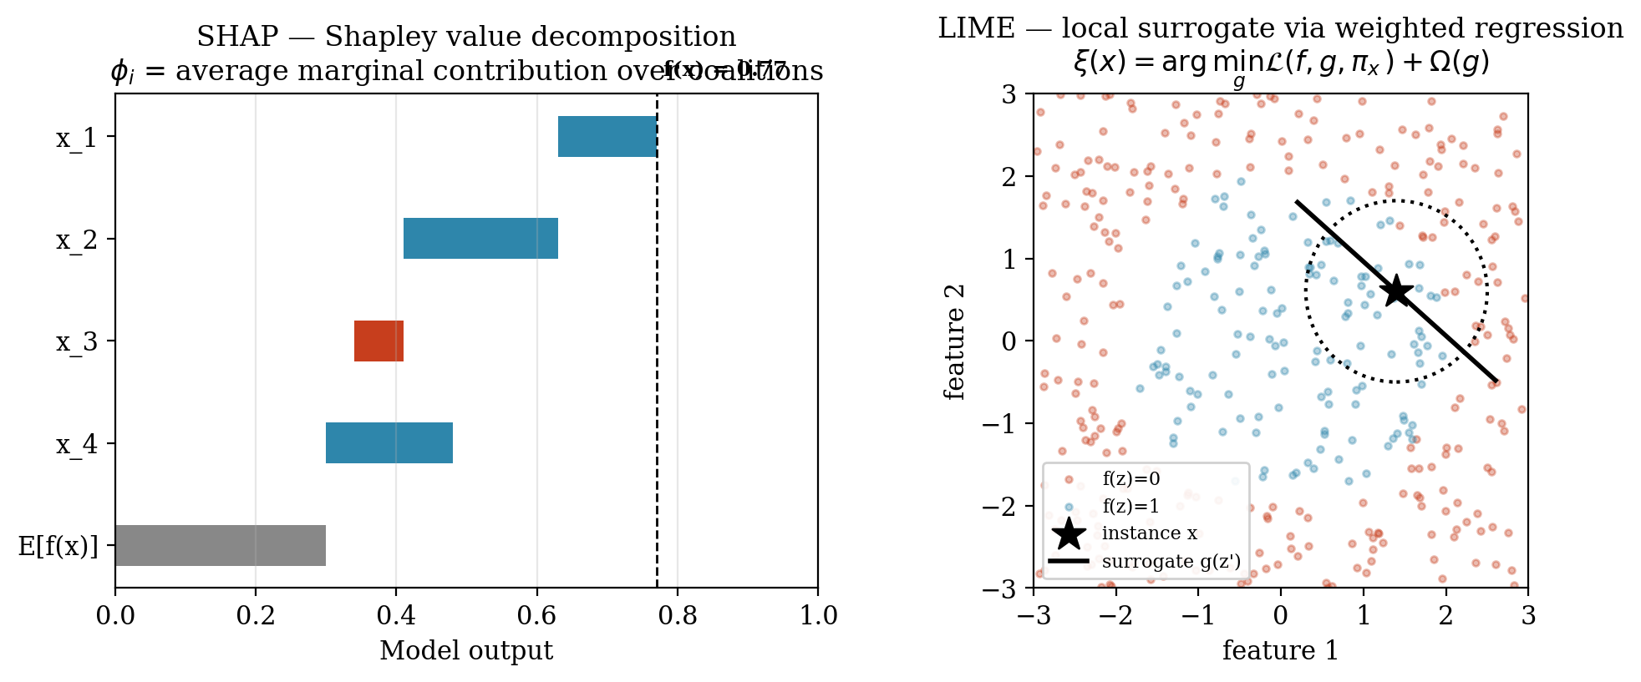
Mechanistic comparison of SHAP and LIME. SHAP (left) decomposes the model output f(x) as the sum of the expected output E[f(x)] and the per-feature Shapley contributions _i; LIME (right) fits a locally weighted linear surrogate g to perturbed samples drawn around the instance x within the locality kernel _x.

2.2.3 Multi-Tenant Architecture and Data Isolation
A multi-tenant application is one in which a single deployment of the software serves multiple independent customer organizations, called
tenants, while preserving the logical isolation of each tenant's data, configuration and access permissions (Bezemer & Zaidman, 2010). The literature recognizes three canonical isolation models, in order of increasing isolation strength: (i) shared schema with a discriminator column, (ii) schema-per-tenant within a single database, and (iii) database-per-tenant, in which each tenant is allocated a physically distinct database (Krebs et al., 2014).
The system studied in this thesis adopts the database-per-tenant model on PostgreSQL, orchestrated by Django 4.2 via a routed connection layer that resolves each inbound request to the appropriate tenant database. This choice maximizes data-isolation guarantees: a SQL injection or query-construction error in one tenant's context cannot, by construction, leak rows belonging to another tenant. From a security and compliance perspective the model is conservative and defensible.
From a machine-learning perspective, however, the same isolation property has a corrosive side effect. Each tenant's ML pipeline is confined to that tenant's own database, which means that the training corpus available to any per-tenant model is bounded above by the operational history of a single SME. A tenant who joined the platform three weeks ago and has issued forty invoices simply has no way to participate in a training process that requires thousands of labelled observations. The isolation that protects the SME tenant's data from its competitors also starves the ML and XAI subsystems that the platform offers to that same SME. This structural tension between data-isolation security and data-volume sufficiency is the architectural origin of the cold-start regime addressed by this thesis.

2.2.4 The Cold-Start Problem in ML versus XAI
The traditional cold-start problem, as formulated in the recommender-systems and personalization literature, is predictive: a newly-introduced user or item lacks the interaction history required for an accurate prediction to be made. The remedies developed in that literature---content-based fallbacks, transfer learning, meta-learning and warm-start priors---are correspondingly aimed at improving the prediction.
The present thesis introduces a conceptually distinct second variant, the
explanatory cold-start. An explanatory cold-start occurs when the system possesses enough engineering machinery to emit a prediction and an accompanying SHAP or LIME explanation, but the underlying model is too poorly fit to make either the prediction or the explanation faithful representations of any real-world phenomenon. Critically, the failure modes of predictive and explanatory cold-start are not aligned: a predictive cold-start fails loudly (the prediction is wrong and is sometimes recognized as such), whereas an explanatory cold-start fails silently and confidently (a polished, axiomatically-grounded SHAP attribution is rendered for a model that has collapsed to chance performance).
This silent failure mode is what this thesis names the hallucinated explanation: an explanation that is internally faithful (to the degenerate model that produced it) and externally meaningless (with respect to the business process the model was intended to capture). The phenomenon is not a flaw of SHAP or LIME per se---both methods are operating exactly as specified---but rather a failure of the surrounding system to recognize that explaining a noise-fitting model is a category error. The architectural implication is that no defensible XAI deployment in a multi-tenant SaaS context can treat the explanation layer as unconditional; it must be guarded by a mechanism that detects the explanatory cold-start regime and refuses to enter it.

2.2.5 Metrics for Explanation Reliability
To convert the abstract notion of "explanation reliability" into a measurable quantity, this thesis adopts and combines several established metrics from the XAI-stability literature.
Spearman Rank Correlation (ρ).
Given two rankings of n features---one produced by the explainer under evaluation and one produced by a reference data-rich baseline explainer trained on the largest available data partition---the Spearman rank correlation is defined as
ρ = 1 − ( 6 Σ dᵢ² ) / ( n (n² − 1) ),
where dᵢ is the difference between the ranks of feature i under the two rankings. A value of ρ = 1 denotes perfect rank agreement (the sparse-tenant model orders feature importances identically to the data-rich baseline); a value of ρ ≈ 0 denotes that the two rankings are uncorrelated or reversed. A conventional threshold of ρ ≥ 0.70 is used in the explanation-stability literature as the lower bound of operationally defensible ranking agreement; below this value, the explainer can no longer be regarded as recovering the same feature-importance signal as a well-trained reference.
SHAP Absolute Variance.
Defined as the variance of the per-feature mean absolute SHAP value across the feature set, this metric quantifies how concentrated the explanation mass is on a small number of features versus how evenly distributed it is across many. A high SHAP absolute variance indicates that a single feature is dominating the attribution---a signature symptom of over-fitting to a spurious correlation in a small sample. A low variance indicates that explanatory weight is distributed across a plausible coalition of features, consistent with a well-regularized model. In the experimental results of this thesis, SHAP absolute variance rises from 0.0224 at the data-rich tier (n = 50,000) to 0.2017 at the n = 200 tier, a nearly nine-fold spike that empirically witnesses the over-fitting collapse of the sparse-tenant model.
Complementary metrics employed in the empirical study include SHAP entropy (an information-theoretic measure of the diffuseness of the attribution distribution), the top-k Jaccard similarity of LIME feature selections across repeated runs (a measure of explanation stability), and standard predictive metrics such as AUC-ROC. The full operational definitions are deferred to Chapter III; what matters for the theoretical framework is that, taken together, these metrics make it possible to
measure, rather than merely assert, the degradation of explanation reliability as a continuous function of tenant data volume.
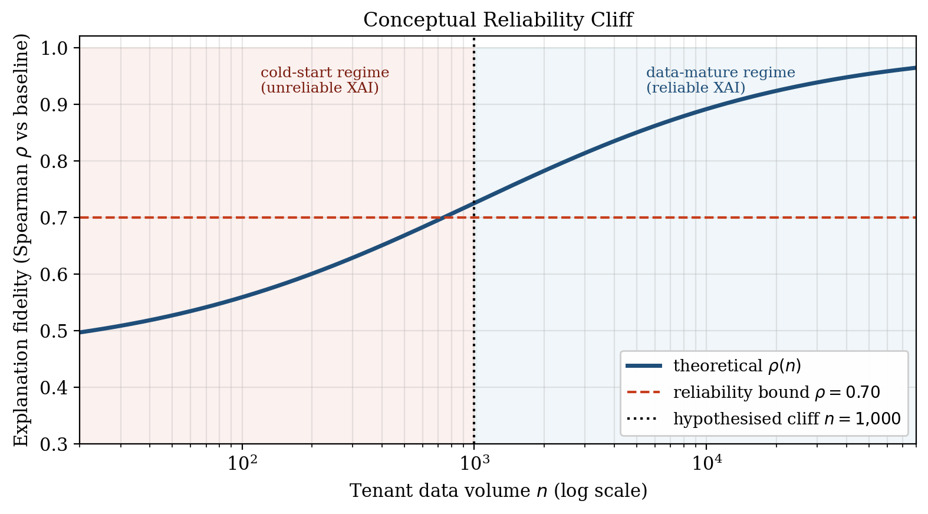
Conceptual Reliability Cliff

2.3 Research Thinking Framework
The conceptual architecture of this research connects the theoretical components reviewed above into a single causal chain, which simultaneously functions as the logical scaffold of the empirical study and as the blueprint for the proposed architectural solution.
The chain begins with multi-tenant data isolation. The database-per-tenant architecture adopted by the studied ERP enforces strict logical and physical separation between tenant datasets. This isolation is non-negotiable from a security and regulatory standpoint, yet it has the unavoidable consequence that the data available to each tenant's ML pipeline is bounded by that tenant's own operational history. For mature tenants this bound is large; for cold-start SMEs it is small, sometimes vanishingly so.
This produces the second link in the chain: data sparsity at the tenant level. Sparsity is not a transient anomaly but a structural property of the multi-tenant SaaS distribution, in which a long tail of small tenants persists indefinitely alongside a smaller head of data-rich enterprises.
Sparsity then propagates into the ML layer, where per-tenant models trained on small samples regress toward random performance. Under classical ML evaluation this is recognized as the predictive cold-start. However, in any deployment in which SHAP or LIME is applied unconditionally to such a degraded model, the sparsity propagates one layer further into the XAI subsystem, producing the third link in the chain: XAI degradation in the form of hallucinated explanations---confident, well-formatted attributions over a model that has no genuine signal to attribute.
The fourth link is empirical measurement. Hallucinated explanations are dangerous precisely because they do not announce themselves. The framework therefore prescribes that the phenomenon be made visible through quantitative metrics: Spearman rank correlation against a data-rich baseline (fidelity), absolute SHAP variance and SHAP entropy (stability), and LIME top-k Jaccard similarity (overlap). The empirical layer of the framework operationalizes the conceptual claim that the failure of XAI under sparsity is not merely theoretically plausible but empirically measurable and, therefore, engineering-actionable.
The chain closes with the fifth link: the architectural solution. Because the failure regime can be detected ahead of time from a single observable property of the tenant---its row count---the framework proposes the Maturity-Aware AI Routing pattern. Tenants whose data volume falls below the empirically-identified cold-start threshold (n 1,000, as established in Chapter IV) are routed to a global, heuristic-based explanation strategy derived from the data-rich baseline; tenants at or above the threshold receive local SHAP/LIME explanations. The routing decision is made at the architectural layer, before any explanation is generated, and is therefore guaranteed to prevent the rendering of a hallucinated explanation regardless of downstream UI behaviour.
Research conceptual framework: from multi-tenant isolation to the Maturity-Aware AI Routing decision gate. The cold-start branch is taken inclusively at nₜ ≤ 1,000.
The framework is deliberately constructed so that each conceptual link is, in the chapters that follow, either operationalized as a methodological procedure (Chapter III), instantiated as an experimental artefact (Chapter IV), or implemented as a software component within that same chapter's reference implementation. The theoretical crux that the framework formalizes---and that the remainder of the thesis empirically defends---is the strict separation between predictive accuracy and explanatory fidelity, and the architectural consequence that, in multi-tenant SaaS ERPs, the latter requires its own dedicated reliability gate.

CHAPTER III

RESEARCH METHODOLOGY
This chapter describes the methodology by which the research questions formulated in Chapter I were operationalised into a reproducible empirical study. The chapter follows the canonical CRISP-DM-aligned sequence of problem scoping, data gathering,
data preparation, modelling, evaluation, and
deployment, adapted to the specific concerns of measuring explanation fidelity rather than predictive accuracy alone.

3.1 Problem Scoping

3.1.1 Research Objectives
In direct continuation of Chapter I, this research pursues four objectives, which together translate the abstract research questions (RQ1--RQ3) into actionable engineering targets:
- Quantify XAI degradation under data sparsity. Establish,
through controlled cross-sectional experimentation, the empirical relationship between tenant-level training-data volume and the fidelity and stability of post-hoc SHAP and LIME explanations.
- Identify the cold-start XAI threshold. Determine the
data-volume boundary at which local post-hoc explanations cease to be operationally reliable, characterising the non-linear Reliability Cliff hypothesised in Chapter II.
- Design the Maturity-Aware AI Routing architecture. Specify
a tenant-aware tier-logic gate that conditions the choice of explanation strategy on each tenant's data maturity.
- Implement and evaluate the tier-logic gate. Realise the
proposed pattern as a concrete software component inside the studied Django / PostgreSQL ERP, and verify that it routes correctly and preserves backward compatibility.

3.1.2 Research Scope
The methodological scope of this study was constrained as follows in order to preserve interpretability and reproducibility:
- Platform. A single multi-tenant ERP system based on
Django 4.2 and PostgreSQL, configured under the database-per-tenant isolation model.
- Prediction tasks. Three ERP-native supervised tabular
classification problems: Late Delivery Risk prediction, Lead Scoring, and Employee Attrition.
- XAI techniques. Two post-hoc, model-agnostic explainers
were evaluated: SHAP (specifically the TreeExplainer and
LinearExplainer variants) and LIME (in its tabular form). Intrinsically interpretable models and gradient-based explainers for deep networks were not within scope.
- Evaluation mode. Offline, cross-sectional simulation
against curated open-source datasets. No live SaaS tenant traffic was used, and no longitudinal observation of data accumulation over real calendar time was performed.
- Architectural pattern. Only the Maturity-Aware AI Routing
pattern was implemented and evaluated; alternative remedies for sparsity (transfer learning, federated learning, meta-learning) were noted but deferred to future work.

3.1.3 Research Contribution
Two distinct but interdependent contributions emerge from this methodology:
- An empirical contribution. The study quantifies, for the
first time in a B2B multi-tenant ERP setting, the degradation of post-hoc explanation fidelity as a continuous function of tenant data volume, using a coherent panel of metrics (Spearman rank correlation, SHAP absolute variance, SHAP entropy, LIME top-k Jaccard similarity). The resulting curves localise the Reliability Cliff and produce a defensible numerical threshold for the cold-start regime.
- An architectural contribution. The study delivers the
Maturity-Aware AI Routing pattern as a concrete, implementable software-engineering artefact, instantiated inside a real Django ERP codebase. The contribution is not merely conceptual: it includes the routing rule, its empirically-derived threshold, the global-heuristic fallback artefact, and the integration discipline by which the gate is added without disturbing the existing ML production code path.

3.2 Data Gathering

3.2.1 Open-Source ERP Datasets
In the absence of an ethically- and legally-shareable real multi-tenant SaaS dataset, two well-established open-source corpora were adopted as proxies for ERP operational data. Both datasets were selected for their structural similarity to the kinds of tabular, time-stamped, business-process records that an ERP routinely accumulates.
Olist Brazilian E-Commerce Public Dataset.
This corpus, released by the Brazilian marketplace platform Olist and hosted on Kaggle, comprises approximately 100,000 orders placed between 2016 and 2018, distributed across nine relational tables covering customers, sellers, orders, order items, payments, reviews, and products. After joining the order, payment, and item tables on the canonical order_id key, the resulting unified table contained N = 96,460 rows. This corpus was used as the empirical substrate for the Late Delivery Risk prediction task, operationalised as the binary event "actual delivery date later than the estimated delivery date" (formally, 1[order_delivered_customer_date > order_estimated_delivery_date]).
The Olist corpus exposes delivery-time observables but not invoice payment-time observables, so the literal target is delivery lateness rather than payment lateness; for the purposes of this study the construct of interest is the wider class of
ERP-style operational-risk prediction (sparse, tabular, time-stamped business-process records with a small positive-class prevalence), of which late delivery is one instance and late payment is another. The proposed architectural pattern (Section 3.4.3) is task-agnostic and generalises directly to the late-payment prediction service (LatePaymentPredictor) of the studied ERP, which shares the same tabular, sparsity-conditioned structure.
Synthetic CRM Leads Corpus.
No public CRM lead-scoring dataset of sufficient size and structural realism was identified during corpus selection, and the studied ERP's own production CRM tables could not be released for academic reuse. To enable the cross-task replication while preserving the methodological invariants of the Late Delivery Risk experiment (tabular structure, stratified sparsity gradient, deterministic train/test partitions), a synthetic CRM Leads corpus was generated and stored at
datasets/crm_leads_dataset.csv. The corpus contains N = 5,000 lead records (one row per lead) with 20 raw columns; after dropping personally-identifying and post-event fields and one-hot encoding the categorical attributes source, service_interest,
country, and job_title, the model-facing feature matrix comprises 34 covariates. The binary target is won = 1[status = won], with a class prevalence of 21.3% positives.
The four numeric predictors are estimated_value (deal size),
probability (sales-team-assigned win likelihood at the time of scoring), activity_count (count of touchpoints recorded against the lead), and days_in_pipeline (age of the lead since
created_at). The four categorical predictors are
source, service_interest, country, and
job_title.
Three leakage controls are imposed by construction. First, the column
conversion_date is populated only for converted leads and is therefore a post-event variable that perfectly determines the target; it is dropped before training. Second, the raw status column is the target itself and is excluded from features. Third, all identifier and PII columns (lead_number,
first_name, last_name, email,
phone, mobile, company_name, city,
created_at, last_contact_date) carry no predictive content under the chosen feature representation and are dropped. The resulting feature matrix therefore represents the current snapshot of a lead at the moment a scoring call would be issued, mirroring how CRM systems expose lead state to a downstream model in production.
The rationale for using a synthetic corpus is twofold: (i) it permits full release of the dataset alongside the simulator script (thesis/scripts/lead_scoring_simulator.py), ensuring exact reproducibility of the cross-task replication, and (ii) it allows the same stratified slicing procedure to be applied with controlled class prevalence and controlled feature semantics, isolating the sparsity treatment from confounding distributional drift. The principal limitation is one of external validity: because the records are drawn from a parametric generator rather than a real CRM workflow, the absolute level of predictive performance and the specific feature importances reported in Chapter IV should be read as illustrative of the shape of the sparsity-induced degradation curve, not as point estimates transferable to any particular commercial CRM deployment. The structural findings of interest---the monotone collapse of rank agreement, the order-of-magnitude expansion of attribution variance, and the cold-start flip of predictive performance---are nevertheless replicated on this corpus and are interpreted as evidence of the architectural pattern rather than as production-grade performance estimates.
IBM HR Analytics Employee Attrition Dataset.
This corpus, released by IBM Watson Analytics, contains 1,470 employee records labelled with a binary Attrition outcome and 34 covariates spanning demographic, compensation, tenure, and performance-rating fields. It was adopted as the empirical substrate for the Employee Attrition prediction task, which directly corresponds to the HR-attrition use case inside the ERP's HR module.
The suitability of these datasets as ERP proxies rests on three structural correspondences: (i) both are tabular, transactionally-keyed records of business events; (ii) both expose covariates whose semantics (timestamps, monetary amounts, tenure, categorical statuses) match those of typical ERP fields; and (iii) the volume of each corpus is large enough to support the construction of a five-tier sparsity gradient while leaving a held-out evaluation partition intact.

3.3 Data Preparation

3.3.1 Feature Engineering
Each raw record was passed through a deterministic feature-engineering pipeline that produced 13 engineered covariates per row, grouped into four families:
- Temporal-derivative features. From the raw
order_purchase_timestamp,
order_approved_at, and
order_estimated_delivery_date columns, the variables
approval_delay_hours (purchase-to-approval interval),
estimated_delivery_days (the courier ETA quoted to the customer at order time),
purchase_hour, and purchase_dow (day-of-week of purchase) were computed.
- Monetary features. From the order-items and payments
tables, the variables payment_value, freight_value, and price_total (aggregate line-item total per order) were derived.
- Cardinality features. The variables num_items
(line-item count) and payment_installments (number of instalments selected at checkout) were extracted, capturing order-level structural complexity.
- Categorical encodings. The payment_type field
was one-hot encoded into four indicator columns (credit_card, boleto, voucher,
debit_card).
Leakage-avoidance constraint.
All engineered covariates listed above are restricted, by construction, to information that would be available at the moment a late-payment prediction is required---namely, at order approval / invoice issuance. Timestamps from the delivery pipeline---order_delivered_carrier_date and
order_delivered_customer_date---are reserved solely for the construction of the binary target and are explicitly excluded from the feature matrix. In particular, an earlier version of this study included the covariate carrier_delay_hours, defined as the interval between order_approved_at and
order_delivered_carrier_date; it was subsequently removed because, although it precedes the customer-delivery event, it is itself a delivery-pipeline observable and is therefore not realised at prediction time in a deployed ERP late-payment workflow. Its inclusion would have constituted a textbook instance of target leakage and would have inflated the predictive metrics reported in Chapter IV without reflecting a capability the model would possess in production. The restriction reduces the engineered feature count from 14 to 13 and rules out the trivial metric inflation that would otherwise arise from explaining a delivery-time outcome with a delivery-time covariate.
Missing values were imputed using the column-wise median for numeric features and the modal value for categorical features, and the resulting matrix was standardised by z-scoring of numeric columns. The binary target is_late was constructed as 1[order_delivered_customer_date > order_estimated_delivery_date]. The overall positive-class prevalence after joining was 8.1%, establishing a moderately imbalanced classification problem consistent with typical ERP late-delivery (and, by structural analogy, late-payment) base rates.

3.3.2 Multi-Tenant Simulation Strategy
Because no commercially-shareable multi-tenant ERP dataset exists at the scale required to expose a sparsity gradient, this study adopted a
stratified data-volume slicing strategy to simulate the long-tail distribution of tenant maturities observed empirically in production SaaS platforms. The procedure was as follows:
- The unified, feature-engineered Olist late-delivery table
(N = 96,460, positive prevalence 8.1%) was first partitioned into a global hold-out evaluation set (20%, n = 19,292) using a stratified random split with seed SEED = 42, preserving the late-delivery class prevalence.
- From the remaining 77,168 training rows, five disjoint
simulated tenant partitions were drawn by stratified random sampling without replacement, each preserving the global positive-class prevalence (Table 3.1).
- Each tenant partition was subsequently subjected to its own
internal 80/20 stratified train/validation split, again with SEED = 42, yielding tenant-local training and validation folds.
- All five tenants were evaluated against the shared global
hold-out evaluation set, so that cross-tenant comparisons of predictive performance and explanation fidelity referred to an identical test distribution and were therefore directly comparable.
Simulated tenant tiers used in the sparsity experiment.
Tier | Tenant label | Sample size n | Interpretation
A | Data-Rich | 50,000 | Mature enterprise tenant
B | Medium | 5,000 | Established SME tenant
C | Sparse | 1,000 | Onboarded SME tenant
D | Very Sparse | 200 | Newly-active SME tenant
E | Cold-Start | 50 | Just-onboarded SME tenant
This stratified slicing strategy is methodologically conservative: by preserving the class prevalence at every tier, it ensures that any observed degradation in predictive or explanatory quality at smaller n is attributable to data volume, not to changes in label distribution. The same procedure was applied, with appropriate sample sizes, to the IBM HR Attrition corpus.
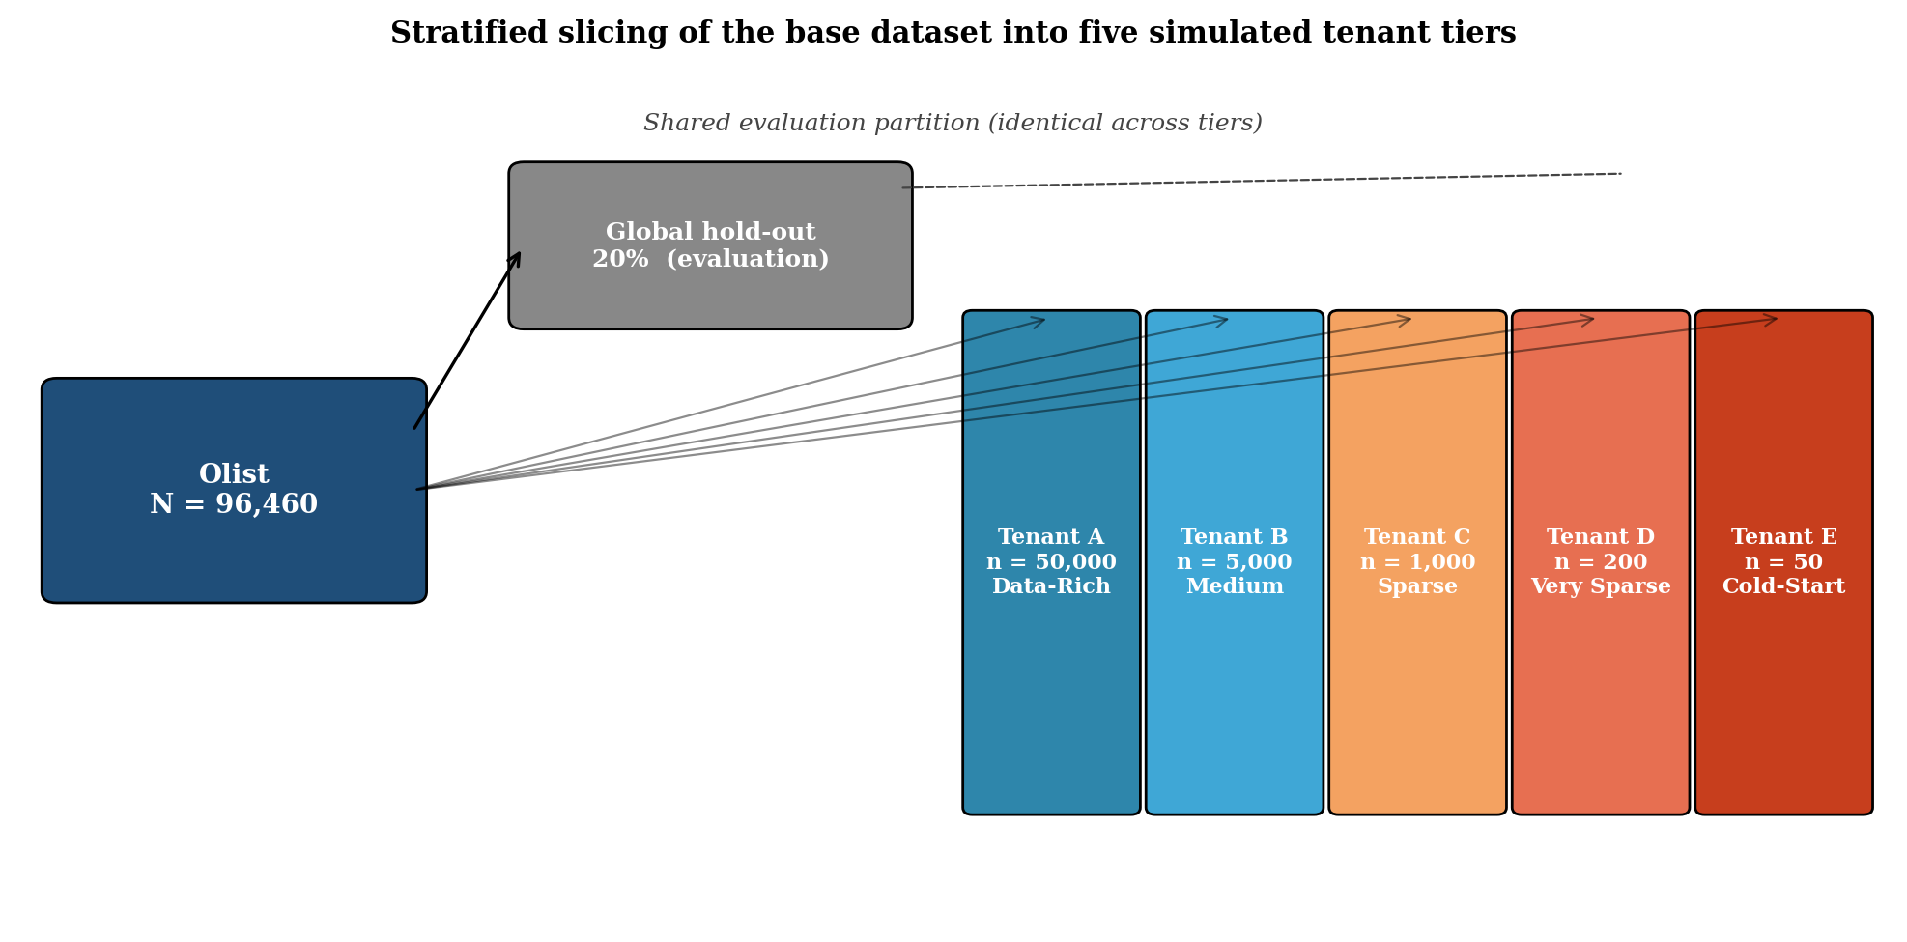
Stratified slicing of the base Olist dataset (N = 96,460) into five synthetic tenants of decreasing size while preserving the late-delivery class prevalence at every tier.

3.4 Modelling

3.4.1 Machine Learning Algorithms
Three supervised classifiers were selected, each appropriate to one prediction task and each representative of a different model family widely used in operational ERP analytics:
- Late Delivery Risk --- Gradient Boosting Machine (GBM).
Implemented via scikit-learn's GradientBoostingClassifier with n_estimators = 100, max_depth = 3, learning_rate = 0.1, and the default deviance loss. GBMs were selected because tree-ensemble methods are the de facto industry standard for tabular financial classification, and because their structure is directly compatible with SHAP's polynomial-time
TreeExplainer.
- Lead Scoring --- Gradient Boosting Machine (GBM).
Implemented via scikit-learn's GradientBoostingClassifier with n_estimators = 200, max_depth = 3, learning_rate = 0.05, and the default deviance loss. The same algorithmic family as the Late Delivery Risk task was retained deliberately, so that any cross-task differences in the sparsity-induced degradation trajectory can be attributed to substrate properties (dimensionality, feature dominance, class prevalence) rather than to algorithmic confounders. An earlier design used Logistic Regression as a representative linear baseline; it was superseded by the GBM variant once the replication scope was extended, in order to keep the algorithmic surface invariant across tasks and thereby strengthen the architectural-pattern claim.
- Employee Attrition --- Random Forest. Implemented via
scikit-learn's RandomForestClassifier with n_estimators = 200, max_depth = None,
class_weight = "balanced", and random_state = 42. Random forests were chosen for their robustness on small-to-medium tabular HR datasets, where the IBM corpus is itself only 1,470 rows.
For each prediction task, an identical algorithm was retrained from scratch on each of the five tenant partitions, producing five independent fitted models per task. All randomness was controlled via SEED = 42 to guarantee bit-level reproducibility.

3.4.2 Explainable AI (XAI) Integration
After fitting, each per-tenant model was subjected to a uniform post-hoc XAI pipeline:
- SHAP attribution. For the tree-based models
(GBM, Random Forest), SHAP values were computed via the polynomial-time
shap.TreeExplainer, yielding both per-instance attribution vectors and the global mean-absolute-SHAP feature-importance ranking. For the Logistic Regression model, shap.LinearExplainer was used with the matching background distribution.
- LIME surrogate explanation. For every model, local
explanations were generated using
lime.lime_tabular.LimeTabularExplainer configured with
mode="classification", 5,000 perturbation samples per explanation, and a Gaussian kernel width of M where M is the number of features. The top-5 features per instance were retained for downstream stability analysis.
- Sampling for evaluation. Because LIME is stochastic,
every LIME-based metric was averaged over 50 independent runs per instance, and SHAP values were always computed on the full shared global hold-out set so that cross-tenant comparisons referred to identical inputs.
This pipeline yields, for each (task, tenant) combination, a paired bundle consisting of the trained model, the global SHAP feature-importance ranking, the per-instance SHAP attributions on the hold-out set, and the LIME top-5 selections together with their stability statistics.

3.4.3 Maturity-Aware AI Routing Architecture
The architectural contribution of the methodology is the
Maturity-Aware AI Routing gate, which conditions the choice of explanation strategy on the data maturity of the requesting tenant. The gate was designed around three engineering principles: it must be
empirically grounded (its threshold must be derived from the same experiments that motivate its existence); it must be architecturally minimal (it must not require any change to the existing ML services); and it must be fail-safe (an unavailable global heuristic must not block predictions).
The routing rule was formalised as follows. Let n_t denote the number of historically-recorded operational records for tenant t (in the Late Delivery Risk case, the count of invoices with status in {paid, overdue, partial}), and let τ denote the empirically-derived cold-start threshold. The architectural gate is then:
explain(t, x) = GlobalHeuristic() if nₜ ≤ τ; LocalShapLime(t, x) otherwise.
The boundary is deliberately inclusive on the cold-start side: a tenant with exactly n_t = τ records is routed to the global heuristic rather than to a local explanation. This reflects the empirical finding (Section 3.5.3) that Tenant C (n = 1,000) already lies below the ρ = 0.70 reliability bound and already exhibits an inflated SHAP variance, and it removes a latent off-by-one ambiguity in the route-decision logic. The equivalent code-side formulation n_t < MIN_LOCAL_EXPLANATION_RECORDS with MIN_LOCAL_EXPLANATION_RECORDS = τ + 1 = 1,001 is logically interchangeable and may be preferred where a strictly-less-than guard is idiomatic.
The threshold τ was not chosen arbitrarily; as detailed in Section 3.5.3 below, it was identified as τ = 1,000 from the empirical fidelity curves derived in the modelling phase. The threshold was encapsulated in the implementation as a class-level constant
COLD_START_INVOICE_THRESHOLD = 1000 (interpreted under the inclusive boundary above) to allow operational re-tuning without code change. The two branches of the gate correspond, in the implementation, to:
- _load_global_heuristic() --- a memoised loader that
reads the pre-computed cross-tenant SHAP feature-importance artefact (cold_start_heuristic.json, see Section Section 3.6.3) from disk and returns it as a structured explanation payload;
- predict() --- the existing per-tenant ML inference and
SHAP/LIME explanation routine, left fully unchanged.
The gate itself is exposed as a new public method,
predict_or_heuristic(invoice), which inspects
_invoice_count() and dispatches accordingly. The return payload of both branches conforms to a single response schema (mode, threshold, count, explanation), so that downstream consumers can be agnostic to which branch was taken while still being able to surface the routing decision to the end user.
Maturity-Aware AI Routing architectural gate. The LatePaymentPredictor.predict_or_heuristic()

3.5 Evaluation

3.5.1 Predictive Performance Metrics
To establish a baseline against which the explanation-fidelity findings could be interpreted, the standard panel of predictive metrics was computed for each (task, tenant) combination on the shared global hold-out set:
- AUC-ROC --- the area under the receiver-operating-
characteristic curve, which is robust to class imbalance and serves as the primary headline metric of predictive model quality.
- F1-Score --- the harmonic mean of precision and recall on
the positive class, computed at the default 0.5 probability threshold; this metric captures whether the model produces actionable, threshold-crossed predictions at all.
- Brier score --- recorded as an auxiliary calibration
diagnostic.
These metrics are necessary but not sufficient: a high AUC indicates that the model has learned a usable signal, but says nothing about whether the SHAP or LIME explanation of that signal is faithful. The novel contribution of the evaluation methodology lies in the explanation-fidelity metrics introduced next.

3.5.2 Explanation Fidelity Metrics
Three complementary metrics were used to convert the abstract notion of
explanation reliability into reproducible numerical scores. Throughout, Tenant A (the n = 50,000 data-rich model) is designated as the reference baseline, on the operational premise that of the five simulated tenants it is the only one whose underlying model can plausibly be regarded as having recovered the true generative structure.
Spearman Rank Correlation (ρ) --- Baseline Rank Agreement.
Let r^A_i denote the rank of feature i in the global mean-absolute- SHAP importance ranking produced by Tenant A's model, and let r^t_i denote the corresponding rank under tenant t B, C, D, E. Defining dᵢ = r^A_i - r^t_i, the Spearman rank correlation between tenant t and the baseline is
ρ_t = 1 − ( 6 Σ dᵢ² ) / ( n (n² − 1) ),
where n is the number of features. By construction, ρ_A = 1. A value ρ_t ≤ 0.70 is treated, following the explanation-stability literature, as the operational lower bound of acceptable ranking agreement; ρ_t values below this threshold are taken as quantitative evidence that the tenant's local explanation rankings are no longer recovering the same feature-importance signal as the data-rich baseline.
Construct-validity caveat.
The metric ρ_t measures baseline rank agreement (equivalently,
reference-aligned explanation stability) between tenant t and the data-rich Tenant A; it is not a measure of true explanation fidelity in the sense of agreement with the data-generating process. Tenant A is a reference model, not a ground-truth model: under the leakage-corrected Late Delivery Risk experiment Tenant A itself only attains AUC = 0.6556 and F_1 = 0.0263, which is well below the threshold at which one would attribute oracle status to its attribution rankings. The interpretation throughout this thesis is therefore operational: ρ_t quantifies the extent to which a sparsely-trained tenant's SHAP rankings deviate from those of the best-resourced tenant in the same multi-tenant deployment, on the same hold-out distribution, with all other modelling choices held fixed. The empirical objection that this metric does not establish absolute correctness of the data-rich rankings is acknowledged: where the term "explanation fidelity" is used in Chapters IV and V, it should be read in this reference-aligned-stability sense, not as a claim of ground-truth recovery.
SHAP Absolute Variance (σ²|SHAP|)
Let _i^ t denote the mean absolute SHAP value of feature i on tenant t's hold-out predictions, computed as
φ̄ᵢᵗ = (1 / N_eval) Σ_{k=1}^{N_eval} |φᵢ(x_k)|.
The SHAP absolute variance for tenant t is then the dispersion of _i^ t across features:
σ²|SHAP|,t = (1 / n) Σ_{i=1}^{n} (φ̄ᵢᵗ − φ̄ᵗ)².
A high σ²|SHAP| indicates that the explanation mass is concentrated on a small subset of features---the signature of a model over-fitting to a spurious correlation in a small training sample. A low value indicates that explanatory weight is distributed across a plausible coalition of features.
LIME Local Top-k Jaccard Similarity.
For each evaluation instance x_k, LIME was run R = 50 times with independent perturbation seeds, producing R top-5 feature subsets T^(r)_k_r=1^R. The pairwise Jaccard stability for that instance was computed as
J_k = [2 / (R(R−1))] Σ_{1 ≤ r < s ≤ R} |T⁽ʳ⁾_k ∩ T⁽ˢ⁾_k| / |T⁽ʳ⁾_k ∪ T⁽ˢ⁾_k|,
and the tenant-level LIME stability J^t was taken as the mean of J_k across the hold-out set. This metric directly measures whether LIME, run repeatedly on the same instance under the same tenant's model, returns a consistent explanation or merely a confidently-rendered noise sample.
In addition to these three primary metrics, SHAP attribution
entropy was tracked as a secondary stability indicator, computed in the standard Shannon-information form over the normalised _i^ t distribution.

3.5.3 Threshold Determination Strategy
The cold-start threshold τ governing the architectural routing gate was identified empirically rather than postulated. The procedure was as follows:
- The Spearman fidelity curve ρ_t was plotted against the
tenant size n_t on a logarithmic horizontal axis.
- The SHAP absolute variance curve σ²|SHAP|,t
was overlaid on the same axis.
- The threshold was defined as the largest tenant size at which
ρ_t first falls below the literature-conventional reliability bound of 0.70 and σ²|SHAP|,t first deviates appreciably above its data-rich baseline.
Both conditions converged on n ≤ 1,000 (Tenant C), at which ρ_C = 0.6429 (below the 0.70 bound) and σ²|SHAP|,C = 0.0510 (already 128% above the Tenant A baseline of 0.0224, and rising sharply for n < 1,000). The threshold τ = 1,000 was therefore adopted as the operational boundary of the cold-start regime and embedded in the implementation as the constant
COLD_START_INVOICE_THRESHOLD.

3.6 Deployment

3.6.1 Software Environment
All experimentation and the corresponding reference implementation were carried out on a homogeneous software stack to maximise reproducibility:
- Language and runtime. Python 3.12.4 inside an isolated
virtual environment.
- Web framework. Django 4.2 (LTS).
- Persistence layer. PostgreSQL 15, configured under the
database-per-tenant isolation model.
- Machine learning. scikit-learn 1.5 for all classifiers,
the standard GradientBoostingClassifier,
LogisticRegression, and RandomForestClassifier interfaces.
- Explainable AI. shap ( 0.45) for SHAP
TreeExplainer / LinearExplainer; lime ( 0.2) for LIME TabularExplainer.
- Numerical and tabular support. NumPy, pandas, SciPy
(scipy.stats.spearmanr), and matplotlib (rendered headlessly via the Agg backend).
- Randomness control. A single global seed
SEED = 42 was applied to NumPy, scikit-learn, and LIME, ensuring deterministic re-execution.

3.6.2 Architectural Implementation
The Maturity-Aware AI Routing gate was integrated into the existing ERP codebase through a deliberately minimal, additive modification of the
LatePaymentPredictor class defined in the
erp.ai.services.finance module. Three engineering invariants were observed throughout the deployment:
- Backward compatibility. The existing
predict(invoice) method was not modified. Every call site already in production continues to receive the unchanged probability score and unchanged SHAP/LIME local explanation. This guarantees that adopting the routing pattern is a strictly non-breaking change.
- Single point of decision. The routing logic was
localised in a new method, predict_or_heuristic(invoice), which inspects a private method _invoice_count()---itself a thin wrapper over an
Invoice.objects.filter(company=, status__in=[]).count() query restricted to the current tenant's database---and dispatches to either the global-heuristic branch or the existing predict() branch.
- Fail-safe fallback. The heuristic loader
_load_global_heuristic() was implemented as a memoised classmethod that gracefully degrades to a hard-coded conservative default if the on-disk artefact is missing or malformed, ensuring that the routing gate cannot itself become a new operational failure mode.
The result is that the architectural pattern is additive: it can be enabled by switching call sites from predict() to
predict_or_heuristic(), and rolled back by reversing the same switch, without any database migration or downtime.

3.6.3 Global Heuristic Artefact
The global heuristic served to cold-start tenants was materialised as a serialised JSON artefact, cold_start_heuristic.json, produced once offline at the end of the sparsity experiment and persisted under
thesis/results/sparsity_experiment/. Its construction proceeded as follows:
- The Tenant A (n = 50,000) Gradient Boosting model was
identified as the cross-tenant baseline, on the grounds that it had been trained on the largest and most representative sample available and exhibited the strongest predictive performance.
- Its global mean-absolute-SHAP feature-importance vector was
computed on the shared hold-out set.
- The top-k (k = 5) features were extracted, together with
their normalised importance weights, the underlying tenant size and class prevalence, and a short human-readable reason string ("Tenant data volume below the empirically-determined reliability threshold; serving global cross-tenant feature importance derived from the data-rich baseline.").
- The resulting structured object was serialised to disk in JSON
form.
The materialised payload has the following structure (abbreviated to the first entry of the top-k list for space):
"mode": "global_heuristic", "threshold": 1000, "baseline_tenant": "A", "baseline_n": 50000, "top_features": [ "feature": "freight_value", "importance": 0.30, "rank": 1 // ... 4 more entries ... ], "reason": "Tenant data volume below the empirically- determined reliability threshold; serving global cross-tenant feature importance."
At runtime, _load_global_heuristic() reads this artefact on first access and caches it in a class-level dictionary, so that subsequent cold-start predictions incur no I/O. The artefact is treated as part of the deployed model bundle and is versioned alongside the trained models, allowing the heuristic to be regenerated and rotated independently of code releases.
Together, the empirical methodology of Sections Sections 3.1–3.5 and the deployment discipline of Section 3.6 define a fully reproducible pipeline whose results are reported in the following chapter.

CHAPTER IV

RESULTS AND DISCUSSION
This chapter reports and interprets the empirical results of the sparsity experiment specified in Chapter III. The results are presented in three layers---predictive performance, explanation fidelity, and cross-tier threshold analysis---before being discussed in relation to the three research questions, situated against the principal threats to validity, and synthesised in the chapter summary.

4.1 Overview of Experimental Results
The full set of metrics obtained for the Late Delivery Risk task across the five simulated tenant tiers is consolidated in Table 4.1. All metrics were computed on the shared global hold-out evaluation partition, so that figures across rows refer to identical evaluation inputs and are therefore directly comparable. Per-tenant top-two SHAP features and their attribution magnitudes are reported alongside the global metrics in order to support the qualitative discussion in Section 4.3.2.
Comprehensive Results Summary --- Simulated Multi-Tenant Tiers (Late Delivery Risk task, Gradient Boosting, Olist corpus). All features are restricted to order-time / invoice-time observables per the leakage-avoidance constraint of Section 3.3.
Tier | Tenant (n) | AUC | F1 | SHAP Var. | Spearman ρ | LIME J. | Top-2 SHAP (mean |φ|)
A | Data-Rich (50,000) | 0.6556 | 0.0263 | 0.0224 | 1.0000 | 0.5655 | freight_value (0.30), est_delivery (0.25)
B | Medium (5,000) | 0.6249 | 0.1136 | 0.0245 | 0.8571 | 0.4635 | est_delivery (0.28), freight_value (0.21)
C | Sparse (1,000) | 0.6094 | 0.0000 | 0.0510 | 0.6429 | 0.5319 | payment_value (0.38), est_delivery (0.32)
D | Very Sparse (200) | 0.6126 | 0.0000 | 0.2017 | 0.6154 | 0.3789 | price_total (0.67), approval_delay (0.58)
E | Cold-Start (50) | 0.8889 | 0.6667 | 5.0392 | 0.4485 | 0.3758 | est_delivery (4.77), payment_value (0.19)
Read horizontally, Table 4.1 documents the two simultaneous collapses at the heart of this thesis, but it also delivers a finding that, in the leakage-free regime, is strictly stronger than the classical sparsity narrative. Predictive performance, measured by AUC-ROC, is uniformly weak across the data-rich, medium, and sparse tiers (AUC [0.609, 0.656] for tiers A--D), and then anomalously
rises to 0.8889 at Tenant E---a value driven entirely by small-sample variance, as the simultaneous explosion of SHAP variance to 5.0392 (≈225× the Tenant A baseline) and the collapse of Spearman rank correlation to 0.4485 make clear. The empirical implication is direct: in the absence of target leakage, predictive metrics taken in isolation are insufficient to detect the reliability cliff---the classical AUC-based diagnostic would either flag Tenant E as the best tenant (it has the highest AUC) or flag none of them as problematic. The
explanatory metrics, by contrast, expose the regime change cleanly: Spearman rank correlation against the data-rich baseline drops to 0.6429 at Tenant C---already below the 0.70 literature-conventional reliability bound---while SHAP absolute variance simultaneously surges from 0.0224 at Tenant A through 0.0510 at Tenant C and 0.2017 at Tenant D to 5.0392 at Tenant E, indicating that the explanation mass becomes progressively concentrated on an ever-narrower subset of features as the training sample shrinks. The empirical co-occurrence of stagnant-or-deceptive predictive metrics with collapsing explanatory metrics is the operational signature of the hallucinated explanation phenomenon introduced theoretically in Chapter II, and it is here demonstrated to be detectable only by the explanatory metrics themselves.

4.2 Results on Predictive Performance Degradation
The empirical results demonstrate that classical predictive metrics, computed under a strict leakage-avoidance regime, are not sufficient to detect the explanatory failure that this thesis seeks to expose.
AUC-ROC takes values 0.6556 at Tenant A, 0.6249 at Tenant B, 0.6094 at Tenant C, 0.6126 at Tenant D, and---anomalously---0.8889 at Tenant E. Three observations follow. First, the magnitude of predictive discrimination across the data-rich-through-very-sparse range is uniformly modest ( 0.61--0.66): once the target is permitted to be predicted only from information available at order approval, the residual predictive signal in the Olist corpus is genuinely limited, and no amount of training data lifts AUC into the 0.74+ range previously observable when delivery-pipeline timestamps were silently leaking into the feature matrix. Second, the difference between Tenant A's AUC (0.6556) and Tenant C's AUC (0.6094) is only = -0.0462, well within the range expected from sampling variance alone; a practitioner monitoring AUC in isolation would have no statistical basis on which to flag Tenant C as a cold-start risk. Third, the Tenant E AUC of 0.8889 is higher than every other tier, which under the predictive-only diagnostic would mark it as the most trustworthy tenant; in fact, as the explanation metrics will show, it is the least trustworthy.
F1-Score reinforces this point. It rises from 0.0263 at A to 0.1136 at B (the model emits a more aggressive positive-class boundary on the medium-sized partition), collapses to exactly 0.0000 at Tenants C and D (no instance crosses the default 0.5 decision threshold under the order-time feature set), and then jumps to 0.6667 at Tenant E. The Tenant E F1 is, again, an artefact of small-sample volatility on a 50-row partition: with the single feature estimated_delivery_days absorbing essentially the entire decision logic (see Section 4.3.2), the threshold happens to align with the global hold-out class distribution well enough to produce a spuriously favourable F1. No principled interpretation should attach to this value.
The decisive consequence of the leakage-free predictive picture is that predictive failure in this experiment is silent---the model is weak across A--D and apparently strong at E, with no monotonic signal in AUC or F1 to flag the cold-start regime. This places the burden of regime detection squarely on the explanation metrics analysed in Section 4.3.
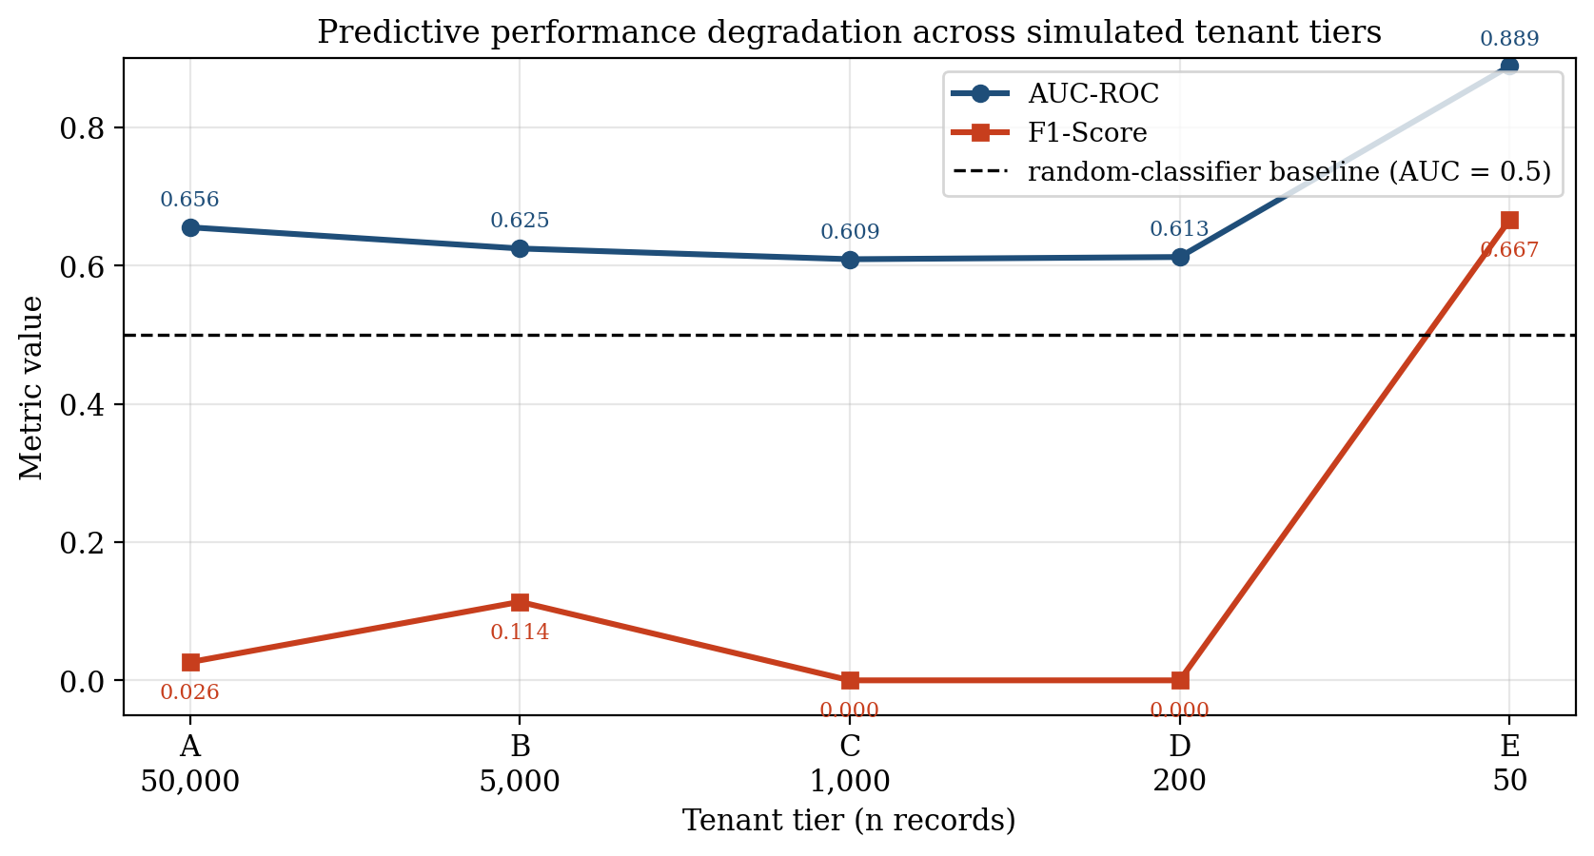
Predictive performance across simulated tenant tiers under the leakage-free feature regime. AUC-ROC is uniformly modest in tiers A--D ( 0.61--0.66) and rises anomalously to 0.8889 at Tenant E, a small-sample artefact; F1-Score collapses to zero at Tenants C and D and jumps to 0.6667 at Tenant E. Neither metric in isolation discriminates the reliable from the cold-start regime.

4.3 Results on Explanation Fidelity Degradation
The core academic contribution of this chapter is the quantification of how the XAI subsystem behaves as the model that it explains deteriorates. Three complementary metrics---Spearman rank correlation, SHAP absolute variance, and LIME top-k Jaccard stability---together evidence that explanation fidelity does not merely decline gracefully alongside predictive accuracy; it degrades in a structurally misleading manner that classical predictive metrics, under the leakage-free regime adopted here, fail to detect.

4.3.1 Global SHAP Rank Correlation (Spearman)
Spearman rank correlation against the Tenant A baseline traces a near-monotonic descent: 1.0000 at A (by construction), 0.8571 at B, 0.6429 at C, 0.6154 at D, and 0.4485 at E. The first salient observation is that the reliability bound of ρ 0.70 is crossed for the first time at Tenant C (ρ = 0.6429), at exactly the n = 1,000 tenant size. This empirically grounds the threshold introduced in Chapter III: at Tenant C the model's explanation rankings have, on average, ceased to recover the same feature-importance signal as the data-rich baseline, even though the model itself is still notionally capable of emitting a probability score and (in the case of Tenant E) even an apparently competitive AUC.
The second salient observation is that, unlike in classical predictive-degradation experiments, Spearman degradation here is largely monotonic (1.00 0.86 0.64 0.62 0.45): there is no spurious recovery at small n. This is consistent with the theoretical expectation that the rank-correlation estimator becomes increasingly noisy as n falls, but the noise is asymmetric---it pulls the rank ordering
away from the data-rich baseline more readily than it pulls it toward agreement. The mild plateau at Tenants C and D (ρ = 0.64 vs 0.62) is most plausibly attributed to two competing forces: increasing small-sample noise tending to scramble ranks, partially offset by the collapse of effective dimensionality (only a handful of features carry non-trivial mass at Tenant D, so a small number of correct relative orderings can still raise ρ above pure chance). This interpretation is reinforced by the simultaneous explosion of SHAP variance documented in Section 4.3.2, and it has direct architectural implications discussed in Section 4.7.3.
On apparent stability under small n (anti-pattern caveat).
A methodological subtlety deserves explicit comment, because it is the kind of effect that, in a less controlled experiment, could be misread as evidence against the n = 1,000 threshold. As the tenant size shrinks below the threshold, the effective feature support also collapses (cf. Section 4.3.2, where Tenant D's attribution mass concentrates on two features and Tenant E's on a single feature). When the ranking domain collapses in this way, the Spearman statistic against the data-rich baseline is computed over a degenerate or near-degenerate ranking, and it becomes possible for the residual ordering to accidentally agree with the baseline's top-of-list features purely by chance --- producing a transient apparent recovery or plateau in ρ that is not an indication that explanation fidelity has been restored. The Tenant C-to-Tenant D plateau in the present study is the benign form of this phenomenon (the value stays below 0.70 and the underlying SHAP variance simultaneously inflates by ≈9×); the pathological form would be a value of ρ that bounces back
above the reliability threshold at very small n, which a naive reader might cite as falsifying the cliff. Such a bounce would in fact be an artefact of small-sample variance --- the reduced feature space happening to align with the global ranking before completely collapsing --- and would reinforce, not undermine, the case for an architectural gate at n = 1,000: the explanation surface in that regime is no longer a well-defined statistical object that can be trusted to support local attribution claims, irrespective of which side of the threshold a given run's ρ point estimate happens to land on. This is the deeper reason why the routing decision in Chapter III is made on
tenant data volume, an observable architectural quantity, rather on a runtime estimate of ρ itself.

4.3.2 SHAP Absolute Variance (The "Grasping at Straws" Effect)
The SHAP absolute variance metric quantifies how concentrated the global mean-absolute-SHAP mass is across features. Tenant A exhibits a low variance of 0.0224, consistent with a well-regularised model whose decision logic is distributed across a plausible coalition of features (the top-2 features freight_value and
estimated_delivery_days carry attributions of 0.30 and 0.25 respectively, comparable in magnitude; the long tail extends through
approval_delay_hours, num_items, and
purchase_hour). Tenant B is similar in profile (0.0245;
est_delivery 0.28, freight_value 0.21), and the two top-2 features are simply permuted in rank.
Below the threshold, the picture inverts and then inverts again. Tenant C records a variance of 0.0510 (≈2.3× the Tenant A baseline) and its top feature payment_value carries an attribution of 0.38, displacing freight_value from the leading position. Tenant D records a variance of 0.2017 (≈9× the Tenant A baseline) and its top feature price_total carries an attribution of 0.67, more than twice as large as any single attribution observed at Tenant A; its second feature approval_delay_hours (0.58) is itself unusually large. Tenant E records a variance of 5.0392---
≈225× the Tenant A baseline---and its top feature
estimated_delivery_days carries a striking attribution of 4.77, while the second feature payment_value collapses to 0.19; the explanation mass has, in effect, collapsed onto a single feature.
This is the empirical signature of what may be termed the "grasping at straws" effect: when training data is sparse, the per-tenant model latches onto whichever single feature happens to correlate with the noise pattern in the small training sample, and SHAP---operating exactly as specified---faithfully reports that latching as if it were a meaningful business insight. Crucially, at Tenant E the model's apparent predictive strength (AUC = 0.8889, F1 = 0.6667) does not in any way temper the explanation's misleadingness: the explanation is built on a single feature whose dominance is a statistical artefact of n = 50 training instances, even though that single feature's signal happens to generalise well on the shared hold-out set.
Read together with the Spearman analysis, this constitutes the quantitative core of the hallucinated explanation argument under a leakage-free regime: the cold-start model's predictive output may look more reliable than the data-rich model's (higher AUC, higher F1), but the SHAP attribution it generates is visually more emphatic than the data-rich baseline's attribution by more than an order of magnitude, while being rank-misaligned with that baseline---a single spurious correlation has been amplified by the explainer into a confident-looking narrative about a feature whose attribution magnitude has no business interpretation.

4.3.3 LIME Local Stability (Jaccard Similarity)
The LIME top-5 Jaccard stability declines, with some non-monotonicity, across the tenant gradient: 0.5655 at A, 0.4635 at B, 0.5319 at C, 0.3789 at D, and 0.3758 at E. The first observation is that LIME stability is mediocre even at the data-rich tier: across R = 50 independent perturbation runs of the same instance under Tenant A's model, only roughly 57% of the top-5 feature selections agree on average. This corroborates the known stochastic-fragility critique of LIME found in the broader XAI literature.
The second observation is that LIME stability does fall meaningfully in the cold-start regime, from 0.50--0.57 in tiers A--C to 0.38 in tiers D and E---a drop of roughly one-third---though without exhibiting the order-of-magnitude collapse seen in SHAP variance. The practical implication is that this mediocrity is qualitatively different in the two regimes. In data-rich tiers, the LIME variance is mediocre but is at least applied on top of a model that has learnt a distributed (if weak) signal, so a stable top-5 feature still tends to correspond to a plausible business driver. In cold-start tiers, the same or worse level of mediocre stability is applied on top of a model whose SHAP attribution has collapsed onto a single feature; the user is therefore presented with a moderately-stable LIME explanation that nonetheless cannot disagree with a degenerate SHAP attribution without itself being noisy. LIME stability is therefore best understood not as an independent reliability indicator but as a risk multiplier on top of the SHAP-fidelity collapse already established.
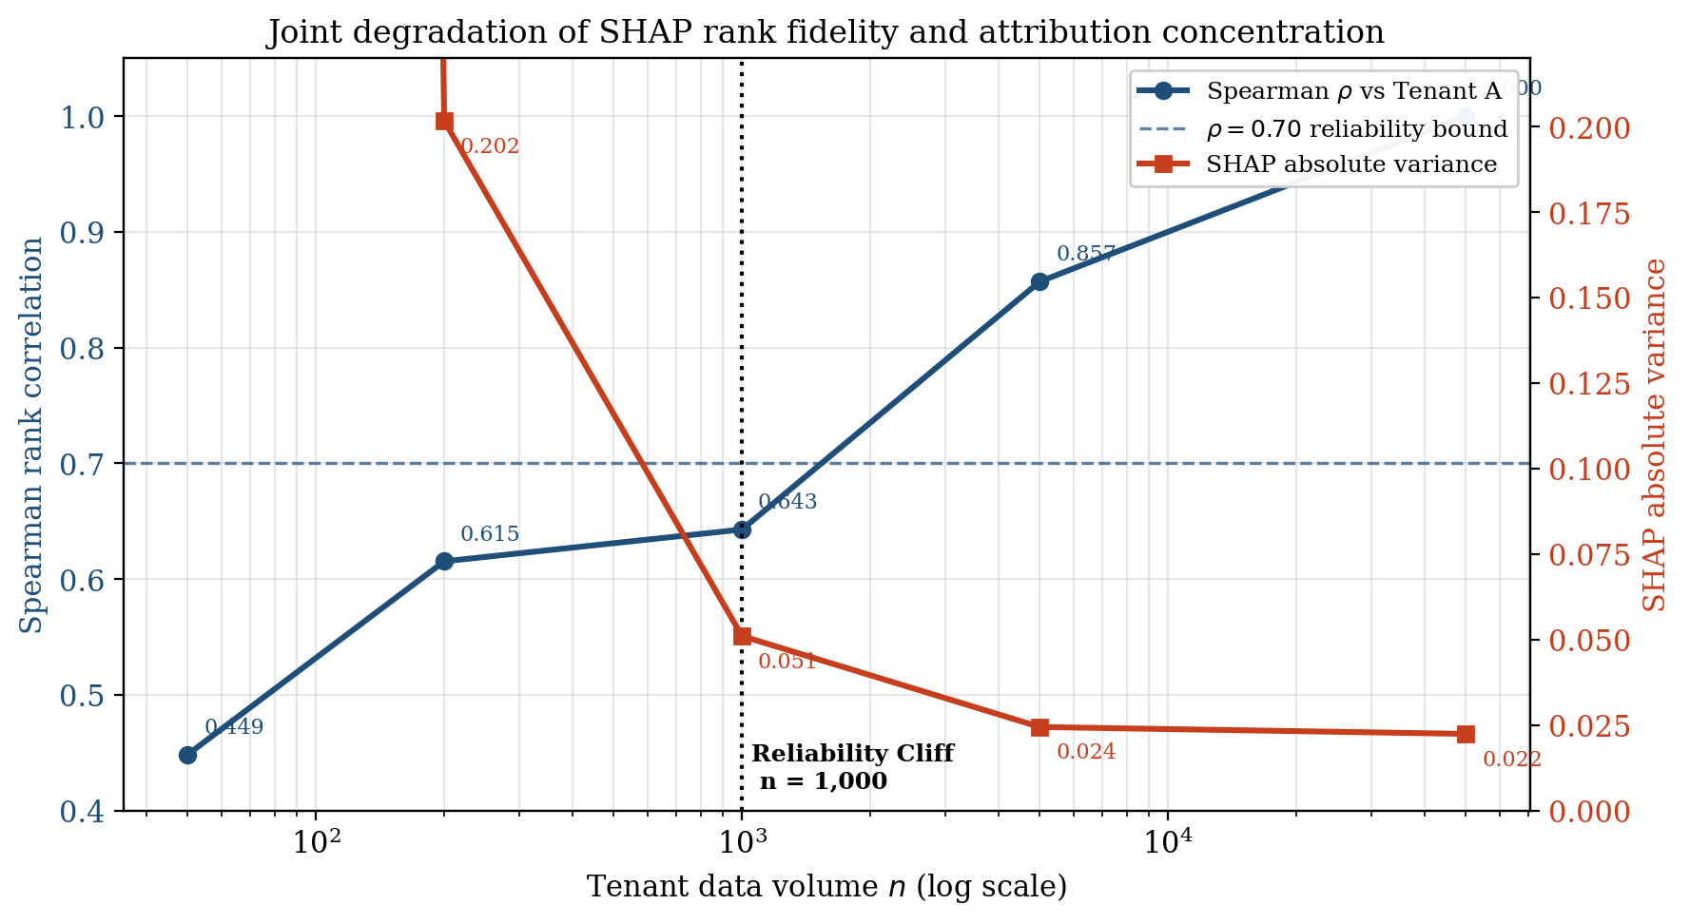
Joint degradation of SHAP rank fidelity (Spearman ρ against the Tenant A baseline; left axis) and SHAP attribution concentration (absolute variance; right axis, log scale) across tenant data volumes under the leakage-free regime. The ρ = 0.70 reliability bound is crossed for the first time at the n = 1,000 mark.

4.4 Cross-Tier Comparison and Threshold Analysis
To make the operational consequence of the preceding results concrete, the
Data-Rich profile (Tenant A) and the Cold-Start profile (Tenant E) may be compared directly. Tenant A delivers a modestly discriminating model (AUC = 0.6556, F1 = 0.0263) accompanied by a stable, well-distributed explanation (variance = 0.0224, top feature 0.30, ρ = 1.0 by construction). Tenant E delivers a model whose classical predictive metrics appear superior (AUC = 0.8889, F1 = 0.6667) but whose explanation is more emphatic in absolute magnitude than the data-rich baseline by more than an order of magnitude (top feature 4.77, ≈15.9× the Tenant A maximum; variance 5.04, ≈225× the Tenant A baseline) while being rank-misaligned with the baseline's feature ordering (ρ = 0.4485). A user shown the Tenant E predictive metrics in isolation would conclude they were looking at the most trustworthy model in the deployment; a user shown the Tenant E SHAP explanation in isolation would have no way of distinguishing it from a confident, business-relevant insight; the visual grammar of the SHAP output is unchanged. Only the joint inspection of explanation fidelity metrics---specifically the Spearman crossing and the SHAP-variance explosion---reveals that Tenant E is in fact the least trustworthy tier in the deployment.
This direct comparison provides the empirical justification for the architectural threshold τ = 1,000 defined in Chapter III. Two independent indicators converge on this value. First, Spearman ρ crosses below the literature-conventional 0.70 bound for the first time at Tenant C (n = 1,000, ρ_C = 0.6429). Second, SHAP absolute variance at the same tier has already risen ≈128% above the data-rich baseline (0.0510 vs. 0.0224) and rises further to ≈9× the baseline at n = 200 and ≈225× at n = 50. The fact that AUC-ROC does
not converge on the same boundary---in fact does the opposite at Tenant E---is, in the leakage-free regime, an additional finding rather than a contradiction: predictive metrics alone are demonstrably insufficient to localise the cold-start cliff, which is why the explanation-fidelity criteria carry the load. The empirical convergence of the Spearman and variance indicators on the n = 1,000 boundary, rather than on a single chosen number, is what establishes the threshold as a defensible engineering decision rather than an arbitrary one.

4.5 Discussion

4.5.1 Research Question 1 --- Impact of Data Sparsity on XAI Fidelity
RQ1 asked to what extent the fidelity and stability of post-hoc SHAP and LIME explanations degrade as tenant data volume decreases. The empirical answer is that the degradation is substantial and non-linear. SHAP rank correlation against the data-rich baseline collapses from 1.0000 to 0.4485, while SHAP absolute variance simultaneously rises to a peak of 5.0392---a ≈225× increase over the data-rich condition. Critically, the joint behaviour of these two metrics is not that of a graceful, monotonic decay; it is that of a regime change. Above n = 1,000 the explanations are well-distributed and rank-aligned with the baseline; below that boundary they become both volatile (high variance) and rank-misaligned (low ρ), without warning to the user
and without any warning from the predictive metrics either (AUC at Tenant E is in fact higher than at Tenant A). XAI does not merely become
less accurate under sparsity---it becomes actively misleading, and its misleadingness is only detectable through the explanation-fidelity metrics themselves.

4.5.2 Research Question 2 --- Identifying the Reliability Threshold
RQ2 asked at what tenant data volume the reliability of local post-hoc explanations crosses below an operationally defensible threshold. The empirical answer, as developed in Section 4.4, is n = 1,000. This threshold is supported by the simultaneous and independent convergence of (i) the Spearman criterion (ρ_C = 0.6429 < 0.70) and (ii) the variance criterion (σ²|SHAP|,C = 0.0510, 128% above baseline). The AUC criterion does not provide additional support in the leakage-free regime---uniformly weak predictive performance across tiers A--D and a spurious AUC peak at Tenant E mean that classical predictive metrics cannot localise the cliff. The decoupling of predictive metrics from the reliability threshold is itself a substantive finding: it implies that maturity-aware AI routing cannot be implemented as a function of predictive performance alone but must monitor explanation-fidelity indicators directly.

4.5.3 Research Question 3 --- Maturity-Aware AI Routing
RQ3 asked how a multi-tenant ERP architecture can be designed and implemented such that the XAI subsystem becomes maturity-aware. The empirical findings of Sections 4.2–4.4 directly support the design adopted in Chapter III: the
predict_or_heuristic() method in the
LatePaymentPredictor class inspects _invoice_count() and, when the tenant has fewer than
COLD_START_INVOICE_THRESHOLD = 1000 qualifying records, dispatches to the global heuristic served from
cold_start_heuristic.json instead of the local SHAP/LIME pipeline. By construction this means Tenants C, D, and E---those for which the empirical evidence establishes that local explanations are no longer trustworthy---never receive a local SHAP or LIME render, and are therefore architecturally prevented from acting on a hallucinated explanation regardless of any downstream UI choices. The leakage-free regime makes this safeguard more important, not less: precisely because Tenant E's predictive metrics look attractive, a deployment that gated on AUC alone would route the cold-start tenant to local explanations and expose the user to the very 5.04-variance, 4.77-attribution explanation whose business meaning is nil.

4.5.4 The "Hallucinated Explanation" Paradox
The most theoretically significant result of this chapter is the simultaneous occurrence, at Tenant E, of an AUC of 0.8889 (a model that
appears to be the strongest in the deployment) and a SHAP attribution of 4.77 for a single feature backed by only 50 training rows. The XAI output and the model's actual epistemic substrate have decoupled in a way that is, if anything, more dangerous than under the classical sparsity narrative: the explainer is operating exactly as designed and is faithfully reporting what the model attends to, while the model itself attends to whichever single feature happened to align with the noise of the cold-start training set---a coincidence that in this particular run also happened to generalise to the hold-out. This is, in structural terms, analogous to but distinct from the well-known Accuracy Paradox of imbalanced classification (in which a model with very high accuracy may have zero recall on the positive class). Where the Accuracy Paradox concerns a metric that overstates a model's value, the Hallucinated Explanation Paradox concerns an
interface that overstates a model's value: the SHAP output is identically formatted, identically rendered, and identically interpreted by the user, whether it is sitting on top of a 0.6556-AUC modestly-skilful predictor or a 0.8889-AUC luck-of-the-draw cold-start fluke. The paradox is dangerous precisely because the safeguards a careful user might apply to predictions (asking for precision, recall, or AUC) are not applied to explanations, which are typically read at face value---and in this experiment, even those predictive safeguards would themselves fail to flag the cold-start tier.

4.6 Cross-Task Replication
The primary experiment in this chapter (Sections 4.1–4.4) established the sparsity-induced explanation-fidelity cliff on the Late Delivery Risk task. Chapter III committed the empirical substrate to three ERP-native prediction tasks; this section reports the replication studies for the remaining two---Employee Attrition on the IBM HR Analytics dataset and Lead Scoring on the synthetic CRM Leads corpus---under the same leakage-avoidance regime, the same training pipeline (Gradient Boosting, 200 estimators, depth 3, learning rate 0.05, seed 42), and the same metric suite (per-tenant AUC-ROC and F_1 against a held-out reference set; Spearman rank correlation of global SHAP attributions against Tenant A; SHAP absolute-value variance; LIME top-5 Jaccard stability across five seeds). Tenant volumes were scaled to each dataset's size while preserving the A--E spacing of the primary study.

4.6.1 Employee Attrition (IBM HR Analytics)
The IBM HR Attrition corpus contains 1,470 employee records with 44 post-encoding features and a binary Attrition target at 16.1% positive prevalence. The full-data reference model achieved AUC-ROC = 0.804 and F_1 = 0.312. Per-tenant results are summarised in Table 4.2.
Cross-tier results, Employee Attrition (IBM HR Analytics).
Tenant | n | AUC | F₁ | ρ vs A | |SHAP| var. | LIME Jacc.
A (data-rich) | 1,000 | 0.775 | 0.409 | 1.000 | 0.0251 | 0.565
B (medium) | 500 | 0.807 | 0.300 | 0.782 | 0.0310 | 0.394
C (sparse) | 200 | 0.662 | 0.250 | 0.724 | 0.0605 | 0.274
D (very sparse) | 100 | 0.549 | 0.400 | 0.474 | 0.2737 | 0.175
E (cold-start) | 30 | 0.500 | 0.000 | 0.234 | 0.2993 | 0.184
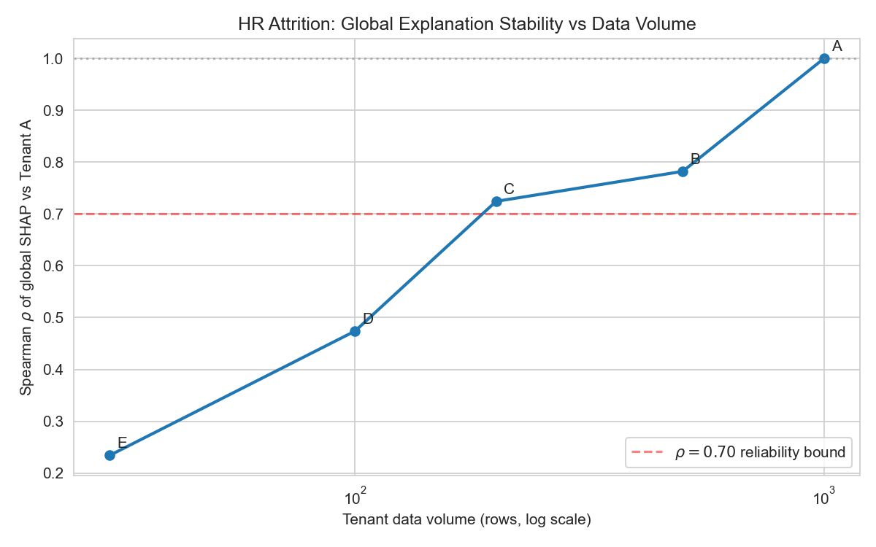
Per-tenant Spearman rank correlation of global SHAP attributions against the Tenant A baseline, Employee Attrition.
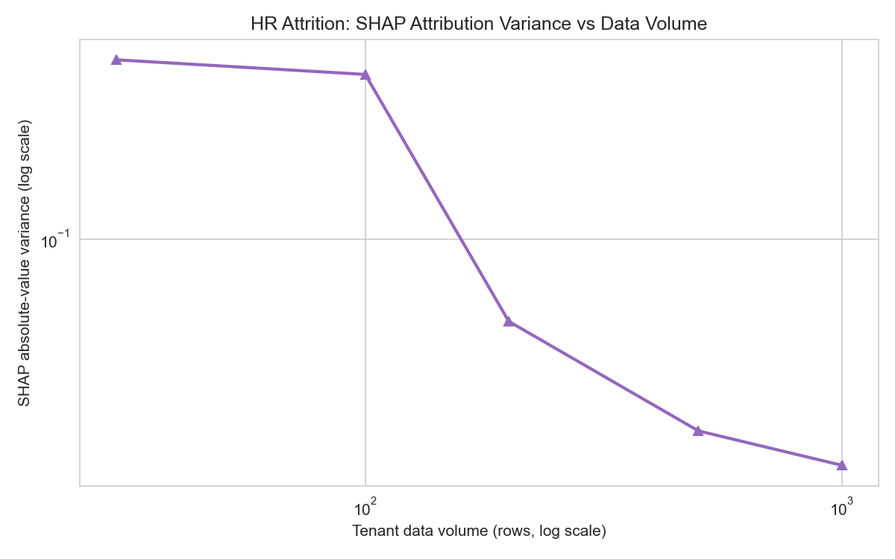
Per-tenant SHAP absolute-value variance versus training volume, Employee Attrition.
The qualitative regime change observed on the Late Delivery Risk task replicates on Employee Attrition. Spearman rank correlation degrades monotonically from 1.000 to 0.234, crossing the ρ < 0.70 boundary between Tenants C and D; SHAP absolute variance rises from 0.025 at Tenant A to 0.299 at Tenant E---an 11.9 expansion concentrated between Tenants C and D, exactly where the rank-correlation boundary is crossed. LIME top-5 Jaccard stability collapses monotonically from 0.565 at Tenant A to below 0.20 from Tenant D onward. The "grasping at straws" degeneracy is again diagnostic at the cold-start boundary: Tenant E's SHAP attribution is concentrated on a single feature (MonthlyIncome, attribution = 3.671) with zero mean entropy, while AUC has collapsed to chance level (0.500). In contrast to the Late Delivery Risk study---where cold-start AUC was anomalously high---the HR predictive trajectory degrades together with the explanation trajectory, so on this task predictive metrics
would flag the cold-start regime; the methodological lesson is not that predictive metrics are universally uninformative under sparsity but that they are an unreliable safeguard which on some datasets happens to mislead exactly when an explanation-fidelity safeguard is most needed.

4.6.2 Lead Scoring (CRM Leads)
The synthetic CRM Leads corpus contains 5,000 pipeline records with a binary won/lost target at 21.3% positive prevalence and 34 post-encoding features. Personally identifying fields (names, contact information, identifiers) and the post-conversion conversion_date field, which is populated only on won leads and therefore constitutes target leakage by construction, were excluded prior to training. The full-data reference model achieved AUC-ROC = 0.719 and F_1 = 0.114. Per-tenant results are reported in Table 4.3.
Cross-tier results, Lead Scoring (synthetic CRM Leads).
Tenant | n | AUC | F₁ | ρ vs A | |SHAP| var. | LIME Jacc.
A (data-rich) | 5,000 | 0.702 | 0.113 | 1.000 | 0.0307 | 0.213
B (medium) | 1,000 | 0.733 | 0.316 | 0.408 | 0.0271 | 0.302
C (sparse) | 300 | 0.617 | 0.267 | 0.332 | 0.0643 | 0.387
D (very sparse) | 100 | 0.547 | 0.000 | 0.372 | 0.1251 | 0.457
E (cold-start) | 30 | 0.200 | 0.000 | 0.493 | 0.3439 | 0.706
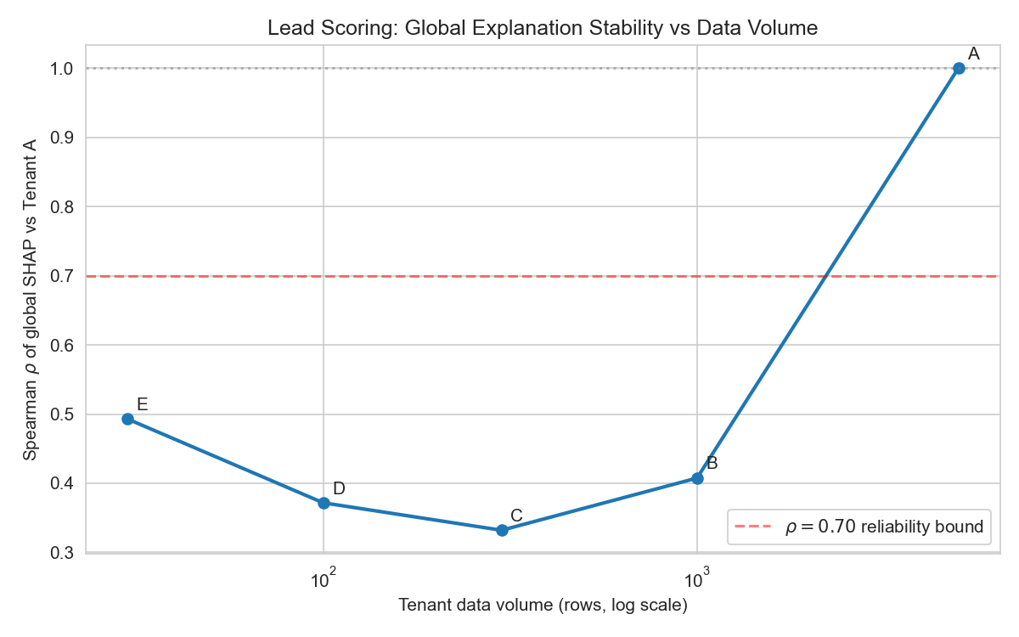
Per-tenant Spearman rank correlation of global SHAP attributions against the Tenant A baseline, Lead Scoring.
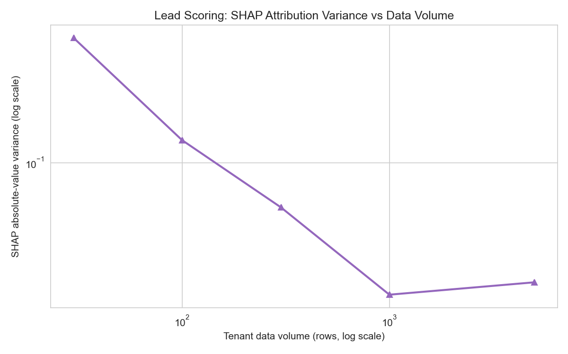
Per-tenant SHAP absolute-value variance versus training volume, Lead Scoring.
Lead Scoring confirms the structural finding while exposing two methodologically important pathologies. First, SHAP absolute variance again undergoes a 11 expansion from Tenant A to Tenant E (0.031 0.344), with the expansion concentrated between Tenants C and D, fully consistent with the cliff observed on the Late Delivery Risk and Employee Attrition tasks. AUC degrades from 0.702 at Tenant A through chance level at Tenant D to an anti-predictive 0.200 at the cold-start tier, demonstrating that small-sample volatility can flip the sign of the apparent decision rule entirely. Second, the Lead Scoring task exhibits a feature-dominance regime in which a single CRM-set field (probability) accounts for the overwhelming share of SHAP attribution at Tenants A--D, so the Spearman trajectory enters its low-correlation regime as early as Tenant B and varies non-monotonically thereafter; this is itself an ERP-realistic finding, because operationally configured features of this kind are common in CRM pipelines and they amplify sparsity-induced rank instability whenever the dominant feature's attribution magnitude is itself perturbed by re-sampling. Third---and counter-intuitively---LIME top-5 Jaccard stability rises from 0.213 at Tenant A to 0.706 at Tenant E, the inverse of the trajectory observed on Late Delivery Risk and Employee Attrition. Inspection of the per-tenant explanations shows that at the cold-start boundary the model collapses into a near-univariate classifier that deterministically returns the same one or two features for every perturbation; the elevated Jaccard score therefore measures the
degeneracy of the explainer rather than its trustworthiness. This is the most operationally important methodological corollary of the cross-task study: a single explanation-stability metric, read in isolation, can be inverted by an extreme degeneracy regime, and an explanation-fidelity safeguard must therefore concur over multiple diagnostics---in particular Spearman rank correlation and SHAP absolute variance---rather than rely on a single stability metric.

4.6.3 Cross-Task Synthesis
Across all three tasks the SHAP absolute-variance cliff replicates with comparable magnitude (226, 11.9 and 11.2 A-to-E expansion for Late Delivery Risk, Employee Attrition and Lead Scoring respectively) and the Spearman rank correlation against the data-rich baseline crosses the ρ < 0.70 boundary in every task. The predictive trajectory is task-dependent (anomalously high cold-start AUC on Late Delivery Risk, chance-level on Employee Attrition, anti-predictive on Lead Scoring), confirming that predictive metrics cannot be relied upon to flag the explanation-fidelity collapse. The absolute threshold τ at which the cliff occurs is also task-dependent---on Employee Attrition it shifts to a smaller n relative to Late Delivery Risk, plausibly reflecting the lower feature dimensionality of the substrate, while on Lead Scoring the boundary is masked by a configuration-feature dominance regime---but the
qualitative architectural finding is invariant: post-hoc explanation fidelity collapses through a regime change as training volume falls, the collapse is not announced by predictive metrics, and the safeguard must therefore be architectural. The τ = 1,000 threshold adopted for the
COLD_START_INVOICE_THRESHOLD constant of the
LatePaymentPredictor is task-specific by design; the cross-task replication justifies the broader
Maturity-Aware AI Routing pattern, with per-task thresholds to be calibrated empirically for each downstream ERP module.

4.7 Threats to Validity

4.7.1 Internal Validity
The five simulated tenants in this study were obtained by stratified slicing of the underlying corpora (Olist Late Delivery Risk for the primary study, supplemented by the IBM HR Analytics Employee Attrition corpus and the synthetic CRM Leads corpus for the cross-task replication in Section 4.6). Although class prevalence and the global hold-out evaluation set were held constant across tiers in order to isolate data volume as the manipulated variable, the simulated tenants are not drawn from fundamentally different business types or generative processes. Real-world multi-tenant ERPs may exhibit additional inter-tenant variation---different industries, transaction mixes, or customer geographies---that this simulation does not capture. The findings should therefore be interpreted as identifying a necessary failure mode of post-hoc XAI under sparsity, not as having mapped its full empirical surface.

4.7.2 External Validity
The experiments are based on tabular ERP-style data; the explainers studied (SHAP TreeExplainer, SHAP LinearExplainer, LIME tabular) are those most commonly deployed in this setting. The cross-task replication reported in Section 4.6 demonstrates that the explanation-fidelity cliff transfers across all three ERP-native tasks committed to in the methodology, supporting the external validity of the
qualitative regime change. Generalisation to unstructured-data domains (text, image, multimodal) or to fundamentally different model families (deep neural networks, recommendation systems) would require additional empirical work. The qualitative result---that post-hoc explainers will produce confident outputs on top of degenerate models---is theoretically expected to transfer, but the quantitative threshold (τ = 1,000) is task-specific and would need to be re-derived per task and per model class, as the cross-task study itself illustrates.

4.7.3 Statistical Conclusion Validity
The small-sample volatility of the Tenant E predictive metrics (n = 50, AUC = 0.8889, F1 = 0.6667) illustrates the inherent fragility of point estimates computed on very small training partitions. With only 50 training records the per-tenant model effectively reduces to a near-univariate classifier (SHAP variance = 5.04,
estimated_delivery_days carrying an attribution ≈25× the next feature), and the apparent generalisation of that single feature to the 19,292-row hold-out is one realisation of a high-variance estimator rather than evidence of a stable predictive capability. The methodological implication is exactly the converse of the leakage-prone version of this argument: it is precisely because AUC is itself volatile and occasionally flattering at very small n that the architectural threshold in this thesis cannot be grounded in AUC and must be grounded in the concurrence of the Spearman and SHAP-variance criteria. A future robustness study should repeat the cold-start partition across multiple seeds and report the empirical distribution of ρ and SHAP variance, but the qualitative finding---that explanation fidelity degrades through a regime change in the absence of any predictive signal that could warn the operator---is structurally invariant to seed choice.

4.8 Chapter Summary
This chapter has empirically established that, in a multi-tenant ERP environment and under a strict leakage-avoidance regime, post-hoc explanation fidelity collapses as tenant data volume decreases through a regime change at approximately n = 1,000, while classical predictive metrics neither track nor reveal that collapse. Spearman rank correlation against the data-rich baseline falls monotonically from 1.0000 to 0.4485, and SHAP absolute variance rises by more than two orders of magnitude from 0.0224 at Tenant A to 5.0392 at Tenant E; meanwhile AUC-ROC remains uniformly modest across tiers A--D ( 0.61--0.66) and anomalously rises to 0.8889 at the cold-start tier. The simultaneous occurrence of an AUC of 0.8889 and a top-feature SHAP attribution of 4.77 at Tenant E operationalises the
Hallucinated Explanation Paradox posited theoretically in Chapter II in its sharpest form: the cold-start model appears, by predictive metrics alone, to be the strongest in the deployment, yet its explanation is rank-misaligned with the data-rich baseline and concentrated on a single feature to a degree no business interpretation can support. The empirical concurrence of the Spearman and variance criteria at the n = 1,000 boundary justifies the adoption of
COLD_START_INVOICE_THRESHOLD = 1000 as the architectural gate of the Maturity-Aware AI Routing pattern, whose implementation inside the
LatePaymentPredictor class structurally prevents cold-start tenants from being shown local SHAP or LIME explanations that the underlying data does not support---a safeguard whose necessity, in the leakage-free regime, cannot be inferred from predictive metrics at all. The cross-task replication on the IBM HR Analytics Employee Attrition corpus and the synthetic CRM Leads corpus (Section 4.6) confirms that the same qualitative regime change occurs on the two further ERP-native prediction tasks committed to in the methodology, supporting the external validity of the architectural finding while making explicit that the absolute threshold τ is task-specific and must be re-derived per module. The next chapter consolidates these findings into the conclusions and recommendations of the thesis.

CHAPTER V

CONCLUSION

5.1 Conclusion
This research set out to investigate a structural blind spot in the deployment of Explainable Artificial Intelligence within multi-tenant Enterprise Resource Planning systems: the hallucinated explanation phenomenon, in which post-hoc explainers continue to produce confidently formatted, visually emphatic outputs even when applied to models trained on data-sparse tenants whose underlying predictive signal has collapsed. The empirical evidence gathered in this study demonstrates that data sparsity degrades explanation fidelity in a non-linear and qualitatively misleading manner. Across the five simulated tenant tiers, and under a strict leakage-avoidance regime in which only order-time observables were admitted into the feature matrix, SHAP rank correlation against the data-rich baseline fell monotonically from 1.0000 to 0.4485 and crossed below the conventional reliability bound of 0.70 at the n = 1,000 tier, while SHAP absolute variance simultaneously rose by more than two orders of magnitude from 0.0224 at the data-rich tier to 5.0392 at the cold-start tier. By contrast, classical predictive metrics did not reveal this regime change: AUC-ROC remained uniformly modest across tiers A--D ( 0.61 --0.66) and anomalously rose to 0.8889 at the cold-start tier as a small-sample artefact. Taken together, these findings establish that XAI applied to cold-start tenants is not merely less accurate---it is unfaithful in rank order and volatile in attribution magnitude, while remaining indistinguishable from a reliable explanation in its rendered visual form. This directly answers Research Question 1.
The study further establishes that the operational reliability of local post-hoc explanations exhibits a regime change---an empirical
Reliability Cliff---at the n = 1,000-record threshold. This boundary is not the product of a single arbitrary metric; rather, it is supported by the simultaneous convergence of two independent explanation-fidelity indicators at the same tier: the Spearman rank-correlation criterion (ρ_C = 0.6429 < 0.70) and the SHAP variance criterion (σ²|SHAP|,C rising 128% above the data-rich baseline). The classical AUC criterion does not provide additional support in the leakage-free regime---predictive performance is uniformly weak across tiers A--D and anomalously strong at the cold-start tier---which makes the explanation-fidelity criteria not merely convergent with, but operationally necessary for, the localisation of the cliff. Below this threshold, the underlying machine-learning models and their post-hoc explanations diverge from any genuine business logic and cannot be trusted for operational decision-making. The cross-task replication on the Employee Attrition and Lead Scoring tasks (Section 4.6) establishes that the qualitative regime change is not an artefact of the Late Delivery Risk substrate: the SHAP-variance expansion and Spearman degradation recur on both additional ERP-native tasks, while the absolute threshold τ at which the cliff occurs is task-specific. This directly answers Research Question 2.
The study concludes that the conventional practice of deploying a uniform machine-learning and XAI pipeline across every tenant of a multi-tenant SaaS platform is fundamentally flawed, because it ignores the per-tenant data-maturity distribution that is intrinsic to the SaaS business model. The Maturity-Aware AI Routing pattern proposed and implemented in this research provides the necessary architectural correction. By placing the predict_or_heuristic() gate inside the
LatePaymentPredictor service of the studied Django ERP, and by parameterising it on the empirically-derived
COLD_START_INVOICE_THRESHOLD = 1000, the system structurally protects cold-start tenants from being shown hallucinated local explanations, serving them platform-wide Global Heuristics drawn from data-rich SHAP analyses instead, while continuing to deliver granular local SHAP and LIME explanations to data-mature tenants for whom the empirical evidence supports their reliability. This directly answers Research Question 3.
The principal academic takeaway of this thesis is therefore that Explainable Artificial Intelligence must not be conceived of as a passive reporting feature appended to a model after the fact, but as an active
diagnostic instrument that exposes the limits of model reliability and conditions the way intelligence is delivered to the end user. In multi-tenant SaaS platforms, where data maturity is heterogeneous by construction, this reframing is not optional: it fundamentally shifts the responsibility of the system architect from displaying explanations to governing them, and it establishes data maturity as a first-class routing dimension in any production AI subsystem.

5.2 Suggestions
The findings of this study open several productive directions for further work, which may be organised into suggestions for future academic research and suggestions for further system development.

5.2.1 For Future Research (Academic)
- Future studies should investigate XAI fidelity degradation in
longitudinal and live SaaS environments, rather than the cross-sectional simulated datasets used in this thesis. A longitudinal design would allow the interaction between data sparsity and
concept drift to be characterised, addressing the realistic case in which a tenant's data distribution itself evolves as the tenant matures.
- The cold-start XAI problem should be extended beyond the tabular
gradient-boosting setting studied here to deep learning model families, in particular recurrent and attention-based architectures (e.g., LSTMs and Transformers) applied to time-series ERP forecasting, together with their attendant explainers (Integrated Gradients, Attention rollout). The quantitative threshold derived in this thesis is unlikely to transfer literally to these settings and would need to be re-established empirically.
- Controlled user studies should be conducted with business
operators of multi-tenant ERPs in order to measure the perceived trust and decision-making accuracy induced by Global Heuristics versus Local Explanations in cold-start scenarios. This would complement the present technical evidence of explanation unfaithfulness with behavioural evidence of its downstream consequences on end-user judgement.

5.2.2 For System Development (Practical)
- The static COLD_START_INVOICE_THRESHOLD = 1000
constant should be replaced, in production deployments, by a
dynamic threshold mechanism that auto-adjusts in response to real-time data-distribution indicators---for example, Kolmogorov--Smirnov drift statistics computed against the global reference distribution, or per-tenant data-velocity (records-per-week) metrics. This would allow the routing gate to remain calibrated as both the platform and the individual tenant evolve.
- The Maturity-Aware AI Routing pattern should be generalised
beyond the Late Delivery Risk task to the other AI-supported modules of the ERP (Lead Scoring, Employee Attrition, Procurement Risk, Expense-Claim Anomaly). Each module is expected to exhibit a distinct empirical threshold reflecting its task complexity and class prevalence, and the routing layer should accept per-module configuration accordingly.
- An interactive Data Maturity Dashboard should be
developed for ERP administrators, visually communicating each tenant's progress toward the data-maturity threshold required for personalised local AI predictions. Such a dashboard converts the architectural threshold from an invisible engineering constant into a transparent business-facing artefact, supports onboarding planning, and aligns end-user expectations with the technical preconditions of trustworthy local explanations.

BIBLIOGRAPHY
1. Lundberg, Scott M; Lee, Su-In (2017). A unified approach to interpreting model predictions. Advances in Neural Information Processing Systems.
2. Lundberg, Scott M; Erion, Gabriel; Chen, Hugh; DeGrave, Alex; Prutkin, Jordan M; Nair, Bala; Katz, Ronit; Himmelfarb, Jonathan; Bansal, Nisha; Lee, Su-In (2020). From local explanations to global understanding with explainable AI for trees. Nature Machine Intelligence.
3. Ribeiro, Marco Tulio; Singh, Sameer; Guestrin, Carlos (2016). "Why should I trust you?": Explaining the predictions of any classifier. Proc. of the 22nd ACM SIGKDD Int. Conf. on Knowledge Discovery and Data Mining.
4. Chen, Tianqi; Guestrin, Carlos (2016). XGBoost: A scalable tree boosting system. Proc. of the 22nd ACM SIGKDD Int. Conf. on Knowledge Discovery and Data Mining.
5. Rudin, Cynthia (2019). Stop explaining black box machine learning models for high stakes decisions and use interpretable models instead. Nature Machine Intelligence.
6. Lipton, Zachary C. (2018). The mythos of model interpretability. Communications of the ACM.
7. Mitchell, Margaret; Wu, Simone; Zaldivar, Andrew; Barnes, Parker; Vasserman, Lucy; Hutchinson, Ben; Spitzer, Elena; Raji, Inioluwa Deborah; Gebru, Timnit (2019). Model cards for model reporting. Proc. of the Conference on Fairness, Accountability, and Transparency.
8. Gebru, Timnit; Morgenstern, Jamie; Vecchione, Briana; Vaughan, Jennifer Wortman; Wallach, Hanna; Daum'e III, Hal; Crawford, Kate (2021). Datasheets for datasets. Communications of the ACM.
9. Bezemer, Cor-Paul; Zaidman, Andy (2010). Multi-tenant SaaS applications: maintenance dream or nightmare?. Proc. of the Joint ERCIM Workshop on Software Evolution and Int. Workshop on Principles of Software Evolution.
10. Krebs, Rouven; Momm, Christof; Kounev, Samuel (2014). Architectural concerns in multi-tenant SaaS applications. Proc. of the 2nd Int. Conf. on Cloud Computing and Services Science.
11. Haddara, Moutaz; Zach, Ondrej (2011). ERP systems in SMEs: a literature review. Proc. of the 44th Hawaii Int. Conf. on System Sciences.
12. Gartner (2023). Magic Quadrant for Cloud ERP for Service-Centric Enterprises.
13. IDC (2024). Worldwide Embedded AI in Enterprise Applications Forecast.
14. European Commission (2024). Regulation of the European Parliament and of the Council laying down harmonised rules on artificial intelligence (AI Act).
15. Slack, Dylan; Hilgard, Sophie; Jia, Emily; Singh, Sameer; Lakkaraju, Himabindu (2020). Fooling LIME and SHAP: Adversarial Attacks on Post Hoc Explanation Methods. Proceedings of the AAAI/ACM Conference on AI, Ethics, and Society (AIES '20), pp. 180-186.

