1. A passenger cancels their booking. You need to remove the booking for the flight. Ensure the ‘booking’ table no longer contains the booking. Simulate an error to test rollback (for example, invalid booking_id).
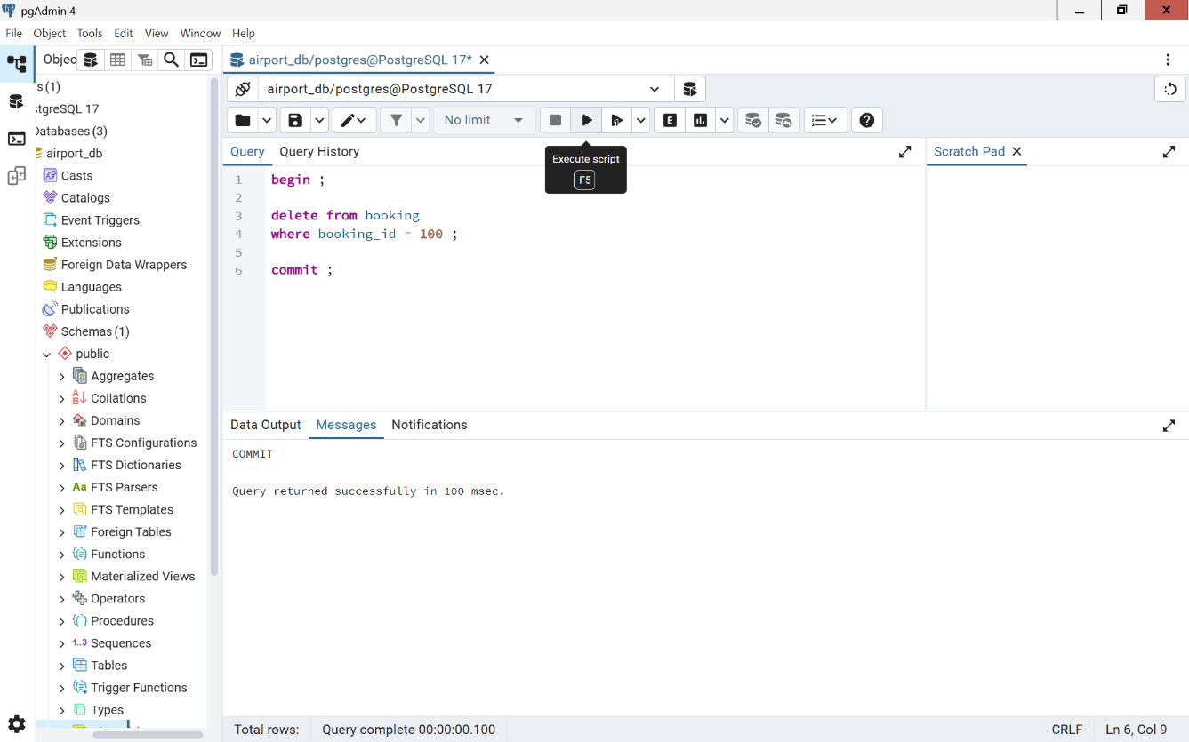
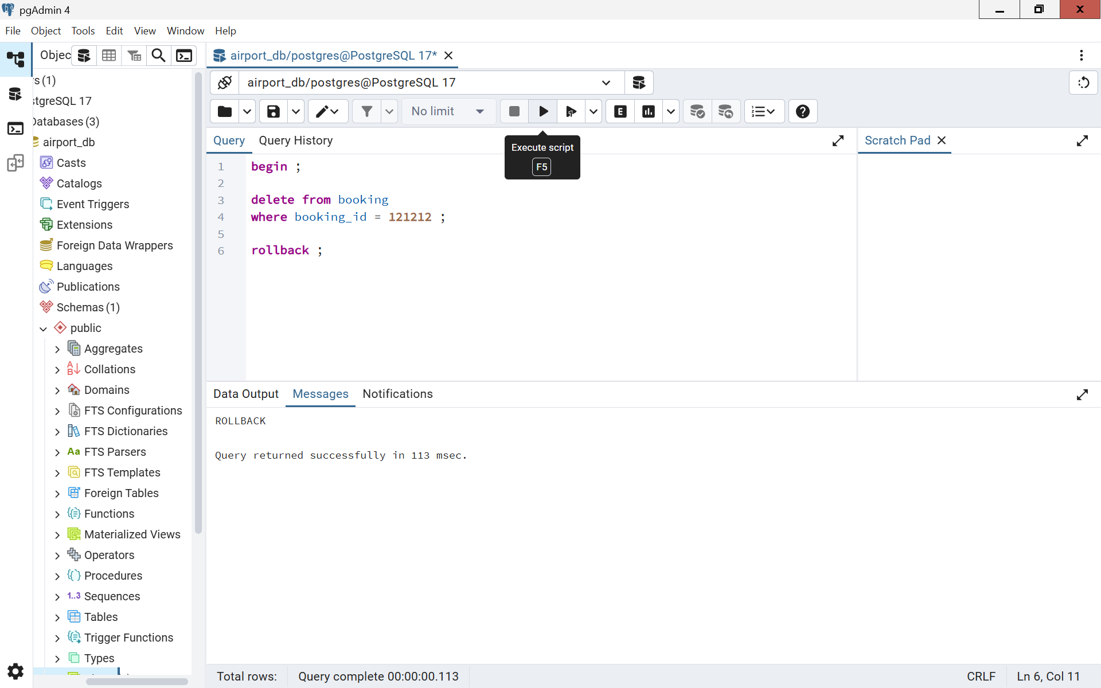

2. Rescheduling a flight. You need to reschedule a flight. Verify the ‘flights’ table reflects the new departure time. Simulate an error to test rollback (for example, invalid flight_id).
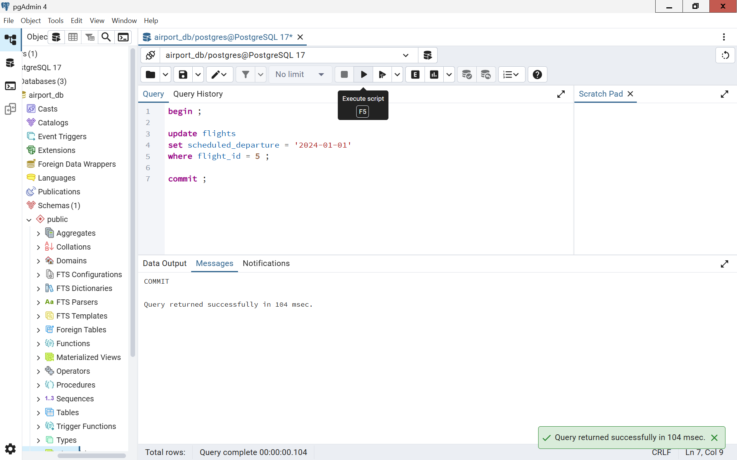
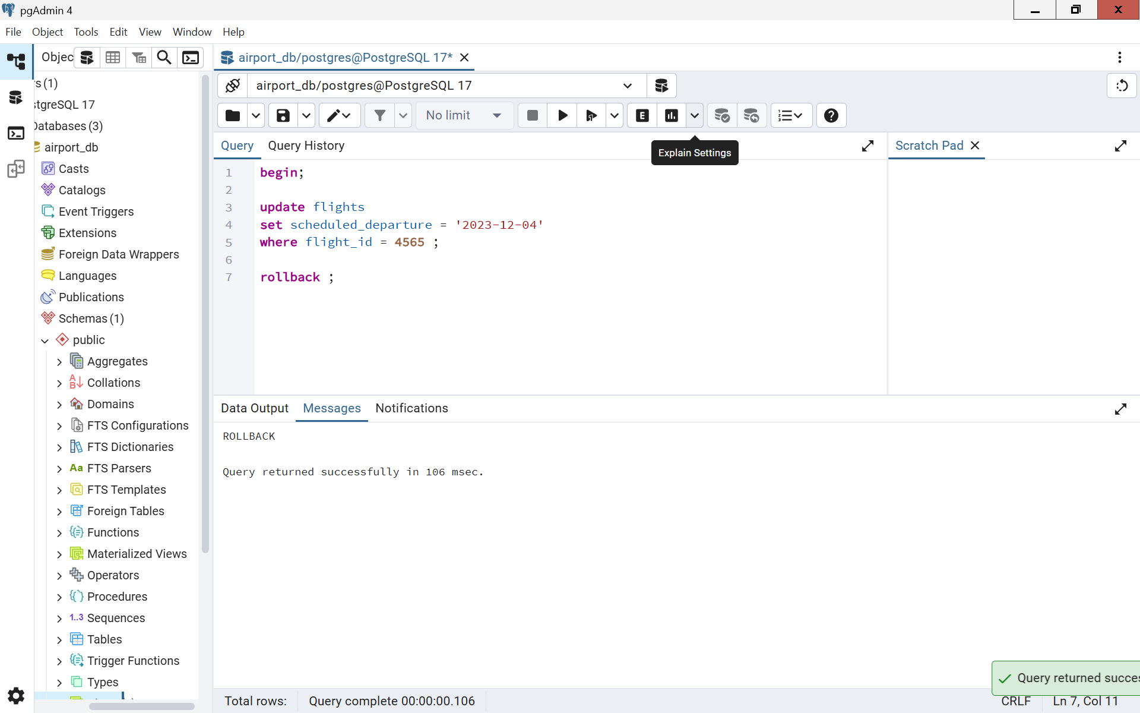
3. Updating ticket prices. You need to decrease the ticket price for a specific flight for all existing bookings. If an error occurs, no changes should be applied.
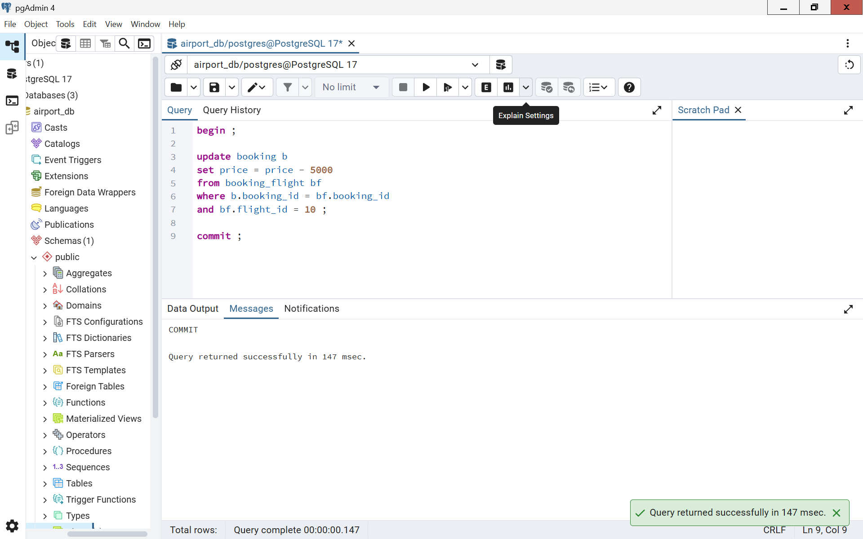
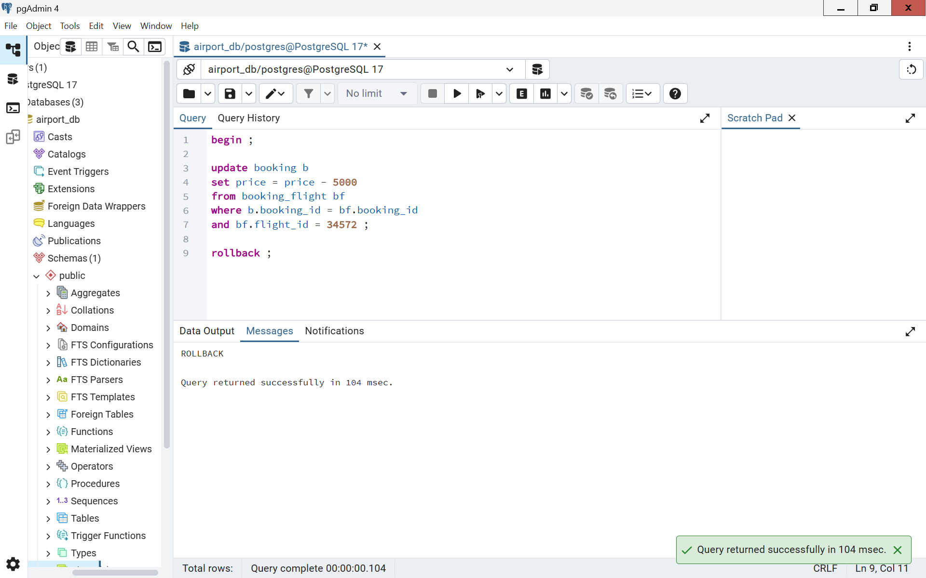
4. A passenger updates their details. Ensure the update is reflected across all associated records, including bookings.
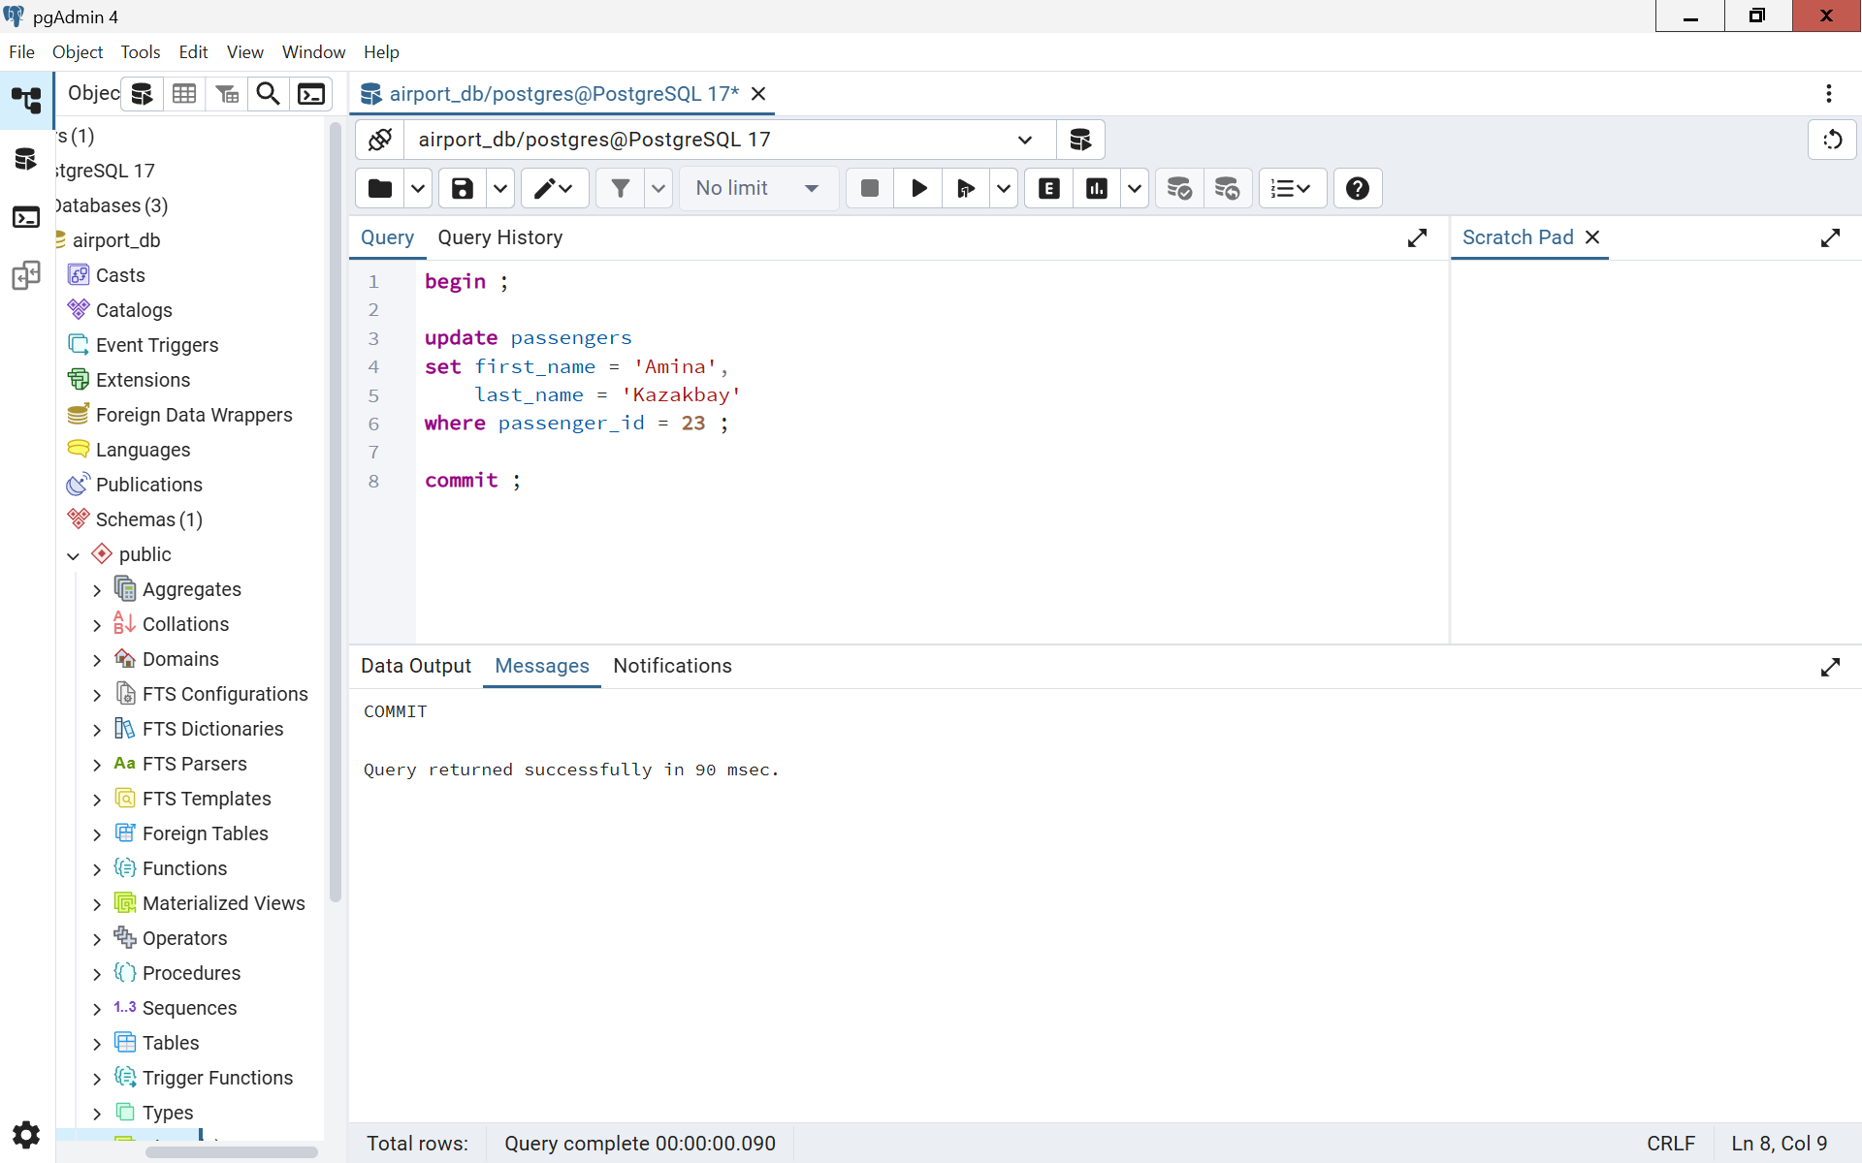
5. A new passenger is registered, and a booking is created. Ensure the new passenger is added and the booking succeeds.
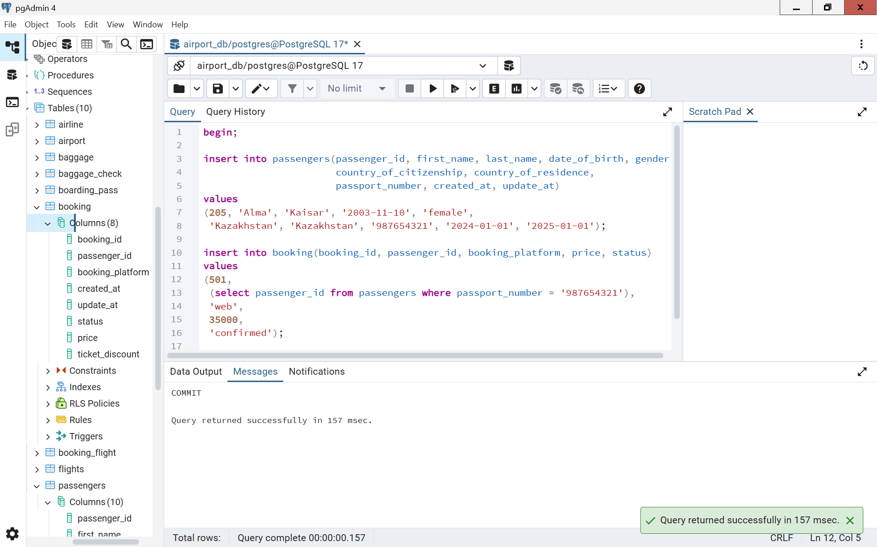
6. Increase the ticket price for all bookings on a specific flight by a fixed amount.
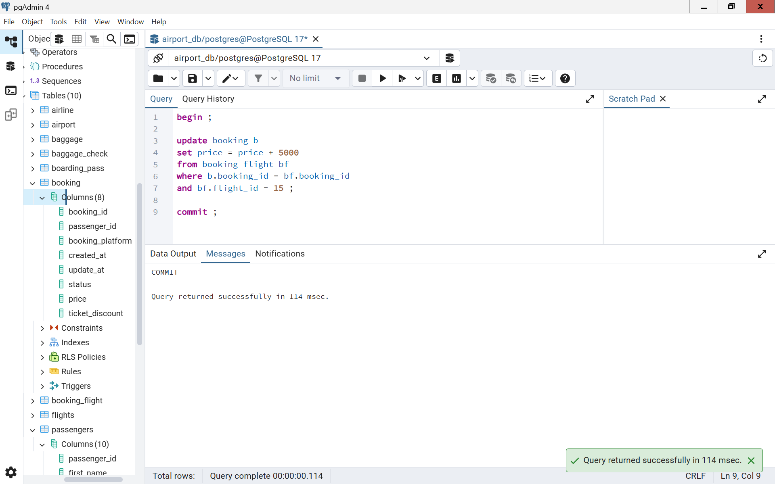
7. Update a baggage weight. A passenger updates the declared weight of their baggage. Ensure that the change is correctly reflected in the database.
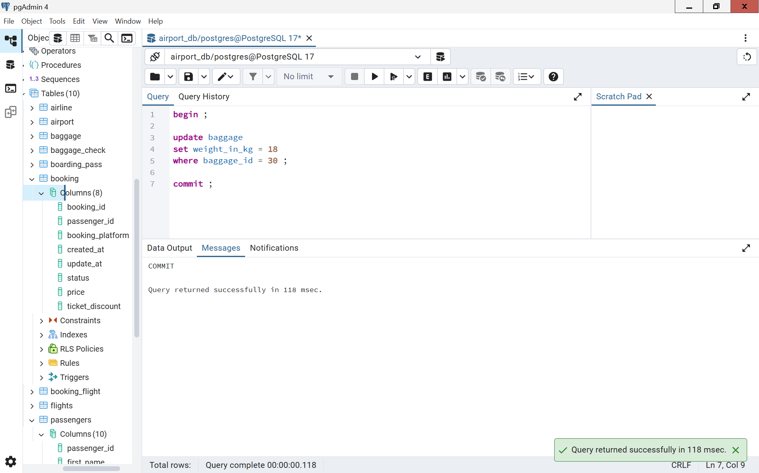
8. Apply a discount to a booking for a specific passenger. If any error occurs, roll back.
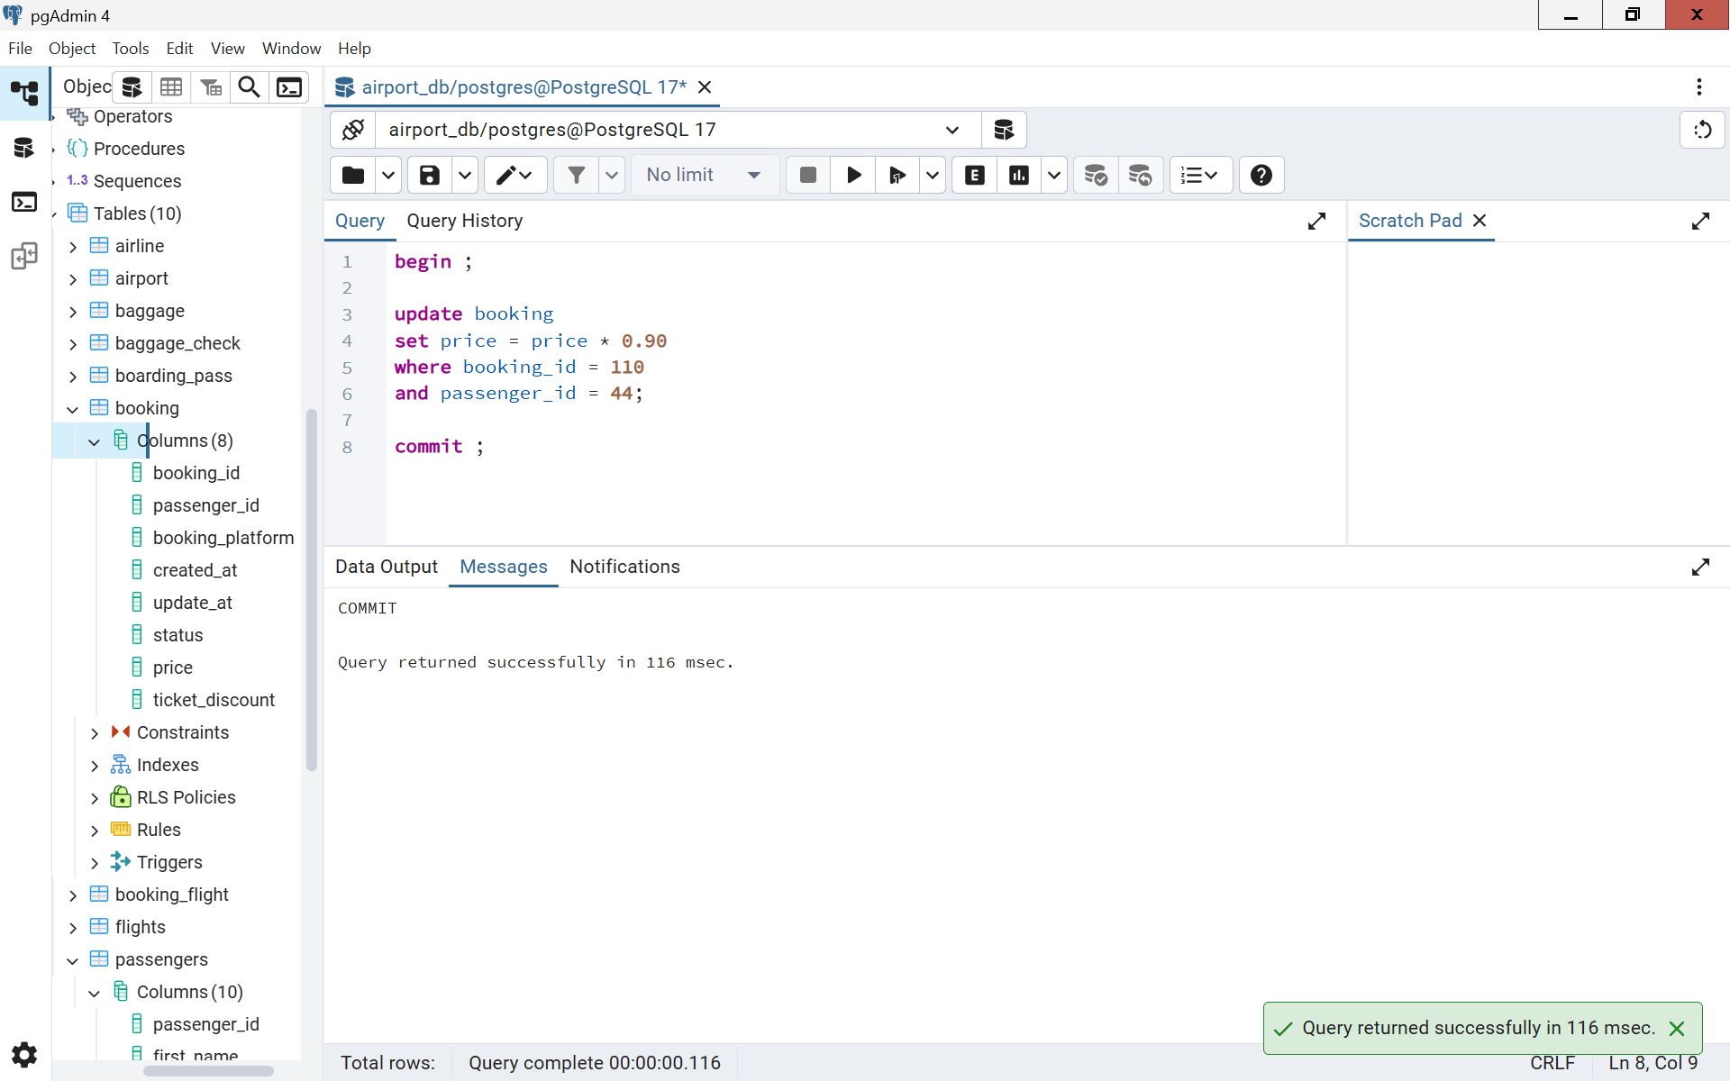
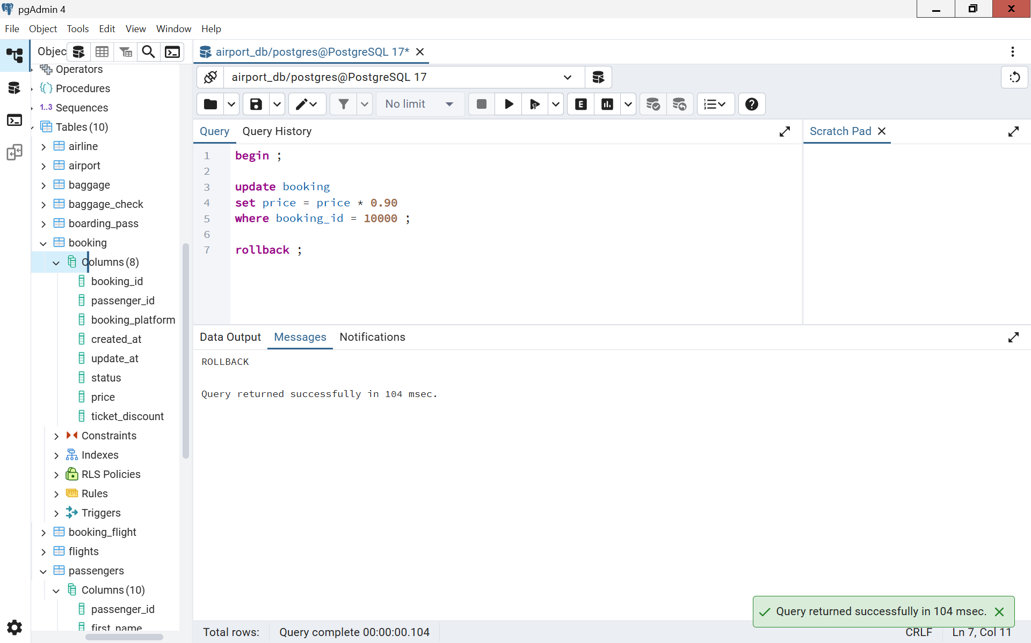
9. Reschedule all bookings for a flight to a new flight.
