1. **Identified Entities:** Airport,Airline,Flight,Passenger,Booking,Boarding_Pass,Baggage,Baggage_Check,Security_Check
2. **Attributes of entities:**

**Airport(**airport_id (PK), airport_name, country, state, city, created_at, updated_at**)**

**Airline(**airline_id (PK), airline_code (Unique), name, country, created_at, updated_at**)**

**Flight(**flight_id (PK), airline_id (FK), departure_airport_id (FK), arrival_airport_id (FK), departing_gate, arriving_gate, scheduled_departure, scheduled_arrival, actual_departure, actual_arrival, created_at, updated_at**)**

**Passenger(**passenger_id (PK), first_name, last_name, gender, date_of_birth, citizenship_country, residence_country, passport_number (Unique), created_at, updated_at**)**

**Booking(**booking_id (PK), flight_id (FK), passenger_id (FK), status, booking_platform, ticket_price, created_at, updated_at)

Boarding_Pass(boarding_pass_id (PK), booking_id (FK), seat, boarding_time, created_at, updated_at**)**

**Baggage(**baggage_id (PK), booking_id (FK), weight_kg, created_at, updated_at)

Baggage_Checking(checking_id (PK), baggage_id (FK), check_result, created_at, updated_at**)**

**Security_Check(**security_check_id (PK), passenger_id (FK), check_result, created_at, updated_at**)**

**3. Normalization (3NF):**

* Each table has a primary key.
* All non-key attributes depend solely on the PK.
* No transitive dependencies — separate BookingChange table to store changes.
* No repeating groups — one record per flight, booking, baggage, etc.

**4. Relations:**

**Airport 1 — N Flight** (departure/arrival): Flight must reference exactly one departure and arrival airport.

**Airline 1 — N Flight**: Each flight belongs to one airline.

**Flight 1 — N Booking**: Bookings cannot exist without a flight.

**Passenger 1 — N Booking**: Passenger may have many bookings.

**Booking 1 — N Boarding_Pass**: One booking can generate many boarding passes.

**Booking 1 — N Baggage**: One booking can have many baggage items.

**Baggage 1 — 0..1 Baggage_Checking**: Each baggage may have zero or one checking record.

**Passenger 1 — N Security_Check**: One passenger can have many security checks.

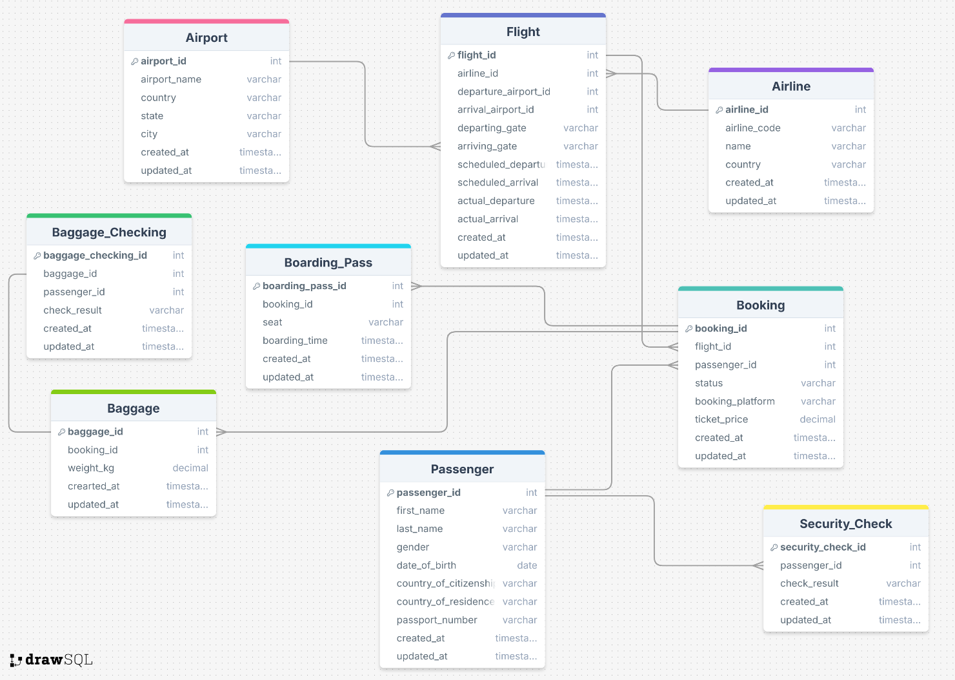

**6. Legend**

* Entity – shown as a box with the entity name
* **PK** – Primary Key (unique identifier for each record)
* **FK** – Foreign Key (connects to primary key of another table)
* Attributes – Characteristics or properties that describe an entity (e.g., name, date, price)
* Relationships – lines connecting entities, labeled with
  + 1:1 – one-to-one relationship
  + 1:N – one-to-many relationship
  + N:M – many-to-many relationship (using a linking table)

**Brief Description:**

* **Airport**: Stores details of all airports.
* **Airline**: Stores airline company data.
* **Flight**: Connects Airline and Airports, contains schedule/actual times.
* **Passenger**: Contains passenger profile info.
* **Booking**: Represents a passenger’s flight reservation.
* **Boarding_Pass**: Generated for each booking, includes seat info.
* **Baggage**: Stores each baggage registered under a booking.
* **Baggage_Checking**: Logs baggage inspection results.
* **Security_Check**: Stores security screening results per passenger.