PORTFOLIO · GAME TESTING

QA Case: Multiplayer Military Simulator
Denis Kurchikov, QA Engineer
3  bug reports from video | 8  checks in a showstopper checklist | 8  test cases for a new effect

About the case
A functional testing case on a multiplayer military simulator. It consists of three independent tasks:
- Task 1. Hangar bugs. Find bugs in a video and write bug reports.
- Task 2. Crew progression. Write a checklist of up to 10 items to catch critical issues in the feature shown in the video.
- Task 3. Afterburner flame. Write five prioritized test cases for a new visual effect.
There was no access to a test build, so bugs were found from video recordings only, and debatable points were checked against the current live client. The game UI in the screenshots is in Russian.
TASK 1

Hangar bugs: finding bugs in a video and reporting them
Task video: hangar, premium account purchase, UI
https://youtu.be/ao7LViPzk28

Assignment: find bugs in the video and write bug reports with all the attributes I consider necessary.

Bugs found
Color - severity: Critical Medium Low
# | Bug | Severity | Priority
1 | Buying a premium account adds Silver Lions instead of deducting Golden Eagles | Critical | High
2 | Nation names in the Research panel are shown as English abbreviations | Medium | Medium
3 | Tooltips do not appear on hover during a camera transition | Low | Low

Bug report 1. Buying a premium account adds Silver Lions instead of deducting Golden Eagles
Precondition | 200+ Golden Eagles on balance
Steps | 1) Launch the game.  2) Open the hangar of any vehicle.  3) Click "Premium account".  4) Note the Golden Eagles and Silver Lions balance.  5) Buy a 1-day premium account.  6) Compare the Golden Eagles and Silver Lions balance.
Expected result | Golden Eagles decrease by 190, Silver Lions stay the same
Actual result | Golden Eagles stay the same (1,125), Silver Lions increase by 190 (273,746 → 273,936)
Severity / priority | Critical / High: the player gets a paid service for free and extra currency on top
Environment, frequency | Unknown (report based on video)
Screenshot | 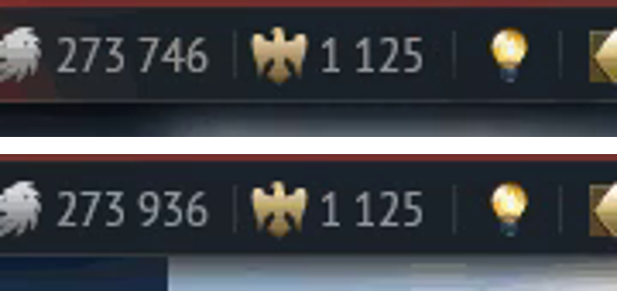  Top: balance before the purchase (~00:09); bottom: after the purchase (~00:30). Lions went up, Eagles did not change.

Bug report 2. Nation names in the Research panel are shown as English abbreviations instead of Russian names
Precondition | Russian UI language
Steps | 1) Launch the game with the Russian UI language.  2) Open the hangar of any vehicle.  3) Look at the row of nation tabs with flags above the vehicle list in the Research section.
Expected result | Nation names are spelled out in Russian («США», «Германия», «СССР», «Британия», «Япония», «Китай», «Италия», «Франция», «Швеция», «Израиль»), as in the current client
Actual result | Two-letter English abbreviations are shown instead (US, DE, SU, GB, JP, CN, IT, FR, SE, IL), while the rest of the UI on screen is localized
Severity / priority | Medium / Medium
Environment, frequency | Unknown (report based on video), presumably reproduces consistently
Note | In the current client (checked personally) these tabs show full Russian names. So the bug either exists only in the older build from the video or has already been fixed.
Screenshot | 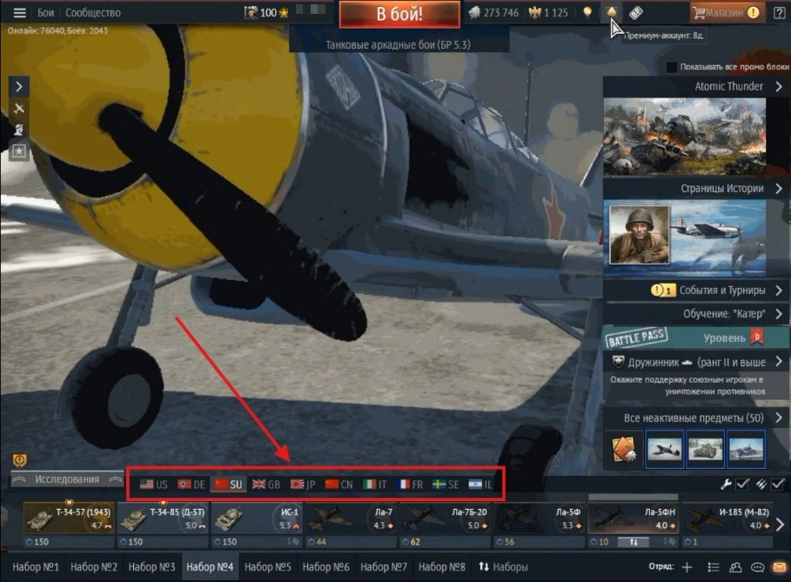

Bug report 3. Tooltips do not appear when hovering over UI elements during a camera transition
Precondition | Player is in the hangar, the camera starts changing angles automatically (with a brief darkening of the 3D scene)
Steps | 1) Open the hangar.  2) Stay idle for about 3 minutes until the camera starts showing the vehicle from different sides.  3) Wait for a camera transition to start (~00:02 in the video).  4) During the transition, hover over a UI element, e.g. the Battle Pass shop icon.  5) Check whether the tooltip appears.
Expected result | The tooltip appears on hover even during a camera transition: the element is visible and clickable
Actual result | During the transition (~00:02) the tooltip does not appear. Right after it (~00:04) hovering over the same element shows the tooltip as usual
Severity / priority | Low / Low
Environment, frequency | Environment unknown (report based on video); seen once on one element, not checked in other sessions
Note | An assumption, not an established fact: the timing matches the scene darkening during the camera transition, so hover handling may be paused for the animation. But these may be two unrelated things, and the game window may also have been inactive. Worth checking separately: hover over different elements during transitions and see if it repeats.
Screenshot | 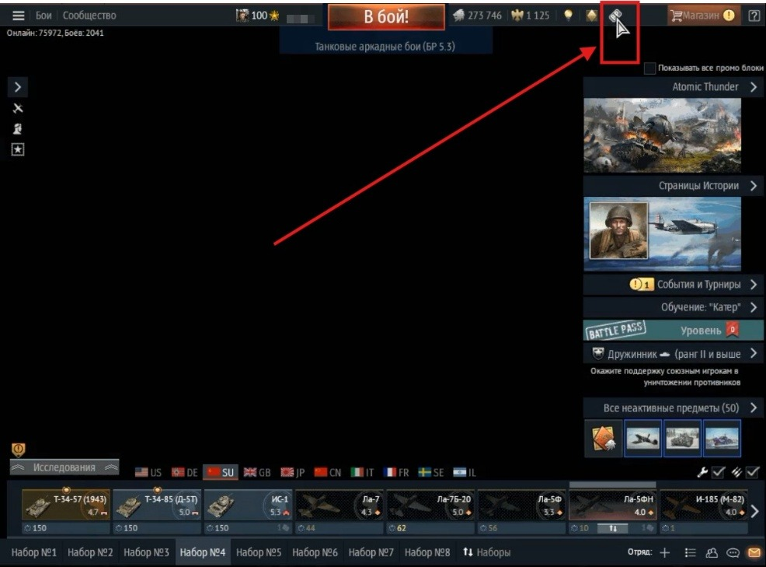
TASK 2

Crew progression: showstopper checklist
Task video: crew window, skills and qualification
https://youtu.be/p1-AlOvXLPM

Assignment: write a checklist of no more than 10 items to catch critical issues (showstoppers) in crew progression.
All items are critical: loss, duplication or unjustified crediting of currency and progress, a broken core function, bypassing paid restrictions. Less severe checks (e.g. whether the calculation formula or the "Buy all" total is correct) are intentionally left out and can go into a separate regression list.
# | Area | Check and steps | Expected result
1 | Economy: currency | Golden Eagles deduction when buying XP via "Accelerated training" for every tier  1) Open the Crew window of any vehicle.  2) Click "Accelerated training".  3) Pick a tier (10 / 130 / 1500 / 17500 points).  4) Confirm and compare Eagles and XP before and after. | Exactly the amount shown in the confirmation dialog is deducted; XP is credited in full, with no loss or duplication
2 | Economy: crew XP | Crew XP deduction when clicking "+" on a skill, including fast repeated clicks  1) Have crew XP available.  2) Open a crew role tab.  3) Quickly double-click "+" on one skill.  4) Compare the actual deduction with the expected one. | One deduction per click at the stated price; a double click does not charge twice for one level
3 | Progress saving | Applying changes with the "Apply" button  1) Upgrade a skill with "+".  2) Click "Apply".  3) Close the window, leave the hangar and come back.  4) Check the skill value. | Skills and crew level are kept after re-entering
4 | Progress saving | Closing the window without clicking "Apply"  1) Upgrade a skill with "+".  2) Close the window with the X without "Apply".  3) Open the Crew window again.  4) Check the XP balance and skill value. | XP is not refunded and the skill is not upgraded retroactively: no way to upgrade for free
5 | Restrictions | Qualification upgrade (Expert → Ace) when the crew level is below the requirement  1) Open the Qualification tab of a vehicle at "Expert".  2) Make sure the crew level is below the requirement (e.g. under 40).  3) Try to buy "Ace" directly, via other tabs and with repeated clicks. | The purchase is impossible by any means until the requirement is met
6 | In-battle effect | Crew skill bonuses match the vehicle's stats in battle  1) Upgrade a skill, e.g. "Awareness".  2) Note the stat value in the hangar.  3) Enter a test battle or the test drive.  4) Compare the in-battle value with the hangar value. | In-battle stats match the values shown in the hangar
7 | In-battle effect | Qualification bonuses match the vehicle's stats in battle  1) Upgrade the qualification (Expert or Ace).  2) Note the stated bonuses.  3) Enter a test battle.  4) Compare actual stats with the stated ones. | In-battle stats match the stated bonuses
8 | Data isolation | One vehicle's qualification does not affect other vehicles in the hangar  1) Upgrade the qualification of vehicle A.  2) Open the Qualification tab of vehicle B of the same nation.  3) Check that it did not upgrade automatically.  4) Check crew skills on other vehicles. | The bonus applies only to the selected vehicle; a paid bonus does not "leak" to other vehicles
The working version of the checklist has a "Status" column (Pass / Fail / Blocked), filled in during the test run.
TASK 3

Afterburner flame: test cases for a new effect
Task video: none, test cases are based on the task statement

Assignment: write five test cases, prioritized by importance, for the new afterburner flame. If there are more ideas, list the rest by title only.
Color - priority: Critical High Medium
TC-01. The flame appears and disappears in sync with turning the afterburner on and off · Critical
Preconditions | A jet with an afterburner (e.g. F-16) in the air, speed and altitude allow using the afterburner
Steps | 1) Turn on the afterburner.  2) Watch the flame appear at the nozzle.  3) Turn off the afterburner.  4) Watch the flame.
Expected result | The flame appears the moment the afterburner is turned on and disappears the moment it is turned off, with no delay and no "stuck" previous state

TC-02. The effect renders correctly at all graphics settings · High
Preconditions | Access to graphics settings; the same jet with an afterburner
Steps | 1) Minimum settings: turn on the afterburner, check the effect.  2) Repeat at medium settings.  3) Repeat at maximum settings and with DLSS / FXAA / SSAA combinations.
Expected result | At every level and anti-aliasing combination the effect is present, undistorted and without visible defects

TC-03. The flame differs between afterburner stages · High
Preconditions | A jet with a staged afterburner (F-16, MiG-29, Tornado, Mirage)
Steps | 1) Engage partial afterburner, note the flame size and brightness.  2) Switch to full afterburner.  3) Compare the flame at the two stages.
Expected result | At full afterburner the flame is noticeably bigger and brighter; the stages are visually distinct

TC-04. Other players see the effect over the network · Medium
Preconditions | Two clients in one battle: player A flies a jet with an afterburner, player B watches from the side
Steps | 1) Player A turns on the afterburner.  2) Player B looks at player A's jet.  3) Compare what B sees with A's actual state.
Expected result | The observer sees the flame at the same time player A turns it on, with no delay that would give anyone an advantage

TC-05. No FPS drop with many afterburning jets on screen · Medium
Preconditions | A test range or battle where 8+ jets can be gathered on screen
Steps | 1) Gather 8-10 jets on screen.  2) Turn on the afterburner on all of them at once.  3) Measure FPS before and after.
Expected result | The FPS drop stays within the project's acceptable budget, with no freezes or UI hangs

Additional test cases
- TC-06. The effect renders correctly in all camera views: cockpit, external, replay, killcam.
- TC-07. No visual artifacts: the flame does not show through the fuselage or clip through clouds and terrain at different angles.
- TC-08. The effect is stable when the afterburner is toggled frequently and quickly (flicker stress test).

How priority was assigned
- Critical: the effect's basic behavior, appearing and disappearing. Without it the feature does not work at all.
- High: noticeably affects how the effect looks in the real game: graphics settings and afterburner stages.
- Medium: affects gameplay fairness and performance, but not whether the effect itself works.

