Avalanche Beacon architecture and business model
June 2021

The following document describes the business model and architecture of an Avalanche Beacon. It is based on arch42 document format
Table of Contents
Glossary 4
History of document 5
Introduction and Goals 6
Actual state 7
Strategies 9
Strategy 1 9
Strategy 2: 9
Strategy 3: 9
Strategy 4: 9
Strategy 5: 9
Goal 10
S.W.O.T. 10
Requirements Overview 11
Rejected requirements: 11
Quality Goals 12
Stakeholders 12
Architecture Constraints 13
Organizational constraints 13
Resources constrains 13
Standard constraints 13
Technical constraints 13
System Scope and Context 15
Business Context: 15
Technical Context 16
Solution Strategy 17
Building Block View 19
White box overall system 19
<Name black box n> 19
<Name interface 1> 19
<Name interface m> 19
Runtime View 20
<Runtime Scenario 1> 20
<Runtime Scenario 2> 20
… 20
<Runtime Scenario n> 20
Deployment View 20
Infrastructure Level 1 20
Infrastructure Level 2 20
<Infrastructure Element 1> 20
<Infrastructure Element 2> 20
<Infrastructure Element n> 20
Cross-cutting Concepts 21
<Concept 1> 21
<Concept 2> 21
<Concept n> 21
Design Decisions 21
Quality Requirements 21
Quality Tree 21
Quality Scenarios 21
Risks and Technical Debts 21
Glossary 21

Glossary

Acronym | Description
AB | Avalanche Beacon
EM | Electromagnetic

History of document

Date and author | Changes
12.06.2021 – Jeremie Gallee | Initiation of document:  - Fill Introduction and Goals section  - Fill Functional requirement and Quality Goals section  - Fill Solution Strategy section
16.06.2021 – Jeremie Gallee | - Update of Quality Goals  - Add of market state in Actual State section  - Fill business and technical context
22.06.2021 – Jeremie Gallee | Update of market state, strategies and goal sections
7.06.2021 – Jeremie Gallee | Update of white box view of the overall system
Wikipedia int

Introduction and Goals
To ensure security to free riders and skiers who goes outside secured ski slopes, an Avalanche Beacon (DVA: Détecteur de Victimes d’Avalanches in french) is used to find any person buried deep inside an avalanche.
Until today, technology used for that is simple and consist of an electromagnetic antenna, spreading “donut” shaped radio waves of 457 kHz. Buried person emits the waves, while the other, outside the avalanche receives the radio waves and follow them.

As seen on figure one, one beacon receives the waves of the buried one and follow those flux until it reaches the closest point of the buried beacon.
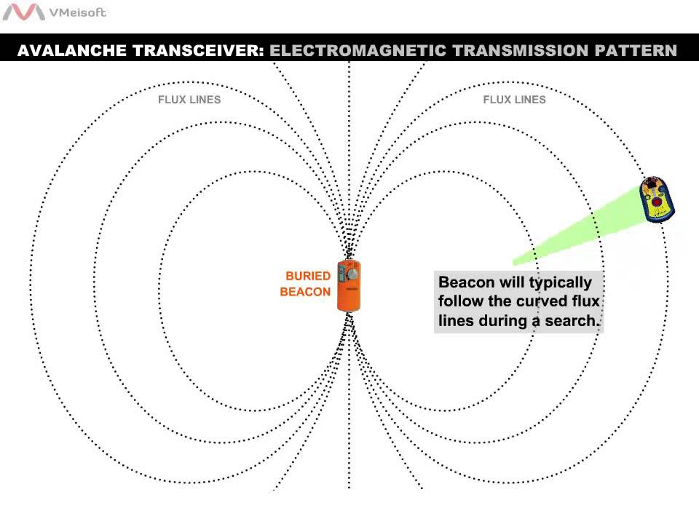Figure 1: Avalanche Beacon principle
All AB are able to send or receive radio waves. They are all per default set to send at the beginning of the ski tour, and set to receive by humans when one of them is buried and need to be found.
The AB are able to compute the distance to the beacon by looking at the power received from the emitting beacon. The closer we are, the stronger are the waves.

The first Avalanche Beacon had one antenna, now some of them have three, which helps to compute the distance and direction of buried AB.

Actual state
But still, every year, people die buried in avalanches. Some due to bad luck, some because people where untrained to use Avalanche Beacon, some because it still takes too long to find the buried man, or group.
To continue reducing this number, some new technologies or products appears. For example, the ABS, a backpack which inflates and makes the avalanche victim bigger, which per coconut effect, don’t get buried too deep (bigger part stays on top when shake).
On Avalanche Beacon, technology seems to stagnate. Some ideas like adding Bluetooth communication or GPS are tried, but without real success. Normal: Bluetooth, despite having a Low Energy standard is very unstable and has a complex software. GPS on the other hand, may consume a lot of electric energy and is also precise to 1 meter, if not 10 in the mountains… And even with a precision to 10 cm, an Avalanche Beacon is still too imprecise to perfectly locate someone.
Those two technologies seems to be the wrong direction, they are powerful, yes, but it is like miniaturizing a bazooka to hunt flies. They are not adapted. Another direction should be used.
It generally look like that AB are now stagnating, despite the evolution of hardware, and main actors in this area are trying to find a new way.
Another point is the evolution of market’s demand and clients. Every year, more and more skiers start to go ski touring to avoid overcrowded ski resorts, or be free to go in “deep snow”. In this escalating quantity of new skiers, some goes without any AB training.
The following table gather products provided by the main actors (Mammut, Pieps, Ortovox and Arva) with their performance. Some companies have the same application product, other not, some have special products

TODO: add AB market

Company | Inflatable backpack | Avalanche Beacon | Avalanche Beacon – Bluetooth | Avalanche Beacon – accelerometer | Avalanche Beacon – other 3 | Avalanche Beacon – other 4
Pieps | Yes | 60 meter reach | Yes | Yes | EN300718 - support of TX600 | Switch between antennas if one detect that it is disturbed by noises
Mammut | Yes | 70 meter digital, 100 meter analog | Yes | Yes | W-link. Capacity to exchange vital data to receiver (so data exchange)
Arva | Yes | 70 meter reach | Yes | Yes | Scroll between victims on user interface
Ortovox | Yes | 40 meter reach | Yes | Yes | Smart Antenna Technology (detect position of antennas)

Strategies
Different possible strategies, regarding the actual market state:

Strategy 1
Make it cheap and low in features/performances.
Pros: will provide a new type of business strategy on the market. All are same price/same performance.
Cons: does anyone really wanting to have a cheap/low performance device to save his friends? I guess not.

Strategy 2:
Provide the same performances or a little bit less than actual AB from Mammut, Pieps or Arva.
Pros: could fight shoulder to shoulder with old actors with a new product, which will be a powerful marketing advertisement. It will also be cheaper because I will not have to pay many people.
Cons: strong risk to be too long to develop, or simply not possible, therefore being impossible, or declare forfeit before selling anything.

Strategy 3:
Same as strategy 2, but concentrate on innovating ideas and technology to reach this goal.
Pros: could reduce the experience gap between old actors and my AB without being a technical master.
Cons: will have to write a lot of patent and be careful that they are not already existing.

Strategy 4:
Arduino like: provide all info about this AB on open source, but sell finished product.
Pros: create a synergy on it, taking advantage on a huge, free human resource.
Cons: may take a huge amount of time before having returns on invest.

Strategy 5:
Reach a state of prototype and contact a company like Patagonia, to have a company structure and income, to develop with them a new product.
Pros: "bypass" the investor problem and assure a comfortable income for myself If I hold the patents I still could have more money than just a salary.
Cons: will not have full power on my product. Thus not making a company.
Note: working for a company like Patagonia is also something very important for me because I may develop this product in the way of a long term device, guaranteed for life, as Patagonia does.

Goal
This project contains two goals which are working in parallel. A primary goal and a secondary goal, which can be seen as a backup wheel.
The primary goal of this project is to carry on with the same AB technology, but optimize the location algorithm and add some new technologies to help this optimization. The aim is not to have a better precision than common Avalanche Beacons, but make have a faster searching AB.
The secondary goal is to gather experience and have better argument to get hired in a company making AB. Maybe provide an open-source AB, available on Github or similar.

S.W.O.T.
Strength: | Opportunities:
- creativity, capacity to bring something innovative  - Free to do anything. Old companies stays often on what they can do | - gather experience in the area, providing an opportunity to apply at a company already making those devices  - innovate in a slow area. Providing new ideas and make a difference on the market
Weakness | Threats
- lack of experience and documentation in the working area  - lack of experience in electronic design and signal processing. Study/Small missions level.  - Small budget and team  - Concurrency has already something good enough to save people’s life | - new technologies from bigger companies may arrive on the market, being more efficient  - W-Link from Mammut  - massive use of accelerometer by the main actors

Requirements Overview
It is wished for the Avalanche Beacon to be able to do the following use cases:
ID | Use case description
UC1 | Save a buried man in an avalanche
UC1-1 | Change from send to receive
UC1-2 | Mark the radio-waves of a founded avalanche victim, allowing human to go to next victim in case of multiple victim avalanche.

UML diagrams of this use case list can be found in appendix. (to be added)
The aim in a first phase is to keep it as simple as possible. We should keep focus on a product which works like the other Avalanche Beacons, even a little bit less efficient. But has a small advantage to the others which makes it special.
Also, we don’t want a heavy featured device, but find our friend as quick as possible. A multi feature device add complexity to the product, and complexity is something that nobody wants when searching for a buried friend...

Rejected requirements:
ID | Use Case description
R-UC1 | Measure altitude.  It may be useful to help measure the difference of altitude between beacons, therefore helping to compute distance between them. But it means add a sensor, therefore development and production costs. Maybe in a next generation of Avalanche Beacon.
R-UC2 | Update Avalanche Beacon.  Too dangerous and “heavy” for me. To be able to update an electronic board, an update system is to be thought and it takes time. Plus, once a user is used to its beacon, he is better with it. Change its behavior every year would just be confusing for him and therefore not recommended.

Quality Goals
It is at the early stage of this project, difficult to list all quality goals, as team is starting to gather experience in the domain.
Still, some of them may be listed here:
- The Avalanche Beacon shall be able find another beacon in a reach of 40-45 meters.
- The Avalanche Beacon shall quickly find buried victims
  - The screen giving direction shall be able to show directions on 360°
  - The Avalanche Beacon shall find the straight direction to buried Avalanche Beacon, 10 seconds after sensing the first radio waves
- The Avalanche Beacon shall be as simple as possible
  - Human User shall be able to change mode (send/search) with one hand and heavy gloves on his hands
  - The Avalanche Beacon shall have a minimalist design, allowing human to kick understand how it works (change from send to receive)
- The Avalanche Beacon shall resist to humidity and be fully waterproof
- The Avalanche Beacon shall resist to temperature to -45°
- The Avalanche Beacon shall work 48 hours
- The Avalanche Beacon shall work with other AB, even if a new technology is present in our product

Stakeholders
Role/Name | Contact | Expectations
Jeremie Gallee | Jeremie Gallee <galleej@gmail.com> | Fulfill goals described in Introduction and Goals section
Luc Verscoore |  | Help Mr Gallee to reach his goals

Architecture Constraints
This section regroups constraints which will guide us for technical decision on the architecture

Organizational constraints
ID | Description
OC1 | Team experience in the area (Avalanche Beacon) is very small and skills about antenna and EM are old
OC2

Resources constrains
ID | Description
OC1 | Budget means are reduced
OC2 | Professional Radio frequency measurement devices are expensive

Standard constraints
ID | Description
OC1 | Avalanche Beacon are controlled by the standard NF EN 300718-3
OC2

Technical constraints
ID | Description
TC1 | Team has only few experience in the Avalanche Beacon technology
TC2 | The Avalanche Beacon must work with batteries (AAA or AA)
TC3 | The Avalanche Beacon must be waterproof and resist to cold temperature (defined in standard)
TC4 | No new/other technology shall be used to search/send radio waves (technologies regulated by the standard)
TC5 | It is wished to keep the hardware to develop as easy as possible to avoid too much work and keep focusing on our main goal

System Scope and Context
This section explain which external human and non-human systems are interacting with our system and what interaction can be done with the Avalanche Beacon

Business Context:

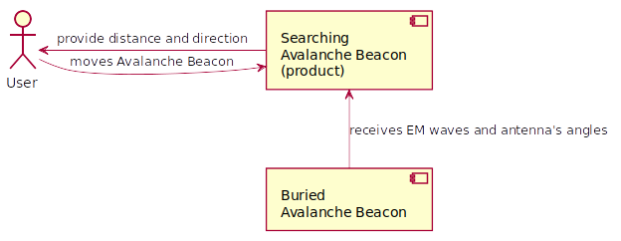Figure 2: Business context
Neighbor system | Description
User | Human. Tries to find buried AB.  - Is often under stress  - Has difficulties to move on the rough ground of an avalanche field  - Has difficulties to manipulate any devices with his hands as they are cold and in thick gloves  Gets info from buried AB and moves Searching Avalanche Beacon around the avalanche field
Buried Avalanche Beacon | Emits electromagnetic radio waves in two different directions which are perpendicular.  Emits the angle of both its antennas against earth’s gravity.

Technical Context

To move the searching AB, User uses his hands.
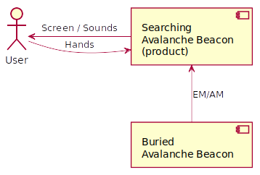Figure 3: Technical context
Distance and direction are transmitted to User through a screen and sounds.
Searching AB receives info about distance and angles through EM and Amplitude Modulations on the EM.

Solution Strategy
To fulfill our main goal, which is optimize the radio waves search algorithm, the idea to use an accelerometer/inertial sensor. Those are now widely existing on the market, are cheap, very energy efficient and extremely small (MEMS).
This accelerometer would provide the the angle, in which direction the antennas are radiating their radio waves. In fact, on a 3D view, radio waves power of those antennas are “donut” shaped, where the axis of the donut is exactly the direction of the antenna. To have the angle with earth would help a lot to know in which direction the antennas are radiating. Therefore better calculating the position of the buried beacon (which is surely not perfectly lying horizontally).
But how to communicate this angle between beacons? The technical constraint TC4 does not allow us to use another emitting technology and add another communication is going against TC5 and our general aim to keep our system simple.
The idea would be to use the radio waves to exchange information between Avalanche Beacon. The idea is to do AM (Amplitude Modulation) on the emitted radio waves (457 kHz). In fact, those are emitted by pulse each second for 100 ms. During this laps of time, use 10 or 20 ms of the pulse to emit an angle, coded on two bytes (65536 values) should not have any influence of the first purpose which is to emit radio waves.

Technical solution 1: use of accelerometer to get antennas angles with earth’s gravity

Technical solution 2: use AM on emitting AB to send info to searching AB.

Logical solution 2: Show how deep the buried AB is, and the approx distances to the closest point. Today, AB just show the distance with emitting AB, It doesn’t split into distance on floor + depth of buried man.
show deep of user, show side search.
It may be possible to estimate the depth of the buried AB, by guessing the floor on which the searching AB is moving. Thus, estimating a side view of the situation:

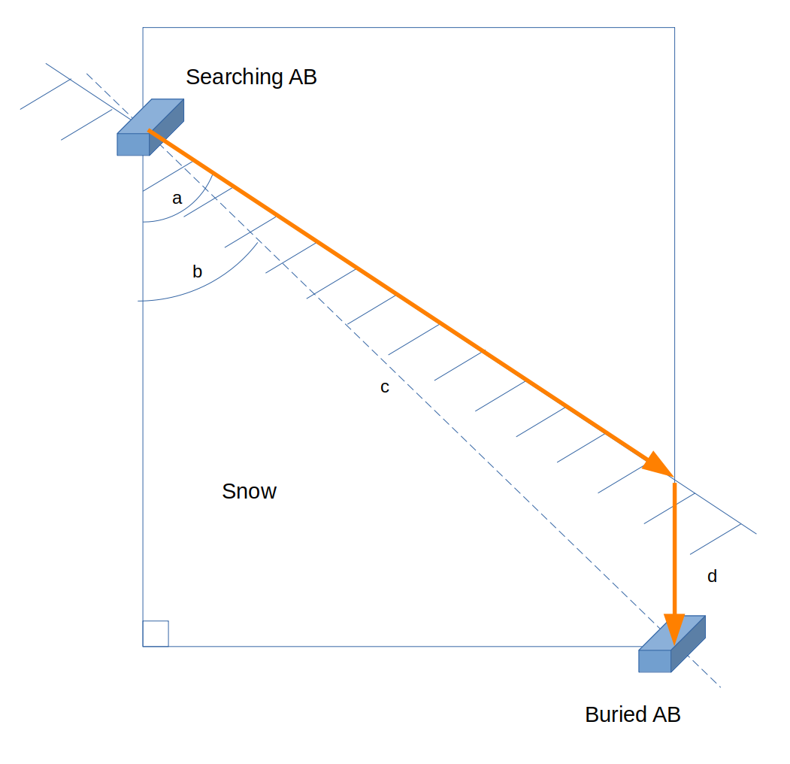

Technical solution 3:
Use of accelerometer to get tilt/angle of the antennas, thus inverting the direction of electromagnetic waves and keep the following antennas position (top view)
This combination, which we can then assert as always true, allows us to better analyze the EM and, based on the flux direction, faster compute the position of buried AB.

Technical solution 4: have moving antennas, one will therefore always be parallel to earth’s gravity. In a disc, the antennas fixed on the moving part will be able to rotate. With a weight, like a pendulum, the disc with antennas will always have one position parallel to gravity.
Difficulty/Risk: to carry energy to spears of antennas, a circular contact in the axis of the disc. This physical contact

Required structure and parts
To fulfill European Standard for avalanche beacons, we must have the following parts:
- Ferromagnetic antennas with coils
- 457 kHz +/- 80 Hz signal generator (emit AB signal) with a precision of 1 Hz (detect different AB)
- A signal processing chain to detect 457 kHz +/- 80 Hz Em waves with 1 Hz precision. This part will also have the task to decode the AM encoded message from emitting AB and the direction of the EM waves
- An intelligence, able to process all inputs, take decisions and give info to user where to go
- An interface with user, giving the decision where to go, made by the intelligence

From those parts, results the main white box overall system (next chapter)

Building Block View
Building block view describes the structure of our AB, from the upper view (overall system) down to the closest view, with all part in details (sub chapters)

White box overall system

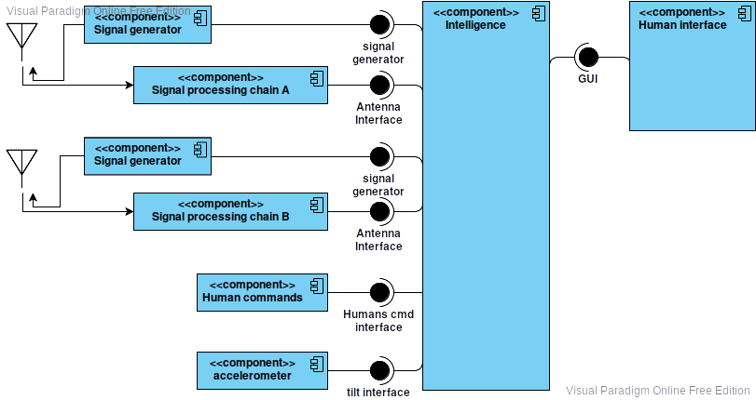Figure 4: AB overall system view

Component signal generator
Signal generator component generates the sinusoidal signal needed to emit electromagnetic waves in the antenna.
Provides:
- Signal generator interface realization
Needs:
- antenna connection (simple wired)
This component exists two times: one for antenna X and one for antenna Y. They are respectively named A and B

Component signal processing chain
Signal processing chain provides the processing of received EM signals when AB is in search mode. It contains sub boxes, each one of them having a special purpose, until all EM noises are processed and info recovered
Provides:
- Antenna interface
Needs:
- Simple wire connection to the antenna
This component exists two times: one for antenna X and one for antenna Y. They are respectively named A and B
Risks:
This component is the most critical one, as it is directly linked to our AB quality and is subject of a lot of noise and perturbation. Furthermore, it is technically difficult to design and no finished solution exists on the market.
Component human commands
Simple inputs allowing user to select mode (emit/search) or mark a found victim.
Provides:
- Human cmd interface
Needs:
Nothing needed for human commands component.
Component accelerometer
Accelerometer component provides the tilt and other info about angles of antennas geometrical plan to the intelligence.
Provides:
- Tilt interface
Needs:
No input is needed for accelerometer component

Component intelligence
This is where all algorithm and decision will be implemented. It will be software and inside a microcontroller in the first time, hardware independent designed, it will be ported to an FPGA later on (when it works). FPGA being way more faster, but also more expensive.
Provides:
No interface is provided by this component. It is the main component.
Needs:
- All provided interfaces are needed by this component

Component human interface
Human interface component is the way our AB provides info to our user about distance to buried victim and about AB configuration/marked victims. It will be done with a screen and sound.
Provides:
- GUI interface (Graphic User Interface)
Needs:
No input needed for this component.

Interface antenna interface
Interface to signal coming from antennas. This interface provides the following info:
- Buried bacon tilt angle
- EM energy received in the antenna (X or Y)
- Direction of the EM flux

Interface signal generator
Interface of the signal generators. It is used by the main intelligence component to generate the desired 457 kHz EM in the antennas.

Interface human cmd interface
Interface which provides the selected mode (search/emit) or if user wants to mark a victim (forget the strongest found signal).

Interface tilt interface
interface for the inner accelerometer, it provides the tilt of the AB.

Interface GUI
Interface provided by screen and buzzer/beeper. It allows the main intelligence component to provide info to user (direction, distance and so on) this interface is not fixed, as it is a standard screen/microcontroller connection. But it shall provide microcontroller the ability to control a matrix of pixel. Which images shall be present will be decided afterwards.

White box signal processing chain component

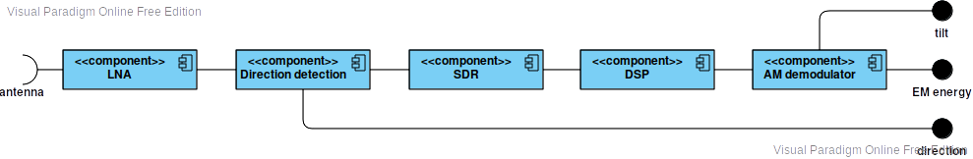
This building block needs to be clarified
LNA: low noise amplifier
Direction detection’s task is to find in which direction (right or left) is the EM flux going
SDR: Software defined Radio
DSP: digital signal processing
AM demodulator: as we want to convoy the tilt of buried AB to searching AB, we use a small amplitude modulation to encode on 256 values the tilt. Its job is to get this info out of the received 457 kHz pulse.

Questions:
- LNA with a pass band first?
- SDR and DSP? Are we not making doublon? Is it useful? What are there purpose then?
Need to clarify the way to get EM energy per pulse and what do we have to do about filtering, sampling, bandpassing, low noise amplifying and so on

Runtime View

<Runtime Scenario 1>
- <insert runtime diagram or textual description of the scenario>
- <insert description of the notable aspects of the interactions between the building block instances depicted in this diagram.>

<Runtime Scenario 2>

…

<Runtime Scenario n>

Deployment View

Infrastructure Level 1
<Overview Diagram>
Motivation
<explanation in text form>
Quality and/or Performance Features
<explanation in text form>
Mapping of Building Blocks to Infrastructure
<description of the mapping>

Infrastructure Level 2

<Infrastructure Element 1>
<diagram + explanation>

<Infrastructure Element 2>
<diagram + explanation>
…

<Infrastructure Element n>
<diagram + explanation>

Cross-cutting Concepts

<Concept 1>
<explanation>

<Concept 2>
<explanation>
…

<Concept n>
<explanation>

Design Decisions

Quality Requirements

Quality Tree

Quality Scenarios

Risks and Technical Debts

Glossary
Term | Definition
<Term-1> | <definition-1>
<Term-2> | <definition-2>

