
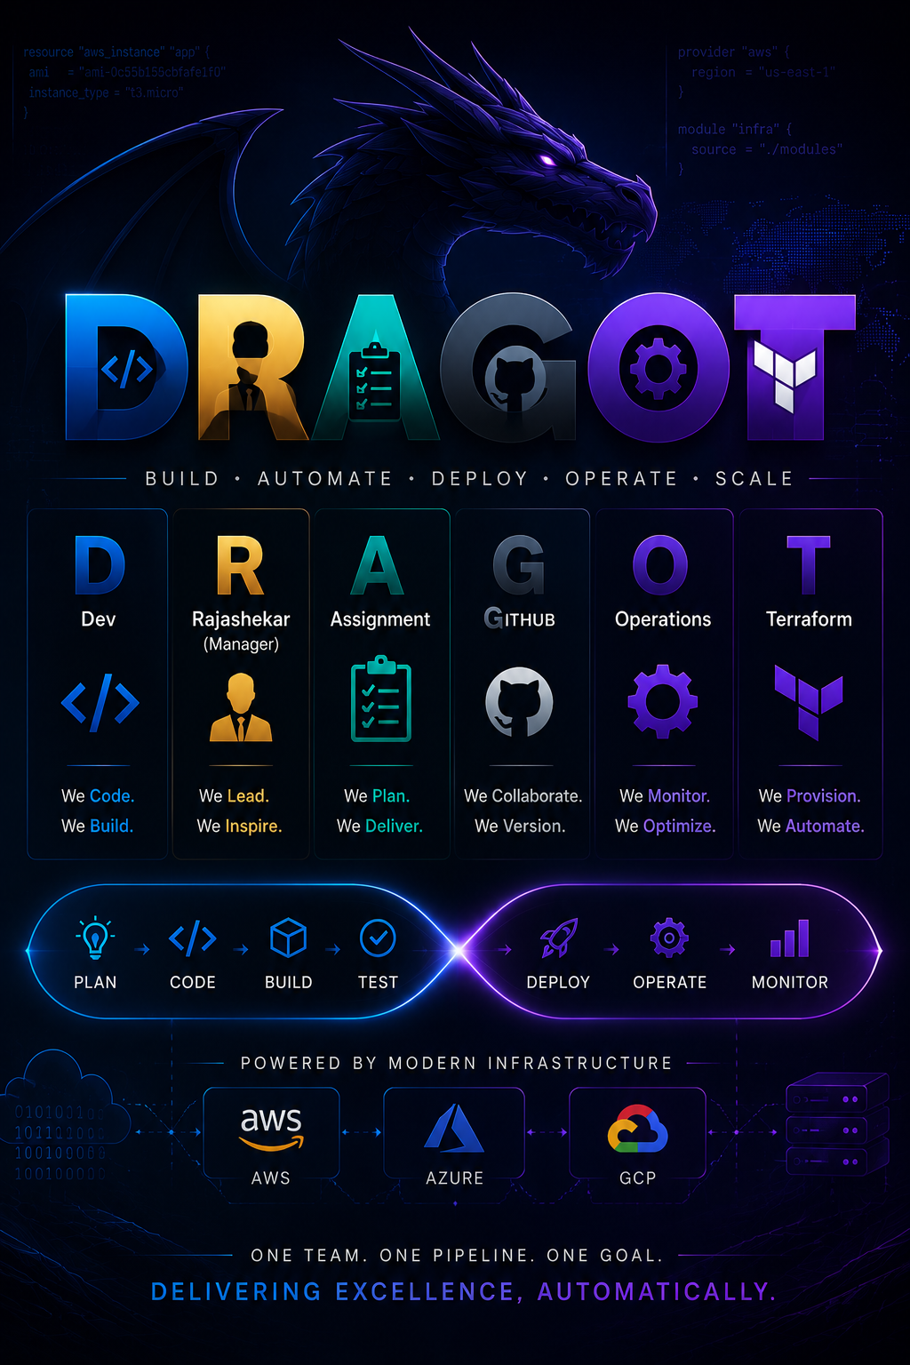

DevOps, GITHUB, Terraform

May 6, 2026

2000123958

Objectives

Create an end-to-end DevOps setup using Azure DevOps by creating a project, repository, and pipeline to build a sample Java/Python application, GITHUB as repo.

Provision Azure Resources including an Azure Subscription, resource Group, and Azure Kubernetes Services (AKS) cluster/WebApp.

Containerize the application using Docker and push the image to Azure Container Registry (ACR).

Create the Pipeline to use the self-hosted Agent for building and deploying the application.

Deploy the containerized application to Azure WebApp.

Optionally, use Helm Charts to Deploy the application into the AKS Cluster as a scalable service, for an alternative hosting approach.

END-to-END DevOps Pipeline

Azure DevOps Configuration
Azure DevOps Organization created
Project created: DRAGOT
Created New Pipeline: DRAGOT_Pipeline
GitHub repository connected as source control

Source Code (Application)
The application source code will be inserted as object attachments in MS Word.
Git hub Repository Link: DRAGOT_Git

ENVIRONMENTS

Created 2 Environments
- dev
- prod
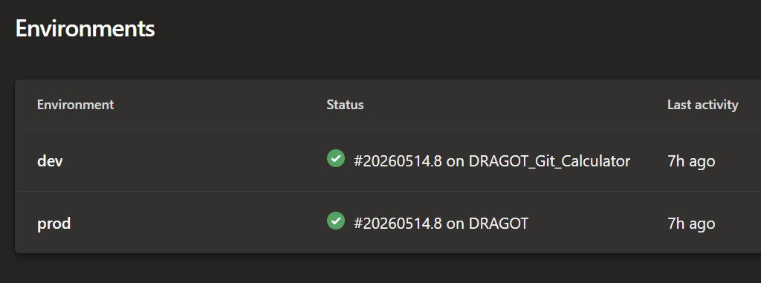

Resources Created
The following Azure resources were provisioned:

DEV ENVIRONMENT

PROD ENVIRONMENT

Infrastructure Code (Terraform / Scripts)
- All the Codes are present in the GitHub Repo in the latest Repo branch
- Current Working Branch Mark_6.

GITHUB REPOSITORY FILE STRUCTURE
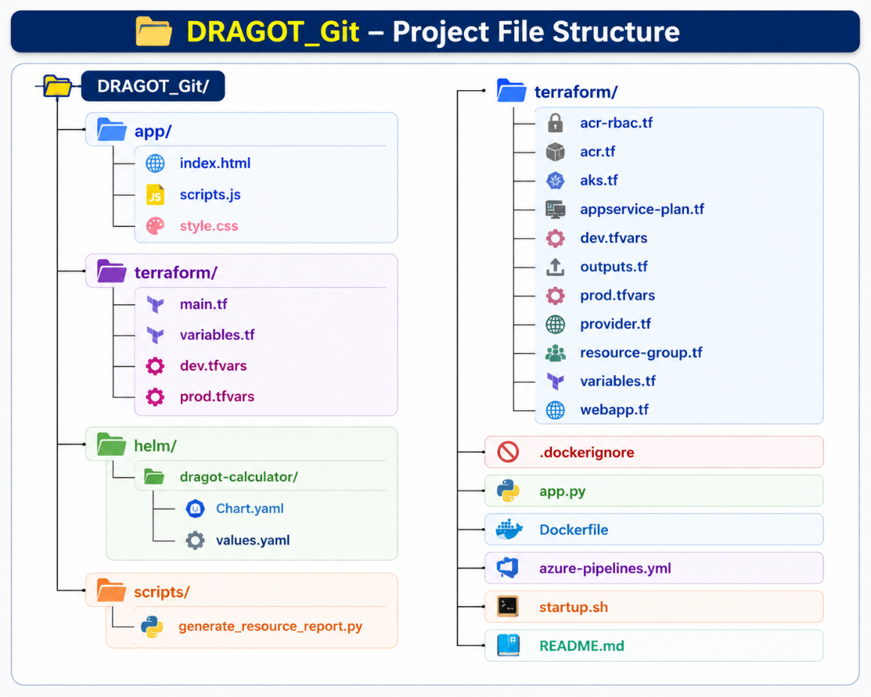

Final Output

Web Page

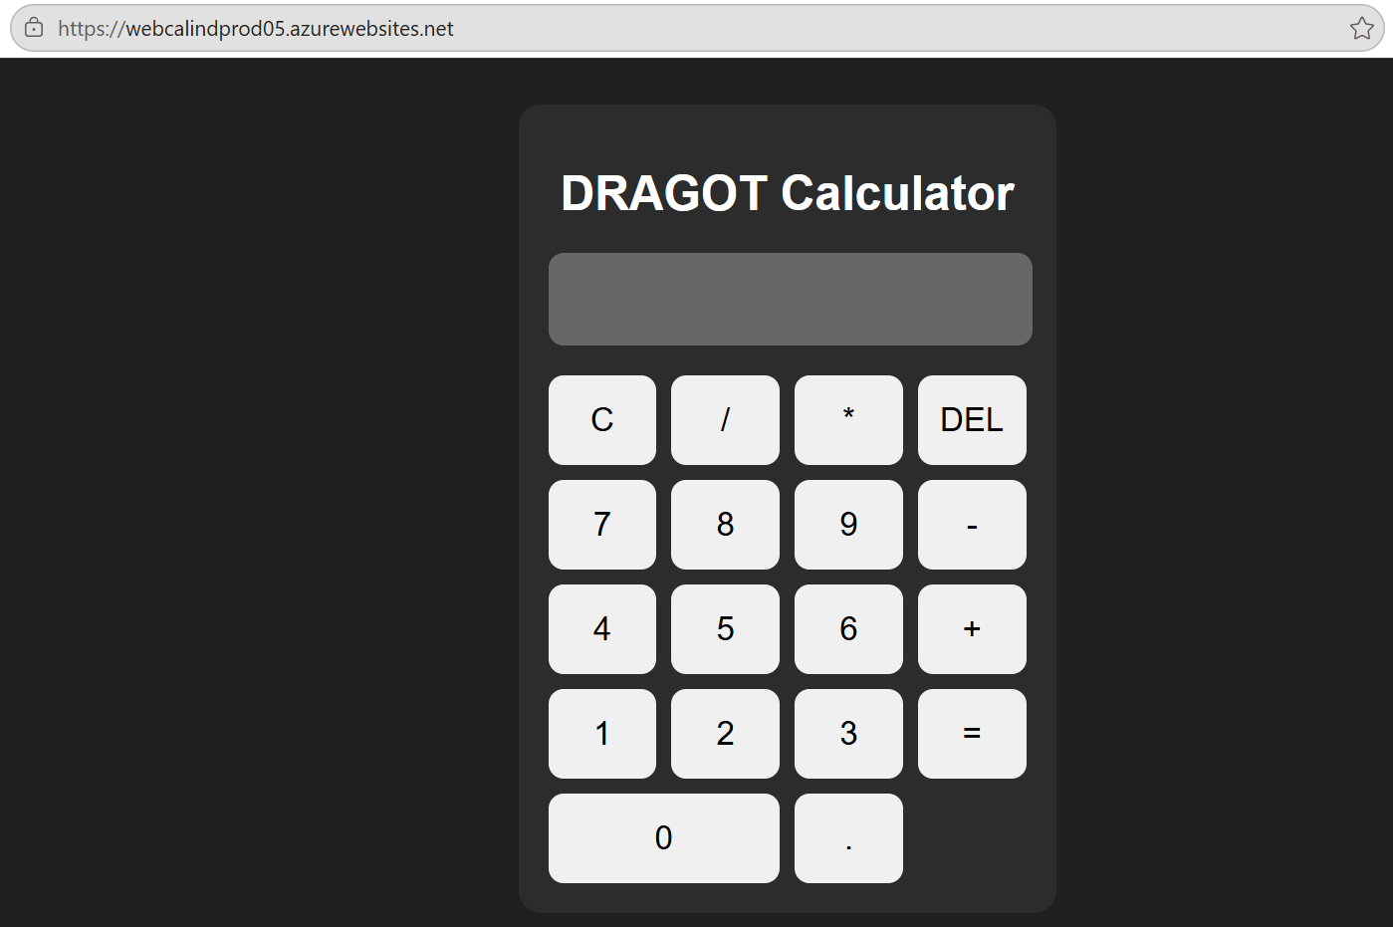

HELM

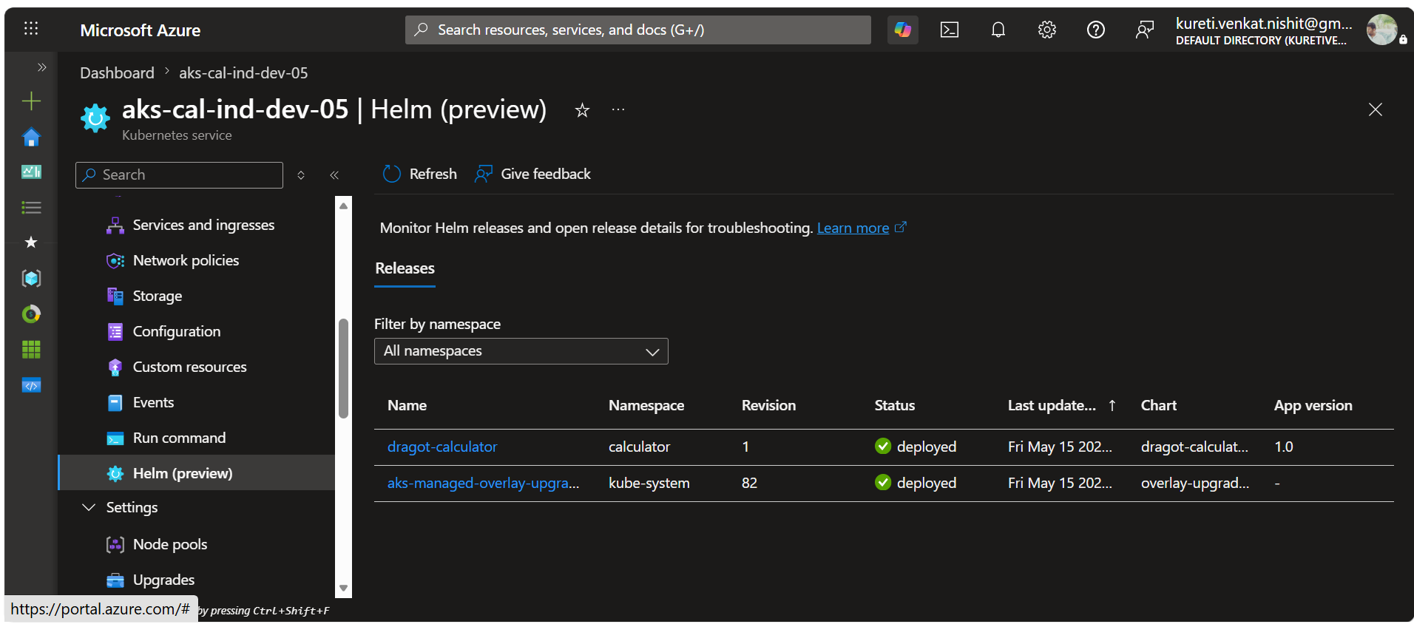

ACR

