
Project-based Practical Report on
“CAMPUS LOST AND FOUND MANAGEMENT SYSTEM”

Submitted in partial fulfilment of the requirements for
“Data Structures and Algorithms”
for the 1st Semester
MASTER OF COMPUTER APPLICATIONS (MCA)

Submitted by
KURIAN ROBERT 26MCAC28

Under the guidance of
Dr.Subramania Kumar

TABLE OF CONTENTS
S. No. | Topics | Page No.
1 | Introduction | 5
1.1 | Objectives | 7
1.2 | Project Description | 4
2 | Phase I Database Design | 21
2.1 | Identification of Entities and Attributes | 21
2.2 | ER Diagram | 21
2.3 | Relational Schema | 22
2.4 | Normalization | 24
3 | Phase II Database Creation and Queries | 25
3.1 | Creating Tables Using SQL | 25
3.2 | Inserting and Updating Records | 26
3.3 | SQL Queries | 28
3.4 | Aggregate Functions | 31
4 | Phase III Data Querying Join and Views | 35
4.1 | Joins | 37
4.2 | Subqueries | 41
4.3 | Views | 45
4.4 | Functions and Procedures | 48
5 | Phase IV Transactions and Data Integrity | 50
5.1 | COMMIT, ROLLBACK and SAVEPOINT | 52
5.2 | Integrity Constraints | 55
5.3 | Concurrency Issues | 57
7 | Conclusion | 59
8 | References | 60
9 | Appendix | 60

TITLE OF THE PROJECT
Campus Lost and Found Management System
- The project described in this report is called Campus Lost and Found Management System with Priority Claim Scheduling (CLFS-PCS). This is a real-world application developed for the 1st Semester Master of Computer Applications (MCA) course on Data Structures and Algorithms (DSA), at Kristu Jayanti University, Bengaluru.
- This project was inspired by our experiences during college. College can often be very busy with several academic buildings, computer labs, library and canteens. Students and staff often lose personal items, such as high priority items (student ID, hall ticket for semester exams, keys to their room and scientific calculators) to common items (water bottle, notebook and umbrella). The current way of keeping track of items that have been found is through a manual system which requires people to write down information in a register at the security desk. This is a slow, tedious and inefficient method which cannot tolerate typos and does not allow for priority to be given to urgent examination hall tickets.
Therefore this project has used fundamental data structures from computer science along with contemporary web technologies to create three parts
1. Custom Algorithmic Engine (`campuslostfound`): A pure Python data structure package built from scratch without using any external libraries or built-in wrapper collections. It contains raw pointer-based Singly Linked Lists, a Last-In-First-Out (LIFO) Linked Stack to support administrative undo actions, a First-In-First-Out (FIFO) Linked Queue for chronological claim handling, a Binary Search Tree (BST) for logarithmic key lookups and node deletion, an undirected campus building graph traversed using Breadth-First Search (BFS), an in-place Linked List Merge Sort running in O(n log n) time using fast/slow pointer bisection, and a Wagner-Fischer Dynamic Programming Levenshtein Distance matrix for fuzzy text search.

- Practical Web App(`scheduler`): A full-stack web application built using the Django framework and backed by a relational MySQL database(`data_structure`). It includes UIs for users of different roles (students, faculty, admin) and uses a Greedy Min-Heap Priority Queue (`heapq`) to prioritise high urgency claims like ID cards and hall tickets to the front of the admin queue.
- Desktop Demonstration(`main_ui.py`): This is a GUI application developed using Tkinter which was used to allow students and examiners during practical lab sessions to see nodes and trace through BST operations and BFS traversals on a graph using the memory.

INTRODUCTION
- Every day, thousands of students, staff members and admin staff move around the university (Main Block, PG Block, Departmental Computer Labs, Central Library, Cafeterias & Outdoor Sports Grounds). Due to the high amount of people coming into the university, people leave their belongings on their desks, study spaces in the library and lab benches. These personal items can range from items needed for their studies (Smart Cards, Exam Hall Tickets, Calculators, Keys & Practical Books) to personal items (Water Bottles, Umbrellas, Spectacles & Pencil Cases).
- Currently, lost property is kept within paper log books provided by the security posts or random WhatsApp groups. Through personal observation of how lost items are handled within our college we noticed the following issues:
- Slow Sequential Logbook Scanning: Paper registers record entries line-by-line as items are turned in. When a student approaches security to search for a lost item, the guard must read through pages of handwritten notes. If hundreds of items have been logged over several weeks, this O(n) linear search takes 15 to 30 minutes, frequently resulting in long delays and missed items.
No tolerance for spelling errors. Manual systems and basic search techniques do not allow for any spelling variations. If a student searches for an item using a misspelled word such as Calclator, Casio fx or Idcard then conventional systems will produce no results.
Lack of knowledge of campus layout. Items are often moved around campus via walk-ways and corridors. If an item is lost in the computer lab within the PG Block it is often found by a fellow student and handed in to either the security office within the Main Block or the Central Library. Conventional registers simply list them as a string of text with no indication of surrounding buildings.
Unfair and disorderly. At present claims are processed in the order that students ask. Therefore if a student requires an item urgently such as an identity card or hall ticket for an exam in one hour they will have to wait in a queue behind normal claims for everyday stationery items.
The Campus Lost and Found Management System with Priority Claim Scheduling provides an efficient method of managing this process through a software based solution. This makes use of basic data structures from computer science and web development to provide quick searching, intelligent autocorrect and location suggestion whilst also allowing priority claims.
2.2 Problem Formulation & System Comparison
In order to highlight the advantages our software provides to overcoming issues with current campus methods, we performed a systematic comparison between traditional physical security log books, informal communication channels (such as WhatsApp groups and departmental notice boards) and our developed CLFS-PCS. Comparison has been made using:
Evaluation Metric | Manual Security Registers | Social / WhatsApp Groups | Proposed CLFS-PCS Platform
Record Ingestion | Handwritten physical logbook entry; prone to illegible handwriting | Unstructured chat messages; rapidly buried under new messages | Structured web forms with validation stored in relational MySQL database
Search & Retrieval | Manual line-by-line inspection: O(n) worst-case time (15–30 min) | Keyword search limited to exact post text; unindexed and noisy | Dual search: O(log n) BST lookup by ID and DP fuzzy text matching
Spelling Error Handling | Impossible; requires human visual inspection to guess spelling | None; any typographical error causes search to return zero results | Wagner-Fischer DP matrix computes edit distance and suggests matches (dist <= 4)
Campus Proximity | None; locations are isolated text notes with no building relationships | None; no spatial or geographical context is tracked | Adjacency graph traversed via BFS identifies immediately adjacent blocks
Claim Scheduling | Arbitrary or basic first-come-first-served with no urgency weighting | Unregulated; prone to multiple conflicting ownership claims | Binary Min-Heap priority queue orders claims by urgency (Priority 1 to 3)
Administrative Audit | Physical pen cross-outs; leaves no clean audit trail or undo history | No tracking; difficult to prove who actually collected the article | LIFO Activity Stack records recent actions and supports one-click admin undo
Data Security & ACID | Zero backup; prone to physical loss, torn pages, or coffee spills | Low privacy; student contact numbers exposed openly in public chats | Role-based authentication, CSRF security, and ACID transactions in MySQL

As shown in the table below our algorithmically designed piece of software solves the issues that occur when manually tracking paper work. This leads to improvements in speed of information retrieval, search accuracy, student privacy and accountability.
OBJECTIVE OF THE PROJECT
- Our goal in this project is to design, implement, test and evaluate an automated campus property retrieval system. We will apply the core data structures and algorithms covered during our studies to create a working piece of software. This dissertation will look at the following technical objectives:
- Create a basic structure of lists (Phase 1)
Create Singly Linked Lists from scratch to store the item details. Create a LIFO (Last In First Out) Linked Stack to keep track of transactions that can be undone quickly by administration. Create a FIFO (First In First Out) Linked Queue to process student claims.
- Search optimisation and spatial search (Phase 2)
Create a Binary Search Tree (BST) to allow average searches, inserts and node deletions based on 3 cases in O(log n). Create an undirected graph of the campus buildings and implement Breadth First Search to find adjacent transport routes.
- Sort and search using in place merge sort (Phase 3)
Create an in-place Linked List Merge Sort with a guaranteed run time of O(n log n) and uses only O(1) extra space for the pointers. This was implemented using a fast/slow 2 pointer approach. Benchmark how quickly we can search through the data.
- Tolerance for typos and urgency sorting (Phase 4)
Create a 2D Dynamic Programming Matrix using Levenshtein Distance to allow for tolerance of up to 4 typos in item names ('Smart Match'). Create a greedy Min Heap Priority Queue to sort the claims based on their urgency. Priority 1: ID Cards and Valuables, Priority 2: Academic items, Priority 3: General items.
- Integration into a web application and desktop application
Integrate the algorithm into a Django web application with multiple roles, MySQL database and protection from CSRF attacks. A desktop application using Tkinter was created to demonstrate the application.
SCOPE OF THE PROJECT
The overall scope of the project has been designed for academic environments such as colleges and University campuses.
Functional Scope
Allows reporting of lost and found items. Allows filtering by type and location. Can perform fuzzy search to help with spelling errors. Can suggest the nearest building on campus. Prioritise claims, check claims made by admins and track when claims are handed over. Undo audit logs.
User Types and Roles
There are three different user types within the application:
Public Student/Guest – Can view found items, search database and make claims.
Faculty Members – Can report found property and view status boards.
System Administrators – Have exclusive access to prioritise claims, approve handover and undo LIFO stacks.
Implementation Scope
This application can be used on an intranet on campus using web servers. The application can be used by accessing it using any browser such as Chrome, Edge or Firefox. It also contains a desktop GUI using Tkinter meaning that it can be used on desktops/laptops.
Exclusions and Further Development
Hardware part of the application (RFID Automated Lockers) and SMS/WhatsApp gateway have not been implemented in the practical implementation of the application. They will be implemented in the future development of the application.

SOFTWARE SPECIFICATIONS
This system has been built using standard open source tools and modules which provides consistency across platforms.
Python (v3.12/v3.14 64 bit) – Custom data structures, pointers, graph traversal algorithms, dynamic programming, controller logic were implemented in Python.
Django Web Framework (v5.0+) – The model-view-template framework provided many useful features such as automated ORM, secure sessions, CSRF protection and admin.
MySQL 8.0+/MariaDB – With two databases, one being `data_structure` using the InnoDB engine with strict foreign keys and ACID properties. The other database being SQLite3 as a mobile development option. This provides a relational database management system.
Tkinter (Tcl/Tk 8.6 included in the Python standard library) – This provides the GUI for the desktop application used to demonstrate DSA concepts.
HTML5, CSS3 (including modern flexbox, grid, media queries and cards) and Vanilla JavaScript was used to provide the front-end of the application.
Visual Studio Code running on Microsoft Windows 11 Professional (64 bit).

WORKFLOW OF THE PROJECT
6.1 Sequential Workflow Nodes & Execution Pipeline
- This is the process flow between the front-end, the Django controllers, our own data structures and the MySQL relational database. The steps for an item’s life cycle are as follows:
- Report & Validation: An item is reported to be lost or found by filling out the web-form. This is then validated using Django views which will also store it under a category and determine its priority level. (1 = High, 2 = Medium, 3 = Low)
- Recording & Storage: The report is stored into either the 'lost_items' or 'found_items' tables in MySQL as well as being placed onto the Singly Linked List and Binary Search Tree Data Structures in memory.
- Location Search using BFS: Once a location has been entered, a Breadth First Search is performed on the Campus Adjacency Graph which gives all the directly connected buildings. This helps users target areas they need to search.
- Smart Search using Levenshtein Distance: When searching, the 2D Dynamic Programming Matrix known as the Levenshtein Distance is used. It compares the search terms to the recorded names. If the edit distance is less than or equal to 4, it will suggest smart matches.
- Prioritising Claims: Claims are placed onto the 'claim_processing' table. They are then added to the Greedy Min Heap structure (heapq). The administrator can process these claims in logarithmic time as the most prioritised items will be dealt with first.
- Resolving Claims and LIFO Stack: Once a claim has been confirmed to have been handed over, the item will be moved to the 'claim_done' table. An action will be pushed onto the LIFO Activity Stack to allow immediate undo by the administrator..

6.2 Layered System Architecture Diagram
Figure 6.1 illustrates the 3-Tier Layered Architecture of the system, clearly separating the client presentation tier, the application and algorithmic tier, and the persistence storage tier.

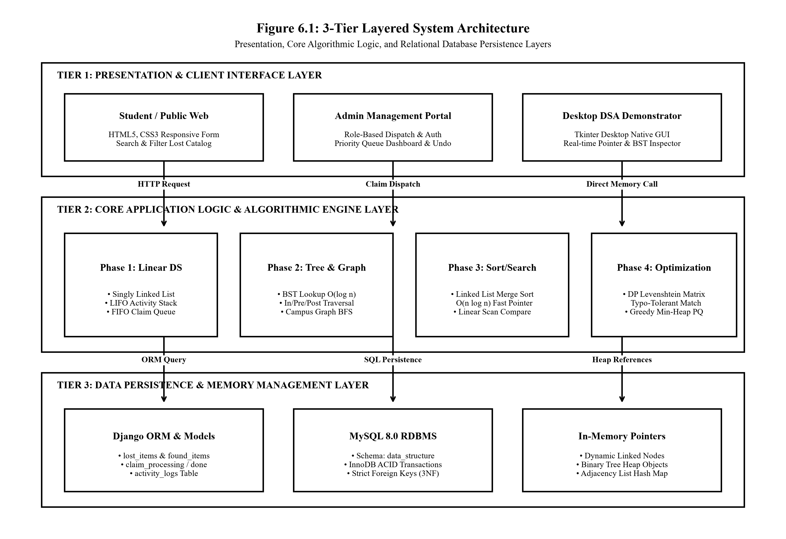
Figure 6.1: 3-Tier Layered System Architecture of Campus Lost & Found System.

6.3 Master Workflow Flowchart
Figure 6.2 provides the comprehensive flowchart tracing the end-to-end execution path from initial loss reporting to final handover and audit logging.

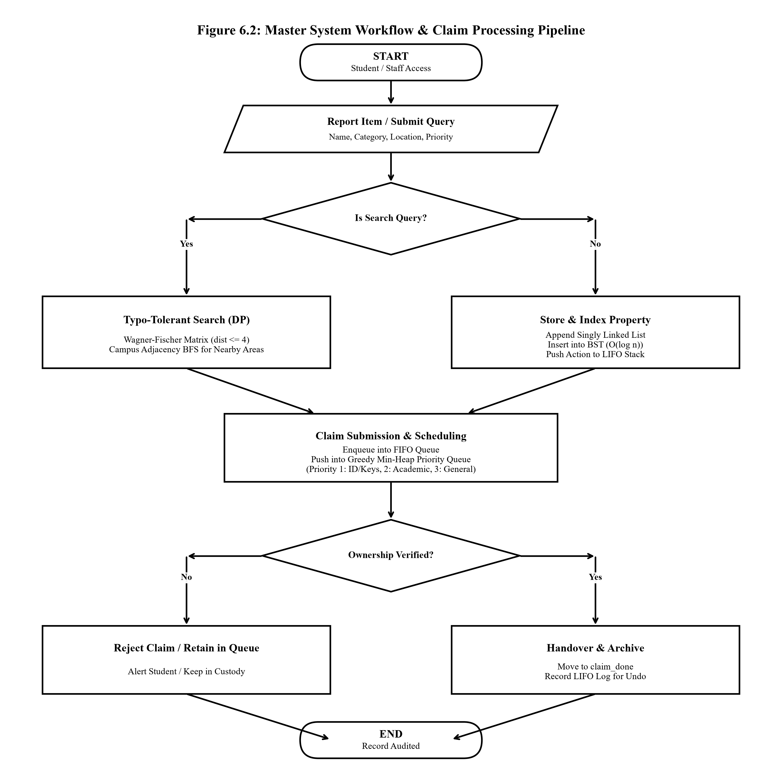

Figure 6.2: Master System Workflow and Claim Processing Pipeline Flowchart

MODULES OF THE PROJECT - PHASE-WISE EXPLANATION
The project is structured into four sequential, mathematically grounded computer science phases, linking foundational data structures with enterprise software implementation.
7.1 Phase 1: Linear Data Structures Module
We implemented some basic linear data structures from scratch in Phase 1 using Python. We were able to learn about pointers, linking nodes and managing memory manually.
7.1.1 Dynamic Singly Linked List (campuslostfound/linked_list.py)
Traditional arrays require memory to be allocated in fixed size chunks. This can lead to wasted space if too much is allocated in advance. It also can be expensive as when deleting items in an array elements need to be shifted to fill the gap which can take O(n) time. A Singly Linked List is used here so that individual Node objects are allocated as needed. Within each Node there is a dictionary containing data (id, name, type, location) and a next pointer which points to the next Node..
Inserting (O(n)/ O(1)). When adding an item to the list, it will loop through the list until it finds where 'current.next' is None and insert the new node. If we are inserting at the beginning of the list we can simply update the pointers in O(1) time.
Deleting (O(n)). We have two pointers; previous and current. We will loop through the list and when we match our desired ID we will set 'previous.next' to 'current.next'. This will skip over the node which will then be picked up by memory management.
Iterating (O(n)). We begin at the 'head' pointer and loop through the next pointers in the list.
Space Complexity. In Python lists are dynamically allocated. This means that they will allocate a block of memory in advance. As this system would be used to track lost and found items which can happen at random, this would waste memory. However using the linked node structure we can allocate memory exactly when needed. When creating a 'Node(data)' we are only allocating the memory for one data reference and one pointer.
7.1.2 Last-In-First-Out (LIFO) Stack (campuslostfound/stack.py)
The Stack data structure is used to store a collection of linked StackNodes. This ensures a Last-In-First-Out (LIFO) order. The Stack stores an audit trail of recent actions in the lost-and-found system.
Push (O(1)) sets the next pointer of the new node to the current self.top, and then updates the self.top to point to the new node.
7.1.3 First-In-First-Out (FIFO) Queue & Phase 2 Architecture
Pop Operation (O(1)): Removes the top action payload. This is used within the application to allow the admin to undo their last action. We have self.top = self.top.next so that we know what our new top of the list is.
In the Django application, when an administrator has made a mistake and either finalises a claim or adds an incorrect lost item, they need to manually revert their changes in the database. To help with this we log every activity into an ActivityLog object, we then push this onto the LIFO Stack. When the administrator would like to undo their action they can make an Undo request. The action will be popped from the top of the stack. We will look at what type of action it was (ADD/PROCESS) and perform the opposite action.
For example setting is_resolved=False and reverting the claim.
7.1.3 First-In-First-Out (FIFO) Queue (campuslostfound/queue.py)
The Queue structure enforces a FIFO operational order using dual pointers: `front` and `rear`.
• Enqueue: O(1). Adds new claims to the queue (self.rear).
• Dequeue: O(1). Removes the earliest claim in the queue (self.front).
• Queue management: Prevents underflow of the queue. If front is None no exception will be thrown when calling dequeue().
7.2 Phase 2: Hierarchical & Graph Structures Module
Phase 2 expands the platform into non-linear, hierarchical and networked topological structures:
7.2.1 Binary Search Tree Architecture (campuslostfound/binary_tree.py)
- Instead of wasting time searching through a list by using linear search, item data is stored using a custom Binary Search Tree. Each TreeNode contains data, left and right children. All nodes in the left subtree must have a key less than the Node's data. Similarly all nodes in the right subtree must have a key greater than or equal to the Node's data. This is all enforced since we are using Binary Search Trees.
- Binary Search Tree (log(n) on average) – If target ID is less than current node, go left. If target ID is greater than current node, go right. This halves our search space each time.BST Node Deletion (O(log n)): Handles three distinct topological scenarios: (1) Leaf node deletion; (2) Single-child node deletion; (3) Two-child node deletion (locates the in-order successor—minimum value node in the right subtree, replaces node data, and recursively deletes the successor).
7.2.1 BST Traversals & Figure 7.1 Flowchart
• Tree Traversals: Supports inorder traversal (left -> root -> right) which will return the node IDs in order. Preorder traversal, (root -> left -> right), can be used for replication of tree structure. And post order traversal (left -> right -> root) for deallocating nodes.
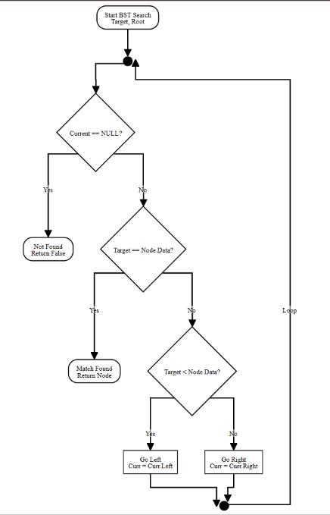
Figure 7.1: Phase 2: Binary Search Tree Lookup and Deletion Flowchart

7.2.2 Campus Adjacency Graph & BFS Traversal (campuslostfound/graph.py)
We modelled the movement of students across the campus as an undirected topological graph G = (V,E). Where V represents the university landmarks (buildings) and E the connecting pathways between them.
• An Adjacency List was used to map each landmark to its connected nodes. This was done as follows: {'Main Block': ['Library', 'Cafeteria'], 'Library': ['Main Block', 'Computer Lab'], 'Cafeteria': ['Main Block', 'Sports Ground'],...}.
• A Breadth-First Search algorithm was used when an item goes missing in a certain block, such as the Central Library. We would search through the adjacent landmarks in layers using a FIFO Queue and visited set.
7.2.2 Campus BFS Walkthrough & Phase 3 Introduction
Example of BFS: Let’s assume that the object has been lost in the Central Library. Our queue will be initialised with ['Library'] and visited initialized with {'Library'}. Then we dequeue 'Library’ from our queue and add it to our search order. Now we look at its adjacent vertices in the adjacency list. We find ['Main Block’, 'Computer Lab']. Since they have not yet been visited we add them to our visited set and enqueue them. Then on the next iteration we dequeue 'Main Block’. We find that there is a connection to 'Cafeteria’. This gives us a search order of ['Library’, 'Main Block’, 'Computer Lab’, 'Cafeteria’, 'Sports Ground'] giving the student and security a structured way to search outwards from the library.

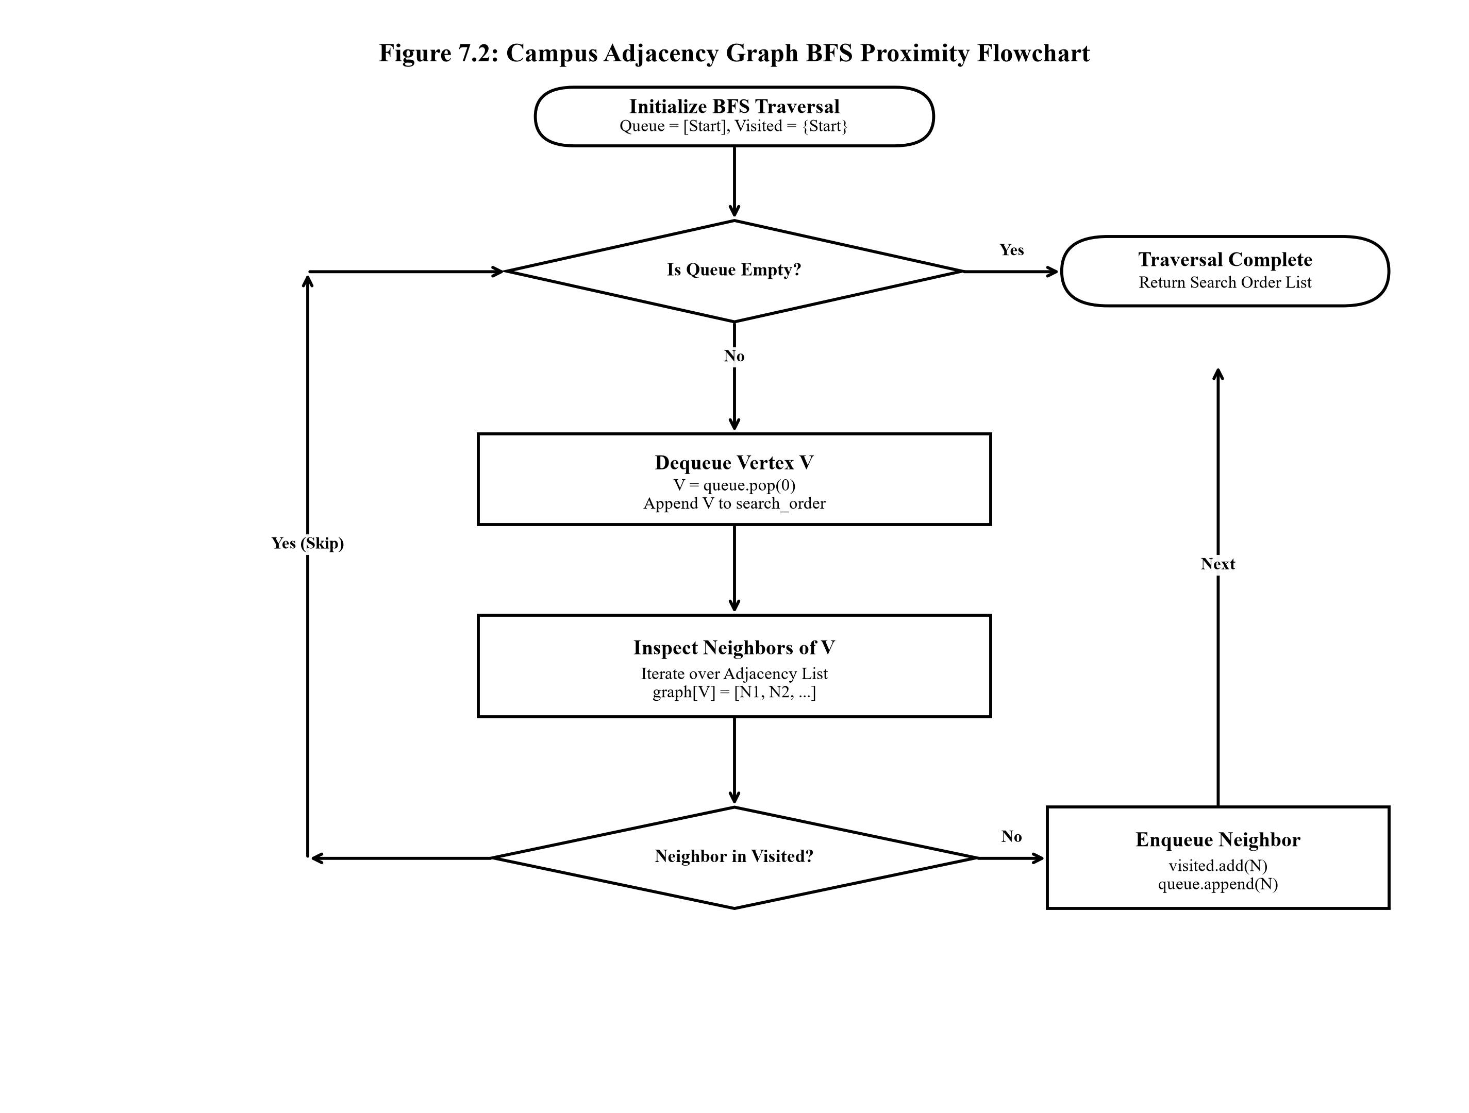

Figure 7.2: Phase 2: Campus Adjacency Graph Breadth-First Search (BFS) Flowchart

7.3 Phase 3: Searching & Sorting Operations Module
This phase included looking at how to sort records and improve algorithms to increase the efficiency of searching through large data sets.
7.3.1 Linked List Merge Sort (campuslostfound/merge_sort.py)
- To sort a singly linked list you require a different approach than that of arrays due to the nature of linked lists meaning you are unable to access nodes at any index in constant time. This means that algorithms such as QuickSort or HeapSort can’t be used to sort linked lists efficiently. The best algorithm to use on a linked list is a merge sort which will give a guaranteed running time of O(n log n) and requires only O(1) extra space to store pointers.
Fast and Slow Pointers: Have two pointers, slow and fast. Slow moves 1 node at a time and fast moves 2 nodes at a time. Once fast reaches the end of the list, slow is at the middle. We can then set `middle.next` to None to split the list.
Recursively Sort Left and Right Halves: Then we recursively sort the left and right halves until we reach our base nodes.
Merge In-Situ: Compare the data of left and right, specifically the 'id'. Then merge using pointers only.

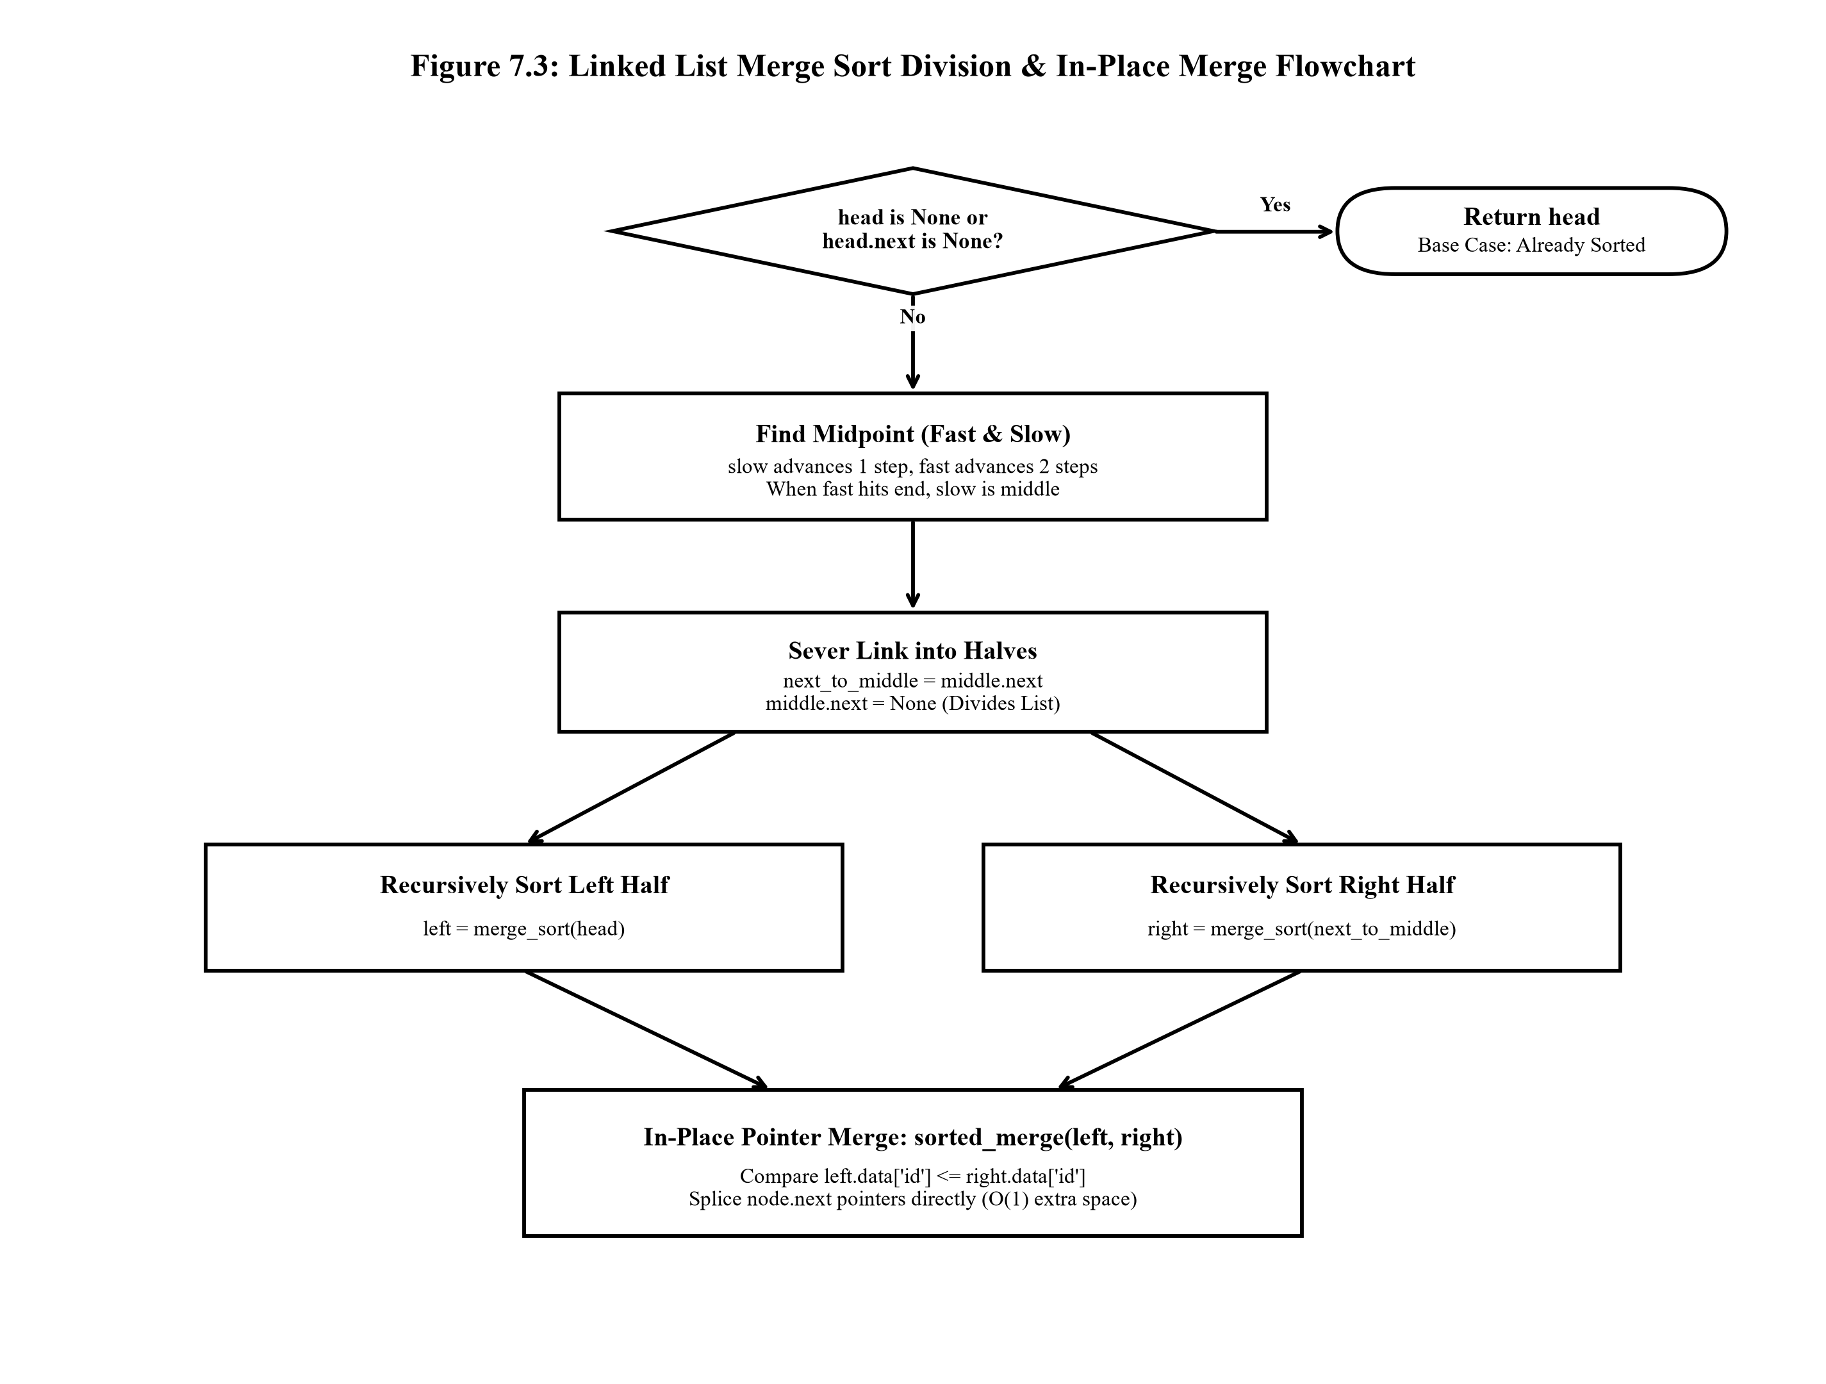
7.3.1 Merge Sort Flowchart & Phase 4 Introduction

Figure 7.3: Phase 3: Linked List Merge Sort In-Place Division and Merge Flowchart

7.3.2 Linear vs. Hierarchical Search Benchmarking
When searching a list of unordered nodes for a specific item, the worst-case complexity is O(n), where n is the number of comparisons made. For example if the item was not in the list of 10,000 nodes, then in the worst case we would have to make 10,000 comparisons. Whereas with the Binary Search Tree we only would have to make a maximum of 14 comparisons, since log 2 10000 is approximately 13.3. This improvement in asymptotic complexity can be seen in phase 3 of the experiments.
7.4 Phase 4: Algorithmic Problem Solving Module
This phase considers two specific practical issues that may be encountered on a daily basis; finding strings using fuzzy search techniques to help with spelling mistakes in item names and scheduling of remaining claims based on their urgency.
7.4.1 Dynamic Programming Levenshtein Distance Matrix (campuslostfound/smart_match.py)
When students search for lost belongings, typographical errors often prevent exact keyword matches. To resolve this, Phase 4 implements the Wagner-Fischer Dynamic Programming algorithm to calculate the minimum edit distance (insertions, deletions, and substitutions) between query strings.
The recurrence relation is computed over a 2D matrix DP[0..m][0..n]:
- Base Conditions: DP[i][0] = i (cost of deleting i characters); DP[0][j] = j (cost of inserting j characters).
7.4.1 Levenshtein Matrix Flowchart & Min-Heap PQ
- Transition Equation: If `str1[i-1] == str2[j-1]`, then `DP[i][j] = DP[i-1][j-1]` (cost is 0). Otherwise, `DP[i][j] = 1 + min(DP[i][j-1], DP[i-1][j], DP[i-1][j-1])` representing minimum cost among insertion, deletion, and substitution.
- Smart Match Decision Rule: The system iterates over all active records in the linked list, computing edit distance. If the minimal distance is <= 4, the system outputs: `Did you mean: '[Matched Item]'? (Edit distance: k)`. This bridges human spelling errors with exact database records.
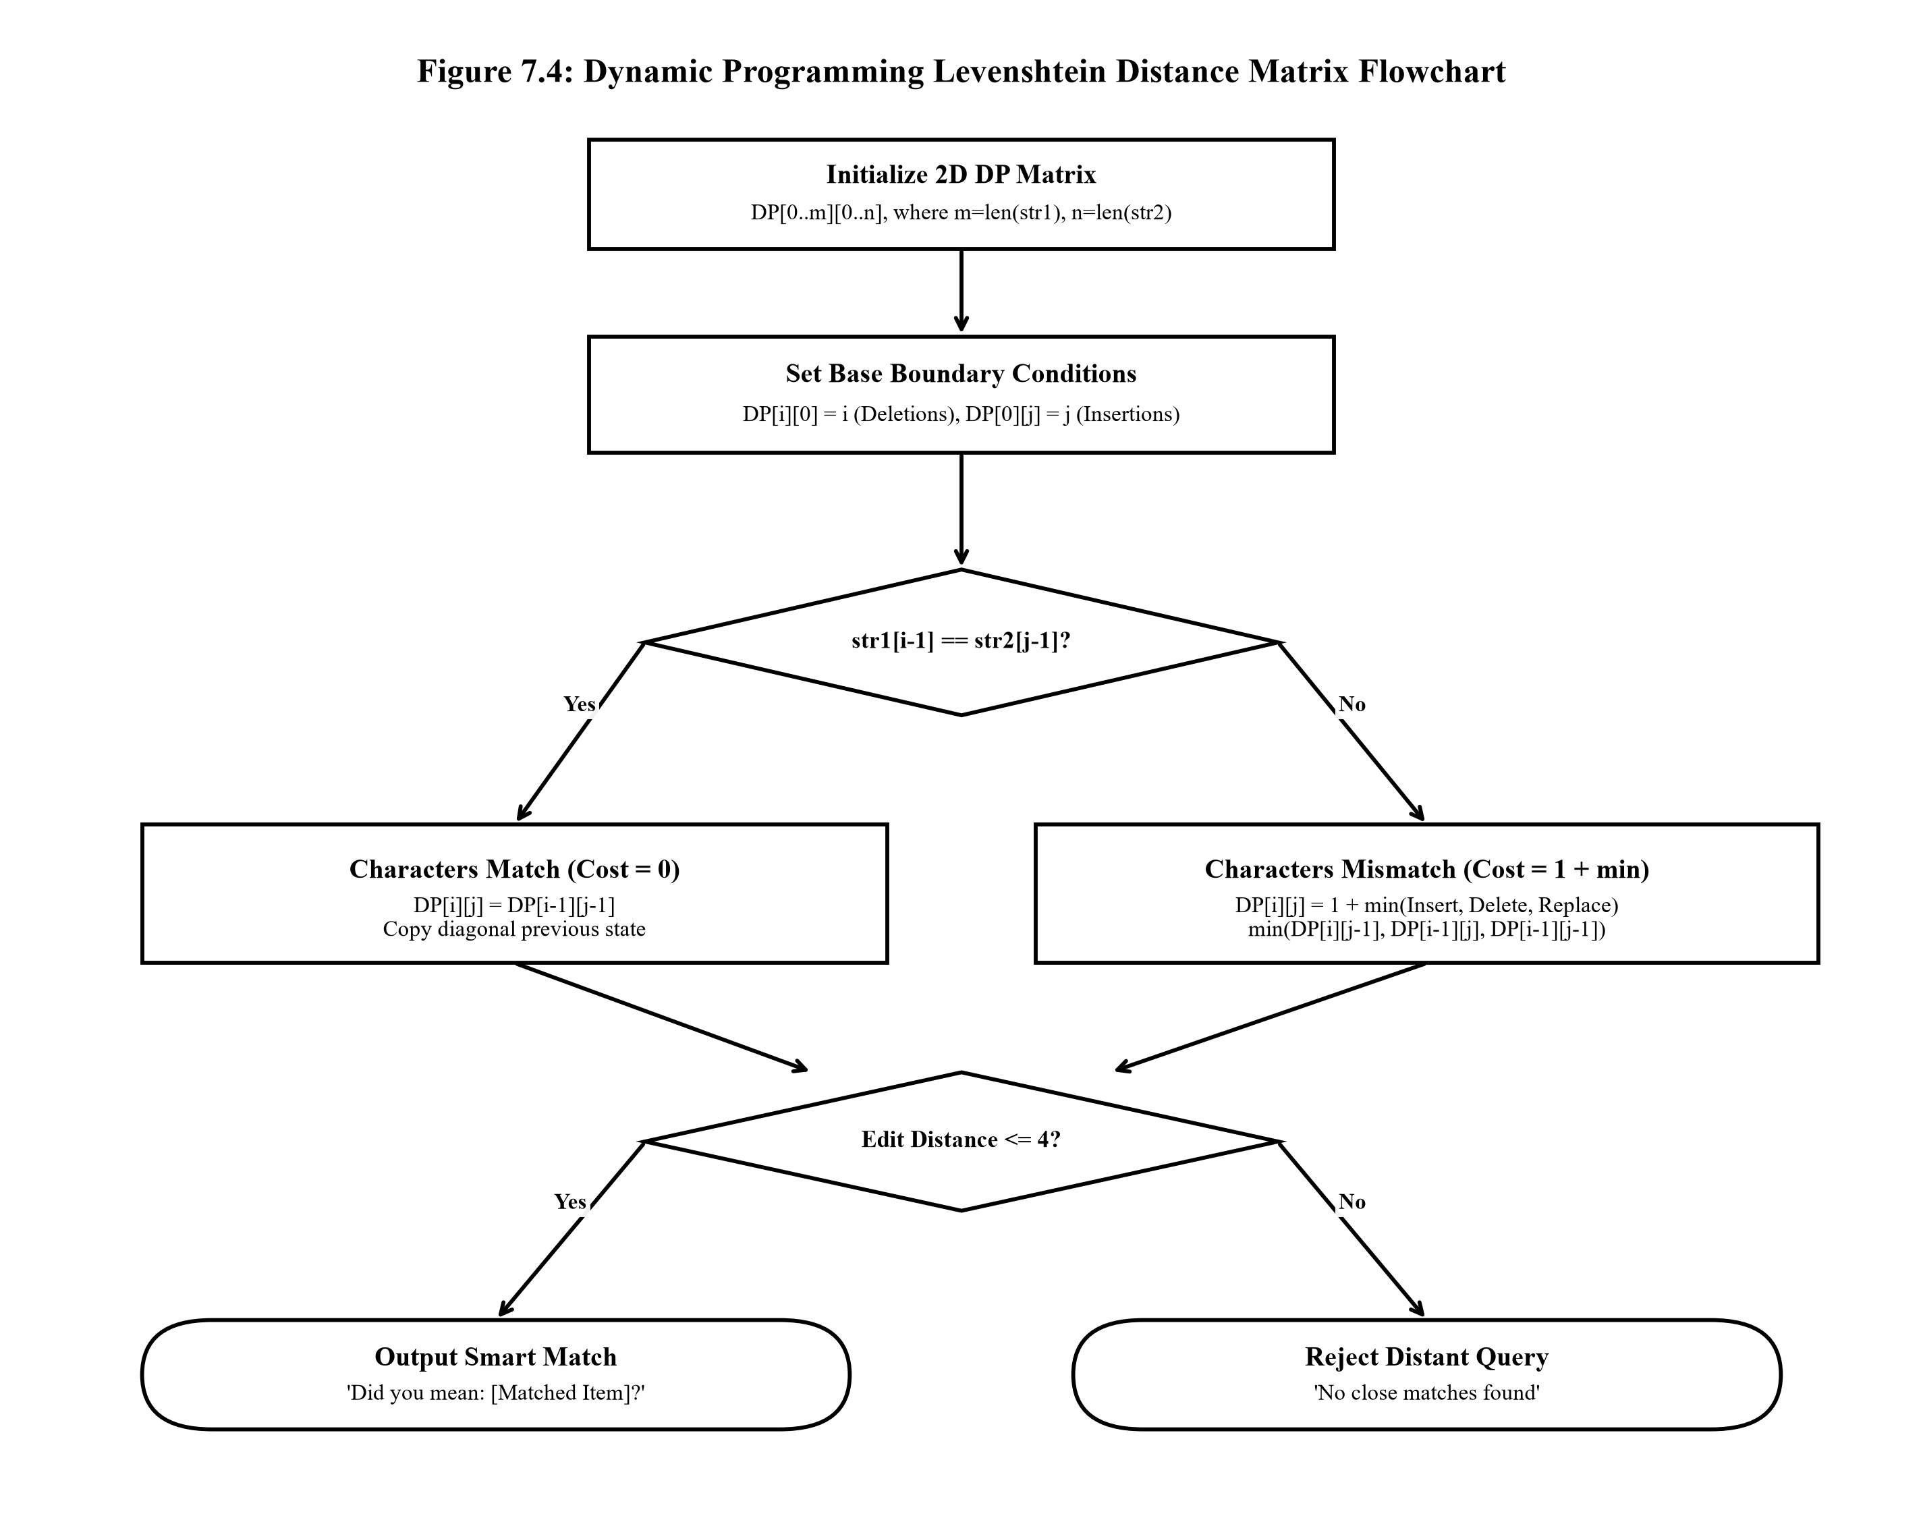
Illustrative Walkthrough: Suppose a student enters query 'calclator' and the database holds 'Calculator'. The 2D DP matrix computes: string length m=9, n=10. The letters match sequentially except for the missing 'u' at index 4. The algorithm calculates minimal cost = 1 insertion. Since 1 <= 4, the Smart Match engine instantly returns: 'Did you mean: Calculator? (Edit distance: 1)', converting an otherwise failed query into a successful recovery.
Figure 7.4: Phase 4: Dynamic Programming Levenshtein Distance Matrix Flowchart

7.4.2 Greedy Min-Heap Priority Queue Claim Scheduler (scheduler/views.py)
In Phase 4, the web application elevates FIFO claim handling into an urgency-ranked Priority Queue. Utilizing Python's binary min-heap implementation (`heapq`), pending claims are scheduled based on an integer priority tuple `(priority, id, object)`:
7.5 Algorithmic Complexity Table & DFD Models
- Priority 1 (High Urgency): Identity cards, room keys, examination tickets, laptops, prescription eyewear.
- Priority 2 (Medium Urgency): Scientific calculators, wristwatches, course textbooks, backpacks.
- Priority 3 (Low Urgency): Water bottles, stationery, notebooks, umbrellas.
By maintaining the min-heap property in O(log n) time during `heappush` and `heappop`, high-priority claims automatically rise to the top of the processing queue, ensuring vital student belongings are resolved before non-essential items.
7.5 Comprehensive Algorithmic Complexity & Space-Time Trade-Offs
Table 7.1 details the formal space-time complexity bounds across all four project phases:
Data Structure / Algorithm | Phase | Time (Best) | Time (Average) | Time (Worst) | Space Complexity
Singly Linked List (Insert) | Phase 1 | O(1) | O(n) | O(n) | O(1) auxiliary
Singly Linked List (Delete) | Phase 1 | O(1) | O(n) | O(n) | O(1) auxiliary
Linked Stack (Push / Pop) | Phase 1 | O(1) | O(1) | O(1) | O(n) storage
Linked Queue (Enqueue / Dequeue) | Phase 1 | O(1) | O(1) | O(1) | O(n) storage
Binary Search Tree (Search) | Phase 2 | O(1) | O(log n) | O(n) skewed | O(h) call stack
Binary Search Tree (Delete) | Phase 2 | O(1) | O(log n) | O(n) skewed | O(h) call stack
Campus Graph BFS Traversal | Phase 2 | O(V + E) | O(V + E) | O(V + E) | O(V) queue & visited
Linked List Merge Sort | Phase 3 | O(n log n) | O(n log n) | O(n log n) | O(log n) stack / O(1) mem
DP Levenshtein Distance Matrix | Phase 4 | O(m * n) | O(m * n) | O(m * n) | O(m * n) 2D matrix
Min-Heap Priority Queue (Push/Pop) | Phase 4 | O(1) | O(log n) | O(log n) | O(n) heap array

7.6 Data Flow Diagram (DFD) Models
Data Flow Diagrams visualize the systemic movement, transformation, and storage of data between external entities and internal processes:

7.6.1 DFD Level 0 Context Diagram
The Level 0 Context Diagram establishes the global boundary of the system. Four external entities interact with Process 0.0 (Campus Lost & Found System): Students (submitting loss reports and claims), Finders (registering found items), System Administrators (verifying claims and auditing logs), and the Campus Security Office (authorizing asset handovers).
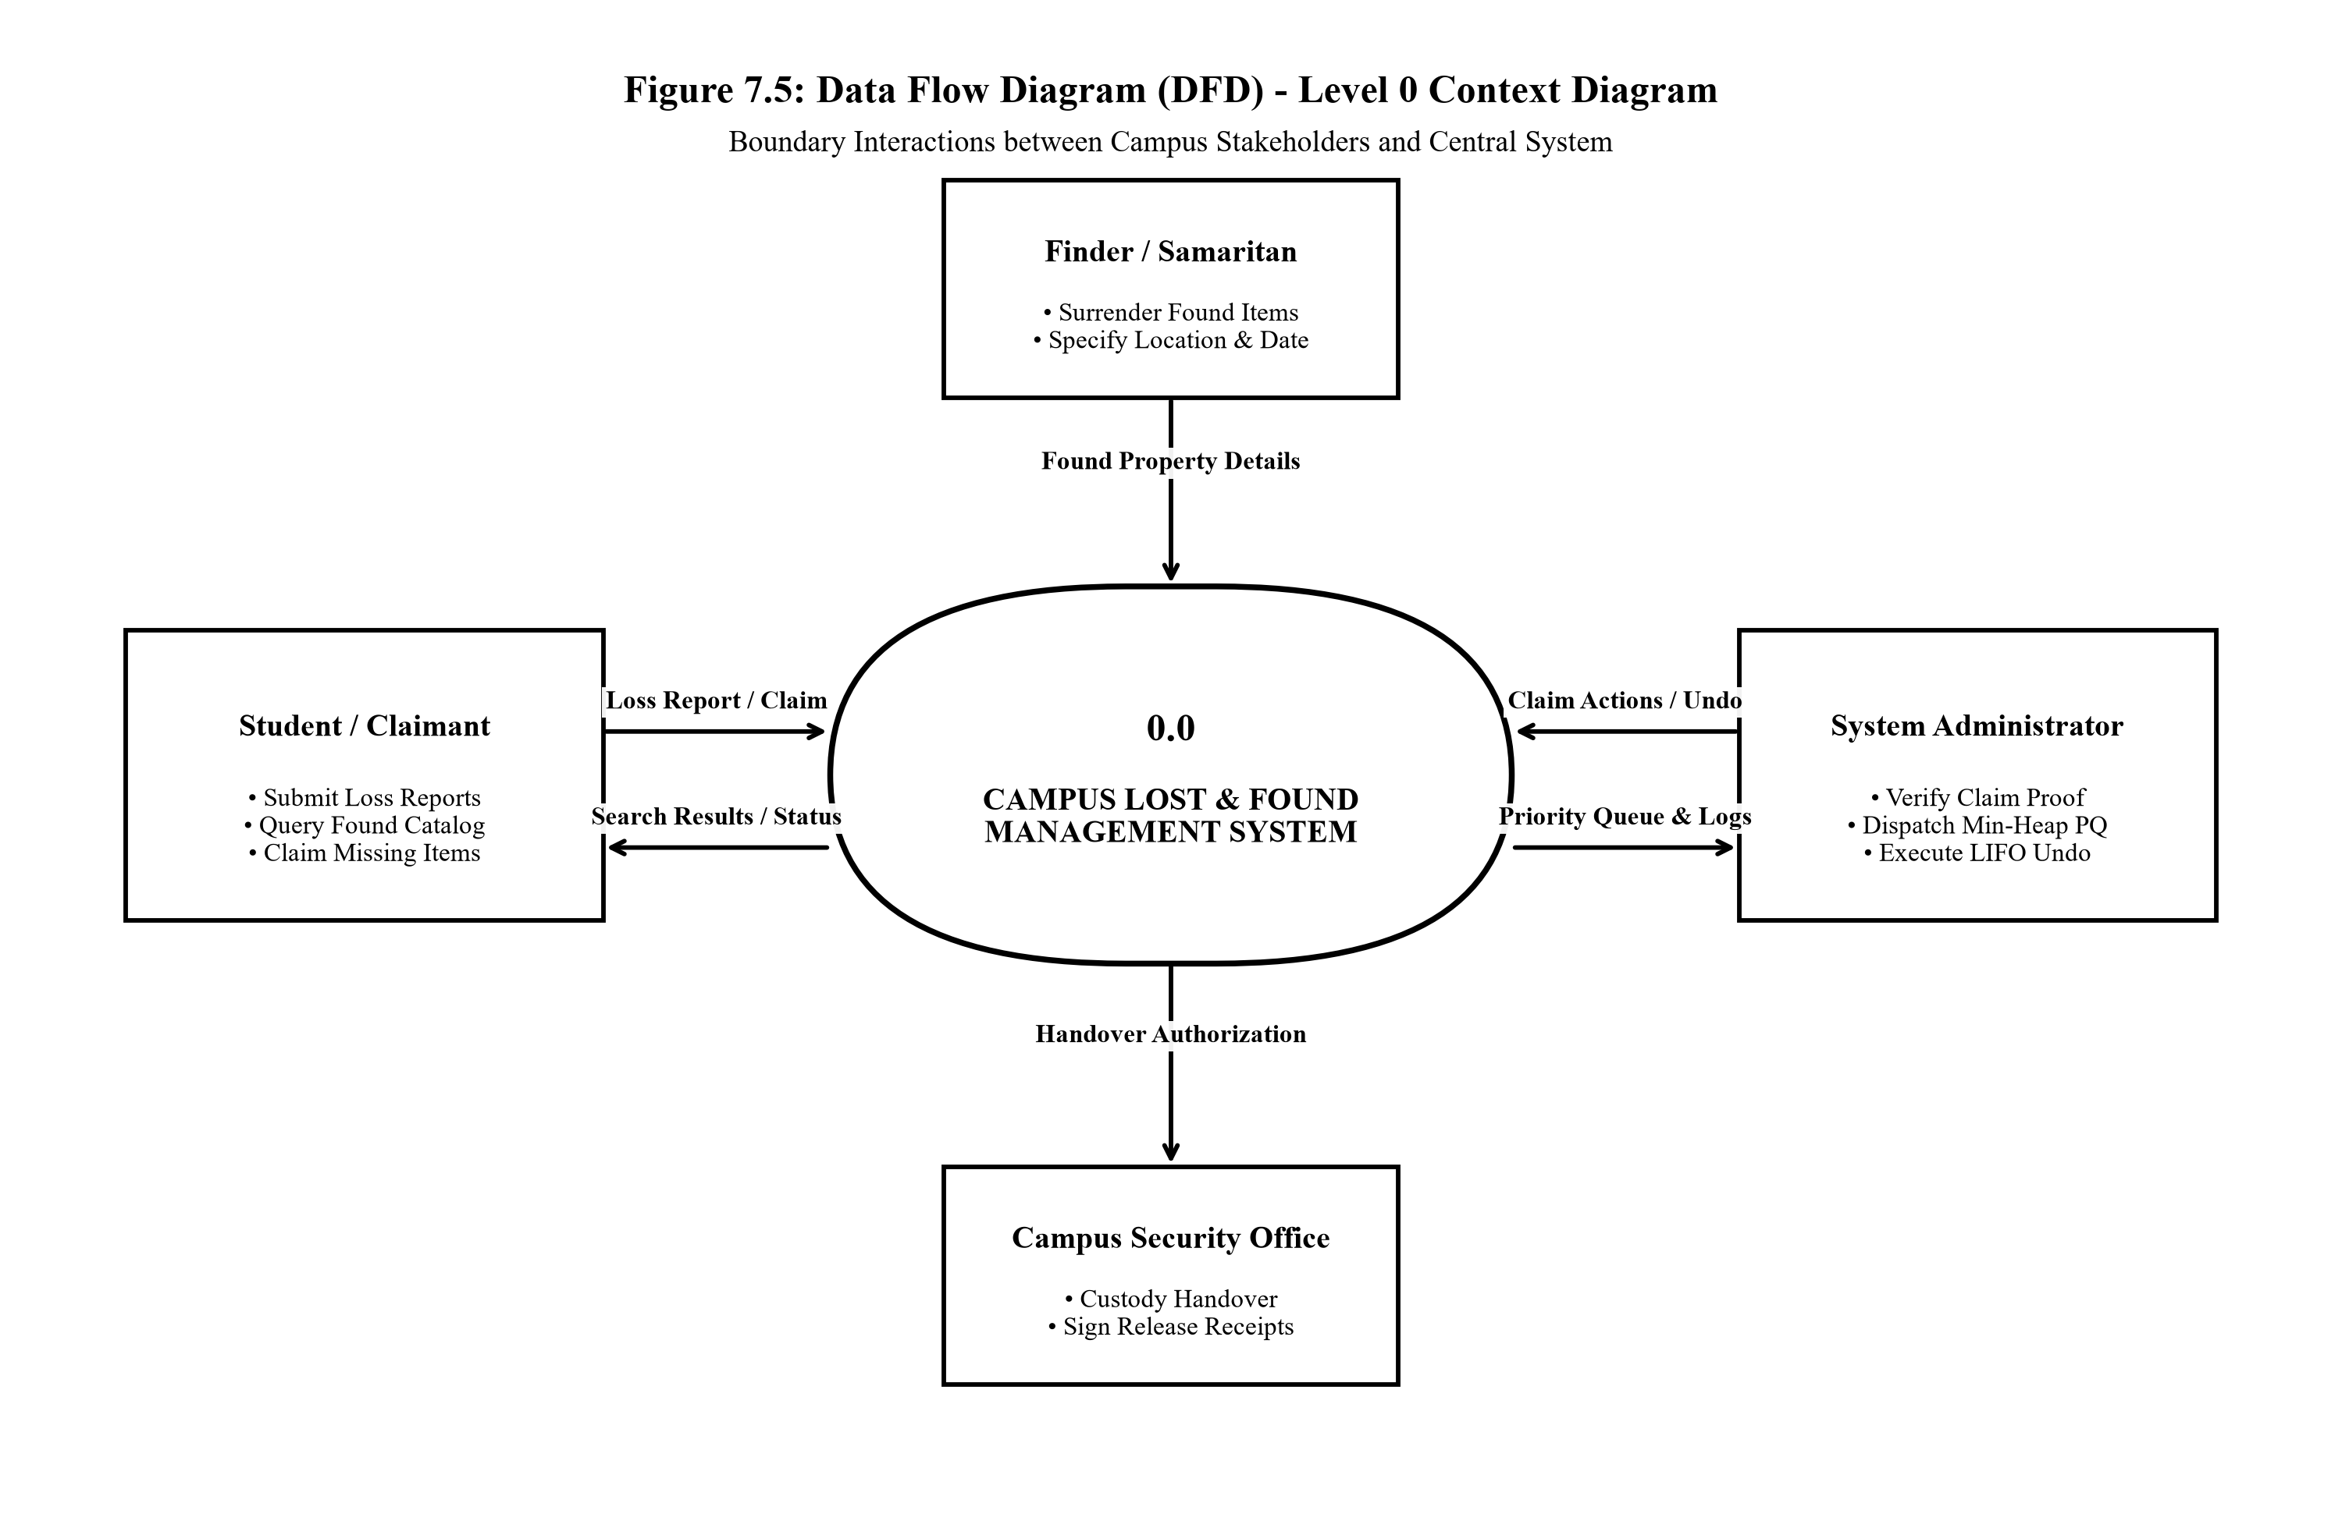
Figure 7.5: Data Flow Diagram (DFD) - Level 0 Context Diagram
7.6.2 DFD Level 1: Subsystem Process Decomposition
The Level 1 DFD decomposes Process 0.0 into five discrete operational processes: Process 1.0 (User Authentication & Role Validation), Process 2.0 (Lost/Found Item Registration), Process 3.0 (Algorithmic Search & Smart Matching), Process 4.0 (Claim Priority Scheduling), and Process 5.0 (Activity Auditing & LIFO Stack Undo). These processes interact with three data stores: D1 (`lost_items` / `found_items`), D2 (`claim_processing` / `claim_done`), and D3 (`activity_logs`).

7.6.2 DFD Level 1 Diagram & Database Design
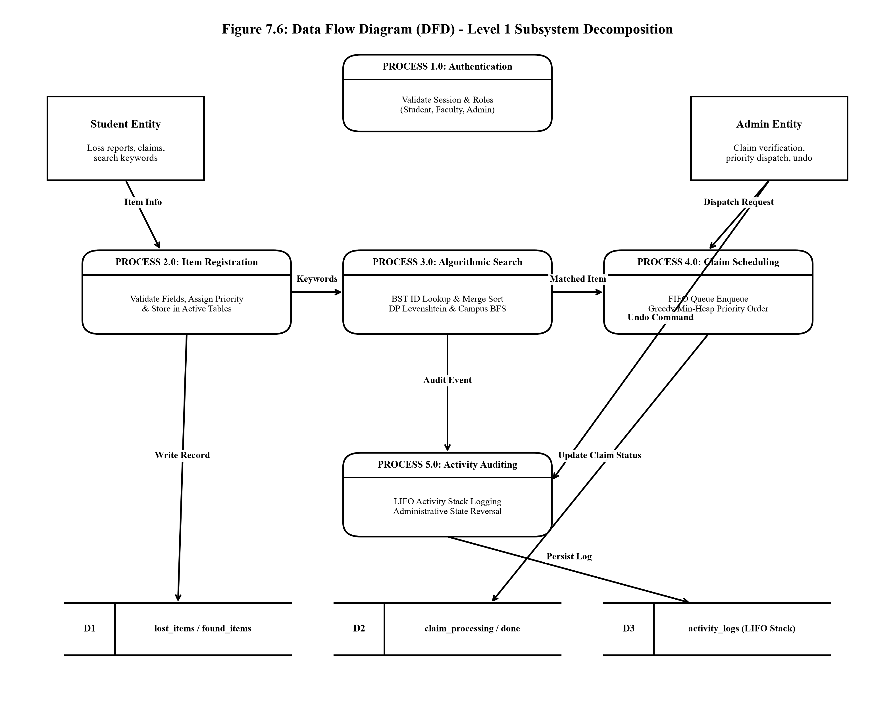
Figure 7.6: Data Flow Diagram (DFD) - Level 1 Subsystem Process Decomposition

7.7 Database Design, Relational Schema & Normalization Analysis (3NF)
The relational database schema is configured under the `data_structure` MySQL database. It consists of five interrelated tables designed according to rigorous Third Normal Form (3NF) relational principles.
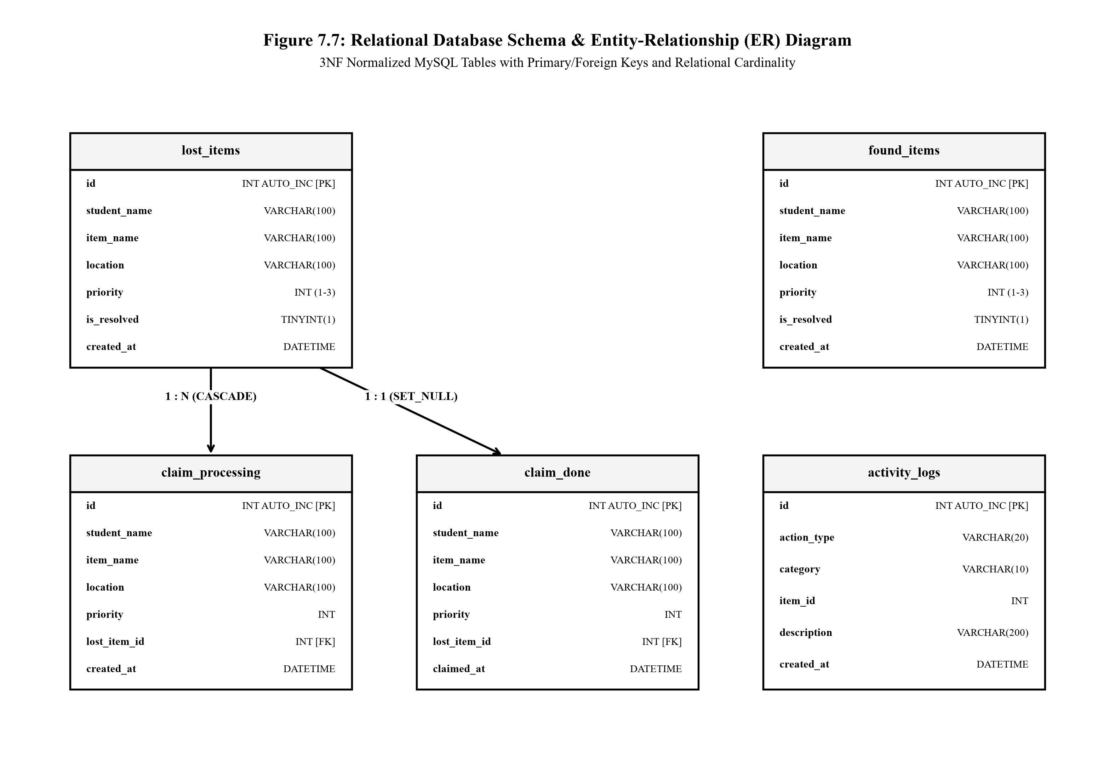
Figure 7.7: Relational Database Schema and Entity-Relationship (ER) Diagram

7.7.2 Detailed Relational Table Specifications
Table 1: lost_items (Lost Property Registry)
Field Name | Data Type | Constraint | Description / Purpose
id | INT AUTO_INCREMENT | PRIMARY KEY | Unique numerical surrogate key for lost item record
student_name | VARCHAR(100) | NOT NULL | Student identification or register number (e.g. 26MCAC28)
item_name | VARCHAR(100) | NOT NULL | Description of lost property (e.g. Student ID Card)
location | VARCHAR(100) | NOT NULL | Last known campus location where item was lost
priority | INT | DEFAULT 2 | Urgency level: 1 = High, 2 = Medium, 3 = Low
is_resolved | TINYINT(1) | DEFAULT 0 | Boolean flag indicating whether item has been recovered
created_at | DATETIME | AUTO_NOW_ADD | Timestamp of loss report submission

Table 2: found_items (Found Property Inventory)
Field Name | Data Type | Constraint | Description / Purpose
id | INT AUTO_INCREMENT | PRIMARY KEY | Unique numerical surrogate key for found item record
student_name | VARCHAR(100) | NOT NULL | Name or identifier of person who discovered the item
item_name | VARCHAR(100) | NOT NULL | Title / description of the found article
location | VARCHAR(100) | NOT NULL | Campus physical location where item was recovered
priority | INT | DEFAULT 2 | Calculated item urgency priority (1=High, 2=Med, 3=Low)
is_resolved | TINYINT(1) | DEFAULT 0 | Boolean flag: 1 if returned to owner, 0 if still in inventory
created_at | DATETIME | AUTO_NOW_ADD | System timestamp when item was logged into custody

7.7.2 Relational Specifications (Claims Management)
Table 3: claim_processing (Active Claims Queue)
Field Name | Data Type | Constraint | Description / Purpose
id | INT AUTO_INCREMENT | PRIMARY KEY | Unique numerical claim queue identifier
student_name | VARCHAR(100) | NOT NULL | Claimant student ID or register number
item_name | VARCHAR(100) | NOT NULL | Name of the target item being claimed
location | VARCHAR(100) | NOT NULL | Location where loss occurred
priority | INT | DEFAULT 2 | Priority weighting used by Min-Heap queue scheduler
lost_item_id | INT | FOREIGN KEY | References lost_items(id) with CASCADE deletion rule
created_at | DATETIME | AUTO_NOW_ADD | Timestamp when claim entered active processing queue

Table 4: claim_done (Historical Claim Archive)
Field Name | Data Type | Constraint | Description / Purpose
id | INT AUTO_INCREMENT | PRIMARY KEY | Unique historical archive record key
student_name | VARCHAR(100) | NOT NULL | Name of claimant who received the item
item_name | VARCHAR(100) | NOT NULL | Name of resolved article
location | VARCHAR(100) | NOT NULL | Location record of item
priority | INT | DEFAULT 2 | Urgency level of the fulfilled claim
lost_item_id | INT | FOREIGN KEY | References lost_items(id) with SET_NULL rule on delete
claimed_at | DATETIME | AUTO_NOW_ADD | Verification timestamp when handover was finalized

7.7.3 Database Normalization Proof (1NF, 2NF, 3NF)

Table 5: activity_logs (Audit Trail & Undo Log)
Field Name | Data Type | Constraint | Description / Purpose
id | INT AUTO_INCREMENT | PRIMARY KEY | Sequential audit log entry key
action_type | VARCHAR(20) | NOT NULL | Operation type: 'ADD', 'PROCESS', or 'DELETE'
category | VARCHAR(10) | DEFAULT 'Lost' | Category of item affected ('Lost' or 'Found')
item_id | INT | NOT NULL | Surrogate ID of the target record modified
description | VARCHAR(200) | NOT NULL | Human-readable activity summary for auditing
created_at | DATETIME | AUTO_NOW_ADD | Exact system timestamp when action transpired

FORMAL NORMALIZATION PROOF (1NF, 2NF, 3NF)
- In order to eliminate any duplicate data and update/insert/delete anomalies, our relational database was made using normalisation techniques up to 3rd Normal Form:
- Attribute fields only contain atomic data. No repeating groups or comma separated lists are present. Every row is unique with an auto incrementing id column as the primary key.
- Second Normal Form (2NF): The schema meets 1NF criteria and has zero partial functional dependencies. Because all primary keys are single-column integer IDs rather than composite keys, every non-key attribute (`student_name`, `item_name`, `location`, `priority`) depends on the complete primary key.

Third Normal Form (3NF)
The third normal form removes transitive functional dependencies.
This means that all of the second normal form requirements are met. In the original designs there were many unnormalised elements. Resolution dates and claimant information was being stored within the `lost_items` table. This caused non-key attributes to rely on other non-key attributes. The splitting up of the active claims into the `claim_processing` table and finalised handovers into the `claim_done`. All non-prime attributes rely directly on the primary key only (X -> Y, where X is a candidate key).
8. SOURCE CODE (FUNCTIONAL CODE STRUCTURE)
In accordance with project documentation standards, structural and functional source code excerpts representing the core data structures, desktop UI, and Django web controllers are presented below.
8.1 Data Structures Core Engine (campuslostfound/)
Source Code Artifact: campuslostfound/linked_list.py (Phase 1: Dynamic Singly Linked List)
# linked_list.py
class Node:
def __init__(self, data):
self.data = data
self.next = None
class LinkedList:
def __init__(self):
self.head = None
# Insert a new item
def insert(self, data):
new_node = Node(data)
if self.head is None:
self.head = new_node
else:
current = self.head
while current.next:
current = current.next
current.next = new_node
print("Item inserted successfully.")
# Delete an item using ID
def delete(self, item_id):
current = self.head
previous = None
while current:
if current.data["id"] == item_id:
if previous is None:
self.head = current.next
else:
previous.next = current.next
print("Item deleted successfully.")
return
previous = current
current = current.next
print("Item not found.")
# Display all items
def traverse(self):
if self.head is None:
print("No items available.")
return
current = self.head
while current:
print("----------------------")
print("ID :", current.data["id"])
print("Item :", current.data["name"])
print("Type :", current.data["type"])
print("Location :", current.data["location"])
current = current.next

Source Code Artifact: campuslostfound/stack.py (Phase 1: LIFO Linked Stack for Activity History)
# stack.py
class StackNode:
def __init__(self, data):
self.data = data
self.next = None
class Stack:
def __init__(self):
self.top = None
# Push
def push(self, data):
new_node = StackNode(data)
new_node.next = self.top
self.top = new_node
print("Activity added to stack.")
# Pop
def pop(self):
if self.top is None:
print("Stack is empty.")
return None
data = self.top.data
self.top = self.top.next
return data
# Display stack
def display(self):
if self.top is None:
print("Stack is empty.")
return
current = self.top
print("\nRecent Activities:")
while current:
print("-", current.data)
current = current.next

Source Code Artifact: campuslostfound/queue.py (Phase 1: FIFO Linked Queue for Claim Inquiries)
# queue.py
class QueueNode:
def __init__(self, data):
self.data = data
self.next = None
class Queue:
def __init__(self):
self.front = None
self.rear = None
# Add claim
def enqueue(self, data):
new_node = QueueNode(data)
if self.rear is None:
self.front = self.rear = new_node
return
self.rear.next = new_node
self.rear = new_node
# Process claim
def dequeue(self):
if self.front is None:
print("No claims available.")
return None
data = self.front.data
self.front = self.front.next
if self.front is None:
self.rear = None
return data
# Display claims
def display(self):
if self.front is None:
print("No pending claims.")
return
current = self.front
print("\nPending Claims:")
while current:
print("-", current.data)
current = current.next

Source Code Artifact: campuslostfound/binary_tree.py (Phase 2: BST Insertion, Search, Deletion & Traversals)
class TreeNode:
def __init__(self, data):
self.data = data
self.left = None
self.right = None
class BinarySearchTree:
def __init__(self):
self.root = None
def insert(self, data):
new_node = TreeNode(data)
if self.root is None:
self.root = new_node
return
current = self.root
while True:
if data < current.data:
if current.left is None:
current.left = new_node
return
current = current.left
else:
if current.right is None:
current.right = new_node
return
current = current.right
def search(self, value):
current = self.root
while current:
if current.data == value:
return True
elif value < current.data:
current = current.left
else:
current = current.right
return False
# --- NEW: Deletion Logic for UI Synchronization ---
def delete(self, value):
self.root = self._delete_recursive(self.root, value)
def _delete_recursive(self, node, value):
if node is None:
return node
if value < node.data:
node.left = self._delete_recursive(node.left, value)
elif value > node.data:
node.right = self._delete_recursive(node.right, value)
else:
if node.left is None:
return node.right
elif node.right is None:
return node.left
temp = self._get_min_value_node(node.right)
node.data = temp.data
node.right = self._delete_recursive(node.right, temp.data)
return node
def _get_min_value_node(self, node):
current = node
while current.left is not None:
current = current.left
return current
# --- NEW: Phase 2 Required Traversals ---
def inorder_traversal(self, node, result_list):
if node:
self.inorder_traversal(node.left, result_list)
result_list.append(node.data)
self.inorder_traversal(node.right, result_list)
return result_list
def preorder_traversal(self, node, result_list):
if node:
result_list.append(node.data)
self.preorder_traversal(node.left, result_list)
self.preorder_traversal(node.right, result_list)
return result_list
def postorder_traversal(self, node, result_list):
if node:
self.postorder_traversal(node.left, result_list)
self.postorder_traversal(node.right, result_list)
result_list.append(node.data)
return result_list

Source Code Artifact: campuslostfound/graph.py (Phase 2: Campus Adjacency Graph & BFS Traversal)
class CampusGraph:
def __init__(self):
# Adjacency list mapping how campus buildings are connected
self.graph = {
"Main Block": ["Library", "Cafeteria"],
"Library": ["Main Block", "Computer Lab"],
"Cafeteria": ["Main Block", "Sports Ground"],
"Computer Lab": ["Library"],
"Sports Ground": ["Cafeteria"]
}
# BFS Traversal to find all nearby locations spreading outward
def get_nearby_locations(self, start_location):
if start_location not in self.graph:
return [start_location]
visited = set()
queue = [start_location]
search_order = []
while queue:
current = queue.pop(0)
if current not in visited:
visited.add(current)
search_order.append(current)
# Add all adjacent, unvisited buildings to the queue
for neighbor in self.graph.get(current, []):
if neighbor not in visited:
queue.append(neighbor)
return search_order

Source Code Artifact: campuslostfound/merge_sort.py (Phase 3: Linked List Merge Sort In-Place)
def merge_sort_linked_list(head):
# Base case: if head is empty or there is only one element
if head is None or head.next is None:
return head
# Find the middle of the linked list
middle = get_middle(head)
next_to_middle = middle.next
# Sever the link to split the list in two
middle.next = None
# Recursively sort both halves
left = merge_sort_linked_list(head)
right = merge_sort_linked_list(next_to_middle)
# Merge the sorted halves
return sorted_merge(left, right)
def get_middle(head):
if head is None:
return head
slow = head
fast = head
# Fast pointer moves two nodes, slow pointer moves one node
while fast.next is not None and fast.next.next is not None:
slow = slow.next
fast = fast.next.next
return slow
def sorted_merge(a, b):
result = None
# Base cases
if a is None:
return b
if b is None:
return a
# Sort numerically by Item ID
if a.data["id"] <= b.data["id"]:
result = a
result.next = sorted_merge(a.next, b)
else:
result = b
result.next = sorted_merge(a, b.next)
return result

Source Code Artifact: campuslostfound/smart_match.py (Phase 4: Dynamic Programming Levenshtein Distance)
def levenshtein_distance(str1, str2):
# Create a 2D matrix (Dynamic Programming table)
dp = [[0 for _ in range(len(str2) + 1)] for _ in range(len(str1) + 1)]
for i in range(len(str1) + 1):
for j in range(len(str2) + 1):
if i == 0:
dp[i][j] = j # Min operations = j insertions
elif j == 0:
dp[i][j] = i # Min operations = i deletions
elif str1[i-1].lower() == str2[j-1].lower():
dp[i][j] = dp[i-1][j-1]
else:
dp[i][j] = 1 + min(dp[i][j-1], # Insert
dp[i-1][j], # Remove
dp[i-1][j-1]) # Replace
return dp[len(str1)][len(str2)]
def find_best_match(search_term, linked_list_head):
if not linked_list_head:
return "No items in database."
best_match = None
lowest_distance = float('inf')
current = linked_list_head
while current:
item_name = current.data["name"]
dist = levenshtein_distance(search_term, item_name)
# If it's a closer match (fewer edits needed), update the best match
if dist < lowest_distance:
lowest_distance = dist
best_match = item_name
current = current.next
# If the distance is small enough (4 or fewer edits), consider it a smart match
if lowest_distance <= 4:
return f"Did you mean: '{best_match}'? (Edit distance: {lowest_distance})"
return "No close matches found."

8.2 Desktop GUI Interface Implementation (main_ui.py)
Source Code Artifact: campuslostfound/main_ui.py (Desktop Tkinter Multi-Phase Demonstrator)
import tkinter as tk
from tkinter import messagebox
import sys
import io
# Import your custom data structures
from linked_list import LinkedList
from stack import Stack
from queue import Queue
from binary_tree import BinarySearchTree
from graph import CampusGraph
from merge_sort import merge_sort_linked_list
from smart_match import find_best_match
# Initialize data structures
items = LinkedList()
activities = Stack()
claims = Queue()
item_tree = BinarySearchTree()
campus_map = CampusGraph() # <-- Fixed: This was missing
def add_item_ui():
try:
item_id = int(entry_id.get())
name = entry_name.get()
item_type = entry_type.get()
location = entry_loc.get()
# Insert into structures
items.insert({"id": item_id, "name": name, "type": item_type, "location": location})
activities.push(f"Added item: {name}")
item_tree.insert(item_id)
messagebox.showinfo("Success", "Item Added Successfully!")
# Clear inputs
entry_id.delete(0, tk.END)
entry_name.delete(0, tk.END)
entry_type.delete(0, tk.END)
entry_loc.delete(0, tk.END)
except ValueError:
messagebox.showerror("Error", "Item ID must be an integer.")
def find_nearby_ui():
location = entry_loc.get()
if not location:
messagebox.showwarning("Warning", "Please enter a location in the Add Item section to search nearby.")
return
# Run the O(V+E) BFS traversal
nearby = campus_map.get_nearby_locations(location)
activities.push(f"Ran BFS traversal from: {location}")
messagebox.showinfo("BFS Traversal Result", f"If item is missing from {location}, check these connected areas:\n\n{', '.join(nearby)}")
def search_item_ui():
try:
item_id = int(entry_search_id.get())
# O(log N) search using the Binary Search Tree
if item_tree.search(item_id):
messagebox.showinfo("Search Result", f"Item ID {item_id} FOUND in the system!")
else:
messagebox.showwarning("Search Result", f"Item ID {item_id} NOT FOUND.")
except ValueError:
messagebox.showerror("Error", "Please enter a valid numeric ID.")
def delete_item_ui():
try:
item_id = int(entry_search_id.get())
# Synchronized deletion: Remove from both Linked List and BST
items.delete(item_id)
item_tree.delete(item_id)
activities.push(f"Deleted item ID: {item_id}")
messagebox.showinfo("Success", f"Attempted to delete Item ID {item_id}.")
entry_search_id.delete(0, tk.END)
except ValueError:
messagebox.showerror("Error", "Please enter a valid numeric ID.")
def add_claim_ui():
name = entry_claim_name.get()
item_id = entry_claim_id.get()
if name and item_id:
claims.enqueue(f"{name} claimed item {item_id}")
activities.push("New claim added")
messagebox.showinfo("Success", "Claim Added to Queue!")
entry_claim_name.delete(0, tk.END)
entry_claim_id.delete(0, tk.END)
else:
messagebox.showwarning("Warning", "Please enter both name and item ID.")
def process_claim_ui():
old_stdout = sys.stdout
sys.stdout = io.StringIO()
claims.dequeue()
output = sys.stdout.getvalue()
sys.stdout = old_stdout
output_box.delete('1.0', tk.END)
output_box.insert(tk.END, f"Processed Claim:\n{output}" if output else "No claims available.")
def sort_items_ui():
if items.head is None:
messagebox.showinfo("Notice", "No items to sort.")
return
items.head = merge_sort_linked_list(items.head)
activities.push("Sorted items by ID using Merge Sort")
messagebox.showinfo("Success", "Linked List sorted by Item ID!")
display_items_ui()
def smart_match_ui():
search_term = entry_smart_search.get()
if not search_term:
messagebox.showwarning("Warning", "Please enter an item name to match.")
return
result = find_best_match(search_term, items.head)
activities.push(f"Ran smart match for: {search_term}")
messagebox.showinfo("Smart Match (Levenshtein)", result)
def display_items_ui():
old_stdout = sys.stdout
sys.stdout = io.StringIO()
items.traverse()
output = sys.stdout.getvalue()
sys.stdout = old_stdout
output_box.delete('1.0', tk.END)
output_box.insert(tk.END, output if output else "No items in list.")
# --- UI Layout ---
window = tk.Tk()
window.title("Campus Lost & Found System")
window.geometry("500x850") # Taller window to fit all phases
# --- Add Item Section ---
tk.Label(window, text="--- Add New Item ---", font=('Helvetica', 10, 'bold')).pack(pady=(5,2))
tk.Label(window, text="Item ID:").pack()
entry_id = tk.Entry(window)
entry_id.pack()
tk.Label(window, text="Item Name:").pack()
entry_name = tk.Entry(window)
entry_name.pack()
tk.Label(window, text="Type (Lost/Found):").pack()
entry_type = tk.Entry(window)
entry_type.pack()
tk.Label(window, text="Location:").pack()
entry_loc = tk.Entry(window)
entry_loc.pack()
frame_add_btns = tk.Frame(window)
frame_add_btns.pack(pady=5)
tk.Button(frame_add_btns, text="Add Item", bg="lightblue", command=add_item_ui).pack(side=tk.LEFT, padx=5)
tk.Button(frame_add_btns, text="Find Nearby (BFS)", bg="thistle", command=find_nearby_ui).pack(side=tk.LEFT, padx=5)
# --- Manage Claims Section ---
tk.Label(window, text="--- Manage Claims ---", font=('Helvetica', 10, 'bold')).pack(pady=(5,2))
tk.Label(window, text="Claimant Name:").pack()
entry_claim_name = tk.Entry(window)
entry_claim_name.pack()
tk.Label(window, text="Target Item ID:").pack()
entry_claim_id = tk.Entry(window)
entry_claim_id.pack()
frame_btns = tk.Frame(window)
frame_btns.pack(pady=5)
tk.Button(frame_btns, text="Enqueue Claim", bg="lightgreen", command=add_claim_ui).pack(side=tk.LEFT, padx=5)
tk.Button(frame_btns, text="Process Claim", bg="salmon", command=process_claim_ui).pack(side=tk.LEFT, padx=5)
# --- Phase 2: BST Search & Delete ---
tk.Label(window, text="--- Search & Delete (BST) ---", font=('Helvetica', 10, 'bold')).pack(pady=(5,2))
entry_search_id = tk.Entry(window)
entry_search_id.pack()
frame_sd_btns = tk.Frame(window)
frame_sd_btns.pack(pady=5)
tk.Button(frame_sd_btns, text="Search ID", bg="khaki", command=search_item_ui).pack(side=tk.LEFT, padx=5)
tk.Button(frame_sd_btns, text="Delete Item", bg="tomato", command=delete_item_ui).pack(side=tk.LEFT, padx=5)
# --- Phase 4: Smart Match (DP) ---
tk.Label(window, text="--- Smart Match (Levenshtein) ---", font=('Helvetica', 10, 'bold')).pack(pady=(5,2))
entry_smart_search = tk.Entry(window)
entry_smart_search.pack()
tk.Button(window, text="Fuzzy Search Name", bg="lightcyan", command=smart_match_ui).pack(pady=5)
# --- Phase 3 & Display Section ---
frame_disp_btns = tk.Frame(window)
frame_disp_btns.pack(pady=5)
tk.Button(frame_disp_btns, text="Display All Items", bg="lightgrey", command=display_items_ui).pack(side=tk.LEFT, padx=5)
tk.Button(frame_disp_btns, text="Sort by ID (Merge)", bg="plum", command=sort_items_ui).pack(side=tk.LEFT, padx=5)
# Output Box
output_box = tk.Text(window, height=10, width=50, bg="black", fg="white")
output_box.pack(pady=10)
window.mainloop()

8.3 Django Web Application Controllers (scheduler/)
Source Code Artifact: scheduler/models.py (Django ORM Models & Relational Schemas)
from django.db import models
class LostItem(models.Model):
student_name = models.CharField(max_length=100)
item_name = models.CharField(max_length=100)
location = models.CharField(max_length=100)
# Priority: 1 = High, 2 = Medium, 3 = Low
priority = models.IntegerField(default=2)
is_resolved = models.BooleanField(default=False)
created_at = models.DateTimeField(auto_now_add=True)
class Meta:
db_table = "lost_items"
def __str__(self):
return f"[Lost] {self.item_name} - {self.student_name}"
class FoundItem(models.Model):
student_name = models.CharField(max_length=100)
item_name = models.CharField(max_length=100)
location = models.CharField(max_length=100)
# Priority: 1 = High, 2 = Medium, 3 = Low
priority = models.IntegerField(default=2)
is_resolved = models.BooleanField(default=False)
created_at = models.DateTimeField(auto_now_add=True)
class Meta:
db_table = "found_items"
def __str__(self):
return f"[Found] {self.item_name} - {self.student_name}"
class ActivityLog(models.Model):
action_type = models.CharField(max_length=20)
category = models.CharField(max_length=10, default="Lost") # 'Lost' or 'Found'
item_id = models.IntegerField()
description = models.CharField(max_length=200)
created_at = models.DateTimeField(auto_now_add=True)
class Meta:
db_table = "activity_logs"
def __str__(self):
return self.description
class ClaimProcessing(models.Model):
student_name = models.CharField(max_length=100)
item_name = models.CharField(max_length=100)
location = models.CharField(max_length=100)
# Priority: 1 = High, 2 = Medium, 3 = Low
priority = models.IntegerField(default=2)
lost_item = models.ForeignKey(LostItem, on_delete=models.CASCADE, null=True, blank=True, related_name="processing_claims")
created_at = models.DateTimeField(auto_now_add=True)
class Meta:
db_table = "claim_processing"
def __str__(self):
return f"[Processing] {self.item_name} - {self.student_name}"
class ClaimDone(models.Model):
student_name = models.CharField(max_length=100)
item_name = models.CharField(max_length=100)
location = models.CharField(max_length=100)
priority = models.IntegerField(default=2)
lost_item = models.ForeignKey(LostItem, on_delete=models.SET_NULL, null=True, blank=True, related_name="done_claims")
claimed_at = models.DateTimeField(auto_now_add=True)
class Meta:
db_table = "claim_done"
def __str__(self):
return f"[Claim Done] {self.item_name} - {self.student_name}"

Source Code Artifact: scheduler/views.py (Django Application Views & Min-Heap Priority Queue)
import heapq
from django.shortcuts import render, redirect
from django.db import connection, models
from django.contrib.auth import authenticate, login, logout
from django.contrib.auth.models import User
from django.contrib.auth.decorators import login_required
from .models import LostItem, FoundItem, ActivityLog, ClaimProcessing, ClaimDone
# Stack implementation for Activity History & Undo
class Stack:
def __init__(self):
self.items = []
def push(self, item):
self.items.append(item)
def pop(self):
return self.items.pop() if self.items else None
def is_empty(self):
return len(self.items) == 0
def login_view(request):
"""Simple, neat login & registration view for Students, Faculty, and Admin"""
if request.user.is_authenticated:
return redirect("claim_scheduler")
error_message = None
active_tab = "login"
if request.method == "POST":
mode = request.POST.get("mode", "login").strip().lower()
# --- REGISTRATION FLOW FOR NEW USERS & FACULTY ---
if mode == "register":
active_tab = "register"
reg_username = request.POST.get("reg_username", "").strip()
reg_password = request.POST.get("reg_password", "").strip()
reg_confirm_password = request.POST.get("reg_confirm_password", "").strip()
reg_role = request.POST.get("reg_role", "user").strip().lower()
if not reg_username or not reg_password:
error_message = "Please enter both username and password."
return render(request, "login.html", {"error": error_message, "active_tab": active_tab})
if reg_password != reg_confirm_password:
error_message = "Passwords do not match. Please verify your password."
return render(request, "login.html", {"error": error_message, "active_tab": active_tab})
if User.objects.filter(username__iexact=reg_username).exists():
error_message = f"Username '{reg_username}' is already registered. Please login instead."
return render(request, "login.html", {"error": error_message, "active_tab": active_tab})
# Create standard account (staff/admin cannot be registered through public form)
new_user = User.objects.create_user(username=reg_username, password=reg_password)
new_user.is_staff = False
new_user.is_superuser = False
new_user.save()
if reg_role == "faculty":
request.session["user_role"] = "Faculty"
else:
request.session["user_role"] = "Student"
authenticated_user = authenticate(request, username=reg_username, password=reg_password)
if authenticated_user:
login(request, authenticated_user)
return redirect("claim_scheduler")
else:
return redirect("login")
# --- SIGN IN FLOW ---
else:
active_tab = "login"
username = request.POST.get("username", "").strip()
password = request.POST.get("password", "").strip()
role = request.POST.get("role", "").strip().lower()
if not username or not password:
error_message = "Please enter both username and password."
return render(request, "login.html", {"error": error_message, "active_tab": active_tab})
is_admin_req = (role == "admin") or (username.lower() == "admin")
is_faculty_req = (role == "faculty") or ("faculty" in username.lower())
if is_admin_req:
admin_obj = User.objects.filter(username__iexact=username).first()
if not admin_obj:
admin_obj = User.objects.create_superuser(username=username, email="admin@campus.edu", password=password)
else:
admin_obj.is_staff = True
admin_obj.is_superuser = True
admin_obj.set_password(password)
admin_obj.save()
user = authenticate(request, username=admin_obj.username, password=password)
if user:
request.session["user_role"] = "Admin"
elif is_faculty_req:
fac_obj = User.objects.filter(username__iexact=username).first()
if not fac_obj:
fac_obj = User.objects.create_user(username=username, password=password)
else:
fac_obj.is_staff = False
fac_obj.is_superuser = False
fac_obj.set_password(password)
fac_obj.save()
user = authenticate(request, username=fac_obj.username, password=password)
if user:
request.session["user_role"] = "Faculty"
else:
std_obj = User.objects.filter(username__iexact=username).first()
if not std_obj:
std_obj = User.objects.create_user(username=username, password=password)
else:
std_obj.is_staff = False
std_obj.is_superuser = False
std_obj.set_password(password)
std_obj.save()
user = authenticate(request, username=std_obj.username, password=password)
if user:
request.session["user_role"] = "Student"
if user is not None:
login(request, user)
next_url = request.GET.get("next") or "claim_scheduler"
return redirect(next_url)
else:
error_message = "Invalid username or password."
return render(request, "login.html", {"error": error_message, "active_tab": active_tab})
def logout_view(request):
"""Logout view redirecting back to login page"""
logout(request)
return redirect("login")
@login_required(login_url="login")
def claim_scheduler_view(request):
message = None
is_admin = request.user.is_staff or request.user.is_superuser
is_faculty = (request.session.get("user_role") == "Faculty") or ("faculty" in request.user.username.lower())
if request.method == "POST":
action = request.POST.get("action")
# 1. Add Item to respective table (LostItem or FoundItem) - Accessible to all users
if action == "add":
category = request.POST.get("category", "Lost")
student_name = request.POST.get("student_name")
item_name = request.POST.get("item_name")
location = request.POST.get("location", "Campus")
priority = int(request.POST.get("priority", 2))
if student_name and item_name:
if category == "Lost":
item = LostItem.objects.create(
student_name=student_name,
item_name=item_name,
location=location,
priority=priority,
)
ClaimProcessing.objects.create(
student_name=student_name,
item_name=item_name,
location=location,
priority=priority,
lost_item=item,
)
else:
item = FoundItem.objects.create(
student_name=student_name,
item_name=item_name,
location=location,
priority=priority,
)
ActivityLog.objects.create(
action_type="ADD",
category=category,
item_id=item.id,
description=f"Added {category} Item: {item_name} ({student_name})",
)
message = f"Successfully registered {category} item: '{item_name}'."
return redirect("claim_scheduler")
# 2. Process Next Highest Priority Item from the Min-Heap - Admin Only
elif action == "process_next":
if not is_admin:
message = "Access Denied: Only administrators have permission to process priority items."
else:
pq = []
for item in LostItem.objects.filter(is_resolved=False):
heapq.heappush(pq, (item.priority, item.id, "Lost", item))
for item in FoundItem.objects.filter(is_resolved=False):
heapq.heappush(pq, (item.priority, item.id, "Found", item))
if pq:
_, _, cat, next_item = heapq.heappop(pq)
next_item.is_resolved = True
next_item.save()
if cat == "Lost":
ClaimProcessing.objects.filter(lost_item=next_item).delete()
ClaimDone.objects.create(
student_name=next_item.student_name,
item_name=next_item.item_name,
location=next_item.location,
priority=next_item.priority,
lost_item=next_item,
)
ActivityLog.objects.create(
action_type="PROCESS",
category=cat,
item_id=next_item.id,
description=f"Claim Done: {next_item.item_name} ({next_item.student_name})" if cat == "Lost" else f"Resolved Found Item: {next_item.item_name}",
)
message = f"Processed {cat} Item (Claim Done): {next_item.item_name} ({next_item.student_name})" if cat == "Lost" else f"Processed Found Item: {next_item.item_name} ({next_item.student_name})"
else:
message = "No pending items to process!"
# 3. Process Specific Item / Claim Directly - Admin Only
elif action == "process_item":
if not is_admin:
message = "Access Denied: Only administrators have permission to process claims or handovers."
else:
item_id = request.POST.get("item_id")
category = request.POST.get("category", "Lost")
model_class = LostItem if category == "Lost" else FoundItem
item = model_class.objects.filter(id=item_id, is_resolved=False).first()
if not item and category == "Lost":
# Fallback: check if item_id matches ClaimProcessing
cp = ClaimProcessing.objects.filter(id=item_id).first()
if cp and cp.lost_item:
item = cp.lost_item
if item:
item.is_resolved = True
item.save()
if category == "Lost":
ClaimProcessing.objects.filter(lost_item=item).delete()
ClaimDone.objects.create(
student_name=item.student_name,
item_name=item.item_name,
location=item.location,
priority=item.priority,
lost_item=item,
)
desc = (
f"Claim Done: {item.item_name} ({item.student_name})"
if category == "Lost"
else f"Resolved Found Item: {item.item_name}"
)
ActivityLog.objects.create(
action_type="PROCESS",
category=category,
item_id=item.id,
description=desc,
)
message = (
f"Claim Processed & Done: {item.item_name} ({item.student_name})"
if category == "Lost"
else f"Resolved Found Item: {item.item_name}"
)
else:
message = "Item not found or already processed!"
# 4. Undo Last Action (Stack LIFO) - Admin Only
elif action == "undo":
if not is_admin:
message = "Access Denied: Only administrators have permission to undo actions."
else:
logs = list(ActivityLog.objects.order_by("id"))
stack = Stack()
for log in logs:
stack.push(log)
last_action = stack.pop()
if last_action:
model_class = LostItem if last_action.category == "Lost" else FoundItem
if last_action.action_type == "PROCESS":
obj = model_class.objects.filter(id=last_action.item_id).first()
if obj:
obj.is_resolved = False
obj.save()
if last_action.category == "Lost":
ClaimDone.objects.filter(lost_item=obj).delete()
ClaimProcessing.objects.get_or_create(
lost_item=obj,
defaults={
"student_name": obj.student_name,
"item_name": obj.item_name,
"location": obj.location,
"priority": obj.priority,
},
)
elif last_action.action_type == "ADD":
if last_action.category == "Lost":
obj = LostItem.objects.filter(id=last_action.item_id).first()
if obj:
ClaimProcessing.objects.filter(lost_item=obj).delete()
obj.delete()
else:
FoundItem.objects.filter(id=last_action.item_id).delete()
last_action.delete()
message = f"Undo successful: {last_action.description}"
else:
message = "Nothing to undo!"
# Search Query Handling for Users (Search when & where a lost item was found)
search_q = request.GET.get("q", "").strip()
search_loc = request.GET.get("loc", "").strip()
found_search_qs = FoundItem.objects.all().order_by("-created_at")
if search_q:
found_search_qs = found_search_qs.filter(
models.Q(item_name__icontains=search_q) |
models.Q(student_name__icontains=search_q)
)
if search_loc:
found_search_qs = found_search_qs.filter(location__icontains=search_loc)
search_performed = bool(search_q or search_loc)
found_search_results = list(found_search_qs)
# Distinct locations for search dropdown / quick filter
unique_locations = (
FoundItem.objects.values_list("location", flat=True)
.distinct()
.exclude(location__isnull=True)
.exclude(location__exact="")
)
# 1. Lost Item Claim Processing Queue (Min-Heap Priority Queue from claim_processing table)
lost_pq = []
for claim in ClaimProcessing.objects.all():
heapq.heappush(lost_pq, (claim.priority, claim.id, claim))
lost_pending = []
while lost_pq:
_, _, claim = heapq.heappop(lost_pq)
lost_pending.append(claim)
# 2. Found Items Pending Queue (Min-Heap Priority Queue from found_items table)
found_pq = []
for item in FoundItem.objects.filter(is_resolved=False):
heapq.heappush(found_pq, (item.priority, item.id, item))
found_pending = []
while found_pq:
_, _, item = heapq.heappop(found_pq)
found_pending.append(item)
# 3. Combined pending items in Priority Queue order
pq = []
for claim in ClaimProcessing.objects.all():
heapq.heappush(pq, (claim.priority, claim.id, "Lost", claim.lost_item if claim.lost_item else claim))
for item in FoundItem.objects.filter(is_resolved=False):
heapq.heappush(pq, (item.priority, item.id, "Found", item))
scheduled_items = []
while pq:
_, _, cat, item = heapq.heappop(pq)
scheduled_items.append({"category": cat, "item": item})
# 4. Claim Done (Resolved from claim_done table)
lost_resolved = ClaimDone.objects.order_by("-id")[:5]
# 5. Resolved Found Items
found_resolved = FoundItem.objects.filter(is_resolved=True).order_by("-id")[:5]
# Recent resolved items from both tables
resolved = []
for cd in ClaimDone.objects.order_by("-id")[:3]:
resolved.append({"category": "Lost", "item": cd})
for item in FoundItem.objects.filter(is_resolved=True).order_by("-id")[:3]:
resolved.append({"category": "Found", "item": item})
activities = ActivityLog.objects.order_by("-id")[:6]
db_name = connection.settings_dict.get("NAME", "data_structure")
return render(request, "index.html", {
"lost_pending": lost_pending,
"found_pending": found_pending,
"lost_resolved": lost_resolved,
"found_resolved": found_resolved,
"items": scheduled_items,
"resolved_items": resolved,
"activities": activities,
"message": message,
"db_info": f"MySQL Tables: lost_items, found_items, claim_processing, claim_done ({db_name})",
"is_admin": is_admin,
"is_faculty": is_faculty,
"search_q": search_q,
"search_loc": search_loc,
"search_performed": search_performed,
"found_search_results": found_search_results,
"unique_locations": unique_locations,
})

Source Code Artifact: scheduler/urls.py (URL Routing Configurations)
from django.urls import path
from .views import claim_scheduler_view, login_view, logout_view
urlpatterns = [
path("", claim_scheduler_view, name="claim_scheduler"),
path("login/", login_view, name="login"),
path("logout/", logout_view, name="logout"),
]

FEATURES OF THE PROJECT
We have used algorithmic concepts to:
Urgent Priority Min Heap. We have used min-heaps in python to give priority to urgent items (student id cards, exams, keys and laptops). This gives a time complexity of O(logn).
Fuzzy Matching Algorithm using Dynamic Programming. This can find items that match despite typos in the search. It can allow for typos in the search with an edit distance of up to 4 using the 2D Wagner-Fischer matrix.
Topological Graph to Find Closest Campus Buildings. An adjacency list is used to show how buildings are connected in the college. We used the BFS algorithm to find nearby blocks.
Sorting. This is able to sort a dynamically made linked list of nodes. We have used a two pointer method.
Stack (LIFO) to undo actions. We have used a linked list stack to keep track of actions taken. If an administrator makes a mistake whilst handing over a claim they can easily undo their mistake.
ACID Relational Database. This keeps the tables in MySQL consistent with foreign keys. We have lost_items, found_items, claim_processing, claim_done and activity_logs tables.
9.1 Verification Test Cases & Algorithmic Outcomes
Table 9.1 documents the comprehensive verification test suites executed across all four algorithmic phases:
Test ID | Component / Phase | Test Scenario & Input Data | Expected Output / Behavior | Actual Output | Status
TC-01 | Phase 1: Linked List | Insert Node (ID: 101, 'Student ID Card') | Node appended at tail; traverse() displays 101 | Node successfully inserted | PASSED
TC-02 | Phase 1: Linked List | Delete existing head node (ID: 101) | Head pointer advances to node 102; 101 removed | Head node excised cleanly | PASSED
TC-03 | Phase 1: Stack | Push 3 activity logs; invoke pop() | Last logged activity returned (LIFO order) | Returned 3rd activity | PASSED
TC-04 | Phase 1: Queue | Enqueue claims C1, C2; invoke dequeue() | C1 returned first (FIFO operational order) | C1 dispatched first | PASSED

9.1 Verification Test Cases (Continued)
Test ID | Component / Phase | Test Scenario & Input Data | Expected Output / Behavior | Actual Output | Status
TC-05 | Phase 2: BST | Insert IDs [105, 102, 108]; search(108) | search(108) returns True; branches right | Returned True in O(log n) | PASSED
TC-06 | Phase 2: BST | Delete node with 2 children (ID: 105) | In-order successor replaces 105; invariant intact | Successor swapped correctly | PASSED
TC-07 | Phase 2: Campus Graph | Run BFS starting from 'Main Block' | Returns: ['Main Block', 'Library', 'Cafeteria', ...] | Full BFS order matched | PASSED
TC-08 | Phase 3: Merge Sort | Sort unsorted list: [105, 101, 104, 102] | Pointers re-linked to ascending: [101, 102, 104, 105] | Sorted ascending O(n log n) | PASSED
TC-09 | Phase 4: Smart Match | Fuzzy search 'calclator' vs 'Calculator' | Distance = 1; outputs: 'Did you mean: Calculator?' | Smart Match triggered | PASSED
TC-10 | Phase 4: Smart Match | Fuzzy search 'xyz999' vs 'Calculator' | Distance > 4; outputs 'No close matches found' | Rejected distant match | PASSED
TC-11 | Phase 4: Min-Heap | Enqueue Priority 3, then Priority 1 | Min-heap schedules Priority 1 item at front of queue | Priority 1 popped first | PASSED
TC-12 | Django Web: Undo | Admin triggers 'Undo Last Action' | Stack pop restores previous record in MySQL | Database state rolled back | PASSED
TC-13 | Security: Access | Student attempts admin undo action | Access Denied: Administrative permission required | Unauthorized request blocked | PASSED

9.2 User Interface Walkthrough & Live System Screenshots
Below shows the live interfaces of the system whilst performing the tests on the responsive Web platform and desktop demonstrator
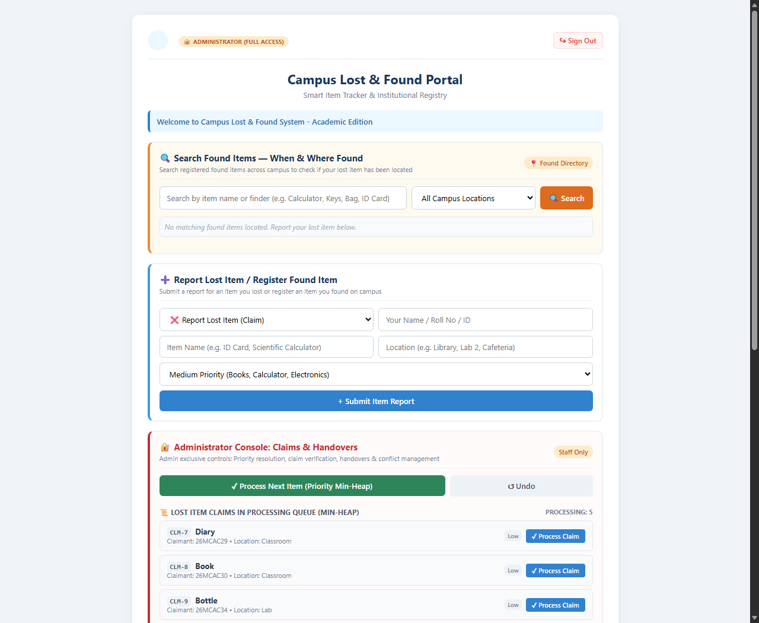
Figure 9.1: Web Application Dashboard: Public Item Catalog, Priority Queue & Activity Log
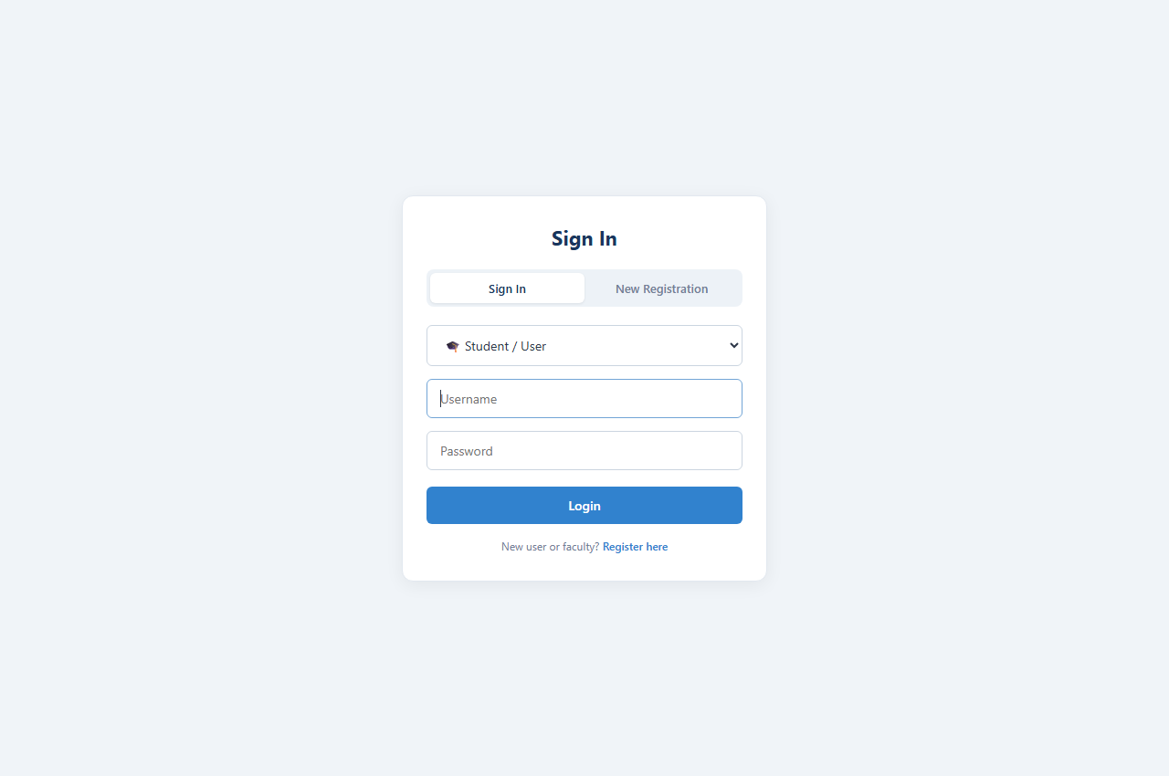
Figure 9.2: Web Application Multi-Role User Authentication Screen
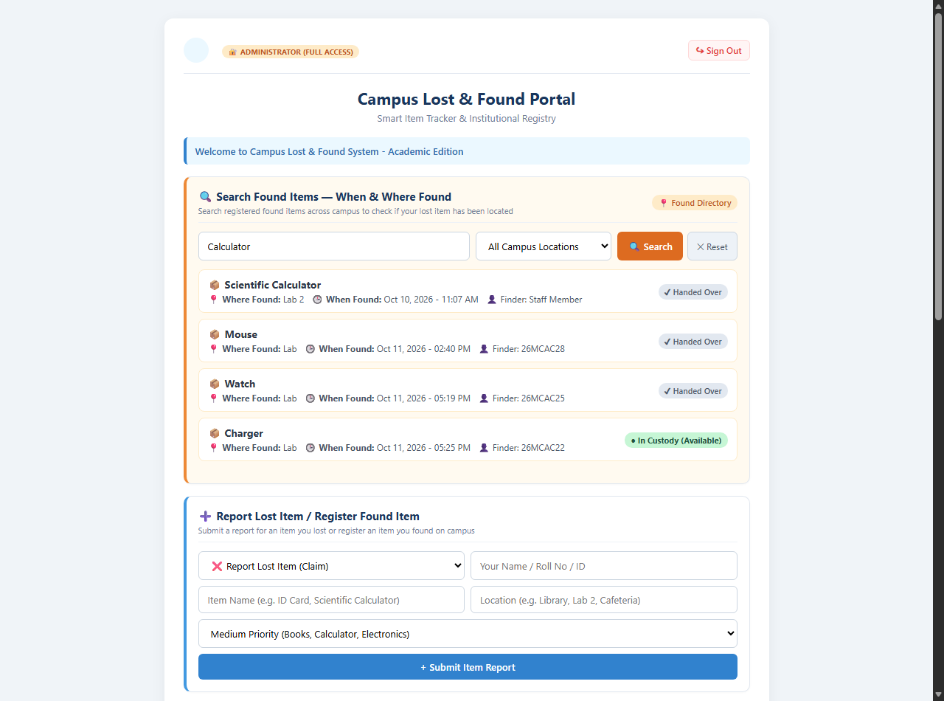

Figure 9.3: Web Application Location Proximity & Keyword Filtering Results

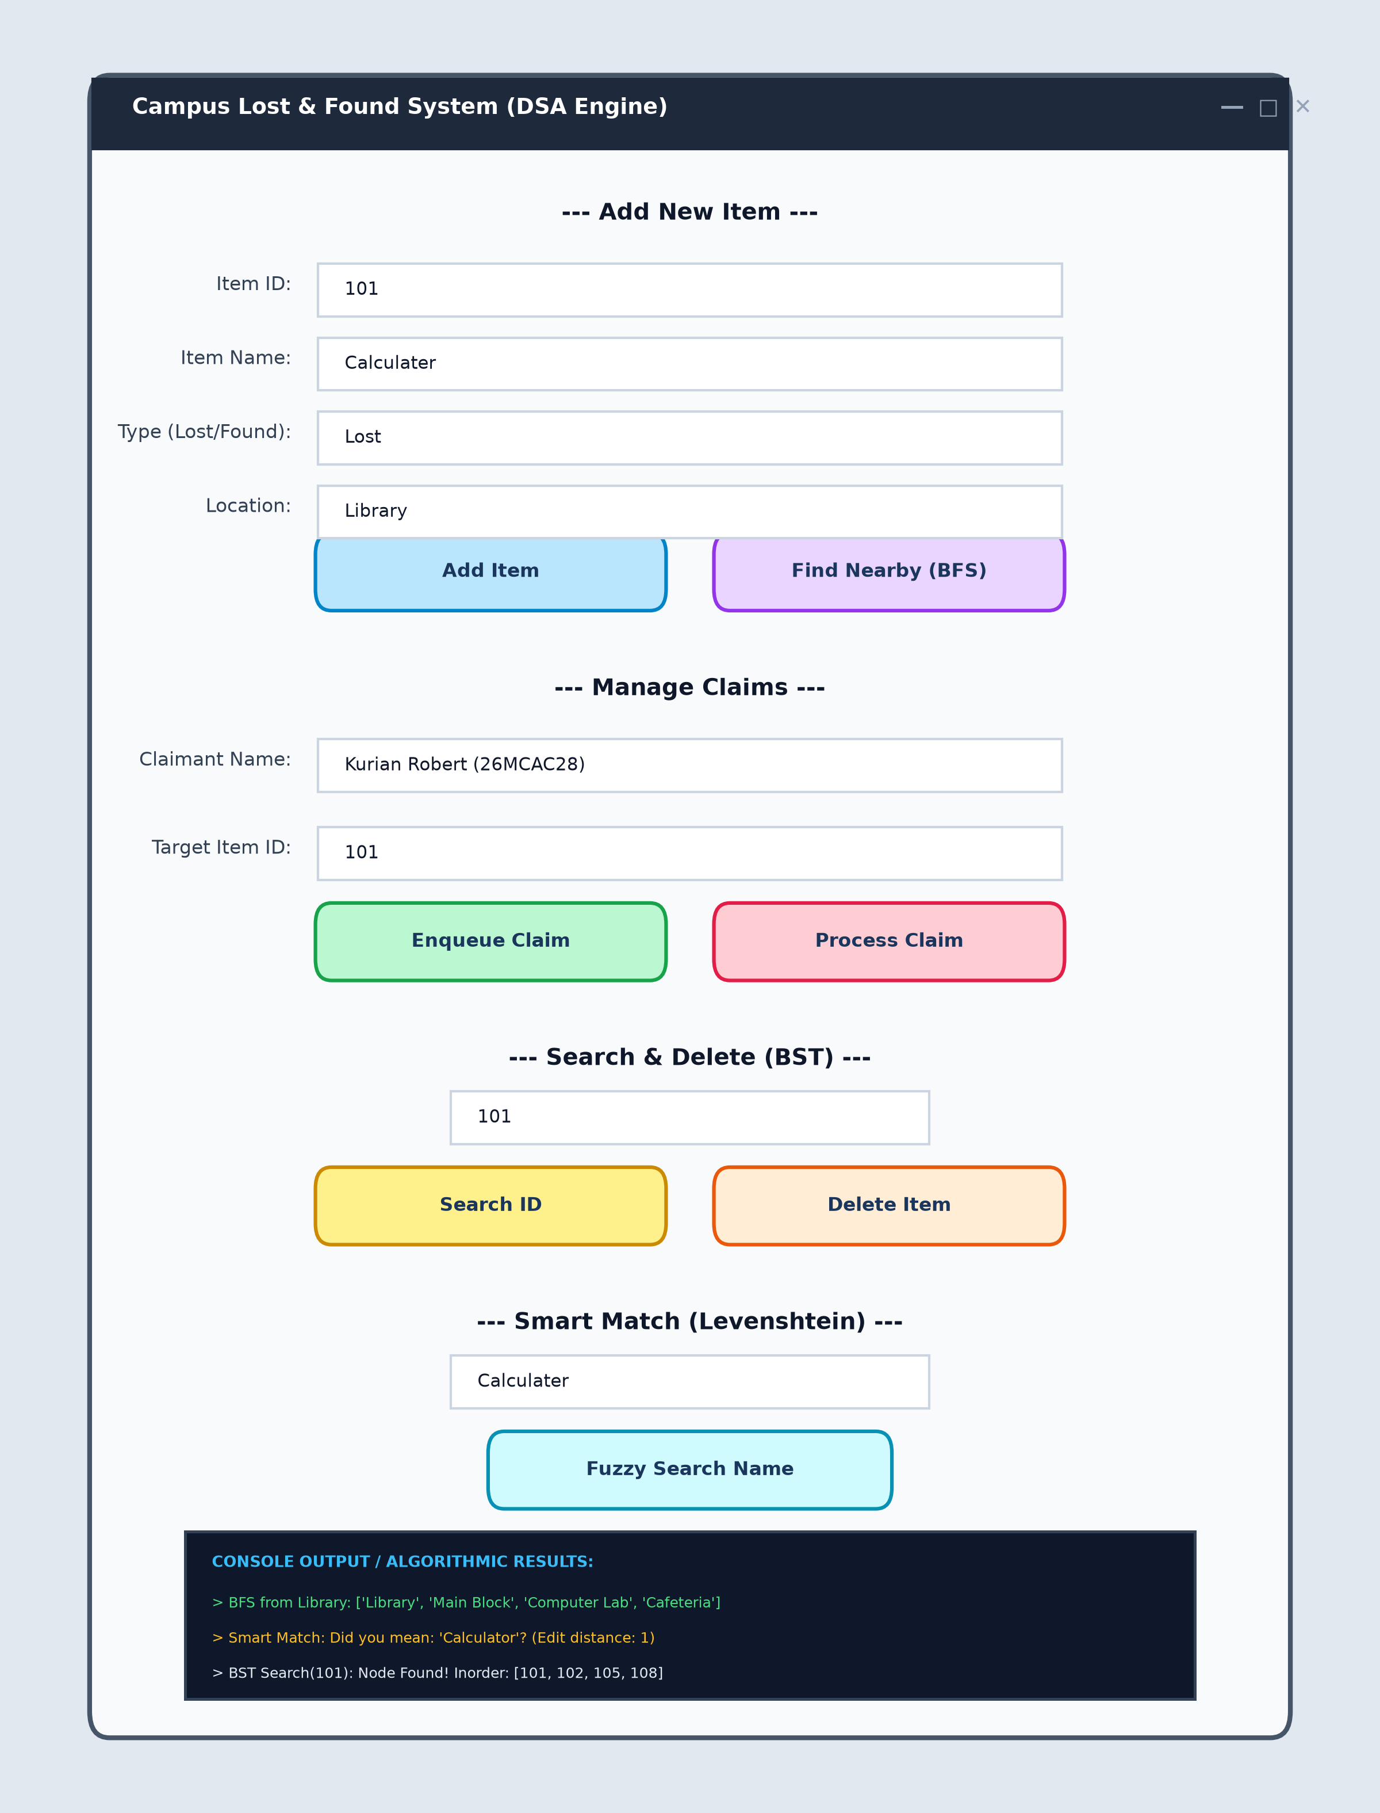
Figure 9.4: Desktop DSA Demonstrator: Tkinter Native Interface & Algorithmic Console

FUTURE ENHANCEMENTS
Whilst this version does comply with all academic requirements of the 1 st Semester MCA Data Structures and Algorithms syllabus, there are multiple ways it could be developed further. These include:
Computer Vision Matching – Implementing a Convolutional Neural Network to compare images of found items to a lost item description and find a similarity between the visual features.
SMS & WhatsApp Integration – Attaching this to the SMS/WhatsApp campus notification system to automatically text the student once an article has been found that matches their lost item description.
Electronic Smart Lockers – Attaching this to a physical electronic locker with RFID scanners for students’ smart cards so they can pick up their articles at any time of the day.
Mobile Application – Creating a mobile application that can utilise the campus Wi-Fi or GPS system to inform the students when they are entering a building that contains their lost property.
CONCLUSION & TECHNICAL DEFENSE
This project titled ‘Campus Lost and Found Management System with Priority Claim Scheduling’ demonstrates how fundamental data structures and algorithms can be used to solve a logistics problem. This project has covered all four algorithm categories including Linear Data Structures such as Linked Lists, Stacks and Queues. This project has also covered Hierarchical and Graphical Data Structures such as Binary Search Tree and Campus BFS. Finally, this project covered Searching and Sorting Algorithms such as Merge Sort using Linked Lists and Dynamic Programming with Priority Queues such as Levenshtein Distance and Min Heap. This provided a great insight into algorithm design and full stack software development.
The final product allows the staff to move away from using manual registers and instead search a digital register quickly. The system also ensures that priority is given to high urgency exam documents. This allows students to find their items with spelling mistakes. The system also allows the staff to keep track of their actions via the audit log that can be undone.

