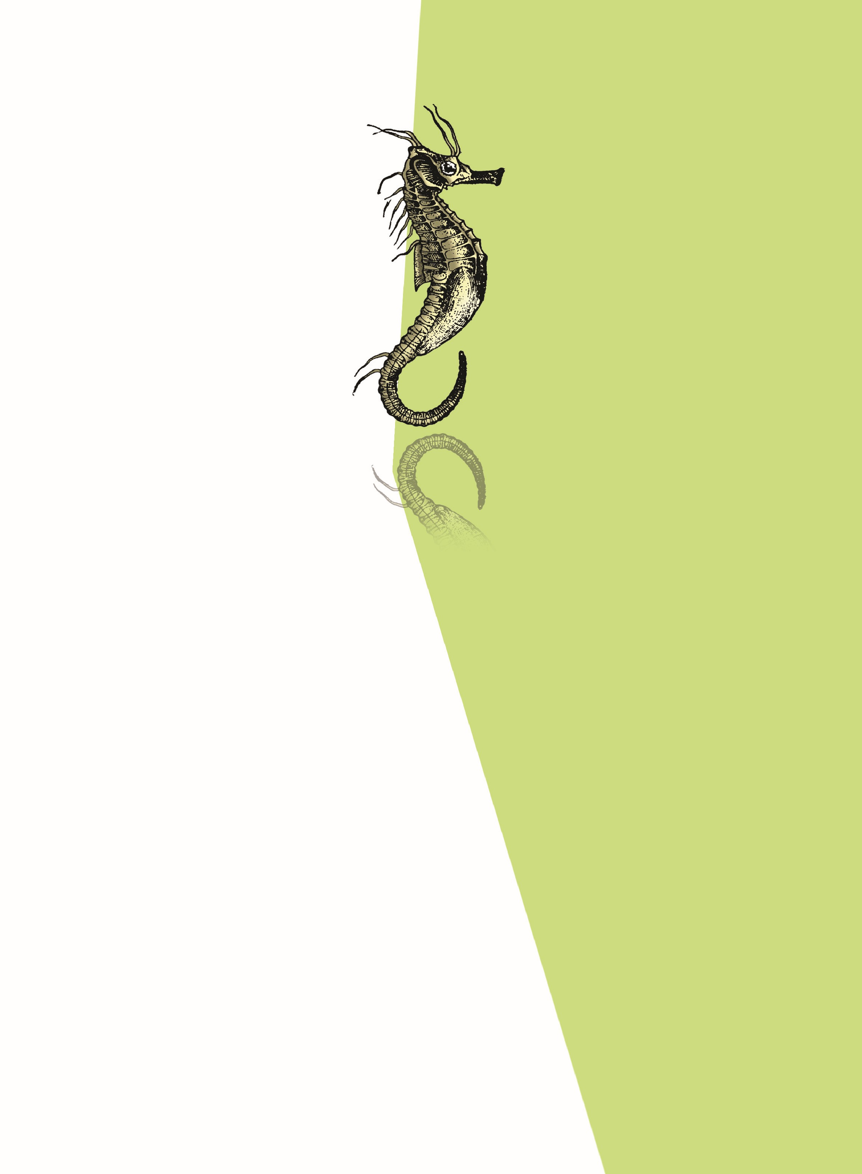
Biology is the science of life forms and living processes. The living world
comprises an amazing diversity of living organisms. Early man could
easily perceive the difference between inanimate matter and living
organisms. Early man deified some of the inanimate matter (wind, sea,
fire etc.) and some among the animals and plants. A common feature of
all such forms of inanimate and animate objects was the sense of awe
or fear that they evoked. The description of living organisms including
human beings began much later in human history. Societies which
indulged in anthropocentric view of biology could register limited
progress in biological knowledge. Systematic and monumental
description of life forms brought in, out of necessity, detailed systems
of identification, nomenclature and classification. The biggest spin off
of such studies was the recognition of the sharing of similarities among
living organisms both horizontally and vertically. That all present day
living organisms are related to each other and also to all organisms
that ever lived on this earth, was a revelation which humbled man and
led to cultural movements for conservation of biodiversity. In the
following chapters of this unit, you will get a description, including
classification, of animals and plants from a taxonomist’s perspective.
DIVERSITY IN THE LIVING WORLD
Chapter 1
The Living World
Chapter 2
Biological Classification
Chapter 3
Plant Kingdom
Chapter 4
Animal Kingdom
U
NIT
1

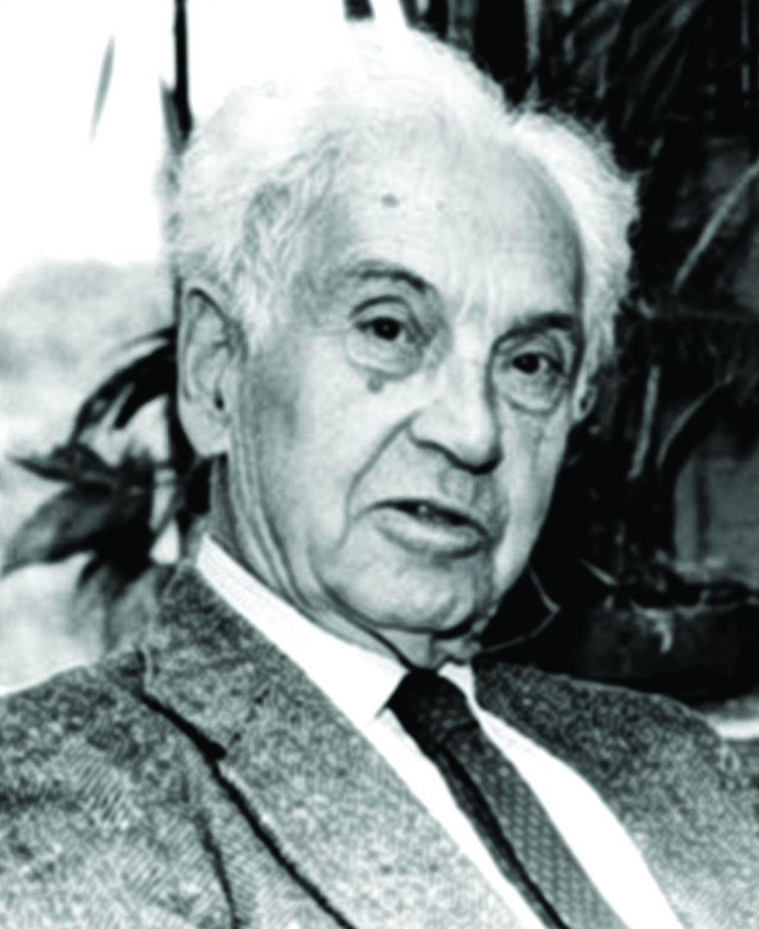
Born on 5 July 1904, in Kempten, Germany, E
RNST
M
AYR
, the
Harvard University evolutionary biologist who has been called
‘The Darwin of the 20
th
century’, was one of the 100 greatest
scientists of all time. Mayr joined Harvard’s Faculty of Arts
and Sciences in 1953 and retired in 1975, assuming the title
Alexander Agassiz Professor of Zoology Emeritus
. Throughout
his nearly 80-year career, his research spanned ornithology,
taxonomy, zoogeography, evolution, systematics, and the
history and philosophy of biology. He almost single-handedly
made the origin of species diversity the central question of
evolutionary biology that it is today. He also pioneered the
currently accepted definition of a biological species. Mayr was
awarded the three prizes widely regarded as the
triple crown
of
biology: the
Balzan Prize
in 1983, the
International Prize for
Biology
in 1994, and the
Crafoord Prize
in 1999. Mayr died at
the age of 100 in the year 2004.
Ernst Mayr
(1904
–
2004)

1.1 Diversity in the Living World
1.2 Taxonomic
Categories


How wonderful is the living world! The wide range of living types is amazing. The extraordinary habitats in which we find living organisms, be it cold mountains, deciduous forests, oceans, fresh water lakes, deserts or hot springs, leave us speechless. The beauty of a galloping horse, of the migrating birds, the valley of flowers or the attacking shark evokes awe and a deep sense of wonder. The ecological conflict and cooperation among members of a population and among populations of a community or even the molecular traffic inside a cell make us deeply reflect on – what indeed is life? This question has two implicit questions within it. The first is a technical one and seeks answer to what living is as opposed to the non-living, and the second is a philosophical one, and seeks answer to what the purpose of life is. As scientists, we shall not attempt answering the second question. We will try to reflect on – what is living?
T
HE

L
IVING

W
ORLD
C
HAPTER

1

1.1 DIVERSITY IN THE LIVING WORLD
If you look around you will see a large variety of living organisms, be it potted plants, insects, birds, your pets or other animals and plants. There are also several organisms that you cannot see with your naked eye but they are all around you. If you were to increase the area that you make observations in, the range and variety of organisms that you see would increase. Obviously, if you were to visit a dense forest, you would probably see a much greater number and kinds of living organisms in it. Each different kind of plant, animal or organism that you see, represents a species. The number of species that are known and described range between 1.7-1.8 million. This refers to biodiversity or the number and

types of organisms present on earth. We should remember here that as we explore new areas, and even old ones, new organisms are continuously being identified.
As stated earlier, there are millions of plants and animals in the world; we know the plants and animals in our own area by their local names. These local names would vary from place to place, even within a country. Probably you would recognise the confusion that would be created if we did not find ways and means to talk to each other, to refer to organisms we are talking about.
Hence, there is a need to standardise the naming of living organisms such that a particular organism is known by the same name all over the world. This process is called nomenclature. Obviously, nomenclature or naming is only possible when the organism is described correctly and we know to what organism the name is attached to. This is identification.
In order to facilitate the study, number of scientists have established procedures to assign a scientific name to each known organism. This is acceptable to biologists all over the world. For plants, scientific names are based on agreed principles and criteria, which are provided in International Code for Botanical Nomenclature (ICBN). You may ask, how are animals named? Animal taxonomists have evolved International Code of Zoological Nomenclature (ICZN). The scientific names ensure that each organism has only one name. Description of any organism should enable the people (in any part of the world) to arrive at the same name. They also ensure that such a name has not been used for any other known organism.
Biologists follow universally accepted principles to provide scientific names to known organisms. Each name has two components – the Generic name and the specific epithet. This system of providing a name with two components is called Binomial nomenclature. This naming system given by Carolus Linnaeus is being practised by biologists all over the world. This naming system using a two word format was found convenient. Let us take the example of mango to understand the way of providing scientific names better. The scientific name of mango is written as Mangifera indica. Let us see how it is a binomial name. In this name Mangifera represents the genus while indica, is a particular species, or a specific epithet. Other universal rules of nomenclature are as follows:
- Biological names are generally in Latin and written in italics. They are Latinised or derived from Latin irrespective of their origin.
- The first word in a biological name represents the genus while the second component denotes the specific epithet.
- Both the words in a biological name, when handwritten, are separately underlined, or printed in italics to indicate their Latin origin.

THE LIVING WORLD
4. The first word denoting the genus starts with a capital letter while the specific epithet starts with a small letter. It can be illustrated with the example of Mangifera indica.
Name of the author appears after the specific epithet, i.e., at the end of the biological name and is written in an abbreviated form, e.g., Mangifera indica Linn. It indicates that this species was first described by Linnaeus.
Since it is nearly impossible to study all the living organisms, it is necessary to devise some means to make this possible. This process is classification. Classification is the process by which anything is grouped into convenient categories based on some easily observable characters. For example, we easily recognise groups such as plants or animals or dogs, cats or insects. The moment we use any of these terms, we associate certain characters with the organism in that group. What image do you see when you think of a dog ? Obviously, each one of us will see ‘dogs’ and not ‘cats’. Now, if we were to think of ‘Alsatians’ we know what we are talking about. Similarly, suppose we were to say ‘mammals’, you would, of course, think of animals with external ears and body hair. Likewise, in plants, if we try to talk of ‘Wheat’, the picture in each of our minds will be of wheat plants, not of rice or any other plant. Hence, all these - ‘Dogs’, ‘Cats’, ‘Mammals’, ‘Wheat’, ‘Rice’, ‘Plants’, ‘Animals’, etc., are convenient categories we use to study organisms. The scientific term for these categories is taxa. Here you must recognise that taxa can indicate categories at very different levels. ‘Plants’ – also form a taxa. ‘Wheat’ is also a taxa. Similarly, ‘animals’, ‘mammals’, ‘dogs’ are all taxa – but you know that a dog is a mammal and mammals are animals. Therefore, ‘animals’, ‘mammals’ and ‘dogs’ represent taxa at different levels.
Hence, based on characteristics, all living organisms can be classified into different taxa. This process of classification is taxonomy. External and internal structure, along with the structure of cell, development process and ecological information of organisms are essential and form the basis of modern taxonomic studies.
Hence, characterisation, identification, classification and nomenclature are the processes that are basic to taxonomy.
Taxonomy is not something new. Human beings have always been interested in knowing more and more about the various kinds of organisms, particularly with reference to their own use. In early days, human beings needed to find sources for their basic needs of food, clothing and shelter. Hence, the earliest classifications were based on the ‘uses’ of various organisms.
Human beings were, since long, not only interested in knowing more about different kinds of organisms and their diversities, but also the relationships among them. This branch of study was referred to as systematics. The word systematics is derived from the Latin word ‘systema’ which means systematic arrangement of organisms. Linnaeus used Systema Naturae as the title of his publication. The scope of systematics was later enlarged to include identification, nomenclature and classification. Systematics takes into account evolutionary relationships between organisms.

1.2 TAXONOMIC CATEGORIES
Classification is not a single step process but involves hierarchy of steps in which each step represents a rank or category. Since the category is a part of overall taxonomic arrangement, it is called the taxonomic category and all categories together constitute the taxonomic hierarchy. Each category, referred to as a unit of classification, in fact, represents a rank and is commonly termed as taxon (pl.: taxa).
Taxonomic categories and hierarchy can be illustrated by an example. Insects represent a group of organisms sharing common features like three pairs of jointed legs. It means insects are recognisable concrete objects which can be classified, and thus were given a rank or category. Can you name other such groups of organisms? Remember, groups represent category. Category further denotes rank. Each rank or taxon, in fact, represents a unit of classification. These taxonomic groups/ categories are distinct biological entities and not merely morphological aggregates.
Taxonomical studies of all known organisms have led to the development of common categories such as kingdom, phylum or division (for plants), class, order, family, genus and species. All organisms, including those in the plant and animal kingdoms have species as the lowest category. Now the question you may ask is, how to place an organism in various categories? The basic requirement is the knowledge of characters of an individual or group of organisms. This helps in identifying similarities and dissimilarities among the individuals of the same kind of organisms as well as of other kinds of organisms.

1.2.1 Species
Taxonomic studies consider a group of individual organisms with fundamental similarities as a species. One should be able to distinguish one species from the other closely related species based on the distinct morphological differences. Let us consider Mangifera indica, Solanum tuberosum (potato) and Panthera leo (lion). All the three names, indica, tuberosum and leo, represent the specific epithets, while the first words Mangifera, Solanum and Panthera are genera and represents another higher level of taxon or category. Each genus may have one or more than one specific epithets representing different organisms, but having morphological similarities. For example, Panthera has another specific epithet called tigris and Solanum includes species like nigrum and

THE LIVING WORLD
melongena. Human beings belong to the species sapiens which is grouped in the genus Homo. The scientific name thus, for human being, is written as Homo sapiens.

1.2.2 Genus
Genus comprises a group of related species which has more characters in common in comparison to species of other genera. We can say that genera are aggregates of closely related species. For example, potato and brinjal are two different species but both belong to the genus Solanum. Lion (Panthera leo), leopard (P. pardus) and tiger (P. tigris) with several common features, are all species of the genus Panthera. This genus differs from another genus Felis which includes cats.

1.2.3 Family
The next category, Family, has a group of related genera with still less number of similarities as compared to genus and species. Families are characterised on the basis of both vegetative and reproductive features of plant species. Among plants for example, three different genera Solanum, Petunia and Datura are placed in the family Solanaceae. Among animals for example, genus Panthera, comprising lion, tiger, leopard is put along with genus, Felis (cats) in the family Felidae. Similarly, if you observe the features of a cat and a dog, you will find some similarities and some differences as well. They are separated into two different families – Felidae and Canidae, respectively.

1.2.4 Order
You have seen earlier that categories like species, genus and families are based on a number of similar characters. Generally, order and other higher taxonomic categories are identified based on the aggregates of characters. Order being a higher category, is the assemblage of families which exhibit a few similar characters. The similar characters are less in number as compared to different genera included in a family. Plant families like Convolvulaceae, Solanaceae are included in the order Polymoniales mainly based on the floral characters. The animal order, Carnivora, includes families like Felidae and Canidae.

1.2.5 Class
This category includes related orders. For example, order Primata comprising monkey, gorilla and gibbon is placed in class Mammalia along with order Carnivora that includes animals like tiger, cat and dog. Class Mammalia has other orders also.

1.2.6 Phylum
Classes comprising animals like fishes, amphibians, reptiles, birds along with mammals constitute the next higher category called Phylum. All

Figure 1.1 Taxonomic categories s h o w i n g hierarchial arrangement in ascending order
these, based on the common features like presence of notochord and dorsal hollow neural system, are included in phylum Chordata. In case of plants, classes with a few similar characters are assigned to a higher category called Division.

1.2.7 Kingdom
All animals belonging to various phyla are assigned to the highest category called Kingdom Animalia in the classification system of animals. The Kingdom Plantae, on the other hand, is distinct, and comprises all plants from various divisions. Henceforth, we will refer to these two groups as animal and plant kingdoms.
The taxonomic categories from species to kingdom have been shown in ascending order starting with species in Figure 1.1. These are broad categories. However, taxonomists have also developed sub-categories in this hierarchy to facilitate more sound and scientific placement of various taxa.
Look at the hierarchy in Figure 1.1. Can you recall the basis of arrangement? Say, for example, as we go higher from species to kingdom, the number of common characteristics goes on decreasing. Lower the taxa, more are the characteristics that the members within the taxon share. Higher the category, greater is the difficulty of determining the relationship to other taxa at the same level. Hence, the problem of classification becomes more complex.
Table 1.1 indicates the taxonomic categories to which some common organisms like housefly, man, mango and wheat belong.

TABLE 1.1 Organisms with their Taxonomic Categories
Common | Biological | Genus | Family | Order | Class | Phylum/
Name | Name |  |  |  |  | Division
Man | Homo sapiens | Homo | Hominidae | Primata | Mammalia | Chordata
Housefly | Musca domestica | Musca | Muscidae | Diptera | Insecta | Arthropoda
Mango | Mangifera indica | Mangifera | Anacardiaceae | Sapindales | Dicotyledonae | Angiospermae
Wheat | Triticum aestivum | Triticum | Poaceae | Poales | Monocotyledonae | Angiospermae
THE LIVING WORLD

SUMMARY
The living world is rich in variety. Millions of plants and animals have been identified and described but a large number still remains unknown. The very range of organisms in terms of size, colour, habitat, physiological and morphological features make us seek the defining characteristics of living organisms. In order to facilitate the study of kinds and diversity of organisms, biologists have evolved certain rules and principles for identification, nomenclature and classification of organisms. The branch of knowledge dealing with these aspects is referred to as taxonomy. The taxonomic studies of various species of plants and animals are useful in agriculture, forestry, industry and in general for knowing our bio-resources and their diversity. The basics of taxonomy like identification, naming and classification of organisms are universally evolved under international codes. Based on the resemblances and distinct differences, each organism is identified and assigned a correct scientific/biological name comprising two words as per the binomial system of nomenclature. An organism represents/occupies a place or position in the system of classification. There are many categories/ ranks which are generally referred to as taxonomic categories or taxa. All the categories constitute a taxonomic hierarchy.

EXERCISES
- Why are living organisms classified?
- Why are the classification systems changing every now and then?
- What different criteria would you choose to classify people that you meet often?
- What do we learn from identification of individuals and populations?
- Given below is the scientific name of Mango. Identify the correctly written name.
Mangifera Indica
Mangifera indica
- Define a taxon. Give some examples of taxa at different hierarchical levels.
- Can you identify the correct sequence of taxonomical categories?
  - SpeciesOrderPhylumKingdom
  - GenusSpeciesOrderKingdom
  - SpeciesGenusOrderPhylum
- Try to collect all the currently accepted meanings for the word ‘species’. Discuss with your teacher the meaning of species in case of higher plants and animals on one hand, and bacteria on the other hand.
- Define and understand the following terms:
(i) Phylum (ii) Class (iii) Family (iv) Order (v) Genus
- Illustrate the taxonomical hierarchy with suitable examples of a plant and an animal.

