QAMP 2025

Adaptive Error Mitigation Framework for Quantum Circuits
Group - 15 | 4-Feb-2026

Project name:
Adaptive Error Mitigation Framework for Quantum Circuits #15

Team members:
Kurian Uthuppu, Aashay Pandharpatte, Shreyansh Agarwal, and Dikshant Dulal (Mentor)

Project Description:
In the current era of Noisy Intermediate-Scale Quantum (NISQ) computing, the primary obstacle to achieving practical quantum advantage is the presence of hardware noise. While various Error Mitigation and Suppression Techniques (EMST) exist, their implementation often requires significant manual "guesswork." Users must typically choose between fixed resilience_level that apply broad strategies regardless of the specific circuit architecture or the fluctuating noise profiles of the target backend. The "Adaptive Error Mitigation Framework" was developed to bridge this gap, providing an intelligent, circuit-aware system that automates the selection and configuration of mitigation strategies to improve expectation values.
The fundamental goal of this project is to transform the process of static assignment of error mitigation protocols by the user to a dynamic process governed by input transpiled circuit and backend properties. In this regard, the "AdaptiveEstimator" is developed as a specialized wrapper for the Qiskit Runtime Estimator that analyzes post-transpiled circuits in real-time, evaluates the unique topological and physical characteristics of a circuit alongside the latest hardware calibration data, and decides and enables required error mitigation techniques. We have implemented our framework for three key EMSTs, namely Twirled Readout Error Extinction (TREX), Dynamical Decoupling (DD), and Zero Noise Extrapolation (ZNE).
A secondary but vital objective is transparency. Unlike "black-box" mitigation tools, this framework prioritizes educational insights. It generates a detailed decision log for every execution, explaining the heuristic reasoning behind each choice. This allows researchers and students to understand why certain techniques were enabled or bypassed, fostering a deeper understanding of the interaction between quantum algorithms and hardware noise.

System Architecture:
The AdaptiveEstimator is the main user interface and functions as a transparent layer over the Qiskit Runtime Estimator. It automatically configures the necessary options dictionary by employing a set of predefined heuristics. This functionality is organized within our framework's modular structure.

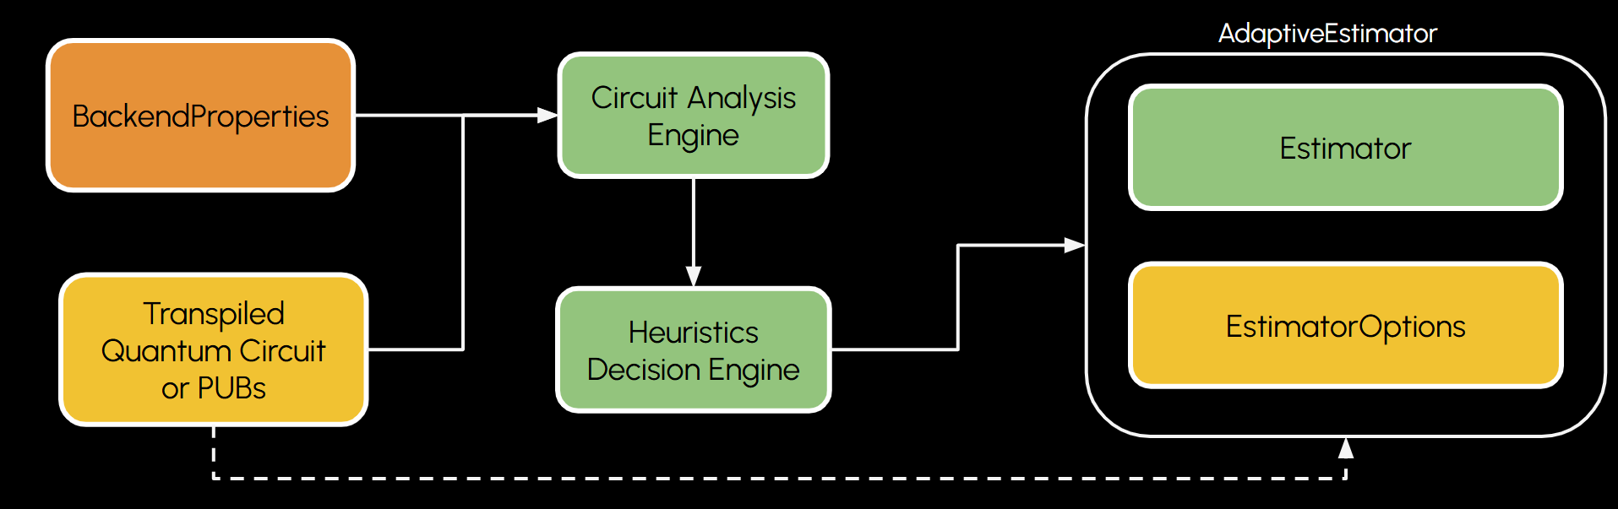
Figure 1: Execution flow of the Adaptive Estimator framework. Typical primitive execution required transpiled circuits along the EstimatorOptions as the input. Our framework employs the circuit analysis engine and the Huristics Engine to fetch the circuit/backend properties, calculate huristics, and enable EMSTs accordingly. The AdaptiveEstimator wrapper is a transparent wrapper that enables EMSTs based on results obtained by the Huristics Decision Engine.

Circuit Analysis Engine
The framework’s intelligence is rooted in its Circuit Analysis Engine. Before a circuit is sent to the backend, the engine extracts critical features with respect to the physical qubits used in the computation given by circuit.final_index_layout. We extract and calculate certain properties such as
1. Basic Circuit Characterization The engine now utilizes the extract_basic_features module to parse circuit properties post-transpilation. It calculates essential metrics such as total depth, gate counts (broken down by type like rz, sx, cz), and 2-qubit gate density. This allows us to establish a baseline for circuit complexity before assessing noise impact.
2. Backend & Hardware Metrics We implemented extract_backend_metrics to pull real-time calibration data from IBM Quantum backends (e.g., ibm_fez). The system retrieves granular data for every qubit and link involved, including T1/T2 coherence times, readout error rates, and specific gate error probabilities. This ensures our mitigation decisions rely on the current state of the hardware rather than static assumptions.
3. Layout & Mapping Analysis To bridge the gap between abstract circuits and physical hardware, we built the get_qubit_layout_mapping function. This maps logical qubits to physical ones, tracking "activity levels" for each qubit and link. This step is crucial for identifying which specific physical components will bear the computational load.

4. Decoherence Risk Assessment A key differentiator in our approach is the analyze_qubit_idling module. By comparing a qubit's idle time against its T2 coherence time, we can now calculate specific decoherence error probabilities. This allows the framework to identify qubits that are "idling to death" and prioritize them for dynamical decoupling.
5. Derived Noise Sensitivity Finally, we aggregated these metrics into the calculate_derived_noise_metrics module. This function identifies "noise hotspots"—specific qubits or pairs with disproportionately high error rates—and calculates a global "connectivity stress" score. This high-level synthesis enables the AdaptiveEstimator to make rapid, heuristic-based decisions on which mitigation strategy to trigger.

Heuristic Logic and Technical Implementation
The framework utilizes three primary heuristics to manage different types of quantum noise:
- Twirled Readout Error Extinction (TREX): This technique focuses on mitigating measurement errors in the estimation of the Pauli observable expectation value. The framework inspects the readout error rates of the active qubits involved in the circuit. If the MAX_READOUT_THRESHOLD exceeds a 1% threshold, TREX is automatically enabled.
- Dynamical Decoupling (DD): DD is used to suppress decoherence and crosstalk during qubit idle times. DD helps in refocusing qubits using a sequence of unitary operations on idle qubits to approximately cancel each other. The performance of the DD sequence depends heavily on the duration of idle time. A short idle time corresponds to a low decoherence probability, which might be hard to mitigate due to imperfect DD pulses. Similarly, a long idle time might introduce bias in qubit dephasing, thereby resulting in different states after the DD pulse correction. Therefore, an optimal window exists that determines the effectiveness of DD pulses. We target this window using the circuit density metric. The circuit density metric is defined as the ratio of active gate time to the total available space in the circuit (qubits × depth).
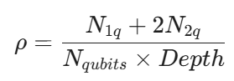
We define two thresholds for circuit density
- DD_MAX_CD_THRESHOLD ( ρ > 0.25 ): The qubits are busy; inserting DD sequences is unnecessary and may introduce X-pulse errors.
- DD_MIN_CD_THRESHOLD ( ρ < 0.07 ): The circuit is sparse, but other coherent errors likely dominate simple dephasing, making DD ineffective.
These thresholds are calculated by observing the overall DD performance and circuits with various values of circuit density. In the AdaptiveEstimator framework, DD is applied to circuits with DD_MIN_CD_THRESHOLD ≤ ρ ≤ $ DD_MAX_CD_THRESHOLD. The threshold values are found by benchmarking the fidelity improvement on the GHZ state.
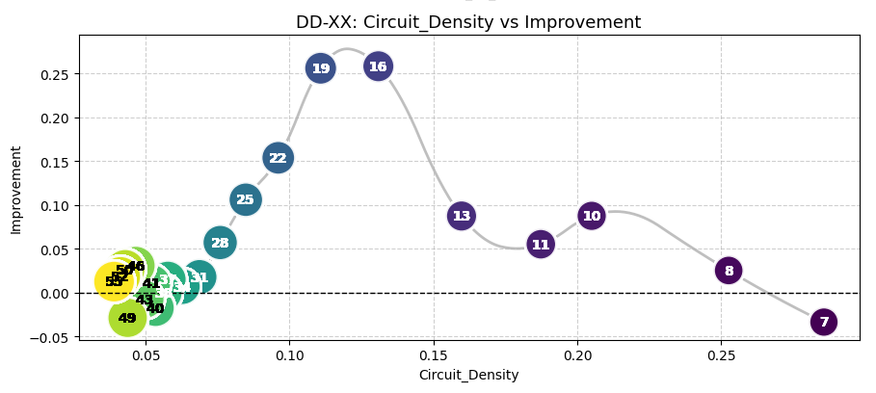
Figure 2: Fidelity improvement of the GHZ circuit vs calculated circuit density values. The number in each data point is the number of qubits present in the circuit. Each data point is labeled with the corresponding number of qubits used in the circuit.

- Zero Noise Extrapolation (ZNE): ZNE addresses gate-related errors by scaling noise and extrapolating to the zero-noise limit. The heuristic we employ calculates the noise sensitivity of the active qubits to errors.
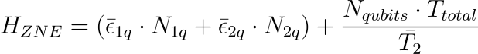
where ${\underline{ϵ}}_{1q}$ is the average single-qubit gate error, ${\underline{ϵ}}_{2q}$ is the average two-qubit gate error, $N_{1q}$ is the total number of single-qubit gates, $N_{2q}$ is the total number of two-qubit gates, $T_{Total}$ is the circuit duration, and ${\underline{T}}_{2}$ is the average $T_{2}$ time for physical qubits in the circuit. $H_{ZNE}$ score balances the cumulative gate error against the decoherence expected over the execution time. If the $H_{ZNE}$ falls between 0.2 (ZNE_MIN_THRESHOLD) and 1.5 (ZNE_MAX_THRESHOLD), ZNE is applied to refine the expectation values. If the value is less than ZNE_MIN_THRESHOLD, the circuit is sufficiently robust (or the noise impact is minimal), so the computational expense of ZNE is not justified. On the other hand, if the value is greater than ZNE_MAX_THRESHOLD, the noise is too overwhelming, and applying gate twirling and folding shall suitably amplify the noise for accurate extrapolation. We calculate error reduction using ZNE for various $H_{ZNE}$ scores and infer these threshold values.
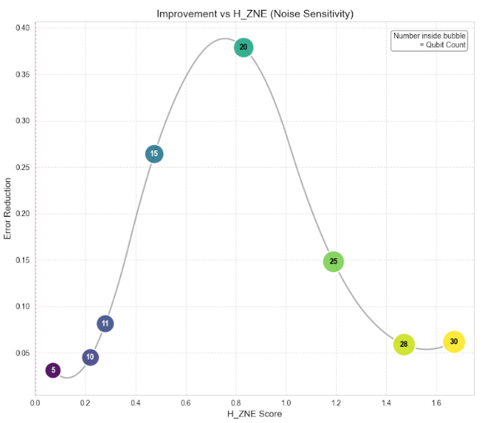
Figure 3: Error Reduction vs. $H_{ZNE}$ score for GHZ echo circuit. We benchmark the error reduction for circuits with 5 to 30 qubits and find an optimal window with significant performance for ZNE.

Results
To validate the framework's effectiveness, we performed extensive benchmarking using GHZ Echo and efficient SU2 Echo circuits. The performance of our AdaptiveEstimator was compared against the standard Qiskit Runtime Estimator(default settings) to determine whether dynamic mitigation provides better fidelity than static configurations.
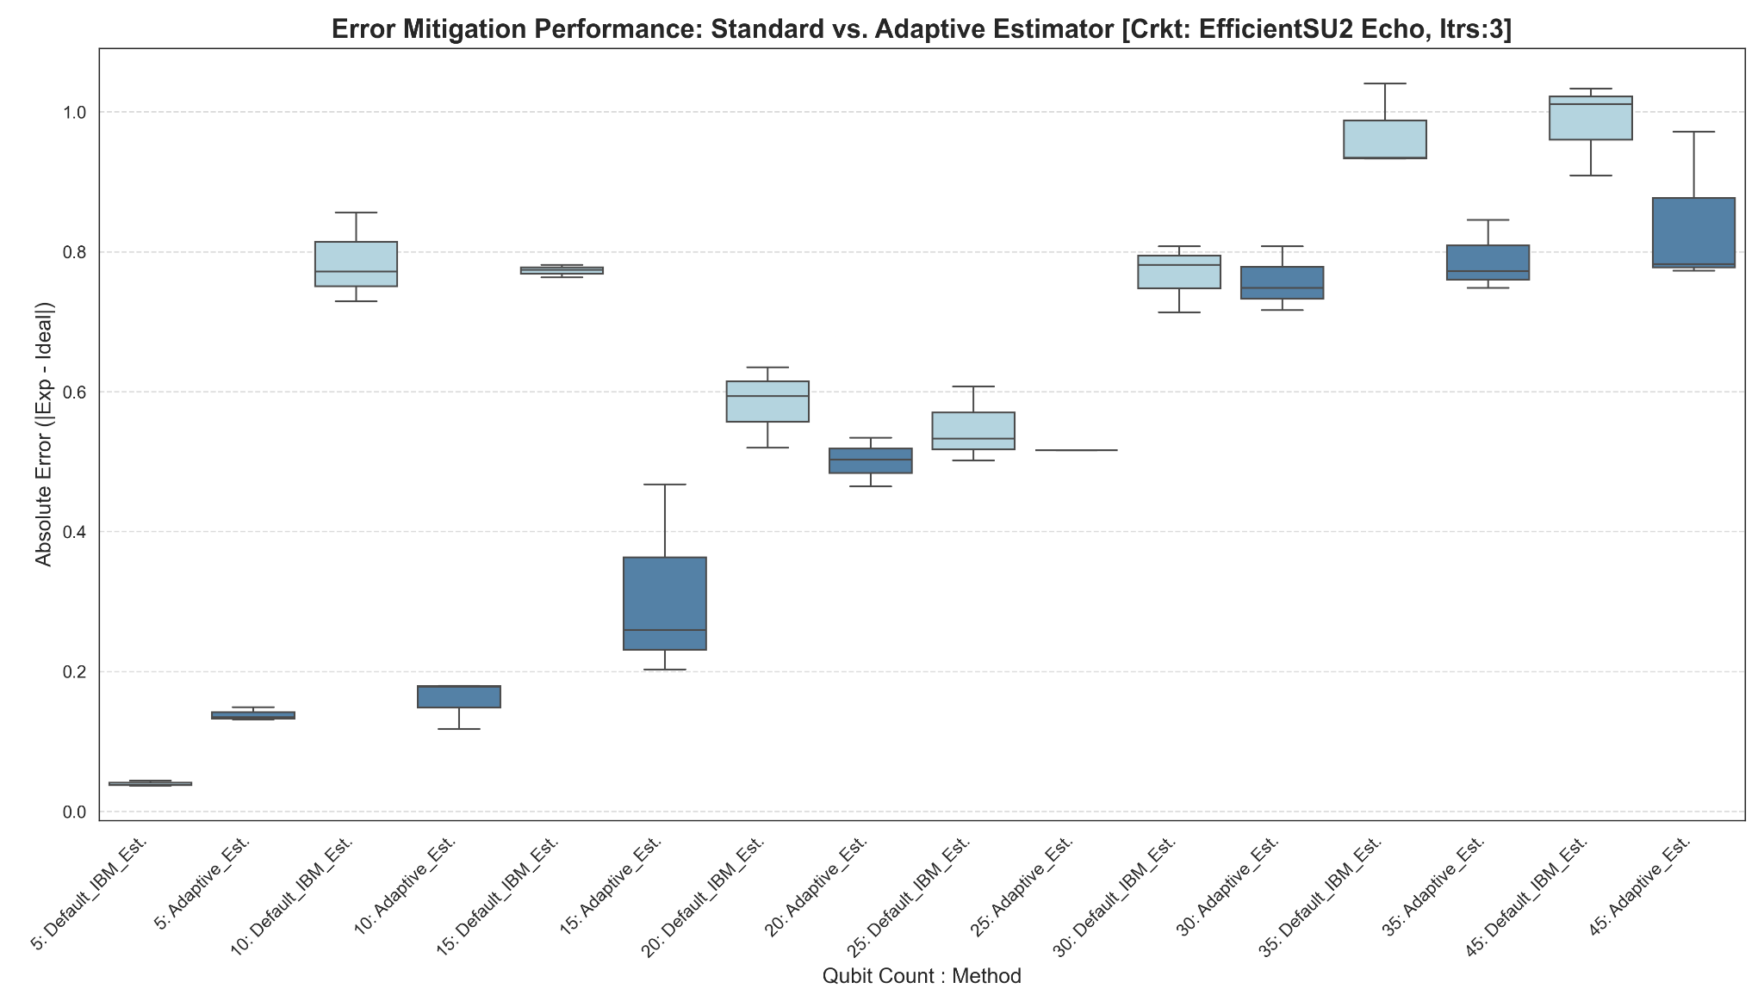
Figure 4: Absolute error observed for Efficient SU2 Echo circuits for qubits 5 to 45 with standrad Estimator and AdaptiveEstimator

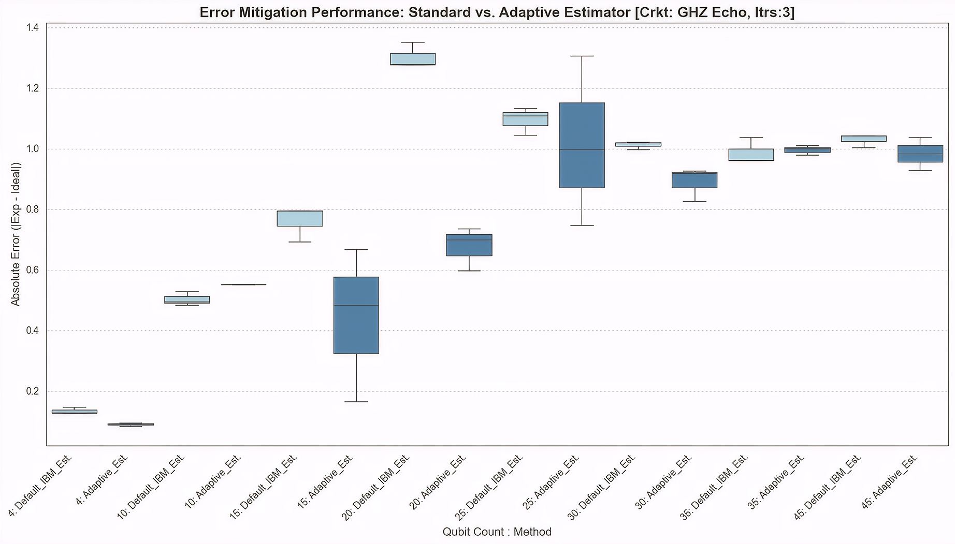
Figure 5: Absolute error observed for GHZ Echo circuits for qubits 5 to 45 with standard Estimator and AdaptiveEstimator.

Challenges and Explorations
The project also encountered significant real-world hardware challenges.
Occurrence of unlikely large estimation values
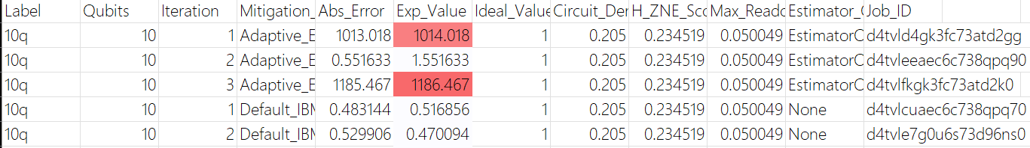
During testing on IBM backends like ibm_fez, the team observed anomalies where expectation values deviated far beyond physical bounds (e.g., reaching 1000+). The data corresponding to the same is as follows.
Figure 6: Occurrence of unlikely large estimation values. To our knowledge, this is not a bug for AdaptiveEstimator, and we shall further report the necessary steps to reproduce the same.
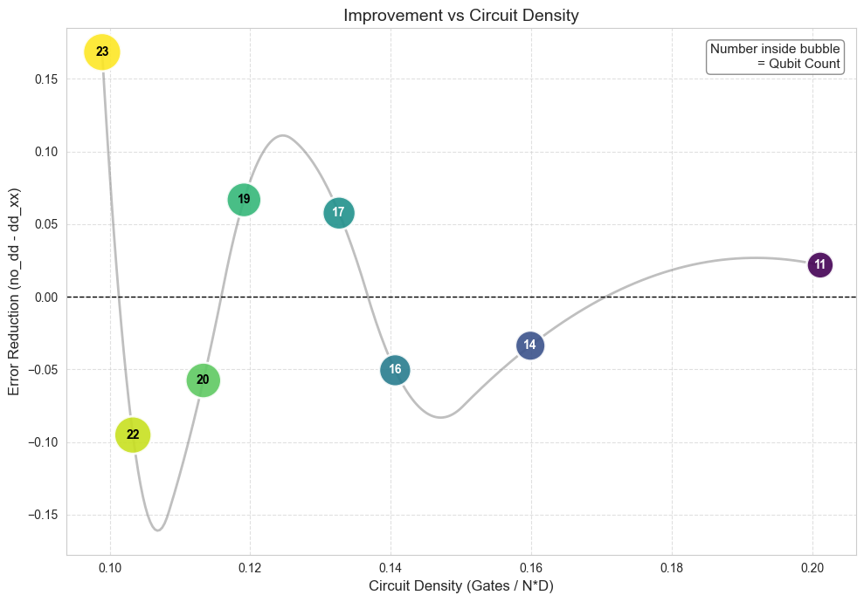
Oscillations in error reduction of $Z^{⊗n}$ expectation value for GHZ circuits.
Figure 7: Oscillations in error were observed for the ${<Z}^{⊗n}>$ calculated for GHZ circuits. A aconsiderable time was spent in finding the reasons for these oscillations
Furthermore, DD sequences appeared to degrade performance in the Estimator primitive compared to the Sampler. These findings led to the submission of a formal IBM Support Ticket (CS4416282), demonstrating the project's role in identifying potential bugs in production-level quantum software stacks.

Future Directions
As the framework matures, the next phase focuses on scaling and generalization. Future work involves benchmarking the heuristics against more complex circuits. Additionally, the team aims to refine the heuristics for the 50–100 qubit range, where noise becomes increasingly non-Markovian and complex. By continuing to iterate on these automated heuristics, the project moves the field closer to a "turnkey" solution for quantum error mitigation, allowing researchers to focus on algorithm design rather than the intricacies of hardware noise.

Links:
Github repo, Presentation Slides, Google_Drive_Link

