To Generate tree :

cmd:

step 1 :

python utils/metadata_tree_config.py --create True --tree_name little_sleepies_womens_sleepwear --tree_config_json_string '{"criteria": [{ "entity": "system_category", "attribute": "Women's Sleepwear & Robes" }, { "entity": "brand", "attribute": "little sleepies" }], "hierarchy": [{ "entity_name": "product_type","required": true },{ "entity_name": "color", "required": true },{ "entity_name": "model", "required": false }]}' -e dev
Output :
litle_sleepies_bedding
- will generate the tree name in the output by using this we will generate tree config
Step 2 :
python utils/metadata_tree_config.py -L=True -n=little_sleepies_bedding -e dev
Output :
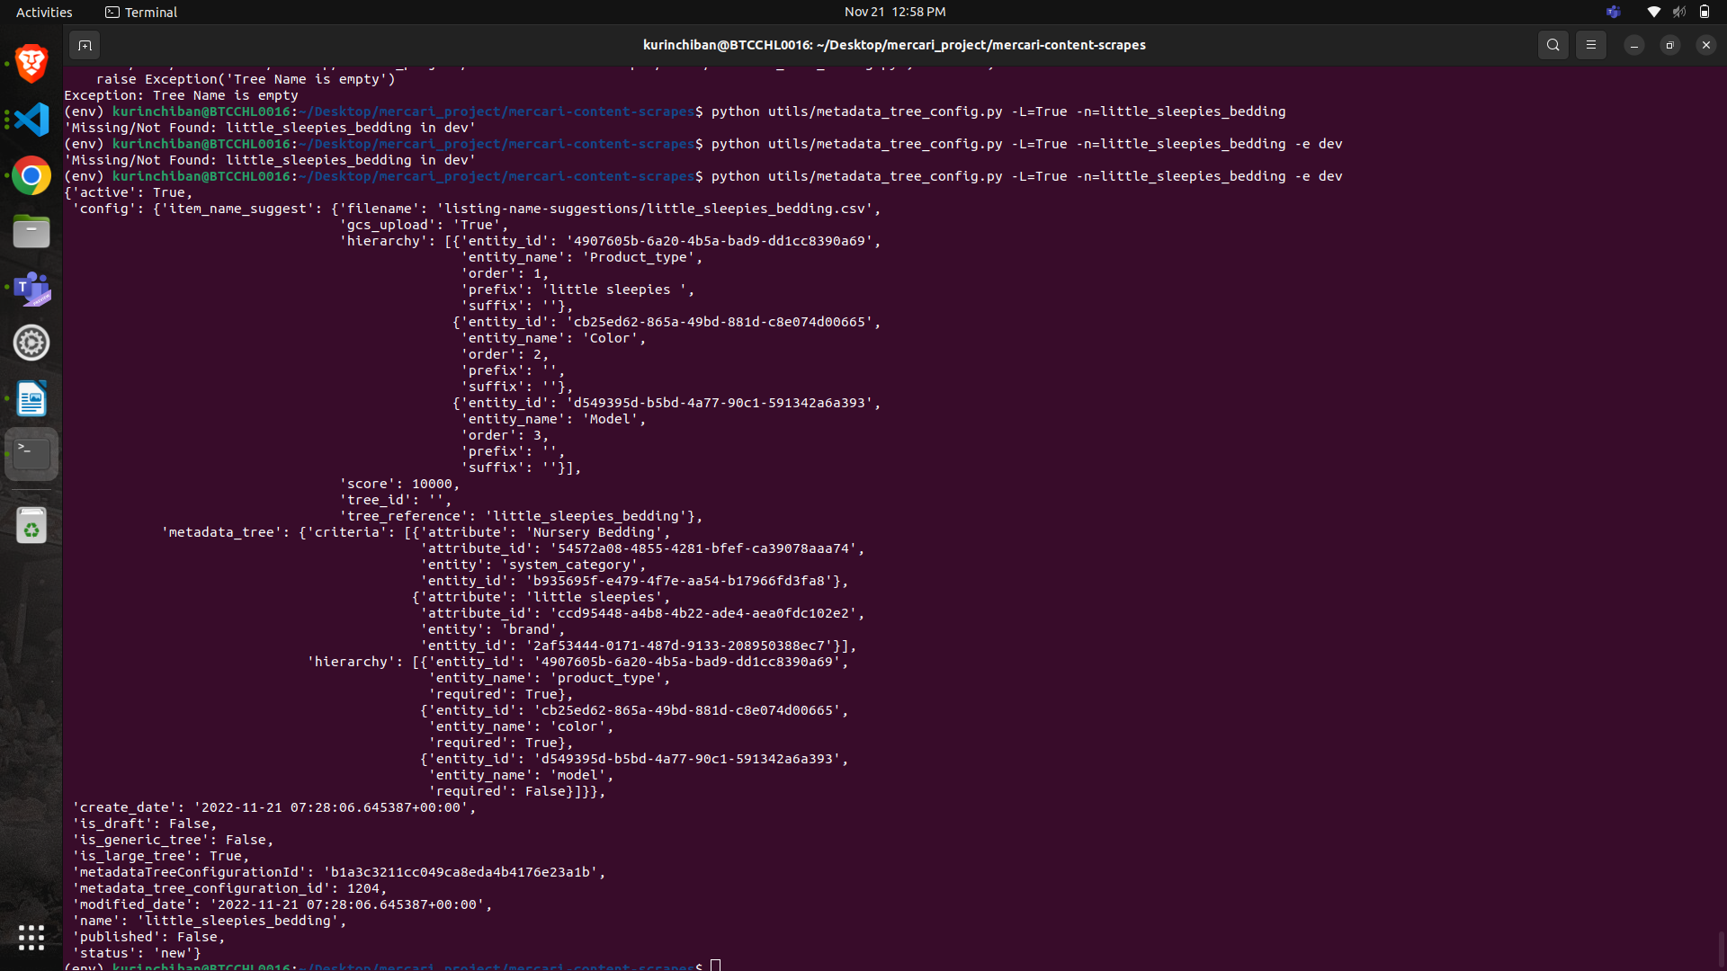

- based on the given meta data tree configred id we have to hit the api in the postman so it will store in the gscpath by downloding the gcs path we can send it to the product manager

