**Team and Project Description**

Team Description:

*Team Name:* MicroLimn Softworks

*Project Manager:* Kounoukla Xeni-Christina

*List of team members:* Gkougkoutoudis Evangelos

Kounoukla Xeni-Christina

Rigopoulos Andreas

Theodoridis Christos

*Communication point:* [microlimnsoftworks@gmail.com](mailto:microlimnsoftworks@gmail.com)

Project Description:

*Project Name:* Arc – Powerful software for a brighter tomorrow in Greek tourism

*Idea Description:*

The project in concern is about the development of a mobile friendly website containing information about the city of Thessaloniki. The main purpose of the website is to help tourists guide themselves in Thessaloniki, providing useful information about the most popular and worth visiting sites of the city. More specifically, in the main webpage an appropriate dynamic map will appear showing different kinds of places based on the user’s location which will be determined by the GPS tracking services that run on user’s mobile device. In the event of clicking on a specific point of interest, a short description of it will show up containing general information, exact location and rating points. The user will be able to select what kind of places will be shown on the map and filter them by criteria like rating points. Additionally, a navigation menu will appear to help the visitor access categorized information. We are planning on connecting this information with real environment with the help of augmented reality mechanisms such as QR Codes. For this purpose, we are going to develop an android mobile application which will be able to read a QR code using the device’s camera and redirect the user to appropriate online content. Finally, a group of users will be responsible for populating the database of sites. We will try to make this process easy and automated with the help of appropriate Foursquare or Google Maps APIs.

*Infrastructure requirements and technologies used:*

Appropriate responsive web design practices will be taken into consideration since we want to give tourists the ability to easily navigate through the website using their mobile devices. The development of the website will involve server side coding in PHP. The database technology that will be used is MySQL. HTML and Javascript will run on user’s client. The android application will be built in Java. For the purposes of the project we will need a web server to host the website as well as a MySQL server to host the database.

*Project Plan:*

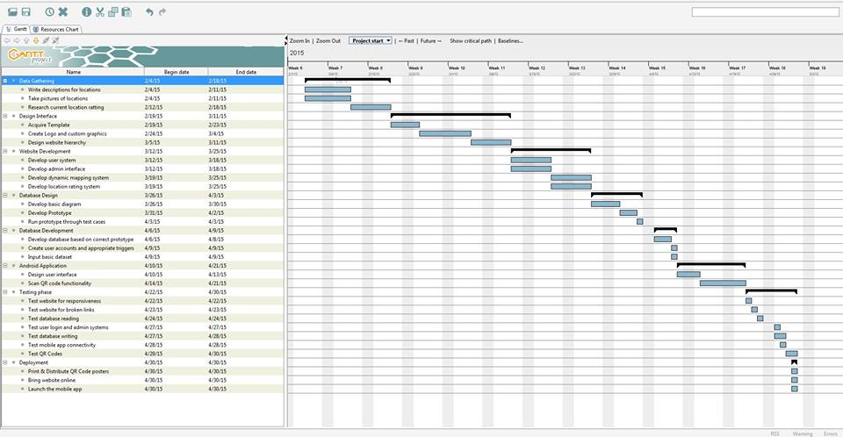

*Data gathering* *04/02 – 18/02*

* Write descriptions for locations 04/02 – 11/02
* Take pictures of locations 04/02 – 11/02
* Research current location rating 12/02 – 18/02

*Design interface 19/02 – 11/03*

* Acquire template 19/02 – 23/02
* Create Logo and custom graphics 24/02 - 04/03
* Design website hierarchy 05/03 – 11/03

*Website development 12/03 – 25/03*

* Develop user system 12/03 – 18/03
* Develop admin interface 12/03 – 18/03
* Develop dynamic mapping system 19/03 – 25/03
* Develop location rating system 19/03 – 25/03

*Database design 26/03 – 03/04*

* Develop basic diagram 26/03 – 30/03
* Develop prototype 31/03 – 02/04
* Run prototype through test cases 03/04 – 03/04

*Database development 05/04 – 09/04*

* Develop database based on correct prototype 05/04 – 08/04
* Create user accounts 09/04 – 09/04
* Input basic dataset 09/04 – 09/04

*Android application 10/04 – 21/04*

* Design user interface 10/04 – 13/04
* Scan QR code functionality 14/04 – 21/04

*Testing phase 22/04 – 30/04*

* Test website for responsiveness 22/04 – 22/04
* Test website for broken links 23/04 – 23/04
* Test database reading 24/04 – 24/04
* Test user login and admin systems 27/04 – 27/04
* Test database writing 27/04 – 28/04
* Test mobile app connectivity 28/04 – 28/04
* Test QR codes 29/04 – 30/04

*Deployment 30/04 – 30/04*

* Print and distribute QR code posters 30/04 – 30/04
* Bring website online 30/04 – 30/04
* Launch the mobile app 30/04 – 30/04