**数据类**

第一段：介绍图表

The given xxx chart illustrates the details concerning xxx.

第二段：明显内容

Generally speaking, it could be obviously witnessed that xxx. What is more, xxx

持续的上升、下降：

The number/percentage/xxx of A exhibits a persistent upward trajectory from 2000 to 2005.

The number/percentage/xxx of A is positively/negatively related to xxx.

The number/percentage/xxx of A surpassed that of B from 2000 to 2005.

第三段：细节数据

Upon closer examination of the data, xxx

The number of A was higher than that of B by 100.

The number of A experienced a remarkable surge, elevating sharply from 100 to 200.

第四段：细节数据

Furthermore, xxx

句子库：

对比：

不论时间，A与B对比：

A towers over B by a substantial differential of 100.

A is of double the magnitude as compared to B.

A is twice the magnitude of B.

同一年份，A与B相比：

Contrasting with the figure of 60 recorded for A in 2000, the corresponding quantity for B in the same timeframe was markedly superior, estimated around 100.

不同年份，A与B相比：

In 2001, A’s count stood at 100, a figure which paled in comparison by 20 to B’s a tally recorded in 2022.

三者对比:

The quantity of A stands at 100, whereas both B and C outstrip this figure with respective number of 110 and 120.

特殊个体对比：

A’s quantity presents a notable anomaly, showing substantial deviation from the other data, exceeding the average by 30.

刷题：  
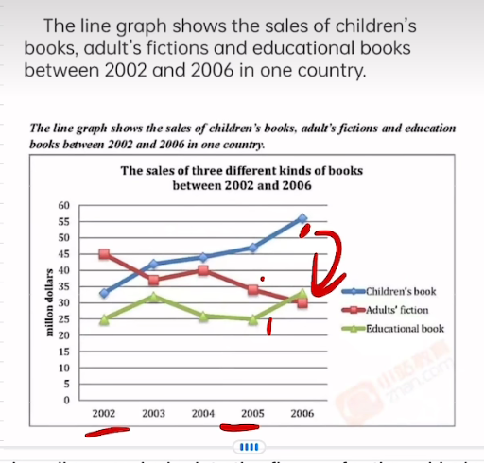

The given line graph depicts the figures for three kinds of books in a certain nation between the years 2002 and 2006.

In general, it is observable that the sales of children’s book exhibited a consistent growth pattern during aforementioned period. Moreover it is noteworthy that the sales of educational books remain ed lower than those of other from 2002 to 2005.

Upon closer examination of the data, it is discernible that the sales of children’s book began at approximately 32 million dollars, escalated around 46 million dollars in 2005, an culminated at higher point in 2006. Conversely, the sales of educational books remained constant, with an average of roughly 28 million dollars.

Furthermore, the sales of adult’s fiction commenced at about 45 million dollars in 2002 and underwent a reduction of about 9 million dollars in 2003. Then, a marginal increase was observed, followed by a drop of approximately 10 million dollars in the subsequent years.

**流程图**

段1: 介绍流程

The diagram demonstrates the intricate details of xxx, providing a comprehensive overview of its integral components.

段2：宏观信息

Generally speaking, it could be obviously witnessed that xxx, What is more, xxx.

The process can be meticulously broken down into a total xxx distinct phrases, each of which plays a pivotal role in the overall sequence.

段3：具体流程

Upon closer examination towards the process, xxx.

段4：具体流程

Moreover,

句子库:

Commencing with the initiation of xxx, the progression then methodically transition through a series of intricately interwoven stages, culminating in the finalization at xxx.

Once reaching the juncture at xxx, the process bifurcates, giving rise two divergent pathways: one leading towards xxx and the other navigating towards xxx.

A cyclic pattern is unmistakably evident, with xxx recurrently looping back to xxx, thereby perpetuating a continuous cycle of operations.

Before advancing to the next phrase, xxx occurs.

Once xxx is finished, the process moves on to xxx.

In the mean time, xxx is happening alongside xxx.

**地图**

第一段：

The map highlights the notable changes took place in xxx from 2022 to 2023.

The provided map portrays the evolving landscape of xxx over the whole period.

第二段：

第三第四段：

In the central region of xxx, a new xxx has been constructed.

During the period, the xxx area has experienced substantial growth and improvement, including the new-building xxx.

Before the xxx to the outhouse lies the xxx.