1. **Flowchart: Fibonacci Numbers**

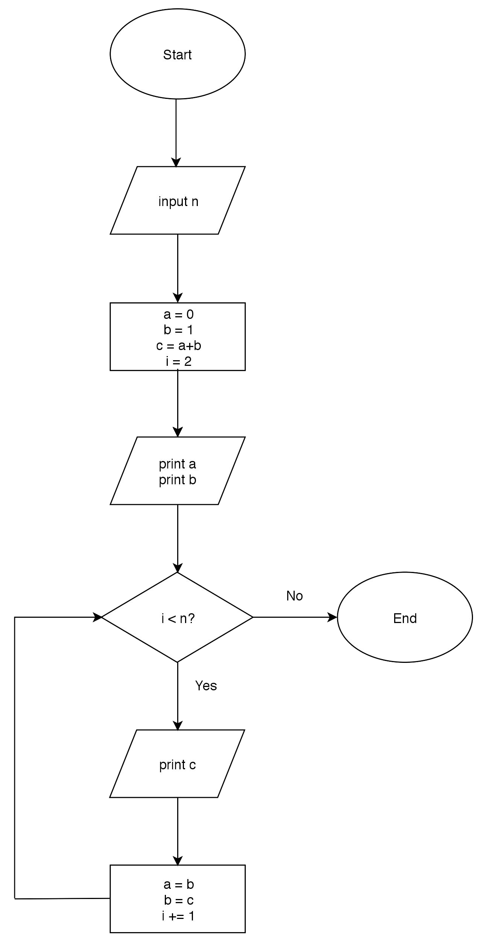

**A. Trace**

|  |  |  |  |  |  |
| --- | --- | --- | --- | --- | --- |
| **n** | **a** | **b** | **c** | **i** | **output** |
| 1 | 0 | 0 | 1 | 2 | 0 |
|  |  |  |  |  | 1 |
| 8 | 0 | 1 | 1 | 2 | 0 |
|  |  |  |  |  | 1 |
|  |  |  |  |  | 1 |
|  | 1 | 1 | 1 | 3 | 1 |
|  | 1 | 1 | 1 | 4 | 1 |
|  | 1 | 1 | 1 | 5 | 1 |
|  | 1 | 1 | 1 | 6 | 1 |
|  | 1 | 1 | 1 | 7 | 1 |
|  | 1 | 1 | 1 | 8 | 1 |
| -15 | 0 | 0 | 1 | 2 |  |

**B. Evaluate**

(a) Are the appropriate symbols used for each step? If no, which symbols are wrong? **Nani?**

(b) Does the flowchart produce correct output for all the test items given? If no, in which test cases did the flowchart produce an incorrect output? **Nah. Only the first test case gives the correct answer.**

(c) Are the instructions properly followed (i.e each item starts in a new page)? If no, which instructions are not followed? **Yeah.**

1. **Flowchart: Approximating *e***

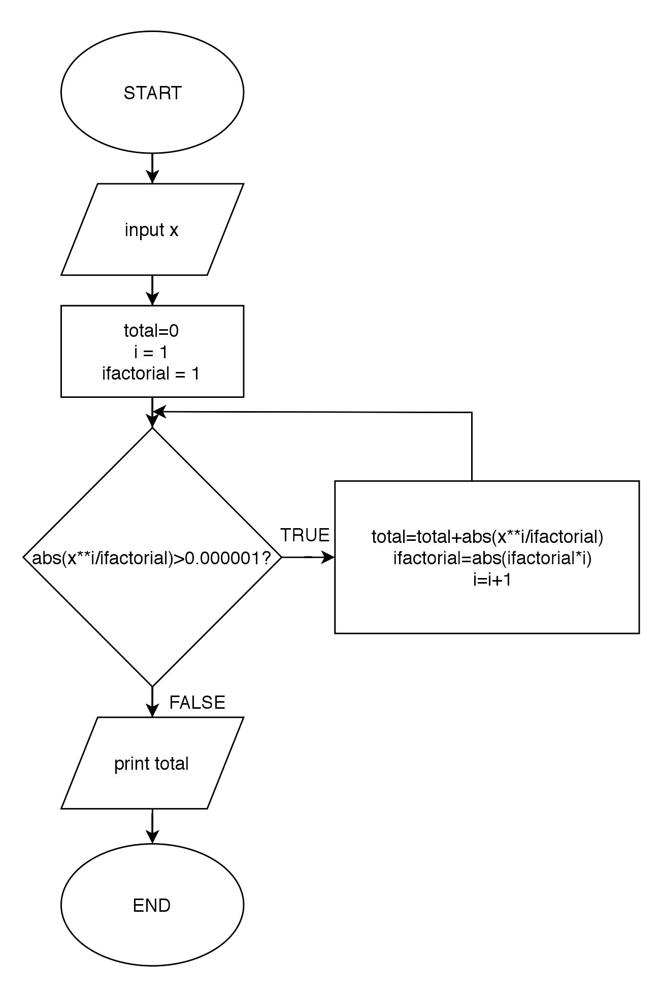

1. **Trace**

|  |  |  |  |  |
| --- | --- | --- | --- | --- |
| **x** | **total** | **i** | **ifactorial** | **output** |
| -1 | 0 | 1 | 1 |  |
|  | 1 | 2 | 1 |  |
|  | 2 | 3 | 2 |  |
|  | 2.5 | 4 | 6 |  |
|  | 2.666667 | 5 | 24 |  |
|  | 2.708333 | 6 | 120 |  |
|  | 2.716667 | 7 | 720 |  |
|  | 2.718056 | 8 | 5040 |  |
|  | 2.718254 | 9 | 40320 |  |
|  | 2.718279 | 10 | 362880 |  |
|  | 2.718282 | 11 | 3628800 | 2.718282 |
| 0 |  |  |  | 0 |
| 3 | 3 | 2 | 1 |  |
|  | 12 | 3 | 2 |  |
|  | 25.5 | 4 | 6 |  |
|  | 39 | 5 | 24 |  |
|  | 49.125 | 6 | 120 |  |
|  | 55.2 | 7 | 720 |  |
|  | 58.237500 | 8 | 5040 |  |
|  | 59.539286 | 9 | 40320 |  |
|  | 60.027455 | 10 | 362880 |  |
|  | 60.190179 | 11 | 3628800 |  |
|  | 60.238996 | 12 | 39916800 |  |
|  | 60.252309 | 13 | 479001600 |  |
|  | 60.255638 | 14 | 6227020800 |  |
|  | 60.256406 | 15 | 87178291200 |  |
|  | 60.256570 | 16 | 1307674368000 |  |
|  | 60.256603 | 17 | 20922789888000 |  |
|  | 60.256609 | 18 | 355687428096000 |  |
|  | 60.256611 | 19 | 6402373705728000 | 60.256611 |

1. **Evaluate**

(a) Are the appropriate symbols used for each step? If no, which symbols are wrong?

(b) Does the flowchart produce correct output for all the test items given? If no, in which test cases did the flowchart produce an incorrect output?

(c) Are the instructions properly followed (i.e each item starts in a new page)? If no, which instructions are not followed?

1. **Flowchart: Largest Element**

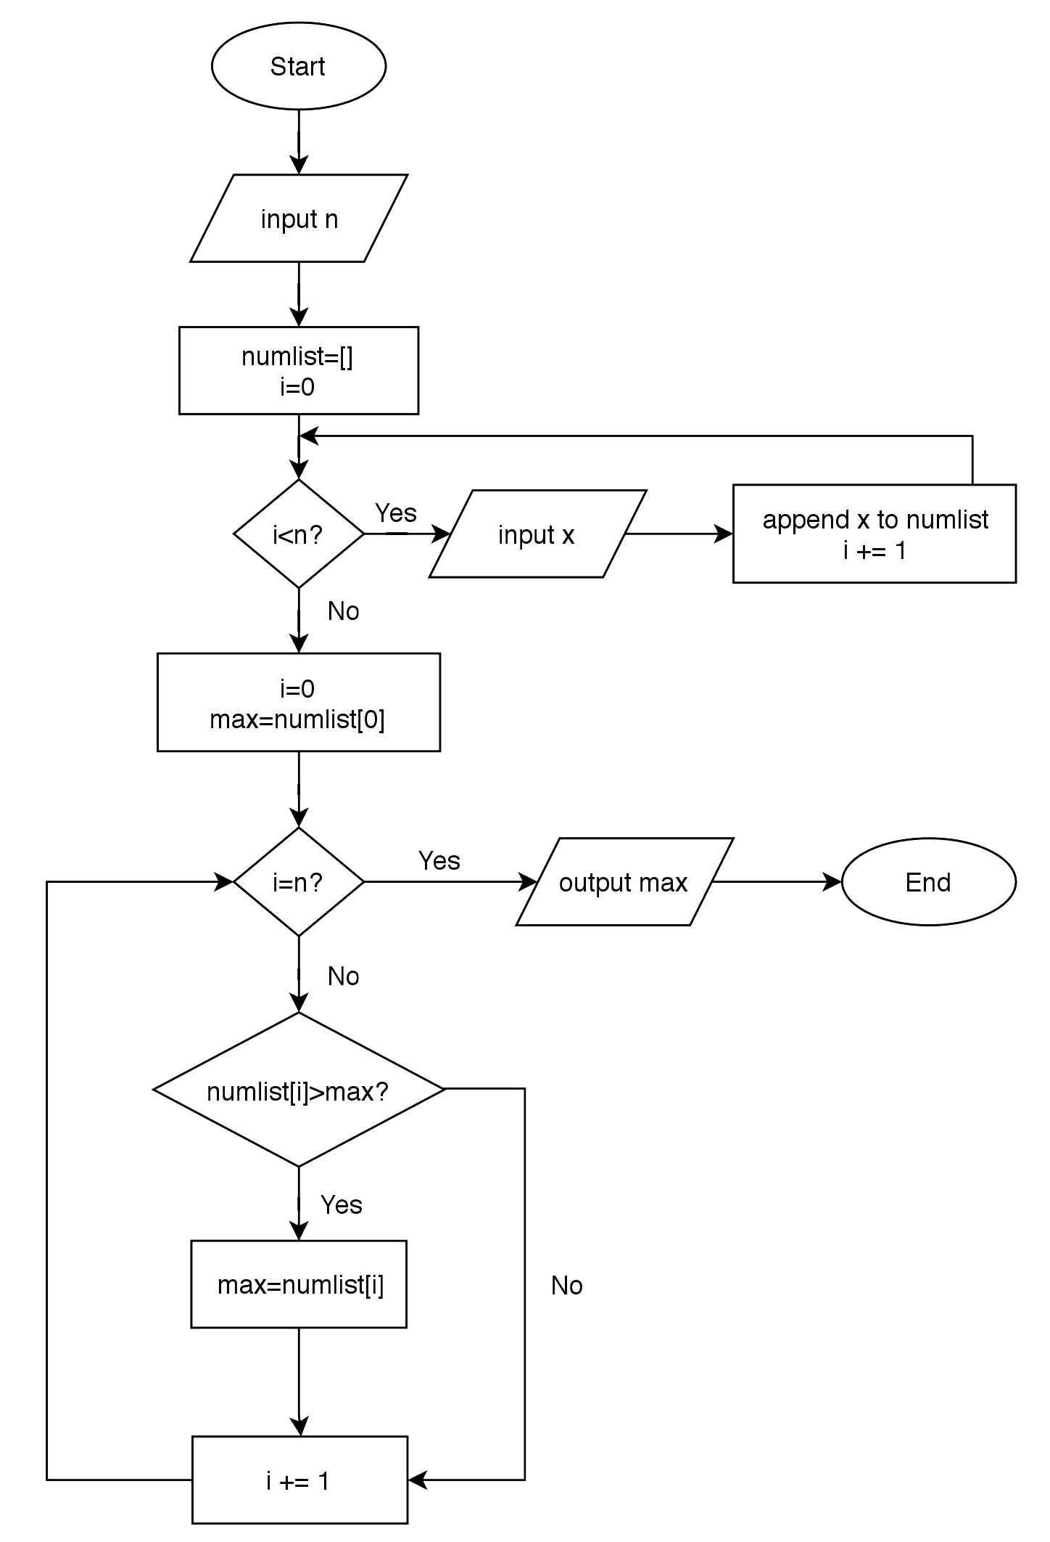

1. **Trace**

|  |  |  |  |  |  |
| --- | --- | --- | --- | --- | --- |
| **n** | **i** | **x** | **numlist** | **max** | **output** |
| 1 | 0 | 100 | [100] |  |  |
|  | 0 |  |  | 100 | 100 |
| 10 | 0 |  | [] |  |  |
|  | 0 | 7 | [7] |  |  |
|  | 1 | 23 | [7, 23] |  |  |
|  | 2 | 344 | [7, 23, 344] |  |  |
|  | 3 | 44 | [7, 23, 344, 44] |  |  |
|  | 4 | 21 | [7, 23, 344, 44, 21] |  |  |
|  | 5 | 691 | [7, 23, 344, 44, 21, 691] |  |  |
|  | 6 | 69 | [7, 23, 344, 44, 21, 691, 69] |  |  |
|  | 7 | 197 | [7, 23, 344, 44, 21, 691, 69, 197] |  |  |
|  | 8 | 43 | [7, 23, 344, 44, 21, 691, 69, 197, 43] |  |  |
|  | 9 | 33 | [7, 23, 344, 44, 21, 691, 69, 197, 43, 43] |  |  |
|  | 0 |  |  | 7 |  |
|  | 1 |  |  | 23 |  |
|  | 2 |  |  | 344 |  |
|  | 3 |  |  | 344 |  |
|  | 4 |  |  | 344 |  |
|  | 5 |  |  | 691 |  |
|  | 6 |  |  | 691 |  |
|  | 7 |  |  | 691 |  |
|  | 8 |  |  | 691 |  |
|  | 9 |  |  | 691 | 691 |
| -1 |  |  |  |  | ERROR |

1. **Evaluate**

(a) Are the appropriate symbols used for each step? If no, which symbols are wrong?

(b) Does the flowchart produce correct output for all the test items given? If no, in which test cases did the flowchart produce an incorrect output?

(c) Are the instructions properly followed (i.e each item starts in a new page)? If no, which instructions are not followed?

1. **Prime Numbers**

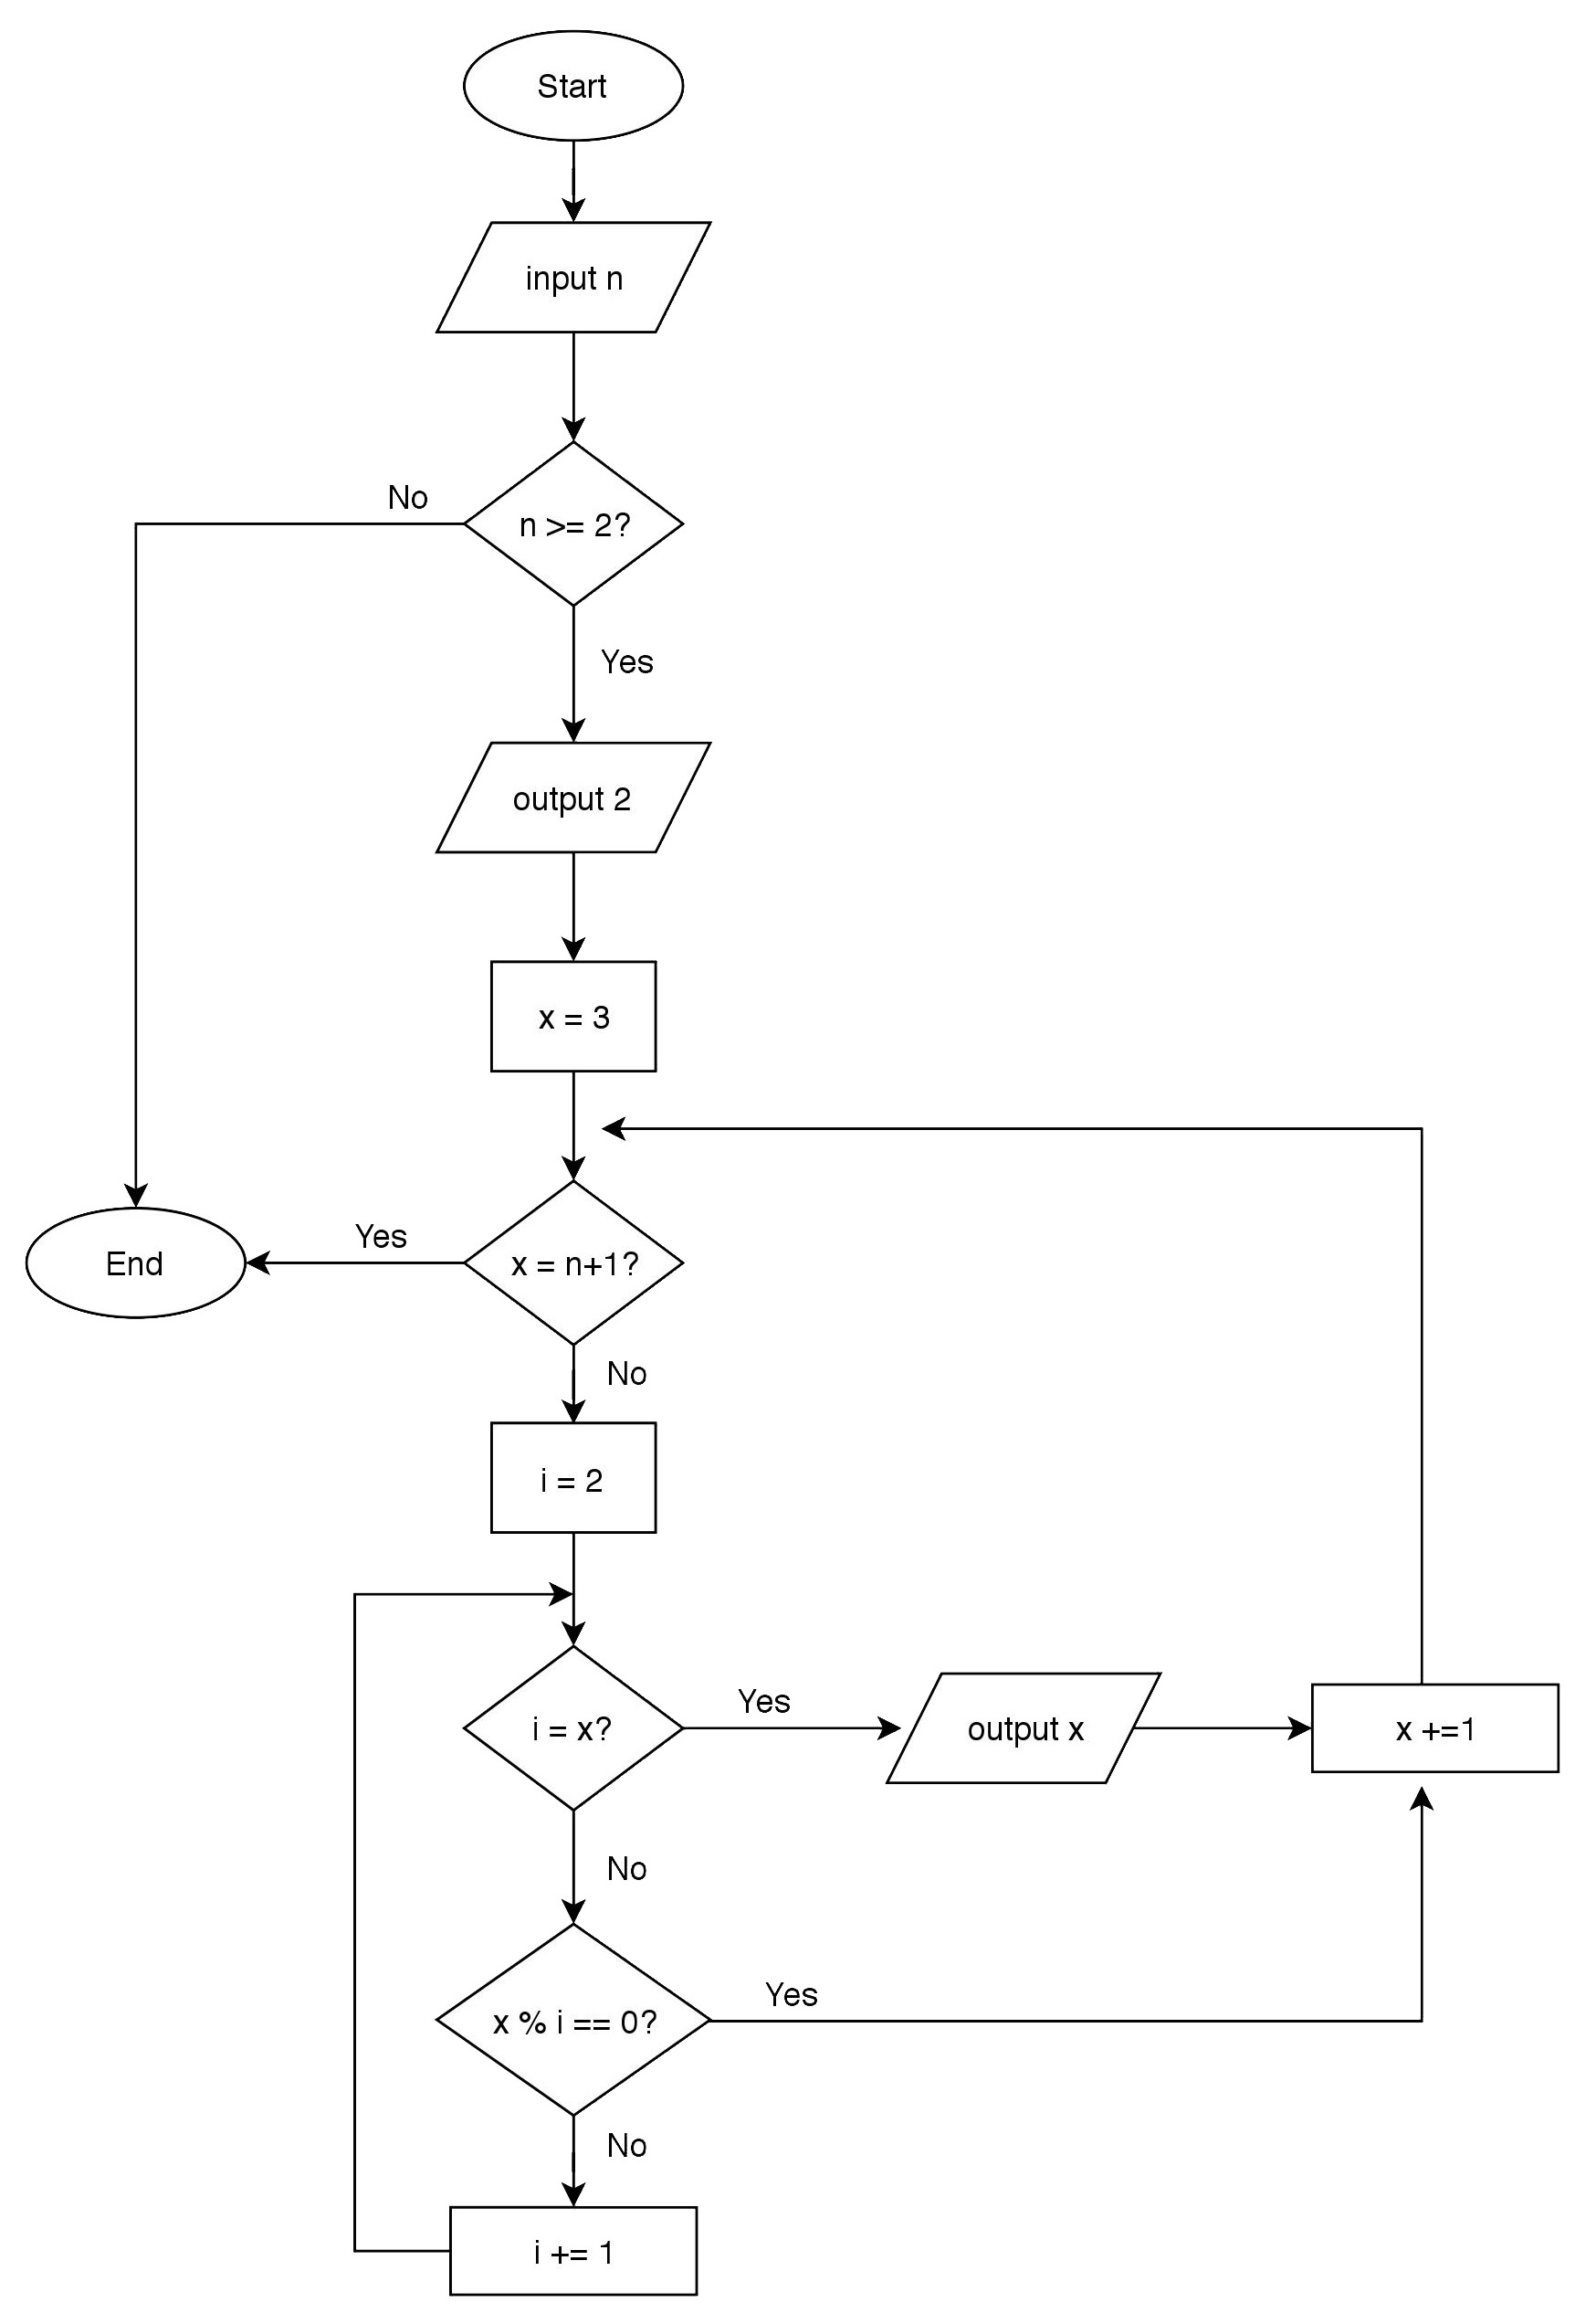

1. **Trace**

|  |  |  |  |  |  |  |  |  |  |  |  |  |  |  |  |  |  |  |  |  |  |  |  |  |  |  |  |  |  |  |  |  |  |  |  |  |  |  |  |  |  |  |  |  |  |  |  |  |  |  |  |  |  |  |  |  |  |  |  |  |  |  |  |  |  |  |  |  |  |  |  |  |  |  |  |  |  |  |  |  |  |  |  |  |  |  |  |  |  |  |  |  |  |  |  |  |  |  |  |  |  |  |  |  |  |  |  |  |  |  |  |  |  |  |  |  |  |  |  |  |  |  |  |  |  |  |  |  |  |  |  |  |  |  |  |  |  |  |  |  |  |  |  |  |  |  |  |  |  |  |  |  |  |  |  |  |  |  |  |  |  |  |  |  |  |  |  |  |  |  |  |  |  |  |  |  |  |  |  |  |  |  |  |  |  |  |  |  |  |  |  |  |  |  |  |  |  |  |  |  |  |  |  |  |  |  |  |  |  |  |  |  |  |  |  |  |  |  |  |  |  |  |  |  |  |  |  |  |  |  |  |  |  |  |  |  |  |  |  |  |  |  |  |  |  |  |  |  |  |  |  |  |  |  |  |  |  |  |  |  |  |  |  |  |  |  |  |  |  |  |  |  |  |  |  |  |  |  |  |  |  |  |  |  |  |  |  |  |  |  |  |  |  |  |  |  |  |  |  |  |  |  |  |  |  |  |  |  |  |  |  |  |  |  |  |  |  |  |  |  |  |  |  |  |  |  |  |  |  |
| --- | --- | --- | --- | --- | --- | --- | --- | --- | --- | --- | --- | --- | --- | --- | --- | --- | --- | --- | --- | --- | --- | --- | --- | --- | --- | --- | --- | --- | --- | --- | --- | --- | --- | --- | --- | --- | --- | --- | --- | --- | --- | --- | --- | --- | --- | --- | --- | --- | --- | --- | --- | --- | --- | --- | --- | --- | --- | --- | --- | --- | --- | --- | --- | --- | --- | --- | --- | --- | --- | --- | --- | --- | --- | --- | --- | --- | --- | --- | --- | --- | --- | --- | --- | --- | --- | --- | --- | --- | --- | --- | --- | --- | --- | --- | --- | --- | --- | --- | --- | --- | --- | --- | --- | --- | --- | --- | --- | --- | --- | --- | --- | --- | --- | --- | --- | --- | --- | --- | --- | --- | --- | --- | --- | --- | --- | --- | --- | --- | --- | --- | --- | --- | --- | --- | --- | --- | --- | --- | --- | --- | --- | --- | --- | --- | --- | --- | --- | --- | --- | --- | --- | --- | --- | --- | --- | --- | --- | --- | --- | --- | --- | --- | --- | --- | --- | --- | --- | --- | --- | --- | --- | --- | --- | --- | --- | --- | --- | --- | --- | --- | --- | --- | --- | --- | --- | --- | --- | --- | --- | --- | --- | --- | --- | --- | --- | --- | --- | --- | --- | --- | --- | --- | --- | --- | --- | --- | --- | --- | --- | --- | --- | --- | --- | --- | --- | --- | --- | --- | --- | --- | --- | --- | --- | --- | --- | --- | --- | --- | --- | --- | --- | --- | --- | --- | --- | --- | --- | --- | --- | --- | --- | --- | --- | --- | --- | --- | --- | --- | --- | --- | --- | --- | --- | --- | --- | --- | --- | --- | --- | --- | --- | --- | --- | --- | --- | --- | --- | --- | --- | --- | --- | --- | --- | --- | --- | --- | --- | --- | --- | --- | --- | --- | --- | --- | --- | --- | --- | --- | --- | --- | --- | --- | --- | --- | --- | --- | --- | --- | --- | --- | --- | --- | --- | --- | --- | --- | --- | --- | --- | --- | --- | --- | --- | --- | --- | --- | --- | --- | --- | --- | --- | --- | --- | --- | --- | --- | --- | --- | --- |
| |  |  |  |  | | --- | --- | --- | --- | | **n** | **x** | **i** | **output** | | 1 |  |  |  | | 130 |  |  | 2 | |  | 3 | 2 |  | |  | 3 | 3 | 3 | |  | 4 | 2 |  | |  | 5 | 2 |  | |  |  | 3 |  | |  |  | 4 |  | |  |  | 5 | 5 | |  | 6 | 2 |  | |  | 7 | 2 |  | |  |  | 3 |  | |  |  | 4 |  | |  |  | … |  | |  |  | 7 | 7 | |  | 8 | 2 |  | |  | 9 | 2 |  | |  |  | 3 |  | |  | 10 | 2 |  | |  | 11 | 2 |  | |  |  | 3 |  | |  |  | 4 |  | |  |  | … |  | |  |  | 11 | 11 | |  | 12 | 2 |  | |  | 13 | 2 |  | |  |  | 3 |  | |  |  | 4 |  | |  |  | … |  | |  |  | 13 | 13 | |  | 14 | 2 |  | |  | 15 | 2 |  | |  |  | 3 |  | |  |  | 4 |  | |  |  | 5 |  | |  | 16 | 2 |  | |  | 17 | 1 |  | |  |  | 2 |  | |  |  | 3 |  | |  |  | … |  | | |  |  |  |  | | --- | --- | --- | --- | | **n** | **x** | **i** | **output** | | 130 | 17 | 17 | 17 | |  | 18 | 2 |  | |  | 19 | 2 |  | |  |  | 3 |  | |  |  | 4 |  | |  |  | … |  | |  |  | 19 | 19 | |  | 20 | 2 |  | |  | 21 | 2 |  | |  |  | 3 |  | |  | 22 | 2 |  | |  | 23 | 2 |  | |  |  | 3 |  | |  |  | 4 |  | |  |  | … |  | |  |  | 23 | 23 | |  | 24 | 2 |  | |  | 25 | 2 |  | |  |  | 3 |  | |  |  | 4 |  | |  |  | 5 |  | |  | 26 | 2 |  | |  | 27 | 2 |  | |  |  | 3 |  | |  | 28 | 2 |  | |  | 29 | 2 |  | |  |  | 3 |  | |  |  | 4 |  | |  |  | … |  | |  |  | 29 | 29 | |  | 30 | 2 |  | |  | 31 | 2 |  | |  |  | 3 |  | |  |  | 4 |  | |  |  | … |  | |  |  | 31 | 31 | |  | 32 | 2 |  | |  | 33 | 2 |  | |  |  | 3 |  | |  | 34 | 2 |  | |
| |  |  |  |  | | --- | --- | --- | --- | | **n** | **x** | **i** | **output** | | 130 | 35 | 2 |  | |  |  | 3 |  | |  |  | 4 |  | |  |  | 5 |  | |  | 36 | 2 |  | |  | 37 | 2 |  | |  |  | 3 |  | |  |  | 4 |  | |  |  | … |  | |  |  | 37 | 37 | |  | 38 | 2 |  | |  | 39 | 2 |  | |  |  | 3 |  | |  | 40 | 2 |  | |  | 41 | 2 |  | |  |  | 3 |  | |  |  | 4 |  | |  |  | … |  | |  |  | 41 | 41 | |  | 42 | 2 |  | |  | 43 | 2 |  | |  |  | 3 |  | |  |  | 4 |  | |  |  | … |  | |  |  | 43 | 43 | |  | 44 | 2 |  | |  | 45 | 2 |  | |  |  | 3 |  | |  |  | 4 |  | |  |  | 5 |  | |  | 46 | 2 |  | |  | 47 | 2 |  | |  |  | 3 |  | |  |  | 4 |  | |  |  | … |  | |  |  | 47 | 47 | |  | 48 | 2 |  | |  | 49 | 2 |  | |  |  | 3 |  | |  |  | … |  | | |  |  |  |  | | --- | --- | --- | --- | | **n** | **x** | **i** | **output** | | 130 | 49 | 7 |  | |  | 50 | 2 |  | |  | 51 | 2 |  | |  |  | 3 |  | |  | 52 | 2 |  | |  | 53 | 2 |  | |  |  | 3 |  | |  |  | 4 |  | |  |  | … |  | |  |  | 53 | 53 | |  | 54 | 2 |  | |  | 55 | 2 |  | |  |  | 3 |  | |  |  | 4 |  | |  |  | 5 |  | |  | 56 | 2 |  | |  | 57 | 2 |  | |  |  | 3 |  | |  | 58 | 2 |  | |  | 59 | 2 |  | |  |  | 3 |  | |  |  | 4 |  | |  |  | … |  | |  |  | 59 | 59 | |  | 60 | 2 |  | |  | 61 | 2 |  | |  |  | 3 |  | |  |  | 4 |  | |  |  | … |  | |  |  | 61 | 61 | |  | 62 | 2 |  | |  | 63 | 2 |  | |  |  | 3 |  | |  | 64 | 2 |  | |  | 65 | 2 |  | |  |  | 3 |  | |  |  | 4 |  | |  |  | 5 |  | |  | 66 | 2 |  | |  | 67 | 2 |  | |

|  |  |  |  |  |  |  |  |  |  |  |  |  |  |  |  |  |  |  |  |  |  |  |  |  |  |  |  |  |  |  |  |  |  |  |  |  |  |  |  |  |  |  |  |  |  |  |  |  |  |  |  |  |  |  |  |  |  |  |  |  |  |  |  |  |  |  |  |  |  |  |  |  |  |  |  |  |  |  |  |  |  |  |  |  |  |  |  |  |  |  |  |  |  |  |  |  |  |  |  |  |  |  |  |  |  |  |  |  |  |  |  |  |  |  |  |  |  |  |  |  |  |  |  |  |  |  |  |  |  |  |  |  |  |  |  |  |  |  |  |  |  |  |  |  |  |  |  |  |  |  |  |  |  |  |  |  |  |  |  |  |  |  |  |  |  |  |  |  |  |  |  |  |  |  |  |  |  |  |  |  |  |  |  |  |  |  |  |  |  |  |  |  |  |  |  |  |  |  |  |  |  |  |  |  |  |  |  |  |  |  |  |  |  |  |  |  |  |  |  |  |  |  |  |  |  |  |  |  |  |  |  |  |  |  |  |  |  |  |  |  |  |  |  |  |  |  |  |  |  |  |  |  |  |  |  |  |  |  |  |  |  |  |  |  |  |  |  |  |  |  |  |  |  |  |  |  |  |  |  |  |  |  |  |  |  |  |  |  |  |  |  |  |  |  |  |  |  |  |  |  |  |  |  |  |  |  |  |  |  |  |  |  |  |  |  |  |  |  |  |  |  |  |  |  |  |  |  |  |  |  |  |  |  |  |  |  |  |
| --- | --- | --- | --- | --- | --- | --- | --- | --- | --- | --- | --- | --- | --- | --- | --- | --- | --- | --- | --- | --- | --- | --- | --- | --- | --- | --- | --- | --- | --- | --- | --- | --- | --- | --- | --- | --- | --- | --- | --- | --- | --- | --- | --- | --- | --- | --- | --- | --- | --- | --- | --- | --- | --- | --- | --- | --- | --- | --- | --- | --- | --- | --- | --- | --- | --- | --- | --- | --- | --- | --- | --- | --- | --- | --- | --- | --- | --- | --- | --- | --- | --- | --- | --- | --- | --- | --- | --- | --- | --- | --- | --- | --- | --- | --- | --- | --- | --- | --- | --- | --- | --- | --- | --- | --- | --- | --- | --- | --- | --- | --- | --- | --- | --- | --- | --- | --- | --- | --- | --- | --- | --- | --- | --- | --- | --- | --- | --- | --- | --- | --- | --- | --- | --- | --- | --- | --- | --- | --- | --- | --- | --- | --- | --- | --- | --- | --- | --- | --- | --- | --- | --- | --- | --- | --- | --- | --- | --- | --- | --- | --- | --- | --- | --- | --- | --- | --- | --- | --- | --- | --- | --- | --- | --- | --- | --- | --- | --- | --- | --- | --- | --- | --- | --- | --- | --- | --- | --- | --- | --- | --- | --- | --- | --- | --- | --- | --- | --- | --- | --- | --- | --- | --- | --- | --- | --- | --- | --- | --- | --- | --- | --- | --- | --- | --- | --- | --- | --- | --- | --- | --- | --- | --- | --- | --- | --- | --- | --- | --- | --- | --- | --- | --- | --- | --- | --- | --- | --- | --- | --- | --- | --- | --- | --- | --- | --- | --- | --- | --- | --- | --- | --- | --- | --- | --- | --- | --- | --- | --- | --- | --- | --- | --- | --- | --- | --- | --- | --- | --- | --- | --- | --- | --- | --- | --- | --- | --- | --- | --- | --- | --- | --- | --- | --- | --- | --- | --- | --- | --- | --- | --- | --- | --- | --- | --- | --- | --- | --- | --- | --- | --- | --- | --- | --- | --- | --- | --- | --- | --- | --- | --- | --- | --- | --- | --- | --- | --- | --- | --- | --- | --- | --- | --- | --- | --- | --- | --- | --- | --- | --- | --- | --- | --- | --- | --- | --- | --- | --- |
| |  |  |  |  | | --- | --- | --- | --- | | **n** | **x** | **i** | **output** | | 130 | 67 | 3 |  | |  |  | 4 |  | |  |  | … |  | |  |  | 67 | 67 | |  | 68 | 2 |  | |  | 69 | 2 |  | |  |  | 3 |  | |  | 70 | 2 |  | |  |  | 3 |  | |  |  | 4 |  | |  |  | 5 |  | |  | 71 | 2 |  | |  |  | 3 |  | |  |  | 4 |  | |  |  | … |  | |  |  | 71 | 71 | |  | 71 | 2 |  | |  | 73 | 2 |  | |  |  | 3 |  | |  |  | 4 |  | |  |  | … |  | |  |  | 73 | 73 | |  | 74 | 2 |  | |  | 75 | 2 |  | |  |  | 3 |  | |  |  | 4 |  | |  |  | 5 |  | |  | 76 | 2 |  | |  | 77 | 2 |  | |  |  | 3 |  | |  |  | 4 |  | |  |  | … |  | |  |  | 7 |  | |  | 78 | 2 |  | |  | 79 | 2 |  | |  |  | 3 |  | |  |  | 4 |  | |  |  | … |  | |  |  | 79 | 79 | |  | 80 | 2 |  | |  | 81 | 2 |  | | |  |  |  |  | | --- | --- | --- | --- | | **n** | **x** | **i** | **output** | | 130 | 81 | 3 |  | |  | 82 | 2 |  | |  | 83 | 2 |  | |  |  | 3 |  | |  |  | 4 |  | |  |  | … |  | |  |  | 83 | 83 | |  | 84 | 2 |  | |  | 85 | 2 |  | |  |  | 3 |  | |  |  | 4 |  | |  |  | 5 |  | |  | 86 | 2 |  | |  | 87 | 2 |  | |  |  | 3 |  | |  | 88 | 2 |  | |  | 89 | 2 |  | |  |  | 3 |  | |  |  | 4 |  | |  |  | … |  | |  |  | 89 | 89 | |  | 90 | 2 |  | |  | 91 | 2 |  | |  |  | 3 |  | |  |  | 4 |  | |  |  | … |  | |  |  | 7 |  | |  | 92 | 2 |  | |  | 93 | 2 |  | |  |  | 3 |  | |  | 94 | 2 |  | |  | 95 | 2 |  | |  |  | 3 |  | |  |  | 4 |  | |  |  | 5 |  | |  | 96 | 2 |  | |  | 97 | 2 |  | |  |  | 3 |  | |  |  | 4 |  | |  |  | … |  | |  |  | 97 | 97 | |
| |  |  |  |  | | --- | --- | --- | --- | | **n** | **x** | **i** | **output** | | 130 | 98 | 2 |  | |  | 99 | 2 |  | |  |  | 3 |  | |  | 100 | 2 |  | |  | 101 | 2 |  | |  |  | 3 |  | |  |  | 4 |  | |  |  | … |  | |  |  | 101 | 101 | |  | 102 | 2 |  | |  | 103 | 2 |  | |  |  | 3 |  | |  |  | 4 |  | |  |  | … |  | |  |  | 103 | 103 | |  | 104 | 2 |  | |  | 105 | 2 |  | |  |  | 3 |  | |  |  | 4 |  | |  |  | 5 |  | |  | 106 | 2 |  | |  | 107 | 2 |  | |  |  | 3 |  | |  |  | 4 |  | |  |  | … |  | |  |  | 107 | 107 | |  | 108 | 2 |  | |  | 109 | 2 |  | |  |  | 3 |  | |  |  | 4 |  | |  |  | … |  | |  |  | 109 | 109 | |  | 110 | 2 |  | |  | 111 | 2 |  | |  |  | 3 |  | |  | 112 | 2 |  | |  | 113 | 2 |  | |  |  | 3 |  | |  |  | 4 |  | |  |  | … |  | |  |  | 113 | 113 | | |  |  |  |  | | --- | --- | --- | --- | | **n** | **x** | **i** | **output** | | 130 | 114 | 2 |  | |  | 115 | 2 |  | |  |  | 3 |  | |  |  | 4 |  | |  |  | 5 |  | |  | 116 | 2 |  | |  | 117 | 2 |  | |  |  | 3 |  | |  | 118 | 2 |  | |  | 119 | 2 |  | |  |  | 3 |  | |  |  | 4 |  | |  |  | … |  | |  |  | 7 |  | |  | 120 | 2 |  | |  | 121 | 2 |  | |  |  | 3 |  | |  |  | 4 |  | |  |  | … |  | |  |  | 11 |  | |  | 122 | 2 |  | |  | 123 | 2 |  | |  |  | 3 |  | |  | 124 | 2 |  | |  | 125 | 2 |  | |  |  | 3 |  | |  |  | 4 |  | |  |  | 5 |  | |  | 126 | 2 |  | |  | 127 | 2 |  | |  |  | 3 |  | |  |  | 4 |  | |  |  | … |  | |  |  | 127 | 127 | |  | 128 | 2 |  | |  | 129 | 2 |  | |  |  | 3 |  | |  | 130 | 2 |  | | -1 |  |  |  | |

1. **Evaluate**

(a) Are the appropriate symbols used for each step? If no, which symbols are wrong?

(b) Does the flowchart produce correct output for all the test items given? If no, in which test cases did the flowchart produce an incorrect output?

(c) Are the instructions properly followed (i.e each item starts in a new page)? If no, which instructions are not followed?

1. **Sum of Digits**

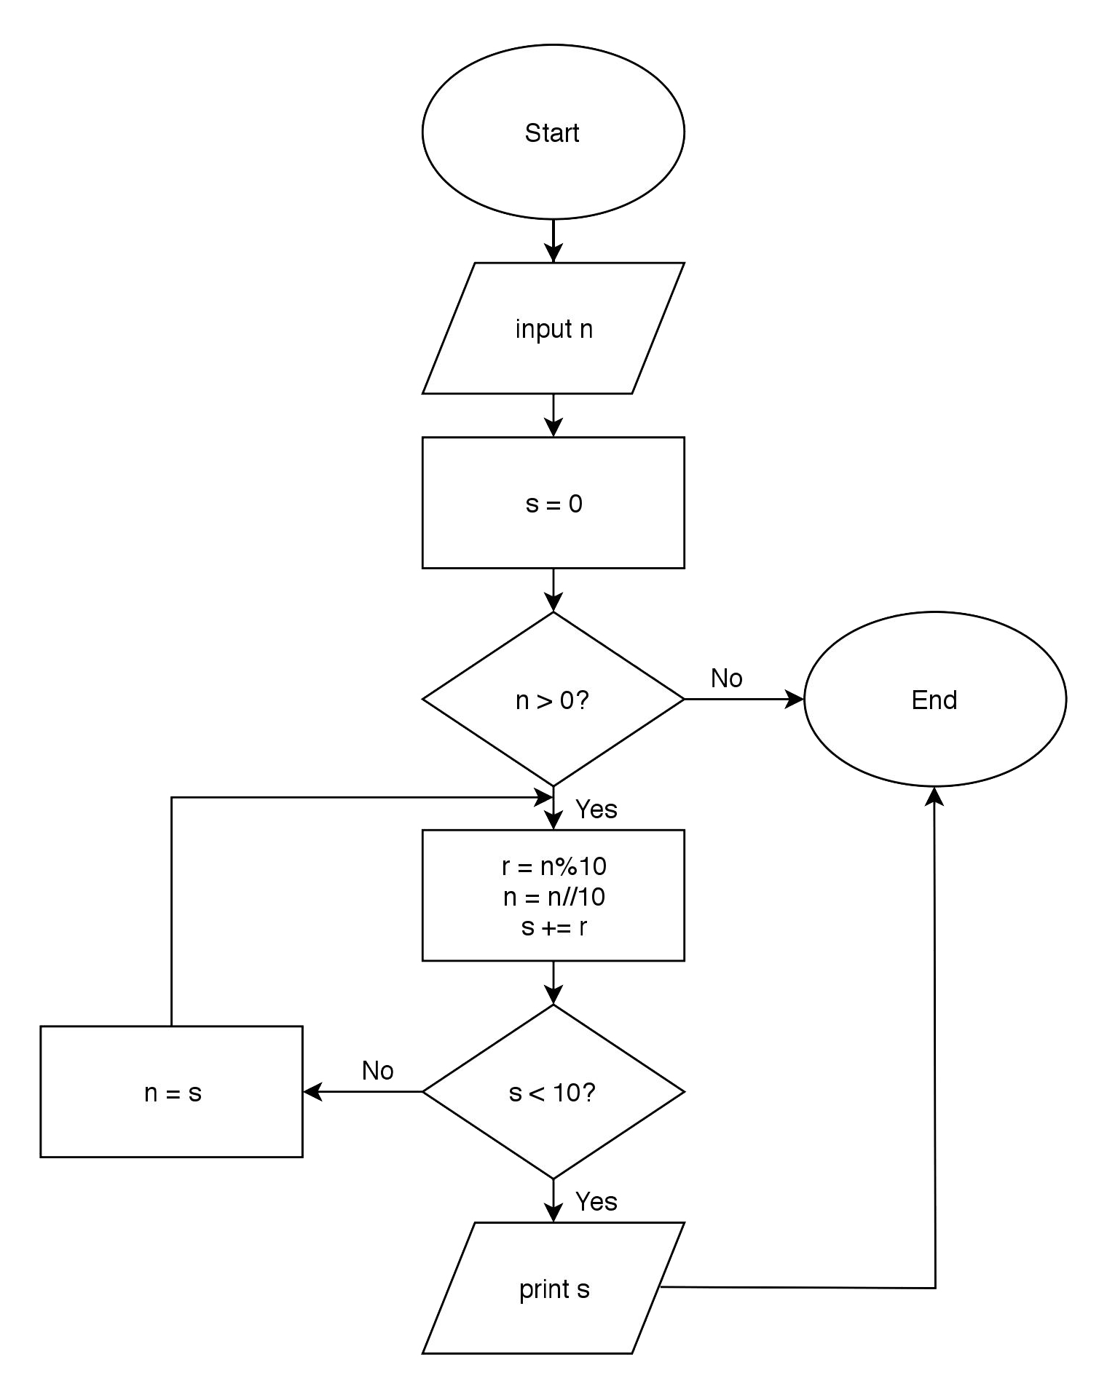

1. **Trace**
2. **Evaluate**

(a) Are the appropriate symbols used for each step? If no, which symbols are wrong?

(b) Does the flowchart produce correct output for all the test items given? If no, in which test cases did the flowchart produce an incorrect output?

(c) Are the instructions properly followed (i.e each item starts in a new page)? If no, which instructions are not followed?

[nevermind this]

Prob 1

|  |  |  |  |  |  |
| --- | --- | --- | --- | --- | --- |
| **n** | **a** | **b** | **c** | **i** | **output** |
| 1 | 0 | 0 | 1 | 2 | 0 |
|  |  |  |  |  | 1 |
| 8 | 0 | 1 | 1 | 2 | 0 |
|  |  |  |  |  | 1 |
|  |  |  |  |  | 1 |
|  | 1 | 1 | 2 | 3 | 2 |
|  | 1 | 2 | 3 | 4 | 3 |
|  | 2 | 3 | 5 | 5 | 5 |
|  | 3 | 5 | 8 | 6 | 8 |
|  | 5 | 8 | 13 | 7 | 13 |
|  | 8 | 13 | 21 | 8 | 21 |
| -15 | 0 | 0 | 1 | 2 |  |