Personal Information

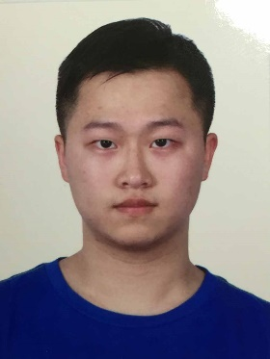Name: Min Tianchen Gender: Male

Mobile: 0086-18351229920 E-mail: [mintianchen@126.com](mailto:mintianchen@126.com)

Birthdate: 1996.3.27 Grade: junior

Address: Room 302, Unit B, Building 17, Zhaofeng Residential,

Changzhou City, Jiangsu Prov.

Education

**2014.9-now**: Majored in Software Engineering at School of Information and Software Engineering, University of Electronic Science and Technology of China.

**Main courses have learned**: *Calculus, Linear Algebra and Space Analytic Geometry, Probability and Mathematical Statistics, Data Structure and Algorithm, Principles of Computer Operating System, Principles of Database and Application, Principles of Computer Organization and Architecture, Basic Computer Network, Compiling Technique, Embedded System and Software, C programming Language, Engineering Graphics.*

**2016.7-2016.8**: Studied in National University of Singapore for summer schooland took two courses: *Biometrics* and *2D Game Engine*.

**GPA**: 4.00 **TOEFL**: 82 **GRE**: 325+3.5(Quantitative: 170, Verbal: 155, Writing: 3.5)

Honors and Awards

• National Scholarship, University of Electronic Science and Technology of China. 2015

• First Prize, UESTC Undergraduate Mathematical Contest in Modeling. 2015

• Model Student of Academic Records, UESTC 2015

• Third Place, badminton match of School of Information and Software Engineering, UESTC

2015

Project Experience

• Designed and built a student grade management system using C language 2014

• Designed and built a shopping website using HTML and JavaScript 2015

• Participated in building an online communication website for college students 2016

• Built a simple face recognition system using Python 2016

• Wrote a 2D-game engine and programed a 2D game using JavaScript 2016

(<http://faculty.washington.edu/ksung/2DGameEngine/StudentProjects/2016.8.NUS/5.Group8/GameSrc/public_html/index.html> above is the website of the game)

Skills

• Familiar with C language, Python, JavaScript, C++ and Java

• Familiar with game programming and web programming

• Good at playing badminton

• Strong-willed, once lost 15KG weight in 3 months