1. Overall structure of an implementation.

An implementation of this homework was done in Java-8-Oracle it consists of a single class called
HiddenMarkovModel which contains all necessary methods to solve all three problems of HMM.
All methods such as (forward, backward, viterbi etc.) are provided with proper comments and documentation. Outline of the implementation is provided in figure below:

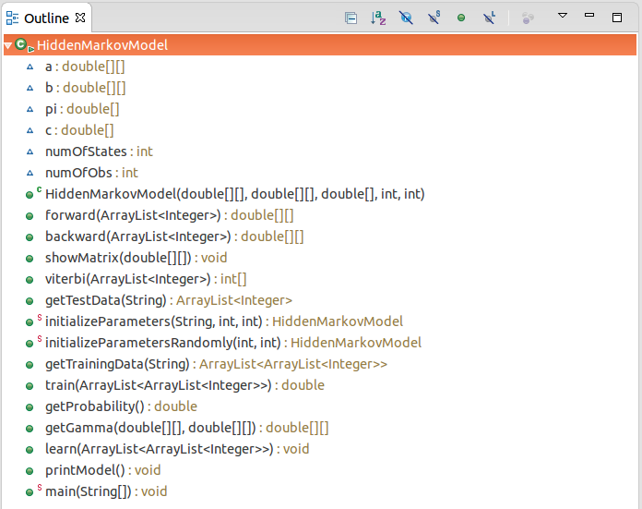

In order to run code with different files you can change file names in the main method. The structure of the file has to be same as the stated in homework statement, files for this homework are provided along with the report. Or, you can change contents of the file keeping the same structure.

2. How to run code

First we need to go to a folder containing source code and all necessary files(model.txt, testdata.txt, data.txt) to compile HiddenMarkovModel.java file using by the following command from a terminal:

kurmanbek@user:~$ javac HiddenMarkovModel.java

After compiling use the following commands to see outputs for different parts of a the homework.

2.1 Part 1

kurmanbek@user:~$ java HiddenMarkovModel "obsv_prob"

2.2 Part 2

kurmanbek@user:~$ java HiddenMarkovModel "viterbi"

2.3 Part 3

kurmanbek@user:~$ java HiddenMarkovModel "learn"

Outputs will be provided in the terminal, if necessary you will be asked for an input. See corresponding parts of the report for more details.

3. Detailed explanations

3.1 Part 1

This part takes observation sequence and model parameters as input from testdata.txt and model.txt files, and then computes the probability of the observation sequence given the model, since for long observation sequence it is common to get underflows, I have implemented forward procedure using scaling which is described in page 272 of Rabiners paper.
For an observation sequence: 0 1 1 0 1 0 , the following outputs are printed:

Probability: 0.001484296712034913
Log probability(natural logarithm): -6.512814213498095

3.2 Part 2
This part takes observation sequence and model parameters as input from testdata.txt and model.txt files, and outputs meaningful and optimal state sequence. For this part Viterbi algorithm was implemented, in order to have less computations I have used log trick which is described in
page 273 of Rabiners paper.
For an observation sequence: 0 1 1 0 1 0 , the following outputs are printed:

Optimal state sequence is : 0 1 1 1 1 1
Log probability(natural logarithm): -7.408067403771226
Number of state transitions needed: 1

3.3 Part 3
This is the most interesting and challenging part of this homework. Given multiple observation sequences of data provided in a data.txt file the aim is to adjust model parameters in order to maximize the probability of all observation sequences given the model. In order to accomplish an aim the Baum-Welch procedure for multiple observation sequences was implemented. Initially the model parameters were initialized according to suggestions of Rabiners paper page 273-274 namely initial state and state transition probabilities were given uniform probabilities. An observation symbol probabilities were initialized randomly. Then the following re-estimation procedure with some optimizations was used in train(dataSequences) method:
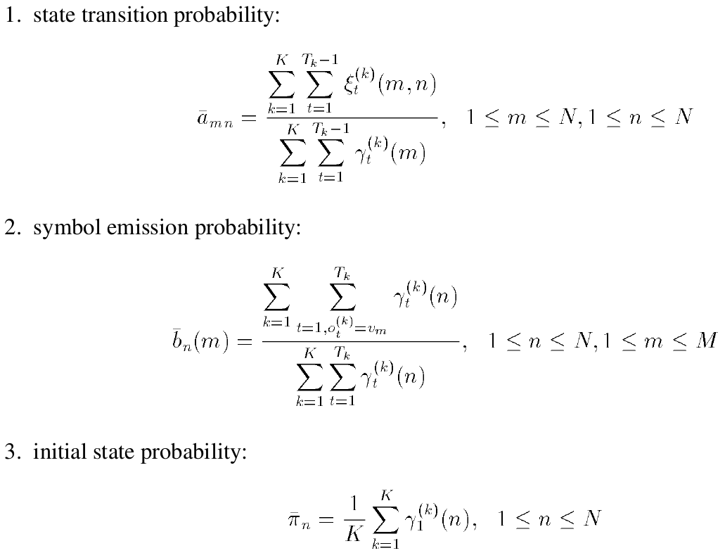
When you run this procedure you will be asked to input number of states from the terminal, by following message,
Please enter number of states:

After your input the training will start, and number of iterations with loss function which is negative log likelihood of all observations will be printed. The training will stop after some convergence(i.e. loss functions doesn't change much). I have defined threshold = 0.0000001 and used the following conditipn to test convergence Math.abs(newLoss - oldLoss) > threshold.
So when difference between two consecutive loss functions becomes smaller than a threshold the convergence occurs and information about the model is printed to a text file called HMMdescription.txt.

For the case of two stated the following rounded outputs are printed to the description file:

Number of states: 2

Model parameters rounded:
Pi
0.05 0.95

A
0.92 0.08
0.04 0.96

B
0.22 0.78
0.94 0.06

Or,

Number of states: 2

Model parameters rounded:
Pi
0.95 0.05

A
0.96 0.04
0.08 0.92

B
0.94 0.06
0.22 0.78

Which are equivalent parameters just state names (i.e. state 0 to 1 and 1 to zero) are changed. As you can see they are very close to actual parameters. You can get outputs for other number of states too.

4. Conclusion
In this assignment all three basic problems of HMM were solved for the case of two observables. All of the necessary precautions to avoid underflow and overflow were taken into account. As a result we were able to learn parameters which are very close to actual model parameters.

