SCHOOL OF COMPUTER SCIENCE AND ARTIFICIAL INTELLIGENCE |  |  |  |  | DEPARTMENT OF COMPUTER SCIENCE ENGINEERING
Program Name: B. Tech |  |  |  | Assignment Type: Lab |  |  | Academic Year:2025-2026
Course Coordinator Name |  |  |  | Dr. Rishabh Mittal
CourseCode |  |  | 23CS002PC304 | Course Title |  | AI Assisted Coding
Year/Sem |  |  | III/II | Regulation |  | R23
Date and Day  of Assignment |  |  | Week6 – Wednusday | Time(s) |  | 23CSBTB01 To 23CSBTB52
Hallticket |  |  | 2303A54071 | Batch |  | 48
Assignment Number:12.3(Present assignment number)/24(Total number of assignments)
 | Q.No. | Question |  |  |  |  |  | Expected Time  to complete
 | 1 | Lab 12: Algorithms with AI Assistance Sorting, Searching, and Algorithm Optimization Using AI Tools  Lab Objectives  The objectives of this laboratory exercise are to:  - Apply AI-assisted programming techniques to implement sorting and searching algorithms.  - Analyze and compare algorithm efficiency using time and space complexity.  - Understand how AI tools can suggest optimizations and alternative algorithmic approaches.  - Strengthen problem-solving skills through real-world, data-driven scenarios.  Learning Outcomes  After completing this lab, students will be able to:  - Implement and optimize classic algorithms using AI-assisted coding tools.  - Compare multiple algorithms for the same problem and justify their selection.  - Measure and analyze runtime performance using experimental data.  - Critically review and refine AI-generated algorithmic solutions.  Task 1: Sorting Student Records for Placement Drive  Scenario  SR University’s Training and Placement Cell needs to shortlist candidates efficiently during campus placements. Student records must be sorted by CGPA in descending order.  Tasks  - Use GitHub Copilot to generate a program that stores student records (Name, Roll Number, CGPA).  - Implement the following sorting algorithms using AI assistance:  - Quick Sort  - Merge Sort  - Measure and compare runtime performance for large datasets.  - Write a function to display the top 10 students based on CGPA.  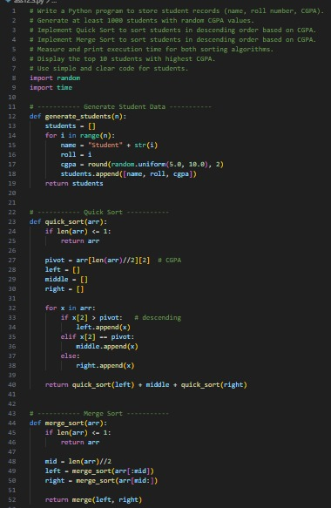  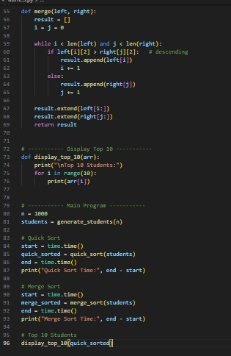  Expected Outcome  - Correctly sorted student records.  - Performance comparison between Quick Sort and Merge Sort.  - Clear output of top-performing students.  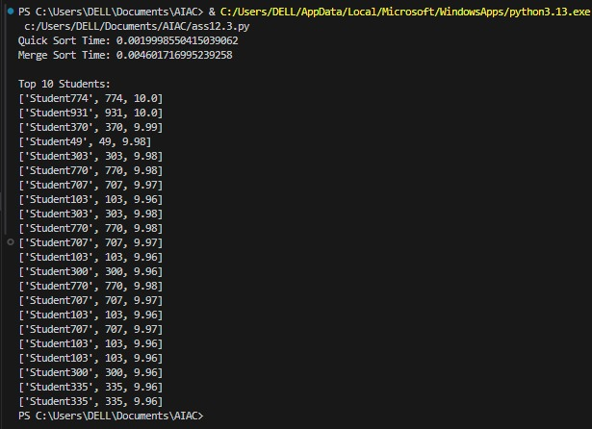  Task 2: Implementing Bubble Sort with AI Comments  - Task: Write a Python implementation of Bubble Sort.  - Instructions:  - Students implement Bubble Sort normally.  - Ask AI to generate inline comments explaining key logic (like swapping, passes, and termination).  - Request AI to provide time complexity analysis.  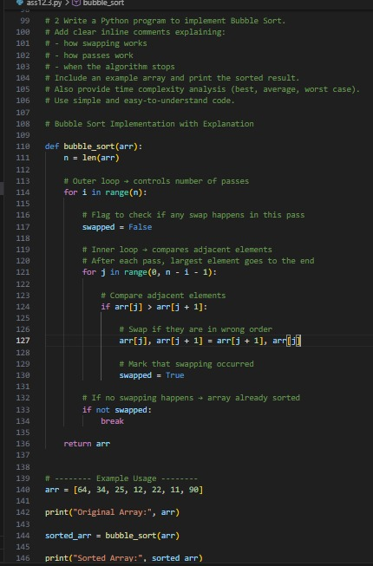  - Expected Output:  - A Bubble Sort implementation with AI-generated explanatory comments and complexity analysis.  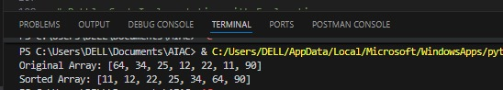  Task 3: Quick Sort and Merge Sort Comparison  - Task: Implement Quick Sort and Merge Sort using recursion.  - Instructions:  - Provide AI with partially completed functions for recursion.  - Ask AI to complete the missing logic and add docstrings.  - Compare both algorithms on random, sorted, and reverse-sorted lists.  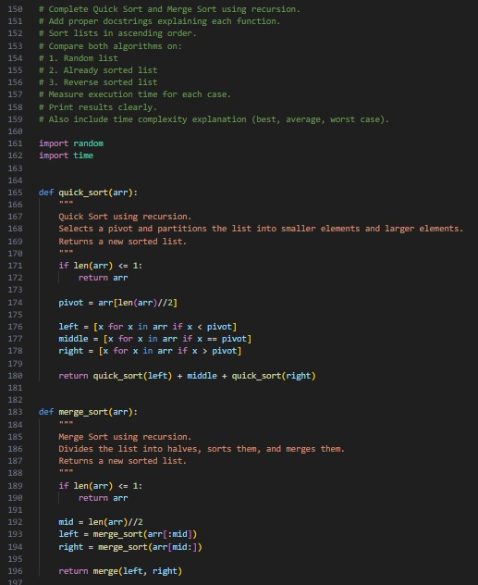  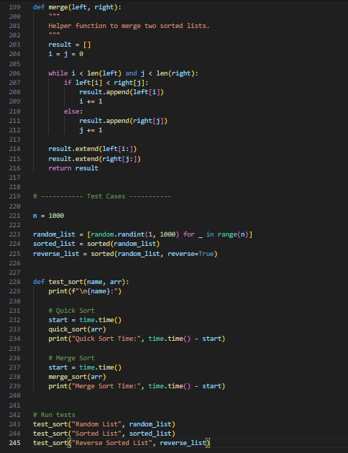  - Expected Output:  - Working Quick Sort and Merge Sort implementations.  - AI-generated explanation of average, best, and worst-case complexities.  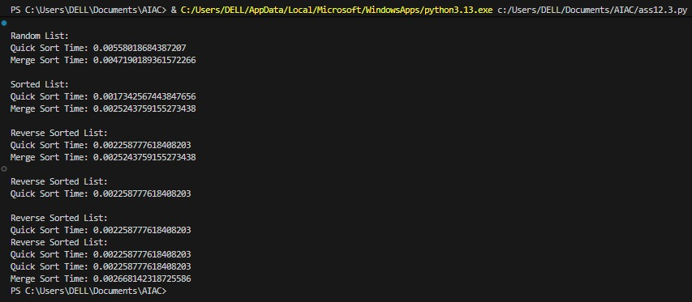  Task 4 (Real-Time Application – Inventory Management System)  Scenario: A retail store’s inventory system contains thousands of products, each with attributes like product ID, name, price, and stock quantity. Store staff need to:  - Quickly search for a product by ID or name.  - Sort products by price or quantity for stock analysis.  Task:  - Use AI to suggest the most efficient search and sort algorithms for this use case.  - Implement the recommended algorithms in Python.  - Justify the choice based on dataset size, update frequency, and performance requirements.  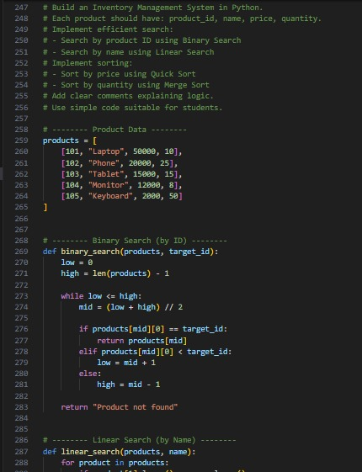  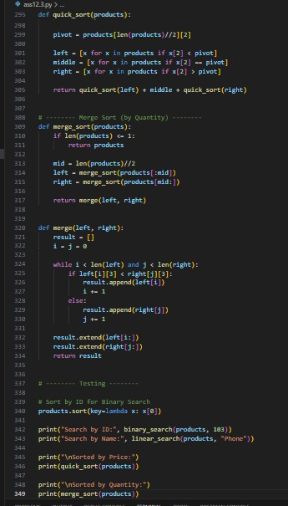  Expected Output:  - A table mapping operation → recommended algorithm → justification.  - Working Python functions for searching and sorting the inventory.  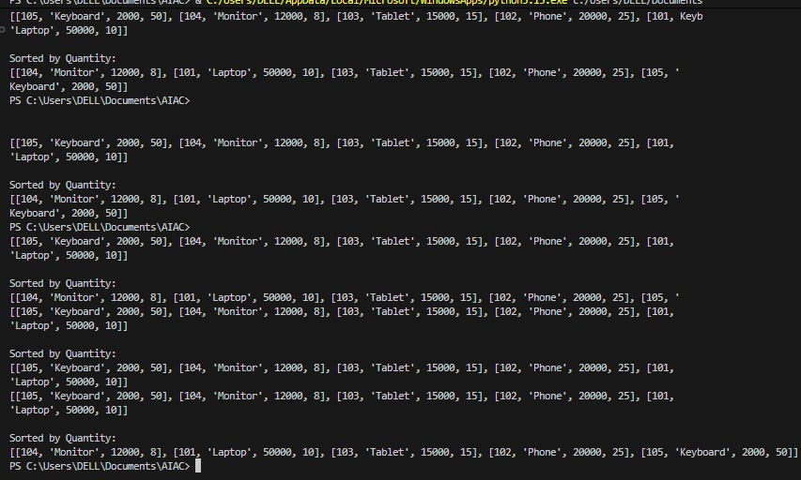  Task 5: Real-Time Stock Data Sorting&Searching  Scenario:  An AI-powered FinTech Lab at SR University is building a tool for analyzing stock price movements. The requirement is to quickly sort stocks by daily gain/loss and search for specific stock symbols efficiently.  - Use GitHub Copilot to fetch or simulate stock price data (Stock Symbol, Opening Price, Closing Price).  - Implement sorting algorithms to rank stocks by percentage change.  - Implement a search function that retrieves stock data instantly when a stock symbol is entered.  - Optimize sorting with Heap Sort and searching with Hash Maps.  - Compare performance with standard library functions (sorted(), dict lookups) and analyze trade-offs.  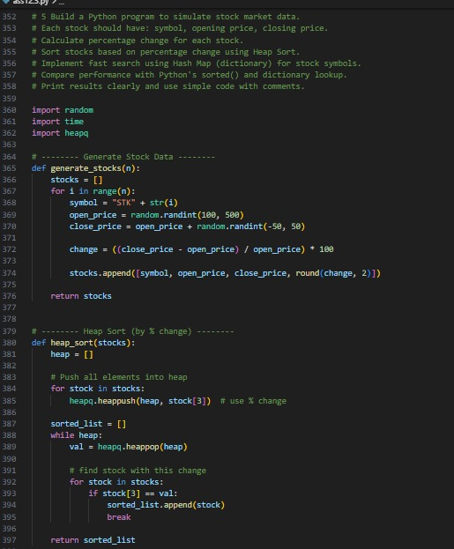  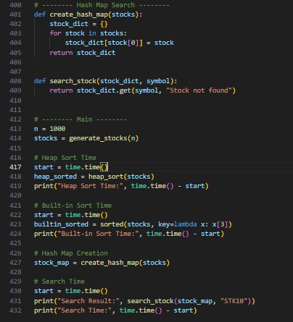  Note: Report should be submitted as a word document for all tasks in a single document with prompts, comments&code explanation, and output and if required, screenshots.  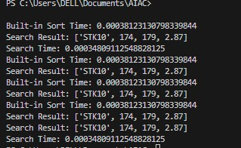 |  |  |  |  |  | Week3 - Wednesday

