Lab 2:

AI Assisted Coding

K.Sathwika 2303A54071
B-48

Exploring Additional AI Coding Tools beyond Copilot – Gemini (Colab) and Cursor AI

Task 1: Statistical Summary for Survey Data
PROMPT:- Python code that reads a list of numbers and calculates the mean, minimum, and maximum values short with explanation.

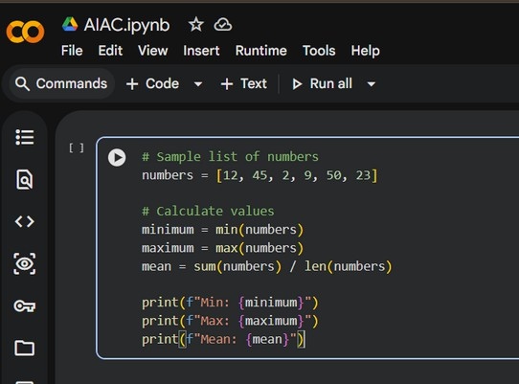

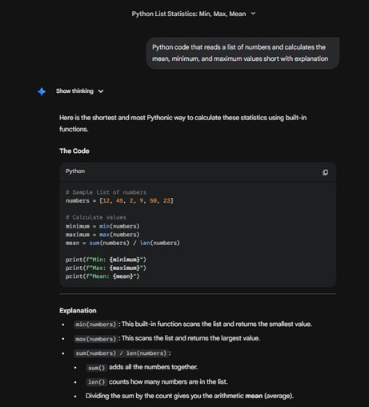

Task 2: Armstrong Number – AI Comparison
PROMPT:- Python code which checks whether the number is Armstrong number or not give short code with explanation.

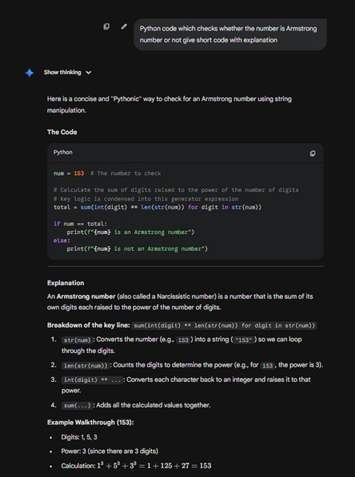

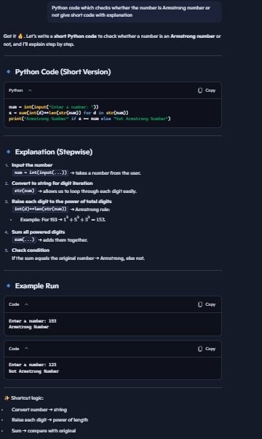

Feature

Digit Loop

Sum

If Check
Style Clarity
Gemini

Goes through digits one by one directly

Adds numbers directly while looping

Uses normal if ... else with two lines
Looks short and stylish Good for quick logic
Copilot

Makes a list of digits first, then goes through them

Adds numbers after making the list

Uses short oneline if ... else
Looks clear and stepbystep Easier for students to learn

Task 3: Leap Year Validation Using Cursor AI
PROMPT1:- Write a Python program to check if a year is a leap year
PROMPT2:- Give me a short Python code with explanation to check leap year

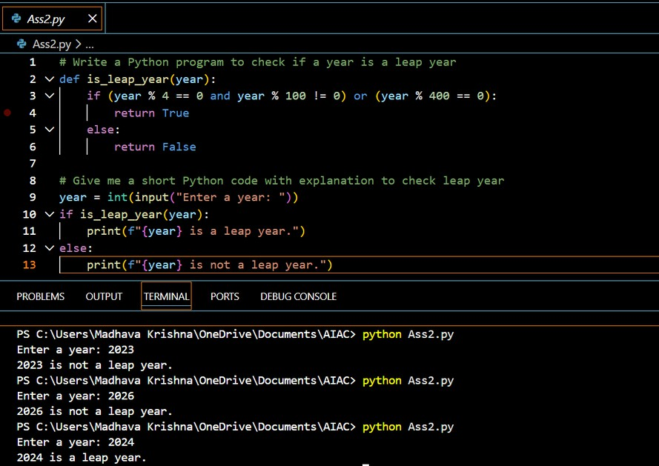
Explanation:-

Divide by 4 rule
If a year divides evenly by 4 → it might be a leap year. Example: 2024 ÷ 4
= 506 → possible leap year.

Divide by 100 rule
If a year divides evenly by 100 → it is not a leap year (skip). Example: 1900 ÷ 100 = 19 → not leap year.

Divide by 400 rule (special case)
If a year divides evenly by 400 → it is a leap year. Example: 2000 ÷ 400 = 5 → leap year.

Readability

Length Style
Best for
First Code

Easier for beginners More lines
Traditional if...else

Learning, exams
Second Code

Slightly harder for beginners Fewer lines
Pythonic one-liner

Quick coding, professionals

Task 4: Student Logic + AI Refactoring (Odd/Even Sum)
PROMPT:- Short code to sum even and odd numbers from a tuple with explanation

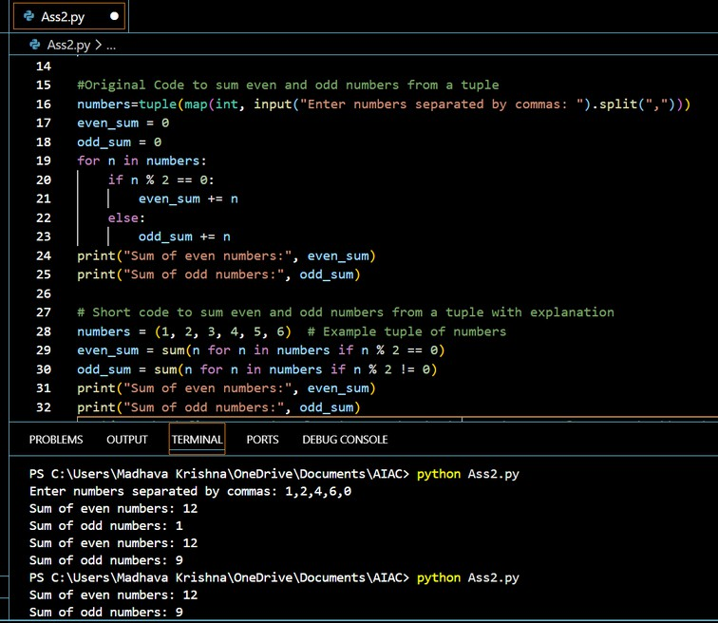

Original Code | Refactored Code | Improvement
8+ lines | 4 lines | Shorter, compact
Step-by-step | Clean one-liners | Easier to read
Manual loop | Built-in sum() | Faster
Basic Python | Clean Python style | Professional

