AI Assisted Coding
Lab Assignment 4.3

H.no:- 2303A54071
Batch:- 48

Task 1: Zero-Shot Prompting – Leap Year Check

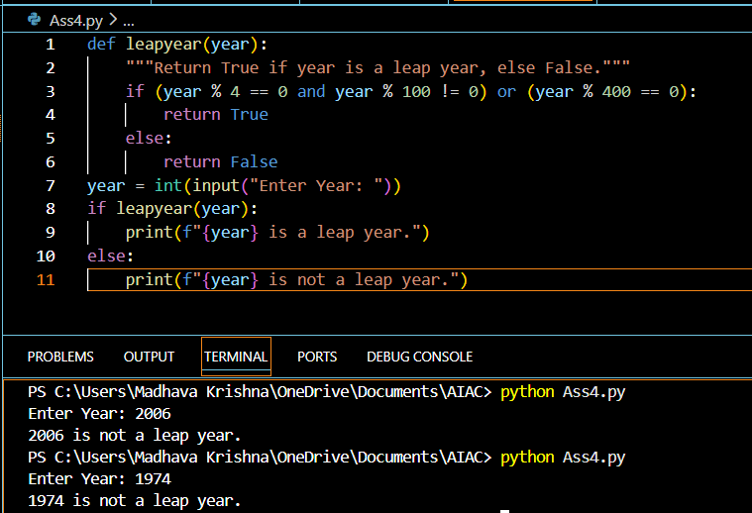

Explanation:
1. A year is a leap year if it is divisible by 4.
2. However, if the year is divisible by 100, it is not a leap year, unless:
3. The year is also divisible by 400, in which case it is a leap year.
For example, the year 2006 is not a leap year because it is not divisible by 4, while the year 1974 is not a leap year because it is not divisible by 4.

Task 2: One-Shot Prompting – Centimeters to Inches Conversion

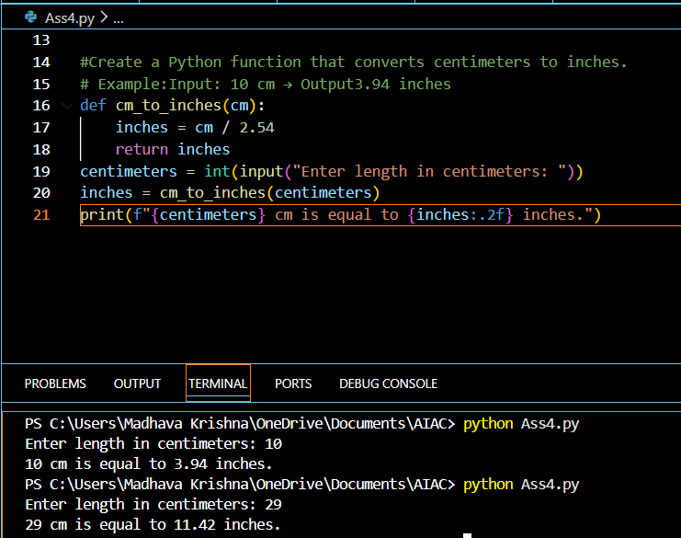

Explanation:
To convert a length from cm to inches, you divide the length in cm by 2.54.
- To convert 10 centimeters to inches, you would calculate 10 cm / 2.54, which equals approximately 3.94 inches.

Task 3: Few-Shot Prompting – Name Formatting

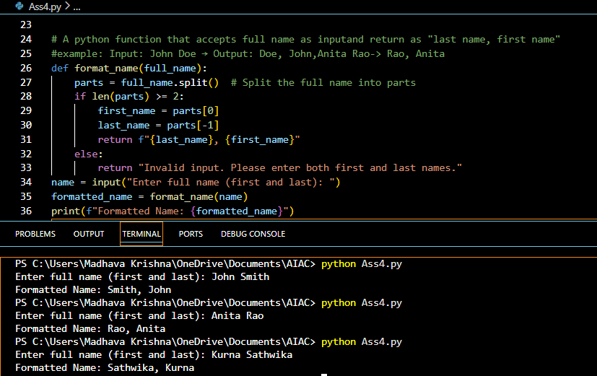

Explanation:
Split():- breaks the name into words
If there are 2 words it takes as “last”,”first” and rearranges otherwise it shows error.

Task 4: Comparative Analysis – Zero-Shot vs Few-Shot

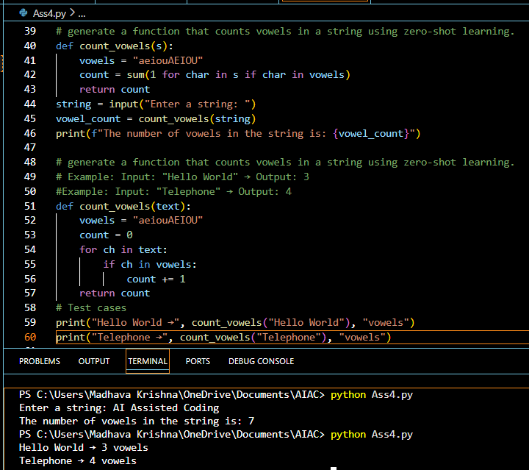

Explanation:
For zero-shot prompting:- It checks each character in the string, if it is vowel it adds 1 to the count.
For Few-shot prompting:- It goes letter by letter using for loop and increase count by 1 if letter is vowel. After the loop return the count.

Task 5: Few-Shot Prompting – File Handling

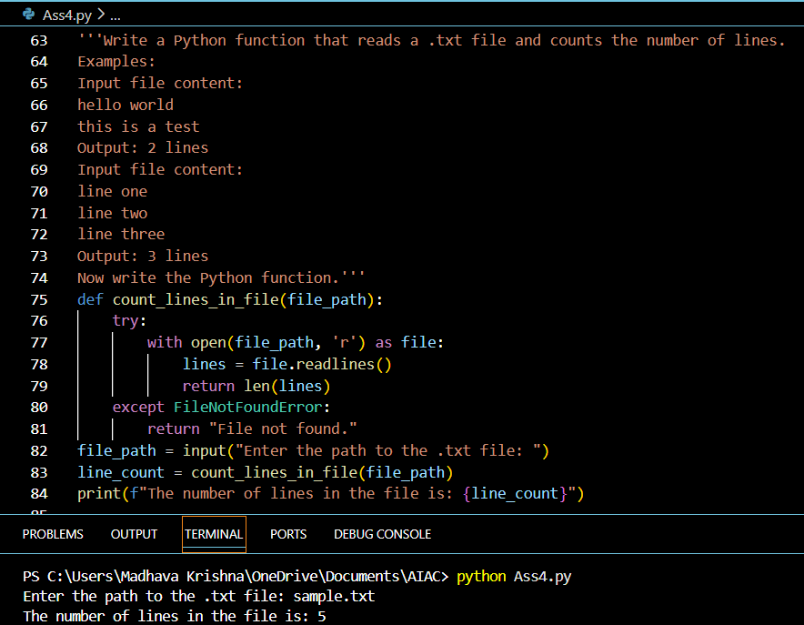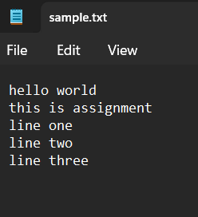

AI-assisted logic explanation:-
To count the number of lines in a .txt file, you can open the file in read mode and use the readlines() method to read all lines into a list.
Then, you can use the len() function to get the number of lines by calculating the length of the list.
Make sure to handle the case where the file might not exist by using a try-except block to catch a FileNotFound Error.

