WEBSITE QA TEST REPORT
LogicsGen Website | Manual Functional & Responsive Testing
Website | https://logicsgen.com/
Testing date | 11 November 2026
Prepared by | Anita Devi
Testing type | Manual functional, form validation, navigation and responsive checks
Test environments | Chrome desktop, Redmi 13 physical mobile, Chrome DevTools responsive mode (768 × 1024)

Prepared as a manual QA summary. This report records the checks completed with the tester and the issues observed. It does not claim that every page or browser combination was tested.
Report version: 1.0 | Prepared: 11 November 2026

1. Executive Summary
The website was checked across key pages and user journeys. The 20 scenarios listed in the Checks That Passed table passed in the tested environments. Three defects or observations are recorded separately: suggested course cards lead to the same incomplete course page; the “Explore All Blog Posts” button redirects to the Courses page instead of the Blogs page; and CAPTCHA could not be clicked in Chrome DevTools responsive emulation at 768 × 1024. The CAPTCHA observation needs verification on a physical tablet. Successful form notifications were observed, but actual email delivery or backend receipt was not verified.
A Lighthouse mobile audit was performed on the LogicsGen homepage. The website received scores of 62 for Performance, 93 for Accessibility, 77 for Best Practices and 100 for SEO. Performance and Best Practices need improvement, while Accessibility and SEO received strong scores. The audit also identified opportunities to improve loading speed, image delivery, JavaScript execution and accessibility. The audit used Navigation mode, Slow 4G simulation and Lighthouse 13.5.0.

Overall result
Area | Result
Navigation and page access | Mostly passed in tested flows
Forms and field validation | Passed in tested desktop and physical mobile flows
Responsive layout | No major overflow observed at tested sizes
Content and links | Issues found – see defect list
Backend delivery and Lighthouse | Backend delivery not verified; Lighthouse mobile homepage audit completed

2. Scope and Test Coverage
Testing focused on common visitor journeys: opening pages, using navigation, viewing courses and services, submitting enquiry forms, and checking layouts on desktop, mobile and tablet-sized screens.
Test environments
- Chrome desktop browser- 156.0.8078.80 (Official Build) (64-bit).
- Physical Redmi 13 mobile phone
- Chrome DevTools responsive emulation at 768 × 1024

3. Checks That Passed

Test / Scenario | Expected Result | Actual Result | Validation Message / Feedback | Status
Homepage loading | Homepage should load with all main content and navigation visible. | Homepage opened and displayed correctly. | No error message. | Passed
Main navigation | Navigation items should open the correct pages. | Main navigation worked correctly. | No error message. | Passed
Services dropdown | Dropdown should open and show service links. | Dropdown opened and tested service links worked. | No error message. | Passed
Courses listing and categories | Course listing and category pages should open and display content. | Pages opened and content was visible. | No error message. | Passed
About Us page | Page should open and display its content. | Page opened and was usable. | No error message. | Passed
Contact Us page | Page and contact form should load correctly. | Page opened and form was visible and usable. | No error message on page load. | Passed
Blogs page | Blog listing should open and display content. | Page opened and blog content was visible. | No error message. | Passed
Empty contact form submission | Required fields should not allow an empty submission. | Submission was blocked and required-field errors appeared. | Full name is required.  Phone number is required.  Email address is required.  Please verify that you are not a robot. | Passed
Invalid name format validation | Numeric or Alphanumeric entries should be rejected. | Invalid name format was rejected. | Please enter a valid name (letters only). | Passed
Invalid email validation | Invalid email format should be rejected. | Invalid email was rejected. | Enter a valid email address. | Passed
Phone number validation | Phone number should accept only 10 digits for India. | Invalid number was rejected; entry was limited to 10 digits. | Enter a 10-digit number for India. | Passed
Message character limit | Message field should allow a maximum of 250 characters. | Field stopped accepting text after 250 characters. | Character counter displayed the entered character count. | Passed
Contact form valid submission | Valid form submission should display a confirmation message. | Success message appeared on desktop and physical mobile. | Thanks for contacting us. Your enquiry has been submitted. | Passed
Development and SEO service page buttons and links | CTAs should navigate or scroll to the correct sections. | Tested CTAs and related-service links worked. | No error message. | Passed
Course enquiry form | Form should validate inputs and show a submission confirmation. | Validation and success notification worked in the tested browser session. | Success notification displayed after valid submission.  “Thanks for contacting us. Your enquiry has been submitted.” | Passed
Blog Read More links | Read More should open the selected blog article. | Tested blog articles opened correctly. | No error message. | Passed
Explore Courses button on Blogs page | Button should navigate to the Courses page. | Button opened the Courses page. | No error message. | Passed
Browser Back and Forward | Browser navigation should move between previously visited pages. | Back and Forward navigation worked. | No error message. | Passed
Tablet layout – 768 × 1024 | Content should fit the screen without horizontal overflow. | Tested pages fitted the viewport without obvious horizontal scrolling. | No error message. | Passed
Mobile menu – Redmi 13 | Mobile menu should open and display navigation options. | Menu opened and tested service navigation worked. | No error message. | Passed
Lighthouse – Mobile Accessibility | Score should be 90 or above. | Score: 93. | Accessibility audit completed successfully. | Passed
Lighthouse – Mobile SEO | Score should be 90 or above. | Score: 100. | SEO audit completed successfully. | Passed

Test Results Summary: The 20 scenarios in the table were marked as Passed. These checks covered page loading, navigation, services, course listings, About Us, Contact Us, Blogs, contact-form validation, course enquiry-form validation and confirmation, blog links, browser navigation and the tested responsive layouts. The website was checked on desktop Chrome, a physical Redmi 13 mobile phone and Chrome DevTools responsive emulation at 768 × 1024. The defects listed in Section 4 are recorded separately and do not change the Passed status of the individual scenarios in this table. The success notification confirms that the website displayed a submission response; it does not confirm actual email delivery or backend receipt.

Lighthouse Audit Results
A Lighthouse audit was completed for the LogicsGen homepage using Chrome DevTools. The audit was run in Navigation mode with the Mobile device setting and all four categories selected.
Audit details
Page tested: https://logicsgen.com/ | Device: Mobile | Mode: Navigation | Network simulation: Slow 4G | Lighthouse version: 13.5.0 | Captured: 11 November 2026 at 4:28 PM (GMT+5:30).
Lighthouse scores: Performance – 62; Accessibility – 93; Best Practices – 77; SEO – 100.
Performance metrics: First Contentful Paint (FCP) – 2.5 s; Largest Contentful Paint (LCP) – 3.9 s; Total Blocking Time (TBT) – 1,000 ms; Speed Index – 3.7 s; Cumulative Layout Shift (CLS) – 0.
Key findings
- Performance: Document request latency, modern HTTP usage and image delivery were flagged for improvement. Render-blocking requests were identified. Diagnostics also flagged JavaScript execution time, main-thread work, unused CSS and JavaScript, image elements without explicit width and height, and JavaScript minification.
- Accessibility: Background and foreground colours did not have sufficient contrast. Touch targets did not have sufficient size or spacing. Lighthouse also listed 10 additional items for manual checking.
- Best Practices: One deprecated API warning was found, and issues were logged in the Chrome DevTools Issues panel.
- SEO: Score was 100. Lighthouse listed one additional item for manual checking.
Recommendation: Optimize image delivery, reduce unused JavaScript and CSS, review render-blocking resources and main-thread work, add explicit image dimensions, improve colour contrast and touch-target spacing, and investigate the deprecated API warning and DevTools Issues panel.
Note: These are automated results from one mobile homepage audit. They do not represent every page or device, and automated accessibility checks do not replace manual testing.

4. Defects and Observations

Test Summary
Manual functional and responsive checks: 20 passed scenarios. Recorded findings: 3 (2 high-severity issues open; 1 low-severity CAPTCHA observation requiring verification). Lighthouse mobile homepage scores: Performance 62, Accessibility 93, Best Practices 77 and SEO 100. Enquiry email delivery/backend receipt remains unverified.
The table below lists the issues found during testing, with clear steps to reproduce each one.
Bug ID | Page / Area | Steps to Reproduce | Actual Result | Expected Result | Impact | Severity | Status | Screenshot Evidence
LG-QA-001 | Course detail pages – “How Do We Claim to Excel?” related-course section | 1. Select any course.  2. Open a course detail page.  3. Scroll to “How Do We Claim to Excel?”.  4. Click on any suggested course cards (for example, React & React Native, Software Testing, or AI & Machine Learning).  5. Check the page that opens. | All suggested course cards open the same /course/testing route.  Redirection link: https://logicsgen.com/course/testing  The destination page is incomplete: some images are missing, feature cards show generic text such as “Feature” or “Description unavailable”, and some descriptions are missing. Blog preview image is also broken. | Each suggested course card should open the correct course page or intended complete destination. The destination should display all intended images, feature names, descriptions and other page content. | Visitors may reach the wrong course information and see an incomplete page, making it harder to choose or enquire about a course. | High | Open – reproduced | LG-QA-001_Related-Course-Cards.png  Description: The “How Do We Claim to Excel?” section showing the suggested course cards before clicking.  LG-QA-001_Incomplete-Course-Page.png  Description: The /course/testing destination showing missing images, generic feature text and missing descriptions.
LG-QA-002 | Course detail pages – “Explore All Blog Posts” | 1. Select any course.  2. Open a course detail page.  3. Scroll to “How Do We Claim to Excel?”.  4. Click on any suggested course cards (for example, React & React Native, Software Testing, or AI & Machine Learning).  5. Check the page that opens.  6. Scroll and click on “Explore All Blog Posts”. | The button “Explore All Blog Posts” redirects to the Courses page instead of the Blogs page.  Redirection link: https://logicsgen.com/courses | Should be redirected to Blogs Page. | Visitors may reach the courses page instead of Blogs Page they intended to view. | High | Open – reproduced | LG-QA-002_Wrong-Blog-CTA-Destination.png  Description: The “Explore All Blog Posts” button and the Courses page that opens instead of the Blogs page.
LG-QA-003 | Contact and course enquiry forms – Chrome DevTools responsive emulation at 768 × 1024 | 1. Open the Contact Us page or a course enquiry form in Chrome.  2. Open DevTools and enable responsive device emulation.  3. Set the viewport to 768 × 1024.  4. Try to click the CAPTCHA checkbox. | CAPTCHA could not be clicked in responsive emulation. Form fields worked, but submission remained blocked because CAPTCHA was incomplete. | CAPTCHA should work on supported mobile and tablet browsers. | If this also happens on a real device, users may be unable to submit enquiries. | Low – investigate | Needs verification | LG-QA-003_DevTools-CAPTCHA.png  Description: CAPTCHA not responding in Chrome DevTools responsive emulation at 768 × 1024. The filename is retained as supplied.

Important notes: The incorrect related-course destinations and incomplete content on /course/testing are grouped under LG-QA-001 because they occur in the same course-navigation journey and destination page. The “Explore All Blog Posts” button redirecting to the Courses page instead of the Blogs page is recorded separately as LG-QA-002. The CAPTCHA issue is recorded as LG-QA-003. CAPTCHA worked in normal desktop Chrome and on the physical Redmi 13; verify it on a physical tablet before treating it as a confirmed production issue.

Status guide: Open = needs fixing; Reproduced = observed again; Needs verification = further testing is required.

5. Items Not Fully Verified
- Success message confirms the website displayed a successful-submission response, but actual email delivery or backend receipt was not verified because the tester did not have access to the receiving inbox or backend logs.
- The CAPTCHA issue was observed in Chrome DevTools responsive emulation at 768 × 1024. CAPTCHA worked in normal desktop Chrome and on the physical Redmi 13. Verification on a physical tablet is still required.
- Lighthouse was run on the homepage in mobile Navigation mode. Other pages have not yet been audited, and a separate desktop audit and manual accessibility checks are still required.
- The “Explore All Blog Posts” redirect is recorded as LG-QA-002 in Section 4. The destination behavior was observed during testing; the defect remains open until corrected and retested.

6. Recommendations / Next Actions
- Correct the suggested course-card destinations so each card opens its intended course page.
- Review /course/testing and restore its missing images, feature names, descriptions and other intended page content.
- Correct the “Explore All Blog Posts” button so it opens the Blogs page instead of the Courses page.
- Ask the development team to confirm that test enquiries are stored and email notifications are delivered.
- Verify CAPTCHA on a physical tablet or another supported mobile/tablet browser before classifying the responsive-emulation observation as a production defect.
- Run Lighthouse on the remaining key pages and perform a separate desktop audit; repeat the homepage audit after performance and best-practice improvements.

7. Screenshot Evidence Guide
Screenshots are included in Section 8 using the filenames below. The browser address bar is shown where available.
Evidence name | What to capture
LG-QA-001_Related-Course-Cards.png | The “How Do We Claim to Excel?” section showing the suggested course cards before clicking.
LG-QA-001_Incomplete-Course-Page.png | The /course/testing destination showing missing images, generic feature text and missing descriptions.
LG-QA-002_Wrong-Blog-CTA-Destination.png | The “Explore All Blog Posts” button and the Courses page that opens instead of the Blogs page.
LG-QA-003_DevTools-CAPTCHA.png | CAPTCHA not responding in Chrome DevTools responsive emulation at 768 × 1024. The filename is retained as supplied.
lighthouse_report.pdf | Five-page Lighthouse mobile homepage report showing category scores, performance metrics and audit findings.

The screenshots in Section 8 correspond to the evidence names below. They show the relevant page sections and, where available, the browser URL.

Screenshot Evidence

- LG-QA-001_Related-Course-Cards.png
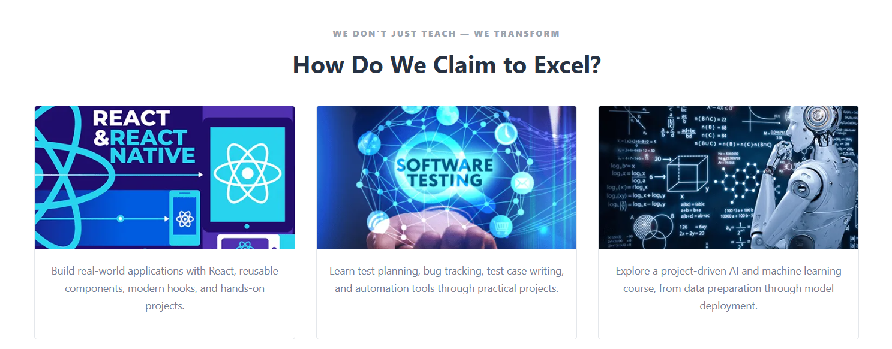
- LG-QA-001_Incomplete-Course-Page.png
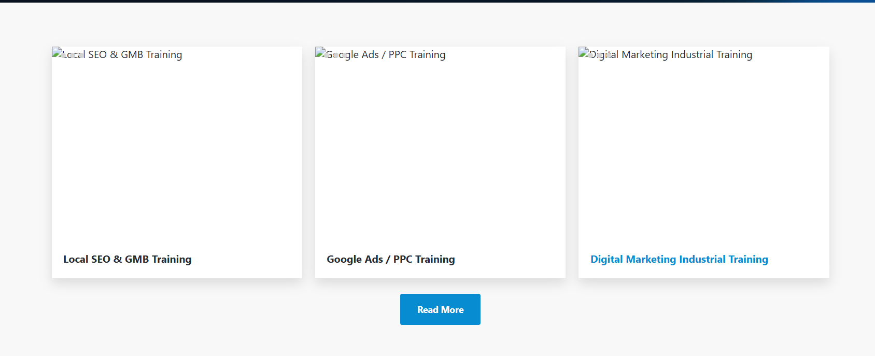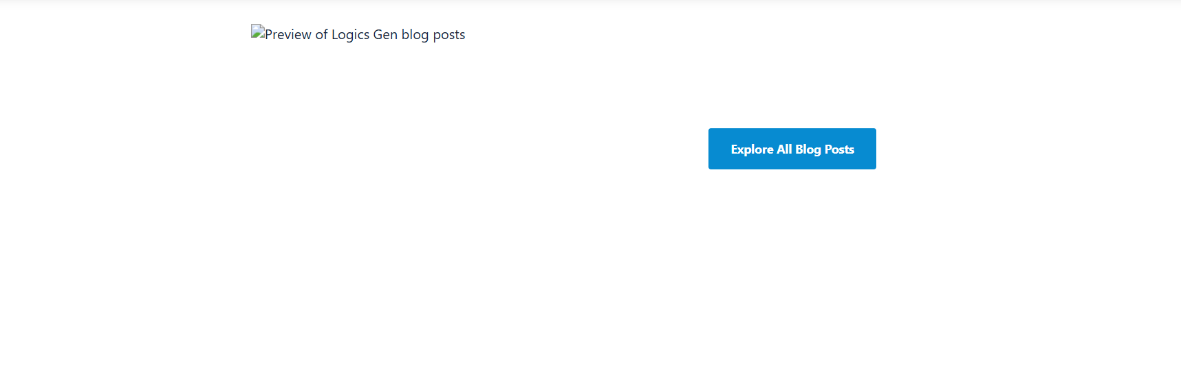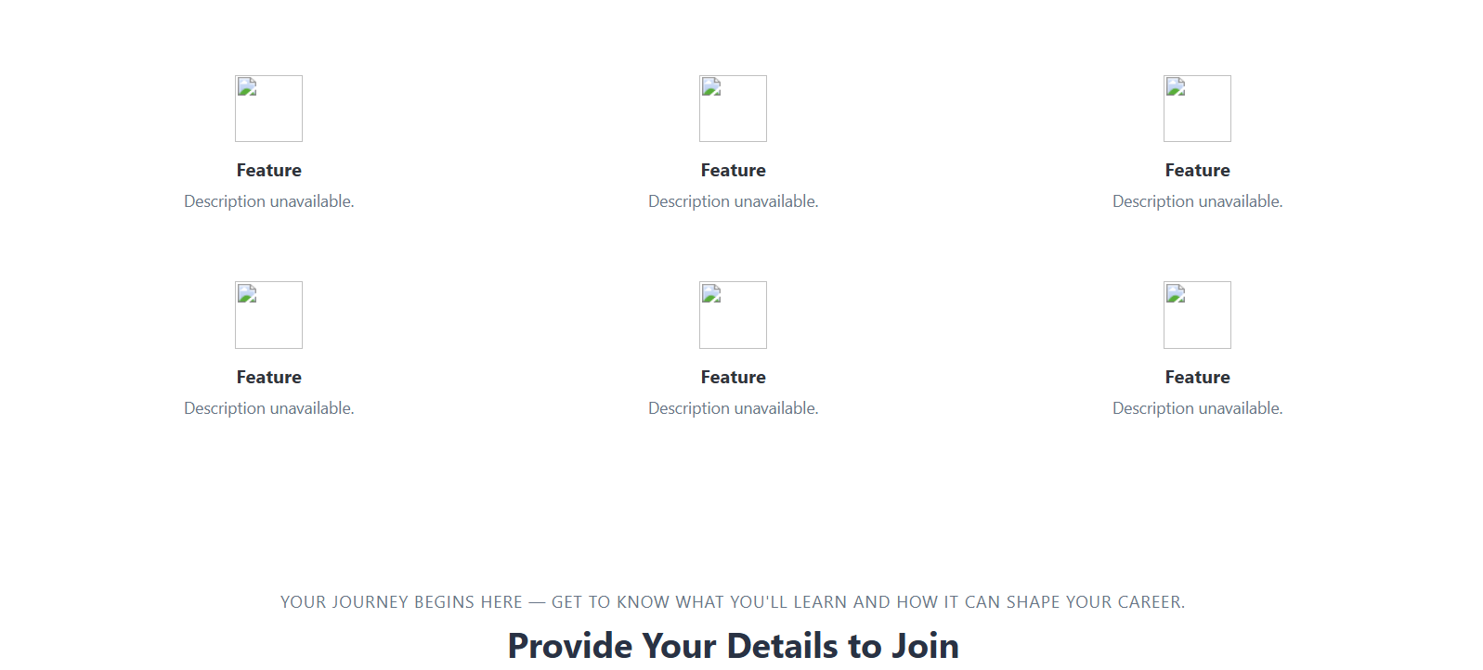

- LG-QA-002_Wrong-Blog-CTA-Destination.png
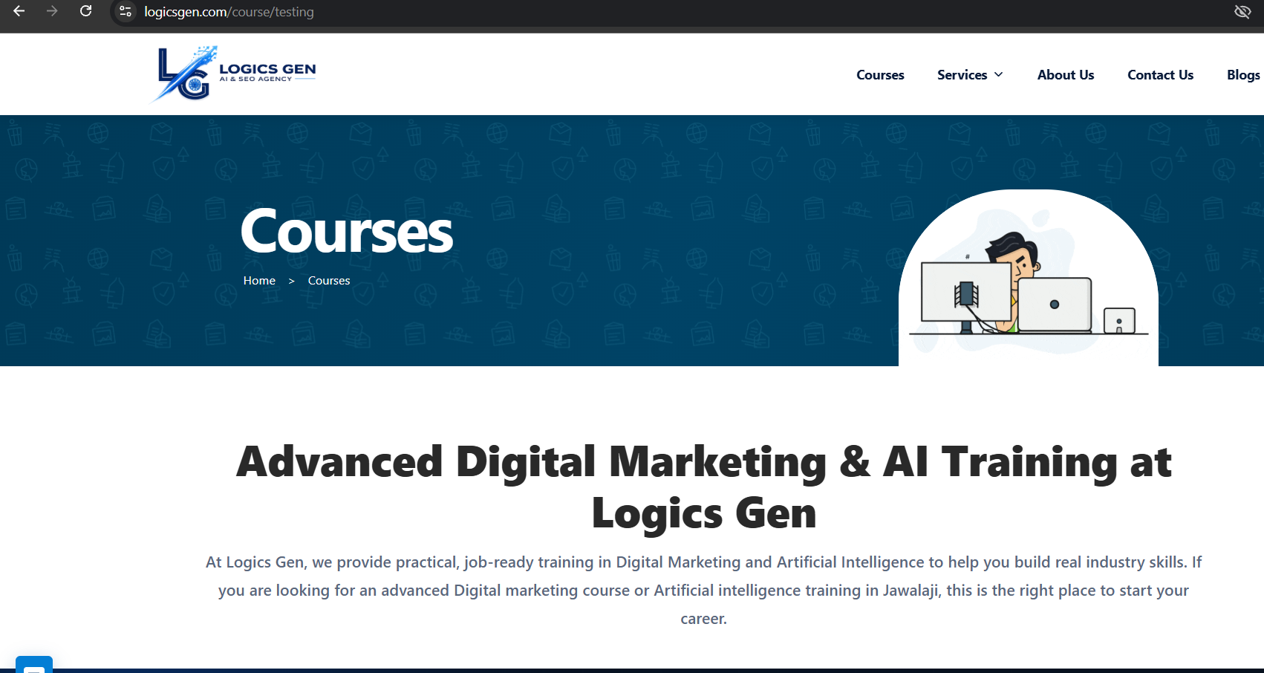

- LG-QA-003_DevTools-CAPTCHA.png
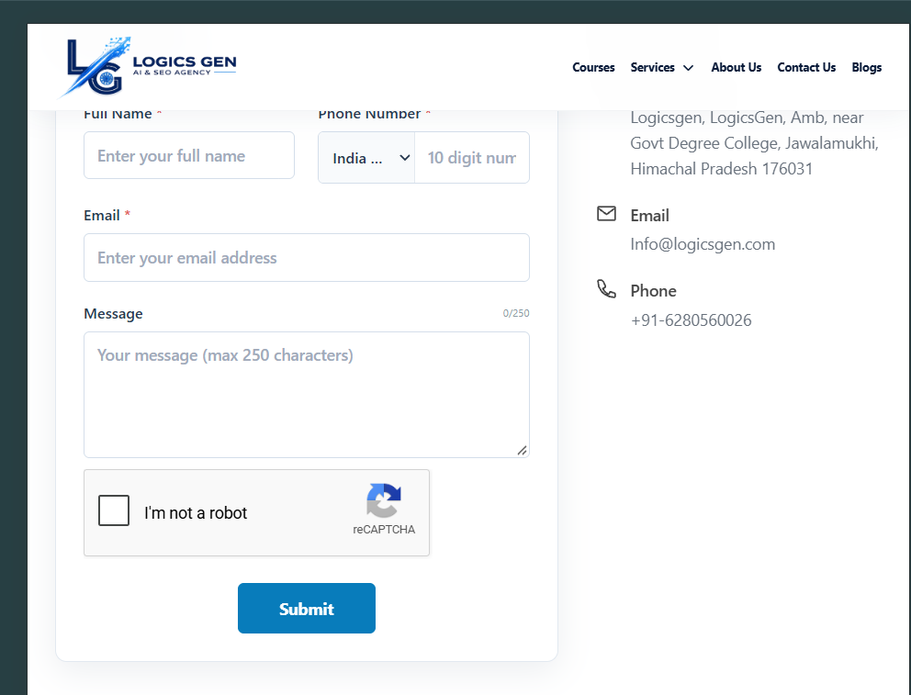

9. Additional QA Coverage Notes
The documented test cases show several useful manual QA techniques. The notes below summarize the techniques evidenced by the checks already recorded; they do not represent additional tests.
- Validation testing: Required-field checks and invalid name, email and phone-number inputs were tested on the contact form.
- Boundary testing: The 250-character message limit was checked, including the point at which the field stopped accepting further text.
- Positive submission testing: Successful confirmation messages were observed for the contact form on desktop and physical mobile, and for the course enquiry form in the tested browser session.
- Navigation testing: Main navigation, service links, course links, blog links, calls to action, and browser Back and Forward behavior were checked.
- Responsive checks: Selected pages and navigation were checked using Chrome DevTools at 768 × 1024 and a physical Redmi 13 mobile phone.
- Automated audit: Lighthouse was run on the homepage in mobile Navigation mode. Its results are reported separately and should not be treated as a full-site audit.

10. Recommended Retest and Closure Checklist
The following actions are recommended for the next QA cycle. They are pending actions, not tests completed in this report.
- Retest LG-QA-001: After the course-card links and destination content are corrected, click each suggested course card and confirm that it opens the intended, complete course page.
- Retest LG-QA-002: After the button is corrected, click “Explore All Blog Posts” and confirm that it opens the Blogs page.
- Verify LG-QA-003: Test CAPTCHA on a physical tablet or another supported tablet browser. Update the finding only after this verification.
- Verify enquiry delivery: Confirm that test enquiries are received by the intended inbox or recorded in the backend. A success notification alone is not proof of delivery.
- Run regression checks: After fixes, repeat the affected navigation journeys and check that the changes have not broken related course, blog or enquiry flows.

Defect closure criteria
Mark a finding as fixed only after the corrected behavior has been retested. Record the retest date, environment, observed result and fresh screenshot or other evidence. If the issue remains, keep it open and document the latest result.

Final note

QA Conclusion
The 20 manual scenarios covered in this report passed in the tested environments. Three findings remain outstanding: incorrect related-course navigation and incomplete course-page content; the “Explore All Blog Posts” button opening the Courses page instead of the Blogs page; and a CAPTCHA interaction issue observed only in Chrome DevTools responsive emulation, pending physical-tablet verification. The mobile Lighthouse audit showed strong Accessibility and SEO scores, while Performance and Best Practices need improvement. Retest the affected journeys after fixes, verify enquiry delivery through the receiving email account or backend, and complete the remaining page/device audits before final QA sign-off.
This report is based on the manual checks and Lighthouse evidence recorded for the tested pages, devices and scenarios. It does not claim complete website, browser or device coverage. The development team should retest each issue after a fix. Enquiry delivery should be confirmed from the backend or receiving email account before the form is marked fully verified.

