

CAPSTONE PROJECT REPORT
Report 1 – Project Introduction

– Cantho, September 2022 –

Table of Contents
I. Project Report 3
1. Status Report 3
2. Team Involvements 3
3. Issues/Suggestions 3
II. Project Introduction 4
1. Overview 4
1.1 Project Information 4
1.2 Project Team 4
a. Supervisor 4
b. Team Members 4
2. Product Background 4
2.1 Machine Learning 4
2.2 Deep Learning 4
2.3 Convolutional Neural Network (CNN) 5
2.4 Resnet 6
2.5 Programming languages 7
2.5.1 C# (Framework use: ASP.NET Core) 7
2.5.2 JavaScript (Framework use: ReactJS) 8
3. Existing Systems 8
3.1 Related works 8
3.2 Existing Systems 8
3.2.1 FPT University’s Exam Online System (EOS) 8
3.2.2 FPT University Learning Management System (LMS) 8
4. Business Opportunity 9
5. Software Product Vision 9
6. Project Scope & Limitations 9
6.1 Major Features 9
6.2 Limitations & Exclusions 10
References 10

I. Project Report

2. Team Involvements
# | Task | Member | Notes (Task Details, etc.)
1 | (document) I. Project Report | HungLH
2 | (document) 1. Overview | KhaTM
3 | (document) 2.1 Machine Learning | HieuTH
4 | (document) 2.2 Deep Learning | KhangLTV
5 | (document) 2.3 CNN | TinTT

II. Project Introduction

1. Overview

1.1 Project Information
- Project name: Applying machine learning in building an online examination support and proctoring system
- Project code: SEP490
- Group name: SEP490.3
- Software type: Web Application

1.2 Project Team

a. Supervisor
Full Name | Email | Phone Number | Title
Lương Hoàng Hướng | Huonglh3@fe.edu.vn | 0941666545 | Lecturer

b. Team Members
Full Name | Email | Mobile | Role
Hồ Khả Minh | minhhkce150582@fpt.edu.vn | 0799663689 | Leader
Tiêu Anh Thọ | thotace150019@fpt.edu.vn | 0937330716 | Member
Đoàn Ngọc Minh | minhdnce150022@fpt.edu.vn | 0704901355 | Member
Trần Khánh Toàn | toantkce150269@fpt.edu.vn | 0961498019 | Member
Thượng Duy Khang | khangtdce150004@fpt.edu.vn | 0909309195 | Member

2. Product Background
We researched and implemented many technologies for theartificial intelligence feature as well as the web application itself. In order to complete this project, we applied machine learning, deep learning and Convolutional Neural Network technology, we also used C# with the .NET framework and Javascript with the ReactJS framework.

2.1 Machine Learning
Machine learning is a field of programming concerned with creating programs that can “learn”, meaning the program can improve its performance by repeating a specific task. With each repetition, the accuracy of the algorithm will improve.
There are many approaches to machine learning, some of them are: supervised learning, unsupervised learning, reinforcement learning. There is no one approach for all problems, depending on the type of data needing to be predicted, an appropriate approach will be selected.

2.2 Deep Learning
Deep learning is a kind of machine learning that uses "artificial neural networks" to extract progressively higher-level characteristics from input, mimicking how people acquire specific sorts of information.

The biological neural networks that shape the structure of the human brain are where the phrase "artificial neural network" originates. Artificial neural networks also feature neurons that are coupled to one another in different levels of the networks, just like the human brain, which has neurons that are connected to one another. Nodes are the name for these neurons.
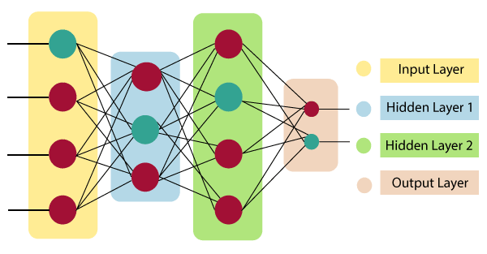
Figure 1 Neural Network architecture
Generally speaking, an artificial neural network has three layers:
- As its name implies, the input layer takes inputs from the programmer in a variety of different formats.
- The hidden layer is displayed between the input and output layers. It does all the computations necessary to uncover patterns and buried features.
- Output Layer: This layer is used to communicate the output after the input has undergone a number of alterations in the hidden layer.
Deep learning models may be used for various tasks since they process information similarly to how the human brain does. The majority of widely used voice recognition, natural language processing (NLP), and picture recognition programs presently employ deep learning. Applications as diverse as self-driving vehicles and language translation services are beginning to use these techniques.

2.3 Convolutional Neural Network (CNN)
Convolutional Neural Network (CNN or ConvNet) is a deep learning neural network widely used in computer vision. Usually, it applies to visual applications such as image classification and natural language processing. One of the benefits of CNN is that it can perform directly on a raw image and does not need any preprocessing.
CNN is a feed-forward neural network containing many convolutional layers stacked on top of each other. It has three main types of layers:

1. Convolution layer
This first layer extracts the critical features from the image and performs the convolution operation through several filters. It considers every image as a matrix of pixel values. Therefore, it slides the filter matrix with a dimension of MxM over the image and calculates the dot product between the image pixels and the filter. The result is a convolved feature matrix called a feature map or an activation map. Finally, it will feed the result to the next layer.
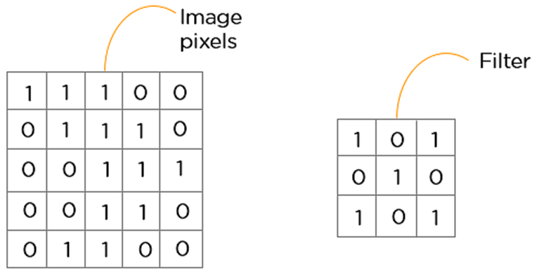
Figure 2 An example of image pixels matrix and filter matrix
2. Pooling layer
The pooling layer is used to reduce the feature map's dimensionality or size, usually applied after the convolution layer. This layer uses numerous filters to identify different parts of the image as edges or corners. Two main kinds of pooling are max and average pooling:
- Max pooling: Each time the filter slides across the image, it takes the maximum value and sends it to the output array. This approach keeps the detected features. As an aside, it is used the most commonly.
- Average pooling: Each time the filter slides across the image, it calculates the average value and sends it to the output array. This approach downsamples the feature map.
3. Fully connected layer
After going through the pooling layer, the feature map will come to the process called flattening, which is used to convert all the 2-Dimensional arrays into a single long continuous linear vector and feed as input to the fully connected layer to classify the image.

2.4 Resnet
ResNet is short for Residual Network, developed by He and his colleagues in 2015. It addressed the problem of vanishing gradients that have hindered the performance of deep neural networks. ResNet has allowed neural networks to be deeper than it has ever been. It does this by introducing Residual Block, where the activation output of previous layers is added to the computation of the activation of later layers.
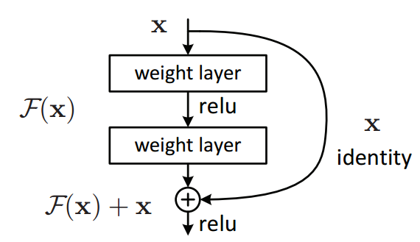
Figure 3 A single residual block
This implementation allows neural networks to easily learn an identity function. It prevents the output of zero towards the later layer in the network. Because of this, it prevents the model from performing worse as you add more layers. Aside from that, it also enables features from previous layers to reach deeper into the network, enabling an increase in accuracy.

2.5 Programming languages

2.5.1 C# (Framework use: ASP.NET Core)
C# (C-Sharp) is an object-oriented and component-oriented programming language created by Microsoft. It is a natural language for creating and using software components. As the name of it, it has roots in the C family and is close to C++ and Java. The first version of C# was released in 2002, and the latest version, C # 10, was released in November 2021. C# is one in all the foremost popular programming languages today. It is used to develop mobile, desktop, web applications, and many more. These are several features that help C# create robust and stable applications:
- Garbage collection automatically releases memory space that is no longer used.
- Nullable types allow the user to assign a null value to a value type variable.
- Exception handling provides a structured approach to prevent the program code from crashing.
- Lambda expressions assist functional programming methods.
- Language Integrated Query (LINQ) gives a more straightforward way to work with data from any source.

To develop the back-end of our product, we use ASP.NET Core framework with C# language. ASP.NET Core is a free cross-platform, high-performance, open-source web framework developed by Microsoft so that it can run smoothly on Windows, Linux, and Mac. This framework unites the features of MVC and Web API into a single web framework. ASP.NET Core applications can run on .NET Core or the full .NET Framework. It supports side-by-side versioning so that a single machine can have multiple versions of .NET Core, and various applications target those versions.

2.5.2 JavaScript (Framework use: ReactJS)
JavaScript (JS) is a lightweight, interpreted, or just-in-time compiled programming language that conforms to the ECMAScript standard. It is a dynamic typing, prototype-based and multi-paradigm scripting language which supports object-oriented, imperative, and functional programming styles. It is the world's most popular programming language. Alongside HTML and CSS, JS is one of the core technologies of the World Wide Web. As of 2022, JavaScript is used on the client side of 98% of websites. Although JS's origin is for use in web browsers, many non-browser environments are using it now, such as Node.js or Apache CouchDB. It has many useful libraries, one of the most popular of them is React.
React (also known as React.js or ReactJS) is a free, open-source JavaScript-based UI library. It is built and maintained by Facebook and the open-source developer community. By encouraging the creation of reusable UI components, React can dramatically reduce the application's development time and better performance. In addition, with frameworks like Next.js, React can be the foundation for single-page, mobile, or server-rendered applications.

3. Existing Systems

3.1 Related works
- With Jadi approach [1], have students install separate software tools on their laptop/personal computer in order to prevent exam fraud. With an accuracy of 97%, it can also detect many kinds of students' ambiguous activity during exams.
- El Kohli [2] uses a 3D convolutional neural network (3D CNN) to detect suspicious items and notify the moderator; the items could be a phone, books, or paper... during exams. This detection system predict with 95% accuracy, which used a model trained on 7,638 selected images.
- A study by Kamalov [3] take students' recent result to check for the anomalous score on the exam using recurrent neural network model. It predicts the exam score to investigate if the score is real or not based on the result of the recent exam. The approach achieves a 100% true positive rate and 4% false positive rate on some real-life datasets, which is a remarkably high level of accuracy in detecting cases of exam fraud.
- In Bawarith's work [4], a system uses a fingerprint reader authenticator and eye tribe tracker to check the direction that the user is looking, and even the total time on out screen were calculated. The accuracy of the system is 97.78% in an experiment with 90 samples.
- Ahmad [5] proposed an online proctoring system to proctor online exams using deep learning techniques. The system has a face recognition feature which uses the HOG (Histogram of Oriented Gradients) face detector and the OpenCV face recognition algorithm. It also has eye blinking detection to detect motionless pictures. This model achieved 97% for face detection and 99.3% accuracy for face recognition.

3.2 Existing Systems

3.2.1 FPT University’s Exam Online System (EOS)
With the motivation to improve the learning process, FPT Education has digitalized many aspects of education. To protect academic integrity, FPT has created EOS for the student to take exams and support the proctor on the invigilate process. Developed on the ASP.NET framework, EOS can run on Windows computers. EOS prevents the student from cheating by two methods. The first method is to block all other applications from running when students start the exam. The second method is to store student answers in both local and server. By that method, local data can still be retrieved if the server is hacked.

3.2.2 FPT University Learning Management System (LMS)
Designed primarily for managing learning resources, LMS has many functions like uploading exercises, slides, and other resources in the teacher role, viewing resources, and submitting exercises in the student role. LMS also has great support for exam management. The teacher can add tests, add questions to the test, and the system will randomise questions and also randomise the order of choice in multiple choice questions. Make use of safe exam browser, LMS also prevents the student from using other applications when taking the exam.

4. Business Opportunity
Since the COVID-19 pandemic, online examination has been a trend in many universities in Vietnam and the world. However, exam fraud was a serious problem of taking exams online due to the many disadvantages of proctors. Thanks to AI and machine learning, we have developed an online examination system that can solve those problems. Our system can automatically detect exam fraud of students based on their head-pose and gives proctors warning about that student. It can be used in any university that needs a system for their students to take an exam online but can still protect academic integrity. Compared to the FPT University’s Exam Online System (EOS), our system allows the student to take the exam and the proctor to monitor the student simultaneously. Moreover, it can assist the proctor in detecting fraud easier.

5. Software Product Vision
Online examinations have some serious adversities, especially integrity and cheating. The purpose of this project focuses on improving the exam-taking process and providing a handy way for the teacher to manage student records, we bring the all-in-one class management, student management and module management. Our application also developed proctoring systems that support anti-cheating to help the proctors to identify any fraud at the time of online exams.

6. Project Scope & Limitations

6.1 Major Features
FE-01: Manage user’s account including four roles (Academic department, teacher, student, head of department).
FE-02: Question bank management.
FE-03: Mark management.
FE-04: Class management.
FE-05: Module management.
FE-06: Exam management.
FE-07: Exam taking (student role).
FE-08: Exam invigilating (teacher role).
FE-09: Detect cheating when students are taking the exam.
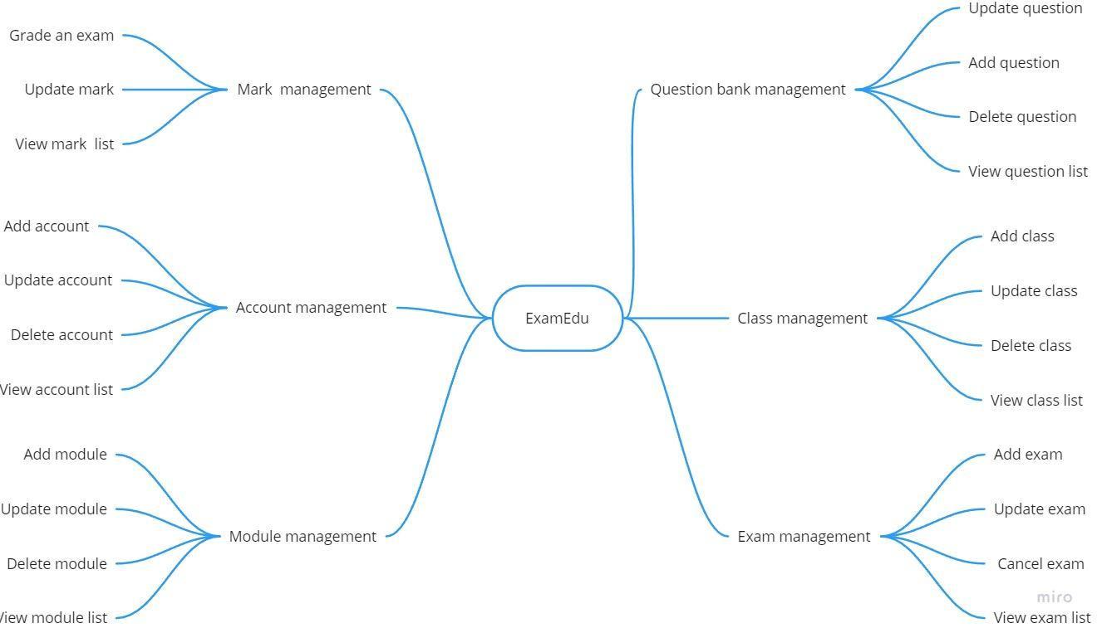
Figure 4 Features diagram of ExamEdu system

6.2 Limitations & Exclusions
LI-1: The cheating detection function only supports the student's front camera.
LI-2: Exam taking and invigilating do not work on mobile devices due to project scope and user’s use case.
LI-3: The website cannot be accessible by incognito window due to some lack of features on the incognito browser.

References
- Amr Jadi: New Detection Cheating Method of Online-Exams during COVID-19 Pandemic. International Journal of Computer Science and Network Security. 21(4), 123–130 (2021)

- Sara EL KOHLI, Youssef JANNAJ, Mehdi MAANAN1, Has-san RHINANE: DEEP LEARNING: NEW APPROACH FOR DETECTING SCHOLAR EXAMS FRAUD. The International Archives of the Photogrammetry, Remote Sensing and Spatial Information Sciences 46(4), 103–107 (2021). https://doi.org/10.5194/isprs-archives-XLVI-4-W3-2021-103-2022

- T Kamalov, F., Sulieman, H., Santandreu Calonge, D.: Machine learning based approach to exam cheating detection. PLOS ONE 16(8), 1–15 (2021). https://doi.org/10.1371/journal.pone.0254340

- Bawarith, R., Basuhail, D.A., Fattouh, D.A., Gamalel-Din, P.D.S.: E-exam cheating detection system. International Journal of Advanced Computer Science and Applications 8(4) (2017). https://doi.org/10.14569/JACSA.2017.080425

- Ahmad, I., AlQurashi, F., Abozinadah, E., Mehmood, R.: A novel deep learning-based online proctoring system using face recognition, eye blinking, and object detection techniques. International Journal of Advanced Computer Science and Applications 12(10) (2021). http://dx.doi.org/10.14569/IJACSA.2021.0121094

https://www.javatpoint.com/artificial-neural-network
https://www.simplilearn.com/tutorials/deep-learning-tutorial/convolutional-neural-network
https://arxiv.org/abs/1512.03385

