

CAPSTONE PROJECT REPORT
Report 2 – Project Management Plan

– Can Tho, September 2022 –

Table of Contents
I. Project Report 3
1. Status Report 3
2. Team Involvements 3
II. Project Management Plan 4
1. Overview 4
1.1 WBS & Estimation 4
1.2 Project Risks 5
2. Management Approach 5
2.1 Project Process 6
2.2 Quality Management 7
2.3 Training Plan 7
3. Master Schedule 8
4. Project Organization 8
4.1 Team & Structures 8
4.2 Roles & Responsibilities 8
5. Project Communication 9
5.1 Communication Plan 9
5.2 External Interface 10
a. FU Contacts 10
b. Customer Contacts 10
6. Configuration Management 10
6.1 Tools & Infrastructures 10
6.2 Document Management 10
6.3 Source Code Management 11

I. Project Report

1. Status Report
# | Work Item | Status | Notes (Work Item in Details)
1 | (Document) Report 2 | Completed

2. Team Involvements
# | Task | Member | Notes (Task Details, etc.)
1 | Project Report | ToanTK
2 | 1.1 WBS & Estimation | ThoTA
3 | 1.2 Project Objectives | ThoTA
4 | 1.3 Project Risks | MinhDN
5 | 2. Management Approach | MinhDN
6 | 2.1 Project Process | KhangTD
7 | 2.2 Quality Management | ThoTA
8 | 2.3 Training Plan | ThoTA
9 | 3. Master Schedule | MinhHK
10 | 4.1 Team & Structures | MinhDN
11 | 4.2 Roles & Responsibilities | MinhDN
12 | 5.1 Communication Plan | ToanTK
13 | 5.2 External Interface | ToanTK
14 | 6.1 Tools & Infrastructures | KhangTD
15 | 6.2 Document Management | KhangTD
16 | 6.3 Source Code Management | ToanTK

II. Project Management Plan

1. Overview

1.1 WBS & Estimation
# | WBS Item | Complexity | Est. Effort  (man-days)
1 | Initiate project |  | 8
1.1 | Define project goal | Medium | 3
1.2 | Define project scope | Medium | 3
1.3 | Define project risk | Simple | 1
1.4 | Choose technology | Simple | 1
2 | Design database | Complex | 10
3 | Develop website back-end |  | 20
3.1 | Manage question bank | Medium | 3
3.2 | Manage class | Simple | 1
3.3 | Manage exam | Medium | 3
3.4 | Manage mark | Medium | 3
3.5 | Manage account | Simple | 1
3.6 | Manage module | Medium | 2
3.7 | Exam taking and invigilating | Complex | 7
4 | Develop website front-end |  | 17
4.1 | Manage question bank | Medium | 2
4.2 | Manage class | Simple | 2
4.3 | Manage exam | Medium | 3
4.4 | Manage mark | Simple | 2
4.5 | Manage account | Simple | 1
4.6 | Manage module | Simple | 2
4.7 | Exam taking and invigilating | Complex | 5
5 | Develop cheating detect model |  | 23
5.1 | Collect data (find dataset) | Medium | 3
5.2 | Find suitable method for training model | Complex | 10
5.3 | Train model | Medium | 4
5.4 | Implement model | Complex | 6
6 | Testing |  | 10
6.1 | Unit test | Medium | 4
6.2 | Integrated test | Simple | 3
6.3 | System test | Simple | 3
Total Estimated Effort (man-days) |  |  | 88

1.2 Project Risks
# | Risk Description | Impact | Possibility | Response Plans
1 | Power outage | Medium | Low | Use mobile data plan to have access to the internet. Wait out the power outage.
2 | Homeworks and assignments | High | High | Form study group to help each other finish homework and assignments as fast as possible
3 | Laptop breakdowns | High | Low | Communicate quickly about the incident, and if necessary assign a new teammate to take on the task.
4 | Preparing for exams | High | High | Form study groups to help each other prepare for exams.
5 | Sick teammate | High | Low | Assign a new teammate to complete a sick teammate’s task.
6 | Requirement changes | High | Low | Start meeting as soon as possible after recognizing a change in requirements to determine which aspects are changed and how to implement the changes.

2. Management Approach
We chose Scrum as the management framework for our project. Scrum is a management methodology that follows the Agile principles. It allows teams to quickly adapt to changing requirements, speed up development and shipment of products through an iterative process, ultimately delivering higher values to customers. It accomplishes this by improving communication between team members, between teams and stakeholders, allowing them to identify pressing issues or changing requirements in time to address them accordingly. It also allows teams to properly prioritise, manage, and implement features.
We will be splitting our project into sprints. Sprints are small time-boxed windows of time where we implement a subset of features of the larger project. Tasks in each sprint are to be completed with high-fidelity, meaning that they are ready for production environments. Sprints often run for 1 to 4 weeks but no more than 1 month.
Before a sprint, the team will hold a meeting to determine the sprint backlog. The sprint backlog is a collection of tasks from the product backlog ordered on priority to ensure the team delivers the most important features first.
During a sprint, team members will perform bi-daily standups to discuss current impediments and may request assistance from other team members. Any changes to requirements that may arise during a sprint are addressed next sprint.
After a sprint is completed, we will perform a sprint review where we go through the events that have happened during the previous sprints. We will take notes of what went in our favour, what did not go well, and establish what needs to be done to address issues and, or, adopt better practices.

2.1 Project Process
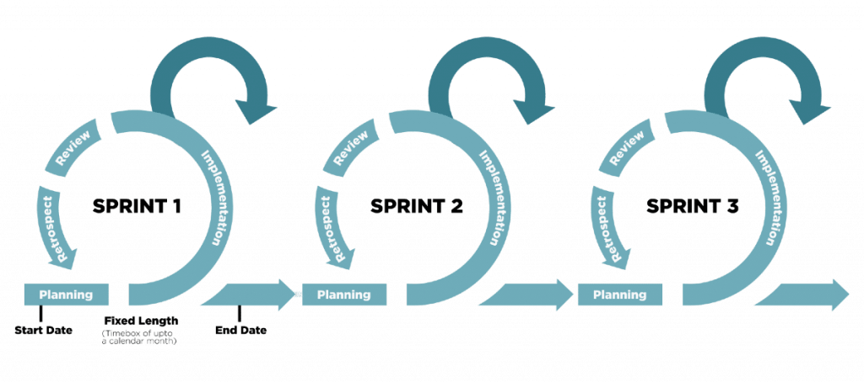
Figure 1 Illustration of Scrum framework
Our software development process model consists of the following stages:
- Organize the backlog: The product owner establishes the product backlog using feedback from users and the development team to make sure the product is towards its product vision.
- Sprint planning: The entire development team chooses tasks from the product backlog and ensures those tasks always align with the sprint goal, also agreed upon by the scrum team to create the sprint backlog.
- Sprint: This is the period when the team works together to complete all tasks in the sprint backlog. We give each sprint a week to be easier to scope.
- Daily scrum or stand up: This is a daily super-short meeting that we usually organize in the morning to assure that the team align with the sprint goal and to get a plan out for the day. The stand-up is also a chance for everyone to express any problem they have with meeting the sprint goal.
- Sprint review: This stage occurs after the sprint is completed. The team gets together to inspect what has been done in the previous sprint. The development team shows the stakeholders and teammates the backlog items that are done to get feedback. The product owner can decide whether to release the increment or not.
- Sprint retrospective: The team comes together to discuss what went well and what needs to be improved next time in this stage.

2.2 Quality Management
Quality management is crucial in software development. Its primary purpose is to ensure the project meets all user requirements for software, success criteria, and quality standards. Quality management impacts all aspects of a software project, so it must be done precisely and carefully.
To ensure that our project quality meets the expectation, we use the following quality management method:
- Defect Prevention: Defect prevention is a technique that must be conducted early (especially in the design and implementation phase) throughout the software development lifecycle and by every team member, regardless of role. A minor defect can lead to a significant failure of the system. To prevent defects, all team members must participate in the requirement phase and communicate effectively to point out any misunderstanding or gap between their expectations and the software requirement. The team must also establish a convention for all software development life cycles (coding convention, communication convention).

- Reviewing: Reviewing can prevent defects and errors from becoming failures and help make maintenance easier. In this phase, the team members will analyse each other's code to find any defect, error, or violation in the coding convention. Reviewing saves the project a significant amount of resources by discovering any misunderstandings in the document and design phase (which cause defects). Based on this phase, the team members can learn early on from their mistakes and improve overall project quality.

- Unit testing: Aim for testing the smallest piece of code, this stage is conducted right after the programmer finishes coding a task, and it is a condition to move to integration testing. Unit testing helps the programmer or tester find the bug in the early stage and prevent them from causing severe failure in the future, reducing the cost of fixing the bug.

- Integration testing: Integration testing is conducted after unit testing and mainly focuses on testing logically combined modules or components of the software. After unit testing, the defect may remain in the software and lead to failure. As a combination of more than one module or component, a function (which is being tested) can be the work of a variety of team members so that misunderstanding can happen, and the function may not work as expected (although each unit is working correctly).

- System testing: In this stage, the system will be tested as fully functional software. System testing is black-box testing and must include a fully integrated system including environment and external peripherals. Its aim is to test the interaction between modules in the system and the interaction between the function being tested with the system as a whole.

- User acceptance testing: It is the last test phase before moving the application to production. User acceptance testing is conducted in real environments where the software will be used by its intended user, aiming for testing end-to-end business flow.

2.3 Training Plan
Training Area | Participants | When, Duration | Waiver Criteria
Git and GitLab | All members | 5/9/2022, 1 slot | Mandatory
ReactJs | All members | 6/9/2022, 3 slot | Mandatory
CNN | All members | 7/9/2022, 2 slot | Mandatory
Flask | MinhDN | 8/9/2022, 1 slot | Mandatory

3. Master Schedule
# | Deliverable | Due Date | Deliverable Scope
1 | Project Plan | 21/8/2022 | Plan project milestone
2 | Report 1 | 10/9/2022 | Evaluate requirements
3 | Report 2 | 17/9/2022 | Architecture Design
4 | Report 3 | 24/9/2022 | SRS Document design
5 | Report 4 | 1/10/2022 | Design class diagram and sequence diagram
6 | Code | 23/11/2022 | Code
7 | Report 5 | 26/11/2022 | Test document
8 | Report 6 | 3/12/2022 | User guide
9 | Report 7 | 10/12/2022 | Final document
10 | Final Product | 10/12/2022

4. Project Organization

4.1 Team & Structures
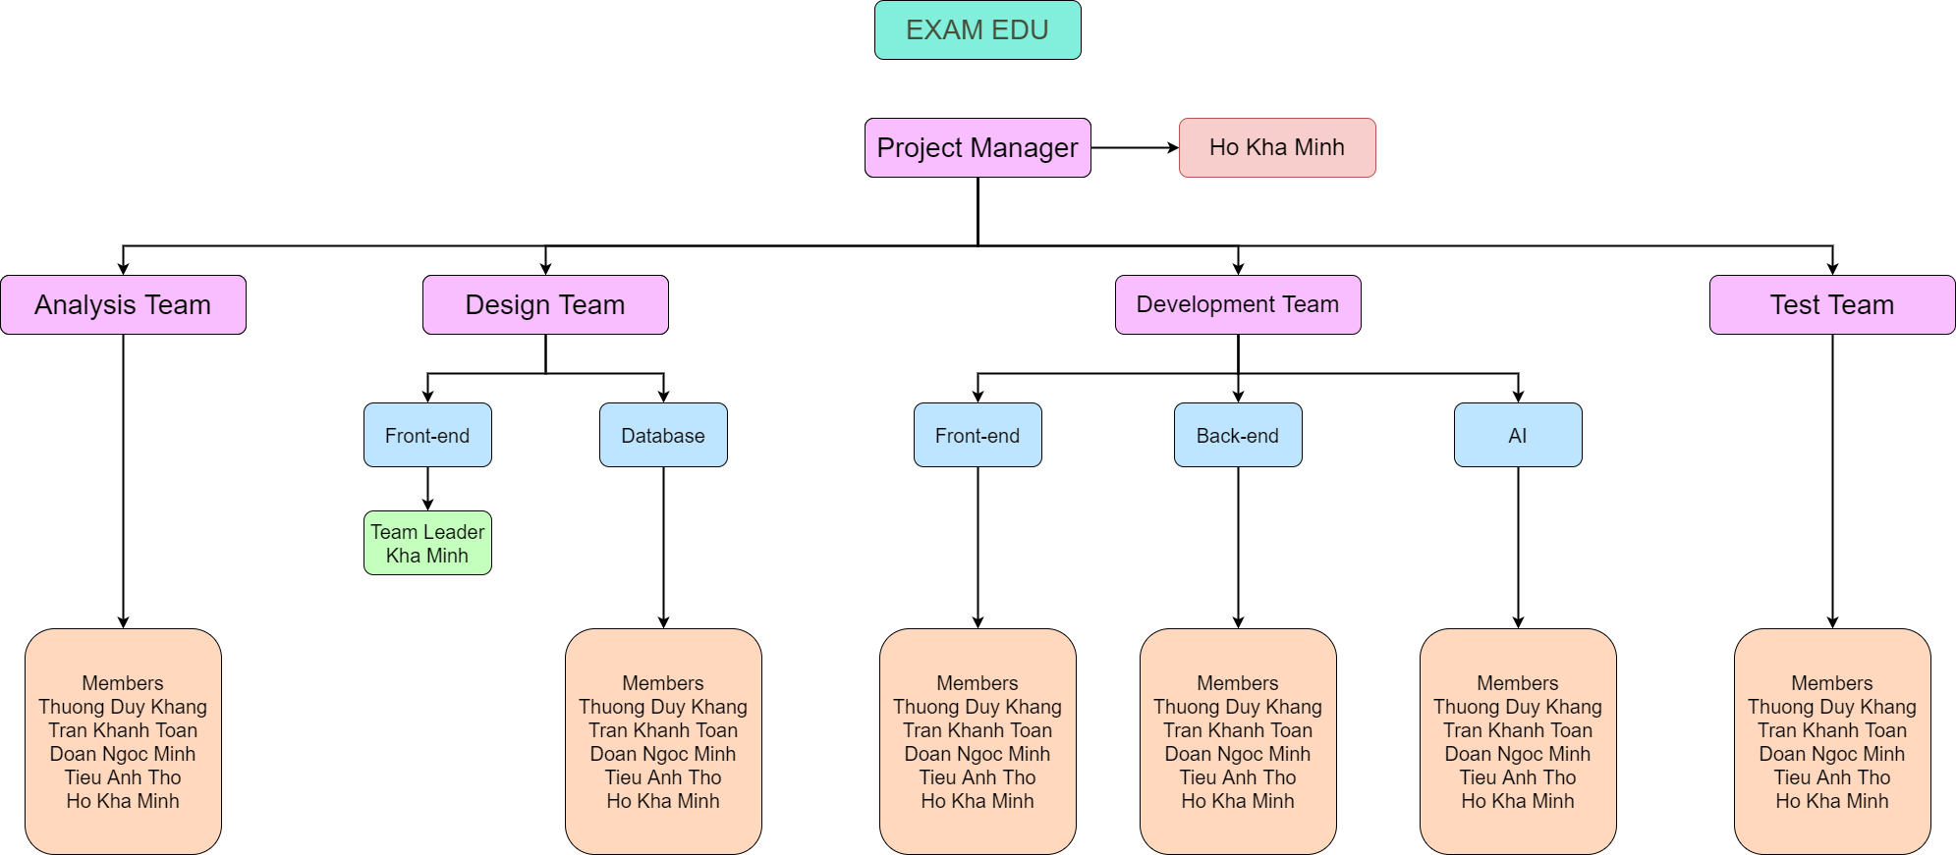
Figure 2 Team & Structures

4.2 Roles & Responsibilities
Role | Responsibility
Project Manager | - Supervise over project status  - Prepare weekly report for supervisor  - Assign document tasks for members
Analysis Member | - Analyse business requirements  - Analyse technical requirements  - Document analyses
Design Leader | - Designs user interface  - Report progresses
Design Member | - Analyse database requirements  - Analyse entity relationships
Development Member | - Choose tasks  - Develop features for the application  - Report progresses  - Assess task difficulty
Test Member | - Perform testing on application’s features  - Report bugs  - Report progresses

5. Project Communication

5.1 Communication Plan
Communication Item | Who/ Target | Purpose | When, Frequency | Type, Tool, Method(s)
Decide Capstone  Project Topic | Team  members | Confirm the thesis’s  topic and overall  information | 1/9/2022 | Discord
Assign Roles and  Tasks | Team  members | Specify roles and tasks do in the capstone project | 2/9/2022 | Discord  Messenger
Plan and schedule  milestones | Team  members | Set up milestones for the whole project | 2/9/2022 | Discord  Google Meet
Daily  communication  and conversation | Team  members | Transfer information  Support  Report status  Brainstorm ideas | Daily | Discord  Messenger  Face-to-face  Google Meet
Team meeting | Team member  Mentor | Report status  Supervisor support  Exchange information  Identify issues | Every Wednesday | Discord  Google Meet

5.2 External Interface

a. FU Contacts
Function | Contact Person  (name, position) | Contact address  (email, telephone) | Responsibility
Supervisor | Luong Hoang Huong | huonglh3@fe.edu.vn  0941666545 | - Provide documentation template  - Give instructions to project team  - Supervise project status  - Review project report  - Review deliverables  - Supervise project status  - Support team members

b. Customer Contacts
Function | Contact Person  (name, position) | Contact address  (email, telephone) | Responsibility
Customer | Luong Hoang  Huong | huonglh3@fe.edu.vn  0941666545 | - Review product stages  - Give feedback about the system  - Answer related questions about  the project

6. Configuration Management

6.1 Tools & Infrastructures
Programming languages | C#, JavaScript
Framework | ASP.NET Core, ReactJS
API | RESTful, Flask
DBMS | PostgreSQL
IDEs/Editors | Visual Studio Code
UML tools | Draw.io
Version Control | GitLab
Deployment server | Heroku, Netlify
Project management tool | Google Sheets

6.2 Document Management
Google Docs is an online word processor and a part of the Google Docs Editors suite offered by Google. Its main functions are similar to Microsoft Word but provide more useful features. Google Docs allows multiple users to create and edit documents online simultaneously. Every change is automatically saved to the cloud of Google, and a revision history is kept, so it helps prevent our documents from getting lost and allows us to revert to the previous version. Furthermore, an editor’s current position is represented by a specific colour/cursor so that other members can view the editing in real-time. In the revision history, each author is distinguished by a different colour; therefore, the team can check to see who has edited which part of the document.

Figure 3 Google Docs logo (Source: Internet)

6.3 Source Code Management
GitLab is a web-based Git repository that offers free open and private repositories, issue-following features, and wikis. We have used GitLab to manage our source code and changes. This service has lots of functions and benefits:
- Available for free
- Easy to manage source code and configure
- Unlimited public and private repositories
- Good support for CI/CD
- Security assurance
Because of our web application features, we have 2 repositories on GitLab: Front end and Back end. In our code management progress, our team must pull code from the branch Main/Master, which stores the primary code on GitLab. We also create 5 more branches for each team member, so we can code, commit and push to our own branch. After the pushing step, we have to create a merge request to merge to the branch Main/Master, check if conflicts happen, and finally merge the changed code to the elementary branch.

Figure 4 GitLab logo (Source: Internet)

https://niftypm.com/blog/manage-sprint-cycle/

