

CAPSTONE PROJECT REPORT
Report 6 – Software User Guides

– Cantho, November 2022 –

Table of Contents
I. Project Report 3
1. Status Report 3
2. Team Involvements 3
3. Issues/Suggestions 3
II. Release Package & User Guides 5
1. Deliverable Package 5
1.1 Source codes & documents 5
1.2 Known Issues, Limitations & Restrictions 5
2. Installation Guides 5
2.1 System Requirements 5
2.2 Setup Files 6
2.3 Installation Instruction 6
3. User Manual 13
3.1 Terms and definitions 13
3.2 System requirements 13
3.3 Application Usage 13
a. Overview 13
b. Authentication 14
c. Role Administrator 20
d. Role Academic department 26
e. Role Teacher 33
c. Role Student 45

I. Project Report

1. Status Report
# | Work Item | Status | Notes (Work Item in Details)
1 | (Document) Report 6 | Completed

2. Team Involvements
# | Task | Member | Notes (Task Details, etc.)
1 | I. Project Report | KhangTD
 | II. Release Package & User Guides
2 | 1. Deliverable Package | ToanTK
 | 2. Installation Guides
3 | 2.1. System Requirements | ToanTK
4 | 2.2. Setup Files | MinhHK
5 | 2.3. Installation Instruction | MinhHK
 | 3. User Manual
6 | 3.1. Terms and definitions | KhangTD
7 | 3.2. System requirements | KhangTD
 | 3.3. Application Usage
8 | a. Overview | MinhHK
9 | b. Authentication | KhangTD
 | c. Role Administrator
10 | 1. Manage account | ThoTA
11 | 2. View deactivated account | ThoTA
12 | 3. Create account by excel | ThoTA
 | d. Role Academic department
13 | 1. Manage modules | MinhDN
14 | 2. Manage classes | MinhHK
15 | 3. Manage exams | MinhDN
 | e. Role Teacher
16 | 1. Manage Exam | KhangTD
17 | 2. Grade written question | ToanTK
18 | 3. Approve/reject to add questions | MinhDN
19 | 4. Request add new question to question bank | ToanTK
 | f. Role Student
20 | 1. Take and submit Exam | ToanTK
21 | 2. Mark report | ThoTA

3. Issues/Suggestions
# | Issue | Status | Notes (Solution, Suggestion, etc.)

II. Release Package & User Guides

1. Deliverable Package

1.1 Source codes & documents

No. | Items | Sub-Items | Type | Version
Code Package
1 | ExamEdu system | ExamEdu Web | New | 1.0
 |  | ExamEdu API | New | 1.0
2 | ExamEdu Cheating Prediction | ExamEdu Prediction Model | New | 1.0
 |  | ExamEdu Training Code | New | 1.0
Database
1 | Tables | ExamEdu.tar | New | 1.0
Documents
1 | Report 1 |  | New | 1.0
2 | Report 2 |  | New | 1.0
3 | Report 3 |  | New | 1.0
4 | Report 4 |  | New | 1.0
5 | Report 5 |  | New | 1.0
6 | Report 6 |  | New | 1.0
7 | Report 7 |  | New | 1.0

1.2 Known Issues, Limitations & Restrictions
- The ExamEdu web application need to use Safe Exam Browser to take the exam.
- The system needs to be connected to the internet during use.

2. Installation Guides

2.1 System Requirements
For server:
- Operating system: Windows 10
- Interpreter/compiler: Python 3.8, .NET 5
- Storage: 40GB HDD available
- RAM: 4GB or higher
- CPU: Intel Core i5-825U or higher
- Database: PostgreSQL 14 or newer
For web client:
- Operating system: Windows 10, macOS 10.13
- Browser: Google Chrome 90, Safari 14.0.3 (macOS), Safari 14 (iOS), Microsoft Edge 89.0 or newer.

2.2 Setup Files
- examedu.zip
- examedu-client.zip
- examedu.tar
- deepLearningAPI.zip
- .vsconfig

2.3 Installation Instruction
- Install PgAdmin and PostgreSQL
Download PostgreSQL version 15 at Download Page, run the installer to complete the setup.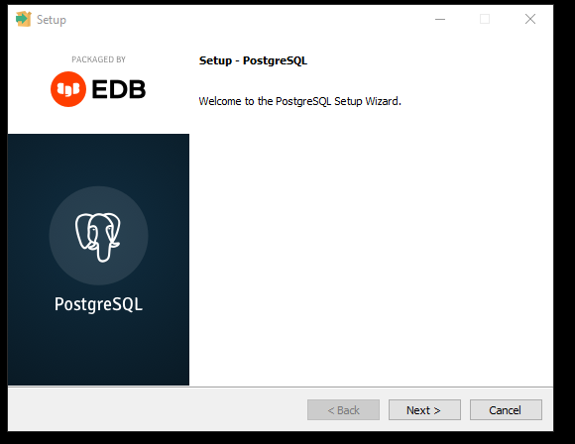
Figure 1 PostgreSQL setup
Then continue to install the Stack Builder to complete your PostgreSQL installation.
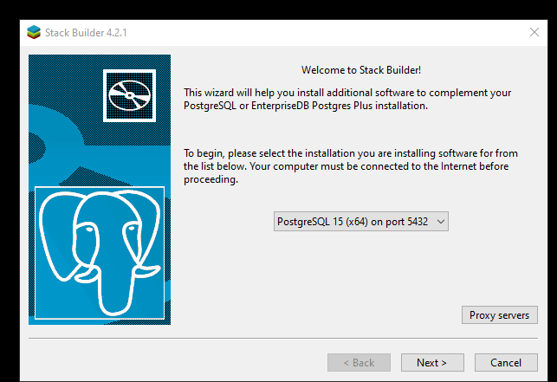
Figure 2 Stack Builder setup
Next, download pgAdmin 4 at the Download page and run the installer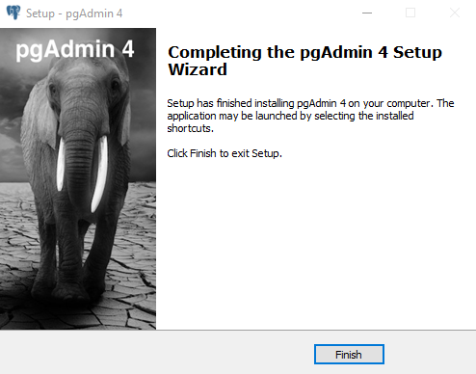
Figure 3 pgAdmin 4 setup
Open pgAdmin 4 and set the software password.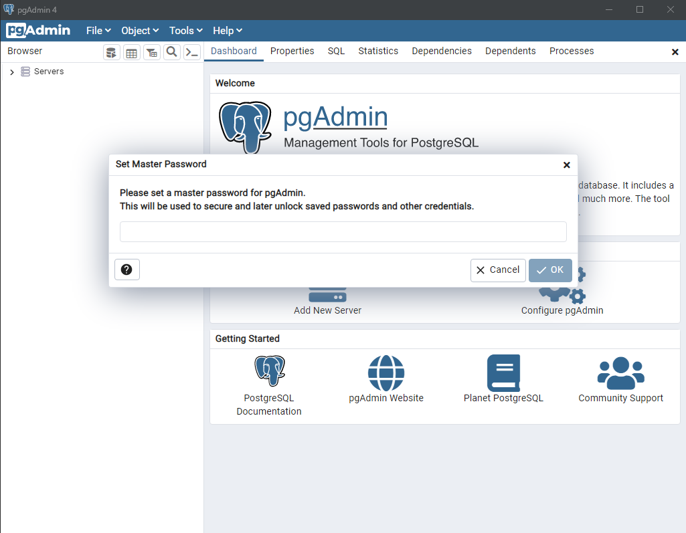
Figure 4 Setting password on pgAdmin 4
Create a local database on pgAdmin, remember to put localhost in the Host Name field, then click “Save”.
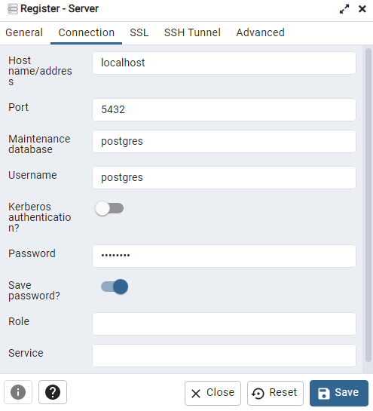
Figure 5 Create database
Import the database schema into the just-created database. In the Filename field, select the .tar file to restore the database. After you completed that, hit “Restore”.
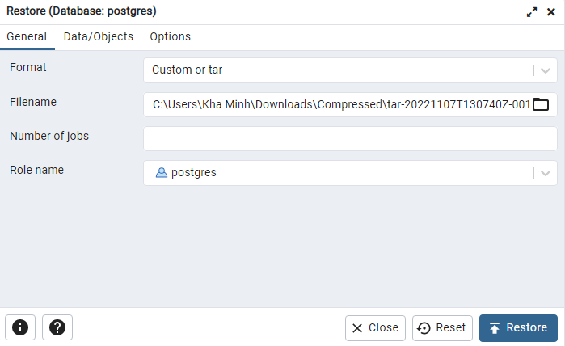
Figure 6 Restore Database
- Install Model AI
Download Windows installer (64-bit) from here, run the installer and click next on the installer until finishes to install Python.
Extract the DeepLearningAPI.zip and install these dependencies:
fastapim uvicorn, numpy, tensorflow-cpu, python-multipart, pillow
Open a terminal inside the extracted folder and run the following command in terminal to install dependencies: python -m pip install -r requirements.txt
Run the follow command to start the server: uvicorn main:app --host 0.0.0.0 --port 80
Your deep learning server is now running on http://0.0.0.0:80
- Install Visual Studio 2022
Download the Visiual Studio 2022 Installer at the Download Page, open the installer, in the “More” button of the Visual Studio Community 2022 tab, select import configuration in order to auto select the right environment for the projects, select the vsConfig file to start the auto downloading and installation.
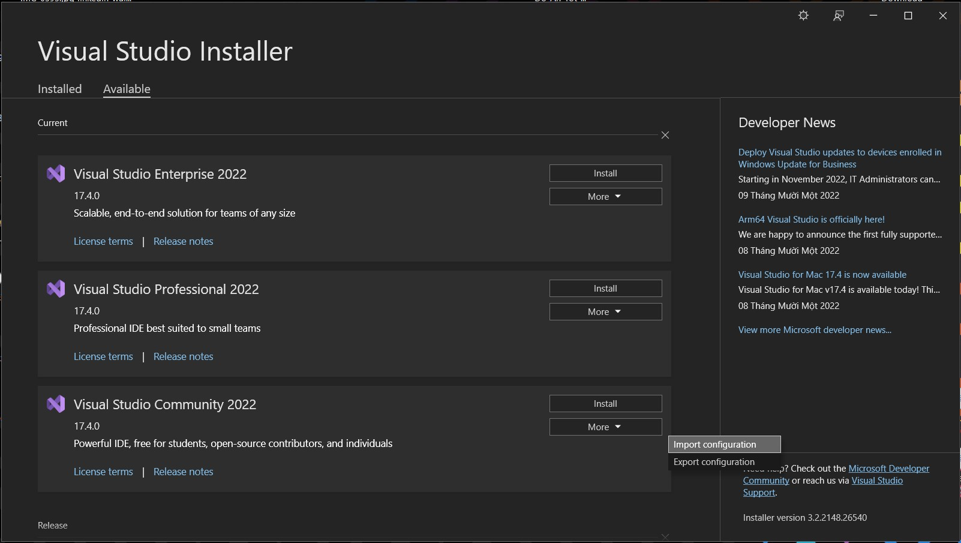
Figure 7 Visual Studio 2022 installer
- Install the Nodejs Environment
Download the installer at the Downloads page, run the installer to compete the installation.
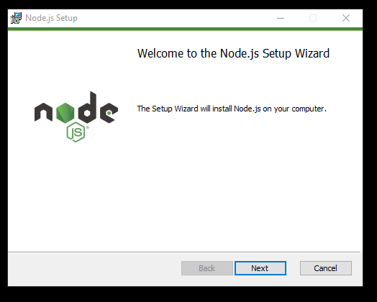
Figure 8 Nodejs setup
- Open the API project and the client project on Visual Studio 2022
Remeber to extract the examedu.zip and examedu-client.zip.
First, open Visual Studio 2022, choose the “Open a project or solution”, then choose the ExamEdu.sln file in the ExamEdu folder, after that, click the “IIS Express” button to run the API project.
Next, open another Visual Studio 2022 window, choose the “Open a local folder”, then choose the ExamEdu-Client folder.
Wait for the project to load, right click on the package.json file, choose the NPM section and click the Install missing npm package, wait for it to complete
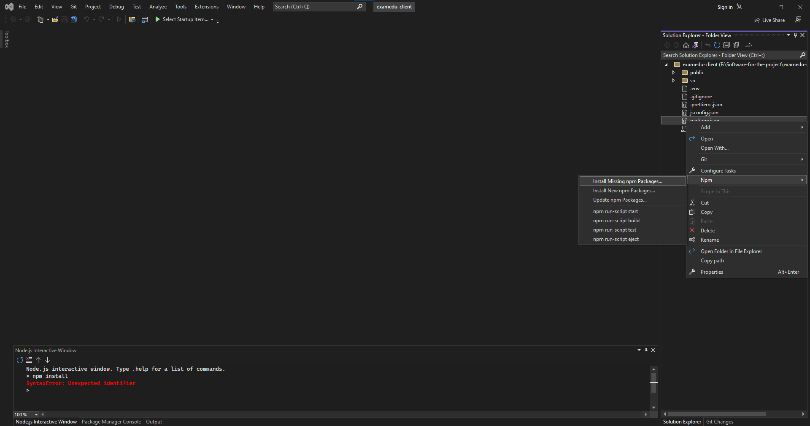
Figure 9 examedu-client project
In the Pakage Manager Console, type in “npm start” to run the client project.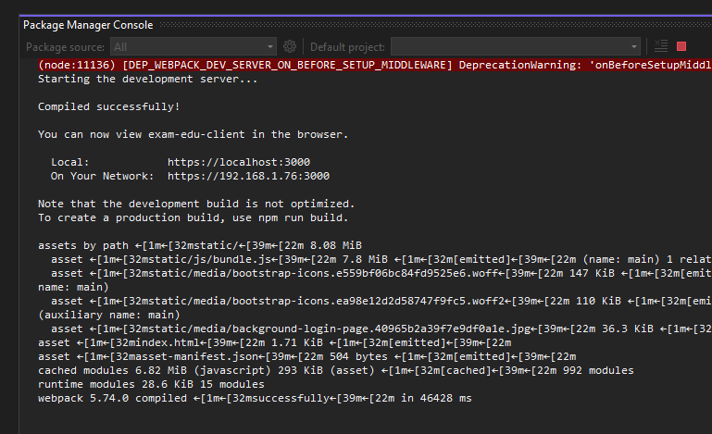
Figure 10 Console log for the client project
After completed, your application should be ready on port 3000.

3. User Manual

3.1 Terms and definitions
No | Term and definition | Description
1 | User | All users in the system, including administrator, academic department, student, teacher, and head of department.
2 | Administrator | An user who has the role of administrator and is allowed to manage user accounts of the system.
3 | Academic Department | An user who has the role of academic department and is responsible for managing classes, modules, exams,...
4 | Student | An user who has the role of student and is allowed to take exams, and view their mark report.
5 | Teacher | An user who has the role of teacher and is responsible for managing their class, create exam,...
6 | Head of Department | An user who has the role of head of department who just like the role of teacher but also are responsible for assigning teacher to execute the add question to the question bank.

3.2 System requirements
For server:
- Operating system: Windows 10.
- Interpreter/compiler: Python 3.8, .NET 5.
- Storage: 40GB HDD available.
- RAM: 4GB or higher.
- CPU: Intel Core i5-825U or higher.
- Database: PostgreSQL 14 or newer.
For web client:
- Operating system: Windows 10, macOS 10.13.
- Browser: Google Chrome 90, Safari 14.0.3 (macOS), Safari 14 (iOS), Microsoft Edge 89.0 or newer.

3.3 Application Usage

a. Overview
Our system has 5 roles (Administrator, Academic Department, Student, Teacher, and Head of Department). All the users have all of the following features:
- Login
- Logout
- Forgot password
An Administrator is the actor who can perform all of the following features:
- Manage system’s account
- View deactivated account list
An Academic Department is the actor who can perform all of the following features:
- Manage Class
- Manage Module
- Manage Exam
A Teacher is the actor who can perform all of the following features:
- View module list
- Manage Exam
- Export excel module’s exam results
- View exam result, analysis
- Create exam paper
- Grade written questions
- View request Add question bank
- Approve/Reject request to add question
- Request add new question to question bank
A Student is the actor who can perform all of the following features:
- View exam schedule
- View exam questions
- Submit exam
- Mark report
- View module list
A Head of Department is the actor who can perform all of Teacher’s features and the following features:
- Assign teacher to process add question request

b. Authentication
- Login
Before using any system feature, user must log in first. When user accesses the system, a login page will be showed up as a default page (Figure 11) and allow them to input their email and password.
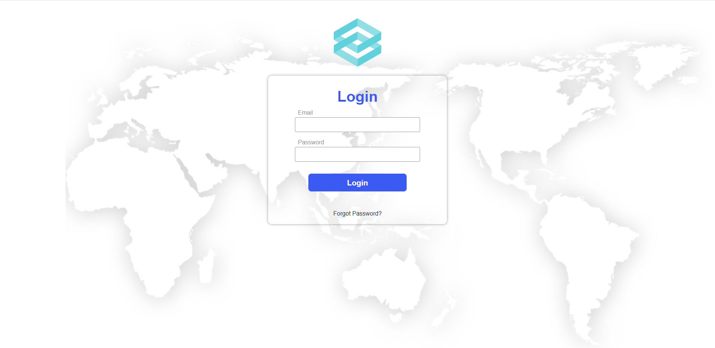
Figure 11 The login page
If user leaves the input field blank or tries to log in with an invalid account, the system will show a corresponding error message (Figure 12, 13, 14, 15).
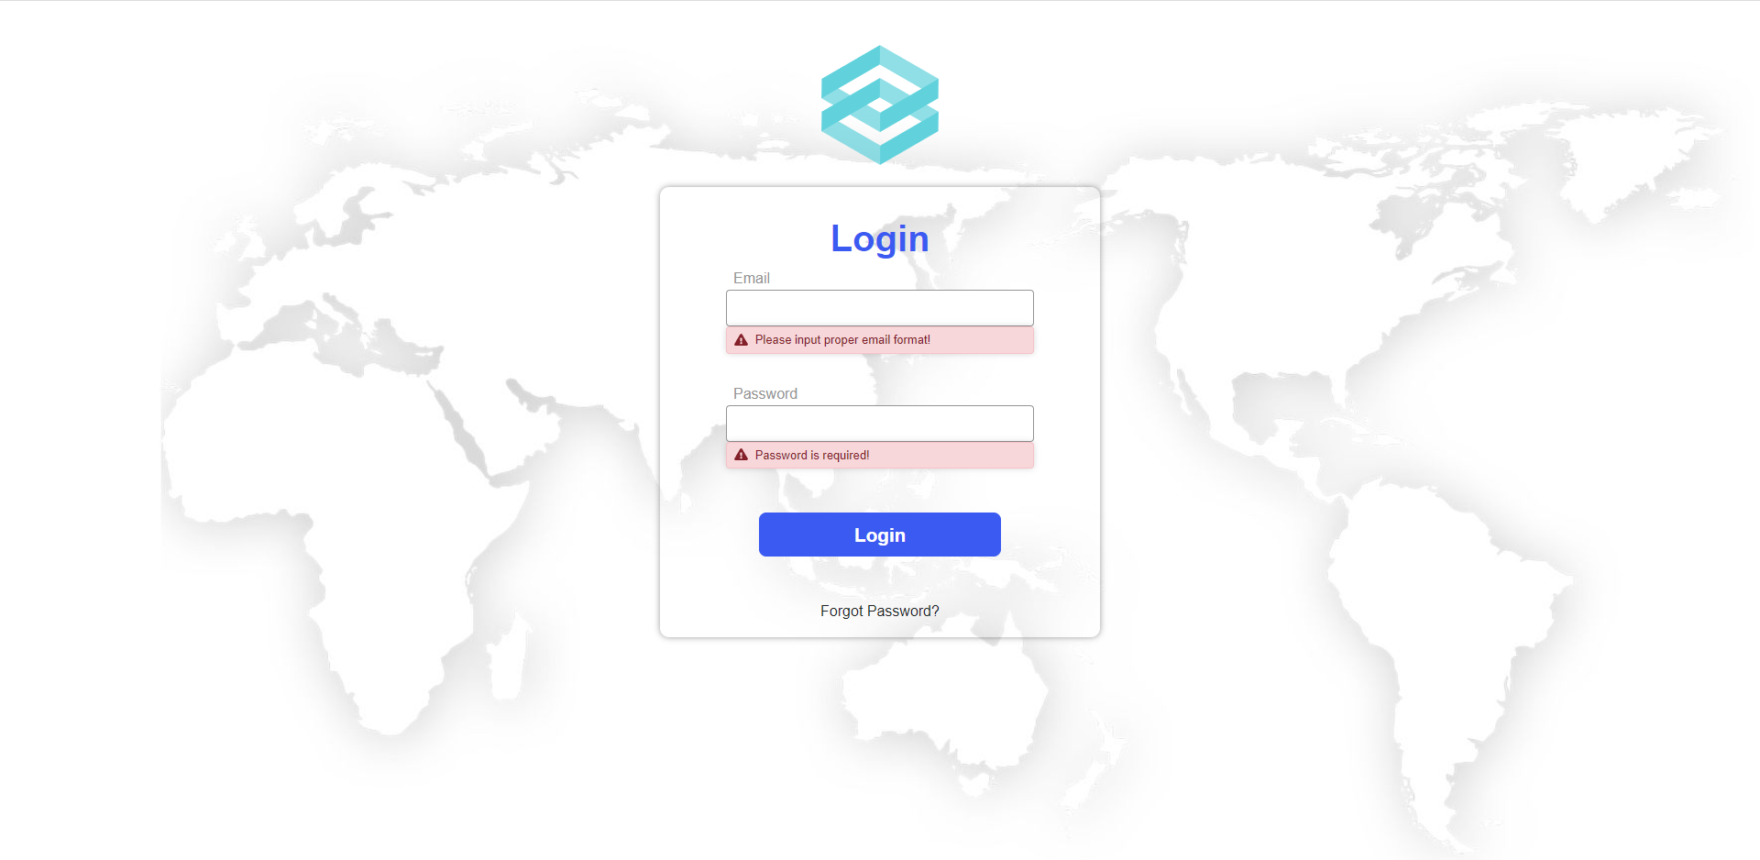
Figure 12 Error displayed when user does not inputs
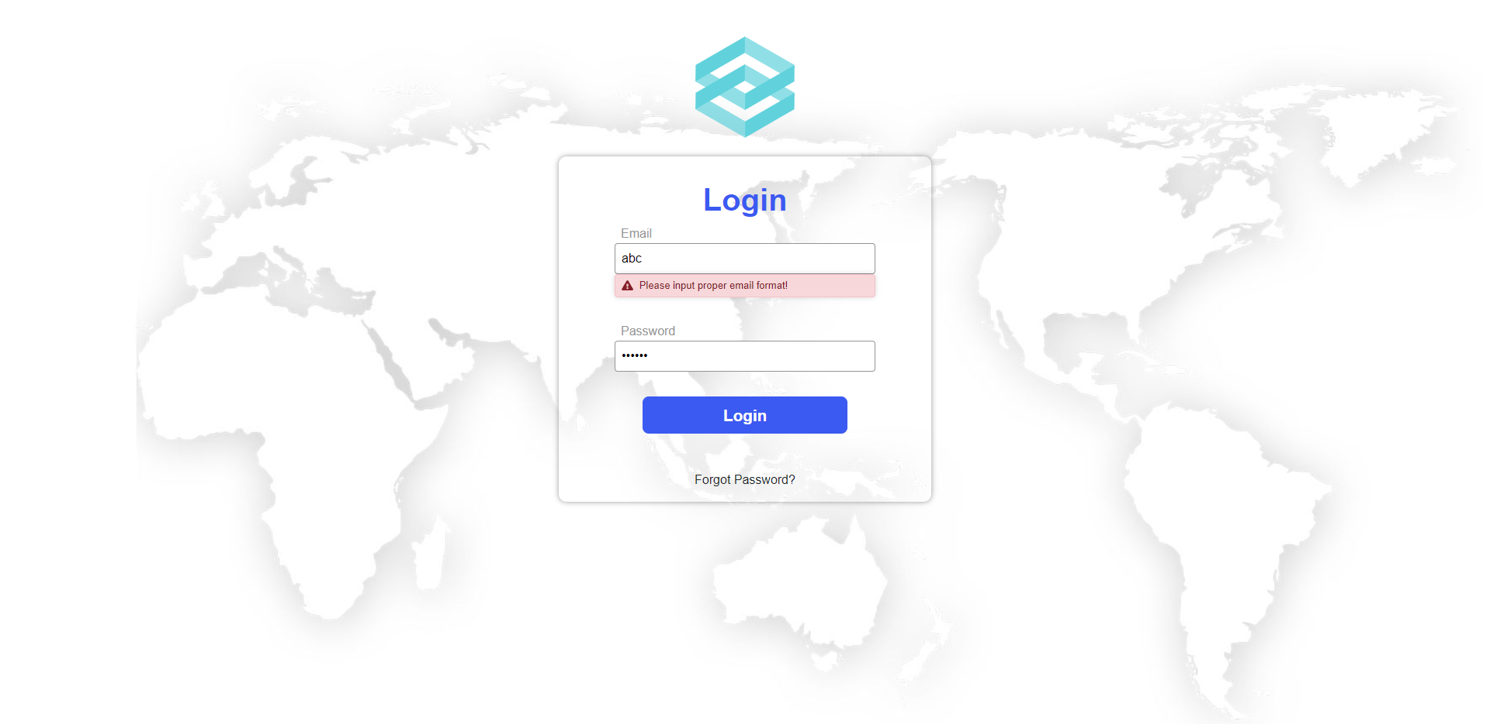
Figure 13 Error displayed when user inputs invalid email format
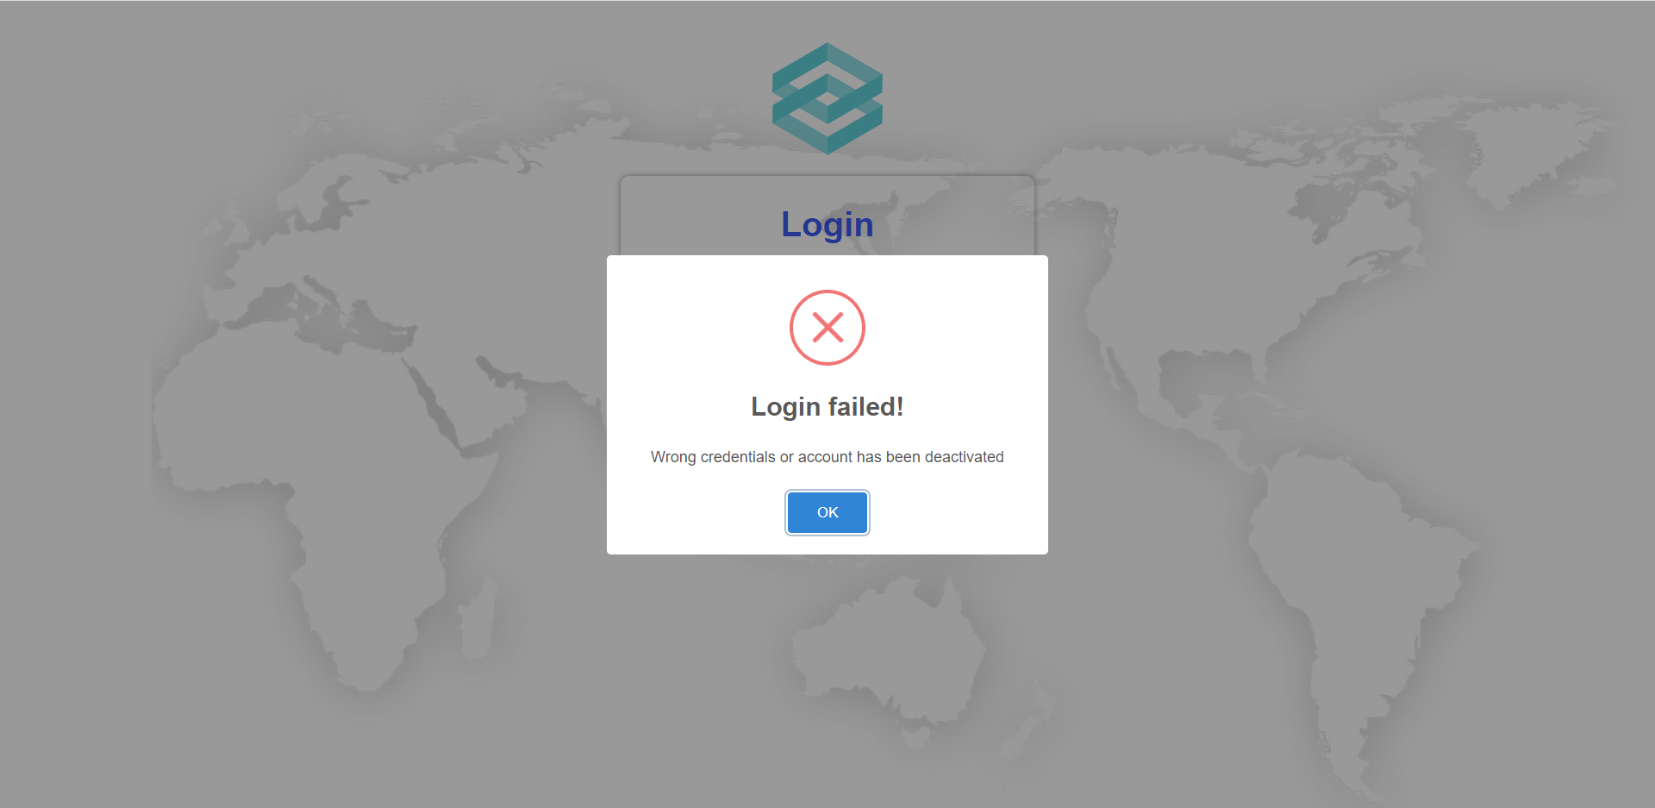
Figure 14 Error displayed when user inputs wrong email or password

Figure 15 Error displayed when user logs in with a deactivated account
After user enters a valid account and clicks on the “Login” button, the system will direct user to main page based on their account role.
- Logout
When user wants to log out from the system and go back to the login page, they can click on the logout icon in the top right corner regardless of the page they are using (Figure 16).
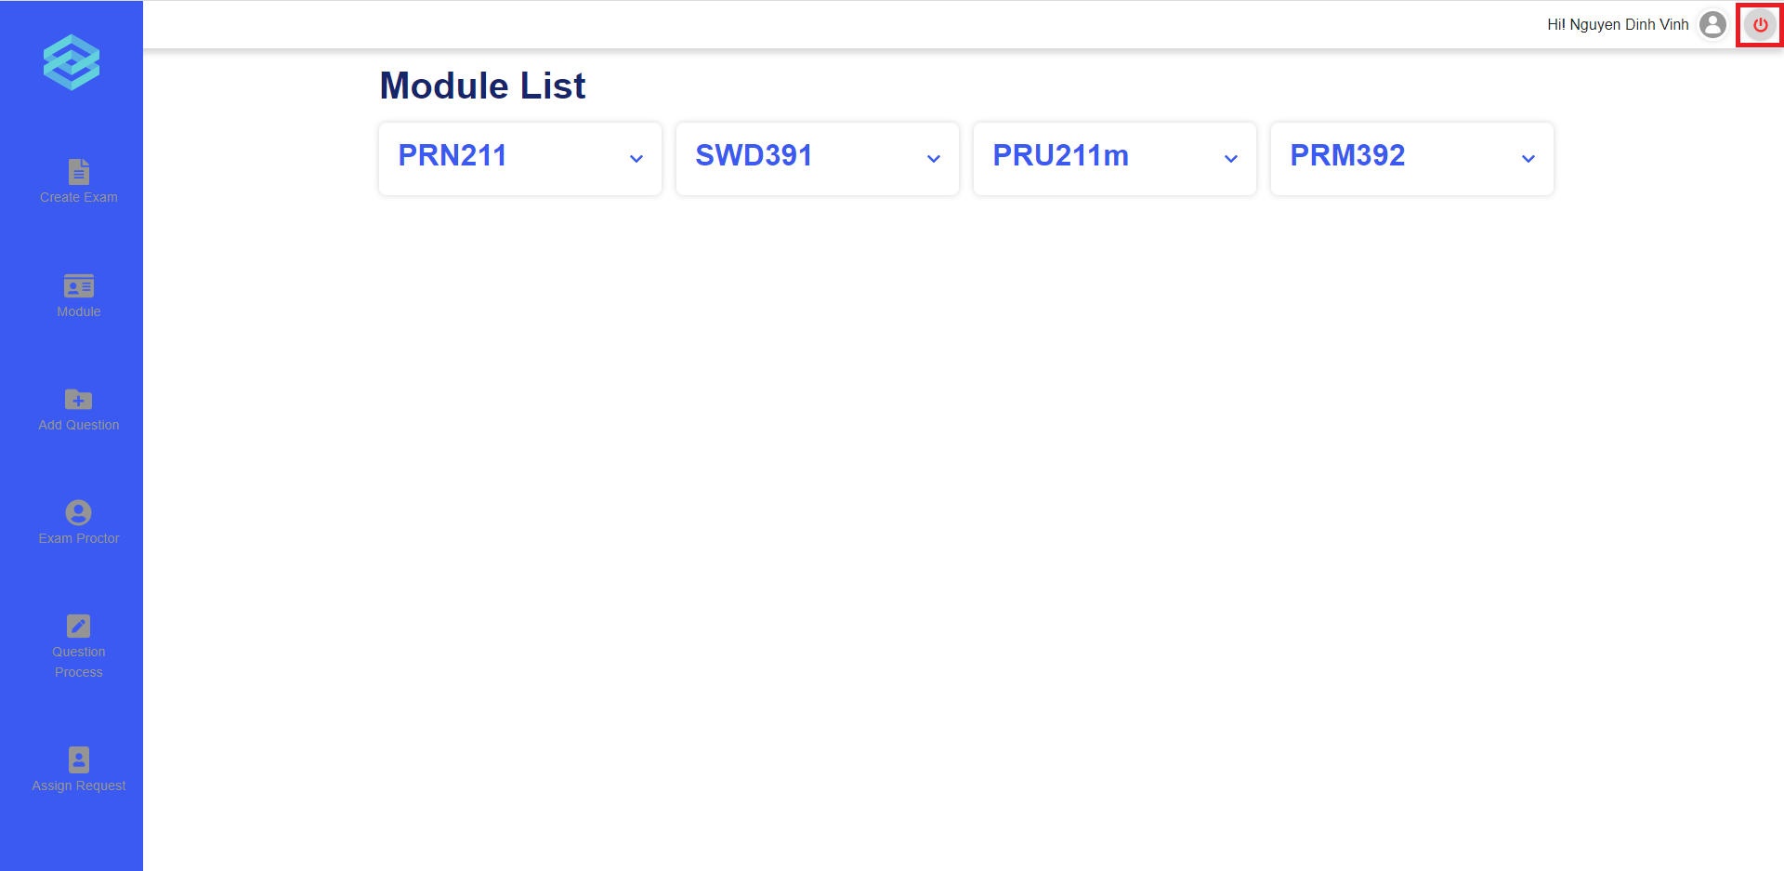
Figure 16 The logout icon
- Forgot password
User can click on the “Forgot Password?” link on the login page to be redirected to the forgot password page in order to reset their password and receive a newly generated password in their email (Figure 17, 18).
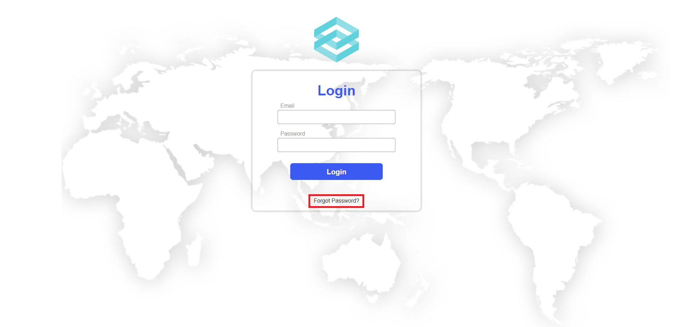
Figure 17 The “Forgot Password?” link
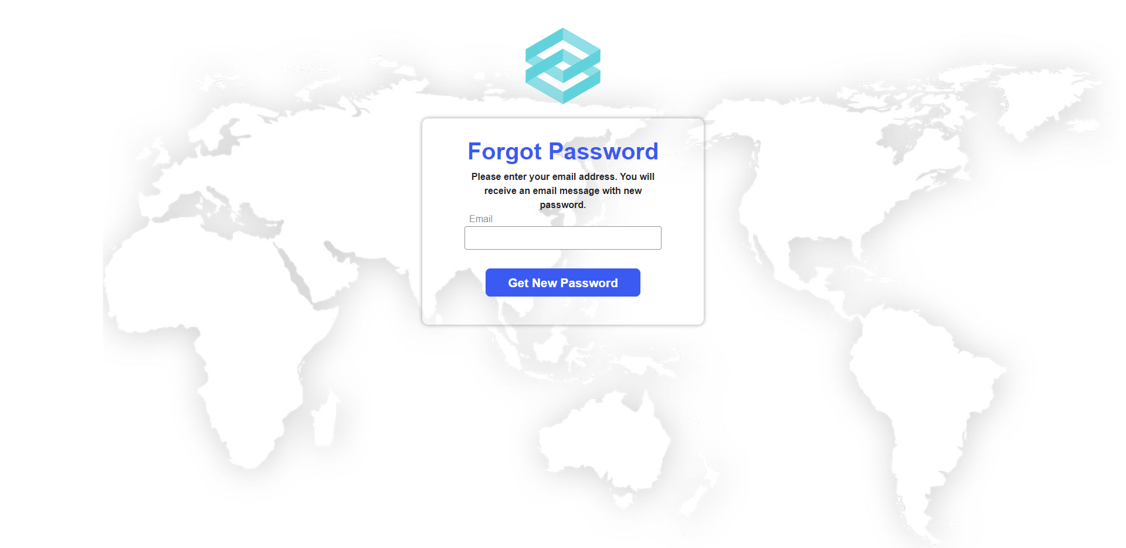
Figure 18 The forgot password page
If user leaves the input field blank or tries to log in with an invalid email address, the system will show a corresponding error message (Figure 19, 20, 21).
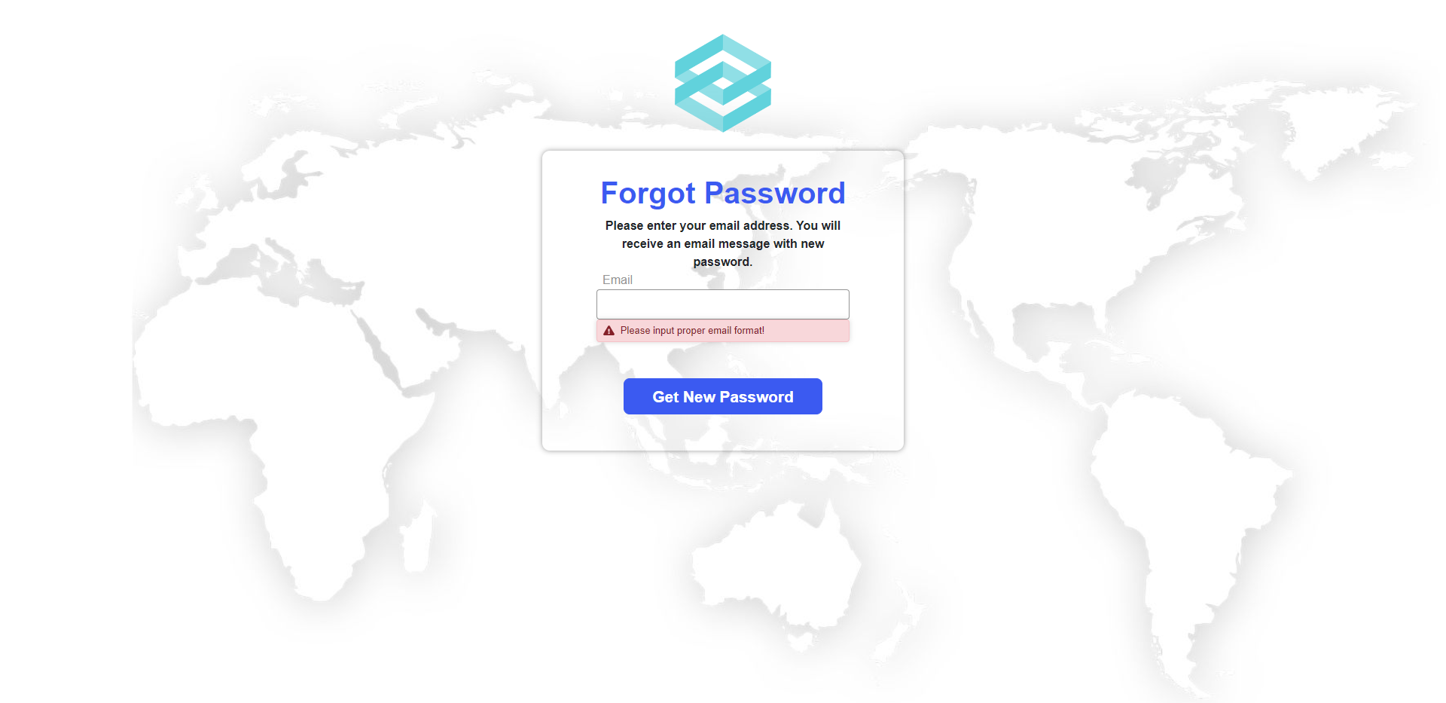
Figure 19 Error displayed when user does not input
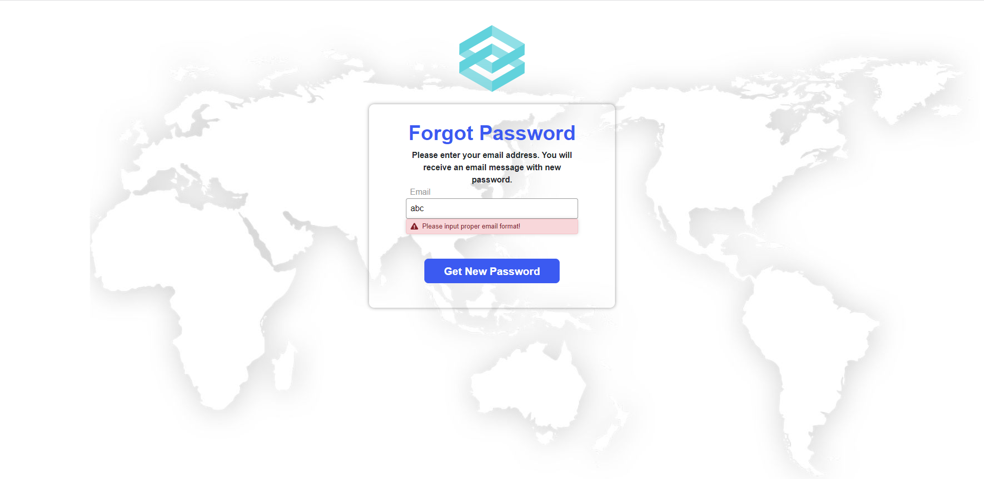
Figure 20 Error displayed when user inputs invalid email format
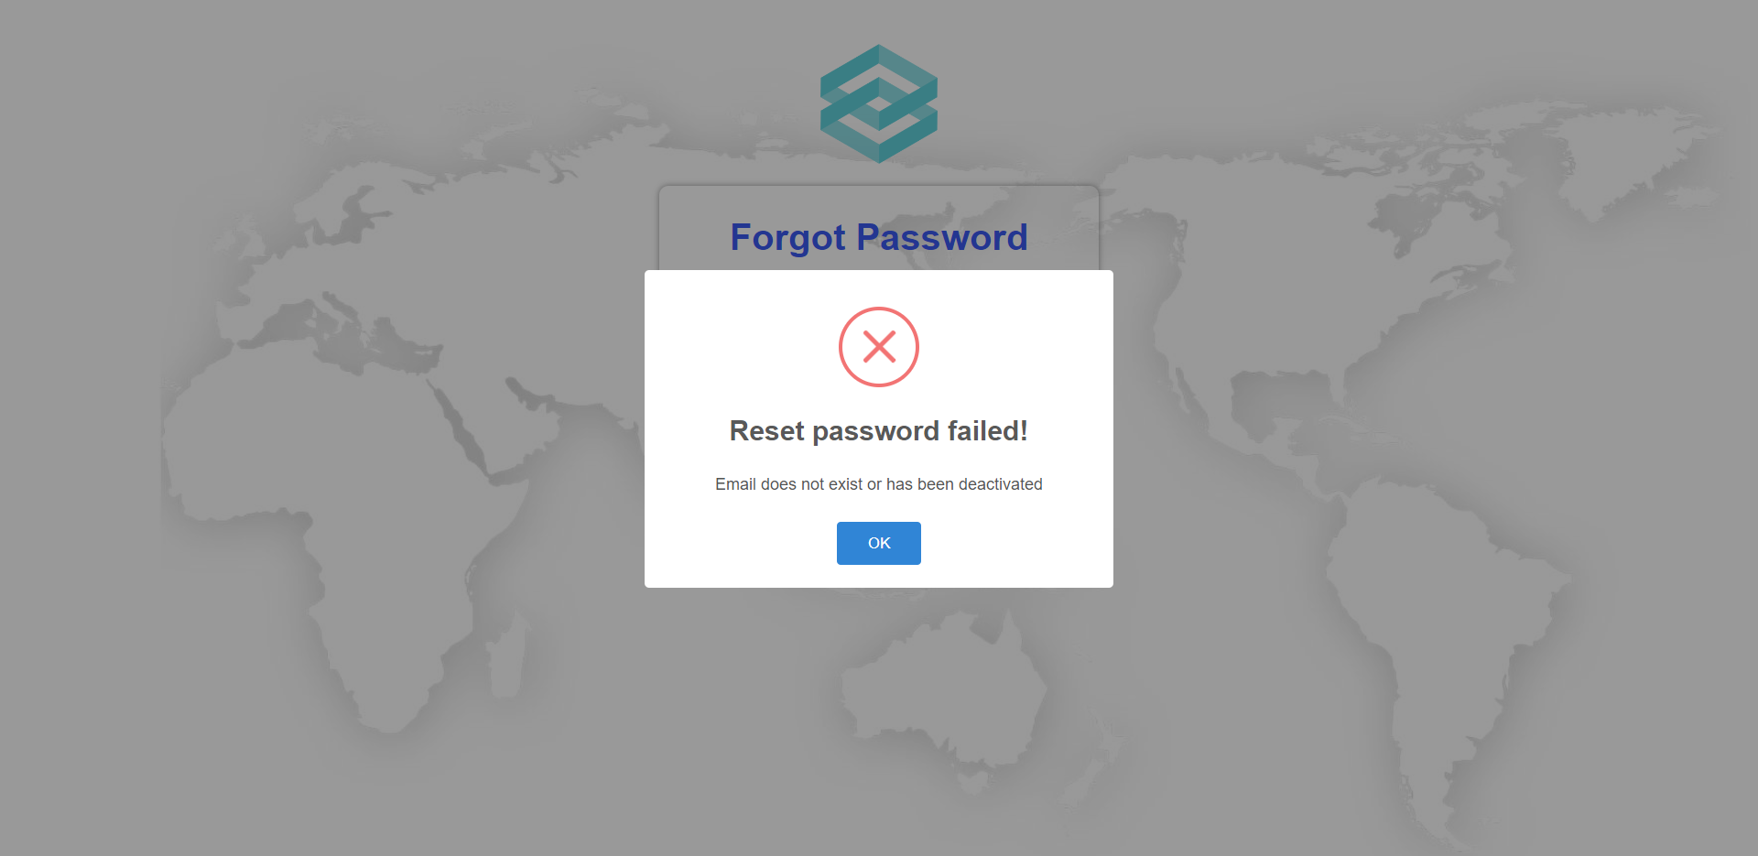
Figure 21 Error displayed when user inputs email not exist
If user inputs a valid email address and click “Get New Password” button, system will send an email containing a newly generated password to the user’s email address and show a success message (Figure 22).
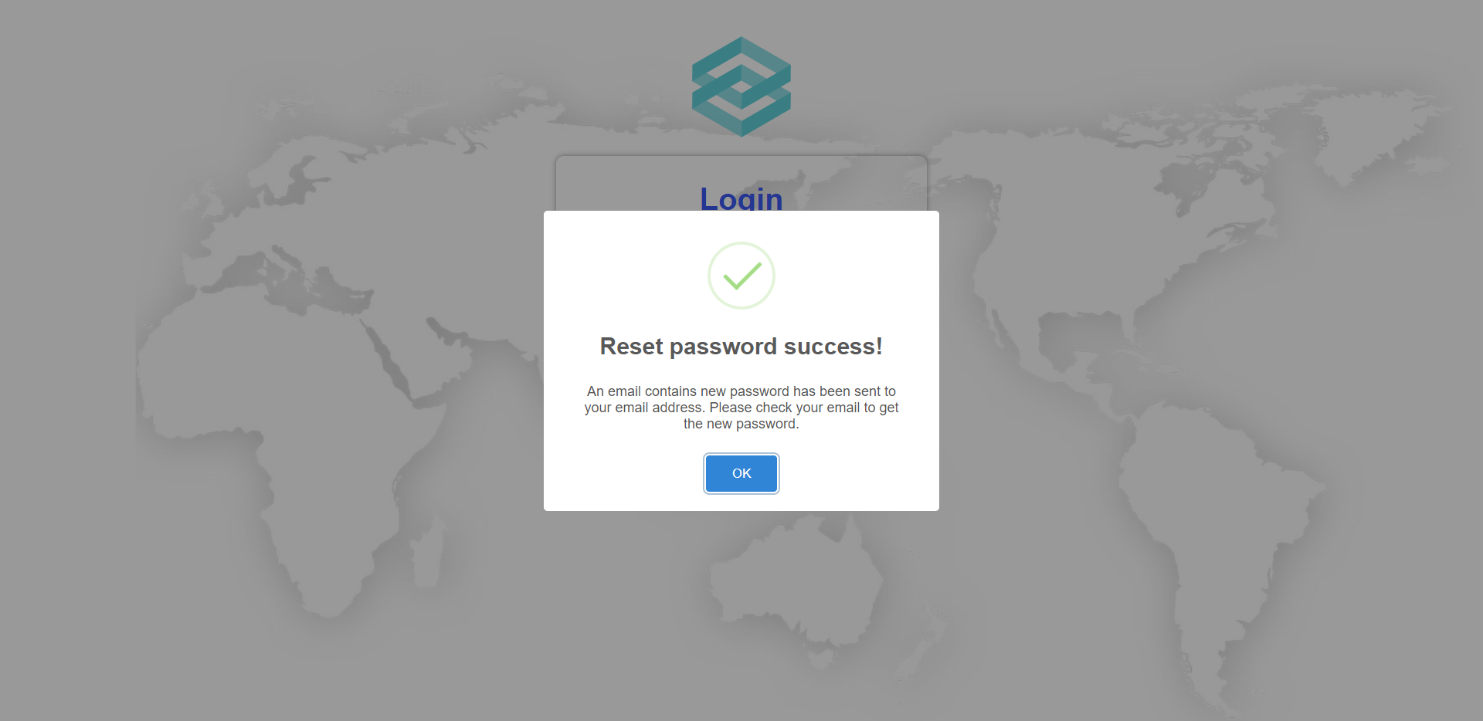
Figure 22 The reset password success message

c. Role Administrator
- Manage Account
1.1 View Account List
- After login as Administrator, an Account List will be displayed.
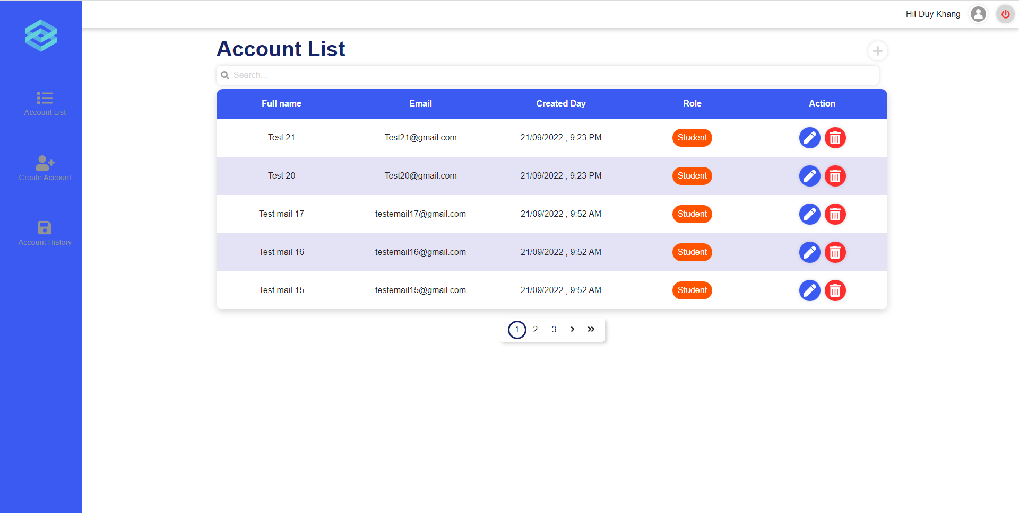
Figure 23 Account list page
1.2 Update Account
-On the main page (Account List Page) click on the [Update account] icon.
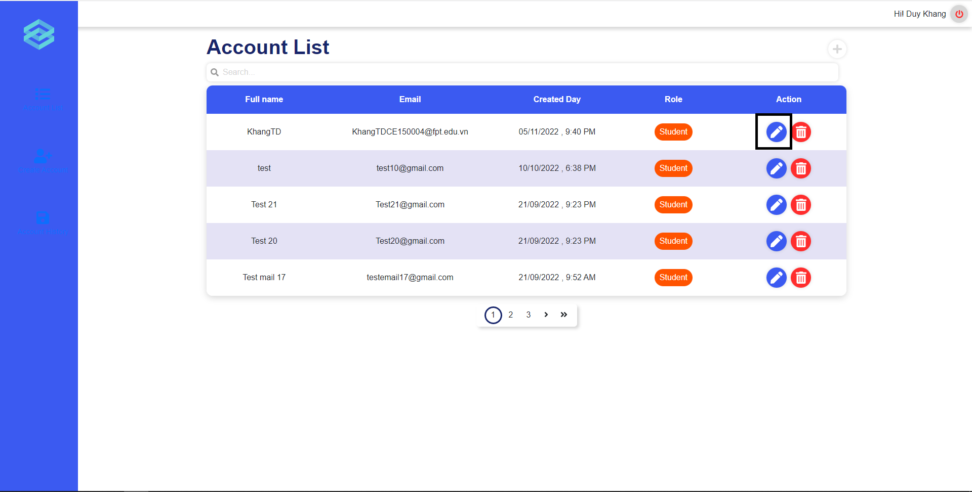
Figure 24 Edit button on Account list page
-A popup will be shown, from which you can change information in the full name and email field of the popup, and click the [Save change] button to update account information.
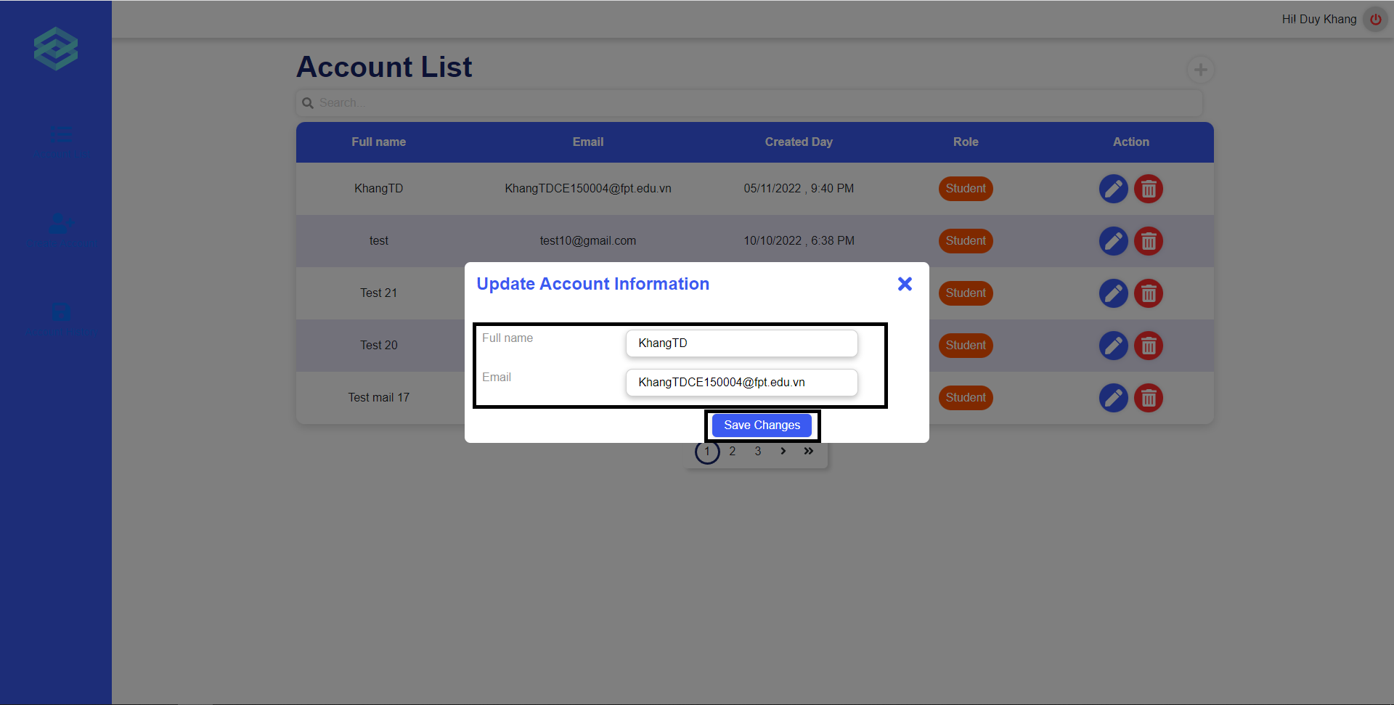
Figure 25 Update account page
1.3 Delete Account
-On the main page (Account List Page) click on the [Delete account] icon.
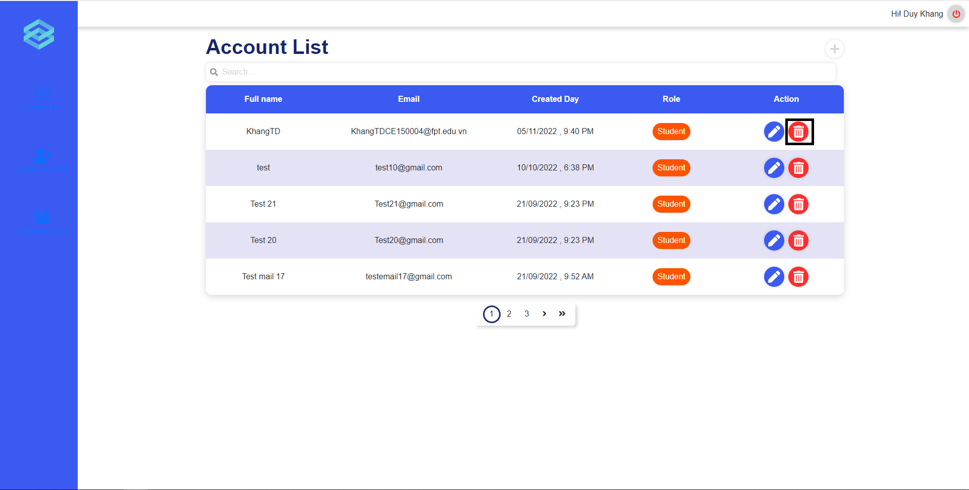
Figure 26 Delete button on Account page
-A popup will be shown, from which you can confirm before deleting. Click on [Confirm] button to delete the account, [Cancel] button to close the popup and cancel the delete.
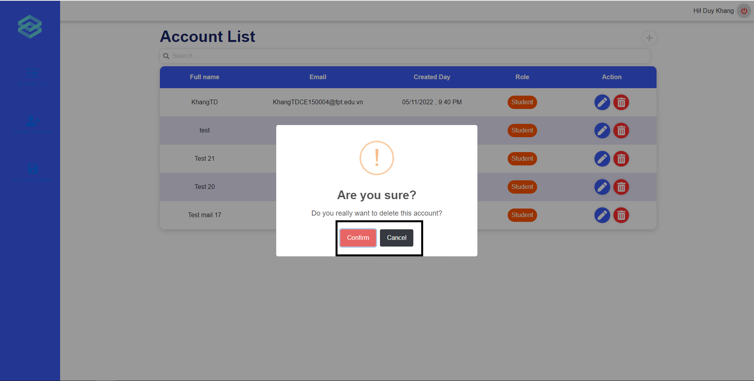
Figure 27 Delete account confirm
1.4 Create Account
-Click on the [Create Account] button on the left vertical navigation bar.
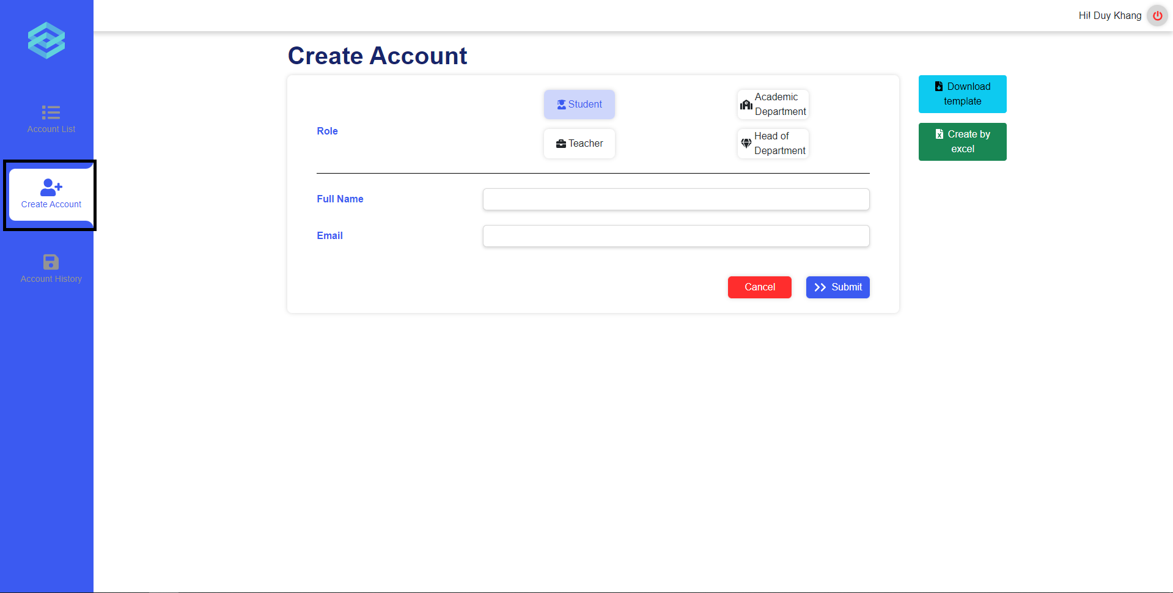
Figure 28 Create new accounts page
-Fill in all the information and click the [submit] button to create a new account.
- View Deactivated Account
-Click on the [ Account History] button on the left vertical navigation bar.
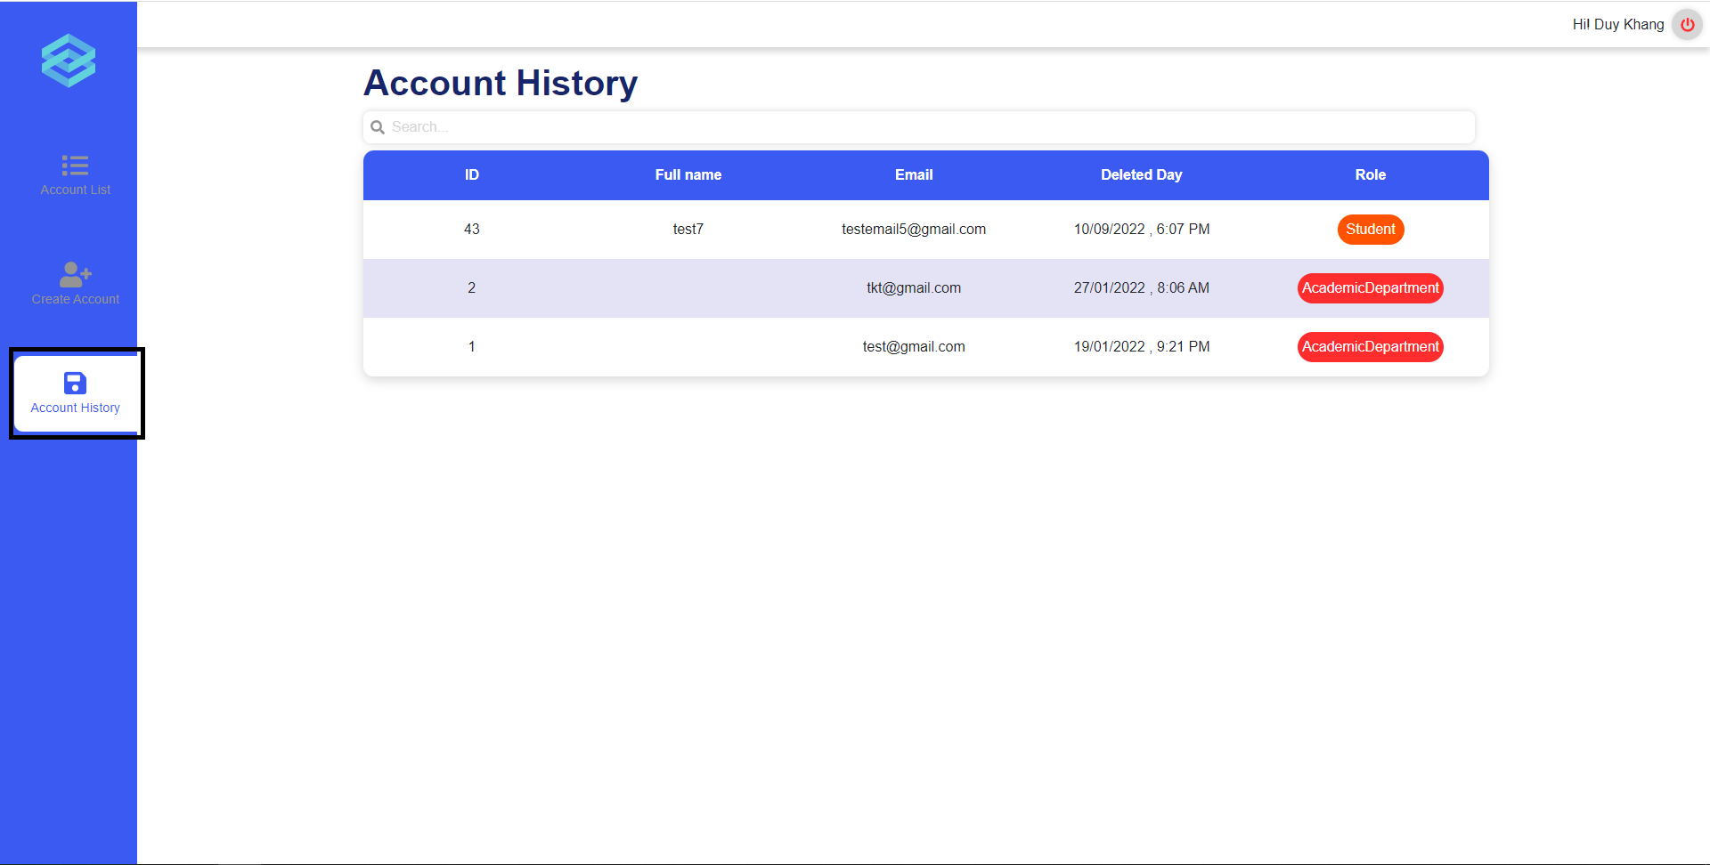
Figure 29 Account history page
- Create account by excel
-Click on the [Create Account] button on the left vertical navigation bar.

Figure 30 Create account by excel
-Click on the [Download template] button to download the excel template.
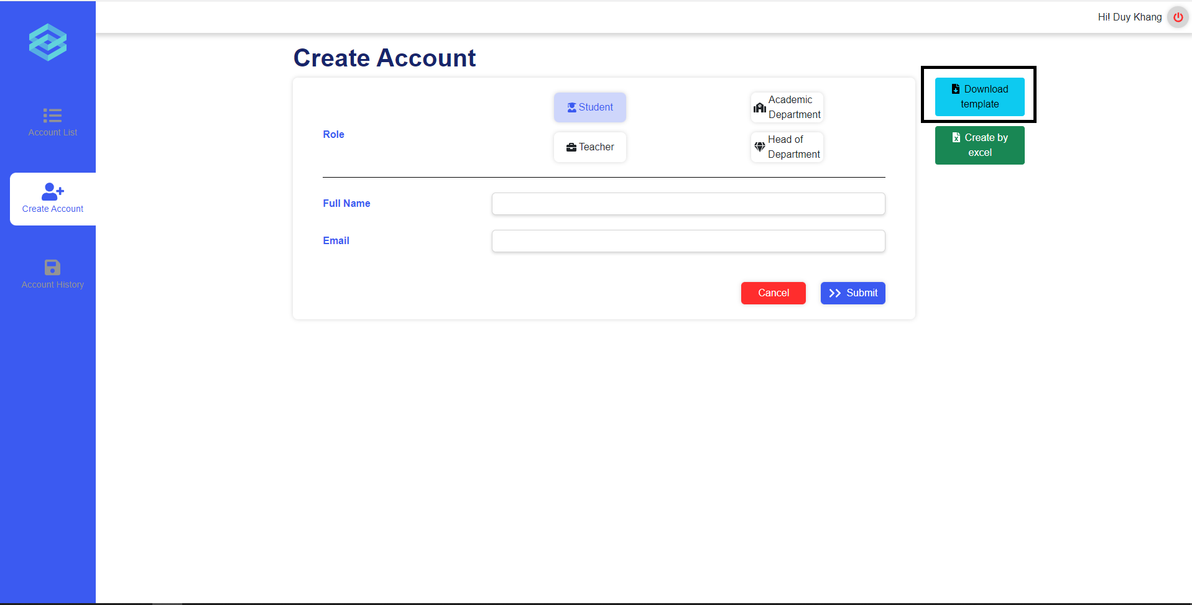
Figure 31 Download button on create account page
-Fill in all the information in excel template and click on the [Create By Excel] button.
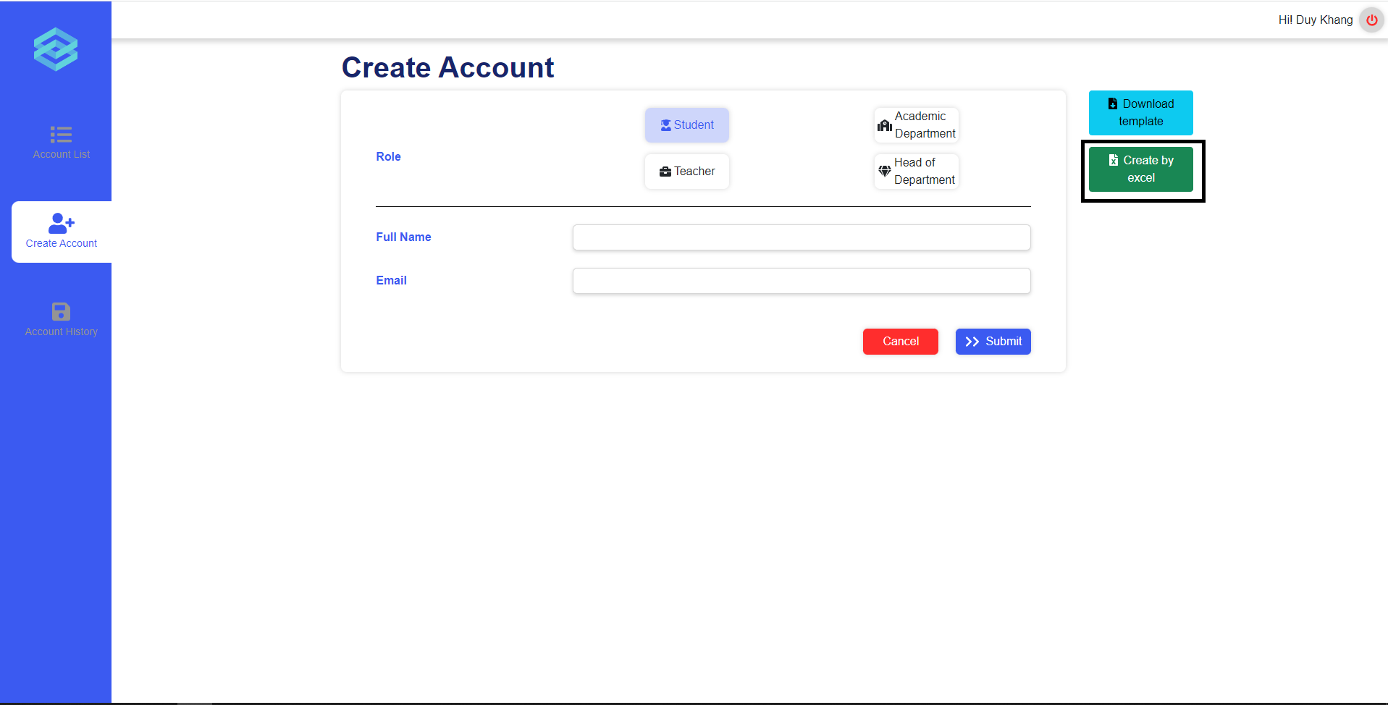
Figure 32 Excel upload button on create account page
-A popup will show. Click on the [Choose file] button and choose the excel file you have filled in in the previous step, after that click on the [submit] button.
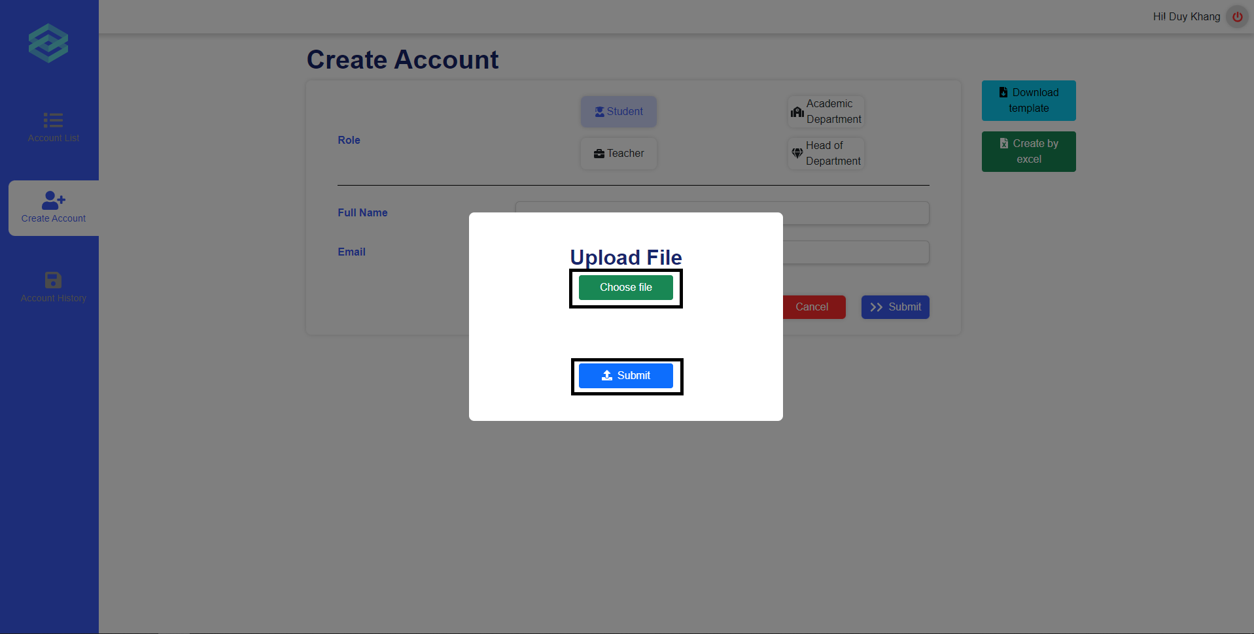
Figure 33 Upload file

d. Role Academic department
- Manage modules
The academic department can perform module related activities from the module list page.
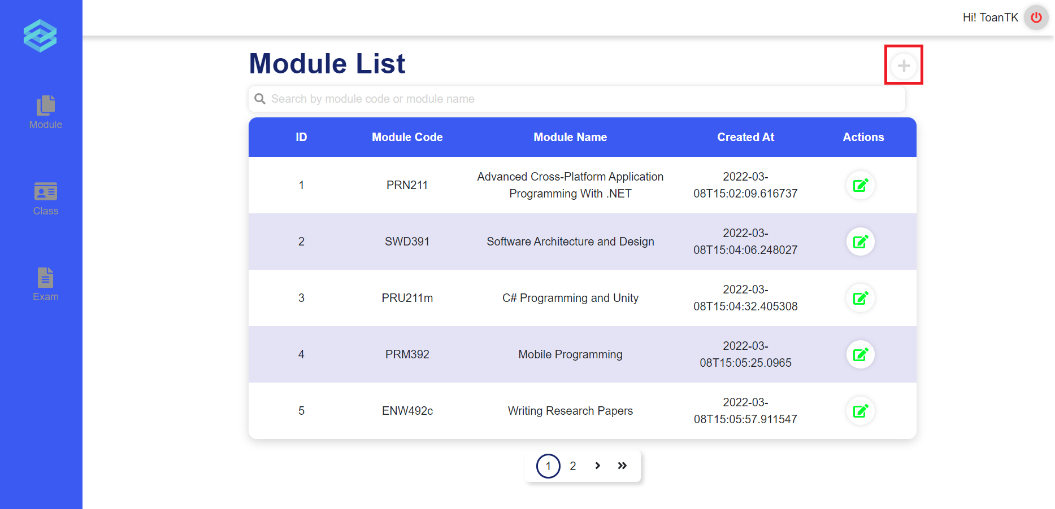
Figure 34 Create module button
They can click on the plus icon to start creating a new module.
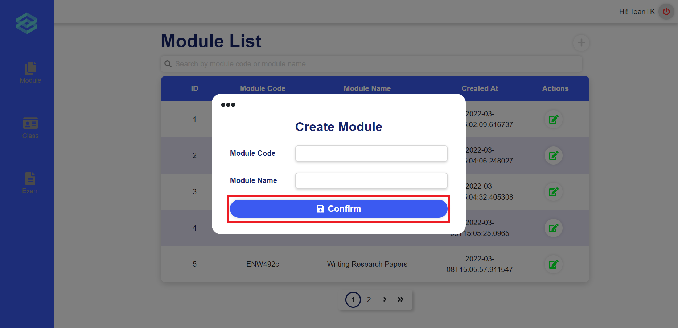
Figure 35 Create module form
After they click the plus icon, a pop up will appear prompting them to input the new module’s code and module’s name. They can then click Confirm to create a new module.
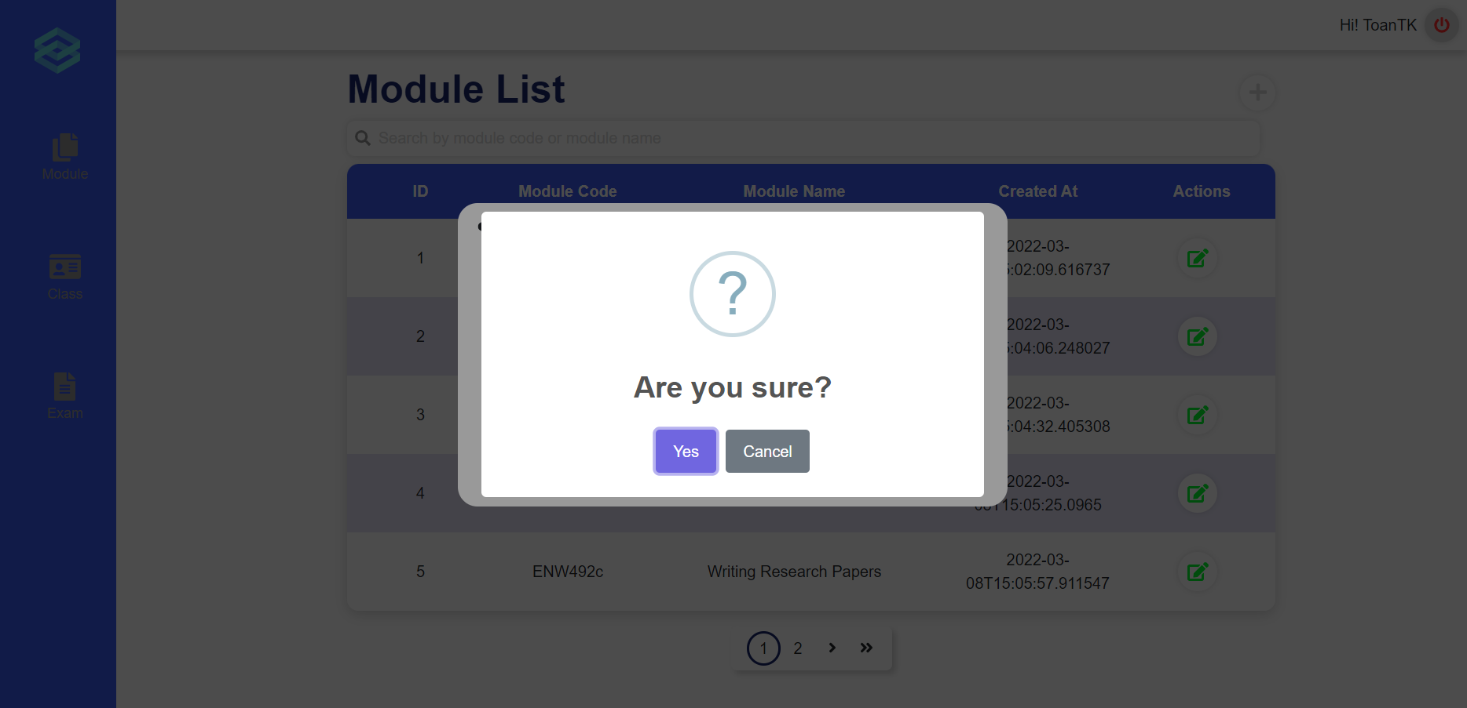
Figure 36 Create module confirm
After clicking confirm, a pop up will appear asking for confirmation. If the user clicks “Yes”, a new module will be created. If the user clicks “Cancel”, they will exit the pop ups.
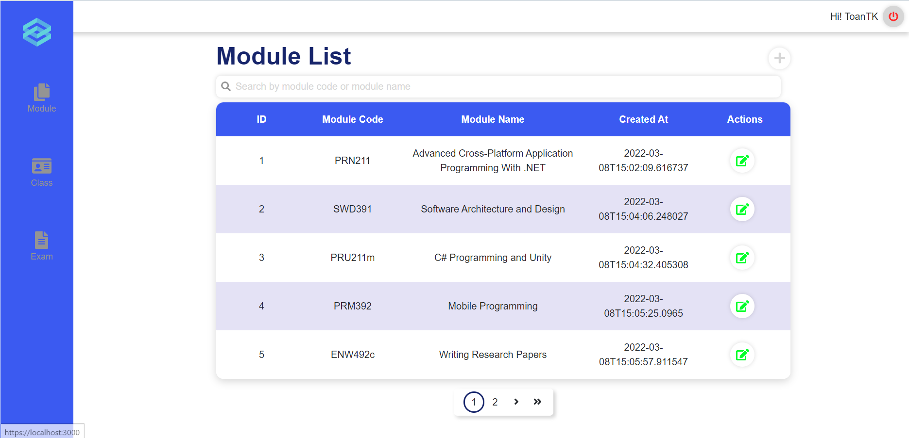
Figure 37 Module list page
The user can start updating a module by click on the edit icon in the actions column for a specific module.
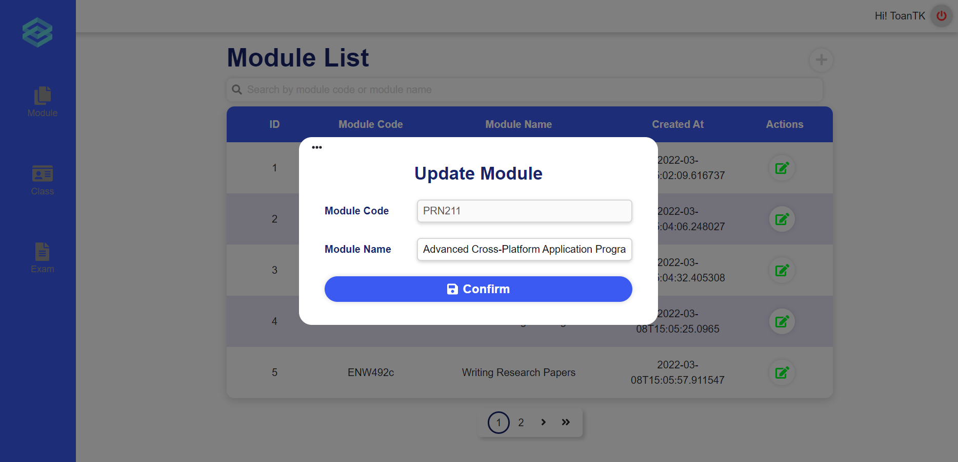
Figure 38 Update module form
After clicking the edit icon, a popup will appear, allowing the user to enter a new module’s name. The user can then click Confirm to proceed.
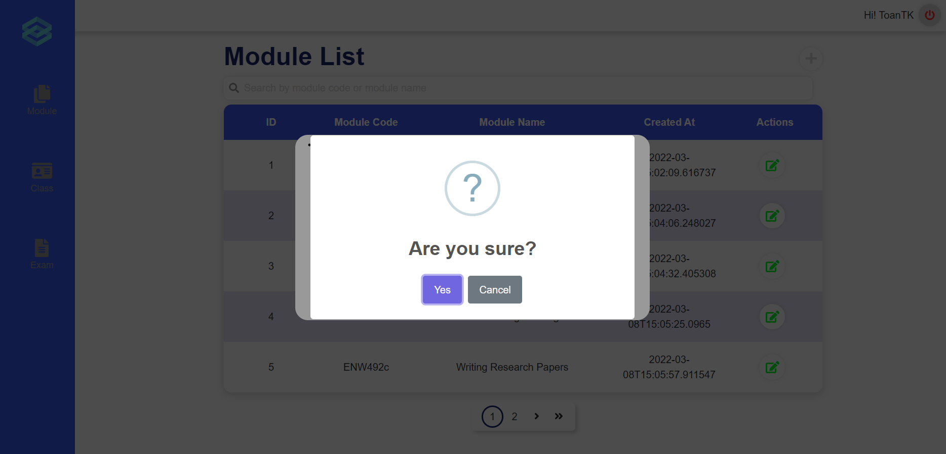
Figure 39 Update module confirm
After clicking confirm, a popup will appear asking for the user’s confirmation. If the user clicks “Yes”, then the module will be updated. If the user clicks “Cancel” then they will exit the popups.
- Manage classes
Users can perform create new class from the class list page by clicking on the plus icon at the top-right of the page.
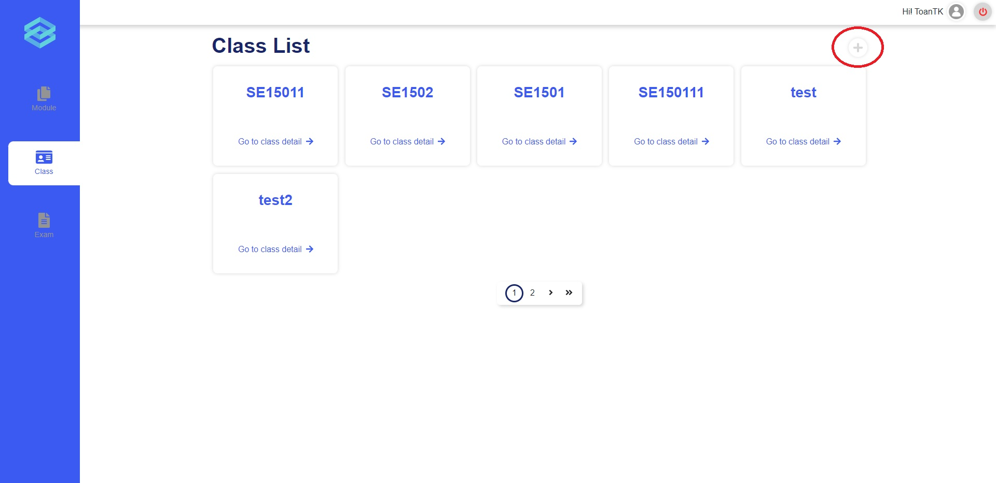
Figure 40 Create class button
The create class form is a multi-level form, user need to fill in all the input fields of all section on the left hand side.
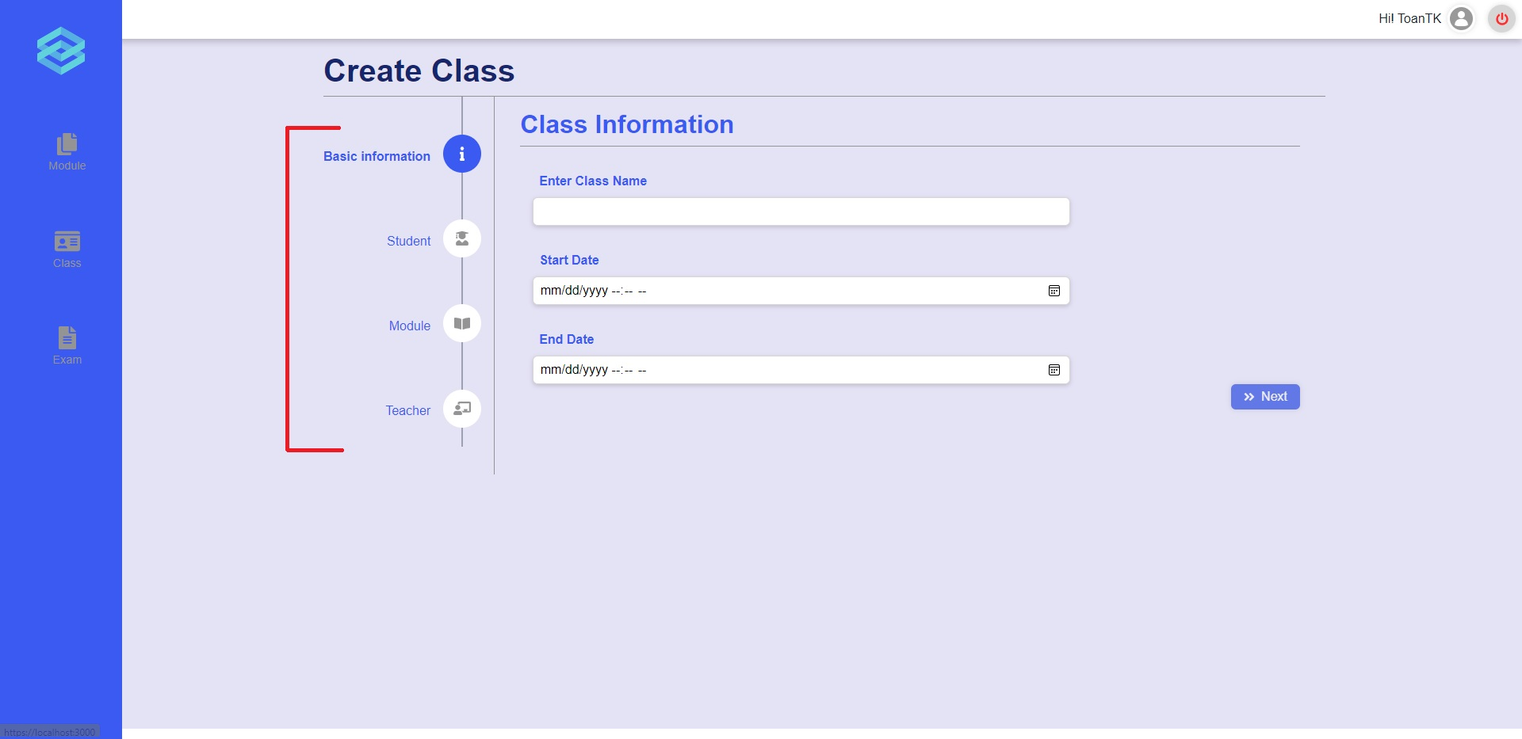
Figure 41 Create class form
Otherwise, by clicking on each class, users are provided a class detail page where all the class information is displayed. User can choose to Update class information or go into detail of each module of the class.
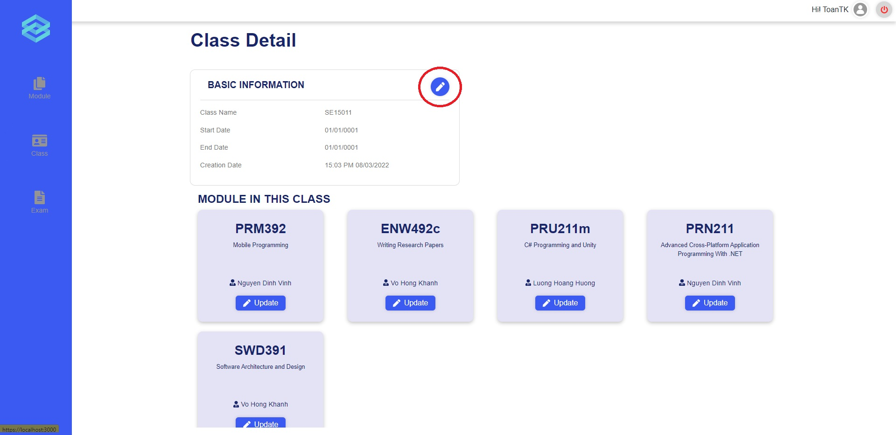
Figure 42 Update class button
To update class information, user just need to edit the text in the input and click “Save Change” to confirm when user is done.
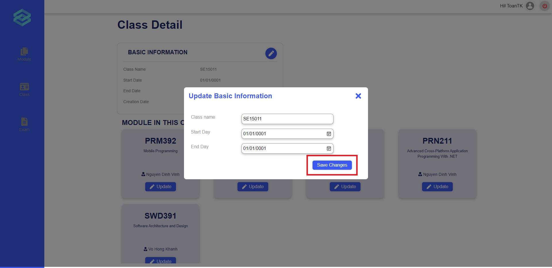
Figure 43 Update class button
- Manage exams
User can start performing exam related activities from the Exam list page.
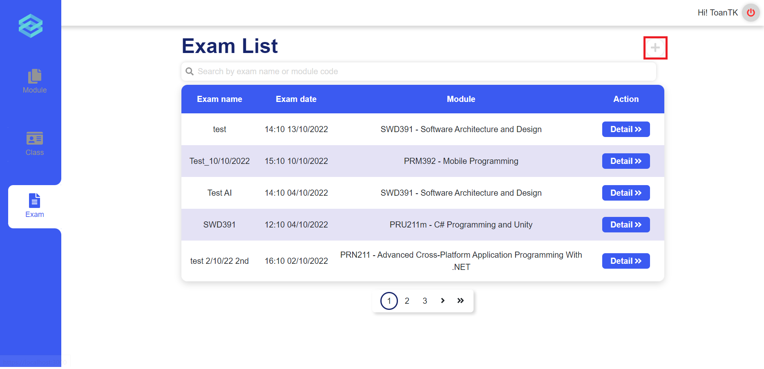
Figure 44 Create Exam button
The user can start creating a new exam by clicking on the plus icon.
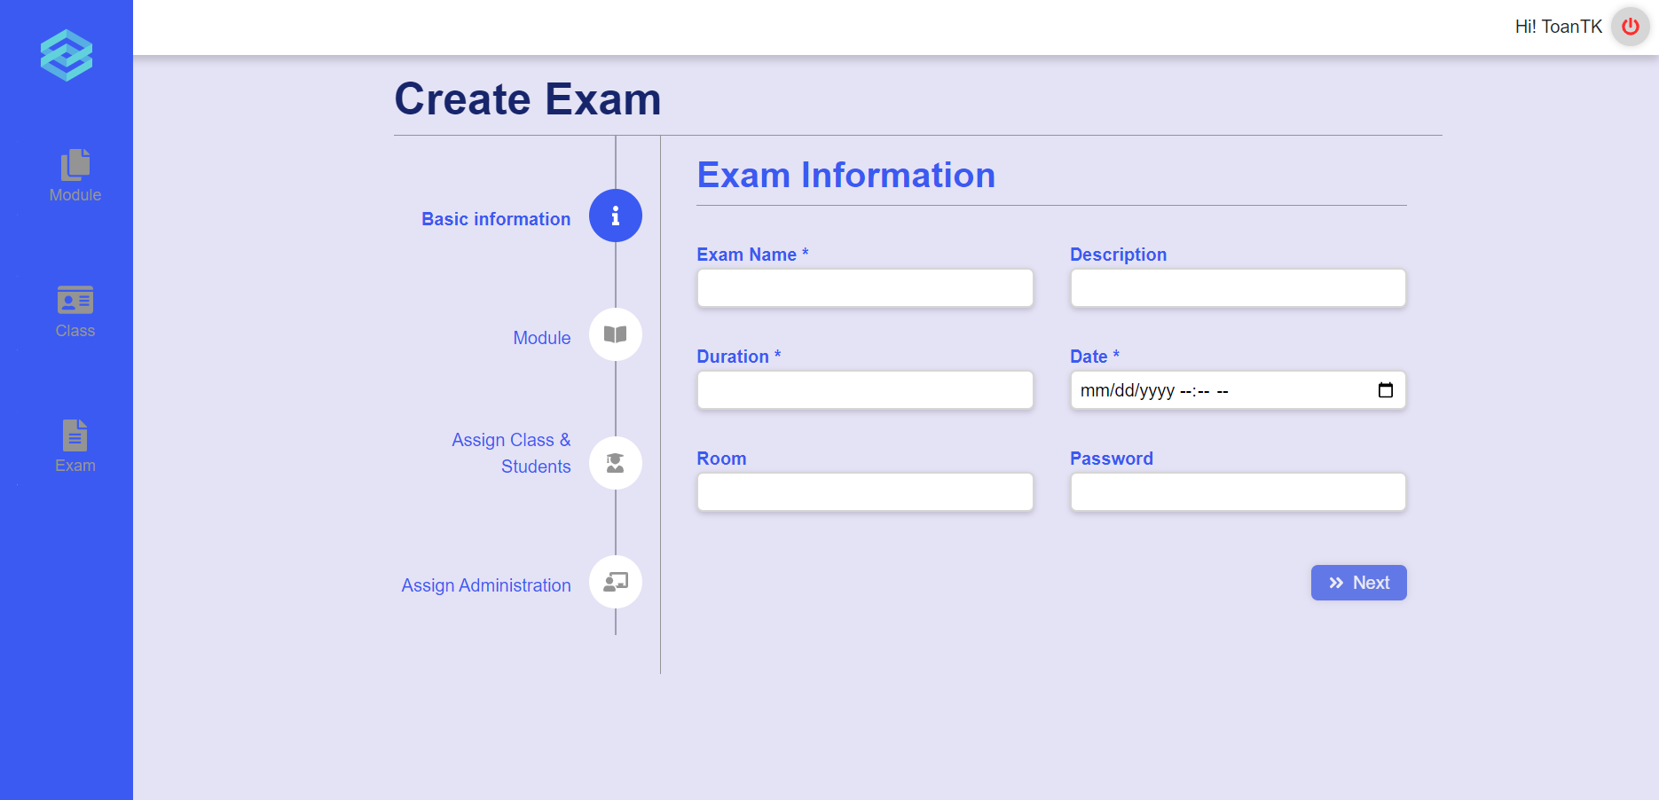
Figure 45 Create Exam button
After clicking the plus icon, the user will be redirected to the create exam page. Here, the user are prompted to input the required information in 4 steps. Step 1, they are required to fill in the Exam Name, Duration and Date. The fields description, room and password are not required. Only if the user has filled all required fields, will the “Next” button be lit up and the user can click on it to proceed.
After successfully filling all the information, the user can click the submit button to create the exam. The program will show a popup asking for the user’s confirmation. If the user agrees to proceed, the exam will be created and they will be redirected to start creating the problem sets for the exam.
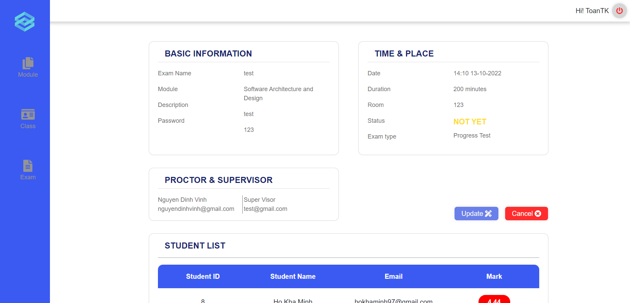
Figure 46 Exam detail page
The user can also access the detail page by clicking on the “Detail” button in the “Action” column for a specific exam. After clicking on the “Detail” button, the user will be redirected to the Detail page. Here the user can view the detail of the exam, and they can also update the exam’s information or cancel the exam.

e. Role Teacher
- Manage exams
1.1. Create exam
After login in successfully with the teacher’s account, user can click on the “Create Exam” icon on the vertical navigation bar to go to a create exam page (Figure 47).
Here, user is prompted to input the required information in 3 steps:
- Step 1, user is required to fill in the Exam Name, Duration, and Date. The fields description, room, and password are not required. Only if the user has filled all required fields, will the “Next” button be lit up and the user can click on it to proceed (Figure 47).
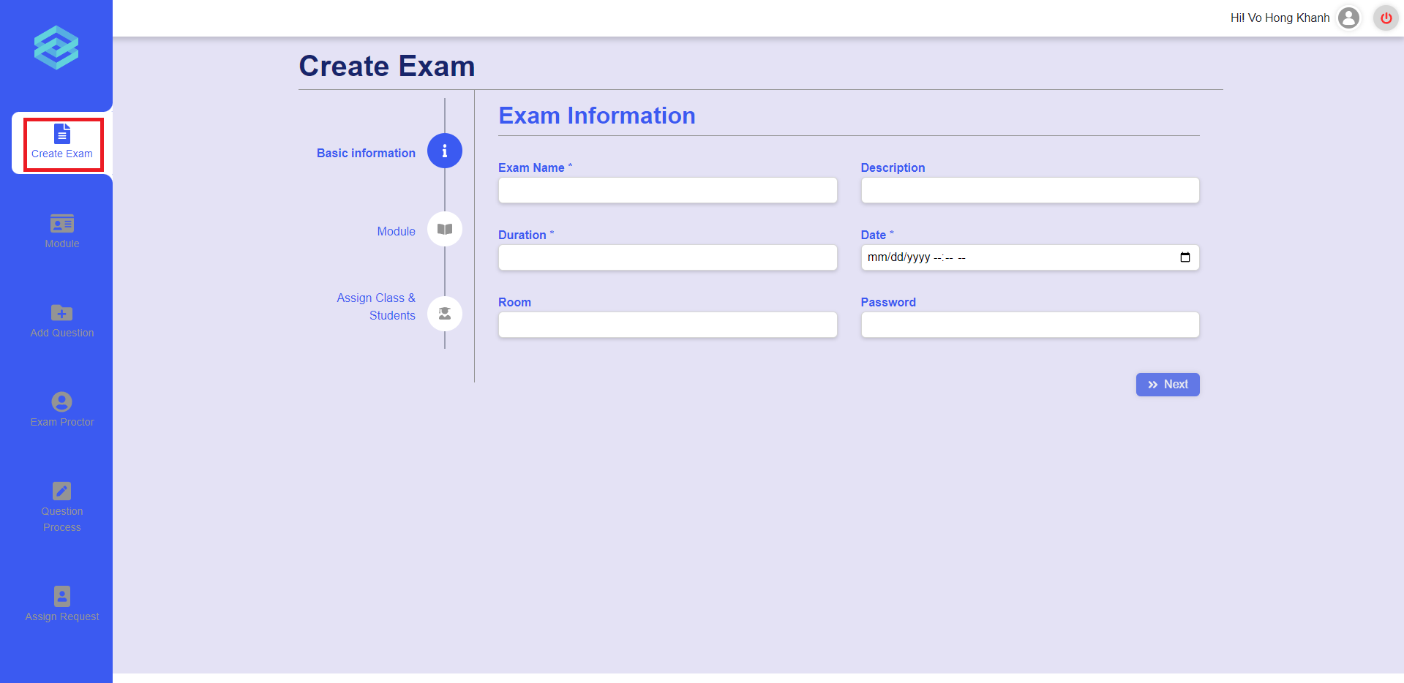
Figure 47 The create exam page in step 1
- Step 2, user is required to select a module for the exam, every time they choose a module in the list, that module code and name will be displayed on the “Chosen Module” tab. After choosing the module, the “Next” button will be lit up and user can click on it to proceed (Figure 48).
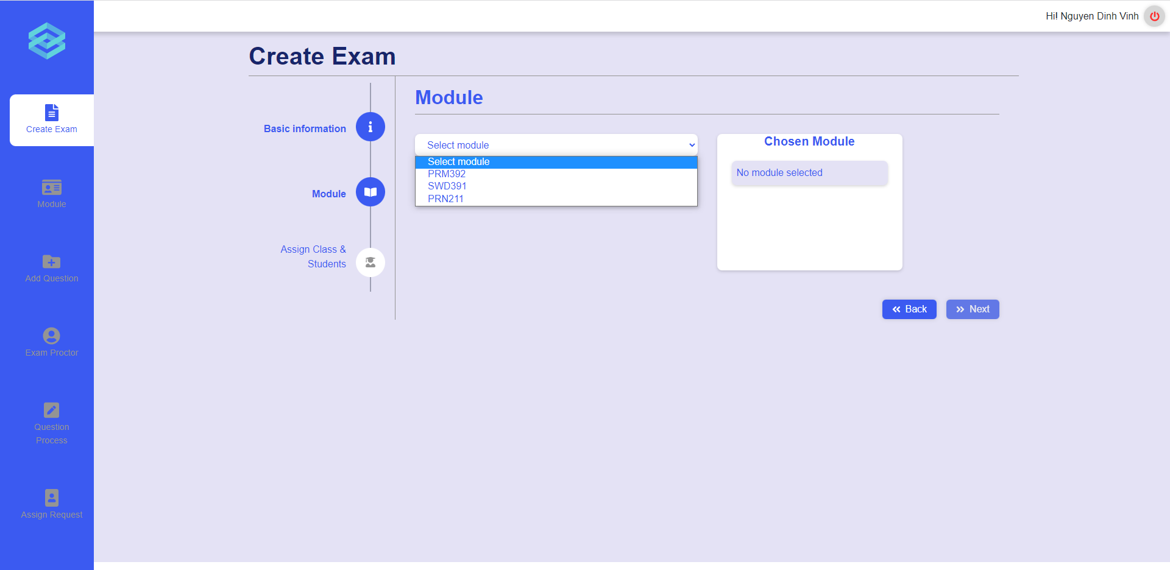
Figure 48 The create exam page in step 2
- Step 3, user is required to assign a class or students to take the exam. User can click on the tab “Class” or “Student” to switch between assigning a class or students. Every time user chooses a class or students, similar to step 2, the name of that class or students will be displayed on the right tab (Figure 49, 50). User can assign one class and one or multiple students to take the exam.
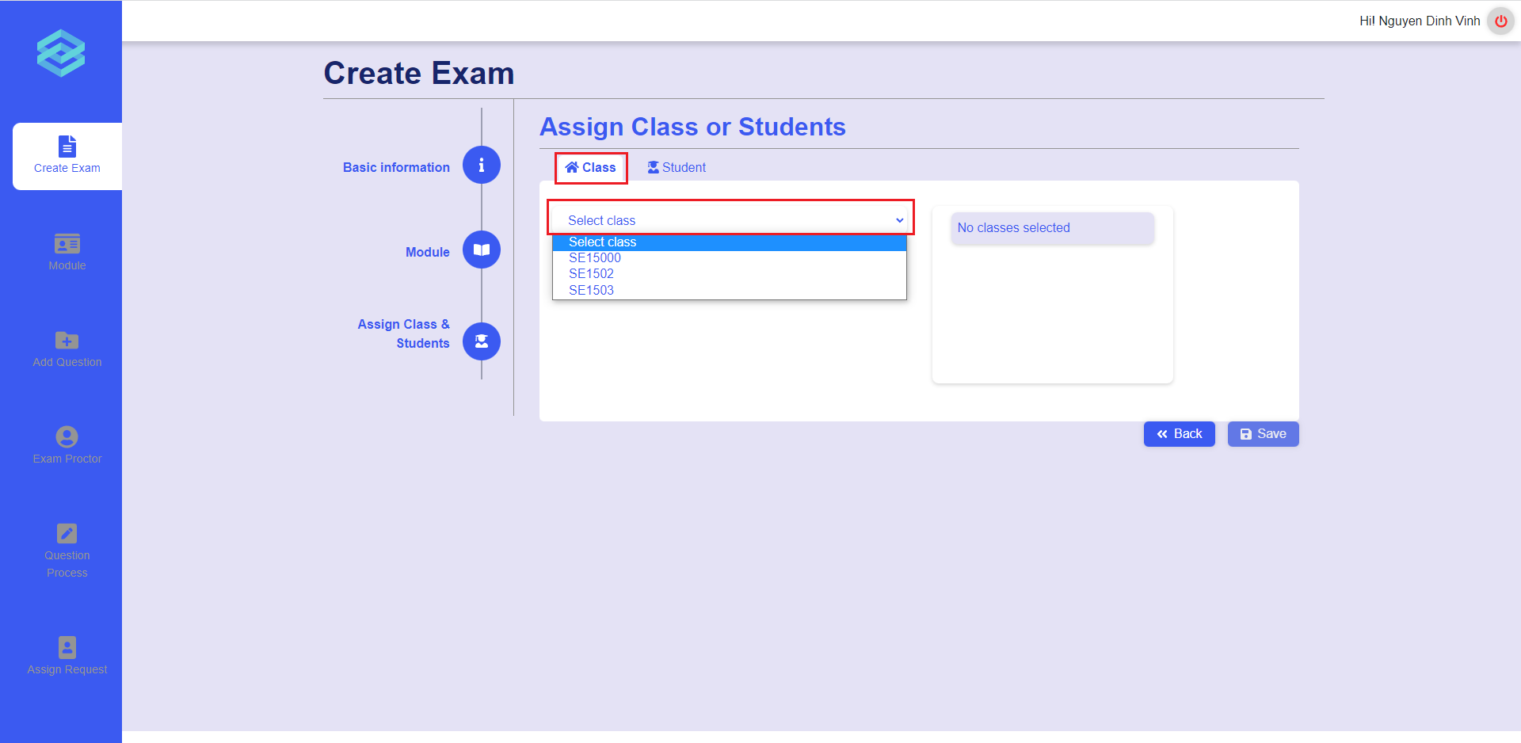
Figure 49 The create exam page in step 3 with class selection

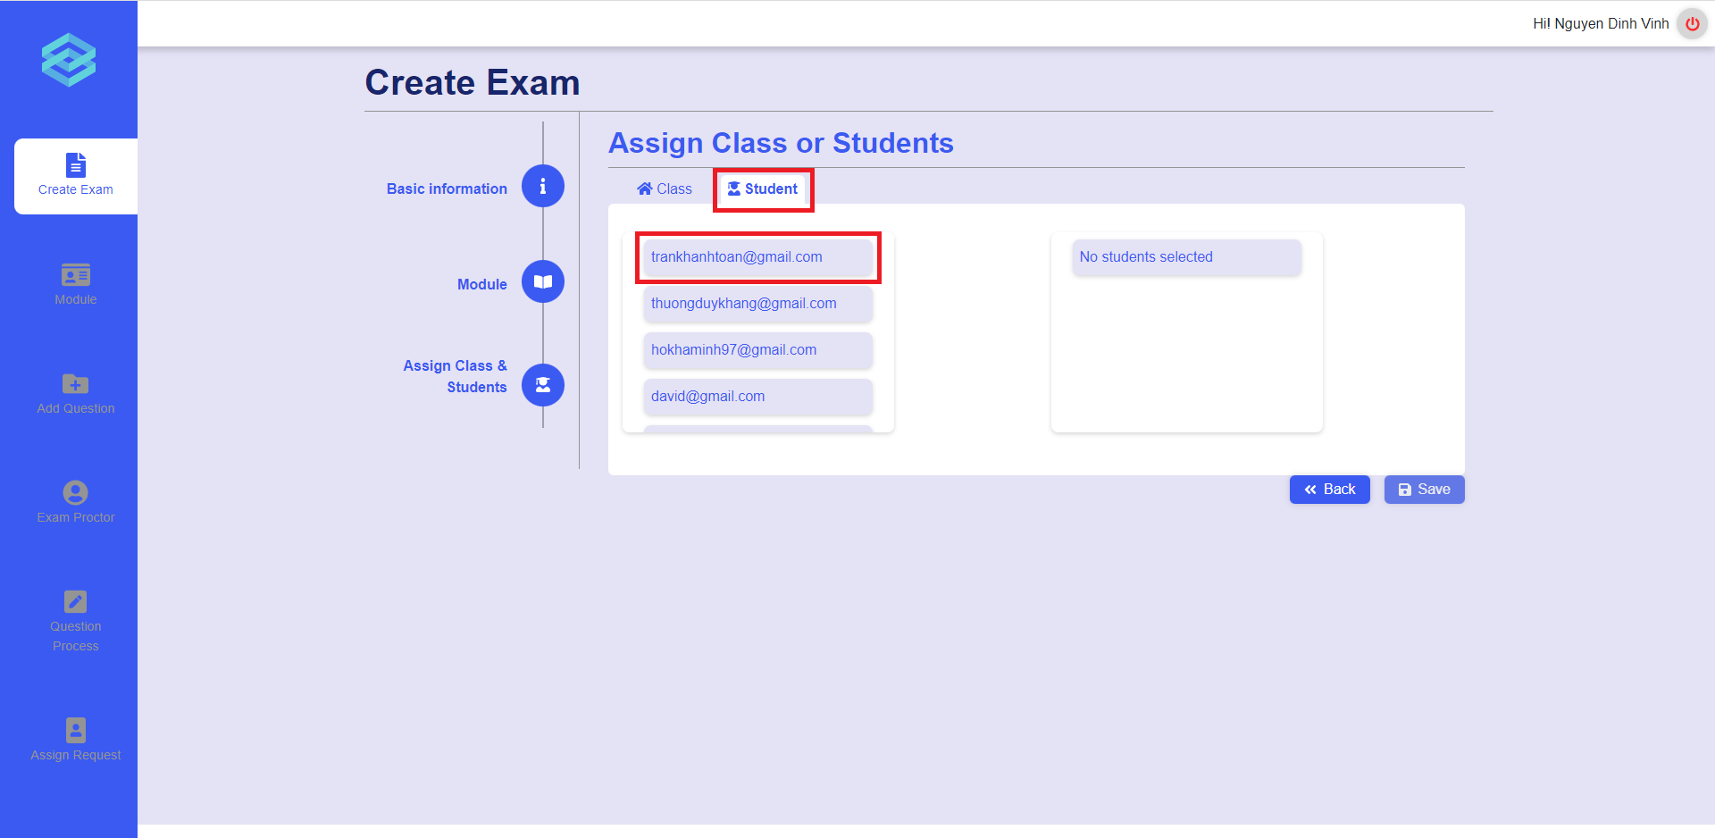
Figure 50 The create exam page in step 3 with student selection
After successfully filling in all the information, the user can click the “Save” button to create the exam. The program will show a popup asking for the user’s confirmation (Figure 51). If the user agrees to proceed, the exam will be created and they will be redirected to start creating the problem sets for the exam.
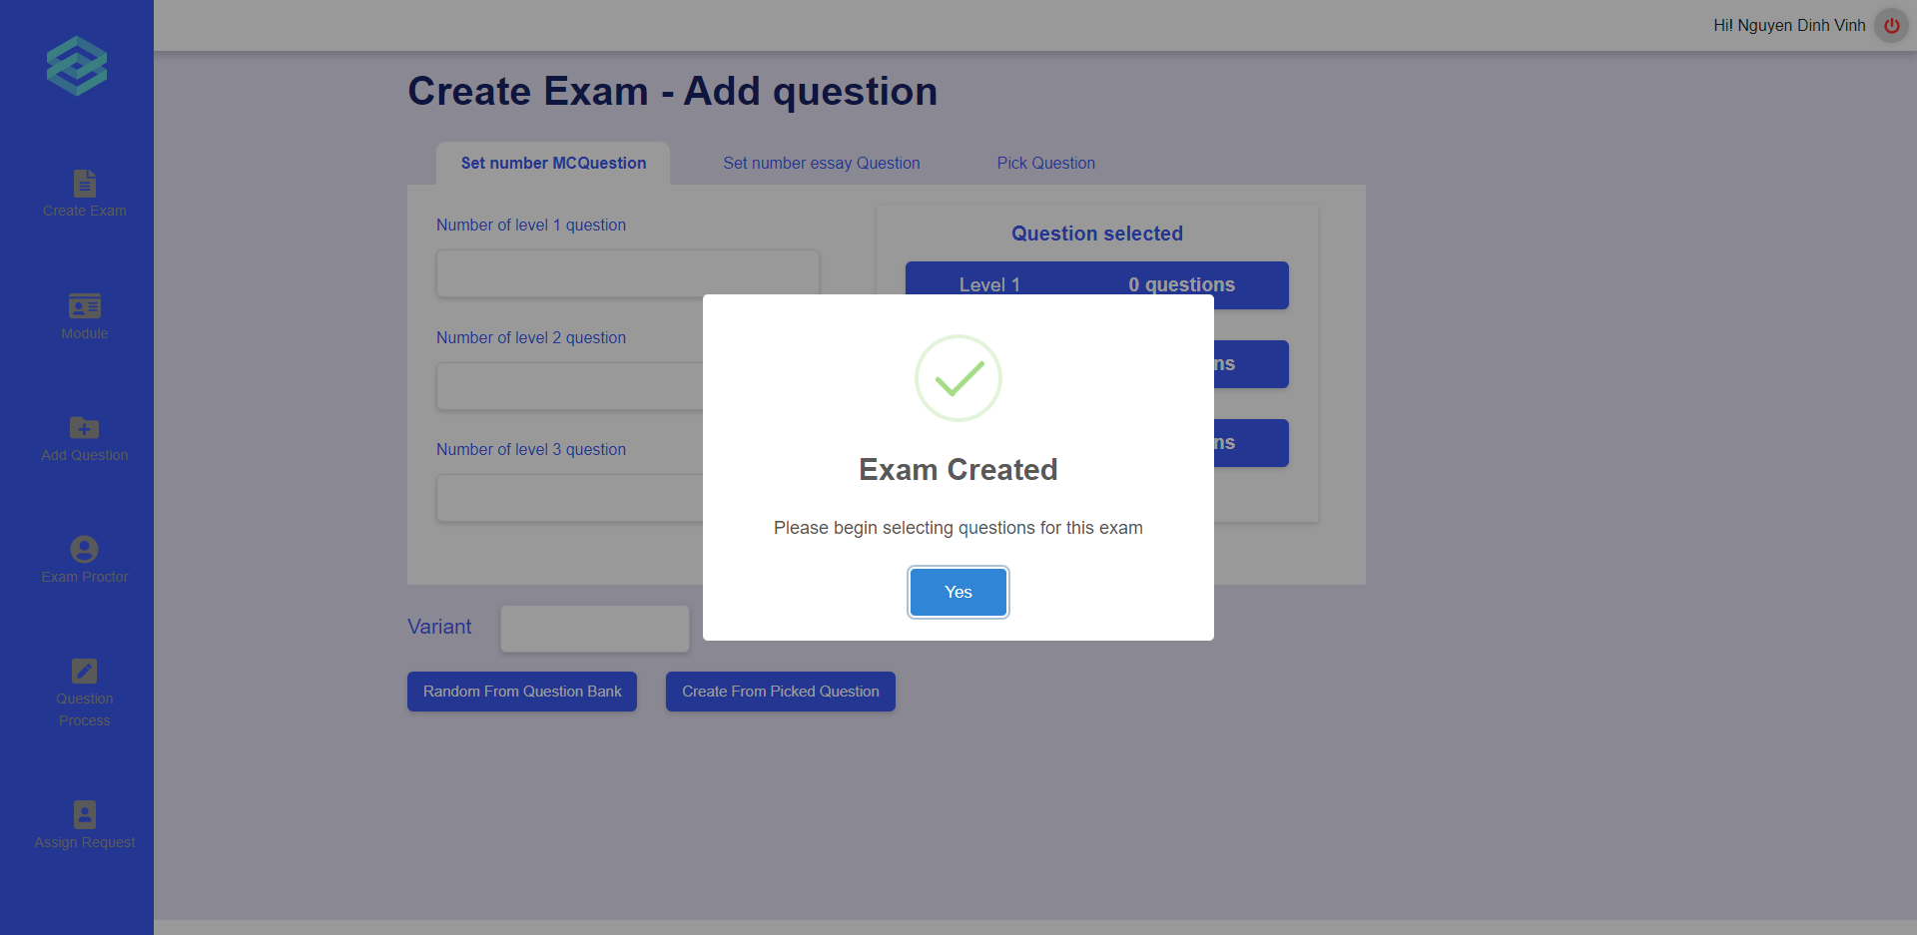
Figure 51 Popup after creating exam successfully
When creating the problem sets for the exam, user can choose to get questions randomly from the question bank or to pick questions by hand. If user wants to get random questions from the question bank, user needs to enter the number of multiple-choice questions or essay questions in each level and then click on the “Random from question bank” button to create the problem sets automatically (Figure 52, 53). Otherwise, if user wants to pick questions from the question bank by hand, user can click on the “Pick Question” tab and click on each question to choose, then they can click on the “Create from picked question” button to create the problem sets from those picked questions (Figure 54). Furthermore, user can enter the number of variants so that system can swap questions randomly to generate the corresponding number of problem sets.
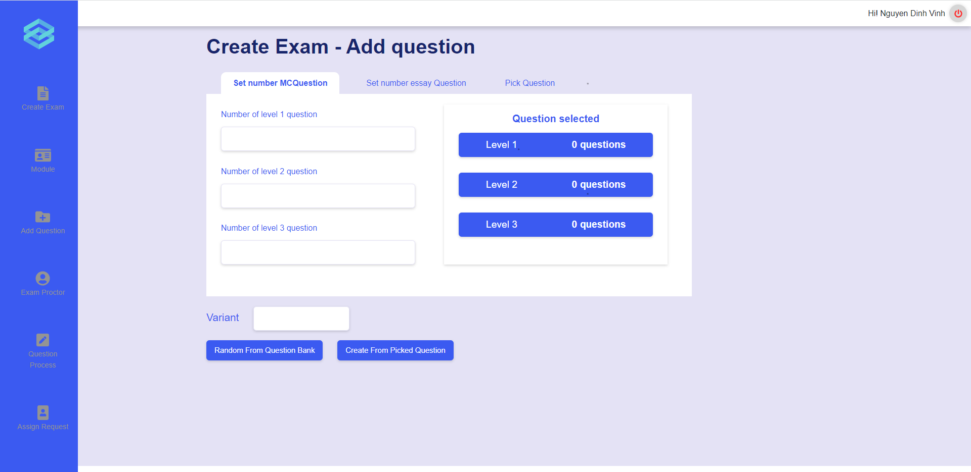
Figure 52 Set number of multiple choice questions
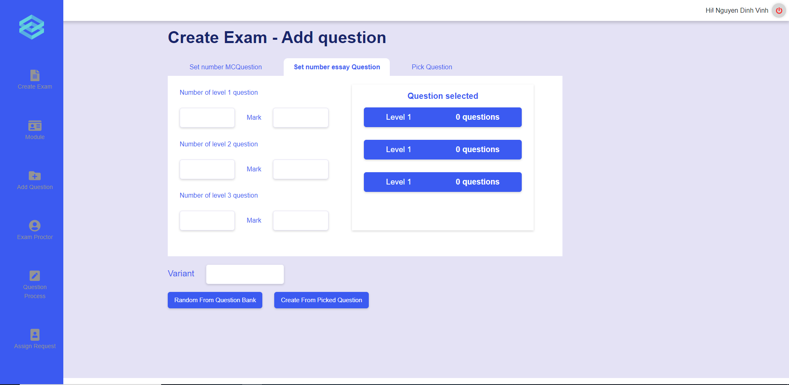
Figure 53 Set number of essay questions
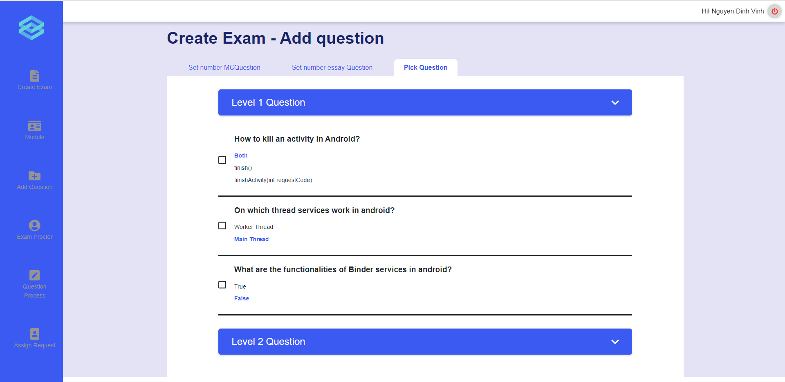
Figure 54 Pick questions from question bank
1.2. View exam list
User can click on the “Module” icon on the vertical navigation bar to go to the module list page, click on the module tab to expand it, and click on the appropriate class under each module tab to go to the exam list (Figure 55, 56).
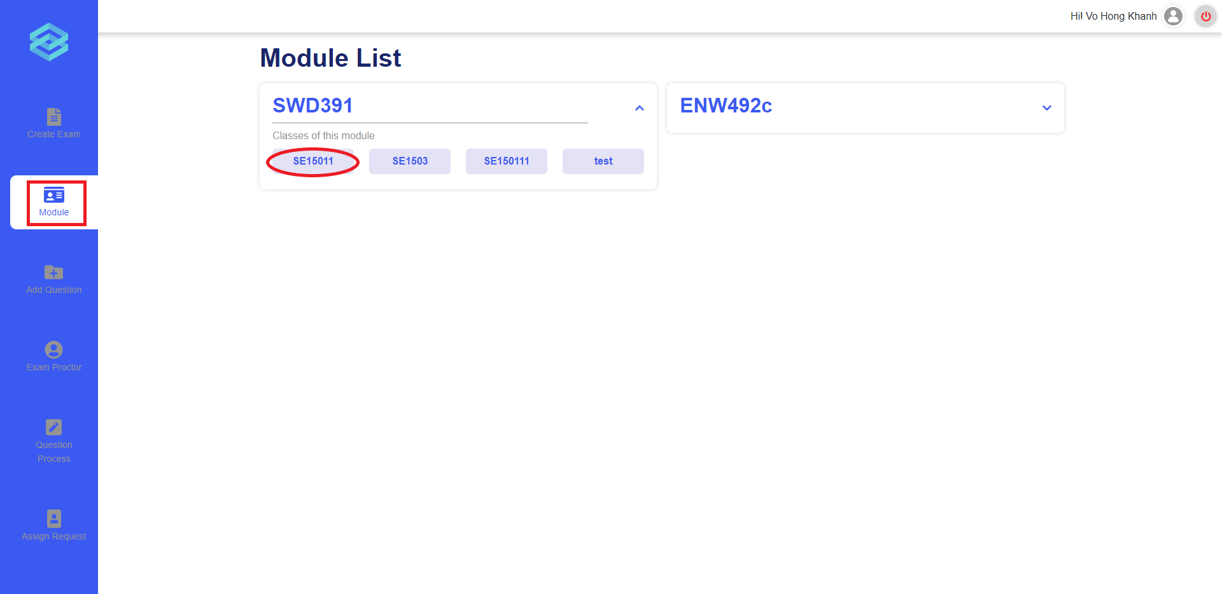
Figure 55 The module list page
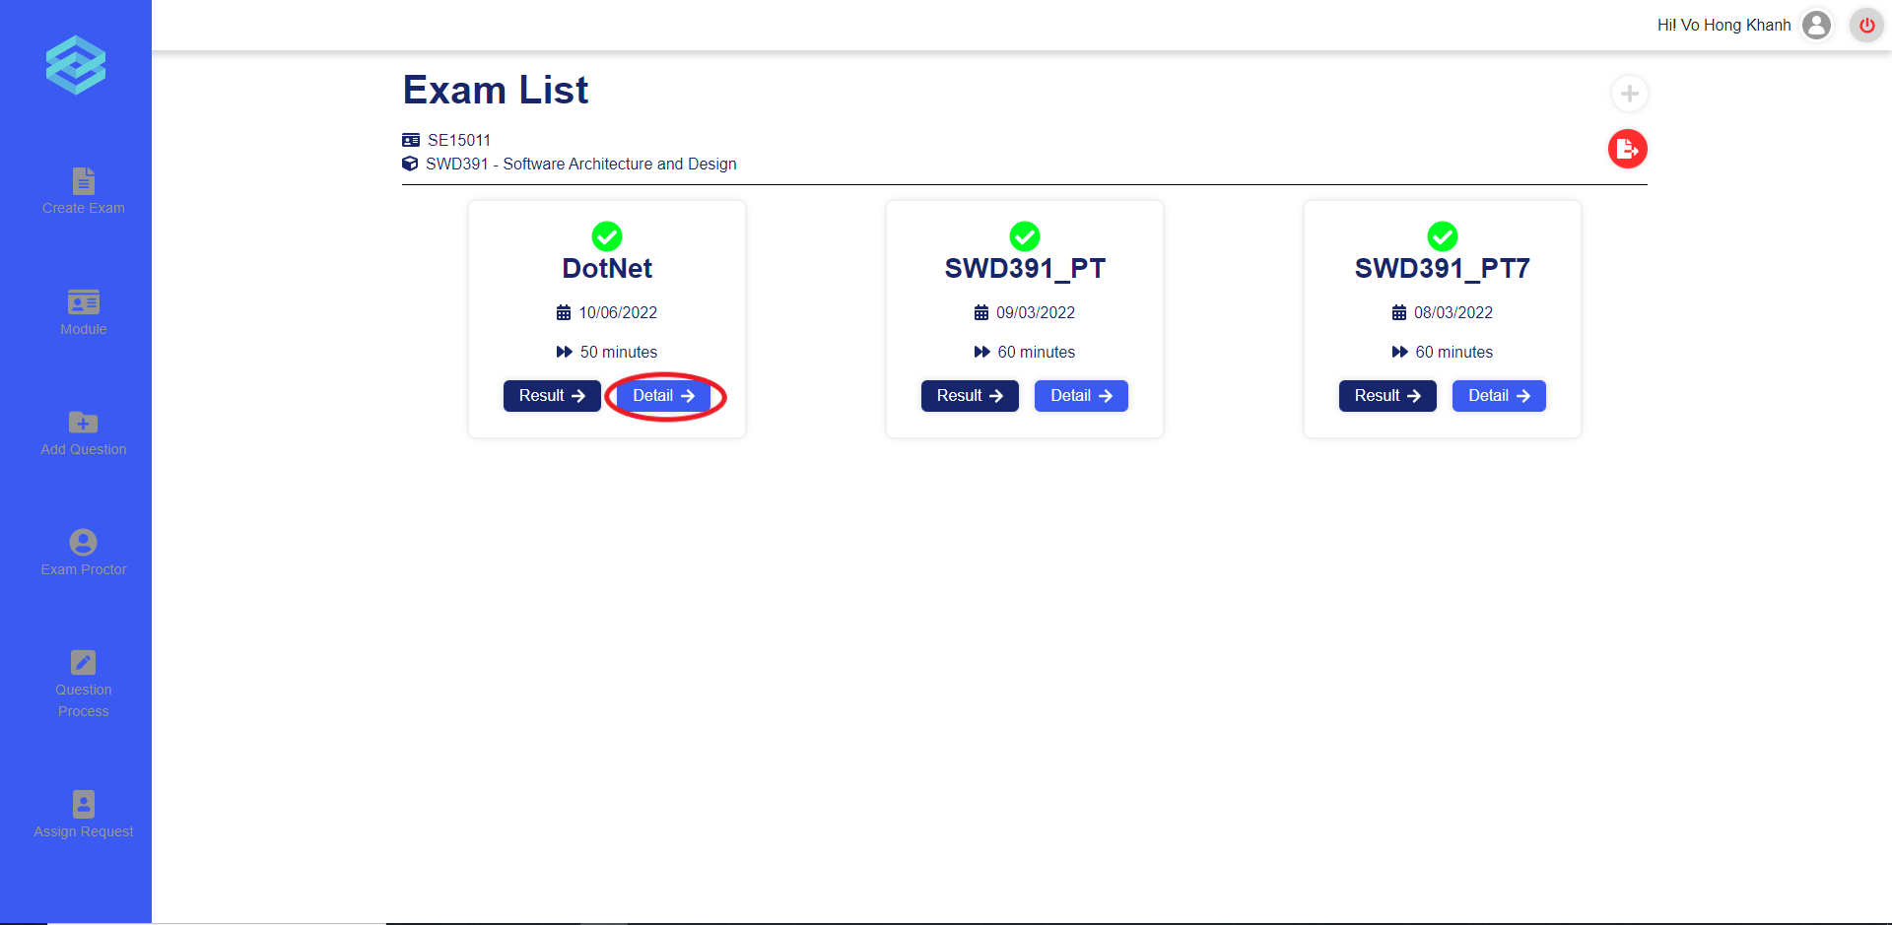
Figure 56 The exam list page and the “Detail” button
1.3. View exam detail
User can click on the “Detail” button in the exam card to view all details of the exam (Figure 56, 57).
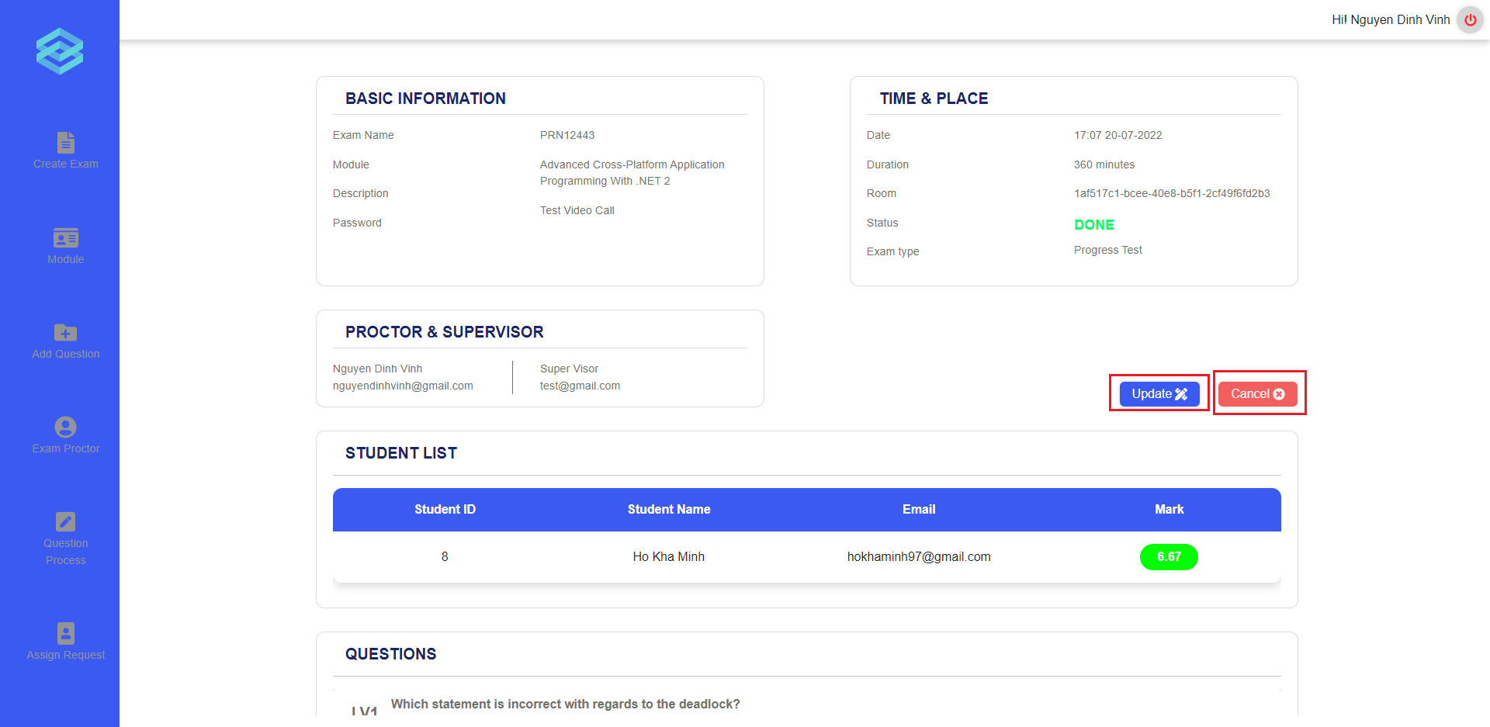
Figure 57 The exam details page with the “Update” and “Cancel” button
1.4. Update exam
User can click on the “Update” button on the exam details page to go to the update exam page (Figure 57). In the update exam page, user can update all the basic information of the exam (Firgure 58).
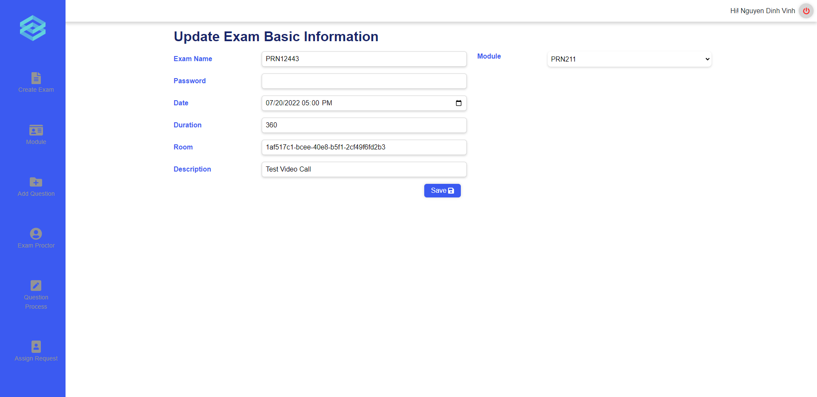
Figure 58 The update exam page
1.5. Cancel exam
User can click on the “Cancel” button on the exam details page to cancel an exam (Figure 57). User can only cancel the exam which has not taken place. After clicking the “Cancel” button, system will show a popup to confirm the cancellation and if user click on “Ok”, the status of that exam will be changed to “Cancelled” (Figure 59, 60).
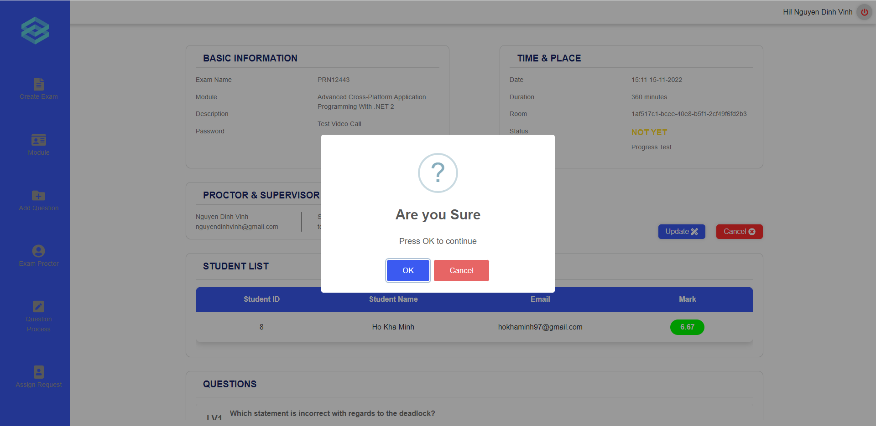
Figure 59 Popup to confirm the exam cancellation
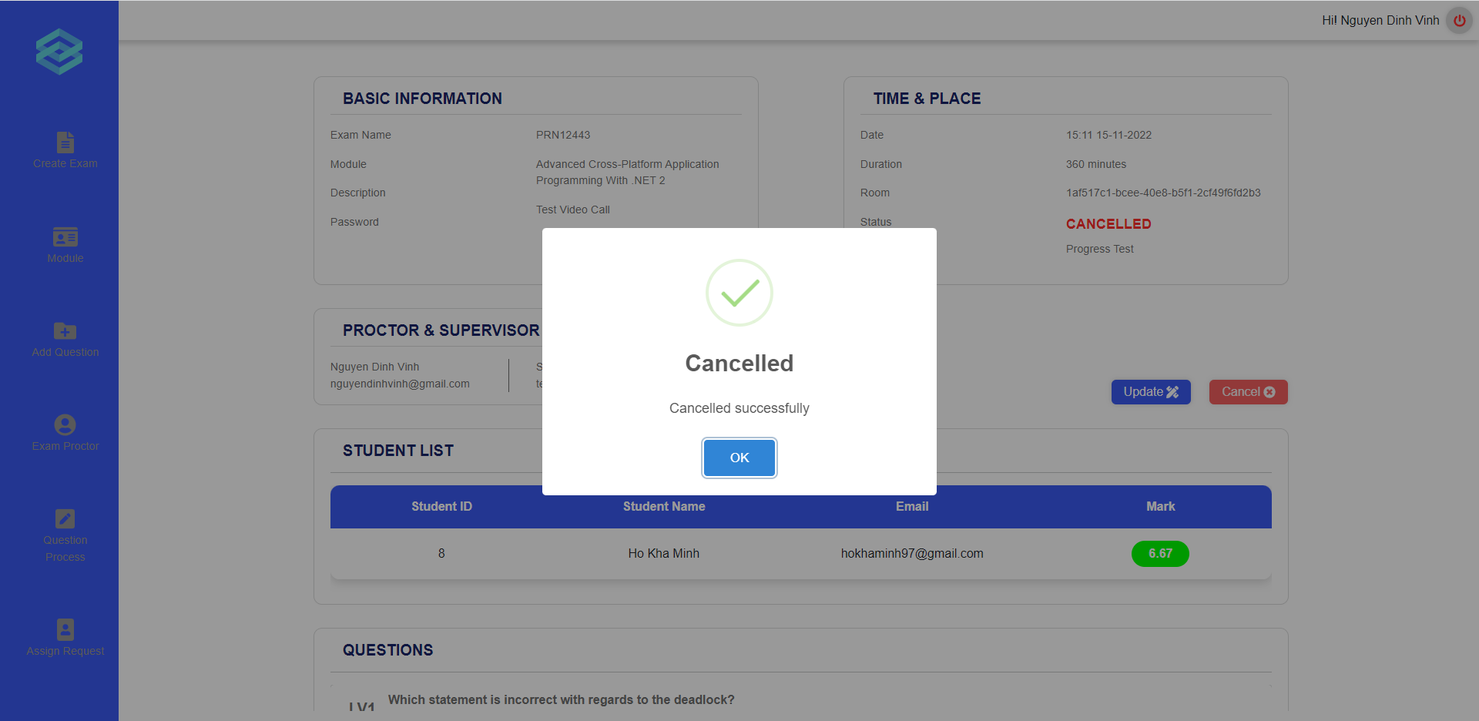
Figure 60 Popup show the successful cancellation message
- Grade written question
Before grading written question, teachers need to find exactly the module and class to see the right exam result.
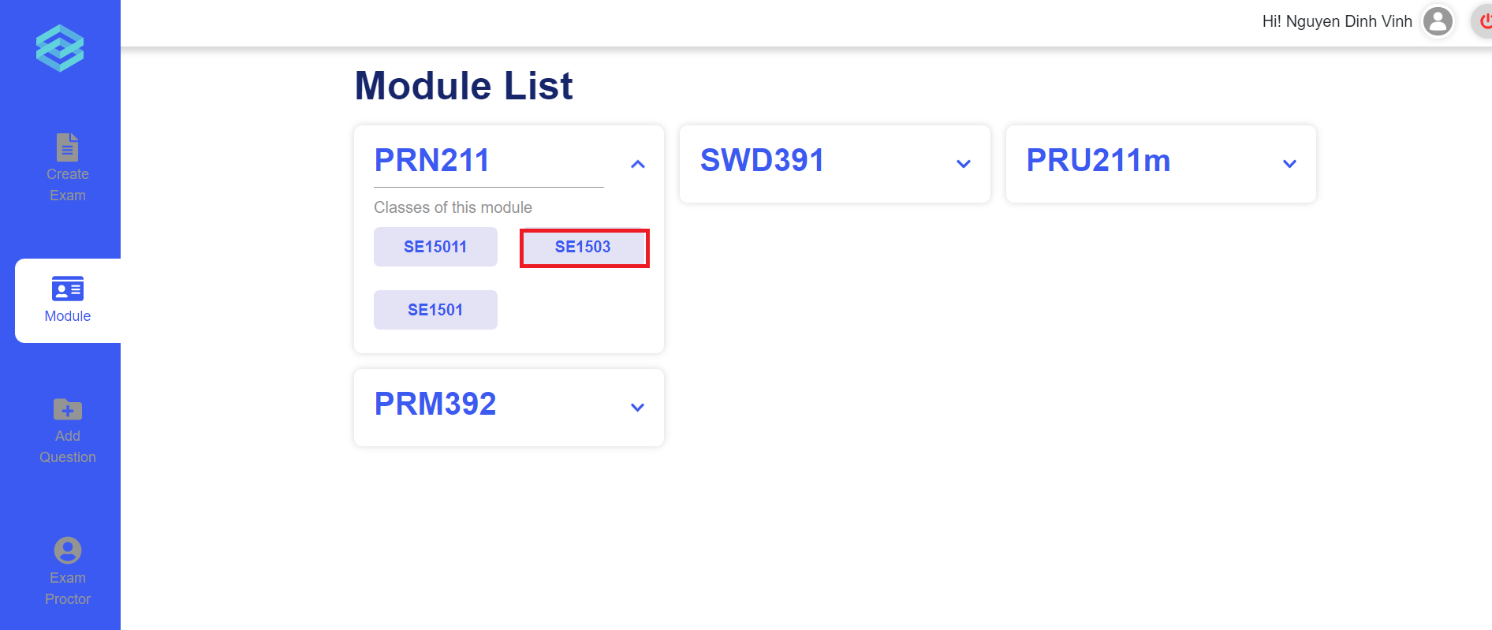
Figure 61 Click on a class
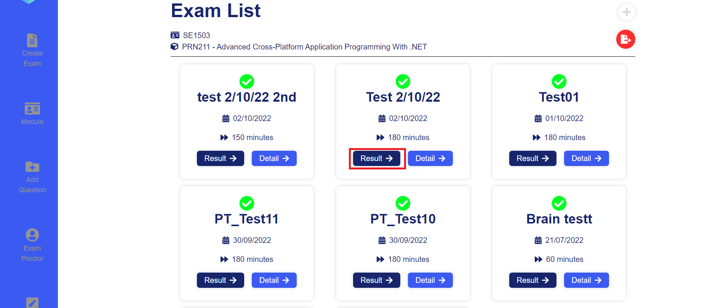
Figure 62 Click on result of an exam
After clicking “Result” button, a list of student results will be displayed and there is a clickable “grade” icon if the student exams have writting question and need to be graded.
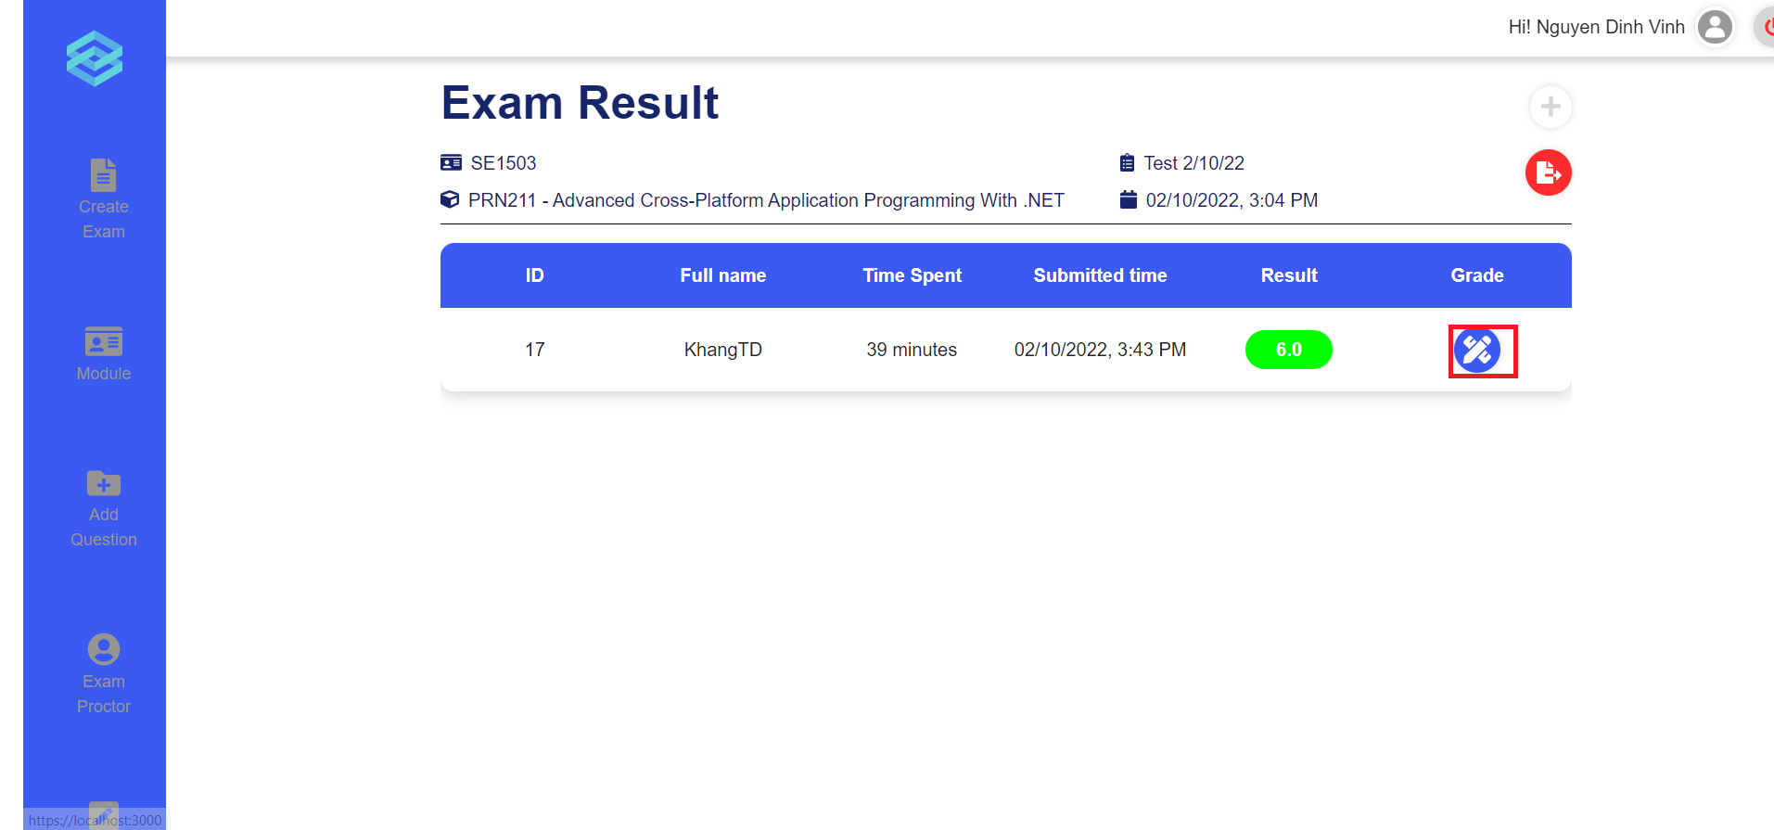
Figure 63 Grade wrtitten question
A pop up modal will appear and show the student writing answers, teacher can inputs valid scores to the forms. If the given scores is invalid, warning message will be displayed to the user.
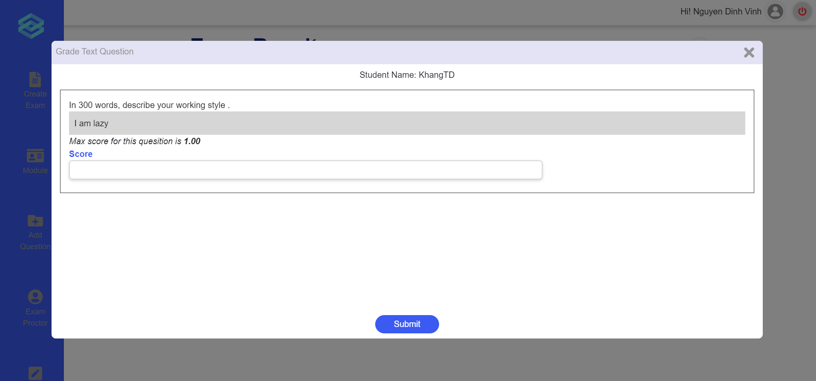
Figure 64 Insert score for the answer
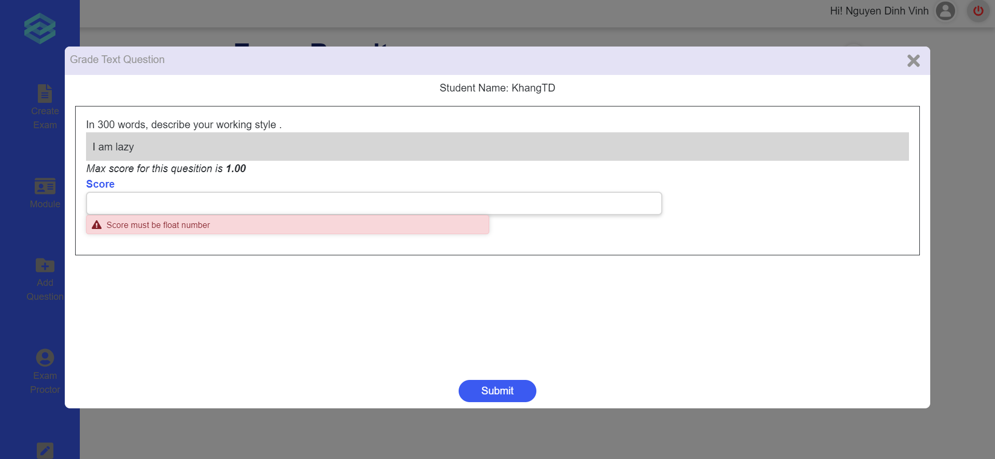
Figure 65 Validation error
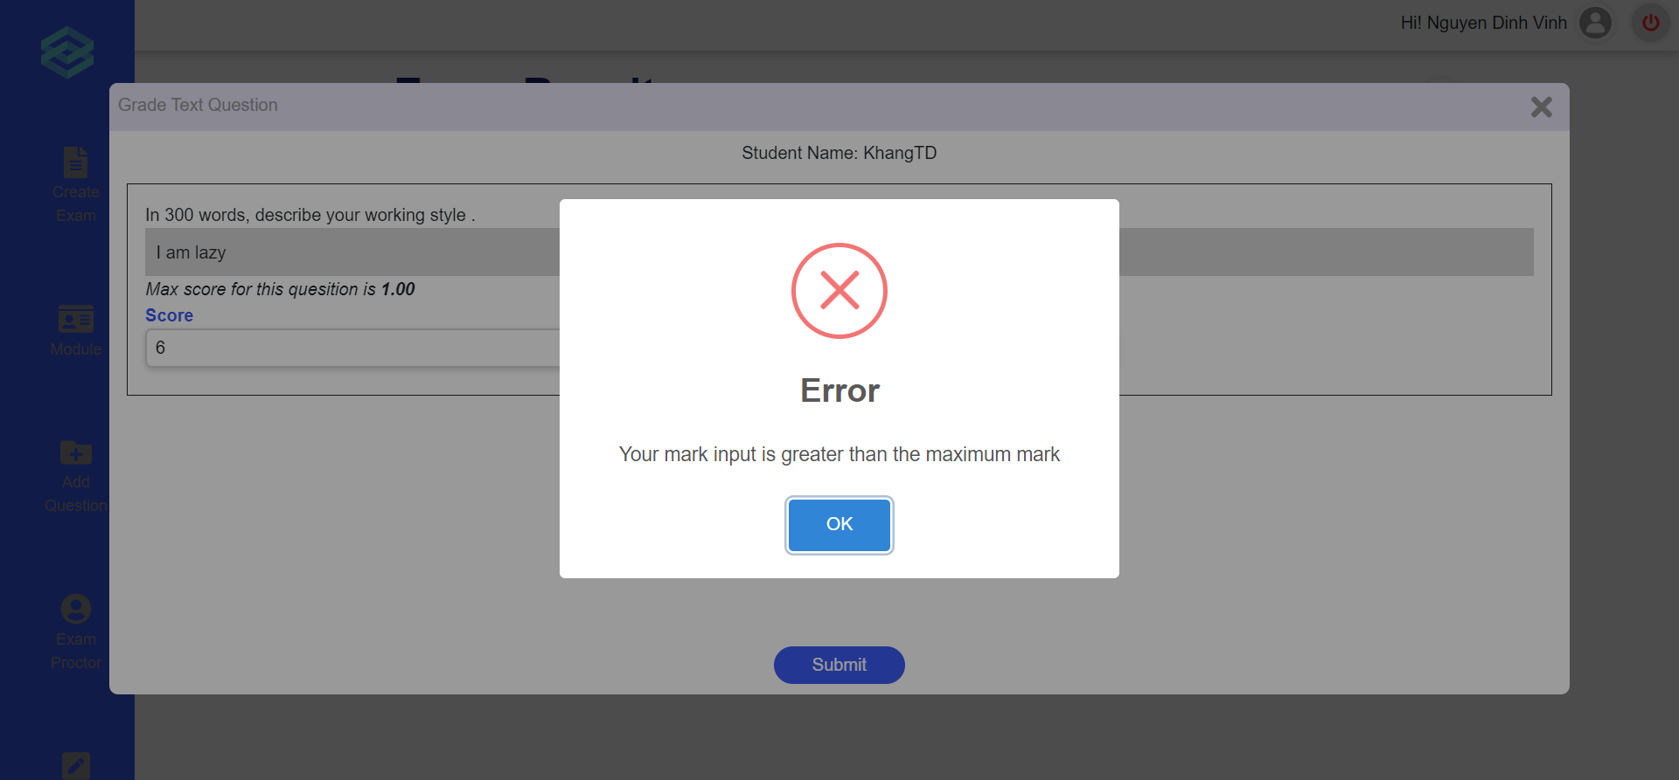
Figure 66 Error pop up
- Approve/reject to add questions
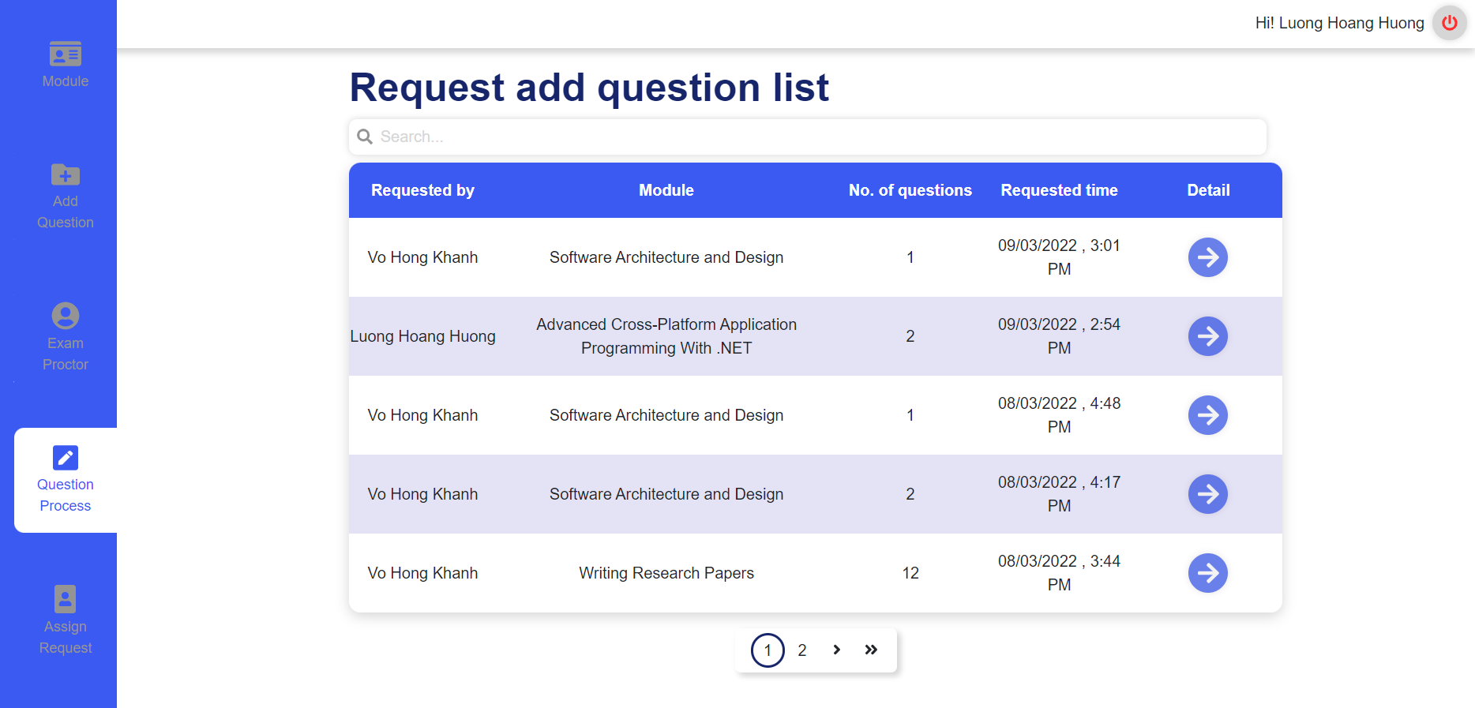
Figure 67 Request add question list
Users can start to approve or reject requests to add questions from the Request add question list page. From this page, the user can click on the arrow icon in the Detail column for a specific request to start reviewing the requested questions.
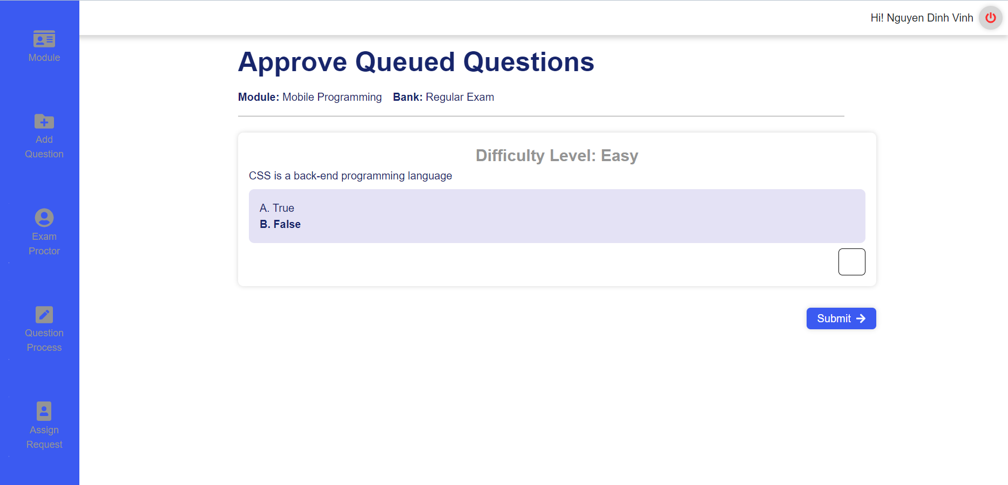
Figure 68 Approve or reject page
After clicking the arrow icon, the user will be redirected to the Approve queued Questions page. In this page the user will be presented with a set of questions that was requested by another user. The user can scroll through the questions and review them. If they choose to approve of a question, they can click on the checkbox located at the bottom right of each question to indicate that they approve of said question. Any questions left unchecked will be considered as unapproved and will not be added to the question bank. After which, the user can click the submit button to finish approving the questions.
- Request add new question to question bank
Users can start to request add new question to the question bank from “Add question” page. From this page, users can choose which modules, question types (multiple choice or text), type of banks (progress test or final exam). Each question needs to be choosed the difficulty level. Users can add question contents, answers, add new questions or delete questions, add question images if necessary. For multiple choice type, users need to decide which answer is right by checking the radio button.
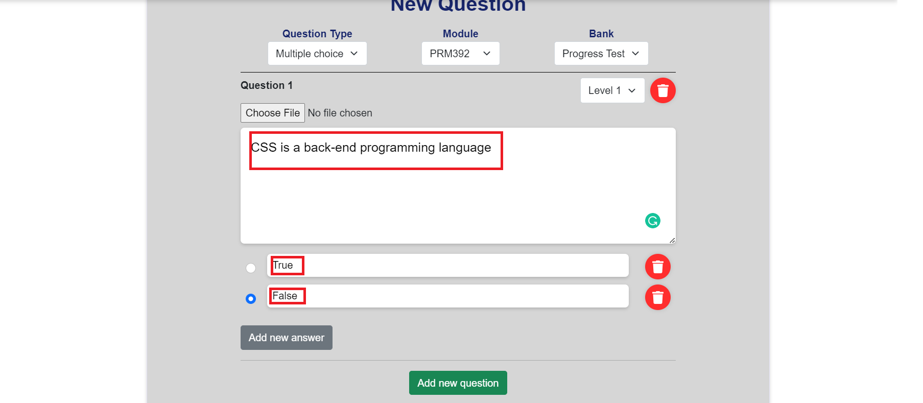
Figure 69 Request add question form
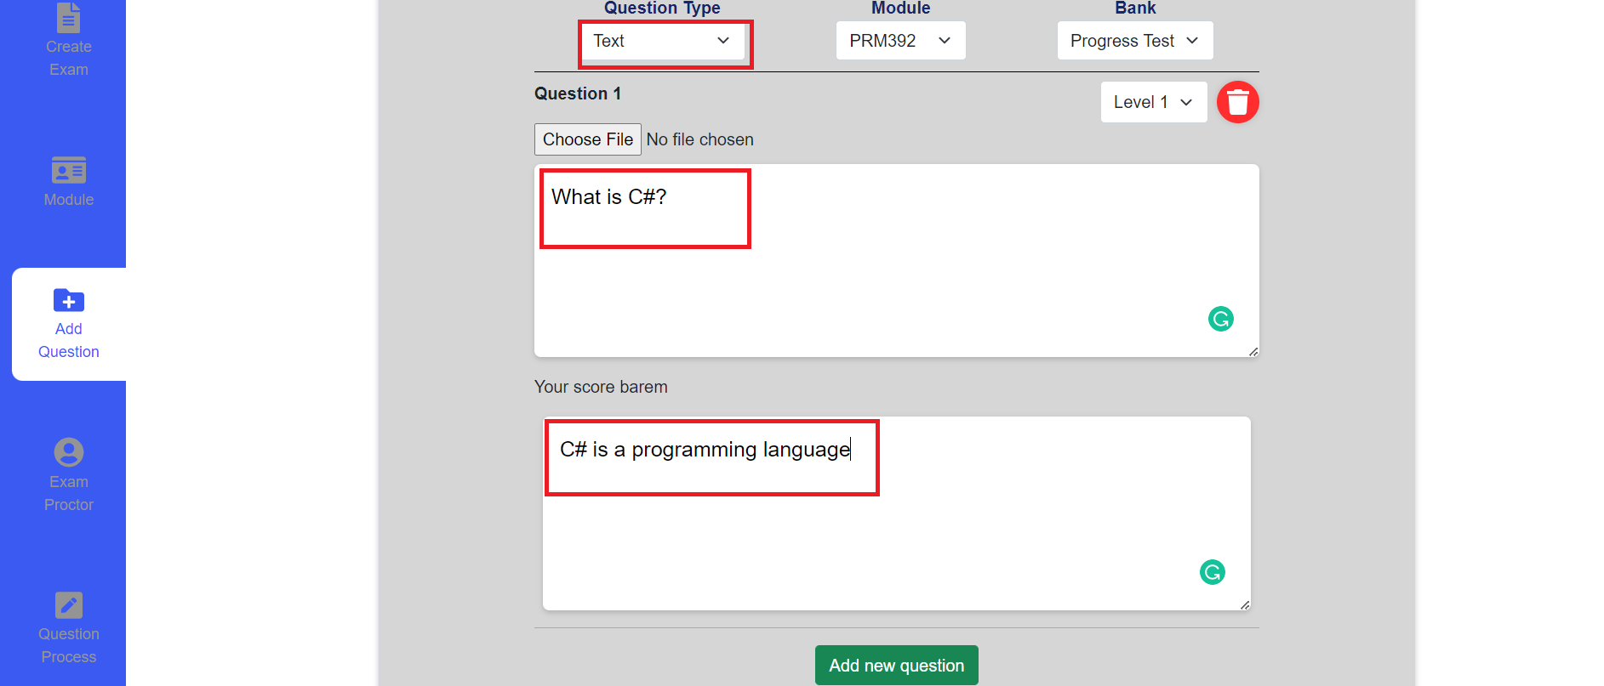
Figure 70 Request add question form
After that, users can click “Send request” button and confirm to finish creating request add new question.
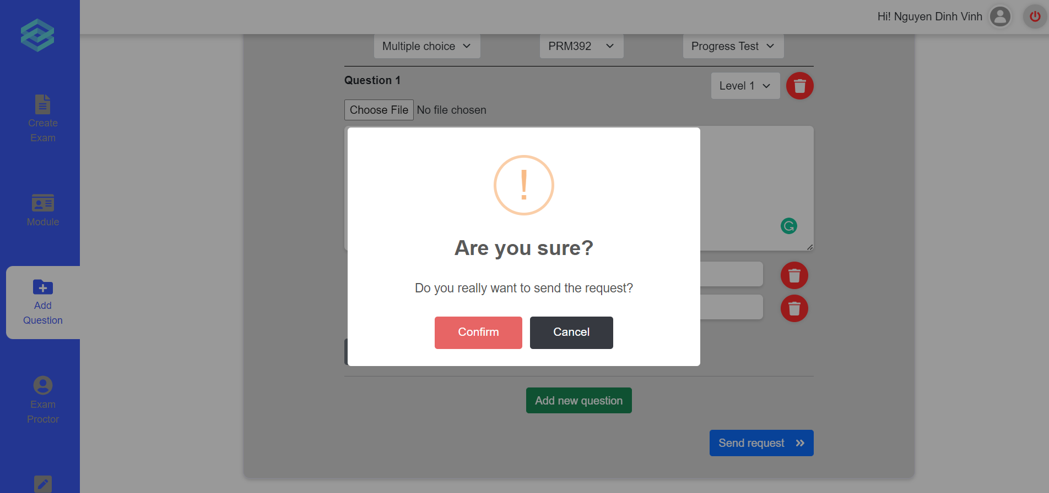
Figure 71 Request add question confirm

c. Role Student
- Take and submit Exam
First, users must login to ExamEdu by Safe Exam Browser to take exam. If there are exams for students, they will appear on the Exam Schedule page. After clicking Start button and typing password (if nesssary), it will redirect to Student Waiting room. The invigilator will start room and then student can join to see the exam question and begin doing exam.
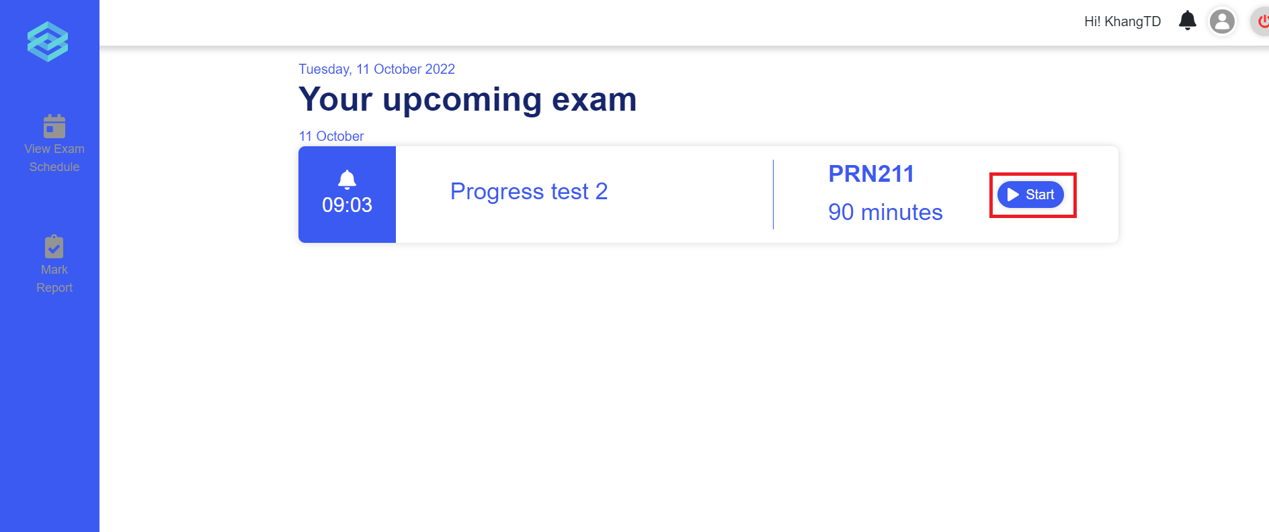
Figure 72 Start an exam
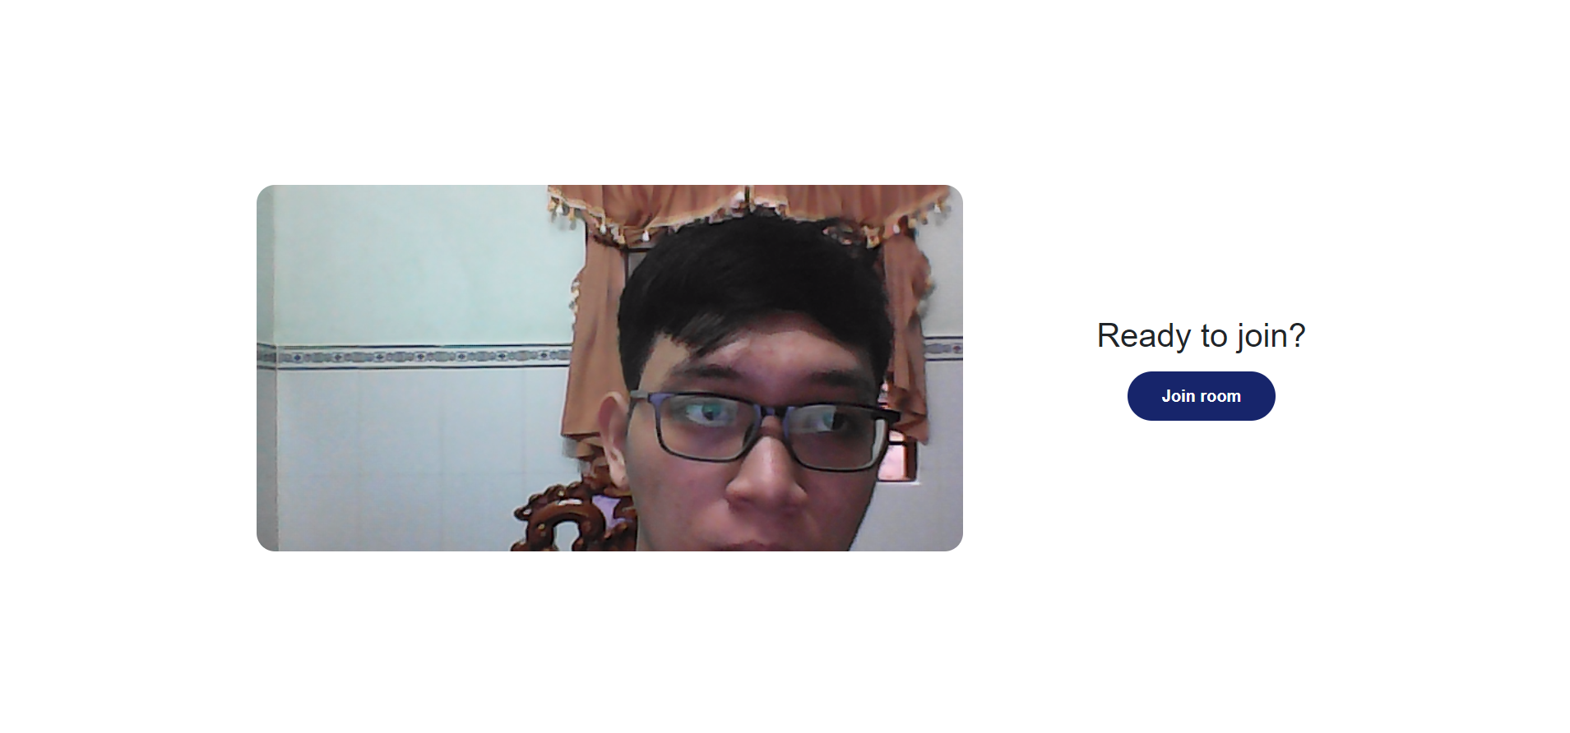
Figure 73 Waiting room
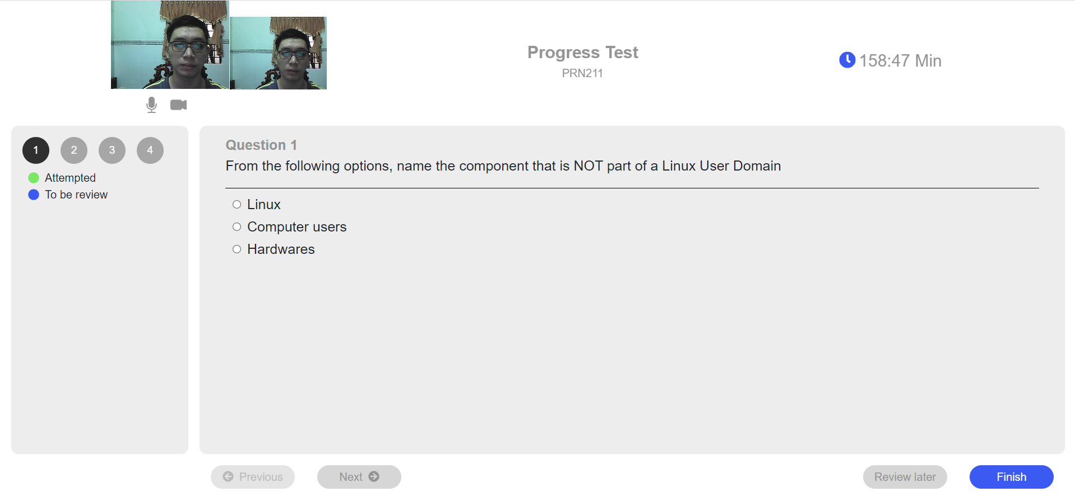
Figure 74 Take an exam
A pop up modal will be displayed to show multiple choice mark and redirect to Student Mark Report page.
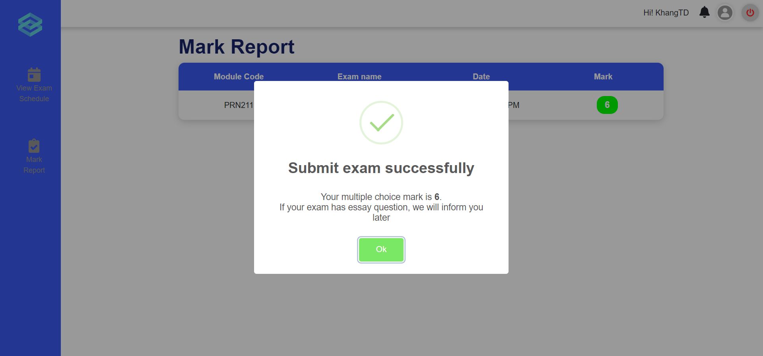
Figure 75 Score notification after exam
- Mark report
-Click on the [Mark Report] button on the left vertical navigation bar.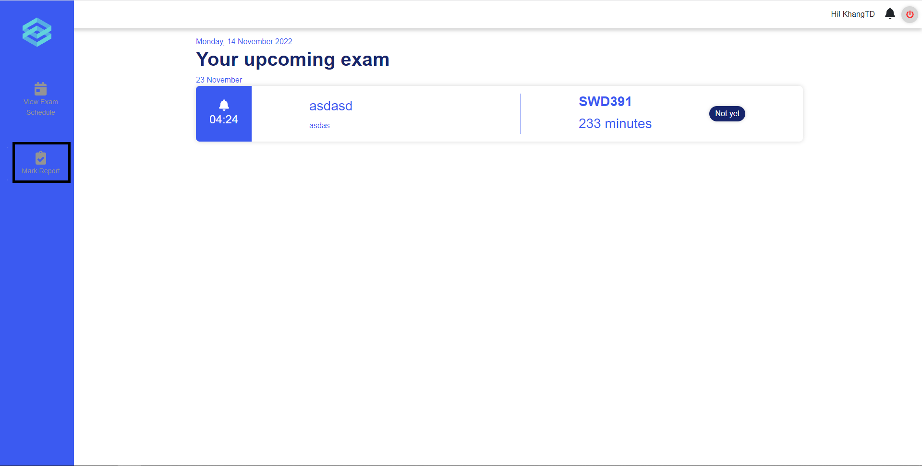
Figure 76 Mark report
-A list of module will be displayed, click on the [View examination result] button to view mark report.
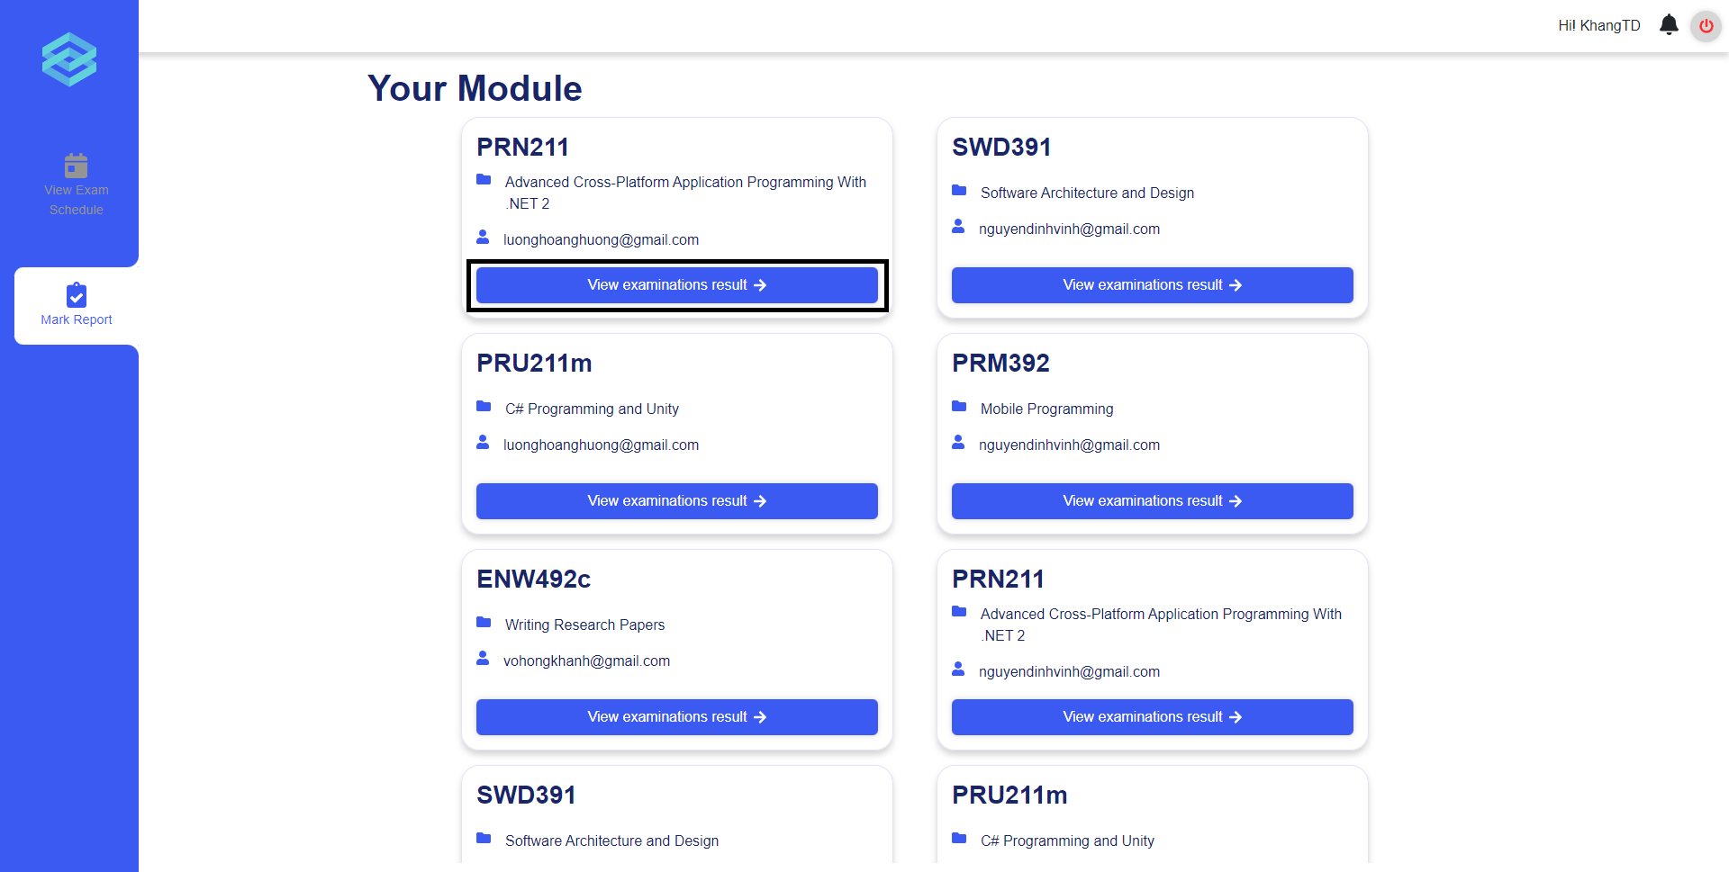
Figure 77 Mark report of the module

