**Quy trình cài đặt PostgreSQL:**

1. 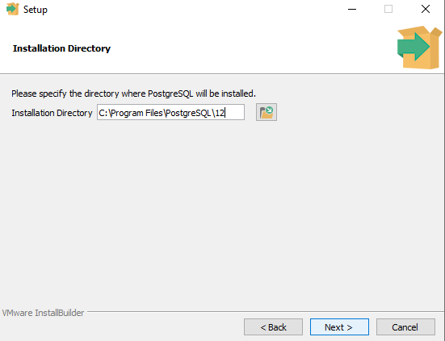
2. 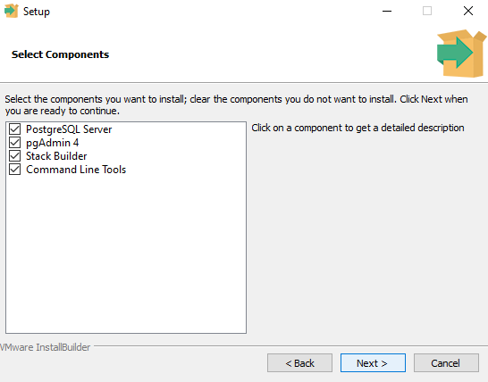
3. 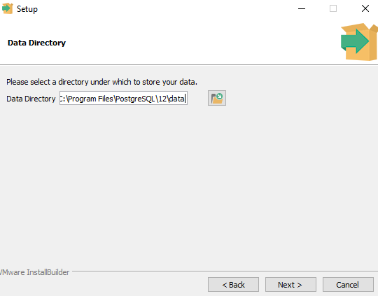
4. 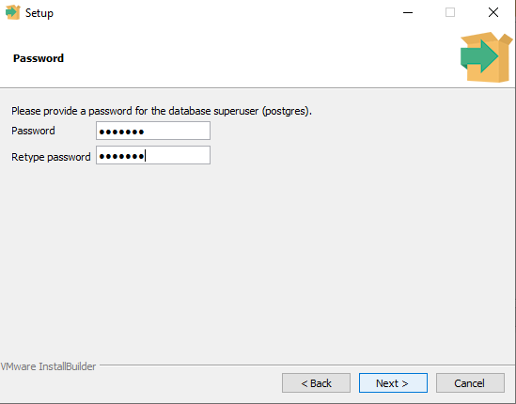
5. 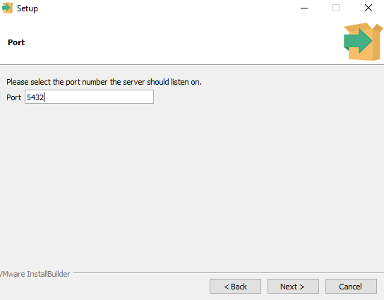
6. 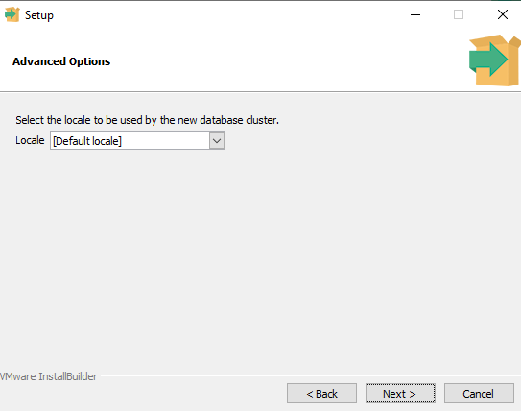
7. 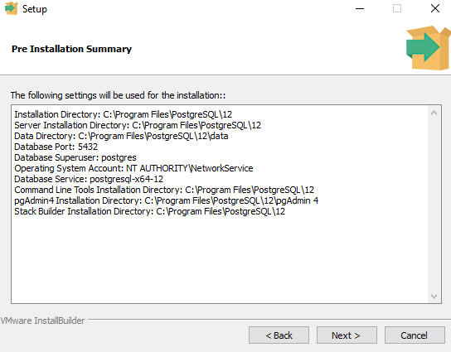
8. 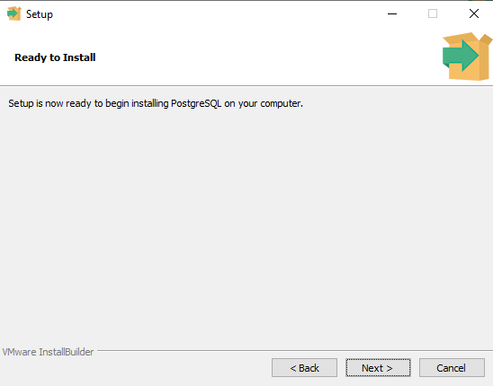
9. 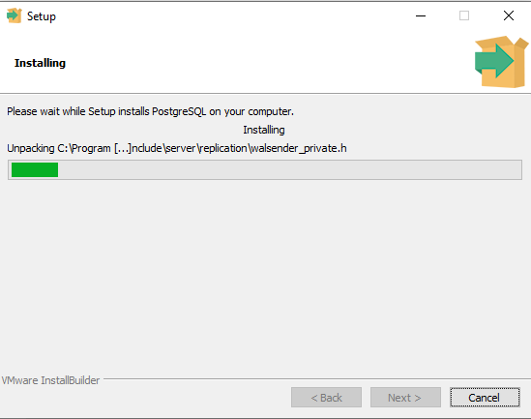
10. 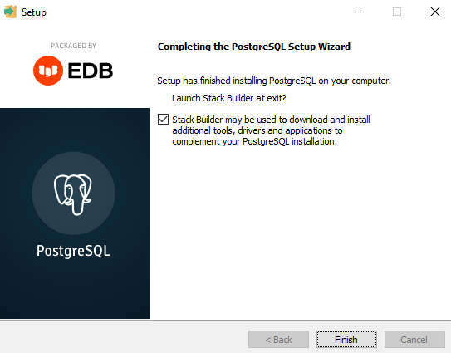
11. 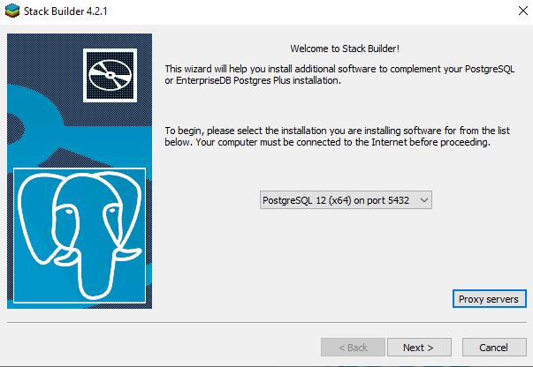
12. 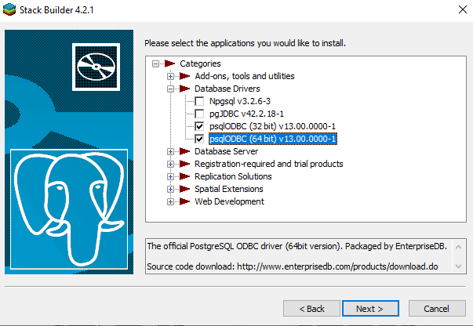
13. 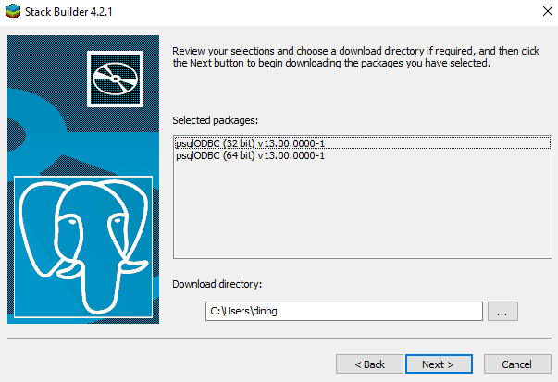
14. 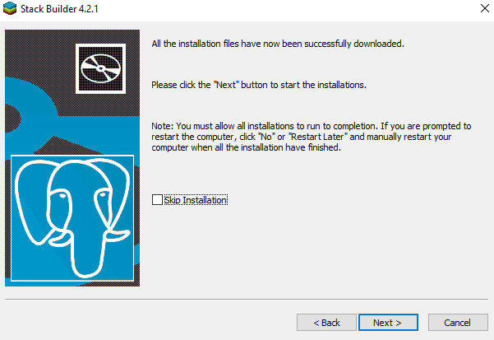
15. 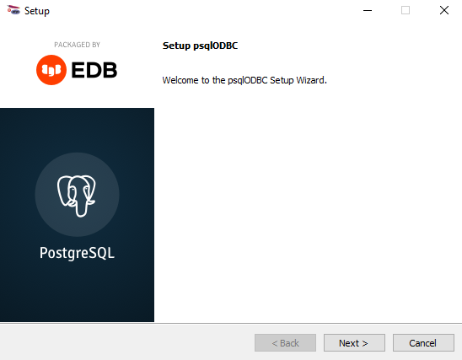
16. 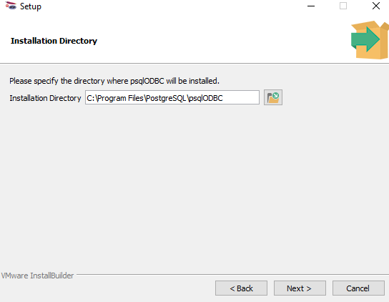
17. 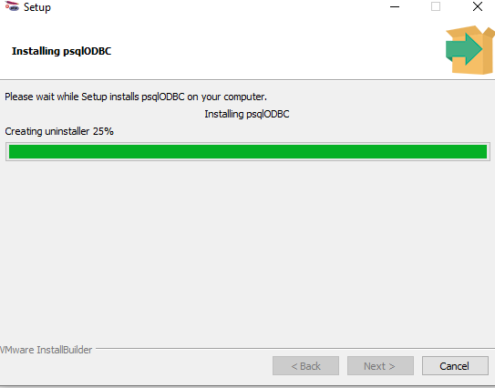
18. 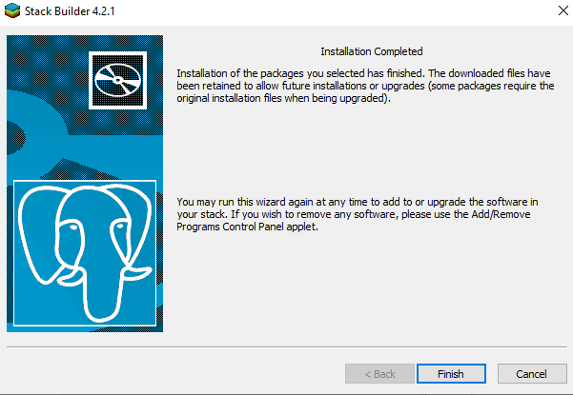

**Các câu lệnh tạo bảng vn_trending:**

DROP TABLE IF EXISTS vn_trending;  
CREATE TABLE vn_trending (  
 Id INT GENERATED ALWAYS AS IDENTITY,  
 keyword VARCHAR(255) NOT NULL,  
 date DATE,  
 Value integer,  
 trend_type VARCHAR(255),  
 CONSTRAINT vn_trending_pkey PRIMARY KEY (id)  
 )  
TABLESPACE pg_default;  
ALTER TABLE public.vn_trending  
OWNER to postgres;

**Các câu lệnh truy vấn đưa ra top 10 key word:**

SELECT *  
FROM( SELECT keyword, trend_type, SUM(vn_trending.Value) AS totalValue  
from public.vn_trending  
Group by vn_trending.keyword, trend_type) AS query1  
ORDER BY query1.totalValue DESC   
FETCH FIRST 10 rows only