

**HO CHI MINH CITY UNIVERSITY**

**OF TECHNOLOGY**

*Faculty of Electronics and Electrical Engineering*

*Lab Report*

**EMBEDDED SYSTEM**

***Group: 5Class: TT01***

***Security Alarm***

*Instructor:*

Bui Quoc Bao

**HO CHI MINH CITY UNIVERSITY OF TECHNOLOGY**

|  |  |
| --- | --- |
| *Student’s names* | *Student’s IDs* |
| Bùi Nguyễn Thành Long | 2051140 |
| Bùi Trung Kiên | 2151106 |
| Trần Văn Sỹ | 2151251 |
| Trần Quang Minh | 2151230 |

*Academic Year*

*2024 - 202*

**1. Introduction**   
The Security Alarm System is designed to enhance the safety of residential, commercial, and industrial properties by detecting unauthorized access, intrusions, or emergency situations. The system will alert users and security personnel through audible alarms, notifications, and automated response mechanisms.

**2. How It Works** - **Main Components**:

* **Sensors**: Detect movement or smoke.
* **Control Unit**: Processes sensor signals.
* **Transmit and Receive signals:** Transmit signals between 2 blocks
* **Alarm**: Makes noise when danger is detected.

**3. Block Diagram**:

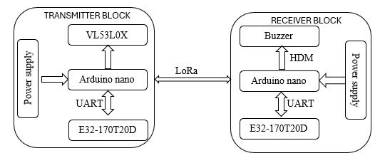

**4. Features**   
- **Turn On/Off**: Uses a switch or PIN code.   
- **Intrusion Detection**: Sensors detect motion or door/window opening.   
- **Fire Detection**: Smoke sensor triggers alarm.

**5. Project Materials**

**- Hardware**:

* Arduino Nano (Microcontroller)
* VL53L0X PIR Motion Sensor
* Buzzer
* Transmitter / Receiver by Wave module LORA E32 433T20D

**- Software**:

* C Programming using Arduino IDE (just adding library to run sensors)

**6. How to Build It**   
- **Setup Sensors**: Connect motion and smoke sensors to the microcontroller.  
- **Program the System**: Write code to detect signals and trigger alarms.   
- **Install Alarm and Display**: Connect buzzer and LCD to show warnings.   
- **Test the System**: Simulate an intrusion or fire to see if it works.   
- **Improve It**: Add extra features like a mobile app or voice alerts.

**7. Limitations and Considerations**   
- **Internet Needed**: Remote alerts need a Wi-Fi connection.   
- **Power Supply**: Needs a battery backup for reliability.   
- **Legal Rules**: Should follow local security and safety laws.

**8. Conclusion**

This project is a great way to learn about security systems and electronics by using some common protocols in embedded like I2C and UART. After this project, you can know how to connect and interact between the components like sensor, buzzer and learn how to transmit and receive information through modules to make up an alarm system. Furthermore, in the future, it can be improved with face-recognition feature not just detecting the existence of obstacles by the sensor.