ITP114-105B Elvis Yeung Yiu Lun 190056855

DSA Assignment Testcases

This assignment is an individual assignment and each student has to submit his/her own work. Plagiarism is a serious offence and any assignments that involve any plagiarism will be given ZERO marks. The award of Zero marks will apply to all parties, regardless of whether or not a student is the original author or the plagiarist. Further disciplinary action will follow.

Fail to rearrange the parcels 11,10,9,3,8,7,6,5,4,2,1

Since 11,10,9 stuck 3 tracks

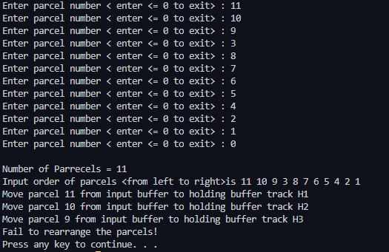

5 4 6 9 7 8 1 2 3

This is A normal case you can see they can 1 to 9 output in order

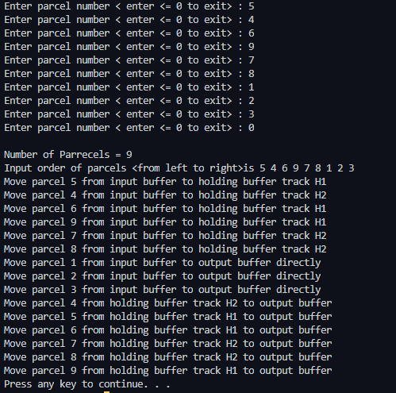

1, 2 ,3, A, 9, 4, 5, 8, 6, 7, 10

This is a input mismatch problem my program will tell the user that you have written a non number, then let the user to keep typing or exit.

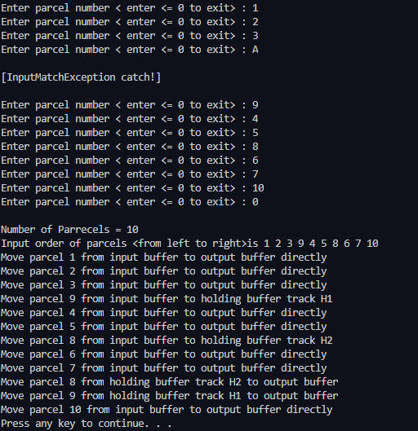

2 2 3 5 5 4 7 6 1 8 9 0

This is a example of number duplication

