CS566 Homework 5

Due – Dec 6, 6:00 PM, at the class beginning

Student’s Name: ___________Jiankun Dong______________

All work must be your own. Upload copy of your homework and any supporting materials (source code and test cases) online to Assignment5 in the CS566_A2 course site
No extensions or late submissions for anything other than major emergency. Show your work in detail.

Q1 [25 pts.]: Evaluate performance characteristics of two string matching algorithms (Brutal Force algorithm and Knuth-Morris-Pratt algorithm) for the following case:

PATTERN: agtacg
STRING: gcagtacgcagagagtatacagtacg

Compare performance of these two algorithms in terms of Preprocessing time and Matching time.
See next page
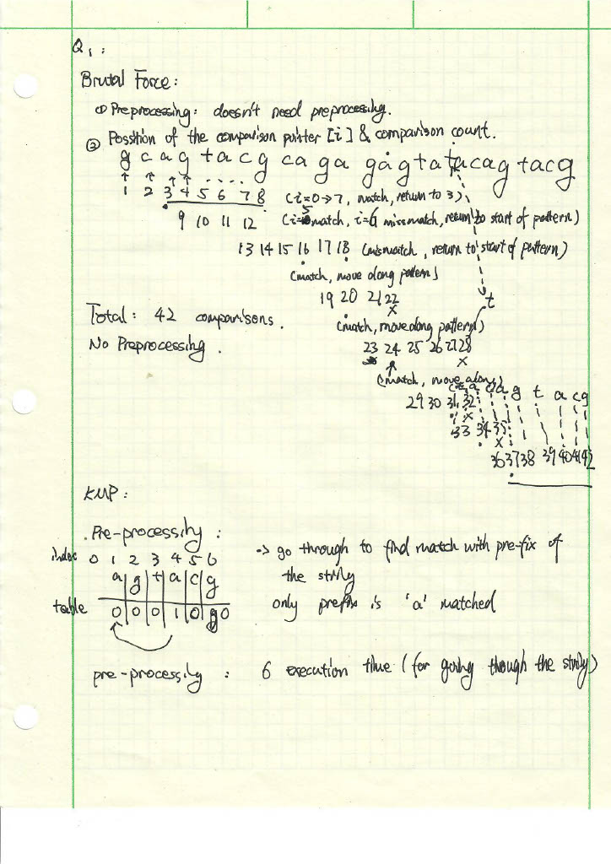
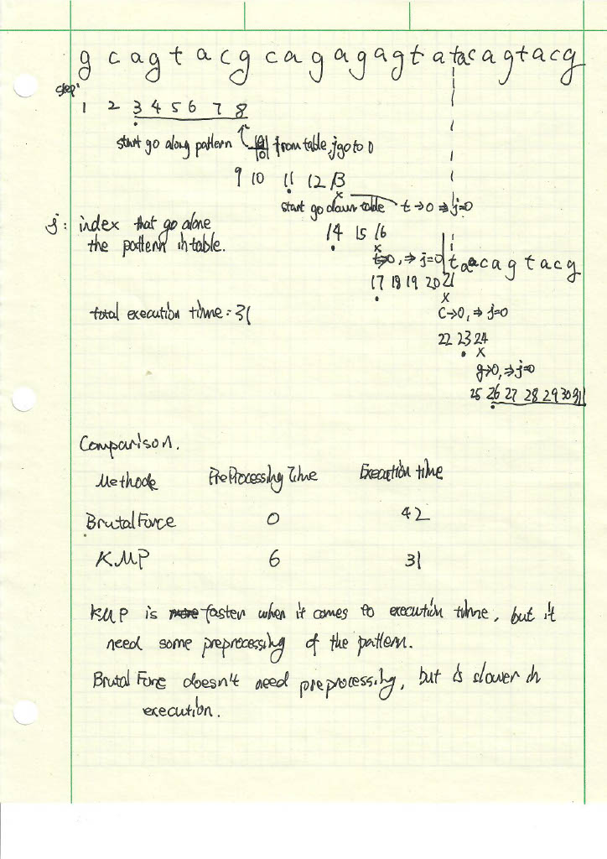

Q2 [30 pts.]: Design AND implement (i.e., write a program) an algorithm based on
text matching that adds two polynomials such as

(x**3 + 5x**2 -3x + 3) + (4x**5 - 2x**2 + 1)

Place the theta value of your algorithm as the first comment in the code. Submit several challenging test cases.

Hint: Input consist of a text string:
“polynomial#1, sign of arithmetic operation, and polynomial#2 ”, where
polynomials consists of monomial like ‘Cx**n’, arithmetical operations ‘+/-‘ and parenthesis ’(‘,’)’. C and n are one-digit integers.
You must parse the text first, identify all terms in both polynomials and output the resultant string. I recommend the “grep” like function for matching string and pattern.
Code:
"""
Theta: (k*log(k)), k is the number of polynomial terms (due to sorting)
HW5 Problem 2
Author: Jiankun Dong
Adding 2 polynomials in string form
"""
import re
def parse_polynomial(poly_str):
# the default regex for python
# because the pattern is fixed (Cx**n), the function has
# theta(n)
monomials = re.findall(r'(-?\d*)x\*?\*?(\d*)', poly_str)
poly_dict = {}
for coef, exp in monomials:
## special case for '-X**n'
if coef == '-':
coef = -1
coef = int(coef) if coef else 1
exp = int(exp) if exp else 1 #'Cx' term
poly_dict[exp] = poly_dict.get(exp, 0) + coef
## handle constant term:
# constant term does exsist if the last one is 'x' or '*constant'
if (poly_str[-1] != 'x') and (poly_str[-2]!='*'):
##constant exsist
poly_dict[0] = int(re.findall(r'(-?\d*)',poly_str)[-2])
return poly_dict
def polynomial_dict_to_string(poly_dict):
terms = []
# sorting takes O(klogk), k is the number of polynomials
for exp, coef in sorted(poly_dict.items(), reverse=True):
if coef != 0:
term = f"{coef:+d}" if coef >= 0 else f"{coef:-d}"
if term == '+1':
term = '+'
term += f"x**{exp}" if exp > 1 else "" if exp == 0 else "x"
terms.append(term)
if terms[0][0] == '+':
terms[0]=terms[0][1:]
return ''.join(terms) if terms else "0"

def add_polynomials(poly1, poly2):
result_dict = poly1.copy()
for exp, coef in poly2.items():
result_dict[exp] = result_dict.get(exp, 0) + coef
return result_dict
def subtract_polynomials(poly1, poly2):
result_dict = poly1.copy()
for exp, coef in poly2.items():
result_dict[exp] = result_dict.get(exp, 0) - coef
return result_dict
def simplify_polynomials(inputStr):
inputLS = inputStr.split(',')
poly1 = inputLS[0]
poly2 = inputLS[2]
operator = inputLS[1]
# Parse input polynomials
poly1_dict = parse_polynomial(poly1)
poly2_dict = parse_polynomial(poly2)
# Perform the operation
if operator == '+':
result_dict = add_polynomials(poly1_dict, poly2_dict)
elif operator == '-':
result_dict = subtract_polynomials(poly1_dict, poly2_dict)
else:
return "Invalid operator. Use '+' or '-'."
# Convert the result back to a polynomial string
result_poly = polynomial_dict_to_string(result_dict)
return result_poly

if __name__ == "__main__":
#testing
#1
expected1 = "4x**5+x**3+3x**2-3x+4"
r1 = simplify_polynomials("x**3+5x**2-3x+3,+,4x**5-2x**2+1")
if r1 == expected1:
print("Test 1 passed!")
print(f"Result: {r1}")
2
expected2 = "2x**5+2x**2-3x+4"
r2 = simplify_polynomials("x**6+5x**5-3x+3,-,x**6+3x**5-2x**2-1")
if r2 == expected2:
print("Test 2 passed!")
print(f"Result: {r2}")
3
expected3 = "8x**5-2x**2-3x-4"
r3 = simplify_polynomials("x**6+5x**5-3x-3,+,-x**6+3x**5-2x**2-1")
if r3 == expected3:
print("Test 3 passed!")
print(f"Result: {r3}")

Test result:
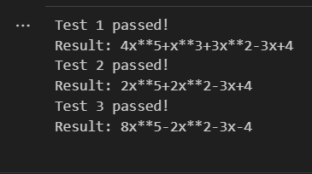
Q3 [25 pts]: What is your INFORMED opinion on the NP problems? Does a deterministic NP polynomial time algorithm exist or not? Your answer should be a well-thought out and informed argument consisting of couple paragraphs at least. No credit for poor grammar and simplistic answers. Your argument should be convincing and strong.
I don’t think it’s likely that P=NP. Due to the nature that if a deterministic NP polynomial time algorithm exists, then we can convert all NP-complete problems into P.
So far, we have yet to find the solution that makes P=NP, while there are a lot of NP-complete problems waiting to be solved I polynomial time. A list of those can be found https://en.wikipedia.org/wiki/List_of_NP-complete_problems . Due to the nature of NP-complete, if one of them is solved in P, all NP-complete problems would be part of P.
There are a lot of classic NP-complete problems that are unlikely to have an algorithm in polynomial time. After reading some research from Geometric Complexity Theory (http://ramakrishnadas.cs.uchicago.edu/gctcacm.pdf). Although it does not yield an deterministic proof that P!=NP, but it has yield valuable insights that goes against P=NP.
If P=NP, it would mean that cryptography as we know it is dead. A lot of cryptography algorithms are dependent on the assumption that NP problems are difficult to solve. And so far, it has held true against consistent attacks and decoding attempts. If P=NP would be true, it would mean that we can efficiently compromise security of a lot of systems.
Q4 [20 pts] Give an example of non-linearities in neural networks used for machine learning. Why is it necessary to have it in networks?
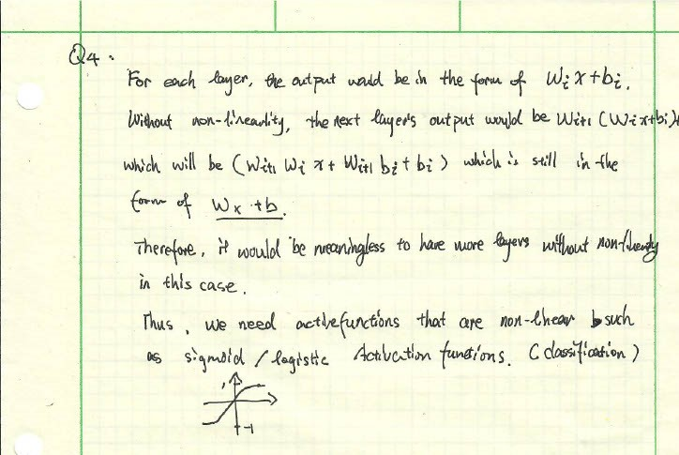
(Typo Correction: the next layer would be W_{i+1}(W_{i} X+b_{i})+b_{i+1} which is W_{i+1}W_{i}X+W_{i+1}b_{i}+b_{i+1})
This particular activation function is also necessary especially if we are trying to solve the output into 2 categories (-1 and 1).

