**Student Name: Tran Nguyen Quang Vinh**

**Student Code: SE184691**

**Subject: PRF192- PFC**

**Workshop 04**

**Objectives: Using Pointer and Function**

**Ex1 ( 2 marks ) :** Write a C program to swap two numbers using pointers and functions. How to swap two numbers using call by reference method.

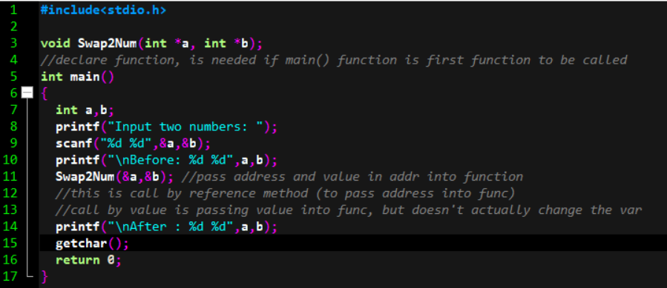

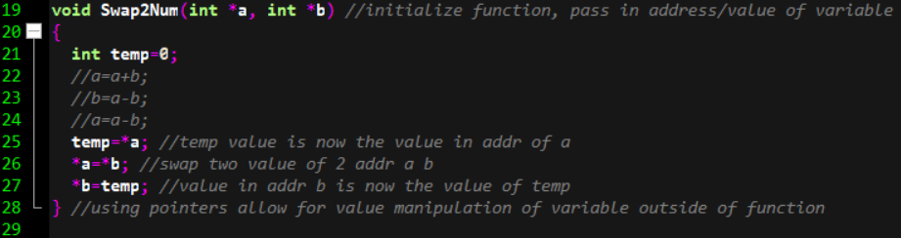

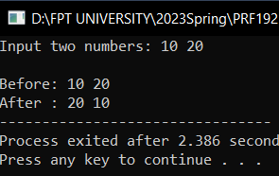

**Ex2 ( 8 marks ) :** Write a C program that will execute repetitively using a simple menu as following:

1. Write a function that prints the sum of even numbers less than n
2. Write a C program that will print out **sum** of **integers** inputted from the keyboard until the value 0 is inputted.
3. Write a function to check whether the year entered by the user is a leap year or not.
4. Quit

