**Student Name: Trần Nguyễn Quang Vinh**

**Student Code: SE184691**

**Subject: PRF192- PFC**

**Workshop 05**

**Objectives: Managing arrays**

**EX1 ( 2 marks) :** Write a C program to input elements ( n>=10) in array and print all negative elements

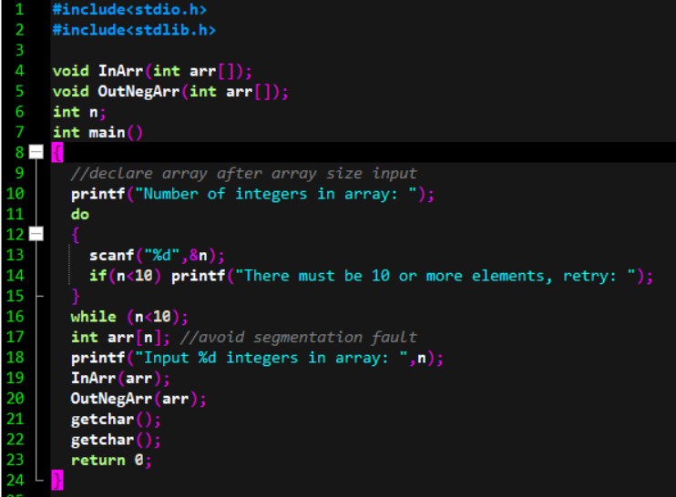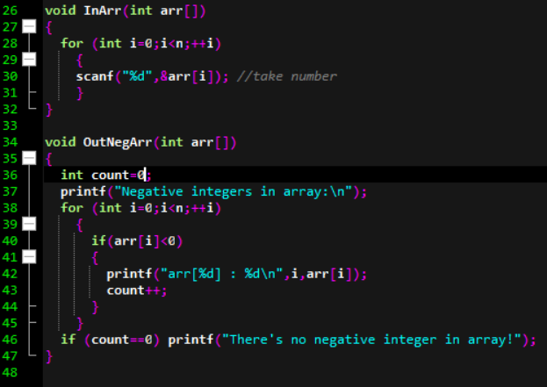

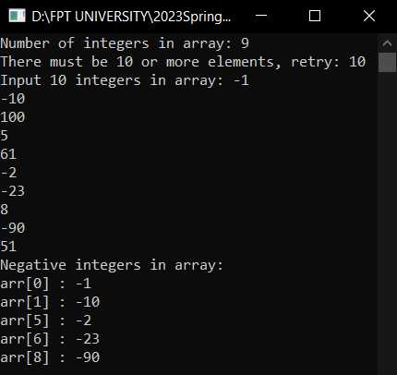

**EX2 ( 3 marks) :** Write a program to find the second largest element in a one-dimensional array of n (n>=10) elements.

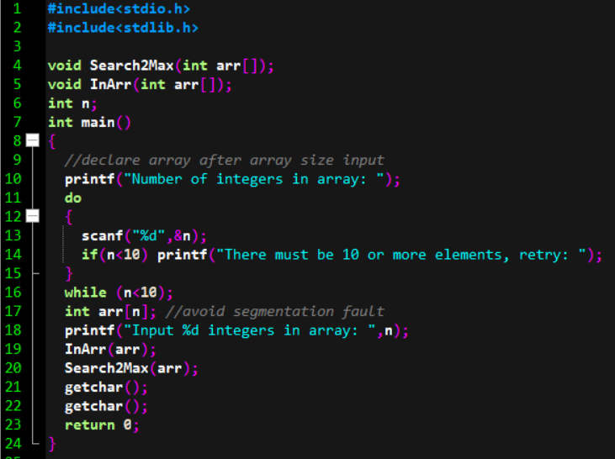

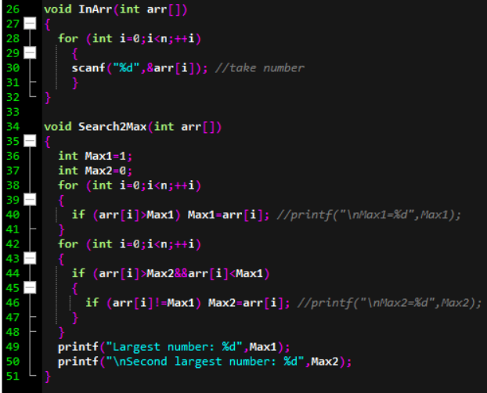

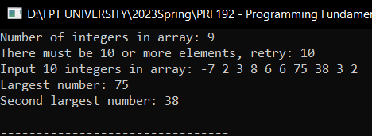

**EX3 ( 5 marks) :** Develop a C-program that helps user managing an 1-D array of real numbers (maximum of 100 elements) , with initial number of elements is 0, using the following simple menu:

1- Enter n values for the elements in the array

2- Search a value

3- Print out the prime numbers in the array

4- Sort the elements that are even in ascending order

5- Print out the array in Descending order

Others- Quit

* When the option 1 is selected, user will enter n values for the elements in the array.
* When the option 2 is selected, Print the position of the element in the array, if it does not exist, print -1.
* When the option 3 is selected, prime numbers will be printed.
* When the option 4 is chosen, Sort the elements that are even in ascending order. Print the sorting results to the screen.
* When the option 5 is chosen, values in array will be printed out in Descending order.

