1.

FIR: H(z) = b₀ + b₁z⁻¹ + b₂z⁻² + ... + bₙz⁻ⁿ

IIR: H(z) = (b₀ + b₁z⁻¹ + b₂z⁻² + ... + bₙz⁻ⁿ)/(1 + a₁z⁻¹ + a₂z⁻² + ... + aₘz⁻ᵐ):

In 1-b, the first one is FIR filter, the second one is IIR filter. Below are the frequency response and zplane plots.

For FIR filter, it has pole 0, and 4 zero located on unit circle equally distributed.

For IIR filter, it has 1 pole at 1, 1 zero at -1.

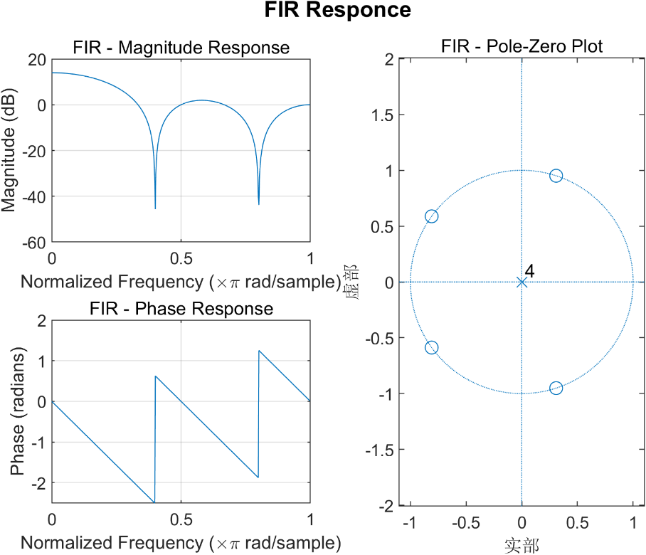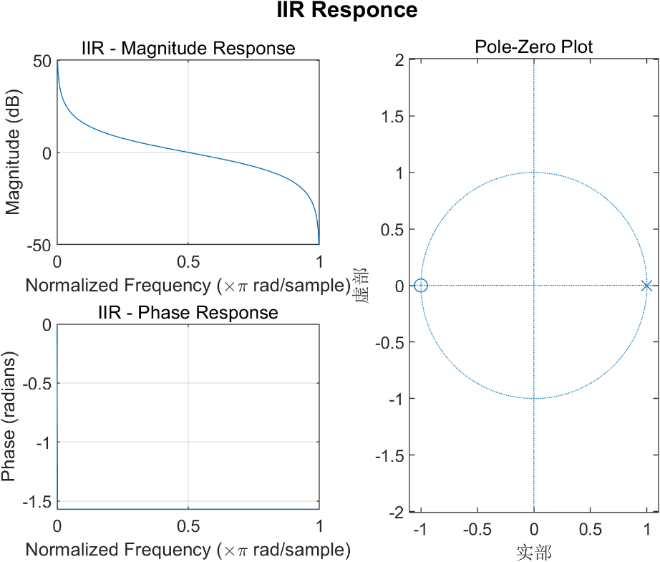

For stability, FIR is always stable because it has no pole. When your input is finite, your output is always finite.

IIR one is not stable, because when your input is [1 0 0 … 0], your output is infinite.

2.

a+b: According to Nyquist Sampling theorem, x1 can be well reconstructed while x2 will be aliased to 200MHz. As those red points shows, the 2 signal have the same x(n) after sampling. You should increase your sampling rate higher than 1600MHz.

C: its’ given as below

x_r(t) = ∑[n=-∞ to ∞] x(nT) * rect((t-nT)/W - 1)

where

rect(t) = 1 for 0 ≤ t ≤ 1

rect(t) = 0 otherwise

d+e: Here is the result reconstructing x1 sampled by 3 Fs. As you can see, for fs>2f1, it can reconstruct with almost no error. However, when fs=500Hz, it can’t be reconstructed, as plot given. And shifting doesn’t influence reconstruction.

3

a.

You can detect the 2M signal peek. Due to leakage it looks like this.

3.b

As shown in the plot, it’s easy to identify the 2 tones from the 2 peeks.

3.c

Due to alias, F2 is aliased to 500M-400M=100M, while F1 stays at 200M, as shown in plot.

3.d

As shown in plot, the 2 main lobes get wider comparing to results before.

