**Set the environment variables**

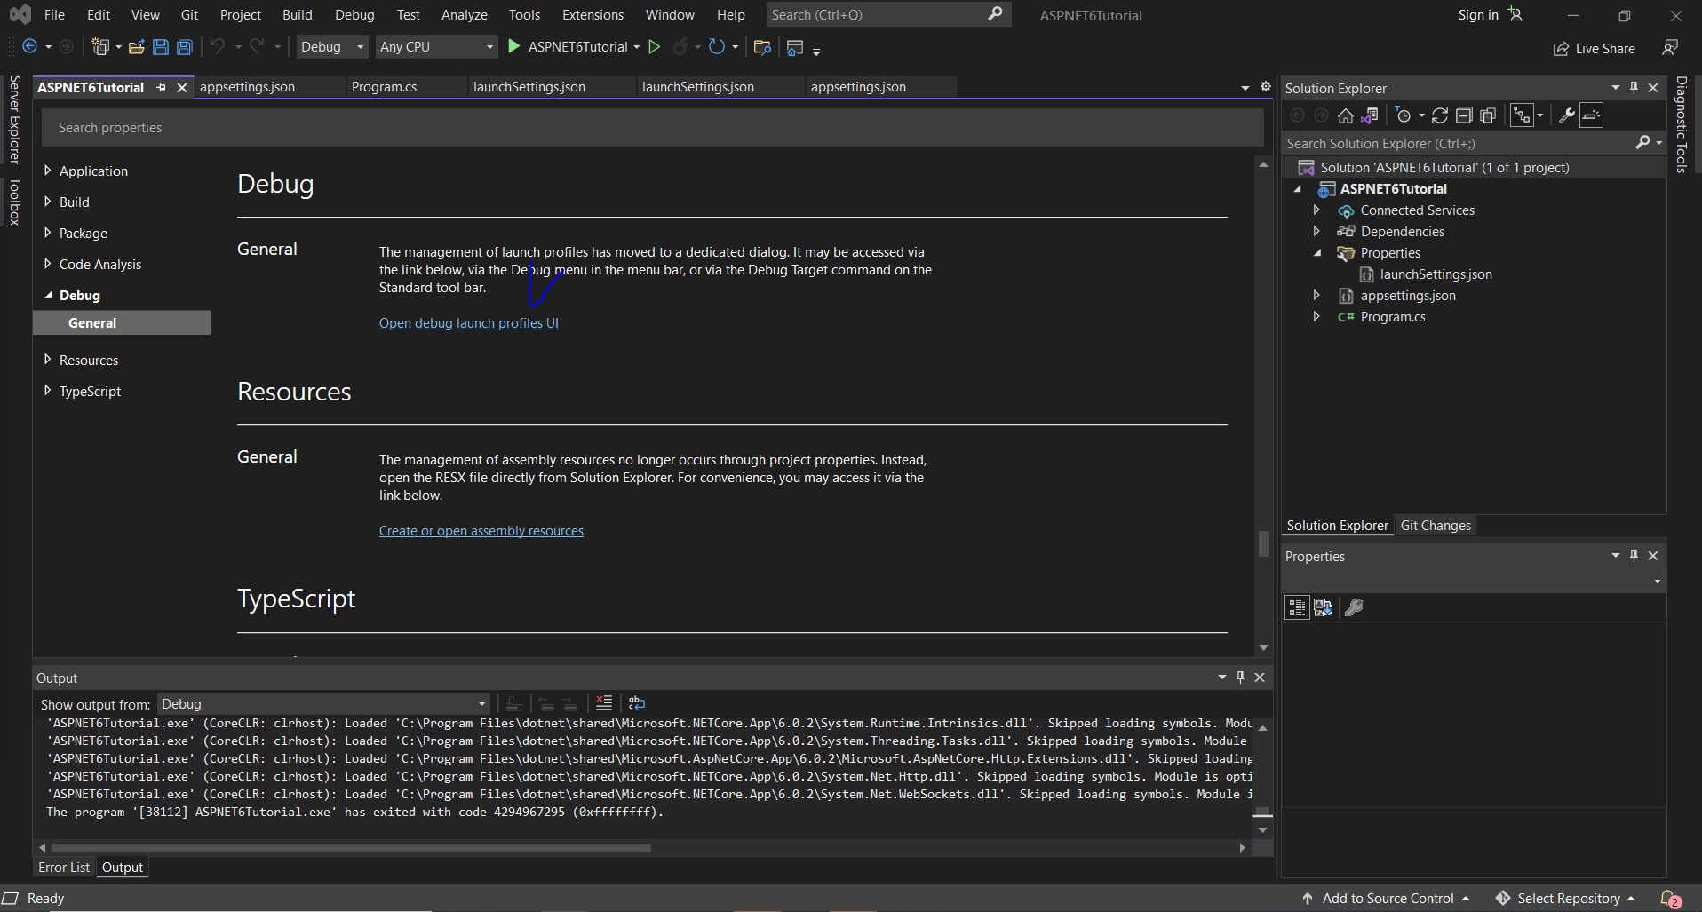

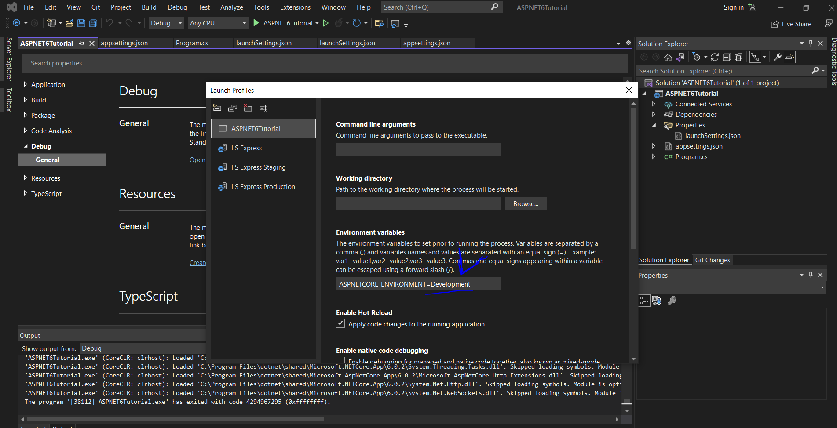

**Set Postman environment variables**

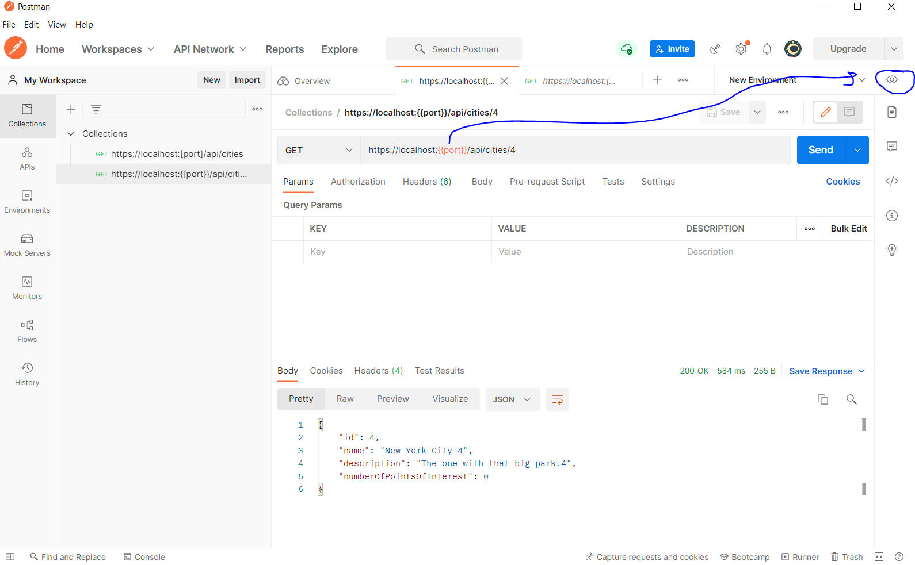

**Postman collections**

**C:\Users\KFarsimadan64912\AppData\Roaming**

GET

[https://localhost:{{port}}/api/cities](https://localhost:%7b%7bport%7d%7d/api/cities)

[https://localhost:{{port}}/api/cities/4](https://localhost:%7b%7bport%7d%7d/api/cities/4)

Entity Framework

**add-migrations ASPNET6TutorialInitialMigration**

**update-database**