Loop3D GeoScience Ontology

# Introduction

The Loop3D Geoscience Ontology is intended to enable implementation of a 3-D geologic data system in a linked data environment that can be integrated with other national and global environmental and geoscience information systems. The model was developed first in UML using the Sparx Enterprise Architect tool, and then implemented in OWL using a combination of text editing and the TopQuadrant TopBraid Composer tool. The OWL implementation is serialized using Turtle notation. One of the design goals is to harmonize the [NADM C1 model](https://pubs.usgs.gov/of/2004/1334/) and the [GeoSciML v3.2](http://geosciml.org/doc/geosciml/3.2/documentation/html/) conceptual model, with the [DOLCE high-level ontology](https://www.researchgate.net/publication/221630979_Sweetening_ontologies_with_DOLCE). The scope of the model includes Earth Materials, Geologic Units, and Geologic Structure, and Geologic Relationships.

The ontology implementation is modularized to enable development of application-specific profiles that bring a minimum of unneeded classes and properties. There are two top-level ontologies, ‘Common’ for high-level cross domain concepts mostly inherited from DOLCE (with some BFO modifications), and ‘Geology’, which contains the basic framework for geoscience concepts. A collection of module are implemented to extend the content of the base modules. The Modules add detailed subclasses and properties of classes in the top level ontologies, bind properties to classes. Vocabularies that define terminology for some property values have been adopted from the [CGI Geoscience Terminology](http://resource.geosciml.org/) vocabularies by converting SKOS representations to OWL. The vocabularies are loosely coupled to the modules, allowing profiles to use of different terminology. Much of the detailed content in the extensions is based on GeoSciML v3.2.

The idea is that any Loop3D dataset would use the base Common and Geology ontology, and set up a ‘Master’ ontology defining a profile that imports those base ontologies, along with the modules and vocabularies that are needed for that profile. The package of owl files in the Version 1 delivery includes a ‘Master’ ontology that imports all modules and vocabularies to enable the entire model, and this is the profile used to implement the included example instances.

# Top Level Classes

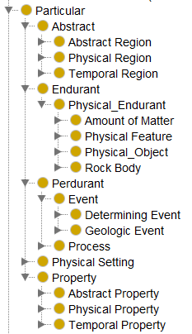

Tbd- description of DOLCE inherited classes, BFO elements uses

# Modules:

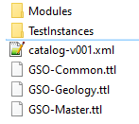

## Geology Base

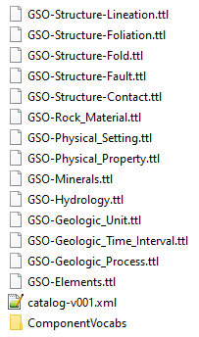

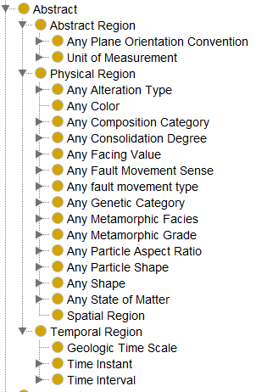

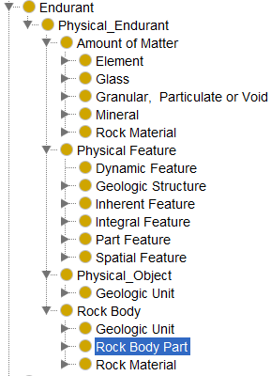

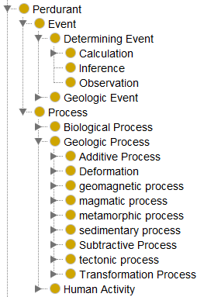

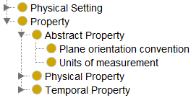

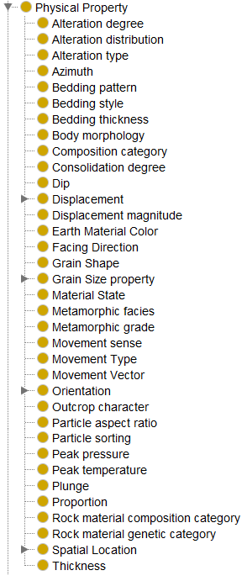

# Namespaces

|  |  |  |
| --- | --- | --- |
| Abbrev. | Namespace URI | Scope |
| dcterms | http://purl.org/dc/terms/ | Dublin core metadata vocabulary |
| gsel | http://loop3d.org/GSO/ontology/2020/1/element/ | Classes for each element by atomic number. Isotopes not distinguished. |
| gsen | http://loop3d.org/GSO/ontology/2020/1/eventenvironment | Event Environment Classes; SubClass from gsoc:Physical_Setting |
| gsfa | http://loop3d.org/GSO/ontology/2020/1/geologicstructure/fault/ | Classes and properties for describing faults |
| gsfo | http://loop3d.org/GSO/ontology/2020/1/geologicstructure/foliation/ | Classes and properties for describing foliation, including sedimentary bedding and tectonic foliation |
| gsgu | http://loop3d.org/GSO/ontology/2020/1/geologicunit/ | Classes and properties for describing geologic units |
| gslth | http://loop3d.org/GSO/ontology/2020/1/lithology/ | Classes and properties for describing Earth materials including gsog:Rock_Material and gso:Granular_Material. Includes CGI simple lithology categories as sub-class of Rock_Material |
| gsmin | http://loop3d.org/GSO/ontology/2020/1/mineral/ | Classes and properties for describing Minerals. Properties mostly inherited from RRUFF datbase. Includes Mineral species from RRUFF as classes. |
| gsoc | http://loop3d.org/GSO/ontology/2020/1/common/ | objectProperties and high level classes that apply globally, based on DOLCE |
| gsog | http://loop3d.org/GSO/ontology/2020/1/geologicfeature/ | High level classes and properties that are used in multiple thematic modules, and provide the framework for geoscience representation. |
| gsol | http://loop3d.org/GSO/ontology/2020/1/geologicstructure/lineation/ | Classes and properties for describing lineation, both primary and tectonic. |
| gsop | http://loop3d.org/GSO/ontology/2020/1/geologicproperty/ | Properties for base geology namespace, shared with multiple modules. [TBD—refactor into gsog and geologic structure] |
| gspr | http://loop3d.org/GSO/ontology/2020/1/geologicprocess/ | Classes for geologic processes, subClass from gsoc:Process or gsog:Geologic_Process. Based on CGI geologic process vocabulary |
| gssf | http://loop3d.org/GSO/ontology/2020/1/geologicstructure/fold/ | Classes and properties for describing fold structures |
| gstime | http://loop3d.org/GSO/ontology/2020/1/ischart/ | Classes for the Internataional Commission on Stratigraphy geologic time scale |
| gsuom | http://loop3d.org/GSO/ontology/2020/1/uom/ | Classes for units of measure. |

# Vocabularies

## Terminology for property values

CGI vocabularies were converted from SKOS to owl with the following mapping:

* skos:Concept 🡪 owl:Class
* skos:broader 🡪 rdfs:subClassOf
* skos:prefLabel 🡪 rdfs:label
* skos:description 🡪 rdfs:comment
* Add dcterms:modified with current date,
* skos:topConceptOf 🡪 rdfs:subClassOf {the class for the gsoc:Abstract/gsoc:Physical_Region representing the concept space
* remove all skos:inScheme triples, and skos:Collection class
* skos:ConceptScheme 🡪 owl:ontology

# Property Pattern

Properties are defined as subclasses of the Top Level Property class defined in common. Properties are defined in modules that correspond to the scope of the property domain. Properties that are not specific to geoscience, having a global scope, are defined in the Common module. Properties with domains spanning multiple geoscience modules are defined in the Property module. Properties specific to the theme of a module are defined in that module.

Properties are bound to classes using the owl:ObjectProperty gsoc:hasProperty, or one of its subtypes.

For example, in the Geologic Unit module (RDF notation is Turtle):

gsog:Geologic_Unit

rdfs:subClassOf [

a owl:Restriction ;

owl:onProperty gsoc:hasPhysicalProperty ;

owl:someValuesFrom gsop:Metamorphic_Grade ;

] .

gsop:Metamorphic_Grade is a property defined in Property module (gsop: namesapce). (Note that note all of the triples included in the definition are shown here.)

gsop:Metamorphic_Grade

rdfs:subClassOf gsoc:Physical_Property ;

rdfs:subClassOf [

a owl:Restriction ;

owl:onProperty gsoc:hasValue ;

owl:someValuesFrom gsop:Metamorphic_Grade_Space ;

] .

This definition asserts that values for the gsop:Metamorphic_Grade property must be instances of gsop:Metamorphic_Grade_Space, or one of its subclasses. Along with the definition of the property, the Property module also defines a class that represents the concept space for values of metamorphic grade:

gsop:Metamorphic_Grade_Space

a owl:Class ;

rdfs:label "Any Metamorphic Grade"@en ;

rdfs:subClassOf gsoc:Physical_Region .

gsoc:Physical_Region is the top level category for value ‘spaces’.

Finally, the metamorphic grade vocabulary is defined in a separate ontology (ComponentVocabs/ Metamorphic_Grade.ttl), with the top-level classes subClassed from gsop:Metamorphic_Grade_Space. The CGI Metamorphic grade vocabulary was mapped to OWL (see mapping process described below). Here are the top concepts in the vocabulary :

**gsmg:metamorphic_grade_not_specified**

a owl:Class ;

dcterms:source "CGI metamorphicgrade SKOS vocabulary 2016-11-22"@en ;

rdfs:comment "for use in normative descriptions to explicitly indicate that any metamorphic condition is allowed (including non-metamorphosed)."@en ;

rdfs:label "metamorphic grade not specified"@en ;

rdfs:subClassOf gsop:Metamorphic_Grade_Space .

**gsmg:metamorphic_grade_unknown**

a owl:Class ;

dcterms:source "CGI metamorphicgrade SKOS vocabulary 2016-11-22"@en ;

rdfs:comment "For use in instance descriptions to indicate that no information is available on metamorphic grade"@en ;

rdfs:label "metamorphic grade unknown"@en ;

rdfs:subClassOf gsop:Metamorphic_Grade_Space .

In a data instance (e.g. ejs: ), values are assigned using blank nodes, unless there is specific instance level information about metamorphic grade:

ejs:JsFormation

a gsog:Formation ;

gsoc:hasPhysicalProperty [

a gsop:Metamorphic_Facies ;

gsop:hasValue [

a gsmf:no_metamorphic_minerals ;

] ;

] .

Where gsmf:no_metamorphic_minerals is a subClassOf gsmg:metamorphic_grade_not_specified

## URI pattern:

Base host name for namespaces:

[http://loop3d.org/GSO/ontology/2020/1](http://loop3d.org/GSO/ontology/2020/1/)

the terminal /1 part indicates a version, and should be incremented for non-backward compatible versions that are released.

{base host name}/{theme} where theme is the subject of a module.

{base host name}/{theme}/{vocabulary} where {vocabulary} is the name of a vocabulary used as the value space (range) for a property in that module

{base host name}/{vocabulary} – where {vocabulary} is a vocabulary used in more than one module.

# Test Instances

