Loop3D GeoScience Ontology

Version 1, Draft 2020-06-18 9:55 AM

Stephen M. Richard, US Geoscience Information Network [smrTucson@gmail.com](mailto:smrTucson@gmail.com)

Boyan Brodaric, Geological Survey of Canada [boyan.brodaric@canada.ca](mailto:boyan.brodaric@canada.ca)

Table of Contents

Introduction 1

GitHub Repository 2

Terminology 2

GSO Common 3

GSO Geology and Geology Modules 6

Namespaces 12

CGI Vocabularies 13

Quality Pattern 13

URI Pattern 14

Test Instances 14

References 14

Appendix 1. SPARQL Queries 16

# Introduction

The GeoScience Ontology (GSO) is a systemized representation of core geological knowledge. It consists of a three-layer framework including: (1) a foundational layer applicable to any discipline, (2) a geological layer forming the root for any aspect of geology, as well as (3) detailed modules that can be refined or supplemented as required for specific geological purposes. It borrows from foundational ontologies for its topmost foundational layer, primarily from DOLCE (Masolo et al., 2003, Borgo and Masolo, 2010) and Basic Formal Ontology (BFO, Arp et al., 2015), but also adds to them and integrates them in a novel way. The root geological layer builds on the NADM (NADM 2004) and GeoSciML (Raymond et al., 2012, CGI Data Model Working Group, 2012) initiatives, extending them conceptually to form a geological superstructure consisting of geological objects, materials, structures, settings, qualities, roles, processes, events, geologic time, and geologic relations. Notably, this superstructure aims to be a comprehensive foundation for representing any aspect of geology. The final layer consists of modules containing specific items building on this superstructure, such as kinds of geological structures (e.g. various faults), time scales (e.g. ICS 2017), or rock materials (e.g. CGI Simple Lithology). This modularized approach enables the substitution or addition of modules for specific needs, allowing for local profiles of GSO.

Although intended for general usage, a driving use-case for GSO is knowledge management for 3D geological modelling. This requires GSO to be easily deployable in internet-free environments, such as remote mining and field camps, and to be readily integrated with 3D modelling software, thus prioritizing compactness and efficiency. For these reasons, GSO is a stand-alone product independent of other ontologies, i.e. it has no external imports. Many modules consist of contents copied from existing ontologies and exchange formats, with links to original sources added as annotations, e.g. copies of many GeoSciML vocabularies are included, albeit converted from SKOS to OWL. This copy, versus import, approach not only avoids unnecessary bloat, but also addresses insurmountable challenges related to conceptual misalignment, insofar as the copied elements are altered to fit into the GSO framework.

GSO is represented in UML, using the Sparx Enterprise Architect tool, and in OWL, using a combination of direct editing and the TopQuadrant TopBraid Composer. The OWL representation is serialized using Turtle notation. The Turtle files (.ttl) have been tested to open in TopBraid Composer Free Edition and Protégé v.5.5, and verified for internal consistency using reasoners within those systems.

The top two GSO layers are serialized as distinct ttl files: ‘Common.ttl’ for the non-geological foundational layer, and ‘Geology.ttl’ for the core geological layer. The modules comprising the third GSO layer are also expressed as distinct ttl files, one for each particular geological aspect. The modules can be seen as analogous to ‘vocabularies’ in non-ontological systems. Such systems differentiate schemas from their content, with vocabularies denoting the content, e.g. database schemas or XML-based data exchange schemas. However, this differentiation is unnecessary in ontological systems, as the entities in schemas and vocabularies are just parts of an ontology. GSO therefore has no vocabularies as such, though its modules are ontological analogs. The number of modules is currently growing as various aspects are added, initially by GSO creators and eventually by other users. The package of owl files in GSO v1 also includes a ‘Master’ ttl file that imports all original modules, and it this suite of files that is described herein and used to encode the example instances.

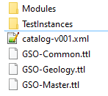

# GitHub Repository

GSO lives in a [GitHub repository](https://github.com/Loop3D/GKM/tree/master/Loop3D-GSO) structured as per Figure 1. The ‘.ttl’ extension indicates the file is encoded using the Turtle serialization (Beckett and Berners-Lee, 2011). The Common and Geology files are in the main directory, along with the Master import file that brings together all components. The Modules folder contains the thematic modules and has a subdirectory ‘ComponentVocabs’ that contains the source (vocabulary) files for the modules. Each main folder contains an OASIS catalog file (e.g. catalog-v001.xml), providing a mapping from GSO URIs to file locations in the repository, necessary because the URIs do not currently resolve on the Web, but must be accessed locally by OWL editors.

Figure . GSO Github

# Terminology

Types are generalizations that broadly include things like classes, kinds and categories, e.g. rock or event. Instances are instantiations of types, e.g. this rock, that event. Individuals cannot be instantiated (this rock has no instances), and entity and thing are used synonymously.

# GSO Common

The following sections present the top entities in the GSO ontology, mainly found in Common.ttl.

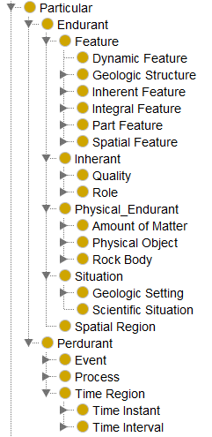

## Top Types

**Particular** is the top type and has individuals as instances, e.g. this rock or that event are instances. **Endurant** is a particular that is wholly present at any time it exists – it endures. It can change in time, may have endurant parts only, and some can survive the loss or replacement of parts, e.g. a geological unit. A **Feature** is an endurant dependent on two or more particulars, e.g. a fault depends on at least two host rock bodies to exist. In contrast, an **Inherent** depends on a single endurant, inheres in any particular, and is either a **Quality** (e.g. density) or **Role** (e.g. rock sample). A **Physical Endurant** is directly located in space, i.e. it occupies a **Spatial Region**, which is a chunk of space. A **Situation** is indirectly located in space, by virtue of the spatial location of its parts, and is a fragment of the world, e.g. a **Geological Setting**. A **Perdurant** is not wholly present at a timepoint, but unfolds in time – it persists, e.g. an earthquake; it may have perdurant parts only. **Processes** and **Events** are perdurants directly located in time and indirectly in space, and processes are the constituents of events. **Time Regions** are chunks of time directly occupied by perdurants.

Figure . Particular

## Physical Endurant

A **Physical Endurant** is directly located in space by occupying a spatial region. An **Amount of Matter** constitutes a physical object, and may be constituted by other matter, such as grains, minerals or elements. A **Physical Object** is constituted by an amount of matter, but is itself never a constituent. A **Rock Object** is a physical object constituted by rock material and identified by some unique qualities or constituents. A **Geologic Unit** is a rock object further identified by topological traits such relations to other units. A **Rock Body** is either a rock object or a rock material, e.g. this rock or that chunk of gold.

A Rock Body is physical endurant that is either a Rock Object or a chunk of Rock Material, e.g. this rock or this chunk of gold are rock bodies.

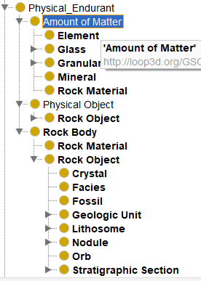

Figure . Physical Endurant

## Feature

A **Feature** is an endurant dependent on, and emergent from, (1) some host endurant and (2) some other particular related to the host. Features are categorized according to the type of relation between host and particular. In **Dynamic Features** the host *participates* in a perdurant, e.g. an earthquake wave emerges from some ground *participating* in shaking. In **Inherent Features** a quality *inheres* in a host, e.g. a fold emerges from a shape *inhering* in a rock body. Folds are also **Morphological Features**, as they emerge from the shape quality. In **Integral Features** some parts of a host are *unified* into an integrated whole, e.g. fabric or bedding emerges from rock body parts *unified* into a pattern. **Part Features** emerge from a *part* of the host, e.g. the top or bottom *part* of a rock body, which are also **Physical Boundaries. Complex Features** have some parts that are features. **Spatial Features** emerge from a *spatial relation*, e.g. a hole from a rock surface *beside* a chunk of space, a fault from the *displacement* of rock bodies, or a contact from the *meeting* of rock bodies. **Material Spatial Features** are constituted by an amount of matter, e.g. a fault zone, and **Immaterial Spatial Features** are not, e.g. rock pores, contacts, or faults. **Geological Structures** are certain features historically identified in geology.

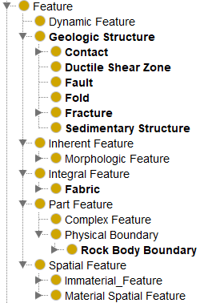

Figure . Feature

## Perdurant

**Perdurants** comprise **Events**, **Processes**, and **Time Regions**. Events and Processes persist in time by accumulating different temporal parts (events or processes, respectively), so that, at any timepoint they are present, they are only partially present. Events and processes are things that happen (persist), while endurants are things that are (endure). Specifically, processes are *how* things happen (deposition process), while events are *what* happens (deposition of a formation), analogous to walking (process) and a walk (event). Processes constitute events in a way similar to how amounts of matter constitute physical objects, e.g. the walk is constituted by the walking. Both processes and events must have at least some endurant participants – an event or process cannot happen unless it is happening to something. **Geologic Processes** are categorized by their material activity (after Perrin *et al*. 2003): whether material is added (**Additive**; e.g. deposition), deformed (**Deformation**, e.g. faulting), removed (**Subtractive**, e.g. erosion), or transformed (**Transformation**, e.g. metamorphism). **Time Regions** are chunks of time, either **Time Intervals** or **Time Instants**, directly occupied by processes and events, and indirectly occupied by their participant endurants, Time regions are the basis for geologic time scales. **Determining Events** provide provenance for scientific validation: whether some particular is observed, calculated or inferred.

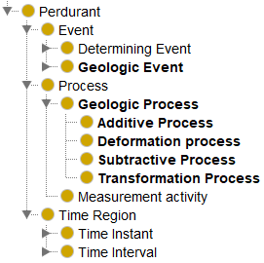

Figure . Perdurant

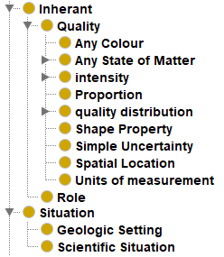

## Inherant and Situation

**Qualities** (properties) are inherent characteristics of things. Qualities inhere in those things, and depend on them, e.g. the colour, weight or density of something inheres in the thing and cannot exist without it. Qualities are found in a separate module as shown in Fig 7. Situations are fragments of the world, and Geologic Settings are geological fragments, e.g. sedimentary or tectonic environments as the context in which geologic processes operate. Expanded geological settings are found in the Geologic Setting module (GSO-Geologic_Setting.ttl).

Figure . Inherants and Situation

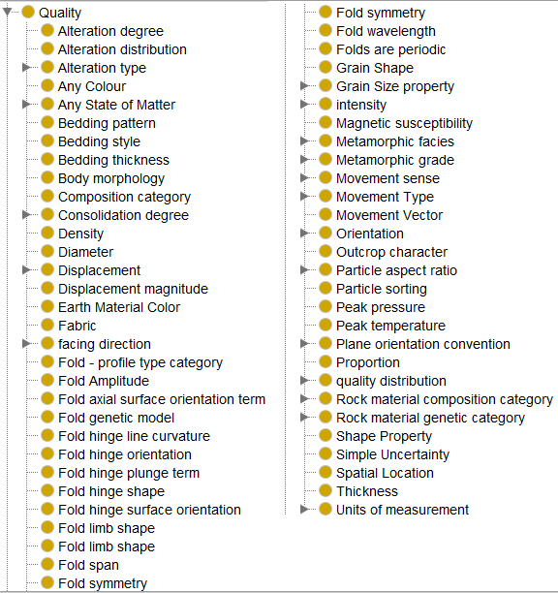

Figure 7. Quality examples

# GSO Geology and Geology Modules

The geology modules are dependent only on the top level Common (GSO-Common.ttl) and Geology (GSO-Geology.ttl) ontologies. Select modules can then imported as needed for a particular application.

## Geology

This is the core geology layer, serialized in GSO-Geology.ttl.

Table . Classes defined in GSO-Geology (gsog: namespace)

| **Name** | **Description** |
| --- | --- |
| Additive Process | process that introduces new matter into the model space |
| Age (time scale rank) | Most granular chronometric time interval; one or more Ages are grouped into an Epoch |
| Aggregate non clastic particle | Generic term for a non-clastic particle that is itself composed of an aggregation of particles. |
| Alteration degree | Specification of the strength of observed alteration. Can be used on Geologic_Unit or Rock_Material |
| Alteration distribution | AlterationDistribution describes the spatial distribution or geometry of alteration zones. eg: patchy, spotted, banded, viens, vein breccia, pervasive, disseminated, etc |
| Alteration type | Specification of alteration types (eg; potassic, argillic, advanced argillic) |
| Amount of Matter Role |  |
| amygdule | Cavity filled with secondary minerals, denotes that cavities are filled vesicles, thus restricted to volcanic rock. Have to model as a cavity/with material. Rock hosts cavity |
| Bedding | Bedding as a fabric representing the average orientation of paleodepositional surface should be encoded through the foliationType; might apply to bedding that is layering or a foliation without layering (e.g. clast alignment in amalgamated beds). |
| Bedding Package | A sub-map scale sequence of strata, e.g. bouma sequence, fining-upward sequence, interbedded sandstone and mudstone. |
| bolide impact | The impact of an extraterrestrial body on the surface of the earth |
| Boundary Stratotype | A stratigraphic section that contains a designated point in a stratigraphic sequence of essentially continuous deposition, preferably marine, chosen for its correlation potential. http://www.stratigraphy.org/upload/bak/chron.htm |
| Chronostratigraphic Unit | A body of rock that includes all rock, layered or unlayered, formed during a specific interval of geologic time, and only during that time. Chronostratigraphic units are bounded by synchronous horizons. The rank and relative magnitude of the units in the chronostratigraphic hierarchy are a function of the length of the time interval that their rocks subtend, rather than of their physical thickness. (<http://www.stratigraphy.org/upload/bak/chron.htm>). |
| Clast | A role for any fragment of material that is a constituent in a rock material that formed by the accumulation of such fragments before lithification. |
| Clast imbrication |  |
| Clast supported |  |
| cometary impact | The impact of a comet on the surface of the earth |
| Complex | A lithostratigraphic unit composed of diverse types of types of rocks (sedimentary, igneous, metamorphic) and characterized by irregularly mixed lithology or by highly complicated structural relations. |
| Contact | A surface that separates touching rock bodies and has no volume (i.e. is low-dimensional). Very general concept representing any kind of surface separating two rock bodies, including primary boundaries such as depositional contacts, all kinds of unconformities, intrusive contacts, and gradational contacts, as well as faults that separate geologic units. (CGI ContactType vocabulary, adapted from Jackson, 1997, page 137, NADM C1 2004). |
| Crystal | An object composed of a single mineral species, with a characteristic geometrical shape, bounded by flat faces with specific, characteristic orientations reflecting a consistent, highly ordered internal arrangement of constituent atoms. |
| crystal constituent | constituent is formed by crystallization from melt or by metamorphic processes. Distinct from constituent roles related to clastic processes, or diagenetic processes. |
| Crystallographic preferred orientation | fabric defined by a preferred orientation of the crystallographic axes of mineral particles in a rock. |
| Deformation process | Parent class for processes that change the shape or location of geologic entities. Includes strain and translation. |
| Ductile Shear Zone | A broadly planar zone (volume of rock) of shear displacement within which deformation has occurred without loss of material continuity. |
| Epoch | A time interval. An Epoch may be subdivided into Ages. Epochs are grouped into Periods. Example epochs: Eocene, Pleistocene. |
| Fabric | A spatial or geometric arrangement of parts of a rock body or features within the rock body that is present throughout the body. |
| Facies | Represents a particular body of rock that is a lateral variant of a lithostratigraphic unit, or a variant of a lithodemic unit. Contrast with lithosome in being a particular, connected body of rock, as opposed to a kind of rock body that is repeated in many places in a unit. |
| Fault | A discrete surface (without volume), or collection of discrete surfaces, each separating some rock bodies such that one body has slid past another; characterized by brittle deformation. |
| Fault Zone | A volume of rock deformed between faults or adjacent to some faults. |
| fenestra | Primary or penecontemporaneous gap or cavity in the framework of a sedimentary rock, larger than grain-supported intersticies. May be open space or have partial to complete fill with secondary cement or introduced sediment. |
| Fold | A curve or bend inherent in a rock body, usually the product of deformation, involving the compression of strata, but may include primary structures, as its definition is not genetic. |
| Foliation | Fabric defined by the planar arrangement of textural or structural features (fabric elements). |
| Fossil | NOTE--this class is intended to represent individual fossil objects. If some kind of material fossils are granular constituents in a sedimentary rock, they should be represented using 'Biogenic_Granular_Material, with sub classes for different kinds of fossils, e.g. in crinoid grainstone, radiolarian chert, diatomite. |
| Fracture | Axiom for gsoc:participantIn is place holders for more specific properties in gsop and gspr. Trying to avoid imports here. |
| Geochronologic Boundary | A time instant that represents an event recorded by a reference physical statigraphic point |
| Geologic Age Instant | A Geologic age that is specified by either a numeric temporal coordinate or correlation with a stratigraphic point via GeochronologicBoundary/isRealizedBy/StratigraphicPoint |
| Geologic Age Interval | A time region that is defined by younger and older Geologic Date Intervals. Typically used for age assignments in geologic maps, where a map unit might include rocks of various ages. |
| Geologic Date Interval | A time interval that is bounded by specified time instants. same as Geochronologic_Age_Interval |
| Geologic Event | When something happens, events are the ‘what’ of the happening, and processes are the how, e.g. a walk (event) and walking (process), or an earthquake (event) and ground shaking (process). An example is the Trans-Hudson Orogeny (event) caused by a subduction (process). The relation between events and processes is constitution: events are constituted by processes, and processes constitute events. Processes and events have at least one endurant as participant, i.e. a happening cannot occur unless it happens to something. Events can only have events as parts. |
| Geologic Process | Processes are the ‘how’ of a happening (see Event above). A geological process typically has input and output participants that are geologic. Processes can only have other processes as parts. |
| Geologic Structure | A pattern in a rock body (foliation, fold), or a feature occurring between rock bodies (contact, fault, fracture). GeoSciML 3.2: A configuration of matter in the Earth based on describable inhomogeneity, pattern, or fracture in a Rock Body. The identity of a GeologicStructure is independent of the material that is the substrate for the structure, though each structure cannot exist without there being a relation between a rock body and some other thing, such as a shape (fold) or other rock body (contact, fault). Includes sedimentary structures. |
| Geologic Time Date | A point in time. Can be (1) a GeochronologicBoundary if it is associated with a location in a particular stratigraphic section, or (2) a GSSA if it is arbitrarily assigned. Requires a Temporal Reference System (not yet included) to describe time values. |
| Geologic Time Interval | A time interval of geological significance, defined by its position between other time intervals, without necessarily specifying the bounding time instants. Can be a part of a time scale. |
| Geologic Time Scale | A collection of Geologic Date Intervals (time intervals denoted by numeric age boundaries) that obey a special topology (after Cox and Richard, 2010). A time scale is itself an interval of time, indeed it could be the complete container for time, i.e. having all other time intervals as parts. |
| Geologic Unit | A rock body identified not only by its geometric, compositional and internal structural characteristics, but also by its topology, i.e. its relations to other rock bodies (after the ICS and N. American stratigraphic codes). |
| Granular Material | A lump of material that consists of particles having a consistent set of properties. Also used to represents a rock body constituent composed of particles that share a set of characteristics, e.g. particle size (distribution), mineralogy, shape.  E.g. the sand that is a constituent in a sandstone, or the feldspar phenocrysts that are a constituent in a granite.at any level of granularity, e.g. rock material, particle, mineral or element. Can have unity (the gold of this ring, tooth, etc.) or not (the gold in this room, rock, etc.) (Lowe 1998). |
| GSSA | A point in time defined by the International Stratigraphic Commission, based on fiat assertion of a time coordinate. |
| GSSP | A stratigraphic point that is hosted by a top and bottom segment of adjacent chronostratigraphic units. The top and bottom are part of an outcrop and part of a stratotype (type section) for the unit. |
| hydrothermal vein | A tabular or sheet-like part of a compound material formed by hydrothermal (or other metasomatic) mineral filling a fracture, may be associated with replacement of the host rock adjacent to the body |
| igneous vein | A tabular or sheet like part of a compound material formed by the intrusion of magma. Syn dike |
| Inclusion | A body of material present as masses with generally sharp boundaries enclosed within a matrix of some other material. |
| Intrusive sheet | A tabular or sheet-like part of a compound material, genetic origin not specified |
| Lineation | Nongenetic term for a penetrative linear structure. |
| lithophysae | Bubble-like cavity with concentric shells of finely crystalline minerals, open space remains in core of structure. Radiating fibrous structure may be present in secondary mineral fill. Typically in silicic volcanic rock. |
| Lithosome | A kind of rock object that has multiple occurrences in a single geologic unit. A mass of rock of uniform character, characterized by geometry, composition, and internal structure. (http://inspire.ec.europa.eu/codelist/CompositionPartRoleValue/lithosome) |
| Lithostratigraphic Unit | Geologic unit defined on the basis of observable and distinctive lithologic properties in combination with stratigraphic relationships. |
| magnetic field reversal | A geomagnetic event in which the Earth's magnetic field reverses direction. |
| Matrix | Material in which something is enclosed or embedded (3b, https://www.merriam-webster.com/dictionary/matrix) |
| meteorite impact | The impact of a meteorite on the surface of the earth |
| miarolitic cavity | An irregular cavity in a phaneritic igneous rock into which small crystals of the rock-forming minerals protrude. |
| Mineral | A mineral is an element or chemical compound that is normally crystalline and that has been formed by geological processes. (Nickel, 1995). |
| mono-mineralic crystal particle | Typical grain constituent in a phaneritic igneous or metamorphic rock, visible to naked eye or with hand lense. Particle are individual mineral grains that have crystallized from melt or through metamorphic processes. In deformed rocks, these my have some subgrain structure but at the scale of description are considered individual particles in a granular material constituent of a rock. |
| Nodule | An irregularly rounded mass of a mineral or mineral aggregate normally having a warty or knobby surface and no internal structure, usually with a contrasting composition from the enclosing sediment or rock matrix in which it is embedded, and that can be separated as a discrete mass from the host material. |
| Orb | Igneous constituent typically mafic, equant rounded spheroid with concentric mineralogic banding |
| Outcrop | A boundary between a rock body and the atmosphere or a liquid body. |
| Overgrowth | A rock body part that encloses some other constituent in the rock body |
| Particle shape fabric | Fabric defined by alignment of the dimensional axes of prolate or oblate particles in a rock. The fabric might result from primary depositional or crystallization process, or from subsequent deformation |
| Pendant | A mass of country rock that is entirely surrounded by an igneous intrusion, such as a batholith or other pluton. |
| pore space | Open space between particles in a granular aggregate. |
| preferred orientation | Fabric defined by preferred crystallographic or grain shape orientation in a rock material. |
| Rock Body | A physical endurant that is either a rock object or rock material. |
| Rock Body Bottom | The bottom (i.e. older) boundary of a rock body. Boundaries as such have minimal thickness and volume and are thus material entities. |
| Rock Body Boundary | A physical boundary hosted by a rock body, and having minimal thickness and volume and thus being a material entity. |
| Rock Body Role | Roles that relate rock bodies |
| Rock Body Top | The top (i.e. younger) boundary of a rock body. |
| Rock Body Void | An open space in a rock body, that can be filled with gas or fluid. |
| Rock Material | A material consisting of an aggregation of particles composed of mineral, glass, or other rock material. General entity for any constituent of rock, sediment, or other material object. |
| Rock Material Outcrop | A boundary between a rock body and the Earth's atmosphere or a water body. |
| Rock Object | A part of the Earth that can be identified in some way and that has a Unity property. |
| Schlieren | a tabular body, generally a few cm to a few metres long, within a plutonic rock, having different mineral proportions and colour to the surrounding rock |
| Sedimentary Fabric | Fabrics in sedimentary rock like "clast-supported", "matrix-supported", "cross-bedding", and "graded bed" are considered kinds of Integral Feature/GeologicStructure because they depend on the configuration of parts of a rock body. |
| Sedimentary Structure | Structures formed in sedimentary rocks related to depositional or diagenetic processes. Includes trace fossils. |
| Separation | a vector (magnitude and orientation) specifying the distance between the intersection of a surface on opposite sides of a displacment surface. In 3-D is the projection of a vector normal to the displaced surface into the displacment surface, but might also be specified as offset of the intersection of displacement surface and marker surface in some other profile view (e.g. horizontal/map view, or a cross section) |
| Slip | a vector (magnitude and orientation) that links a peircing point on opposite sides of a displacement surface. |
| Stratigraphic Point | A spatially restricted part of a Contact feature, typically located by a point. |
| Stratigraphic Section | A rock object that represents a continuous strip of rock material that includes a sequence of stratified layers. |
| Stratotype | Add SHACL rule that a Stratotype may not have a 'hasReference' relation |
| Subtractive Process | A process that removes matter from some physical object. |
| Supereon | A high ranking geologic time interval; direct parts are Eons. |
| syngenetic nodule | Particle formed by chemical precipitation at sediment-water interface, lacking layered structure that characterizes coated grains. Includes glauconite grains, manganese nodules, phosphate grains. Manganese nodule--\An irregular, black to brown, friable |
| Transformation Process | A process that changes the characteristics of matter within a physical object. |
| vesicle | Cavity in volcanic rock formed by trapped gas. Use amygdule if filled with secondary mineral. |
| Volcanic Glass | Glass formed by rapid cooling of lava |
| vug | Irregular cavity in rock, generic term with no connotation of origin of cavity. May be lined with crystals of different mineral compostion to the host rock |
| Xenolith | Inclusion of pre-intrusive country rock in intrusive igneous matrix, cm to about 10 meter diameter in longest dimension. Use term pendant for larger blocks or for lithologically heterogeneous blocks. |

## Geologic Structure Modules

Geologic structures are represented in five separate sub-modules.

1. **GSO-Structure-Contact.ttl** contains the various types of contacts derived from the CGI vocabulary. Qualities specific to contacts are not currently defined.
2. **GSO-Structure-Fault.ttl** contains the CGI Fault Type, Fault Movement Sense and Fault Movement Type classes, and defines the Displacement property and its components Fault_Movement_Magnitude, Fault_Movement_Sense, Fault_Movement_Type, and Fault_Movement_Vector.
3. **GSO-Structure-Fold.ttl** defines a set of properties and classes for describing Folds, Fold Systems, and Fold Hinge and Fold Limb as parts of a fold. Physical properties defined and bound here include: Fold_Amplitude, Fold_Axial_Surface_Orientation, Fold_Genetic_Model, Fold_Hinge_Orientation, Fold_Hinge_Plunge, Fold_Hinge_Surface_Orientation, Fold_InterLimb_Angle, Fold_Limb_Shape, Fold_Profile_Type, Fold_Span, Fold_Symmetry, Fold_Wavelength, Hinge_Line_Curvature, Hinge_Shape, and Is_Periodic. Vocabularies for the terminological properties are not currently implemented, and property values are specified as free text.
4. **GSO-Structure-Foliation.ttl** defines classes for planar fabrics in rocks, as defined by the IUGS Commission for Geoscience Information (CGI) Geoscience Terminology Working Group CGI foliationtype SKOS vocabulary 2018-08-03. Includes primary (e.g., sedimentary and igneous) and deformation-related (e.g., metamorphic and tectonic) planar fabrics. No foliation-specific qualities are defined.
5. **GSO-Structure-Lineation.ttl** defines classes for linear fabrics in rocks, as defined by the IUGS Commission for Geoscience Information (CGI) Geoscience Terminology Working Group CGI lineationtype SKOS vocabulary 2016-11-21. No lineation-specific qualities are defined.

## Rock Material Module

This module includes rock type categories modified from the CGI SimpleLithology SKOS vocabulary, along with qualities from GeoSciML v3.2. Scope includes gsog:Rock_Material and gsog:Granular Material. GSO granular material is analogous to GeoSciMLv3.2 compound material particle geometry description. Physical qualities defined include Consolidation_Degree, Grain_Shape, Grain_Size_Average, Grain_Size_Min, Grain_Size_Max, Particle_Aspect_Ratio_Category, Particle_Sorting_Category, Rock_Material_Color, Rock_Material_Composition_Category, Rock_Material_Genetic_Category. This module imports modules for consolidation degree, composition category, genetic category, metamorphic facies, metamorphic grade, particle shape, and particle type.

## Elements Module

An ontology module for chemical elements, including URIs. Extracted from WikiData via SPARQL query, with local URIs defined in the <http://loop3d.org/GSO/ontology/2020/1/> space. Qualities for each element include atomic number, abbreviation, WikiData URI, CHEBI URI and Encyclopedia Britannica link.

## Minerals Module

An ontology module for some 4600 mineral species extracted from the RRUFF database with URIs in <http://loop3d.org/GSO/ontology/2020/1/>. The content has been enhanced with links mined from the Wiki­Data mineral list, which only yielded about 3600 species. Qualities on each species include a list of elements present in the mineral (chemistryelements), the crystal system, Fleischer’s Group classification, a URL link to the handbook of mineralogy, the IMA chemical formula (html encoded), the IMA mineral number, IMA status, IUPAC chemical name, the Mindat.org ID number, URL link to Mindat.org, the RRUFF chemical formula (HTML encoded), the RRUFF name (with extended character set), RRUFF name html encoded, RRUFF name plain (plain ASCII characters substituted for special characters), status notes, structural group (provided by RRUFF), Strunz (version 10) class code, Label for the Strunz class, URL for mineral in WebMineral, and adoption date from Wikipedia. Not all fields are populated for all species. Some subclass relations were added in this ontology for feldspars and clay minerals to facilitate rock mineralogy descriptions. Additional work needs to be done to define useful mineral groups for rock description, and also to select a reduced set of perhaps 500 minerals that are likely to be useful for 3-D Earth models.

## Geologic Process Module

This ontology module represents geologic processes, as well some anthropogenic or biologic processes that impact geology. It is based on terms and definitions from the 2016 SKOS-RDF version of the CGI Event Process vocabulary, but some revisions have been made in the hierarchy, along with mapping to the functional process categories additive, subtractive, transformation, and deformation (Perrin et al, 2005).

## Physical Setting Module

This ontology contains items from the 2016 SKOS-RDF version of the IUGS Commission for Geoscience Information (CGI) Geoscience Terminology Working Group Event Environment vocabulary, to describe the physical setting within which a GeologicEvent takes place. It is construed broadly to include those settings specified by climate, tectonics, physiography or geography, as well as subsurface settings specified by pressure, temperature, chemical environment, or tectonics.

## Geologic Unit Module

The Geologic Unit module extends the Chronostratigraphic Unit and Lithostratigraphic Unit types with additional kinds of geologic units, as defined by the IUGS Commission for Geoscience Information (CGI) Geoscience Terminology Working Group Geologic Unit type vocabulary. Qualities for Geologic Units are based on GeoSciML 3.2 and include Bedding_Pattern, Bedding_Style, Bedding_Thickness_Category, Geologic_Unit_Body_Morphology, Geologic_Unit_Composition_Category, and Geologic_Unit_Outcrop_Character. Values for these qualities have not been implemented and are currently specified as free text. The Alteration type, Metamorphic Facies and Metamorphic Grade component vocabularies are imported.

## Geologic Time Interval Module

This ontology is conceptually aligned with the Cox and Richard (2014) OWL implementation of the Geologic Time Scale, simplified to minimize import dependencies and taking advantage of foundational ontological distinctions. Named time intervals from a time scale are instances of the Geologic_Time_Interval subclasses like Eon, Era, Period, as appropriate. The bounding time positions for the named time intervals are implemented as Geochronologic_Boundary instances or as GSSA instances, with time coordinates in million years before present (abbreviated Ma).

The geologic time intervals are considered chronometric entities in GSO, with their identity defined by the time points (dates) of their boundaries. Thus, a change in an assigned interval boundary date indicates a different time interval, e.g. Jurassic in the 2004 and 2017 ICS time charts are different entities, as they have different boundary dates, but Jurassic in the 2004 and 2010 ICS time charts are the same interval and entity. Any time interval can have a reference chronostratigraphic unit in the physical rock record, which is a geologic units formed during that time interval. Furthermore, each boundary of a time interval can also have a reference in the rock record, with the reference being an observed contact (Stratigraphic Point) that might be internationally ratified (GSSP).

~~This is in contrast to a chronostratigraphic view of a time scale in which an actual physical manifestation (stratotype) in the rock record is the anchor that defines a geologic time interval. The time coordinates (dates) assigned to the interval boundaries vary across versions of the International Chronostratigraphic Chart from the International Commission on Stratigraphy as geochronologic data improve to refine our understanding of the temporal position of the interval boundary. The practical implication of this difference for implementing a representation of the time scale is that in the chronometric view, each geologic time interval (gsog:Geologic_Date_Interval) has a unique time coordinate (gsog:Geologic_Time_Date) for its younger and older boundary. If a new estimate for the time of either boundary is adopted, then an new instance of gsog:Geologic_Date_Interval is created. The Geologic_Time_Date references the corresponding Stratigraphic_Point that anchors it. In an implementation of the chronostratigraphic view, each geologic time interval would be associated with a unique stratigraphic point for its younger and older boundary. New time interval instances would be created if a new definition of either boundary stratigraphic point is adopted, e.g. when a GSSP is ratified. The stratigraphic point might have multiple Time_Instant values corresponding to different estimations of its temporal position.~~

A time scale is then a collection of time intervals having an appropriate temporal topology, and the time intervals are parts of the time scale. A geologic time scale in GSO is thus a chunk of time partitioned into geologically relevant intervals, with this relevancy grounded in the rock record where possible. GSO currently includes definitions for intervals from the ISC2004 time scale (Gradstein et al., 2004), the ISC2017-02 time scale (<https://stratigraphy.org/icschart/ChronostratChart2017-02.pdf>) and the ISC2020-01 time scale (<https://stratigraphy.org/icschart/ChronostratChart2020-01.pdf>). If the temporal position of the boundaries does not change across versions, then the same interval is used. Only if the boundary date estimate changes is a new interval instantiated. However, a new interval instance is not instantiated if the boundaries of some internal subdivision change. For example the temporal boundaries defining the Miocene and Oligocene are the same in the 2004, 2017 and 2020 versions, even though certain subdivisions changes, e.g. the date estimates for the boundaries of the Serravallian Age of the Miocene changed between the 2004 and 2017 time scale publication.

## Quality Module

GSO includes some common qualities (properties) used by several other modules, mostly related to orientation and metamorphic description.

## Hydrology Module

This module includes hydrology types. Currently it defines hydrologic event and hydrologic process as types of Perdurant.

# Namespaces

|  |  |  |
| --- | --- | --- |
| **Prefix** | **URI** | **Scope** |
| dcterms | http://purl.org/dc/terms/ | Dublin core metadata vocabulary |
| gsel | http://loop3d.org/GSO/ontology/2020/1/element/ | Elements by atomic number. Isotopes not distinguished. |
| gsen | http://loop3d.org/GSO/ontology/2020/1/eventenvironment | Event Environments; SubClasses of gsoc:Physical_Setting. |
| gsfa | http://loop3d.org/GSO/ontology/2020/1/geologicstructure/fault/ | Faults. |
| gsfo | http://loop3d.org/GSO/ontology/2020/1/geologicstructure/foliation/ | Foliations, including sedimentary bedding and tectonic foliation |
| gsgu | http://loop3d.org/GSO/ontology/2020/1/geologicunit/ | Geologic units. |
| gslth | http://loop3d.org/GSO/ontology/2020/1/lithology/ | Materials: gsog:Rock_Material and gso:Granular_Material. Includes the CGI Simple Lithology categories as sub-classes of Rock_Material. |
| gsmin | http://loop3d.org/GSO/ontology/2020/1/mineral/ | Minerals. Qualities mostly inherited from RRUFF database. Includes Mineral species from RRUFF as classes. |
| gsoc | http://loop3d.org/GSO/ontology/2020/1/common/ | Entities and relations that apply universally. |
| gsog | http://loop3d.org/GSO/ontology/2020/1/geologicfeature/ | Entities and relations that used in multiple modules, forming the framework for geoscience representation. |
| gsol | http://loop3d.org/GSO/ontology/2020/1/geologicstructure/lineation/ | Lineations, both primary and tectonic. |
| gsoq | http://loop3d.org/GSO/ontology/2020/1/geologicquality/ | Geologic qualities shared with multiple modules. |
| gspr | http://loop3d.org/GSO/ontology/2020/1/geologicprocess/ | Geologic processes, subClassed from gsoc:Process or gsog:Geologic_Process. Based on CGI geologic process vocabulary |
| gssf | http://loop3d.org/GSO/ontology/2020/1/geologicstructure/fold/ | Folds. |
| gstime | http://loop3d.org/GSO/ontology/2020/1/ischart/ | Entities representing the International Commission on Stratigraphy geologic time scale. |
| gsuom | http://loop3d.org/GSO/ontology/2020/1/uom/ | Units of measure. |

# CGI Vocabularies

Many [CGI vocabularies](http://resource.geosciml.org/vocabulary/cgi/2016/) were converted from SKOS to owl with the following mapping:

* skos:Concept 🡪 owl:Class
* skos:broader 🡪 rdfs:subClassOf
* skos:prefLabel 🡪 rdfs:label
* skos:description 🡪 rdfs:comment
* dcterms:modified with current date
* skos:topConceptOf 🡪 rdfs:subClassOf
* remove all skos:inScheme triples and skos:Collection classes
* skos:ConceptScheme 🡪 owl:ontology

# Quality Pattern

Quality and Role are both subclasses of ‘Inherent’, a foundational type for things that depend for their existence on a single independent particular that is its bearer. An Inherent is associated with the bearer via the 'inheresIn' relation (or one of its subrelations). An Inherent is an Endurant because it is present in its totality at any time that it exists. Non-geologic qualities, e.g. density, colour, orientation, that are general are defined in the Common module. Geologic qualities that span multiple geoscience modules are defined in the Quality module. Other qualities applicable only to certain modules are defined in those modules.

Bearers are bound to their qualities via the gsoc:hasQuality relation, and qualities to their bearers via the gsoc:isQualityOf relation. Importantly, qualities such as Colour can have values such as Red. Qualities are bound to their values via the hasValue relation in principle, but in practice, due to OWL constraints, there are two binding relations: gsoc:hasValue for binding to types, such as Red, and hasDataValue for binding to literal types, such as numbers (e.g. 10.13) or strings (e.g. “foo”), which are implemented as simple xml types (e.g. text, decimal, date). In an instance, typed quality values are also instances and typically assigned using blank nodes: in the example below, a blank node is used to specify the type of quality (gsop:Metamorphic_Grade), and another blank node is used to specify the medium metamorphic grade value.

con:XmRockBody

a gsog:Complex ;

gsoc:hasConstituent [

a gslth:gneiss ;

gsoc:hasQuality [

a gsop:Metamorphic_Grade ;

gsoc:hasValue [ a gsmg:medium_metamorphic_grade ]

] ;

] ;

Importantly, qualities can bear qualities to form complex qualities, such as colour bearing the hue, saturation, and brightness qualities. Units of measure also considered a quality carried by another quality.

# URI Pattern

The base host name for namespaces is:

{base host name}= <http://loop3d.org/GSO/ontology/2020/1>

the terminal /1 part indicates a version, and should be incremented for non-backward compatible versions that are released.

To build up a URI, additional segments are added on the URI path:

{base host name}/{theme} where theme is the subject of a module.

{base host name}/{theme}/{vocabulary} where {vocabulary} is the name of a vocabulary used as the value space (range) for a property in that module

{base host name}/{vocabulary} – where {vocabulary} is a vocabulary used in more than one module.

# Worked Examples

## Roles:

### Statement: Pluton Z contains pendants of metasedimentary rock derived from Formation X

The pentant is represented as a rock object that is part of the pluton. The pluton is composed (hasConstituent) of granite.

rol:plutonz

a gsog:Rock_Object ;

rdfs:label “Pluton Z” @en ;

gsoc:hasConstituent [ a gslth:granite ];

gsoc:hasPart [

a gslth:metamorphic_rock;

gsoc:hasRole gsog:Pendant ;

hasQuality [

a gslth:Rock_Material_Genetic_Category

gsoc:hasValue gsgc:metasedimentary_genesis

];

gsog:isTransformedFrom rol:formationx;

] .

rol:formationx

a gsog:Formation

rdfs:label “Formation X” @en .

### Statement: a geologic unit is composed of conglomerate that contains clasts of granite and diorite

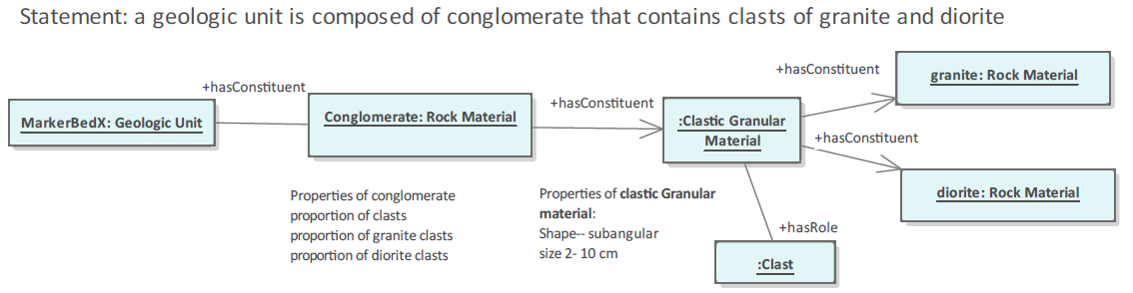

Example of nested hasConstitutent and hasRole relations to represent complex composition of a heterogeneous rock.

rol:markerbedx

a gsrbp:marker_bed ;

rdfs:label "Marker bed X" @en;

gsoc:hasConstituent [

a gslth:conglomerate ;

rdfs:label "Marker bed X conglomeraate" @en;

gsoc:hasConstituent [

a gspt:lithic_clast ;

rdfs:comment "clast-supported conglomerate, 80 percent clasts" @en ;

rdfs:label "Framework clasts" @en ;

gsoc:hasRole gspt:Framework_Clast ;

gsoc:hasQuality [

a gsoc:Proportion ;

rdfs:label "80 percent of rock is clasts" @en ;

gsoc:hasDataValue "80"^^xsd:decimal ;

gsoc:hasUOM [a gsuom:percent] ;

];

gsoc:hasConstituent [

a gspt:lithic_clast ;

gsoc:hasRole gsog:Clast ;

rdfs:label "40 percent of clasts are well rounded granite, 3-8 cm diameter" @en ;

gsoc:hasConstituent [ a gslth:granite ];

gsoc:hasQuality [

a gsoc:Shape

rdfs:comment "shape is a composite property, with components roundness, aspect ratio, represented as qualities of a quality (Shape), "

gsoc:hasQuality [

a gslth:Grain_Roundness;

gsoc:hasDataValue "Well rounded" @en ];

];

gsoc:hasQuality [

a gsoc:Proportion ;

gsoc:hasDataValue "40"^^xsd:decimal ;=

gsoc:hasUOM [a gsuom:percent] ;

];

gsoc:hasQuality [

a gslth:Grain_Size_Max ;

gsoc:hasDataValue "80"^^xsd:decimal ;=

gsoc:hasUOM [a gsuom:millimeter] ;

];

gsoc:hasQuality [

a gslth:Grain_Size_Min ;

gsoc:hasDataValue "30"^^xsd:decimal ;=

gsoc:hasUOM [a gsuom:millimeter] ;

];

]

];

gsoc:hasConstituent [

a gspt:lithic_clast ;

gsoc:hasRole gsog:Clast ;

gsoc:hasConstituent [ a gslth:diorite ];

rdfs:label "60 percent of clasts are sub-rounded diorite, 6-15 cm diameter" @en ;

gsoc:hasQuality [

a gsoc:Shape [

gsoc:hasQuality [

a gslth:Grain_Roundness;

gsoc:hasDataValue "Sub-rounded" @en ];

]

] ;

gsoc:hasQuality [

a gsoc:Proportion ;

gsoc:hasDataValue "60"^^xsd:decimal ;

gsoc:hasUOM [a gsuom:percent] ;

];

gsoc:hasQuality [

a gslth:Grain_Size_Max ;

gsoc:hasDataValue "150"^^xsd:decimal ;=

gsoc:hasUOM [a gsuom:millimeter] ;

];

gsoc:hasQuality [

a gslth:Grain_Size_Min ;

gsoc:hasDataValue "60"^^xsd:decimal ;=

gsoc:hasUOM [a gsuom:millimeter] ;

];

]

];

gsoc:hasConstituent [

a gslth:clastic_sandstone ;

gsoc:hasRole gsog:Matrix ;

rdfs:label "sandstone matrix between clasts" @en ;

gsoc:hasQuality [

a gsoc:Proportion ;

gsoc:hasDataValue "20"^^xsd:decimal ;

gsoc:hasUOM [a gsuom:percent] ;

];

]

.

### Statement: A Rhyolite contains phenocrysts of Sanidine

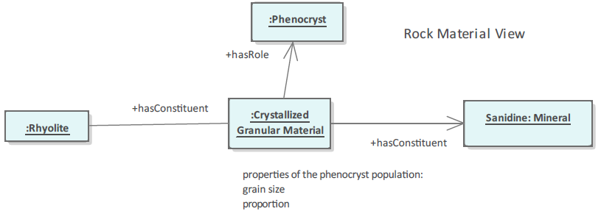

A more complete description of the rhyolite would probably include other phenocrysts, a description of the groundmass, and if applicable description of flow-banding fabric, lithophysae, etc.

rol:rhyoliteoftubac

a gslth:rhyolite ;

rdfs:label "Rhyolite of Tubac" @en ;

rdfs:comment "Contains 15% 1-3 mm euhedral sanidine phenocrysts " @en ;

gsoc:hasConstituent [

a gsog:Mono-mineralic_crystal_particle;

gsoc:hasQuality [

a gsoc:Proportion ;

gsoc:hasDataValue "15"^^xsd:decimal ;

gsoc:hasUOM [a gsuom:percent] ;

];

gsoc:hasConstituent [

a gsmin:sanidine ;

gsoc:hasRole gspt:phenocryst ;

gsoc:hasQuality [

a gsoc:Shape ;

gsoc:hasDataValue "euhedral" ;

];

gsoc:hasQuality [

a gslth:Grain_Size_Max ;

gsoc:hasDataValue "1"^^xsd:decimal ;

gsoc:hasUOM [a gsuom:millimeter] ;

];

gsoc:hasQuality [

a gslth:Grain_Size_Min ;

gsoc:hasDataValue "3"^^xsd:decimal ;

gsoc:hasUOM [a gsuom:millimeter] ;

];

]

]

.

### Statement: SMR2011-12-16-01 is sample of Formation Z

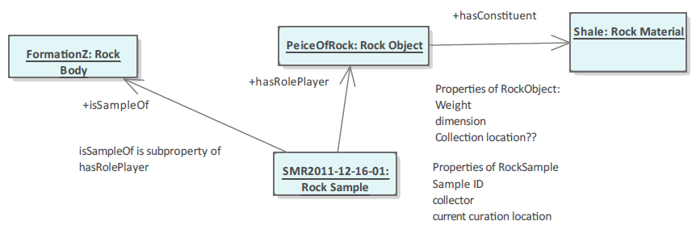

Note that the encoding below starts with the rock object and uses the invers of hasRolePlayer (hasRole) to link the rock object to the sample. Subclasses of rock object for different kinds of samples would probably be useful.

rol:SMR2011-12-16-01

a gsog:Rock_Object;

gsoc:hasConstituent [a gslth:shale ] ;

gsoc:hasQuality [

gsoq:Diameter ;

gsoc:hasDataValue "100"^^xsd:decimal;

gsoc:hasUOM [ a gsuom:millimeter ]

];

gsoc:hasRole [

a gsog:Rock_Sample ;

gsoc:isSampleOf rol:formationx ;

gsoc:determinedBy [

a gsoc:Determining_Event;

rdfs:label "event of obtaining the sample in the field." @en ;

rdfs:comment "constituent processes could be used to document the sampling procedure. Consider importing SOSA or PROV vocabularies for better sample description." @en ;

gsoc:hasIndirectSpatialLocation [

a gsoc:Spatial_Region;

rdfs:label "Sampling location";

rdfs:comment "location of sampling event is indirect, anchored in the location of the sampling site" @en ;

gsoc:hasQuality [

a gsoc:Spatial_Location

gsoc:hasDataValue "<http://www.opengis.net/def/crs/OGC/1.3/CRS84> POINT (144.359002125 -38.167672488)" ;

]

]

]

] .

# Test Instances

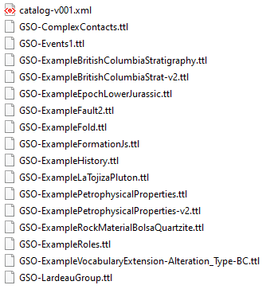

Figure . Example instances included in the version one package.

A set of example instances has been constructed in parallel with development of GSO for testing and illustration purposes.

# References

Arp, Robert, Smith, Barry, and Spear, Andrew D., 2015, Building Ontologies with Basic Formal Ontology: MIT Press, Cambridge, MA, 220 pages.

Beckett, David, and Berners-Lee, Tim, 2011-03-28, Turtle - Terse RDF Triple Language: W3C Team Submission, accessed at https://www.w3.org/TeamSubmission/turtle/.

Borgo, S., and Masolo, C., 2010, Foundational choices in DOLCE, R. Poli et al. (eds.), Theory and Applications of Ontology: Computer Applications, Springer Science+Business Media B.V., DOI 10.1007/978-90-481-8847-5_13.

CGI Data Model Working Group, 2012, GeoSciML v3.2 Online Documentation, accessed at <http://geosciml.org/doc/geosciml/3.2/documentation/html/index.htm>.

Cox, S.J.D., Richard, S.M., 2014, A geologic timescale ontology and service: Earth Science Informatics, DOI: 10.1007/s12145-014-0170-6

Gangemi, A., Guarino, N., Masolo, C., Oltramari, A., Schneider, L., 2002, Sweetening ontologies with DOLCE: Proceedings Knowledge Engineering and Knowledge Management, Ontologies and the Semantic Web, 13th International Conference, EKAW 2002, Siguenza, Spain, October 1-4, 2002, DOI: 10.1007/3-540-45810-7_18.

Lowe, E.J. 1998, Entity, Identity and Unity: Erkenntnis, Vol. 48, No. 2/3, pp. 191-208.

Masolo, C., Borgo, S., Gangemi, A., Guarino, N., and Oltramari, A., 2003, WonderWeb deliverable D18: Technical report, Laboratory for Applied Ontology, ISTC-CNR, Trento, Italy.

Nickel, Ernest H. (1995), The definition of a mineral. The Canadian Mineralogist. 33 (3): 689–90.

North American Geologic Map Data Model (NADM) Steering Committee Data Model Design Team, 2004, NADM Conceptual Model 1.0—A Conceptual Model for Geologic Map Information: U.S. Geological Survey Open-File Report 2004-1334, accessed at <https://pubs.usgs.gov/of/2004/1334/>.

Perrin, Michel, Zhu-Colas, Beiting, Rainaud, Jean- François, and Schneider, Sébastien, 2005, Knowledge-driven applications for geological modeling: Journal of Petroleum Science and Engineering 47(1):89-104, DOI: 10.1016/j.petrol.2004.11.010.

Raymond O., Duclaux G., Boisvert E., Cipolloni C., Cox S., Laxton J., Letourneau F., Richard S., Ritchie A., Sen M., Serrano J-J., Simons B., and Vuollo J., 2012, GeoSciML v3.0 - a significant upgrade of the CGI-IUGS geoscience data model: Geophysical Research Abstracts, EGU General Assembly 2012, EGU2012-2711, Vol. 14, Available from: https://www.researchgate.net/publication/258616003_GeoSciML_v30_-_a_significant_upgrade_of_the_CGI-IUGS_geoscience_data_model [accessed May 16 2020].

# Appendix 1. SPARQL Queries

## Get all the time ordinal eras in a version of the Geologic time scale

Three versions of the International Chronostratigraphic Chart from the International Commission on Stratigraphy have been implemented in the GSO-Geologic_Time_Interval.ttl module as a proof of concept. These are the 2020 (gstime:isc2020-01), 2017 (gstime:isc2017-02) and 2004 (gstime:isc2004-04) versions. The following query will generate a table with all the named intervals, their lower boundary age assigned per version, and labels for the type of Geochronologic boundary defined (if there is one defined).

QUERY:

prefix dc: <http://purl.org/dc/elements/1.1/>

prefix gts: <http://resource.geosciml.org/ontology/timescale/gts#>

prefix skos: <http://www.w3.org/2004/02/skos/core#>

prefix time: <http://www.w3.org/2006/time#>

prefix ts: <http://resource.geosciml.org/vocabulary/timescale/>

prefix gsog: <http://loop3d.org/GSO/ontology/2020/1/geologicfeature/>

**SELECT** **DISTINCT** ?tconcept ?label ?date ?reflabel ?boundary

**WHERE**

{

?tconcept gsoc:isPartOf gstime:isc2004-04.

?tconcept rdf:type/rdfs:subClassOf* gsog:Geologic_Date_Interval.

?tconcept rdfs:label ?label.

**OPTIONAL** {?tconcept gsog:hasOlderDate ?boundary .

?boundary gsoc:isPartOf gstime:isc2004-04.

?boundary gsog:hasDate ?date .

**OPTIONAL** { ?boundary gsoc:hasReference [rdfs:label ?reflabel] }

}

}

**ORDER** **BY** ?date

RESULTS: