

**GEOLOGICAL SURVEY OF CANADA**

**OPEN FILE XXXX**

**The GeoScience Ontology Reference**

**B. Brodaric and S.M. Richard**

**2021**



**GEOLOGICAL SURVEY OF CANADA**

**OPEN FILE XXXX**

**The GeoScience Ontology Reference**

**B. Brodaric**1 **and S.M. Richard**2

1 Geological Survey of Canada

2 US Geoscience Information Network

**2021**

© Her Majesty the Queen in Right of Canada, as represented by the Minister of Natural Resources, 20xx

Information contained in this publication or product may be reproduced, in part or in whole, and by any means, for personal or public non-commercial purposes, without charge or further permission, unless otherwise specified.

You are asked to:

• exercise due diligence in ensuring the accuracy of the materials reproduced;

• indicate the complete title of the materials reproduced, and the name of the author organization; and

• indicate that the reproduction is a copy of an official work that is published by Natural Resources Canada (NRCan) and that the reproduction has not been produced in affiliation with, or with the endorsement of, NRCan.

Commercial reproduction and distribution is prohibited except with written permission from NRCan. For more information, contact NRCan at [nrcan.copyrightdroitdauteur.rncan@canada.ca](mailto:nrcan.copyrightdroitdauteur.rncan@canada.ca).

Permanent link: https://doi.org/10.4095/xxxxxxx

This publication is available for free download through GEOSCAN (<http://geoscan.nrcan.gc.ca/>).

**Recommended citation**

Brodaric, B., Richard, S. 2021. The GeoScience Ontology Reference; Geological Survey of Canada, Open File xxxx, xxx p. https://doi.org/10.4095/xxxxxxx

Publications in this series have not been edited; they are released as submitted by the author

Table of Contents

1. Introduction 4

2. GSO Common 5

3. GSO Geology 10

4. GSO Modules 16

5. Examples 19

Acknowledgements 28

References 29

Appendix 1. SPARQL Queries 30

List of Figures

Figure 1: GSO Github 5

Figure 2: GSO Particular 5

Figure 3: GSO Endurant 6

Figure 4: GSO Perdurant 7

Figure 5: Structure of a feature 7

Figure 6: GSO Feature 8

Figure 7: GSO Situation 8

Figure 8: GSO Relations 9

Figure 9: GSO Fundamental Relations 9

Figure 10: Geological material endurants 10

Figure 11: Geological perdurants 11

Figure 12: Geological features 12

Figure 13: Geological Relations 16

Figure 14: Rock material and role example 23

Figure 15: Geological unit, role, and rock material example 24

Figure 16: Rock sample example 26

Figure 17: Partial results from SPARQL query for geological time units 31

Figure 18: Partial results from SPARQL query for petrophysical properties 32

Figure 19: Results of contact and contact process type query 32

Figure 20: Results of rock type query 33

Figure 21: Lithology for units in Isle of Wight. 34

List of Tables

Table 1: GSO geological feature examples 13

Table 2: GSO Geology types 14

Table 3: GSO Modules 17

Table 4: GSO example files 27

# Introduction

The GeoScience Ontology (GSO) is a systemized representation of key geoscience knowledge. It consists of a three-layer framework including a foundational layer applicable to any discipline, a geological layer forming the root for any aspect of geology, as well as detailed modules that can be refined or supplemented as required for specific purposes.

(1) For its topmost foundational layer, GSO it is inspired by existing foundational ontologies, primarily DOLCE (Masolo et al., 2003; Borgo and Masolo, 2010), Basic Formal Ontology (BFO; Arp *et al*., 2015), and Unified Foundational Ontology (UFO; Guizzardi & Wagner, 2010), adapting key items and integrating them in a unique way.

(2) For its middle layer - the root geoscience layer – GSO builds on the NADM (NADM 2004) and GeoSciML (Raymond *et al*., 2012; CGI Data Model Working Group, 2012) initiatives, extending them conceptually to form a geological superstructure. This superstructure aims to be a comprehensive foundation for representing any aspect of geology, including entities such as geological objects, materials, structures, settings, qualities, roles, processes, events, geologic time, and geologic relations.

(3) The final layer consists of geoscience modules that extend the geological superstructure, such as kinds of geological structures (e.g. various faults), specific time scales (e.g. ICS 2017), or kinds of rock materials (e.g. CGI Simple Lithology). This modularized approach enables the substitution or addition of modules for specific needs, such as customized extensions for distinct organizations or systems, and minimizes module inter-dependence.

Although intended for general geoscience usage, a driving use-case for GSO is knowledge management for 3D geological modelling, specifically for the LOOP initiative (<https://loop3d.org>). Deployment in internet-free areas, such as remote mining and field camps, is also a requirement, as is ready coupling with 3D modelling software. Compactness and efficiency are thus priorities, as is logical consistency to promote effective reasoning. For these reasons, GSO is a stand-alone product that does not import other ontologies. However, many modules consist of contents adapted from existing ontologies and exchange formats, with links to original sources added as annotations, e.g. some GeoSciML vocabularies are converted from SKOS to GSO and OWL. This adapt, versus import, approach not only avoids unnecessary bloat, but also addresses difficult challenges of conceptual misalignment between imports. Another factor is the strong research emphasis, which is facilitated by this compact approach: in addition to its goal of being an operational and useful knowledge structure, GSO is also a vehicle for developing and testing new ontological ideas with application to geology.

GSO is represented in UML, using the Sparx Enterprise Architect tool, and in OWL, using a combination of raw text editing and tools such as the TopQuadrant TopBraid Composer and Protégé. The OWL representation is serialized using Turtle notation and is considered the normative representation. The Turtle files (.ttl) have been tested to open in TopBraid Composer Free Edition and Protégé, and validate with the ELK reasoner in Protégé.

## Terminology

Types are generalizations that broadly include things such as classes, kinds and categories, e.g. Rock Body or Event. An instance is single thing that instantiates a type, e.g. this rock body or that event. Individuals cannot be instantiated (this rock body has no instances), and entity and thing are used synonymously. Relations are associations between things, such as the touching of rock bodies. Specializations are narrower types, such as Rock Body being a specialization (or subtype, or subclass) of Material Object, and subrelations (or subproperties) are narrower relations, such as *contains* being a subrelation of spatial relation.

## GitHub Repository

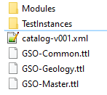The top two GSO layers are serialized as distinct files, using the Turtle ‘ttl’ serialization (Beckett and Berners-Lee, 2011): ‘GSO-Common.ttl’ for the non-geological foundational layer, and ‘GSO-Geology.ttl’ for the geological layer. The modules comprising the third GSO layer are also distinct ttl files, one for each geological aspect. The number of modules is currently growing as various aspects are added, initially by GSO creators and eventually by other users. The GSO package also includes a GSO-Master.ttl file that imports all original modules and comprises the full original GSO ontology – it has been used to create the example instances in the Github TestIntances directory.

Figure 1: GSO Github

GSO lives in a [GitHub repository](https://github.com/Loop3D/GKM/tree/master/Loop3D-GSO) (<https://github.com/Loop3D/GKM/tree/master/Loop3D-GSO>) structured as per Figure 1. The Common, Geology, and Master files are in the main directory. Each folder should contain an OASIS catalog file (e.g. catalog-v001.xml), providing a mapping from GSO URIs to file locations in the repository, which is required by OWL editors to resolve imports locally when GSO is unavailable online. However, users might need to generate the catalog-v001.xml file locally.

# GSO Common

GSO Common contains the most general non-geological entities.

## Particular

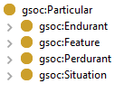**Particular** is the top type in GSO, and all its instances (called particulars) are individuals such as this rock or that event. There are four subtypes of particulars: endurants, perdurants, features and situations (Figure 2). An **Endurant** is fully present at any time it exists – it endures -- e.g. a rock, and has endurant parts only. Unlike endurants, a **Perdurant** unfolds in time – it persists, is not fully present at any timepoint, and has perdurant parts only, e.g. an earthquake. Processes and events are key types of perdurants. A **Feature** is a derived entity dependent on two or more other particulars, e.g. a fault depends on at least two host rock bodies to exist. Any feature is also an endurant, perdurant, or situation – features overlap with these types, e.g. a fault is also an endurant, as it wholly exists at any timepoint. A **Situation** is a fragment of the world, such as some geological setting, and consists of some grouping of particulars, possibly including endurants, perdurants, features, and other situations.

Figure 2: GSO Particular

: Particular

## Endurant

Endurants are either physical or nonphysical (Figure 3). Physical endurants occupy space directly (are contained by space) or are the space being occupied (the container), and non-physical endurants do not occupy space directly. A **Material Endurant** is then a physical endurant directly occupying a 3D **Spatial Region**, and is either a **Material Object** (e.g. a rock formation) or an **Amount of Matter** (e.g. a rock material). An amount of matter (e.g. some sandstone) might constitute a material object(e.g. a rock formation), and might be constituted by other matter, such as granular material, minerals, and elements; however, a material object itself never constitutes any matter. Amounts of matter are solid (**Solid Matter**) or fluid (**Fluid Matter;** i.e. gasses and liquids), and can also be unified and bounded, e.g. a single chunk of sandstone with a distinct boundary, or not unified and unbounded, e.g. the collection of sand grains and matrix/cement in the sandstone, or grains of sand in a beach (after Lowe, 1998). All amounts of matter in GSO are currently aggregations, not single entities, 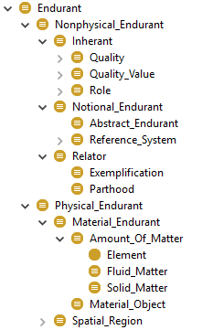e.g. an instance of **Element** is an aggregation of atoms, not a single atom. This requires **Element** to be a direct subtype of **Amount Of Matter**, because element aggregations can be either solid or fluid. Inclusion of single elements (atoms) would then be placed as solid particle subtypes of **Element**. A **Nonphysical Endurant** is an aspatial entity: it does not directly occupy space, but might indirectly occupy it via related entities, e.g. a thickness or colour indirectly occupy space by virtue of their physical bearer, such as a rock body. A nonphysical endurant is an **Inherant**, **Notional Endurant**, or **Relator**. Inherants (e.g. a thickness, color) and relators (e.g. a meeting, marriage, employment) might occupy space indirectly, but notional endurants do not occupy space at all, neither directly nor indirectly (e.g. a number). Inherants and relators are distinguished by inherence and dependence: an inherant *inheres-in* and *depends-on* a single thing, its bearer (e.g. a thickness on a rock body) while a relator depends on multiple things, without inhering in them (e.g. a meeting depends on the participants that meet, but does not inhere-in them - it is not fully *in* each of them). The three kinds of inherant are **Quality**, **Quality Value**, and **Role**. Qualities are traits, e.g. thickness, which can have quality values within reference systems that change in time, e.g. thick, 1 m, or 1-2m. These values are essential parts of the quality, i.e. they are mandatory but can change in time. While qualities and their values inhere-in and depend-on a single thing, their bearer, a **Role** inheres-in (is played-by) one thing, but depends on multiple things: the role of clast is played by a rock material within a rock object, and depends on both the material and object. This is due to roles existing in the context of a relation (in GSO): e.g. if a constitution relation links a rock material and object, then the clast role is played by the material, but is dependent on all the things in the relation (i.e. on both the material and object).

Figure 3: GSO Endurant

Like roles, a **Relator** is also relational: it is an entity reified from a relation, e.g. the *meeting* entity reified from the *x meets y* relation. Exemplification and Parthood are relators for the exemplification (to exemplify / be exemplified) and parthood (have / be a part) relations. Relators may or may not occupy space, and if so only indirectly, that is, only if some of the related things occupy space directly, e.g. a meeting occupies space indirectly by virtue of its human participants. In contrast, a **Notional Endurant** cannot occupy space at all, neither directly nor indirectly, e.g. mathematical entities such as numbers or reference systems. However, some notional endurants can occupy time indirectly, and others cannot occupy time at all. For example, some mathematical reference systems are in fact temporal, e.g. those dependent on a physical entity such as a spatial coordinate system for the Earth, which could neither pre-exist nor post-exist the Earth. In contrast, **Abstract Endurant**s do not occupy time nor space: e.g. numbers are both atemporal and aspatial.

## Perdurant

A **Perdurant** can be an **Event**, **Process**, or **Time Region** (Figure 4). Events, Processes, and time intervals persist in time by accumulating different time-indexed parts, so they are only partially present at any timepoint they exist. They differ from endurants insofar as they are things that happen (persist), while endurants are things that just are (endure). Specifically, processes are *how* things happen (e.g. ground shaking, deposition process), events are *what* happens (e.g. earthquake, deposition of a formation), and time intervals are *when* they happen 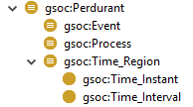(e.g. Jurassic Period). They cannot change, but have static qualities only (Galton & Mizoguchi 2009), e.g. a time interval has a fixed duration value. Then, qualities that appear to vary are actually static qualities of perdurant parts, e.g. each intensity value of a process or event is a static value of a time-indexed part of the process or event.

Processes and events are further intimately connected: processes constitute events analogous to how amounts of matter constitute material objects (Galton & Mizoguchi 2009), e.g. the earthquake is constituted by the ground shaking, and the deposition event is constituted by the deposition process. Both processes and events must have endurant participants – they cannot happen unless they happen to something, e.g. the earthquake shakes the ground, some material is deposited. **Time Regions** are chunks of time, analogous to spatial regions being chunks of space. They are not fully present at a timepoint, except for time instants, which are treated as anomalous perdurants. Time regions are directly occupied by perdurants, and indirectly occupied by related endurants, such as participants in processes or events. A **Time Instant** is a point of time, and a **Time Interval** is a span of time between instants. Time regions, together with features, are the basis for geological time scales.

Figure 4: GSO Perdurant

## Feature

A **Feature** is a parasitic and derivative entity: it is ontologically dependent on other entities (i.e. parasitic) and emerges from a reified relation linking these entities (i.e. derivative; after Brodaric 2019). Examples of features are holes, boundaries, geological structures, and smiles. A hole is derived from the containment of a space by an object. Boundaries derive from the relation between an object’s external and internal parts. Geological structures derive from a relation between rock bodies or their constituents, and possibly other things, e.g. a contact derives from the immaterial surface between 'touching' rock bodies. A smile derives from an arrangement of lips, eyes and teeth on a particular face.

Figure 5: Structure of a feature

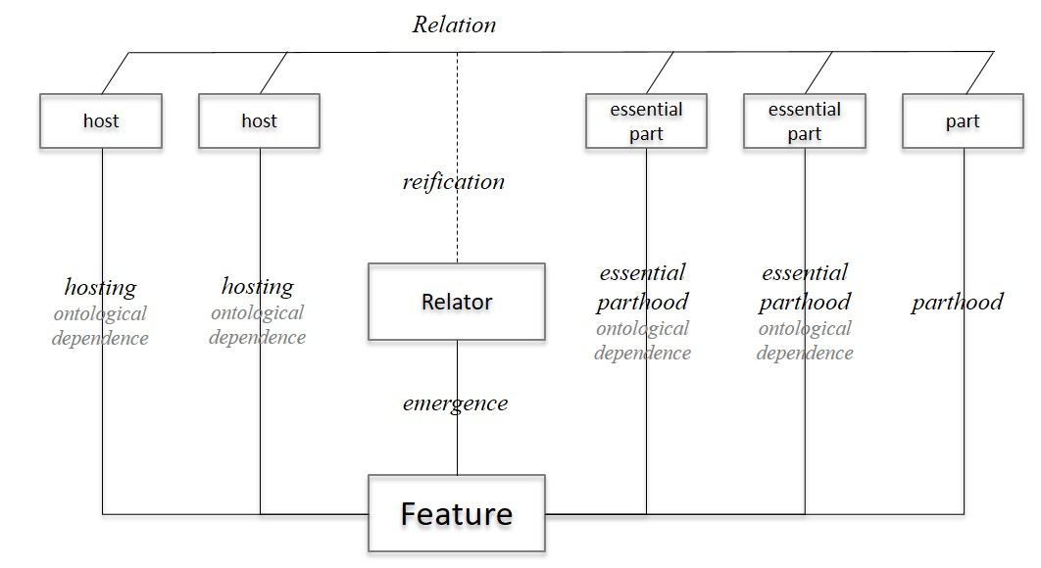A GSO feature is distinct from a geospatial feature as defined by open geospatial standards (OGC 2009). While GSO feature and geospatial feature overlap, they are not equivalent, nor does one specialize the other, mainly because GSO features are parasitic and derivative, and do not necessarily occupy space. Then, temporal features such as a pause in a process or event are not geospatial features, due to lack of direct spatial occupation, and geospatial features such buildings and rivers are not GSO features, because they are not parasitic nor derivative.

As shown in Figure 5, each entity in the feature’s relation is either a host for, or part of, the feature. Hosts are entities on which a feature depends, but are not necessarily part of the feature: e.g. the entity containing the hole or having a boundary, the rock bodies that touch, or the face that is smiling. The remaining entities in the relation are parts of the feature, with some being essential parts. Essential parts are mandatory but can change in time: e.g. when an object moves the hole is comprised of a different space, when an object shrinks through loss of material the boundary is comprised of a different material, when rock bodies move the contacts between them are comprised of different surfaces in space, and teeth can be replaced within a smile. All parts together (i.e. in sum) form a single improper part of the feature, comprising it entirely: e.g. the complete space of a hole, the thin veneer of material bounding an object, the immaterial surface between rock bodies, the sum of lips, eyes, and teeth of a smile

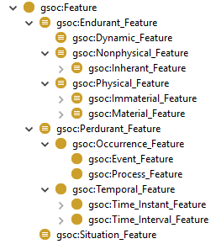In GSO, features are categorized by type of part (Figure 6). An **Endurant Feature** has endurant essential parts, a **Perdurant Feature** has perdurant essential parts, and a **Situation Feature** has situations as essential parts. Then, a **Nonphysical Feature** has nonphysical endurant parts, such as a shape quality, e.g. a fold, a **Physical Feature** has physical endurant parts, e.g. a material boundary or a hole, and a **Dynamic Feature** has essential endurant parts, but is hosted by a perdurant, e.g. an ocean wave. A perdurant feature is either an **Occurrence Feature** having processes or events as essential parts, e.g. a winning goal or peak ground shaking, or is a **Temporal Feature** having time region essential parts, e.g. a pause in a process or event, a gap between them, or their start or end times (their temporal boundaries). These feature types will also appear as subtypes of Endurant, Perdurant, or Situation, but only on manual import of GSO-Feature.ttl, as they are excluded from Master.ttl for simplicity.

Figure 6: GSO Feature

## Situation

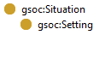A **Situation** is a fragment of the world. It is a whole with particulars as parts unified by some criteria (Figure 7). The parts of a situation can be unrelated in any essential way, e.g. not all endurants in a situation need participate in perdurants in the situation. Because of this mixture, **Situation** is neither a subtype of endurant nor perdurant, as it can have both as parts. However, some situations are endurants, i.e. those consisting entirely of endurants, and others are likewise perdurants. Situations might then occupy space and time directly or indirectly, as per the nature of their parts. A **Setting** is a situation unified by some relation to a specific individual, with the setting serving as a context for the individual. For example, a geological setting is typically a causal context for a specific geological individual: an Alluvial Fan Setting is comprised of an alluvial fan and particulars instrumental in its creation, such as sedimentary materials and processes.

Figure 7: GSO Situation

## Relation

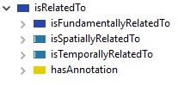Relations are associations between entities, such as *overlies* (e.g. rock body *X* overlies rock body *Y*) or *isPartOf* (e.g. rock body *Z* is part of rock body *Y*). Relations must be distinguished from seemingly similar entities, such as relators, roles, or features, all of which are derived from relations, but are not relations themselves. For example, if two rock bodies touch spatially with a common surface between them, then each rock body plays the role of toucher (role) and is involved in an instance of touching (relator), and a contact emerges (feature – the surface between them). Note the entities associated by the relation are referred to as its relata.

For purposes of internal hierarchical organization, GSO includes the topmost *isRelatedTo* relation, which is further delineated into four kinds of subrelations (Figure 8): fundamental (*isFundamentallyRelatedTo*), spatial (*isSpatiallyRelatedTo*), temporal (*isTemporallyRelatedTo*), and annotation (*hasAnnotation*). Annotations associate an entity with meta-information, such as comments or labels. Spatial relations hold between entities that are spatially located, including chunks of space as well as entities directly or indirectly occupying such chunks, and are concerned with how their spatial locations are associated. Included are topological spatial relations (after Cohn *et al*., 1997) as well as some dependent varieties, e.g. *adjacentlyDependsOn* necessarily associates a stratigraphic unit to spatially adjacent units. Analogously, temporal relations hold between entities that are temporally located, are founded on Allen’s interval delineations (after Allen, 1983), and also include dependent varieties: e.g. adjacent dependency not only requires spatial adjacency, but also temporal adjacency, such as stratigraphic units necessarily being adjacent to other units in both space and time.

Figure 8: GSO Relations

Unlike spatial and temporal relations, which are limited to relata located in space and/or time, fundamental relations might apply to relata from any domain, including abstracts. Key fundamental relations are *dependence*, *determination*, *exemplification*, *parthood*, *production*, and *reference* (Figure 9). Each of these is symmetric (non-directional), but has non-symmetric subrelations, e.g. among the subrelations of parthood are *isPartOf* and *hasPart*, which are non-symmetric and mutually inverse. Dependence and parthood are by far the most utilized relations in GSO. Dependence has many subrelations beginning with generic ontological dependence, in which an entity depends on some other unspecific entity of a certain type for its existence, essence, and its identity. Generic dependence is further delineated into relata that: temporally co-exist (constant dependence); are external to each other (external dependence), that is, are neither mutual parts, constituents, nor qualities; one is 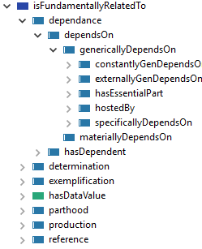parasitic on the others (hosting); and one depends on specific other entities for its existence, essence, and identity (specific ontological dependence). Many key GSO relations are subrelations of one or more of these types of dependence. For example, the *inheresIn* relation, which associates an inherant (e.g. quality, quality value, or role) with its bearer, is a subrelation of constant and specific dependence, insofar as the bearer must temporally co-exist with the inherant, but the inherant cannot inhere in any other bearer. Moreoever, the *isPartOf* and *hasPart* subrelations of parthood are also delineated by dependence: wholes are (1) generically dependent on essential parts, which can be missing at some but not all times, and can be exchanged, added or removed; (2) generically dependent on persistent parts, which cannot be missing at any time, but can be exchanged or added; and (3) specifically dependent on static parts, which cannot be missing nor exchanged, added or removed (after Brodaric *et al.* 2019). Note that constitution is a variety of persistent parthood, because constituents are more granular parts. A constituted whole, then, such as a material object, must have constituents (i.e. amounts of matter) at every time it exists, but the constituents can be exchanged or added, though not completely removed.

Figure 9: GSO Fundamental Relations

The remaining fundamental relations are less widely used in core GSO modules. *Determination* is an epistemological relation connecting an entity to the underlying evidence or methods used to discover, verify or validate it. *Exemplification* associates an entity with pertinent examples, including a prototypical instance or part (e.g. a stratotype). *Production* associates the output (product) of an event or process with some input, such that the input *isProductionInput* for the output, which inversely is *isProducedFrom* the input. *Reference* associates a frame of reference with an entity; for now, only quality values have frames of reference. Lastly, *hasDataValue* associates a measured quality value with a standard data type such as a numeric, text, or date value.

# GSO Geology

The GSO geology layer (GSO-Geology.ttl) contains the topmost geological entities, such that each geological entity specializes a common entity, either Endurant, Perdurant, Feature, Situation or some subtype.

## Geological Endurant

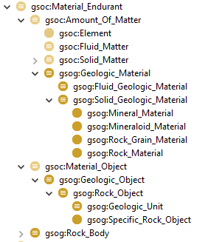A geological physical endurant (Figure 10) is either a **Geologic Material** or **Geologic Object**. Geological materials are primarily produced by geological processes or events, and are dominantly solid (**Solid Geologic Material**) or fluid (**Fluid Geologic Material**), or are just a **Geologic Material** if having major solid and fluid components. Solid Geologic materials include **Rock Material** (e.g. granite, sandstone), **Rock Grain Material** (e.g. the feldspar grains in a granite, or quartz grains in a sandstone), **Mineral** **Material** (e.g. quartz), and **Mineraloid Material** (e.g. obsidian, amber, opal). These materials occur at different levels of matter, such that higher level entities are made of (constituted by) aggregations from lower levels: e.g. a rock material such as sandstone is made of quartz grains, which are made of quartz mineral unit cells, themselves made of chemical element atoms. Not all rock materials have grains – i.e. this level is not mandatory – but all are made of minerals or mineraloids. The key notion being that aggregations at a lower level form a distinct entity at a higher level, under some unity criteria: a mineral is an aggregate of atoms arranged in a specific crystal structure defined by a unit cell; a mineraloid is an aggregate of atoms with no systematic crystal structure; a grain is an aggregation of mineral unit cells (or mineraloid substance) having a distinct boundary with surrounding grains; and a rock material is an aggregation of grains typically with different composition and shape, or an aggregation of minerals or mineraloids, with a distinct boundary from other rock materials.

Figure 10: Geological material endurants

A **Geologic Object** is a material object that can be constituted by any mixture of geological solids or fluids, e.g. a petroleum basin might be considered a geological object having rock material and fluid material as distinct constituents, as well as having their related objects as parts: the reservoir as the solid part, and the gas or liquid bodies are the fluid parts. A **Rock Object** is then a specialized geological object constituted by solid geological materials only, e.g. a reservoir is a rock object that may contain fluids (in its pores), but is not constituted by the fluids nor has them as parts, thus is distinct from them. A **Rock Body** is a hybrid entity, as it can be either an amount of solid geological material or a rock object. It is a useful way to refer to a rock mass without distinguishing it as object or material, e.g. a fracture can be hosted by a sandstone layer or its related formation.

GSO further delineates two types of rock objects: **Specific Rock Object** and **Geologic Unit**. A specific rock object is a single mass of rock material that is not contextual, as it can be moved to another location and retain identity: e.g. a crystal, boulder, concretion, or material fossil could all be relocated to Mars and remain the same entity. Conversely, a geologic unit is not a specific rock object, both because it can be fragmented into pieces (e.g. by faulting) and maintain identity, and because it is contextual and cannot be relocated without losing identity. For example, a formation might be fragmented into pieces and furthermore cannot be relocated to Mars and be the same formation, because its relations to surrounding rocks would then differ as would its reliance on specific processes and events.

GSO Geology does not contain nonphysical geological endurants, but certain modules do: e.g. the Geologic Role module has various roles such as rock sample, clast, inclusion, and protolith, and Geologic Quality has qualities such as bedding thickness, various orientations (e.g. Azimuth, Dip, Plunge), and metamorphic grade. Other specialized modules also include pertinent roles and qualities, such as those directly relevant to folds or faults.

## Geological Perdurant

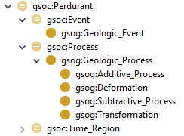A geological perdurant is either a **Geologic Process** or **Geologic Event** (Figure 11). Geologic events are not further delineated in GSO, but geological processes are differentiated by their effect on a rock body’s material (after Perrin *et al.* 2005): a **Subtractive Process** removes material (e.g. erosion), an **Additive Process** adds material (sedimentation), a **Deformation Process** deforms and/or shifts the material (e.g. ductile deformation or faulting), and a **Transformation Process** alters the material to another material (e.g. metamorphism). As per their generic counterparts, geologic events are constituted by geologic processes, e.g. the earthquake by the ground shaking and the depositional event by the depositional process. Geologic time regions are also perdurants, but indirectly as a result of being features.

Figure 11: Geological perdurants

## Geological Feature

Geological features include geological structures, physical rock boundaries (e.g. the top or bottom part of a geological unit), physical voids (e.g. porespace or a drill hole), geological time regions (e.g. Jurassic Period) and their temporal boundaries (e.g. end of the Jurassic Period). However, GSO-Geology.ttl contains only **Geologic Structure, Rock_Body_Boundary,** and core temporal features (Figure 12), with the remaining features found in modules such as Geologic_Feature.ttl or Geologic_Structure.ttl. Geological features are primarily either material, immaterial, inherant, or temporal.

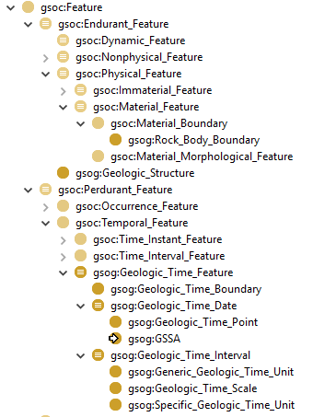Geological structures are a subgroup of the things that are geological features. A geological structure is a derivative entity that depends on at least one rock body as host or part, as well as on some other things, with the rock body and those other things related in a specific way. For example, a contact is a spatial region located where rock bodies touch: the contact is hosted by the rock bodies, has a low-dimensional spatial region (surface, line, point) as essential part, and emerges from the relation in which the rock body boundaries touch and are coincident with the spatial region. Table 1 sketches a GSO description of several geological features, including some representative geological structures.

Material features derive from physical parts made of matter. Examples include a fault zone derived from the rock body between or beside faults, or a boundary at the top of a rock body derived from its uppermost material portion. Immaterial features derive from physical parts that are not made of matter, so from spatial regions: e.g. a contact or fault derived from the surface between rock bodies, pore space derived from the microscopic spaces between constituents within a rock body, or a drill hole derived from a macroscopic, cylindrical space penetrating a rock body from its exterior.

Figure 12: Geological features

In contrast to material features, inherant features derive from nonphysical parts, i.e. neither material nor spatial. The most prominent types of inherant features are derived from qualities or relators (i.e. patterns). An example of a quality-based geologic feature is a fold, which is derived from the value of the shape quality carried by a host rock body. The shape value is an essential part, one that can change over time as the fold stretches or contracts in time, such that each stretched or contracted shape value will be the fold at that time.

A relator-based geologic feature is a pattern inhering in a rock body, such as a fabric. The pattern reflects a certain relation between the rock body’s parts (e.g. rock layer pattern) or constituents (e.g. mineral pattern). However, because a pattern is an object, while a relation is not, the relation must be reified into an object (i.e. into a relator instance) to be a feature. For example, a linear arrangement of things is reified into a lineation relator instance, which becomes a mineral lineation when hosted by a rock body and having mineral amounts as parts. Note the essential parts of a pattern feature are not any of the things being related, such the minerals in a mineral lineation, rather the relator instances themselves are the parts – this reflects the fact that a pattern is a non-physical entity and cannot have physical things as parts, such as minerals or other rock bodies. For example, when a group of minerals adds members in time causing elongation, the essential parts of the lineation are not the groups of minerals at distinct times. The parts are, in fact, the different linear patterns hosted by the various mineral groups at distinct times. Foliations are planar patterns of a rock body’s parts or constituents, bedding is a stratified pattern of a rock body’s parts, and fabric is any such pattern in a rock body.

Table 1: GSO geological feature examples

|  |  |  |  |  |
| --- | --- | --- | --- | --- |
| **Feature** | **Type** | **Host** | **Essential Part** | **Relation** |
| fault zone | Material Feature | faults | rock body | rock body between/beside faults |
| rock body top | Material Feature | rock body | rock body part (boundary) | topmost part of a rock body |
| contact | Immaterial Feature | rock bodies | low-dimensional spatial region (surface, point, line) | spatial region where adjacent rock bodies meet |
| fault | Immaterial Feature | rock bodies | low-dimensional spatial region (surface, point, line) | spatial region where offset adjacent rock bodies meet |
| drill hole | Immaterial Feature | rock bodies | spatial region (volume) | space intruding a rock body |
| fabric | Inherant Feature | rock body | relator: pattern in parts or constituents of host | arrangement of parts or constituents of host |
| lineation | Inherant Feature | rock body | relator: linear pattern in parts or constituents of host | linear arrangement of parts or constituents of host |
| foliation | Inherant Feature | rock body | relator: planar pattern in parts or constituents of host | planar arrangement of parts or constituents of host |
| bedding | Inherant Feature | rock body | relator: stratified pattern in parts or constituents of host | stratified arrangement of parts of host |
| fold | Inherant Feature | rock body | shape quality value | shape value inheres in a rock body |
| geologic time interval | Time Interval Feature | rock body | time interval or geologic time interval | time interval occupied indirectly by a rock body (e.g. chronostrat unit) |
| geologic time scale | Time Interval Feature | rock body | geologic time interval | time interval occupied indirectly by a rock body (e.g. all Earth rocks) |
| geologic time boundary | Temporal Boundary | geologic time interval | geologic time date | beginning or end of a geologic time interval |

A **Geologic Time Feature** derives from a rock body indirectly occupying a time region and produced by a defining event at that time. The rock body and event host the feature, while the time region is an essential part of the feature. All geologic time features are thus hosted by entities in the rock record: geologic intervals are hosted by material referents, such as the Jurassic Period by the Jurassic System, and geological time dates are variously hosted by material referents-- designated contacts, or rocks with auxiliary evidence for a date.

There are two views of geological time interval features. In one view, the time interval is occupied by the event that formed the hosting rock body, such as the event forming the Jurassic System. Alternatively, the time interval is the span of time between events that formed the rock body’s boundaries (e.g. the start of the Jurassic System and the start of the Cretaceous System). This second view is taken by the International Commission on Stratigraphy (ICS) (Remane *et al*. 1996) in current approaches to Geologic Time Scale. A geologic time interval then has two temporal boundaries, each tied to a specific time instant, and each instant is ideally hosted by an event and a stratigraphic point (i.e. a Global Boundary Stratotype Section and Point; GSSP), or loosely affiliated with some events and dated rocks, but not specific boundaries, from which a date is asserted (i.e. a Global Standard Stratigraphic Age; GSSA).

A **Geologic Time Boundary** (e.g. start of the Jurassic Period) has a time instant, a **Geologic Time Date**, as essential part, and is hosted by a geologic time interval and its material referent: the start of the Jurassic Period could not exist without the Jurassic Period and Jurassic System. A boundary’s time instant is further hosted by a stratigraphic point and possibly an event (**Geologic Time Point**), or by a rock body with auxiliary evidence for a date, such as a lab analysis (**GSSA**). Geologic time intervals are thus started and ended by other geologic time features, including time boundaries, and have time regions as essential parts. They are also delineated into time units and scales, using the type of essential part as discriminating criteria. A **Specific Geologic Time Unit** (e.g. Jurassic 2017) has a non-geologic time interval as static part (e.g. 201 Ma – 145 Ma), which cannot change – if it changed (i.e. if either of its boundaries alters) it would no longer be e.g. Jurassic 2017. Specific time units are thus derived from the spatial and temporal location of its rock body boundaries. A **Generic** **Geologic Time Unit** (e.g. Jurassic Period) has specific geologic time intervals as non-static essential parts, which can change over time. This means, ontologically, the Jurassic Period is the sum of all its different manifestations, such as Jurassic 2010, 2017, 2020. Furthermore, at any one time, there might be one or more specific units accepted by the community as the best manifestation of a generic time unit. Generic time units are thus derived from their temporal position between other time units, without necessarily specifying bounding time instants or spatial locations. Alternative approaches might interpret generic time units as a theoretical entity, such as a type or a theory part, but then such units would not be chunks of time, which seems problematic, and would require an ontology of theories. Therefore, for now, generic time units are understood as chunks of time in GSO. Lastly, a **Geologic Time Scale** is a collection of either specific or generic geologic time units, which are its static parts – i.e. if a time unit changes then the altered collection becomes a different time scale. A time scale in this sense is essentially (1) tied to a specific rock body (e.g. the Earth’s rock mass), and (2) an interval of time subdivided into other geological time units. In general, this approach aligns with prior work on geologic time (Cox & Richard, 2014), while providing a new ontological interpretation grounded in the notion of temporal features.

## Geological Situation

Geological situations are typically causal settings, that is, they are a causal context for a particular geological entity, such as for a geological unit or rock material. The setting thus consists of a collection of things influencing what the entity is and how it came to be. An **Alluvial Fan Setting** is an example: it has essential parts such as an alluvial fan, a deposition process, and some alluvial material for which the other parts form a setting. Various setting types are included in a default geological setting module.

Table 2: GSO Geology lists and briefly describes all types in the GSO geology layer.

Table 2: GSO Geology types

| **GSO-Geology Type** | **Description** |
| --- | --- |
| Additive Process | A process that adds material to some geologic material or object. |
| Deformation | A process that deforms the material of some geologic material or object. Includes strain and translation. |
| Fluid Geologic Material | Includes all forms of geologic fluids such as lava, molten rock, or gases. |
| Generic Geologic Time Unit | A geologic time interval (e.g. Jurassic Period) with components (essential parts) that are specific geological time units (e.g. Jurassic 2017). |
| Geologic Event | When something happens, events are the ‘what’ of the happening, and processes are the ‘how’. E.g. the Trans-Hudson Orogeny event caused by a subduction process. The relation between events and processes is constitution: events are constituted by processes, and processes constitute events. Geologic processes and events have at least one geologic endurant as participant, i.e. a happening cannot occur unless it happens to something (e.g. to rock bodies in the Trans-Hudson region). Events can only have events as parts. |
| Geologic Material | An amount of matter primarily (dominantly) having parts created by geologic processes. Can include minor parts that are not of geologic origin, such as organic material. |
| Geologic Object | A material object constituted by some geological material and generically dependent on some process or event – i.e. it cannot exist without some geologic process or event. |
| Geologic Process | Processes are the ‘how’ of a happening (see Geologic Event above). A geological process typically has input and output participants that are geologic endurants. Processes can only have other processes as parts. |
| Geologic Structure | A pattern in a rock body (foliation, fold), or a feature occurring between rock bodies (contact, fault, fracture). |
| Geologic Time Boundary | A boundary for a geologic time interval, e.g. end of the Jurassic Period. |
| Geologic Time Date | A point in time hosted by a rock object. Can be (1) a GSSP if it is associated with a location in a particular stratigraphic section, or (2) a GSSA if it is arbitrarily assigned. |
| Geologic Time Feature | A temporal feature dependent on (hosted by) a rock object. |
| Geologic Time Interval | A temporal feature dependent on a rock body and having parts that are (geologic) time intervals. |
| Geologic Time Point | A time date hosted by an event and stratigraphic point on a contact, such as a Global Boundary Stratotype Section and Point defined by the International Stratigraphic Commission. |
| Geologic Time Scale | A collection of geological time intervals (excluding time scales) hosted by a rock body (e.g. the Earth’s rock mass) and following a certain topology. A time scale is itself an interval of time, indeed it could be the complete container for time associated with a certain rock mass. |
| Geologic Unit | A rock object that is not a specific rock object - it is dependent on its surroundings and can be fragmented. Geologic units are identified not only by geometric, compositional and internal structural characteristics, but also by topology, i.e. spatio-temporal relations to other rock bodies. |
| GSSA | Global Standard Stratigraphic Age: a geologic time date defined by the International Stratigraphic Commission, based on assertion of a time point and loosely affiliated with some rock body related to e.g. an event, age date or a field observation. |
| Mineral Material | An amount of mineral. |
| Mineraloid Material | An amount of amorphous material, typically with a variable chemical composition. Includes natural glasses and silica gels, as well as anthropomorphic manufactured material. |
| Rock Body | A material endurant, either a rock object or a solid geologic material. |
| Rock Body Boundary | A material boundary hosted by a rock body and composed of the exterior-facing material of the rock body. |
| Rock Grain Material | An amount of rock grains that share a set of characteristics, e.g. genesis, particle size (distribution), mineralogy, shape. |
| Rock Material | An amount of lithological material constituting a rock object. |
| Rock Object | A material object constituted by only solid geological materials. |
| Solid Geologic Material | A geologic material primarily (dominantly) having parts that are solid. |
| Specific Geologic Time Unit | A geologic time interval (e.g. Jurassic 2017) with assigned (numeric) boundary positions (e.g. 201 Ma – 145 Ma). |
| Specific Rock Object | A rock object that is not spatio-temporally dependent, i.e. can be moved from its surroundings and retain identity; is a single un-fragmented body. |
| Subtractive Process | A process that removes material from some geologic material or object. |
| Transformation | A process that changes the material of some geologic material or object. Includes metamorphism, metasomatism, alteration, weathering. |

## Geological Relation

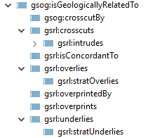A geological relation associates two geological entities (in GSO), typically in both space and time. For example, in the *crosscuts* relation, if X *crosscuts* Y, then X both spatially intersects and is younger than Y. Note the ontology of geological relations in GSO is preliminary and incomplete, and its current content is merely a placeholder for more evolved future developments.

The preliminary geological relations included in GSO are (Figure 13): the concordance of a foliation with something else, the spatial over/underlying of rock bodies as well as stratigraphic versions in which over/underlying rock bodies are younger/older than associated rock bodies, and the overprinting of a rock body or feature by a foliation or lineation.

Figure 13: Geological Relations

# GSO Modules

Each GSO module is dependent on (imports) at least GSO-Common, with the geology modules additionally dependent on GSO-Geology and possibly a small number of other modules. This modularization enables an application to deploy only essential modules.

GSO comes with 27 distinct modules in this initial release. These are described below in Table 3 and grouped under headings for geological endurants, geological features, geological perdurants, geological settings, geological relations, and non-geological entities; note the gso: prefix stands for [https://w3id.org/gso/](http://loop3d.org/GSO/ontology/2020/1/). In most cases, contents are incomplete and are included as (1) seeding for future expansion and (2) a template for user-specific module design. However, some framework modules, such as for minerals, elements, and units of measure, are adapted from mature efforts and have significant and well-developed content.

Many modules are seeded from [CGI vocabularies](http://resource.geosciml.org/vocabulary/cgi/2016/), converted from SKOS to owl as follows:

* skos:Concept 🡪 owl:Class
* skos:broader 🡪 rdfs:subClassOf
* skos:prefLabel 🡪 rdfs:label
* skos:description 🡪 rdfs:comment
* dcterms:modified with current date
* skos:topConceptOf 🡪 rdfs:subClassOf
* remove all skos:inScheme triples and skos:Collection classes
* skos:ConceptScheme 🡪 owl:ontology

Table 3: GSO Modules

| **Module Name** | **Prefix** | **URI** | **Description** |
| --- | --- | --- | --- |
| ***Geologic Endurants*** |  |  |  |
| Geologic Granular Material | gsgm | gso:granularmaterial/ | Types of geological material composed of particles sharing a set of characteristics, e.g. genesis, particle size (distribution), mineralogy, shape, or sorting; includes qualities for specifying size and shape. Based on the CGI vocabulary. |
| Geologic Mineral | gsmin | gso:mineral/ | Specifies ~4600 mineral species extracted from the RRUFF database with URIs in the GSO namespace. Further enhanced with links mined from the Wiki­Data mineral list (~3600 species). Includes original qualities as annotations, and mapping to http URLs from mindat, handbook of mineralogy and webmineral.. Additional work required to identify sub-groupings useful for (1) rock description, and (2) 3D models. |
| Geologic Quality | gsgq | gso:geologicquality/ | Types of geologic qualities common to multiple modules, such as those for orientation. Module-specific qualities are typically specified within the module. |
| Geologic Reference System | gsrs | gso:geologicreferencesystem/ | Types of conventions used to report measurement data. Currently, mainly for field measurement, e.g. right-hand-rule or dip-dip-direction for reporting planar orientation. |
| Geologic Rock  Material | gsrm | gso:rockmaterial/ | Types of rock materials (lithologies) from the CGI vocabulary; also includes related qualities and quality values, such as various degrees of consolidation. |
| Geologic Rock Object | gsro | gso:rockobject/ | Types for geologic objects (e.g. core, crust, mantle) and specific rock objects (e.g. crystal, fossil object, concretion); excludes geologic units. |
| Geologic Role | gsor | gso:geologicrole/ | Types of geologic roles, such as those played by historical rock bodies (protolith), rock body parts (clast) or minerals (xenocryst). |
| Geologic Unit | gsgu | gso:geologicunit/ | Types of material geologic units, delineated into stratigraphic and non-stratigraphic. Includes material unit ranks such as Formation (for lithostratigraphic units) or Stage (for chonostratigraphic units). |
| ***Geologic Features*** |  |  |  |
| Geologic Feature | gsgf | gso:geologicfeature/ | Types of geologic features that are not geologic structures nor geologic time features, such as those for voids (e.g. porespace, drill hole), material boundaries (e.g. rock body top, outcrop), or material objects (e.g. fault zone). |
| Geologic Structure | gsos | gso:geologicstructure/ | General types of geological structures, with specializations and qualities specified in additional modules. Includes various fabrics, sedimentary structure, and fracture. |
| Geologic Structure Contact | gscn | gso:geologiccontact/ | Types of contacts from the CGI vocabulary. |
| Geologic Structure Fault | gsfa | gso:geologicfault/ | Types of faults from the CGI vocabulary, and related qualities, such as movement magnitude and sense. |
| Geologic Structure Fold | gsfd | gso:geologicfold/ | Types of folds from the CGI vocabulary, and related qualities, such as amplitude and shape. |
| Geologic Structure Foliation | gsfo | gso:geologicfoliation/ | Types of foliations from the CGI vocabulary. Includes primary (e.g., sedimentary and igneous) and deformation-related (e.g., metamorphic and tectonic) planar fabrics. |
| Geologic Structure Lineation | gsol | gso:geologiclineation/ | Types of lineations from the CGI vocabulary. |
| Geologic Time | gst | gso:geologictime/ | Instances of generic geologic time units, such as Jurassic Period, and related boundaries, such as Base of the Jurassic Period. |
| Geologic Time Ischart | gstime | gso:ischart/ | Instances of specific geologic time units, such as Jurassic 2017, and related time scales, e.g. ICS 2017. GSO includes specific time units from the ISC2004 time scale (Gradstein et al., 2004), the ISC2017-02 time scale (<https://stratigraphy.org/icschart/ChronostratChart2017-02.pdf>) and the ISC2020-01 time scale (<https://stratigraphy.org/icschart/ChronostratChart2020-01.pdf>). Note that specific time units are re-used across time scales, with a new time unit introduced only if there is a change to its boundary location or the estimated temporal position (date) of the boundary. For example, Jurassic in the 2004 and 2010 ICS time charts is the same specific geologic time unit, but Jurassic in the 2004 and 2017 ICS time charts are different specific geologic time unit, as they have different boundary dates. However, changes to boundaries of internal subdivisions do not trigger a new unit. For example, the temporal boundaries defining the Miocene and Oligocene are the same in the 2004, 2017 and 2020 versions, even though certain subdivisions change, e.g. the date estimates for the boundaries of the Serravallian Age of the Miocene are different in the 2004 and 2017 ICS time scales. |
| ***Geologic Perdurants*** |  |  |  |
| Geologic Process | gspr | gso:geologicprocess/ | Types of geologic processes, with augmentations to the CGI Event Process vocabulary, as well some anthropogenic or biologic processes that impact geology. |
| Geologic Event | gsev | gso:geologicevent/ | Types of geologic events, currently with subtypes only for extra-terrestrial impacts and magnetic field reversals. |
| ***Geologic Settings*** |  |  |  |
| Geologic Setting | gsen | gso:geologicsetting/ | Types of geological settings mainly from the CGI Event Environment vocabulary, construed broadly to include the physical environment causally affecting a geological entity, typically an event. Includes surface settings driven by climate, tectonics, physiography or geography, subsurface settings driven by pressure, temperature, and chemical environment, and tectonic and extra-terrestrial settings. |
| ***Geologic Relations*** |  |  |  |
| Geologic Relation | gsrl | gso:geologicrelation/ | Specifies a small number of geological relations, such as cross-cuts, overlies, and overprints. Requires expansion. |
| ***Non-geological*** |  |  |  |
| Element | gsel | gso:element/ | Types of chemical elements, extracted from WikiData with local URIs defined in the GSO namespace. Qualities (as owl:annotation) for each element include atomic number, abbreviation, WikiData URI, CHEBI URI and Encyclopedia Britannica link. Does not include isotopes. |
| Feature | gsof | gso:feature/ | Adds features as subtypes to core entities of endurant, perdurant and situation, to respect the fact that e.g. a hole is not only an immaterial feature but also a spatial region, a material boundary is also a material endurant, and a temporal boundary is also a time region. |
| Hydrology | gsoh | gso:hydrology/ | Placeholder for hydrologic entities, currently limited to Hydrologic Process and Hydrologic Event. |
| Perdurant | gspd | gso:perdurant | Types of perdurants unrelated to geology or the environment. Currently, contains types of events that determine how some entity is discovered, identified or verified: assertion, inference, observation, or calculation, with the latter broadly construed to be algorithmic in some sense, including mathematical, simulated or modelled. |
| Quality | gsoq | gso:quality/ | Types of useful qualities and values not included in GSO-Common, such as intensity, colour, density, displacement, and orientation. |
| Unit of Measure (UOM) | unit | http://qudt.org/vocab/unit/ | Units of measure ontology, adapted from QUDT by Nichohas Carr. |

# Examples

The examples described in this section encode instances of types specified above. They are taken from real-world examples found in the geological literature or provided by GSO collaborators.

## Quality Pattern

Bearers of qualities are bound to their qualities via the gsoc:hasQuality relation, and qualities to their bearers via the gsoc:isQualityOf relation. Importantly, qualities such as Thickness can have named categorical values such as Thin, Thin to Thick, or quantitative measurement values such as 1.2m, 1.2m-4.3m. Qualities are bound to their values via the hasValue relation. Values are subtypes of gsoc:Quality_Value. In an instance, qualities and quality values are also instances and typically specified a using blank node: in the example below, a blank node is used to specify the type of quality (gsgq:Metamorphic_Grade), and another blank node is used to specify the medium metamorphic grade value. This instance-based approach makes sense inasmuch as qualities and their values are particularized, due to having different bearers: my thickness is different from your thickness, and my 1m thickness value is then different from your 1m thickness value.

con:XmRockBody

a gsgu:Complex ;

gsoc:hasConstituent [

a gsrm:Gneiss ;

gsoc:hasQuality [

a gsgq:Metamorphic_Grade ;

gsoc:hasValue [ a gsgq:Medium_Metamorphic_Grade ]

] ;

] ;

Importantly, qualities can bear qualities to form complex qualities, such as colour bearing the hue, saturation, and brightness qualities. Units of measure is also a quality, one carried only by a measurement value.

## Example 1: Geologic Unit

Jurassic formation has lower and upper parts.

ejs:JsFormation

a gsgu:Formation ;

gsoc:occupiesTimeIndirectly gstime:LowerJurassic2017 ;

rdfs:label "Lower Jurassic Age sedimentary rocks"@en ;

gsoc:hasPart ejs:JsFormation-lower ;

gsoc:hasPart ejs:JsFormation-upper ;

gsoc:hasPart ejs:baseJs-6 ;

gsoc:hasPart ejs:topJs-2 ;

gsoc:hasQuality [

a gsgq:Bedding_Thickness ;

rdfs:label "thin to medium bedded"@en ;

gsoc:hasValue [

a gsoc:Range_Value ;

gsoc:hasStartValue [

a gsoc:Measure_Value;

gsoc:hasDataValue "Thin bedded"@en ];

gsoc:hasEndValue [

a gsoc:Measure_Value;

gsoc:hasDataValue "Medium Bedded"@en ] ;

] ];

gsoc:hasQuality [

a gsgq:Metamorphic_Grade ;

gsoc:hasValue [ a gsgq:Not_Metamorphosed ] ;

rdfs:label "not metamorphosed"@en ] ;

rdfs:comment "Several surfaces are not elucidated as parts in this example, but are referenced in the Contact instances below. These surfaces would participate in intrusion and also ?contact metamorphism? processes"@en ;

rdfs:comment "clasts of Cb Quartzite are abundant in the lower part of the unit. The lower part is a fining-upward sequence from conglomeratic sandstone to fine-grained sandstone. There is a marker bed that is a tuff in the upper part of the lower clastic interval. Upper part is massive limestone with abundant ammonites"@en ;

rdfs:label "Js Formation"@en .

ejs:JsFormation-lower

a gsgu:Lithostratigraphic_Unit ;

gsoc:hasRole [ a gsgu:Stratigraphic_Part ];

gsoc:hasPart ejs:JsFormationMarker-6_4 ;

gsoc:hasPart ejs:baseJs-6 ;

gsoc:hasPart ejs:stratPart_1 ;

gsoc:hasPart ejs:stratPart_2 ;

gsoc:hasPart ejs:stratPart_3 ;

gsrl:underlies ejs:JsFormation-upper .

ejs:JsFormation-upper

a gsgu:Lithostratigraphic_Unit ;

gsoc:hasRole [ a gsgu:Stratigraphic_Part ];

gsoc:hasConstituent [

a gsrm:Limestone ;

gsoc:hasConstituent [

a gsgm:Material_Fossil_Particle_Material ;

gsoc:hasRole [a gsor:Floating_Clast ] ;

gsoc:isProducedFrom [ a <https://en.wikipedia.org/wiki/Ammonitida> ];

] ;

gsoc:hasConstituent [

a gsgm:Micrite ;

gsoc:hasConstituent [a gsmin:calcite ] ;

gsoc:hasRole [a gsor:Sedimentary_Matrix ] ]

] ;

rdfs:comment "massive limestone with abundant ammonites in a micrite matrix" @en .

## Example 2: Geologic Event

Cretaceous dike intrusion event is younger than granitoid intrusion:

evn1:Cretaceous_dike_intrusion

a gsog:Geologic_Event ;

gsoc:occupiesTimeDirectly evn1:Cretaceous90Ma ;

gsoc:hasConstituent [ a gspr:Intrusion_Process ] ;

gsoc:hasSetting [ a gsen:Upper_Continental_Crust_Setting ] ;

gsoc:timeYoungerThan evn1:Kg_Intrusion ;

rdfs:label "90 Ma Dike Intrusion"@en ;

.

evn1:Cretaceous90Ma

a gsoc:Time_Instant ;

rdfs:label "90 +/- 8 Ma"@en ;

gsoc:hasQuality [

a gsoc:Time_Instant_Location ;

gsoc:hasValue [

a gsoc:Time_Numeric_Value

gsoc:hasUOM [ a unit:MegaYR ] ;

gsoc:hasQuality [

a gsoc:Uncertainty ;

gsoc:hasValue [

a gsoc:Numeric_Value ;

gsoc:hasDataValue "8"^^xsd:decimal ;

gsoc:hasUOM [ a unit:MegaYR ]

]

];

gsoc: hasDataValue "90"^^xsd:decimal ;

]

] .

evn1:Kg_Intrusion

a gsog:Geologic_Event ;

rdfs:label "Cretaceous Intrusion Event"@en

gsoc:occupiesTimeDirectly [

a gsoc:Time_Instant ;

rdfs:label "Cretaceous 110 +/-3 Ma Age Date"@en ;

gsoc:hasQuality [

a gsoc:Time_Instant_Location ;

gsoc:hasValue [

a gsoc:Time_Numeric_Value ;

gsoc:DataValue “110”^^xsd:decimal ;

gsoc:hasUOM [ a unit:MegaYR ] ;

gsoc:determinedBy evn1:upbconcordantanalysis ;

gsoc:hasQuality [

a gsoc:Uncertainty ;

gsoc:hasValue [

a gsoc:Numeric_Value;

gsoc:hasDataValue "3"^^xsd:decimal ;

gsoc:hasUOM [ a unit:MegaYR ]

] ]

]

] ;

gsoc:timeYoungerThan evn1:JsGenesis ;

gsoc:hasConstituent [ a gspr:Intrusion_Process ] ;

gsog:hasSetting [ a gsen:Middle_Continental_Crust_Setting ]

.

## Example 3: Rock Object and Role

Pluton Z contains pendants of metasedimentary rock derived from Formation X.

rol:plutonz

rdf:type gsgu:Pluton ;

gsoc:hasPart [

rdf:type gsog:Rock_Object ;

rdf:type gsrm:Metasedimentary_Rock ;

gsoc:hasRole [ rdf:type gsor:Pendant ] ;

gsoc:isParticipantIn [

rdf:type gspr:Metamorphic_Process ;

gsoc:hasParticipant [

rdf:type gsog:Rock_Body ;

gsoc:hasRole [ rdf:type gsoc:Protolith ] ;

gsoc:isPartOf rol:formationx ;

] ]

] ;

gsoc:hasPart [

a gsog:Rock_Object ;

gsoc:hasConstituent gsrm:Granite ;

gsoc:hasRole [ rdf:type gsog:Main_Body ] ;

] ;

rdfs:label "Pluton Z"@en ;

.

## Example 4: Rock Material and Role

A Rhyolite contains phenocrysts of Sanidine (Figure 14).

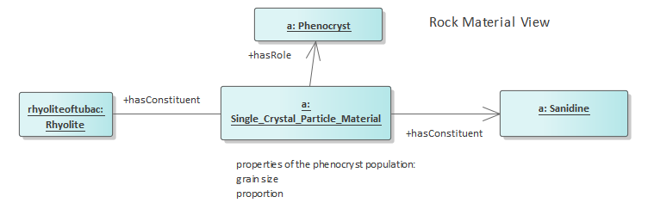

Figure 14: Rock material and role example

A more complete description of the rhyolite would probably include other phenocrysts, a description of the groundmass, and if applicable description of flow-banding fabric, lithophysae, etc.

rol:rhyoliteoftubac

a gsrm:Rhyolite ;

rdfs:label "Rhyolite of Tubac" @en ;

rdfs:comment "Contains 15% 1-3 mm euhedral sanidine phenocrysts " @en ;

gsoc:hasConstituent [

a gsgm:Single_Crystal_Particle_Material ;

gsoc:hasConstituent [ a gsmin:sanidine ] ;

gsoc:hasRole [

a gsor:Phenocryst ;

gsoc:hasQuality [

a gsoc:Proportion ;

gsoc:hasValue [

a gsoc:Numeric_Value ;

gsoc:hasDataValue "15"^^xsd:decimal ;

gsoc:hasUOM [ a unit:PERCENT ]

] ] ;

gsoc:hasQuality [

a gsoc:Shape ;

gsoc:hasValue [

a gsoc:Measure_Value ;

gsoc:hasDataValue "euhedral" ] ;

gsoc:hasQuality [

a gsgm:Grain_Size ;

rdfs:label "1-3 mm diameter crystals";

gsoc:hasValue [

a gsoc:Range_Value ;

gsoc:hasEndValue [

a gsoc:Numeric_Value;

gsoc:hasDataValue "3"^^xsd:decimal ;

gsoc:hasUOM [ a unit:MilliM ] ;

rdfs:label "3 mm maximum" ] ;

gsoc:hasStartValue [

a gsoc:Numeric_Value ;

gsoc:hasDataValue "1"^^xsd:decimal ;

gsoc:hasUOM [ a unit:MilliM ] ;

rdfs:label "1 mm minimum" ;

]

] ] ] .

### Example 5: Geologic Unit, Role, and Rock Material

A geologic unit is composed of conglomerate that contains clasts of granite and diorite (Figure 15).

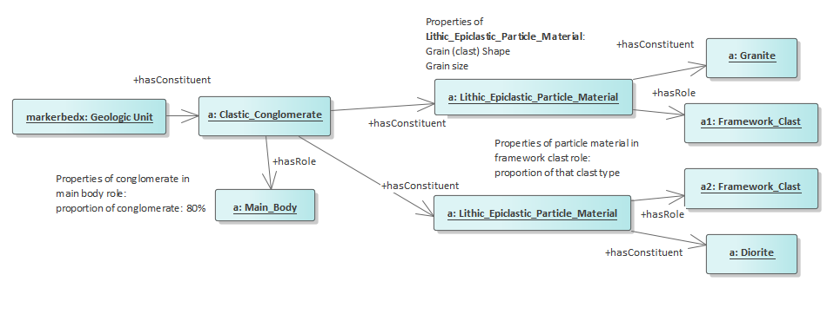

Figure 15: Geological unit, role, and rock material example

Example of nested hasConstitutent and hasRole relations to represent complex composition of a heterogeneous rock.

rol:markerbedx

a gsgu:Marker_Bed ;

rdfs:label "Marker bed X"@en ;

gsoc:hasConstituent [

a gsrm:Clastic_Sandstone ;

rdfs:label "sandstone matrix between clasts"@en ;

gsoc:hasRole [

a gsog:Matrix ;

gsoc:hasQuality [

a gsoc:Proportion ;

rdfs:label "proportion of matrix is 20%";

gsoc:hasValue [

a gsoc:Numeric_Value;

gsoc:hasDataValue "20"^^xsd:decimal ;

gsoc:hasUOM [ a unit:PERCENT ]

] ]

]

] ;

gsoc:hasConstituent [

a gsrm:Clastic_Conglomerate ;

rdfs:label "Marker bed X conglomerate"@en ;

rdfs:comment "clast-supported conglomerate, 80 percent clasts"@en ;

gsoc:hasRole [

a gsog:Main_Body ;

gsoc:hasQuality [

a gsoc:Proportion ;

gsoc:hasValue [

a gsoc:Numeric_Value ;

gsoc:hasDataValue "80"^^xsd:decimal ;

gsoc:hasUOM [ a unit:PERCENT ]

] ]

];

gsoc:hasConstituent [

a gsgm:Lithic_Epiclastic_Particle_Material ;

rdfs:comment "60 percent of clasts in conglomerate are sub-rounded diorite, 6-15 cm diameter"@en ;

gsoc:hasConstituent [a gsrm:Diorite ] ;

gsoc:hasRole [

a gsor:Framework_Clast ;

gsoc:hasQuality [

a gsoc:Proportion ;

gsoc:hasValue [

a gsoc:Numeric_Value;

gsoc:hasDataValue "60"^^xsd:decimal ;

gsoc:hasUOM [ a unit:PERCENT ]

] ];

gsoc:hasQuality [

a gsgm:Particle_Shape ;

gsoc:hasQuality [

a gsgm:Grain_Roundness;

gsoc:hasValue [

a gsgm:sub_rounded ;

rdfs:label "Sub-rounded"@en ;

]

]

];

gsoc:hasQuality [

a gsgm:Grain_Size ;

rdfs:label "60-150 mm diameter clasts";

gsoc:hasValue [

a gsoc:Range_Value ;

gsoc:hasEndValue [

a gsoc:Numeric_Value;

gsoc:hasDataValue "150"^^xsd:decimal ;

gsoc:hasUOM [ a unit:MilliM ] ;

rdfs:label "150 mm maximum"@en ;

] ;

gsoc:hasStartValue [

a gsoc:Numeric_Value ;

gsoc:hasDataValue "60"^^xsd:decimal ;

gsoc:hasUOM [ a unit:MilliM ] ;

rdfs:label "60 mm minimum"@en ;

] ]

]

]

] ;

gsoc:hasConstituent [

a gsgm:Lithic_Epiclastic_Particle_Material ;

rdfs:comment "40 percent of clasts in conglomerate are well rounded granite, 3-8 cm diameter"@en ;

gsoc:hasConstituent [ a gsrm:Granite ] ;

gsoc:hasRole [

a gsor:Framework_Clast ;

gsoc:hasQuality [

a gsoc:Proportion ;

gsoc:hasValue [

a gsoc:Numeric_Value ;

gsoc:hasDataValue "40"^^xsd:decimal ;

gsoc:hasUOM [ a unit:PERCENT ]

]

];

gsoc:hasQuality [

a gsgm:Particle_Shape ;

gsoc:hasQuality [

a gsgm:Grain_Roundness;

rdfs:comment "shape of granite clasts" @en;

gsoc:hasValue [

a gsgm:well_rounded ;

rdfs:label "Well rounded"@en ;

] ]

];

] ] ] .

### Example 6: Rock Sample

SMR2011-12-16-01 is sample of Formation Z (Figure 16).

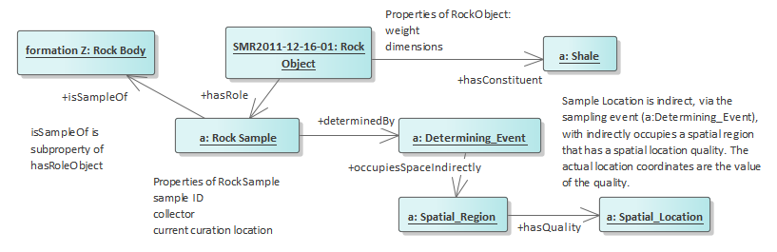

Figure 16: Rock sample example

Note that the encoding below starts with the rock object and uses the inverse of hasRolePlayer (hasRole) to link the rock object to the sample. Subclasses of rock object for different kinds of samples would probably be useful.

rol:SMR2011-12-16-01

a gsog:Rock_Object;

gsoc:hasConstituent [a gsrm:shale ] ;

gsoc:hasQuality [

gsoq:Diameter ;

gsoc:hasValue [

a gsoc:Numeric_Value ;

gsoc:hasDataValue "100"^^xsd:decimal;

gsoc:hasUOM [ a unit:MilliM ]

] ];

gsoc:hasRole [

a gsor:Rock_Sample ;

gsoc:isSampleOf rol:formationZ ;

gsoc:determinedBy [

a gspd:Determining_Event;

rdfs:label "event of obtaining the sample in the field." @en ;

rdfs:comment "constituent processes could be used to document the sampling procedure. Consider importing SOSA or PROV vocabularies for better sample description." @en ;

gsoc:occupiesSpaceIndirectly [

a gsoc:Spatial_Region;

rdfs:label "Sampling location";

rdfs:comment "location of sampling event is indirect, anchored in the location of the sampling site" @en ;

gsoc:hasQuality [

a gsoc:Spatial_Location ;

gsoc:hasValue [

a gsoc:WKT_Value;

gsoc:hasDataValue "<http://www.opengis.net/def/crs/OGC/1.3/CRS84> POINT (144.359002125 -38.167672488)" ;

]

] ] ]] .

## Example files

GSO example files, created for demonstration and testing purposes, are listed and briefly described in Table 4.

Table 4: GSO example files

| **Example file** | **Description** |
| --- | --- |
| GSO-ComplexContacts.ttl | Imports GSO-ExampleFormationJs.ttl and describes internal contacts within the unit and contacts with various other units. Js is a Jurassic age sedimentary unit that has a lower clastic part with an internal tuff marker bed, and an upper limestone part. The unit unconformably overlies tilted Paleozoic strata that overly Early Proterozoic metamorphic rocks; it is intruded by a Cretaceous granite, and the granite and Js are intruded by a Cretaceous diorite dike. After the igneous activity, a period of exhumation and erosion removed the cover on the Jurassic sediment and Cretaceous igneous rocks, and Late Miocene sediment covered this unconformity. |
| GSO-Events1.ttl | Describes series of depositional and intrusive events, with their ages and relationships |
| GSO-ExampleBritishColumbiaStrat-v2.ttl | Example encoding density and magnetic susceptibility for some RockMaterial Classes. The rock material in a formation is an instance of the material class that is 'partOf' the 'body' of that kind of material in the region, which is also an instance of the material class. E.g. the wacke constituent in the Tezzeron Sequence is an instance of gsrm:Wacke that is part of the 'wacke in British Columbia', which is an instance of gsrm:Wacke. |
| GSO-ExampleFault2.ttl | Describes faults participating in the deformation sequence described in GSO-ExampleHistory.ttl. |
| GSO-ExampleFaultKannaV4Model.ttl | Describes a set of crosscutting fault relationships from the Kanna V4 model. Data from Eric de Kemp, GSC |
| GSO-ExampleFold.ttl | Describes simple fold with amplitude, axial surface and axial surface orientation. |
| GSO-ExampleFormationJs.ttl | Describes formation with several members, ages and some lithology description. |
| GSO-ExampleGeosciAustraliaStratUnit.ttl | Description of two units from GA strat lexicon, mapped to GSO from GeoSciML. |
| GSO-ExampleHistory.ttl | Example history representation, based on geology shown in EasternRinconMountainsXSec.png figure in the Loop3D-GSO.TestInstances directory on GitHub |
| GSO-ExampleIsleOfWightStrat-pm1.ttl | Age, basic lithology, and stratigraphic relations for units on the Isle of Wight. Data from Rachel Heaven, BGS. |
| GSO-ExampleLaTojizaPluton.ttl | Description of pluton, pluton phase, intrusive relationships, based on descriptions in A. ARANGUREN, J. CUEVAS, J. M. TUBI´A, T. ROMA´ N-BERDIEL, A. CASAS-SAINZ, & A. CASAS-PONSATI, 2003, Granite laccolith emplacement in the Iberian arc: AMS and gravity study of the La Tojiza pluton (NW Spain): Journal of the Geological Society, London, Vol. 160, 2003, pp. 435–445. DOI: 10.1144/0016-764902-079 |
| GSO-ExamplePetrophysicalProperties_v2.ttl | Magnetic susceptibility and density data for units in GSO-ExampleBritishColumbiaStrat-v2.ttl; imports that ontology. |
| GSO-ExampleRockMaterialBolsaQuartzite.ttl | Example encoding of a lithology description for a formation; description of rock material constituents of Bolsa Quartzite Formation |
| GSO-ExampleRoles.ttl | Example rock sample, pluton pendant, and phenocryst as roles. |
| GSO-ExampleVocabularyExtension-Alteration_Type-BC.ttl | Extend CGI alteration type vocabulary to account for alteration reported in British Columbia Geological Survey, 2008, Rock Properties Database |
| GSO-LardeauGroup.ttl | Stratigraphy of Lardeau group, British Columbia. |

# Acknowledgements

We gratefully acknowledge support from the Canad3D project, Open Geoscience Initiative of Natural Resources Canada, and from the Australian Research Council funded Loop project, Enabling Stochastic 3D Geological Modelling (LP170100985), in collaboration with the OneGeology initiative. Also thanked are the many collaborators from Loop, including: E. de Kemp, M. Hillier, M. Parquer, E. Boisvert, M. Lindsay, L.Ailleres, M. Jessel, R.E. Heaven, D. Lescinsky, and N. Car.

# References

Allen, James F. (1983) Maintaining knowledge about temporal intervals. [Communications of the ACM](https://dl.acm.org/magazine/cacm), November 1983. <https://doi.org/10.1145/182.358434>.

Arp, Robert, Smith, Barry, and Spear, Andrew D. (2015) Building Ontologies with Basic Formal Ontology: MIT Press, Cambridge, MA, 220 pages.

Beckett, David, and Berners-Lee, Tim, 2011-03-28, Turtle - Terse RDF Triple Language: W3C Team Submission, accessed at https://www.w3.org/TeamSubmission/turtle/.

Borgo, S., and Masolo, C. (2010) Foundational choices in DOLCE. In: R. Poli et al. (eds.), Theory and Applications of Ontology: Computer Applications, Springer Science+Business Media B.V., DOI 10.1007/978-90-481-8847-5_13.

Brodaric, B. (2019). Kinds of Physical Features. Proceedings. In: The 3rd Workshop on Foundational Ontologies, FOUST III. Medical University of Graz, AT, September 23-25. <http://ceur-ws.org/Vol-2518/paper-FOUST5.pdf>.

Brodaric, B., Hahmann, T., Gruninger, M. (2019) Water Features and Their Parts. *Applied Ontology*, 14(2019):1–42*.* DOI: 10.3233/AO-190205

CGI Data Model Working Group, 2012, GeoSciML v3.2 Online Documentation, accessed at <http://geosciml.org/doc/geosciml/3.2/documentation/html/index.htm>.

Cohn, A.G., Bennett, B., Gooday, J., Gotts, M.M. (1997). Qualitative Spatial Representation and Reasoning with the Region Connection Calculus. GeoInformatica, **1**(3): 275–316. [*doi*](https://en.wikipedia.org/wiki/Doi_(identifier)):[*10.1023/A:1009712514511*](https://doi.org/10.1023%2FA%3A1009712514511)

Cox, Simon J. D. and Richard, Stephen M. (2005). "A formal model for the geologic time scale and global stratotype section and point, compatible with geospatial information transfer standards". *Geosphere*, 1 (3): 119–137.

Cox, S.J.D. and Richard, S.M. (2014) A geologic timescale ontology and service. *Earth Science Informatics*. DOI: 10.1007/s12145-014-0170-6.

Galton, A. & Mizoguchi, R. (2009). The water falls but the waterfall does not fall: New perspectives on objects, processes, and events. *Applied Ontology*, *4*(2), 71–107.

Guizzardi G. and Wagner G. (2010) Using the Unified Foundational Ontology (UFO) as a Foundation for General Conceptual Modeling Languages. In: Poli R., Healy M., Kameas A. (eds) Theory and Applications of Ontology: Computer Applications. Springer, Dordrecht. <https://doi.org/10.1007/978-90-481-8847-5_8>

Lowe, E.J. 1998, Entity, Identity and Unity. *Erkenntnis*, 48(2/3):191-208.

Masolo, C., Borgo, S., Gangemi, A., Guarino, N., and Oltramari, A., 2003, WonderWeb deliverable D18: Technical report, Laboratory for Applied Ontology, ISTC-CNR, Trento, Italy.

North American Geologic Map Data Model (NADM) Steering Committee Data Model Design Team, 2004, NADM Conceptual Model 1.0—A Conceptual Model for Geologic Map Information: U.S. Geological Survey Open-File Report 2004-1334, accessed at <https://pubs.usgs.gov/of/2004/1334/>.

Open Geospatial Consortium (OGC) (2009). C. Kottmann and C. Reed (Eds.): The OpenGIS abstract specification, topic 5: Features. Open Geospatial Consortium (OGC) 08-126, v5.0.

Perrin, Michel, Zhu-Colas, Beiting, Rainaud, Jean- François, and Schneider, Sébastien, 2005, Knowledge-driven applications for geological modeling. *Journal of Petroleum Science and Engineering*, 47(1):89-104. DOI: 10.1016/j.petrol.2004.11.010

Raymond O., Duclaux G., Boisvert E., Cipolloni C., Cox S., Laxton J., Letourneau F., Richard S., Ritchie A., Sen M., Serrano J-J., Simons B., and Vuollo J., 2012, GeoSciML v3.0 - a significant upgrade of the CGI-IUGS geoscience data model: Geophysical Research Abstracts, EGU General Assembly 2012, EGU2012-2711, Vol. 14, Available from: https://www.researchgate.net/publication/258616003_GeoSciML_v30_-_a_significant_upgrade_of_the_CGI-IUGS_geoscience_data_model [accessed May 16 2020].

Remane et al., 1996, Revised guidelines for the establishment of global chronostratigraphic standards by the International Commission on Stratigraphy (ICS). *Episodes*, 19:77-81. Accessed at https://stratigraphy.org/files/Remane1996.pdf.

# Appendix 1. SPARQL Queries

## Get all the time ordinal eras in a version of the Geologic time scale

Three versions of the International Chronostratigraphic Chart from the International Commission on Stratigraphy have been implemented in the GSO-Geologic_Time_Interval.ttl module as a proof of concept. These are the 2020 (gstime:isc2020-01), 2017 (gstime:isc2017-02) and 2004 (gstime:isc2004-04) versions. The following query will generate a table with all the named intervals, their lower boundary age assigned per version, and labels for the type of Geochronologic boundary defined (if there is one defined).

QUERY:

prefix rdf: <http://www.w3.org/1999/02/22-rdf-syntax-ns#>

prefix rdfs: <http://www.w3.org/2000/01/rdf-schema#>

prefix gstime: <https://w3id.org/gso/ischart/>

prefix gsog: <https://w3id.org/gso/geology/>

prefix gsoc: <https://w3id.org/gso/common/>

**SELECT** **DISTINCT** ?tconcept ?label ?date ?reflabel ?boundary

**WHERE** {

?tconcept gsoc:isPartOf gstime:isc2004-04.

?tconcept rdf:type/rdfs:subClassOf* gsog:Geologic_Time_Interval.

?tconcept rdfs:label ?label.

**OPTIONAL** {?tconcept gsoc:timeStartedBy ?boundary .

?boundary gsoc:isPartOf gstime:isc2004-04 ;

a gsog:Geologic_Time_Boundary ;

gsoc:hasEssentialPart/gsoc:hasStaticPart ?timeinst .

?timeinst a gsoc:Time_Instant ;

gsoc:hasQuality/gsoc:hasValue/gsoc:hasDataValue ?date .

**OPTIONAL** { ?boundary gsoc:hasEssentialPart/gsoc:staticHostedBy ?sp.

?sp rdfs:label ?reflabel } } }

**ORDER** **BY** ?date

RESULTS:

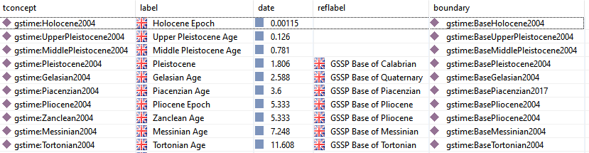

Figure 17: Partial results from SPARQL query for geological time units

## Get physical properties for rock types in British Columbia Database

This query pulls physical properties from the GSO-ExamplePetrophysicalProperties_v2.ttl example file, which imports stratigraphic descriptions from GSO-ExampleBritishColumbiaStrat-v2.ttl.

prefix gsog: <https://w3id.org/gso/geology/>

prefix rdf: <http://www.w3.org/1999/02/22-rdf-syntax-ns#>

prefix rdfs: <http://www.w3.org/2000/01/rdf-schema#>

prefix gsoc: <https://w3id.org/gso/common/>

prefix gsrm: <https://w3id.org/gso/rockmaterial/>

**SELECT** ?formationname ?rocktype ?qualType ?val ?uncer ?inst

**WHERE** {

?formation gsoc:hasConstituent ?rock ;

rdfs:label ?formationname .

?rock rdf:type ?rocktype ;

gsoc:hasQuality ?qual.

?qual a ?qualType ;

gsoc:hasValue/gsoc:hasDataValue ?val .

**OPTIONAL** {?qual gsoc:hasValue/gsoc:hasUncertainty ?uncer . }

**OPTIONAL** {?qual gsoc:hasValue/gsoc:determinedBy/gsoc:hasConstituent/rdfs:label ?inst . }

}

RESULTS:

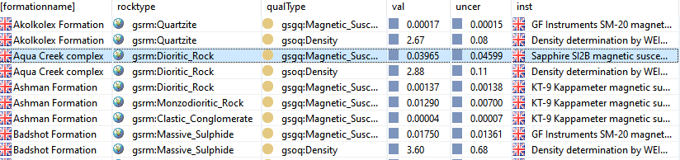

Figure 18: Partial results from SPARQL query for petrophysical properties

## Get the boundaries of a geologic unit and the process type for the boundary.

This query operates on the GSO-ComplexContacts example.

prefix gsoc: <https://w3id.org/gso/common/>

prefix gsog: <https://w3id.org/gso/geology/>

prefix con: <https://w3id.org/gso/ex-complexcontact#>

**SELECT** ?bnd ?proctype

**WHERE** {

?bnd a gsog:Rock_Body_Boundary ;

gsoc:hostedBy con:KdDike ;

gsoc:isParticipantIn ?proc.

?proc a ?proctype.

}

RESULTS:

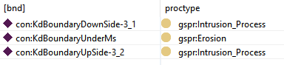

Figure 19: Results of contact and contact process type query

## Get all the rock types that appear in a dataset.

Returns labels in all languages available.

prefix rdf: <http://www.w3.org/1999/02/22-rdf-syntax-ns#>

prefix rdfs: <http://www.w3.org/2000/01/rdf-schema#>

prefix gsog: <https://w3id.org/gso/geology/>

**SELECT** **DISTINCT** ?subject ?label

**WHERE** {

?subject rdfs:subClassOf* gsog:Rock_Material .

?rock a ?subject .

**OPTIONAL** { ?subject rdfs:label ?label }

}

**ORDER** **BY** ?subject

RESULTS:

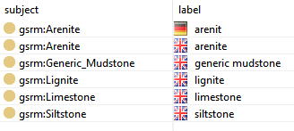

Figure 20: Results of rock type query

## Get Lithology for units in Isle of Wight.

prefix rdf: <http://www.w3.org/1999/02/22-rdf-syntax-ns#>

prefix rdfs: <http://www.w3.org/2000/01/rdf-schema#>

prefix gsoc: <https://w3id.org/gso/common/>

prefix gsrm: <https://w3id.org/gso/rockmaterial/>

prefix gsog: <https://w3id.org/gso/geology/>

prefix gsgu: <https://w3id.org/gso/geologicunit/>

**SELECT** ?unitname ?rockClassLabel ?rlabel ?plabel

**WHERE**

{

?subject rdfs:subClassOf* gsgu:Stratigraphic_Unit .

?x a ?subject .

?x gsoc:hasConstituent ?y;

rdfs:label ?unitname .

?y rdf:type ?rockClass .

?rockClass rdfs:label ?rockClassLabel .

**FILTER** LANGMATCHES( LANG(?rockClassLabel), "en" ) .

**OPTIONAL** {

?y gsoc:hasRole ?srole.

?srole a ?roleType ;

gsoc:hasQuality ?qual .

?roleType rdfs:label ?rlabel.

}

**OPTIONAL** {

?qual rdf:type gsoc:Proportion ;

gsoc:hasValue ?v .

?v rdf:type ?propval .

?propval rdfs:label ?plabel }

}

**ORDER** **BY** ?unitname

RESULTS:

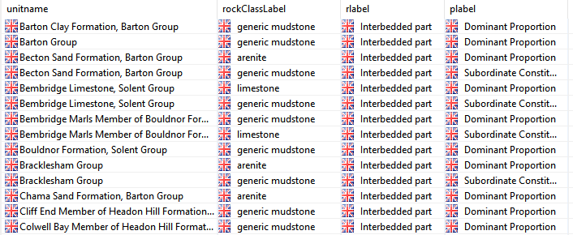

Figure 21: Lithology for units in Isle of Wight.